EuroSun2026
Coupling characteristics of PV generation and energy consumption in PV building: based on operation data of a ZEB in Beijing

Bojia Li 1 (corresponding author), Mengmeng Bian 1, Zhifeng Sun 1, Xinyu Zhang 2, Tao He 1
1 China Academy of Building Research, Beijing (China);
2 State Key Laboratory of Building Safety and Environment, Beijing (China)
Email(s): libojia@outlook.com

Summary
Coupling characteristics of PV generation and energy consumption are important for optimizing PV system design and achieving higher energy-saving and emission reduction goals. Yearly operation data of a Zero Emission Building in Beijing have been analyzed. Electricity and heat consumption, PV power generation with different orientations and types, and also the coupling characteristics of typical office buildings have been investigated. Results show that the annual energy consumption per building area was 64.9 kWh/m², and the PV generation was 73.2 kWh/m² per building area, achieving net zero emissions in operation stage. Annual self-consumption ratio was 30.9%, and the self-sufficiency ratio of building electricity consumption was 57.5%. It has also been found the PV generation hours of thin-film modules were 142 hours longer, but their electricity output was 23.1% less than monocrystalline silicon modules with same tilt. The relevant data could provide reference for design and optimization of low carbon of zero emission buildings.
Keywords: PV building, PV generation efficiency, self-consumption ratio, self-sufficiency ratio
Field of application for the findings: Low carbon or zero carbon buildings
Addressed audience: Researchers in the field of Building PV System
- Introduction
In China, building operation energy consumption accounts for approximately 22% of total national energy consumption, and carbon emissions also account for around 22% of the total. Promoting applications of renewable energy such as PV system in building sector is a promised way to achieve the national carbon reduction strategy.
PV building is not only applying PV systems on buildings, but also deep integration of electricity consumption and PV output to improve self-consumption ratio (SCR), to get better economic performance and realizing building energy conservation and carbon reduction. Generally, both building energy consumption and PV generation are unstable. Therefore, coupling characteristics of PV generation and energy consumption constitute an important foundation for optimizing design of building PV systems.
However, current studies on the coupling characteristics analysis mostly rely on simulated data. Talavera et al. (2019) proposed a method for determining the scale of building PV systems based on the PV SCR and building self-sufficiency ratio (SSR), aiming to maximize self-consumption and minimize grid impact. Ma et al. (2022) analyzed the economy and optimized configuration of grid-connected PV-battery systems in residential buildings based on annual hourly simulations. Fresitas et al. (2018) optimized the size of PV system on building facades and roof to improve the SSR through simulation. Zou et al. (2022) established a PV-battery system model to investigate the coupling characteristic in an office building.
Regarding studies based on actual operation data, Fan et al. (2019) established building energy consumption prediction models with monitoring data. Liu et al. (2021) conducted optimization analysis on PV, battery and hydrogen vehicle storage systems based on operation data from a net-zero energy community, but such monitoring data were mainly used for validation.
In summary, most current research on coupling characteristics of PV generation and building energy consumption is simulation-based, while relatively few studies based on long-term operation data.
This study is based on actual monitoring data of a zero emission office building in Beijing. The annual electricity and heating consumption have been quantitatively analyzed, together with actual electricity generation of PV systems with different orientations and types. The coupling characteristics and comparing results could provide a references for the optimal design of PV and flexible control systems in such low carbon or zero emission projects.
- Building and PV systems
The building analyzed in this study is located in Chaoyang District, Beijing, China. It is a 2‑story office building with a total floor area of 3 025 m², accommodating about 200 office staff. This building has been retrofit to a zero emission building in December 2021. About 236.1 kWp PV panels were installed on the roof and façade (Wuyun et al. 2024).
To conduct research on generation performance comparison of PV systems with different module types, orientations and installation tilts, the building has been specially designed. Monocrystalline silicon, thin film, translucent PV glass, and other types of PV modules were adopted in this building. In this research, 221.6 kWp PV system has been used to analyze the coupling characteristics. And all the PV systems were divided into 10 subsystems for metering generation data separately. Detailed configuration of PV systems are listed in Tab. 1.
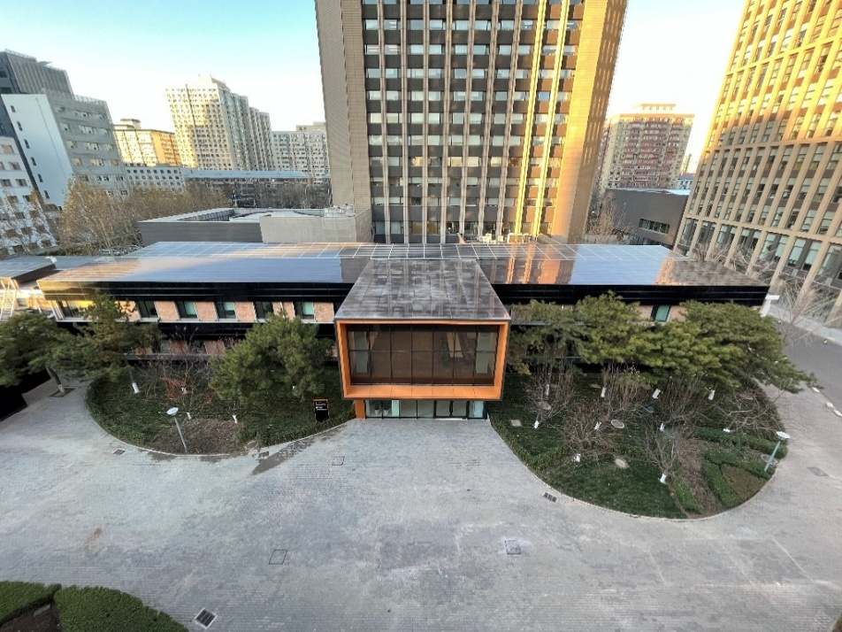
Fig.1: Zero emission building outlook
Tab.1: Configuration of PV systems in Zero Emission Building
PV sub-systems | Location | Module Type | STC efficiency | Numbers of module | PV area  (m²) | PV capacity  (kWp)
1 | Main building roof  -North-West part | Monocrystalline silicon module | 20% | 90 | 142.56 | 28.8
2 | Main building roof  -North-East part | Monocrystalline silicon module | 20% | 99 | 178.2 | 36
3 | Sub building roof | Monocrystalline silicon module | 20% | 98 | 178.2 | 36
4 | Main building roof-South | Thin-film module | 15% | 473 | 337.68 | 46.9
5 | Lobby roof | Thin-film module | 15% | 225 | 161.28 | 22.4
6 | Main building south façade  -West part | Thin-film module | 15% | 173 | 124.56 | 17.3
7.1 | Main building south façade  -East part | Thin-film module | 15% | 140 | 100.8 | 14
7.2 | Lobby south facade | 70% transparent module | 4.5% | 14 | 51.66 | 2.2
8 | Lobby west façade | Thin-film module | 15% | 70 | 50.4 | 7
9 | Lobby east façade | Thin-film module | 15% | 70 | 50.4 | 7
10 | Sub building east façade | Thin-film module | 15% | 40 | 28.8 | 4
Total |  |  |  | 1492 | 1404.54 | 221.6

In addition, the building is equipped with various operation data monitoring systems, including PV power generation, electricity consumption, heating consumption, and meteorological data, to support analysis on the coupling characteristics of PV generation and energy consumption. This research based on the monitoring data in 2022. Dur to covid-19, some days monitoring system stopped, and the effective period was 314 days in 2022. In these 314 days, total solar irradiance on the horizontal plane was 1 250.6 kWh/m². The total PV generation was 182 071 kWh. And the total electricity consumption was 102 072 kWh. Fig. 2 shows the Hourly PV generation in 2022.
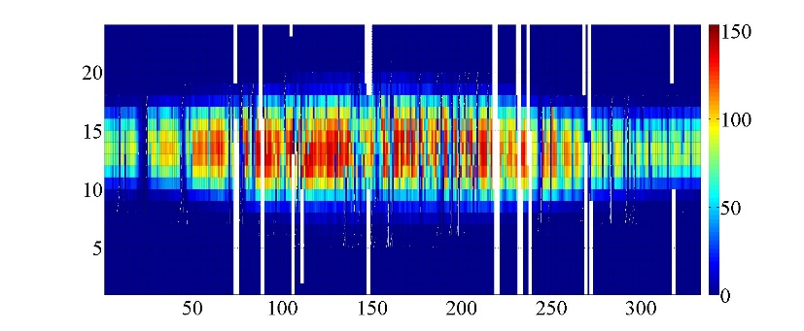
Days of the year
PV generation, kWh

Hours
Fig. 2: Hourly PV generation in 2022
- Data analysis
3.1. Building Energy Consumption
According to monitoring data in 2022, the effective period was 314 days, and total electricity consumption was 102 072 kWh. After converting the energy consumption to 365 days on monthly basis, total electricity consumption was 116 041 kWh, about 38.7 kWh per building area. Besides the electricity consumption, this building had a space heating system using hot water provided by district heating system. The annual heating energy was about 179 576 kWh, about 59.9 kWh per building area, as shown in Fig.3 (a). According to Chinese national standard GB 55015-2021, heating energy consumption has been converted into equivalent electrical energy. The average daily energy consumption is shown in Fig.3 (b).

(a)Monthly electric and heating power consumption (b) Average daily electricity and heating consumption
Fig.3: Monthly electricity and heating consumption
Because it is an office building, the average daily electricity consumption dropped a lot during weekends, as shown in Fig.4 (a). Comparing with heating consumption data, there is no significant difference in average daily data between workday and weekend in each month, as shown in Fig.4 (b). It is speculated that this is due to the lack of adjustment measures in the central heating system. Therefore, there is considerable potential for energy-saving in heating.

(a) Comparison of electricity consumption (b) Comparison of heating consumption
Fig.4: Comparison of daily consumption between weekday and weekend
3.2. PV generation
In 2022, total horizontal solar irradiance during monitoring period was 1250.6 kWh/m², and the total PV generation was 182 071 kWh. After converting to 365 days on monthly basis, the total PV generation was 219 561 kWh, about 73.2 kWh per building area. And average daily PV generation was 601.5 kWh, annual power generation hours was 990.8 h. The average daily electric power output and power generation hours of PV system for each month are shown in Fig.5 and Tab.2.

Fig.5: Average daily electric power output and power generation hours for each month
Tab.2: Electricity power output for each month
Month | Effective monitoring days | Monitored PV generation (kWh) | Average daily PV generation (kWh) | power generation hours (h)
Jan | 31 | 10241 | 330.36 | 46.21
Fab | 28 | 14439 | 515.69 | 65.16
Mar | 27 | 16610 | 615.20 | 86.06
Apr | 15 | 12173 | 811.51 | 109.86
May | 24 | 19789 | 824.53 | 115.34
Jun | 16 | 11118 | 694.89 | 94.07
Jul | 31 | 22097 | 712.82 | 99.72
Aug | 31 | 21330 | 688.06 | 96.25
Sep | 23 | 17921 | 779.17 | 105.48
Oct | 28 | 14327 | 511.67 | 71.58
Nov | 30 | 11032 | 367.74 | 49.78
Dec | 30 | 10994 | 366.47 | 51.27
Total | 314 | 182071 | 601.54 | 990.78

Tab.3 shows annual incident irradiance, power generation and efficiency of each PV subsystem. The system efficiency was calculated according to Chinese national standard GB/T 50801-2013, and it included the panel and inverter efficiency, as while as the influencing factors during operation. The power generation data in Tab. 7 revealed that the total installed capacity of PV subsystem 1-5 arranged on the roof accounts for 76.8% of the total installed capacity, yet their power generation accounts for 93.1% of the total annual power generation. This demonstrated that building roofs are the primary choice for PV system. Furthermore, due to surrounding buildings and greenery (as shown in Fig.6), the power generation of facade PV systems was less than normal PV systems.
Tab.3: Testing results on annual power generation performance of different PV systems
PV sub-systems |  | PV capacity  (kWp) | Orientation | Incident irradiance (kWh/m²) | Shading coefficient | PV generation  (kWh) | System efficiency | power generation hours (h)
1 |  | 28.8 | South, 5° | 1572.34 | 1 | 32583.49 | 14.5% | 1131.37
2 |  | 36 | South, 5° | 1572.34 | 0.9 | 38503.32 | 15.3% | 1069.54
3 |  | 36 | South, 5° | 1572.34 | 1 | 43184.36 | 15.4% | 1199.57
4 |  | 46.9 | South, 5° | 1572.34 | 1 | 62919.01 | 11.9% | 1341.56
5 |  | 22.4 | Horizontal | 1513.39 | 1 | 27165.06 | 11.1% | 1212.73
6 |  | 17.3 | South, 90° | 1194.03 | 0.4 | 4360.47 | 7.3% | 252.05
7 |  | 16.2 | South, 90° | 1194.03 | 0.5 | 6653.62 | 9.6% | 410.72
8 |  | 7 | West, 90° | 843.64 | 0.5 | 1872.25 | 8.8% | 267.46
9 |  | 7 | East, 90° | 854.72 | 0.4 | 1549.21 | 9.0% | 221.32
10 |  | 4 | East, 90° | 854.72 | 0.4 | 770.24 | 7.8% | 192.56
Total | 221.6 |  |  |  |  | 219561.03 | 12.8% | 990.78

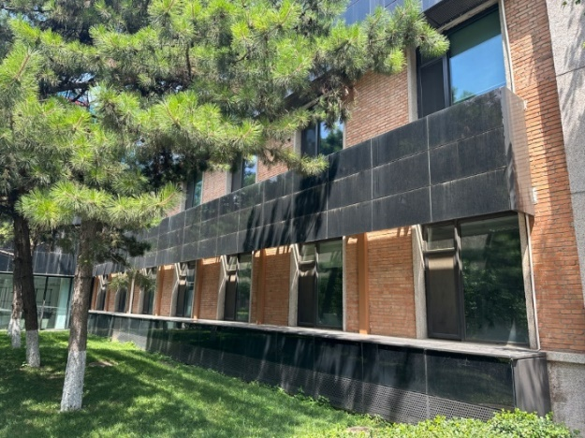
Fig.6: Some PV modules on the south facade blocked by trees on the summer solstice
There are 2 PV subsystems with same area, orientation and tilts on the roof, the difference is that one uses monocrystalline silicon modules (STC efficiency 20%) and the other uses thin-film modules (STC efficiency 15%). Fig.7(a) shows the performance for these 2 subsystems. It could be found that the PV generation hours of thin-film modules were 142 hours longer. However, thin-film system’s electricity output was 23.1% less than monocrystalline silicon system due to the efficiency difference. Therefore, for PV systems installed on building roofs, monocrystalline silicon modules can achieve higher power generation, while thin-film modules can provide longer power generation duration.

(a) Comparison of monocrystalline silicon and thin film modules (b) Average daily power generation and consumption
Fig.7: Monthly module performance comparison, energy consumption and generation
3.3. Coupling characteristics
Based on the 2022 monitoring data, the total PV generation was 219 561 kWh, and the total energy consumption was 194 523.7 kWh. In general, the annual net energy output was 25 037.3 kWh, about 11.4% of total electricity generation. This building realized zero emission in operation stage.
For the coupling of generation and consumption, annual self-consumption ratio (SCR) and self-sufficiency ratio (SSR) were calculated as following equations.
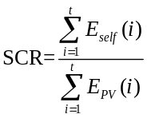 | (eq.1)
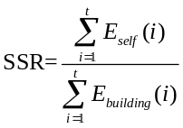 | (eq.2)
Where, SCR is self-consumption ratio, %. SSR is self-sufficiency ratio, %. E_{self}(i) is the electricity directly supplied to the building from PV system at time i, kWh. E_{PV}(i) is the electricity PV generated at time i, kWh. E_{building}(i) is the electricity building consumed at time i, kWh.
After calculating, the building’s annual SCR was 30.9%, and SSR was 57.5%. The SCR was relatively low in transition season, and the SSR was relatively low in winter, as shown in Fig.7(b). The introduction of energy storage and flexible energy consumption technologies could further improve their coupling performance.
- Conclusion
Coupling characteristics of PV generation and energy consumption are important for optimizing PV system design and achieving higher energy-saving and emission reduction goals. Yearly operation data of a Zero Emission Building in Beijing have been analyzed in this paper.
The annual energy consumption per building area was 64.9 kWh/m², and the PV generation was 73.2 kWh/m² per building area, achieving net zero emissions in operation stage.
Annual self-consumption ratio was 30.9%, and the self-sufficiency ratio of building electricity consumption was 57.5%.
It has also been found the PV generation hours of thin-film modules were 142 hours longer, but their electricity output was 23.1% less than monocrystalline silicon modules with same tilt.
These results could provide reference for design and optimization of low carbon of zero emission buildings.
- References
Fan, C., Sun, Y.J., Zhao, Y., et al., 2019. Deep learning-based feature engineering methods for improved building energy prediction. Applied Energy. 240, 35-45.
Fresitas, S.C.R., Brito, M.C., 2018. Minimizing storage needs for large scale photovoltaics in the urban environment. Solar Energy. 159, 375-389.
Liu, J., Chen, X., Yang, H.X., et al., 2021. Hybrid renewable energy applications in zero-energy buildings and communities integrating battery and hydrogen vehicle storage. Applied Energy. 290, 116733.
Ma, T., Zhang, Y.J., Gu, W.B., et al., 2022. Strategy comparison and techno-economic evaluation of a grid-connected photovoltaic-battery system. Renewable Energy. 197, 1049-1060.
Talavera, D.L., Muñoz-Rodríguez, F.J., Jiménez-Castillo, G., et al., 2019. A new approach to sizing the photovoltaic generator in self-consumption systems based on cost-competitiveness, maximizing direct self-consumption. Renewable Energy. 130, 1021-1035.
Wuyun, Q., Li, B.J., Bian, M.M., et al., 2024. Demonstration and data analysis of a Zero Emission Building (ZEB) in Beijing, China. Solar Energy. 272, 112488.
Zou, B., Peng, J.Q., Li, S.H., et al., 2022. Comparative study of the dynamic programming-based and rule-based operation strategies for grid-connected PV-battery systems of office buildings. Applied Energy. 305, 117875.

