EuroSun2026
GLOBAL EVOLUTION OF DISTRICT COOLING SYSTEMS: COMPARATIVE REGIONAL PATTERNS, ARCHETYPES AND IMPLICATIONS FOR SOLAR-BASED URBAN COOLING
Kedar Mehta^{1*} and Jyotirmay Mathur²
¹ Campus Mainburg, Deggendorf Institute of Technology, Deggendorf (Germany)
² Center for Energy and Environment, Malaviya National Institute of Technology, Jaipur (India)
* Correspondence Author: Kedar.mehta@th-deg.de
Summary
This study presents a comparative assessment of 32 district cooling projects across six global regions, including 31 operational systems and one planned project. The analysis examined commissioning patterns, delivery arrangements and documented cooling production configurations. The results reveal three distinct regional archetypes. Europe is characterised by ambient water and free cooling, documented in seven of nine projects. The Middle East is dominated by private concession based central chiller systems, representing seven of eight cases. Asia follows a mixed pathway that combines established urban networks with newer storage enabled developments. Across the operational sample, 11 projects use ambient or free cooling, seven include thermal energy storage and 13 are classified as chiller or other systems. Private or concession arrangements account for 21 projects, compared with eight public utility and two institutional systems. These differences lead to distinct solar integration pathways. Central chiller systems can combine photovoltaic electricity with storage to address evening cooling demand, while ambient water systems can use solar electricity for pumping, auxiliaries and residual refrigeration. The findings show that solar based district cooling must be matched to regional resources, existing infrastructure and delivery structures. Further hourly analysis is required to quantify solar utilisation, storage performance, grid peak reduction, water demand and emissions.
Keywords: District cooling, solar cooling, urban energy systems, cooling production technology, ownership and operational models, renewable integration, thermal energy storage, decarbonization
Field of application for the findings: Urban energy planning, solar-integrated district cooling systems, renewable energy integration strategies, district energy system design, climate-responsive cooling infrastructure development
Addressed audience: Researchers in solar and district energy systems, urban energy planners, policy makers, infrastructure developers and stakeholders involved in sustainable urban cooling solutions
- Introduction
Space cooling is becoming a central energy-planning challenge. The International Energy Agency estimates that electricity use for space cooling could more than triple by 2050 without stronger efficiency action, while the largest growth occurs in hot and rapidly urbanising economies[1]. Cooling is also temporally concentrated: high ambient temperature raises both building loads and electricity-system peaks. Conventional room-level equipment can meet individual needs, but it fragments maintenance, refrigerant management and load control. District cooling systems (DCS) instead produce chilled water centrally and distribute it to multiple buildings. Load diversity, larger equipment, coordinated operation and thermal energy storage (TES) can improve system efficiency and shift electric demand, although benefits are not automatic and depend on density, network losses, supply temperature, pumping, part-load operation, water use and the carbon intensity of electricity [2,3].
Solar energy creates a particularly relevant coupling opportunity. In many cooling-dominated climates, daytime cooling demand broadly overlaps photovoltaic (PV) output. Central chillers can therefore increase direct solar use, while chilled-water or ice storage shifts production from sunny hours to the evening peak. Solar thermal collectors can also drive absorption chillers, but this route is sensitive to collector temperature, auxiliary electricity, cooling-tower water, utilisation and economics [3,4].

The District cooling systems (DCS) literature contains detailed optimisation studies, technology reviews and individual case reports. Reviews explain production technologies and storage [5], while international guidelines address planning, business models and project development. However, evidence is still fragmented across operator pages, public agencies and case reports. Cross-regional discussions often combine three different questions when systems emerged, who delivers them and which local resource they exploit, without a consistent coding framework. This weakens transferability: a Scandinavian utility using seawater free cooling cannot simply be copied into a hot-arid concession, even if both are called district cooling. Space cooling demand is rapidly increasing in urban areas due to rising ambient temperatures, expanding building floor area, urban heat island effects, and growing expectations for thermal comfort. In many regions, cooling demand contributes significantly to peak electricity loads, placing stress on power systems during periods of high demand. These peak loads often coincide with periods of strong solar PV generation, creating opportunities for solar-aligned cooling strategies that combine renewable electricity with thermal storage and demand flexibility[6]. DCS are increasingly recognized as an effective approach to improve cooling efficiency through centralized production, enable large-scale thermal energy storage, and integrate low-carbon cooling sources such as seawater, deep lake water, free cooling, waste heat-driven absorption cooling, and renewable electricity [7]. By aggregating cooling demand and optimizing system operation, district cooling can significantly reduce electricity consumption and improve system reliability in dense urban environments. Despite growing interest in district cooling technologies, the existing evidence base remains fragmented. Most studies focus on individual case studies or specific technological solutions, while systematic cross-regional comparisons of deployment timing, governance models, and technology configurations remain limited [8]. This lack of comparative analysis constrains the transferability of lessons for cities and utilities seeking to implement large-scale cooling infrastructure [9]. This study addresses this gap by developing a comparative global framework for analyzing district cooling systems. Using a dataset-driven approach, the research evaluates regional deployment patterns, institutional delivery models, and technology configurations to identify pathways for integrating solar-based cooling within urban energy systems. The study addresses the following research questions:
- How do adoption timelines for DCS differ across globe (early adoption vs rapid scaling)?
- What do these patterns imply for solar-based cooling integration (PV-coupled cooling, solar thermal cooling, and storage-enabled load shifting)?
- State of the art and research gap
District cooling should be understood as urban energy infrastructure rather than simply as a larger version of an individual building chiller. A complete district cooling system combines central production plants, hydraulic distribution networks, energy transfer stations, customer systems, metering, control and long term commercial relationships [10]. By connecting buildings with different occupancy patterns and internal heat gains, the network can use demand diversity to reduce the required capacity compared with the sum of individual building peaks. Central plants can also operate several chillers close to their most efficient operating points and accommodate equipment such as large heat exchangers, thermal storage tanks and alternative heat sinks that would be impractical at individual buildings [11]. However, these advantages are not guaranteed. High pumping demand, heat gains within the network, insufficient temperature differences between supply and return water and low utilisation of installed capacity can substantially reduce system performance [2].
More recent concepts connect cooling with wider electricity, heating and waste heat systems, including ambient temperature and bidirectional networks. This development has not followed the same path in every region. Some cities operate technically advanced plants within conventional contractual arrangements, while newly planned urban districts may rely on large central chillers without using natural cooling sources [12]. Cross regional comparison therefore requires separate consideration of system age, physical energy source and institutional delivery model [13]. Renewable energy can be integrated into district cooling through electricity supply, thermally driven cooling or the direct use of a natural heat sink [14]. Solar photovoltaic cooling uses renewable electricity to operate efficient compression chillers and distribution pumps. Its main strengths are modularity, relatively rapid installation and compatibility with established cooling equipment. Its main limitation is the timing of generation. Solar electricity production may decline before the late afternoon or evening cooling peak, while cloudy and humid weather can create high latent cooling loads during periods of reduced solar irradiance. Solar thermal cooling follows a different route by supplying heat to absorption or adsorption chillers [15]. This can reduce compressor electricity consumption, but the overall performance depends on collector temperature, thermal storage, heat rejection, auxiliary electricity use and chiller behaviour under partial load. Reviews of renewable district cooling and solar driven absorption systems show that favourable thermodynamic performance does not automatically lead to attractive annual economics [16,17].
Ambient water and free cooling provide another pathway. Where water temperatures and environmental regulations permit, seawater, deep lakes, rivers or fjords can reduce the need for mechanical refrigeration. These resources are geographically limited and may require substantial investment in water intakes, pumping systems and heat exchangers. Their use can also create ecological concerns related to discharge temperatures, aquatic organisms, water chemistry and system resilience under a changing climate [18]. Natural cooling and solar electricity should therefore not be treated as competing options. Solar electricity can supply pumping and residual mechanical cooling, while the water source provides a low temperature heat sink. In most cases, the preferred sequence is to reduce cooling demand first, use direct or free cooling where feasible, meet the remaining demand with efficient mechanical equipment and apply storage and control to align system operation with renewable energy availability. Thermal energy storage adds another important function by transforming a district cooling plant from a system that simply follows demand into one that can shift its operation across time [19].
Sensible chilled water storage provides relatively high storage efficiency and uses conventional equipment, although its moderate temperature difference requires considerable tank volume. Ice storage offers higher energy density, but the lower evaporation temperatures required during charging generally reduce chiller efficiency. Latent heat storage materials can operate within intermediate temperature ranges, although questions remain about cost, heat transfer performance and material degradation [20,21]. The different roles of storage in district energy systems, while plant studies show that its value depends strongly on the selected objective. Minimising electricity costs, demand charges, primary energy use, carbon emissions or installed chiller capacity can each result in a different operating schedule [22]. Control must therefore be considered together with the physical storage system. A fixed time of use strategy may shift electricity consumption without reducing total energy use. Model predictive and data driven control can include forecasts of weather, cooling demand, solar generation and electricity prices, but these approaches require reliable instrumentation, clear operating limits and robust fallback strategies. This ownership question forms part of the wider business and governance dimension of district cooling. Because the network requires high initial investment and depends heavily on customer connections, its performance is closely linked to institutional arrangements. Public utilities may accept longer investment periods and can coordinate network construction with road development, public buildings and access to local heat sinks [23]. Private concessions can provide specialist expertise in design, financing, construction and operation, but their commercial viability depends on contracted capacity, energy consumption and tariff structures. Campus systems represent another model because a single organisation often owns both the cooling supply and much of the connected demand. This reduces transaction complexity and can support coordinated operation of solar generation and thermal storage.
Existing studies provide well developed accounts of district cooling technologies, solar cooling and storage optimisation. However, there is still no compact empirical framework that consistently connects regional diffusion, institutional delivery models and available cooling resources with the selection of an appropriate solar integration pathway [20]. This gap is important because transferring a highly visible reference project from one city to another can be misleading. A city may attempt to reproduce the plant technology while lacking the necessary water permit, anchor customers, electricity conditions or institutional capacity that made the original project successful. The present study addresses this problem by systematically coding regional development, delivery structure and cooling resource, and by evaluating the resulting district cooling archetypes through a common set of solar integration metrics.
- Materials and methods
3.1 Study design and case selection
The study is based on a structured register of 32 district cooling projects (c.f. Fig. 1). Information was collected from publicly available operator websites, utility documents, government publications and technical case descriptions published up to July 2026. A project was included when the available sources identified a specific district or campus network and provided, at minimum, its location, operator and operational or planned commissioning date. General descriptions of district cooling activity without a clearly identifiable project were not included. The final register covers six regions: nine projects in Asia (including one planned project), nine in Europe, eight in the Middle East, four in North America, and one each in Oceania and Africa. The dataset should therefore be understood as a comparative sample rather than a complete global inventory of district cooling systems. Each project is treated as one unit of analysis, even when the same operator manages several networks.
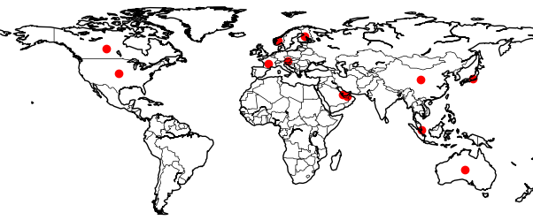
Fig 1: Global distribution of district cooling systems included in the presented study (Red dots indicate country-level locations of the DCS)
For each case, information was recorded on the region, city, project name, operator, first year of operation, delivery model, and documented production configuration. Where multiple sources were available, the reported commissioning date and operating organisation were cross checked. The earliest confirmed year of operation was then retained. For networks developed in several phases, the year in which the first phase began supplying cooling was used. Subsequent plant additions and network expansions were not treated as separate projects. Changi Airport Terminal 5 was classified as a planned project and excluded from all calculations based on commissioning year. Consequently, 31 projects were included in the operational analysis. Capacity was not applied as a weighting variable because public sources reported refrigeration tons, cooling capacity in megawatts, contracted demand, and installed plant capacity using different system boundaries and reporting years. Combining these values would therefore have resulted in potentially misleading comparisons.
Each project was classified according to its delivery arrangement and production configuration. The delivery arrangement was classified as public or utility led when the network was operated primarily by a municipality, government body, or integrated utility. It was classified as private or concession based when the system was managed by a specialised private provider, joint venture, or development concession. The institutional category included systems operated by universities, airports, hospitals, and other campus organisations. This classification represents the principal operating arrangement rather than the ownership structure of every participating organisation. Where the appropriate category was unclear, the classification was based on the detailed description of the operator rather than on company names or automated keyword matching.
Production configurations were divided into three mutually exclusive categories. The first category comprised ambient water or free cooling systems with documented use of seawater, lake water, river water, fjord water, or another natural cooling source. The second category included chiller systems with thermal energy storage, specifically systems using documented chilled water or ice storage without a confirmed ambient water source. The third category comprised chiller or other systems for which neither ambient water use nor thermal energy storage was confirmed. Where a project combined ambient water cooling with thermal storage, it was assigned to the ambient water category because access to a natural heat sink is strongly determined by local geographical conditions. The presence of storage was recorded separately in the case notes. A conservative coding approach was adopted throughout the analysis. Technologies that were not mentioned in the available sources were recorded as not documented rather than assumed to be absent. The reported counts therefore represent the minimum number of confirmed cases and should not be interpreted as complete technical inventories.
Projects were subsequently grouped by region. The number of operational cases, earliest commissioning year, and median commissioning year were calculated for each regional group. The earliest year indicates the first documented project within the regional sample, whereas the median year limits the influence of a single pioneering case and provides a more representative indication of the general timing of regional development. Temporal development was examined by arranging the operational projects chronologically and adding one project in the year in which each network first entered operation. This procedure produced the cumulative development curves presented in the results.
The shares of delivery arrangements and production configurations were calculated by dividing the number of projects in each category by the relevant regional or total operational sample. This approach ensured that every reported count and percentage could be traced directly to the coded project register. Given the uneven number of cases across regions, particularly in Africa, Oceania, and North America, formal significance testing and causal regression analysis were considered inappropriate. Instead, three robustness checks were applied to support the descriptive interpretation. First, the planned project was excluded from all operational statistics. Second, median commissioning years were evaluated together with the earliest commissioning year. Third, broader conclusions were drawn only when the individual case descriptions and the corresponding category counts indicated a consistent pattern. The resulting shares describe only the projects included in the study and should not be interpreted as estimates of regional or global market prevalence.
The project register contains information on system design, geographical location, and delivery arrangement, but it does not provide consistent hourly data on cooling demand, electricity consumption, solar generation, or storage operation. Consequently, the solar performance of all 32 projects could not be calculated directly. Instead, four indicators are defined to provide future studies with a common basis for assessing solar integration in district cooling systems when hourly operational data are available. These indicators are proposed assessment metrics and were not calculated for the projects included in this study. They should be interpreted collectively rather than individually. For example, a system may achieve a high direct solar contribution while producing only a limited reduction in peak electricity demand, particularly when the maximum cooling load occurs after solar generation has declined. Similarly, a high storage contribution may improve operational flexibility without reducing emissions when the storage system is charged using electricity with a high carbon intensity. A comprehensive assessment should therefore also consider photovoltaic self consumption, storage losses, unmet cooling demand, water consumption, refrigerant leakage, and life cycle emissions. The four proposed metrics provide a structured basis, informed by the literature, for matching solar integration strategies with different district cooling configurations. They should not be interpreted as simulated or measured results for the 32 projects examined in this study.
- Results
4.1 Comparative regional patterns
The spatial analysis includes 31 operational district cooling projects distributed across six regions. The planned Changi Airport Terminal 5 project was excluded from the operational comparison. Asia, Europe and the Middle East account for 25 of the 31 operational cases and therefore provide the main basis for regional comparison. North America contains four cases, while Africa and Oceania are represented by one project each. The results describe patterns within the selected project register and should not be interpreted as estimates of regional market size or global prevalence.
The geographical distribution reveals clearly different development pathways. Asia has the longest timeline, extending from the Shinjuku system in 1971 to GIFT City in 2015. The median commissioning year is 2007, but this single value hides two distinct periods of development. The Japanese systems in Shinjuku, central Tokyo and Yokohama represent an early urban district heating and cooling tradition. Later projects such as Marina Bay, Kai Tak, Putrajaya, Qianhai and GIFT City are more closely associated with planned commercial, governmental and mixed use districts. Asia should therefore not be treated as one emerging district cooling market. It combines mature inner city networks with newer systems developed as part of large urban expansion projects.
Europe follows a different pattern. Its nine projects entered operation between 1989 and 2009, with a median year of 2002. Rather than showing a sharp period of expansion, the European cases form a relatively continuous sequence. Oslo, Paris and Stockholm were followed by Helsinki, Barcelona, Amsterdam, Copenhagen, Vienna and Geneva. Seven of the nine European projects use an explicitly documented ambient water source or free cooling arrangement. These include river water in Paris, seawater in Helsinki and Copenhagen, lake water in Amsterdam and Geneva, and fjord water in Oslo. The European pattern is therefore characterised not only by relatively early adoption, but also by the integration of cooling networks with locally available water resources and established municipal energy infrastructure.
The Middle Eastern sample is more recent and much more concentrated. All eight projects began operation or phased development after 2003, and the median commissioning year is approximately 2010. Seven of the eight cases are operated through private or concession based arrangements. Seven are also classified as chiller or other systems because no ambient water or free cooling resource was documented. The regional pattern is represented by large systems serving Dubai, Doha, Lusail, Abu Dhabi and Masdar City, together with the institutional system at KAUST. District cooling in this group is closely associated with high density developments where cooling demand, network construction and customer connection can be coordinated during urban development. Unlike Europe, the main spatial advantage is not access to cold natural water. It is the concentration of a large cooling demand within a planned service area.
North America contains four different project types within a small sample. Toronto and Cornell use deep lake water, Austin combines municipal district cooling with thermal storage, and Philadelphia represents private district energy service based on conventional chilled water production. This diversity is important because it shows that geography and institutional setting can be more informative than the regional label alone. The Toronto and Cornell systems are shaped by access to deep and cold water, while the Austin system is shaped by municipal electricity and peak load management. The North American cases therefore do not form one dominant regional model. Barangaroo in Australia represents a seawater based precinct system, while the Egyptian New Administrative Capital represents a recent large urban development based mainly on central chilled water production. These projects are useful for identifying possible pathways, but a single case cannot establish a regional pattern. The Oceanian and African results are therefore interpreted at the project level only.
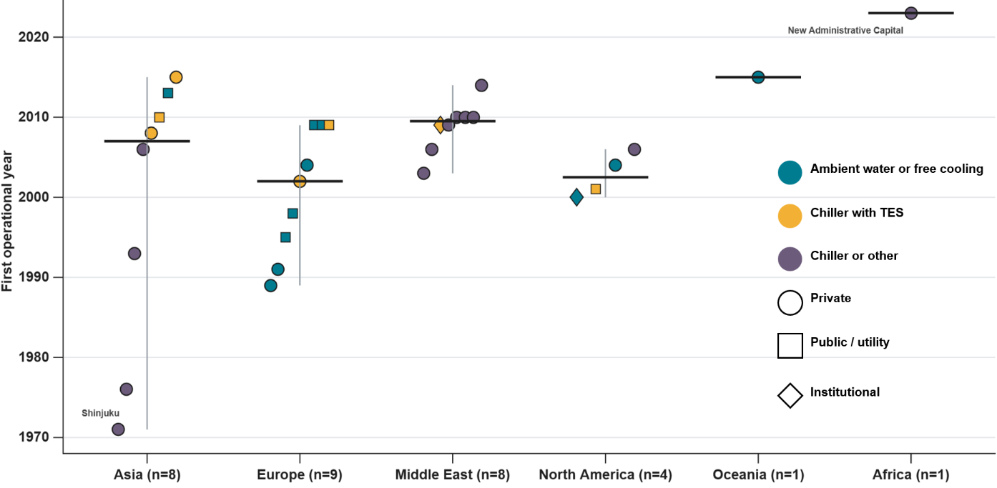
4.2 District cooling archetypes
Three main technical configurations were identified across the 31 operational projects. Ambient water or explicit free cooling is documented in 11 cases, representing approximately 35 percent of the sample. Chillers combined with thermal energy storage are documented in seven cases, or approximately 23 percent. The remaining 13 projects, approximately 42 percent, are classified as chiller or other systems because neither an ambient water source nor thermal storage was confirmed in the available project information. These categories describe the dominant documented feature and not the complete equipment installed at every plant.
The first archetype is the water linked urban utility system. It is most visible in Europe, where seven of nine projects belong to the ambient water or free cooling category. Toronto, Cornell, Kai Tak and Barangaroo provide comparable examples outside Europe. These projects are located near rivers, lakes, seas or fjords that can serve as heat sinks or provide direct cooling under suitable temperature conditions. Their common feature is the use of local geography as part of the cooling infrastructure. However, the presence of a water body does not automatically produce an efficient system. Intake depth, seasonal water temperature, pumping distance, fouling, environmental permissions and discharge restrictions determine whether the resource can provide useful cooling. This archetype is therefore highly location specific and cannot be transferred to inland or hot water locations simply by copying the plant design.
The second archetype is the storage enabled chiller network. Seven projects are assigned to this group, including Putrajaya, Qianhai and GIFT City in Asia, Barcelona and Vienna in Europe, Austin in North America and one Middle Eastern institutional case. These systems use chilled water or ice storage to separate the time of cooling production from the time of cooling delivery. The geographical resource is not a natural heat sink but the availability of land, plant space, electrical capacity and an operating structure able to schedule charging and discharging. Storage is particularly relevant where electricity prices, cooling peaks or renewable electricity availability change during the day. Its value nevertheless depends on operation. Storage charged during an unfavourable period may shift demand without reducing primary energy use or emissions.
The third archetype is the concession led central chiller system. This is dominant in the Middle Eastern subset and is also present in parts of Asia and Africa. The systems serve large urban developments through central electrically driven cooling plants and extensive distribution networks. Their advantage comes from scale, load diversity and coordinated infrastructure development rather than from natural cooling. The model can be effective where a developer or specialist provider can secure plant sites, pipe corridors and customer connections during district construction. Its main vulnerability is dependence on future connected demand. If customer uptake is slower than expected, plant and network capacity may remain underused.
A fourth, smaller archetype is the institutional campus network. Cornell and KAUST are the two institutional cases in the register. Their technical configurations differ, but their governance structure offers a common advantage. One organisation controls much of the cooling supply, building demand and infrastructure planning. This can reduce contractual complexity and make coordinated operation of chillers, storage, photovoltaic generation and building loads easier than in a network serving many independent customers.
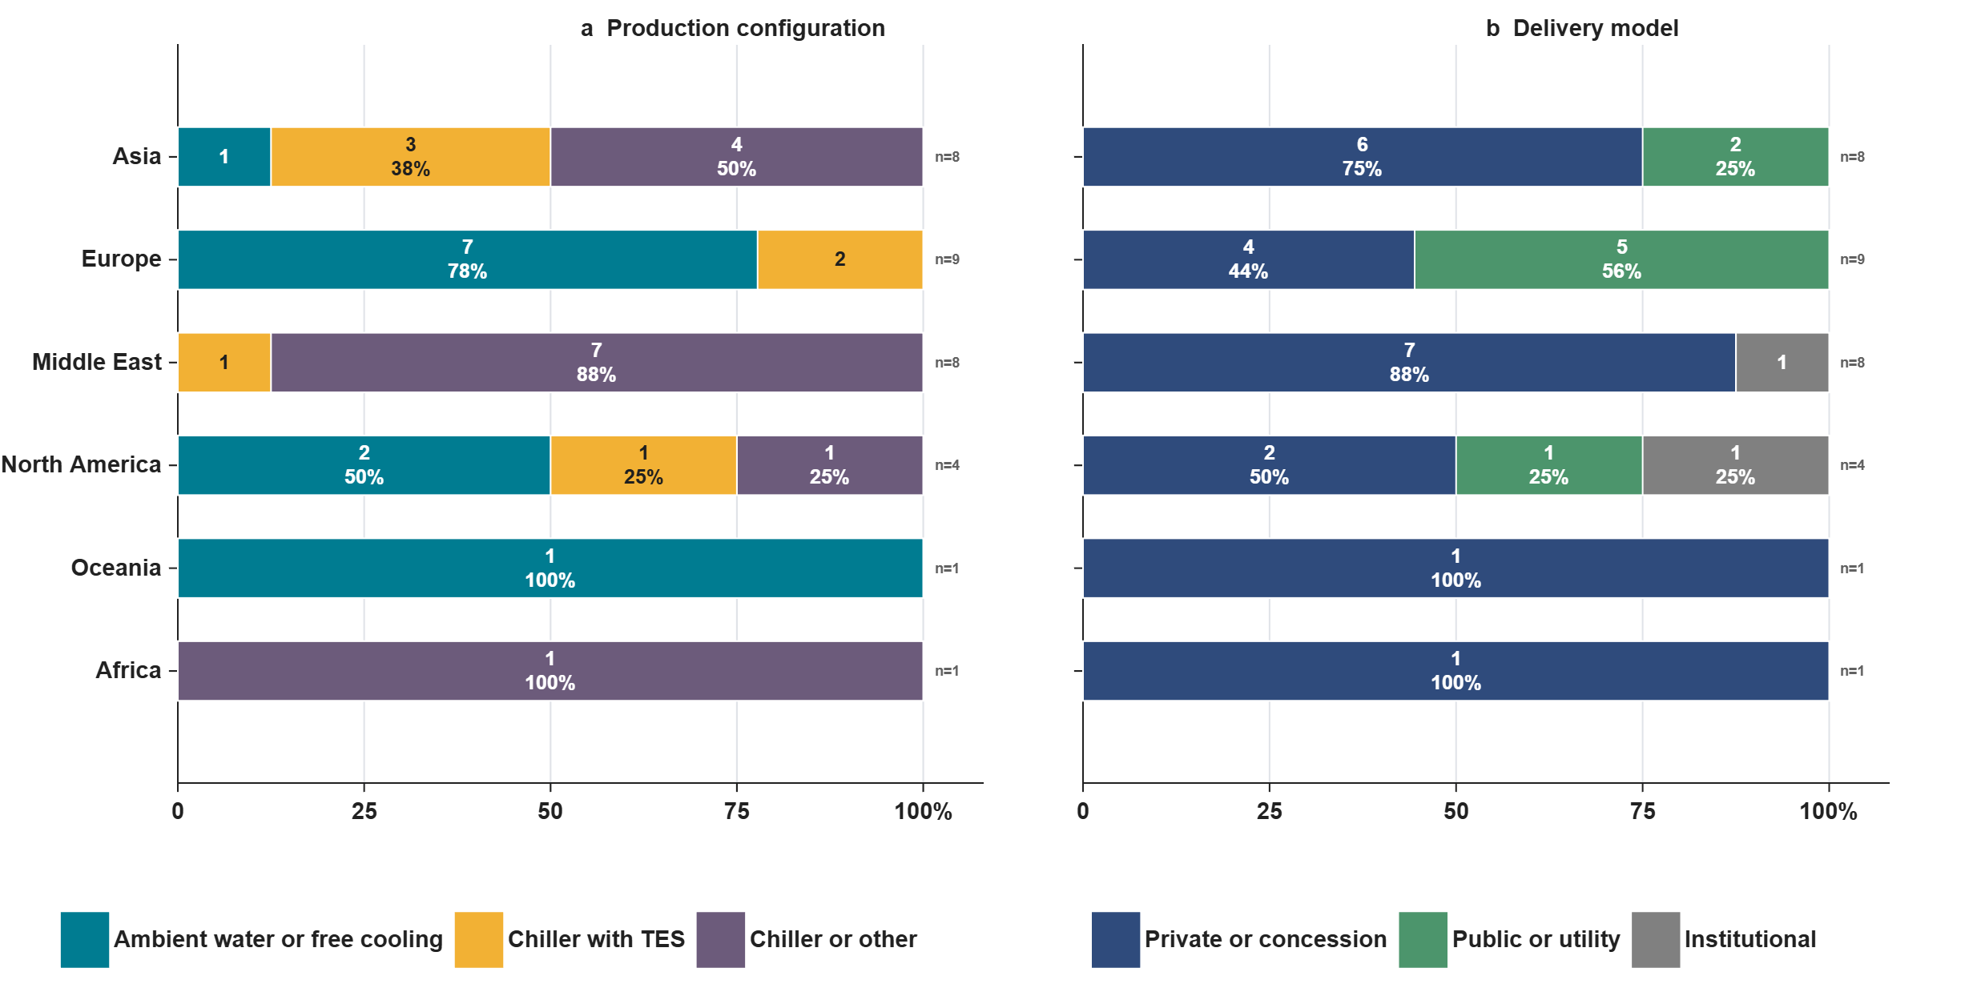
The relationship between delivery model and production configuration provides an additional result. Of the 31 operational systems, 21 are private or concession based, eight are public or utility led and two are institutional. Within the public or utility group, five cases use ambient water and three use chillers with storage. None of the public cases in this sample falls into the chiller or other category. In contrast, 13 of the 21 private or concession cases are classified as chiller or other systems. The remaining private cases include five ambient water systems and three storage based systems. This association does not demonstrate that ownership determines technology. It indicates that the selected public utilities are strongly associated with projects that use local water resources or storage, while private concessions are more common in large developments based on conventional central chilling. Differences in public reporting may also influence this pattern.
4.3 Comparative association analysis
Fig. 3 reveals clear regional differences in production configuration. Of the 31 operational projects, 11 (35%) use ambient water or free cooling, seven (23%) combine chillers with thermal energy storage, and 13 (42%) are classified as chiller or other systems. Europe is dominated by ambient water cooling, which accounts for seven of nine projects (78%) and 64% of all ambient water cases in the sample. In contrast, seven of eight Middle Eastern projects (88%) use chiller or other systems, representing 54% of this category globally, while only one includes documented storage. Asia has the most balanced profile, comprising four chiller or other systems (50%), three storage enabled systems (38%), and one ambient water system (12%). North America includes two ambient water systems, one storage system, and one chiller or other system. The single projects in Oceania and Africa use ambient water and conventional chiller configurations, respectively, but cannot represent wider regional patterns.
Delivery arrangements also show a strong association with production configuration. Private or concession based arrangements account for 21 projects (68%), compared with eight public or utility led systems (26%) and two institutional systems (6%). Among private projects, 13 (62%) are classified as chiller or other, five (24%) use ambient water, and three (14%) include storage. All 13 chiller or other systems in the sample are privately operated. In comparison, five public or utility led projects (62%) use ambient water and three (38%) include storage, while none is classified as chiller or other. Public systems therefore account for 45% of all ambient water cases and 43% of storage enabled systems, possibly reflecting their greater ability to secure long term access to water resources, land, pipe corridors, and storage sites. The two institutional cases consist of one ambient water system and one storage enabled system.
These patterns imply different pathways for solar integration. The 13 chiller or other systems, particularly those in the Middle East, offer the most direct opportunity for photovoltaic generation to reduce daytime electricity demand, although additional storage may be required to extend solar cooling beyond daylight hours. The seven storage enabled systems already provide a pathway for shifting solar driven cooling production to later demand periods, subject to storage capacity, efficiency, and operating strategy. In the 11 ambient water systems, photovoltaic electricity can support intake pumps, distribution pumps, auxiliary equipment, and residual mechanical cooling. Overall, Figure 3 identifies three descriptive archetypes: European ambient water systems, Middle Eastern private central chiller systems, and Asian mixed systems with a relatively strong storage presence. These associations do not establish causality but demonstrate that solar integration strategies should reflect regional resources, production configuration, and delivery arrangements.
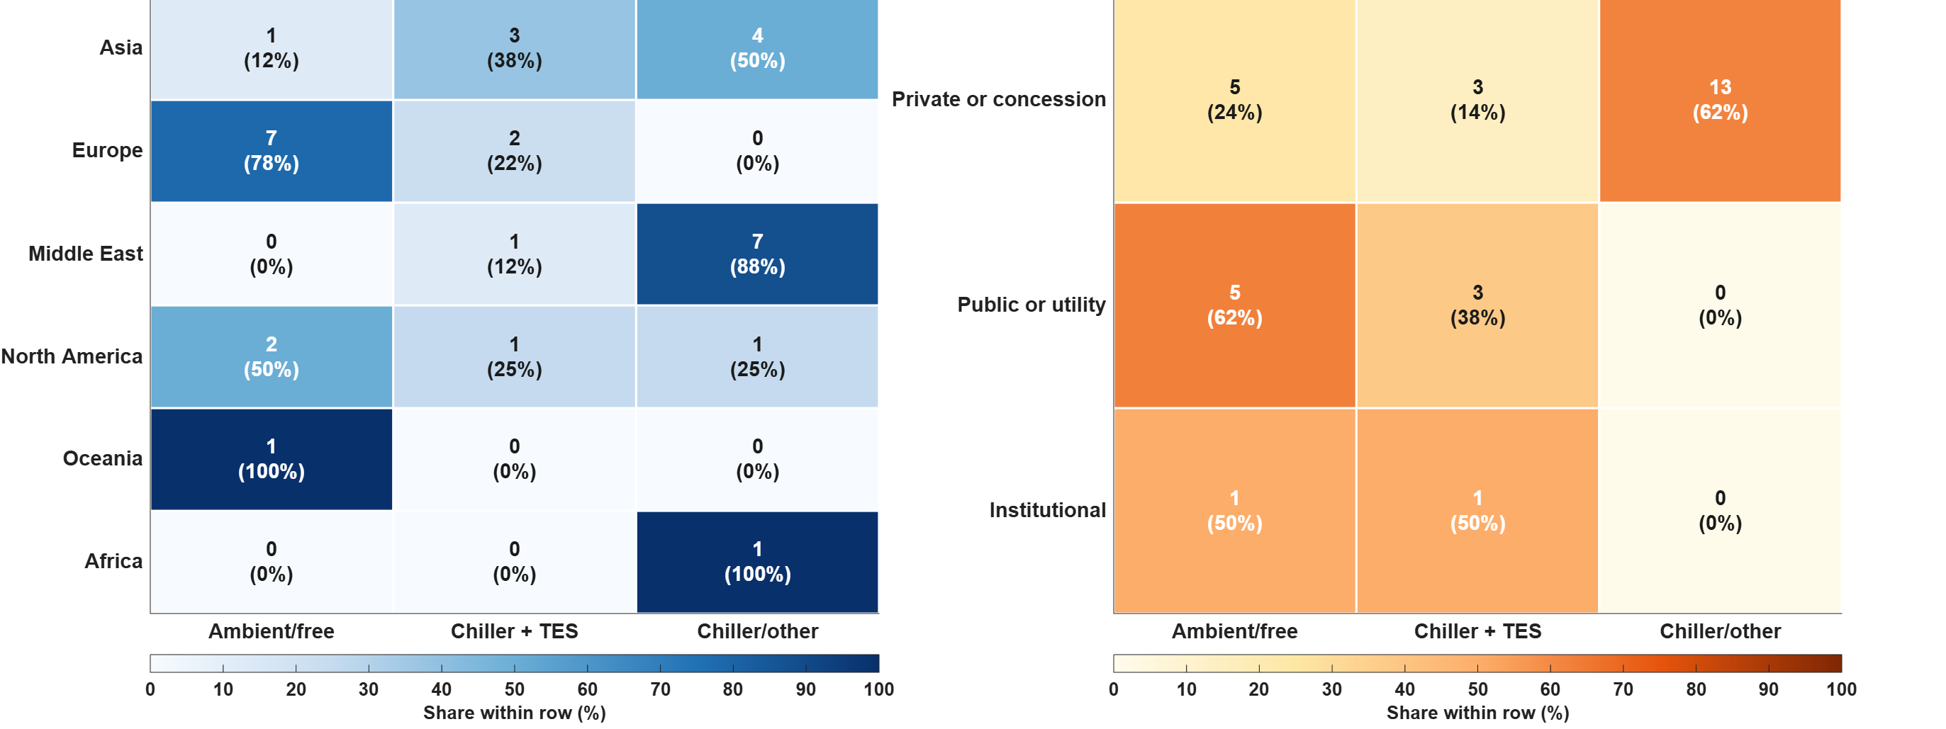
- Discussion
The comparative results show that solar integration cannot follow one universal district cooling model. The appropriate pathway depends on the existing production configuration, the availability of natural heat sinks, the timing of cooling demand and the organisation responsible for investment and operation. Of the 31 operational systems, 13 rely mainly on conventional chiller configurations, 11 use ambient water or free cooling, and seven include documented thermal energy storage. These three groups require fundamentally different solar strategies.
The first pathway combines photovoltaic generation with efficient electric chillers and thermal energy storage. It is particularly relevant to the Middle East, where seven of eight projects are classified as chiller or other systems, and to newer Asian developments. Large central plants provide a concentrated electrical load that can absorb substantial daytime photovoltaic production. However, cooling demand often remains high during the late afternoon and evening, when solar generation declines, so direct PV supply alone may reduce daytime electricity consumption without substantially reducing maximum grid demand. Chilled water or ice storage can address this mismatch by shifting part of the cooling production into periods of high solar availability, but the operating objective must be defined carefully, since charging storage whenever electricity is cheapest does not necessarily maximise renewable utilisation or reduce emissions. Solar forecasting, cooling demand prediction and coordinated chiller dispatch are needed to decide when chillers should meet demand directly and when cooling should instead be stored. The second pathway applies to the 11 ambient water and free cooling projects that dominate the European sample. Here, photovoltaic electricity should complement rather than replace the natural cooling source, supplying intake pumps, distribution pumps, heat exchangers, auxiliary systems and the residual mechanical refrigeration needed when water temperatures are too high or demand exceeds the available natural cooling capacity. The benefit must therefore be evaluated at the level of the complete network, since focusing only on compressor electricity would overlook potentially significant pumping demand. Storage may add further flexibility by coordinating water source availability, PV production and customer demand. Climate change is a relevant constraint here too, as rising river, lake or seawater temperatures could reduce future free cooling hours and increase reliance on mechanical backup. A third pathway applies to established high-density urban networks, particularly the early Asian systems, where limited roof area and competing land uses can restrict on-site PV capacity near the cooling plant. Solar integration here may instead rely on PV façades, generation at peripheral utility sites, parking structures, or contracted renewable electricity from outside the district. The distinction between physical solar supply and contractual renewable procurement should be stated clearly: contracted renewable electricity can reduce annual carbon accounting, but it does not necessarily reduce local grid peaks or provide operational flexibility during extreme heat. Which of these pathways can actually be implemented depends on the delivery model. Public and utility systems, representing eight projects, can coordinate solar generation, water resources, storage sites and municipal buildings over long investment horizons. Private concessions, representing 21 projects, offer greater potential for standardised deployment across large developments, but solar and storage investment must be supported by tariff structures and a clear allocation of savings. Institutional networks can coordinate plants and buildings within a single organisation, making them well suited to testing integrated solar, storage and demand control.
- Conclusion
This study compared 32 district cooling projects across six regions, including 31 operational systems and one planned project, to examine how regional conditions, delivery arrangements and production configurations influence solar integration pathways. The results reveal three main archetypes. European projects are strongly associated with ambient water and free cooling, which appears in seven of nine cases. Middle Eastern projects are dominated by private concession models and central chiller systems, with seven of eight cases classified as chiller or other. Asia presents a more diverse structure, combining early urban networks with newer storage enabled developments. These differences indicate that solar based district cooling cannot be implemented through a universal technical solution. Central chiller systems offer strong potential for photovoltaic electricity combined with thermal storage to address evening cooling demand. Ambient water systems require solar electricity mainly for pumping, auxiliaries and residual refrigeration. Dense established networks may depend on offsite renewable generation where local installation space is limited. Delivery arrangements are equally important because they determine investment responsibility, customer coordination and the allocation of flexibility benefits. The findings provide a structured basis for selecting appropriate solar cooling pathways. However, hourly demand, solar generation, storage operation, water consumption and emissions data are needed before project specific performance can be quantified.
- References

[1] G. Falchetta, E.D. Cian, F. Pavanello, I.S. Wing, Inequalities in global residential cooling energy use to 2050, Nat Commun 15 (2024) 7874. https://doi.org/10.1038/s41467-024-52028-8.
[2] V. Eveloy, D.S. Ayou, Sustainable District Cooling Systems: Status, Challenges, and Future Opportunities, with Emphasis on Cooling-Dominated Regions, Energies 12 (2019) 235. https://doi.org/10.3390/en12020235.
[3] K.M. Powell, W.J. Cole, U.F. Ekarika, T.F. Edgar, Optimal chiller loading in a district cooling system with thermal energy storage, Energy 50 (2013) 445–453. https://doi.org/10.1016/j.energy.2012.10.058.
[4] M. Kargaran, H.R. Goshayeshi, I. Zahmatkesh, S.R. Saleh, Next-generation cooling strategies for photovoltaics: A review of pathways toward high efficiency, low carbon, and climate resilience, Results in Engineering 29 (2026) 108556. https://doi.org/10.1016/j.rineng.2025.108556.
[5] W. Gang, S. Wang, F. Xiao, D. Gao, District cooling systems: Technology integration, system optimization, challenges and opportunities for applications, Renew. Sustain. Energy Rev. 53 (2016) 253–264. https://doi.org/10.1016/j.rser.2015.08.051.
[6] S. Boesten, W. Ivens, S.C. Dekker, H. Eijdems, 5th generation district heating and cooling systems as a solution for renewable urban thermal energy supply, Adv. Geosci. 49 (2019) 129–136. https://doi.org/10.5194/adgeo-49-129-2019.
[7] M.K. Anser, A.A. Nassani, K.M. Al-Aiban, K. Zaman, M. Haffar, Urban heat islands and energy consumption patterns: Evaluating renewable energy strategies for a sustainable future, Energy Rep. 13 (2025) 3760–3772. https://doi.org/10.1016/j.egyr.2025.03.033.
[8] A. Inayat, M. Raza, District cooling system via renewable energy sources: A review, Renew. Sustain. Energy Rev. 107 (2019) 360–373. https://doi.org/10.1016/j.rser.2019.03.023.
[9] T. Dimitriou, N. Skandalos, A. Basak, S. Chakraborty, D. D'Agostino, C. Maduta, K. Panchabikesan, D. Parker, D. Karamanis, Cooling the city, powering the future: A critical assessment of nature-based and technological cooling strategies for urban BIPV systems, Renew. Sustain. Energy Rev. 227 (2026) 116573. https://doi.org/10.1016/j.rser.2025.116573.
[10] N. Monghasemi, A. Vadiee, S. Vouros, K. Kyprianidis, Control strategies for district heating and cooling systems: a comprehensive review across production, distribution, and end-user levels, Energy Inform. 9 (2026) 45. https://doi.org/10.1186/s42162-026-00650-9.
[11] M.A. Reshi, M. Mursaleen, A comprehensive review of optimization approaches of district cooling systems, Evol. Intel. 18 (2025) 111. https://doi.org/10.1007/s12065-025-01097-9.
[12] J. Dai, S. Ikeda, R. Ooka, Control strategies in fifth-generation district heating and cooling systems: A review, Sustain. Cities Soc. 148 (2026) 107690. https://doi.org/10.1016/j.scs.2026.107690.
[13] A. Volkova, A. Hlebnikov, A. Ledvanov, T. Kirs, U. Raudsepp, E. Latõšov, District Cooling Network Planning. A Case Study of Tallinn, IJSEPM 34 (2022) 63–78. https://doi.org/10.54337/ijsepm.7011.
[14] S. Mazzoni, B. Nastasi, District cooling optimal operation to decarbonize urban cold energy supply, Energy Convers. Manag. 341 (2025) 120019. https://doi.org/10.1016/j.enconman.2025.120019.
[15] F. Ghaith, Z. Al Rayes, A. Umar, Design and Optimization of Solar-Powered Cooling/Heating System with Heat Pump Integration for Natatoriums in Hot–Arid Climates, Energies 19 (2026) 2359. https://doi.org/10.3390/en19102359.
[16] F.H. Ali, Q.R. Al-Amir, H.K. Hamzah, A. Alahmer, Unveiling the potential of solar cooling technologies for sustainable energy and environmental solutions, Energy Convers. Manag. 321 (2024) 119034. https://doi.org/10.1016/j.enconman.2024.119034.
[17] M. Rafieuddin Ahmed, P.K. Krishnakumar et al., Impacts of thermal and cold discharge from power plants on marine benthos and its mitigation measures: a systematic review, Front. Mar. Sci. 11 (2024) 1465289. https://doi.org/10.3389/fmars.2024.1465289.
[18] Y. Martínez-Ruiz, D.F. Manotas-Duque, H. Ramírez-Malule, Financial risk assessment of a district cooling system, Energy 278 (2023) 127879. https://doi.org/10.1016/j.energy.2023.127879.
[19] F.H. Ali, Q.R. Al-Amir, H.K. Hamzah, A. Alahmer, Unveiling the potential of solar cooling technologies for sustainable energy and environmental solutions, Energy Convers. Manag. 321 (2024) 119034. https://doi.org/10.1016/j.enconman.2024.119034.
[20] V. Munćan, I. Mujan, D. Macura, A.S. Anđelković, The state of district heating and cooling in Europe — A literature-based assessment, Energy 304 (2024) 132191. https://doi.org/10.1016/j.energy.2024.132191.
[21] F. Manzella, L. Gasia, C. Sole, L.F. Cabeza, Phase change material-based thermal energy storage, Cell Rep. Phys. Sci. 2 (2021) 100541. https://doi.org/10.1016/j.xcrp.2021.100541.
[22] G. Alva, L. Liu, X. Huang, G. Fang, A comprehensive review of thermal energy storage, Sustainability 10 (2018) 191. https://doi.org/10.3390/su10010191.
[23] R. Lund, U. Persson, Mapping of potential heat sources for heat pumps for district heating in Denmark, Energy 110 (2016) 485–496. https://doi.org/10.1016/j.energy.2015.12.127.

