Study of antimicrobial capacity in reinforced composites with mineral filler

L. Nobre¹, J. Bessa², F. Cunha³, R. Fangueiro⁴ and R. Pereira⁵

¹CVR – Centro para a Valorização de Resíduos, Rua de Francos nº 350, 4800-058 Guimarães, Portugal Email: luisnobre@fibrenamics.com, Web Page: https://www.web.fibrenamics.com/en/
²CVR – Centro para a Valorização de Resíduos, Rua de Francos nº 350, 4800-058 Guimarães, Portugal Email: joaobessa@fibrenamics.com, Web Page: https://www.web.fibrenamics.com/en/
³2C2T – Centro de Ciência e Tecnologia Têxtil, University of Minho, 4800-058 Guimarães, Portugal
⁴University of Minho, Department of Mechanical Engineering, Campus de Azurém, 4800-058 Guimarães, Portugal
⁵ELV Empresa de Lousas de Valongo, Rua Central das Vinhas nº510, 4440-032 Valongo, Portugal

Keywords: Composite materials, antimicrobial capacity, recycling, slate waste

Abstract

This work presents a study carried out with the objective of equipping a composite material with antimicrobial behavior. The composite material was composed by 70% of slate waste and the functionalization of them is applied, in order to further increase its market applications. Nowadays, the materials used in a hospital context, among others, need to have an antimicrobial behavior. In this context two different ways of composite materials funcionalization with this capacity were presented. The materials used to provide the composite antimicrobial finishing material were silver salts. Through the method of functionalization of the material by surface coating, four different compositions of a silver salts , 5%, 8%, 15% and 20%, were tested. By the method of functionalizing the composite in the matrix, i.e. mixing the silver salts in the epoxy resin, the percentages of 5 and 8 were tested. Afterwards, in order to evaluate the antimicrobial capacity of the final products, specific tests according to JIS Z 2801: 2000 standard were performed, with the objective to guarantee an antimicrobial finish that has the capacity to eliminate 99% of the bacteria. This study shows that the use of silver salts can be used to produce composite materials with antimicrobial properties.

1. Introduction

The technology development and the world population growth has led to an overuse of resources, both natural and synthetic ones, which has aroused several concerns about environmental sustainability. In this context, the use, recovery and recycling of the materials into new raw materials to another ones is one of the main trends actually verified. The population’s increase, the constant growth in demand and use of resources mean that it is necessary to move towards a more sustainable society [1]. In this context, it is fundamental to replace the end-of-life concept of a linear economy for a circular one, whereby the innovation-driven flow that is able to reduce, reuse, recover and recycle materials. Thus, in a world in constant evolution, innovation becomes one of the key factors for improving the competitiveness of institutions and the territorial development. The adoption of a more innovative and sustainable position, taking advantage of synergies of high technological level and waste material use, in the generation of added value, is, actually,a way of minimize the scarcity of natural resources.
In Portugal, some of the main wastes generated includes the slate dust, mainly from the stone extraction and processing industries. Approximately 85% of the mineral dust come from the cutting and treatment processes of these industries. Moreover, it is estimated that by processing each ton of mineral based products, about 30 tonnes of waste is generated, without any type of recovery or recycling, thus causing a high environmental impact [2]. In this context, the use, recovery and recycling of the materials into new raw materials to another ones is one of the main trends actually verified. Several scientific groups and researchers have been looking for development of composites with natural materials as reinforcement, in order to obtain a more sustainable products, also allow the cost reduction of components and has higher mechanical properties and corrosion resistance, comparing with a conventional materials.
In addition to the sustainability of the resources and the need to recycle the materials, another important trend currently verified is related to the functionalization of the materials, in order to enhance its own properties or provide new ones, such as an antimicrobial capacity. This aspect acquire special importance in specific applications, such as benches of hospitals, kitchens, washbasins, among others, where degradation of the components can occur after some time due to the attack of microbial agents and possible contamination of the environment. So, to counteract this negative point, there is the possibility of to incorporate additives to these components, allowing effective combat against microorganisms, like as quaternary ammonium compounds (QAC's ), silver salts or silver nanoparticles [4].
This paper report the experimental work regarding the apply of silver salts in thermosetting ecocomposites reinforced by slate waste in order to give the antimicrobial capacity to these materials. This new property can be developed through two different methods, which were tested, namely: in the first one, the addition of the silver salts is done in the resin formulation of the composite material; in the second method, the salts were added to an impermeabilization solvent, which is subsequently used to apply a surface coating into the ecocomposite material. The properties of the products were morphologically and chemically characterized by scanning electron microscopy (SEM) and Energy Dispersive Spectroscopy (EDS), respectively, in order to evaluate the dispersion, morphology and chemical composition of the particles. In order to evaluate the antimicrobial capacity of the final products, specific tests according to JIS Z 2801: 2000 standard were performed, with the objective to guarantee an antimicrobial finish that has the capacity eliminate 99% of the bacteria.

2. Materials and Methods

2.1. Materials

The mineral waste used comes from slate rock, which is a metamorphic rock composed primarily of silicate and clay elements. This material is essentially generated from the extraction and sanding processes. Epoxy resin, a thermosetting polymer, was supplied by Sika, reference SR GreenPoxy 56, with up to 56% of its molecular structure coming from plant origin, becoming this polymer an ecological environmentally friendly resin. This percentage is a function of the carbon origin contained in the epoxy molecule. This resin is out coming from the latest innovations in bio-based chemistry. SR GreenPoxy 56 has a density of 1.198 g cm⁻³ and a viscosity of 800 mPa s at 25°C.
The Bactiblock®, which is a very used additive against the proliferation of bacteria, is a patented antimicrobial additive suitable for use on product surfaces of polymeric base, which is based on a clay functionalized by silver salts, creating a commercial antimicrobial product of natural origin and highly efficient. This is to prevent the proliferation of bacteria, fungi and other organisms.
A commercial waterproofing solvent, Platinum Surface, supplied by Stone Care Europe, it was also used to mix the silver salts and to use as the surface coating.

2.2 Methods

2.2.1 Composite Materials Production

In this section, the experimental methodology will be presented.
As defined, the objective of this study is to create a ecocomposite, composed by 30% of a polymeric matrix reinforced by 70% of slate residues, where bioactive agents would be incorporated on the surface with the function of to prevent the proliferation of bacteria, fungi and other organisms.
For the functionalization of composite materials, two different possibilities were studied.
In the first one, which is the most common method used, the coating of the antimicrobial agent in the surface finish was applied.
In the second one, an alternative method was developed, since the fist one presents some limitations, namely the fact that when it is subjected to a abrasion action, the product lost the antimicrobial protection. So, to minimize this aspect, the antimicrobial additive is incorporated in the polymer matrix, during the production of the composite material. Subsequently, it was also necessary to carry out a polishing of the samples containing the additive in the matrix, since the resin waterproofs the antimicrobial additive.
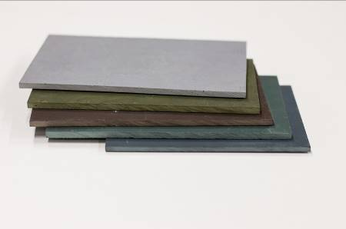
Figure 1. Ecocomposites

2.2.2. Characterization Tests

2.2.2.1 SEM/EDS

Morphological analysis of the silver salts in the composite material were preformed in an Ultra-High-Resolution Scanning Electron Microscopy, NOVA 200 Nano SEM, FEI Company. This system has an X-ray microanalysis system and a energy dispersive spectrometer (EDS) that allows to analyze the chemical composition of the samples.

2.2.2.2 Antimicrobial test
The antimicrobial test used was based on the international standard JIS Z 2801:2000. This Japanese Industrial Standard has been used for standardizing the method for evaluating antimicrobial efficacy in antimicrobial products. This testing method is applicable to a plastic, metal and ceramic products. Two representative bacteria were studied, namely Escherichia coli and Staphylococcus aureus, since these bacteria are the main responsible of the most founded infections in medical devices. This method consists in placing a bacterial inoculum into contact with the composite samples surface, during a certain period of time (between 18 and 24 h).
After the test, the value of the antimicrobial activity was calculated according to the following equation 1, where R – Value of antimicrobial activity, A – Mean number of viable cells of bacteria immediately after inoculation in the untreated test piece, B – Mean number of viable bacteria cells in untreated test piece after 24 h and C – Mean number of viable bacteria cells in the antimicrobial test piece after 24 h;

R = [log(B/A) – log (C/A)] | (1)

3. Results and discussion

3.1 Samples description

As referred before, two different methods were used to study the antimicrobial behavior. The resulting sets of optimized samples are schematized on Tables 1 and 2. Table 1 lists the configurations of the composites that were produced using the surface coating method (method 1), while Table 2 contains the composites with matrix additives (method 2). The obtained results from Table 1 and Table 2 are presented separately (in the sections 3.3.1 and 3.3.2, respectively), and, after that, a full comparison of the results will be made.

Table 1. Samples composition using the coating method (method 1).

Samples | % Silver salts
B | Reference
C | Only coating
D | 15% in coating
E | 20% in coating
H | 5% in coating
I | 8% in coating

Table 2. Samples composition using the functionalization method in the matrix (method 2).

Samples | % Silver salts
B | Reference
F | 5% in matrix
G | 8% in the matrix
J | 5% in matrix + sample polish
L | 8% in matrix + sample polish

3.2 SEM/EDS analysis

In the Figure 2 and Table 3 are presented SEM results and a chemical analysis (EDS) of the composite materials, respectively. The samples that were submitted to SEM/EDS analysis were only those illustrated in this figures, since it was an optimization work.

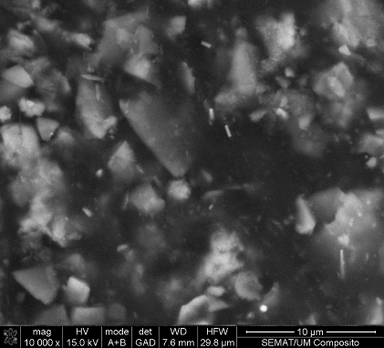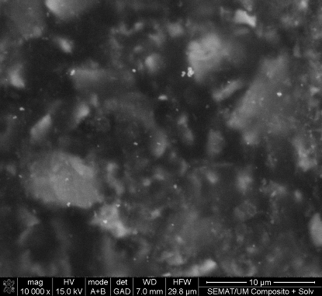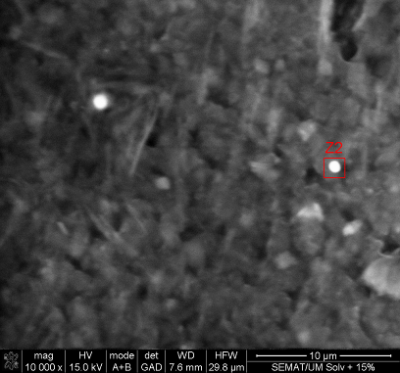
a
b
c

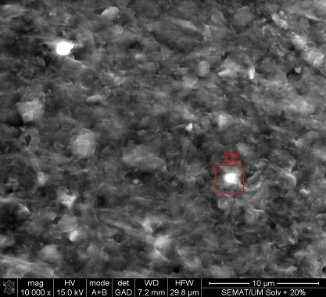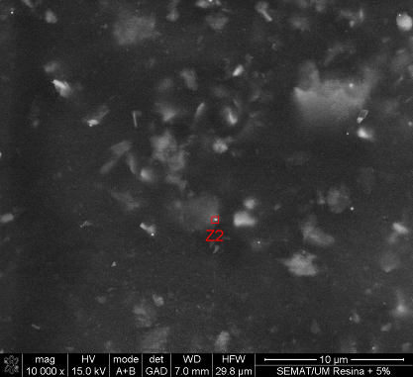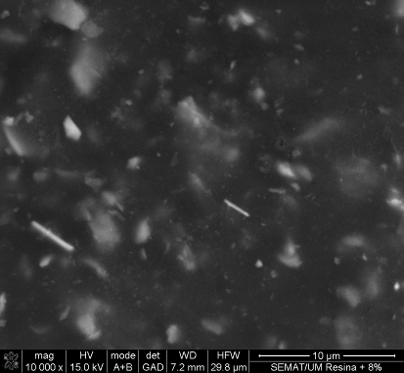
d
e
f

Figure 2. SEM images of (a) Sample B, (b) Sample C, (c) Sample D, (d) Sample E, (e) Sample F and

By analyzing the following images, it can be verified that all samples have similar morphology, presenting gray particles (corresponding to slate waste) in black background (corresponding to thermosetting matrix). Firstly, by comparing images a and b of Figure 2, it can be concluded that the waterproofing solvent can cover the entire sample, because of the difference in the definition of the particles. By analyzing the images with the additive incorporated in the surface coating (c and d) it is possible to conclude that there are particles of silver salts in their composition, due to its defined size and circular shape. In addition to this, it can also be concluded that there is a homogenous dispersion of the particles. In the case of the sample with 5% silver salts (image e), some particles can be observed in spite of their small size.

Table 3. Composites chemical analysis.

Samples | Elements (wt. %)
 | C K | O K | Si K | Ag L
D | 22.12 | 31.33 | 33.3 | 9.90
E | 19.05 | 37.19 | 26.14 | 12.08
F | 54.83 | 27.75 | 8.14 | 1.24

Through the analysis of Table 3 it is possible to conclude that the addition of higher percentages of silver salts originates an increase of the amount of silver mass in the observed zone, such as verified in the chemical analysis. In sample (F), with 5% of silver salts in the matrix, the amount of silver in mass is much lower in relation to the previous samples, D and E. This fact can be justified by the impermabilization of the salts by the matrix and, because of that, the microscope beam can not reach the particles. From these results an optimization need of this type of samples appears, as mentioned in section 2.1.1, which consists in the the need to polish the samples to have the particles on the surface. The results of the antimicrobial assay will show the success of this procedure.

3.3 Antimicrobial test

The results obtained for the functionalized composites, through method 1, are presented Figure 3. These results shows that it was possible to optimize the concentration of antimicrobial additive to be added to the prototypes through antimicrobial surface coating. Sample H has 5% of additive and an increase of antimicrobial efficacy, comparing with previous ones (D and E), is already observed, which means that 15% and 20% amounts were too high and did not means an increase in the antimicrobial activity. Sample I presents 8% additive and a significant increase can be observed in relation to sample H.

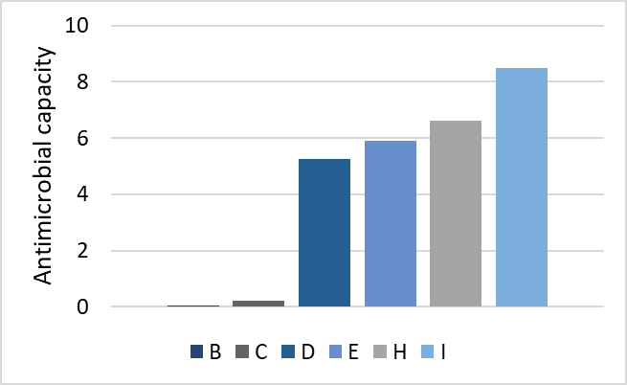

Figure 3. Antimicrobial results of the samples using the coating method (method 1).

The Figure 4 presents the functionalized samples by the addition method of silver salts in the matrix of the composite material (method 2). These results indicates that an excellent antimicrobial capacity was achieved by polishing the samples. The sample J, which is polished, presents 5% of additive and a significant antimicrobial activity is already observed. The same behavior is verified for sample L, which means that the polishing of the sample causes the increase of silver particles on the surface and can eliminate the bacteria that have been placed in the samples.

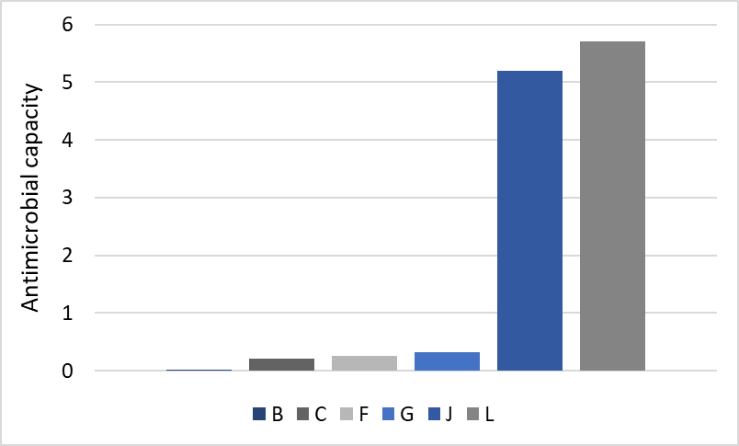
Figure 4. Antimicrobial results of the samples using the functionalization method in the matrix (method 2).

4. Conclusions

The obtained results in this study allows to reach some important conclusions. First of all, the samples polishing (sample J and L) allows an increase of antimicrobial capacity until 5,7. Moreover, with the decrease of the amount of the antimicrobial additive in the surface coating in (samples H and I, it can be concluded that the ideal concentration was reached when the antimicrobial capacity was increased.
In summary, the standard of this assay indicates that for values greater than 2, it can be concluded that the products present antimicrobial activity. Given this, the prototypes developed have a very high level of antimicrobial capacity.

Acknowledgments

The authors gratefully acknowledge the funding by P2020, under the Individual Project SI I&DT n.º NORTE-01-0247-FEDER-011458, entitled as “ECO_FUNC_COMP – Eco-Compósitos funcionais com base em resíduos minerais”.

References

[1] “World Population Clock,” World Meters, [Online]. Available: http://www.worldometers.info/world-population/. [03 Abril 2017].
[2] A. Carbonell-Verdú, D. García-García, A. Jordá, M. Samper e R. Balart, “Development of slate fiber reinforced high density polyethylene composites for injection molding,” Composites: Part B, pp. 460-466, 2015.
[3] M.D. Samper, R. Petrucci, L. Sánchez- Nacher, R. Balart, J.M. Kenny, “New environmentally friendly composite laminates with epoxidized linseed oil (ELO) and slate fiber fabrics”, Composites: Part B, pp. 203–209, 2015.
[4] M. Gopiraman, A.W. Jatoi, S. Hiromichi, K.Yamaguchi, H. Jeon, I.Chung, I. Kim, “Silver coated anionic cellulose nanofiber composites for an efficient antimicrobial activity”, Carbohydrate Polymers, pp. 51-59, 2016.

