EuroSun2026
Life Cycle Assessment of Social Housing in Humid Tropical Climates: Decarbonization through Bio-based Materials and Passive Design

Ludiany Olly Bedens NEGRIEL, Ted SOUBDHAN
Laboratoire LARGE, Faculty of Sciences, Department of Physics, University of Antilles, Campus Fouillole, Pointe-à-Pitre 97157, Guadeloupe
negriel_ludiany@yahoo.fr*Corresponding author Tel.: +590 691242769
ted.soubdhan@univ-antilles.fr

Abstract
Tropical island territories combine high exposure to climate change, strong dependence on imported construction products and electricity systems whose environmental performance differs substantially from continental contexts. This study applies a regionalized cradle-to-grave Life Cycle Assessment (LCA) to an actual social-housing development located in Guadeloupe in order to identify the main environmental hotspots and derive decarbonization pathways from the diagnosis rather than defining mitigation measures a priori. The inventory was regionalized by reconstructing the Guadeloupe electricity mix and by modelling the island supply chain for imported materials. Electricity consumption is the dominant whole-life of the total Global Warming Potential (GWP) hotspot, contributing 86.32% of total GWP. At the production stage the structural works account for 71.9% of the GWP. A complementary product-stage analysis of the reinforced-concrete superstructure shows that progressive concrete-to-timber substitution can reduce its GWP by 17.5%, 35.7% and 53.9% for 25%, 50% and 75% substitution scenarios. The results establish a hierarchy of action for tropical island social housing: first decarbonize electricity supply and reduce operational demand, then address embodied impacts through material efficiency, lower-carbon mineral products and bio-based structural solutions. Sensitivity analysis using ReCiPe confirms the stability of the main hotspot ranking, while highlighting method-dependent behaviour for particulate-matter formation. The study demonstrates the value of regionalized LCA for prioritizing decarbonization strategies in island construction contexts.
Keywords: life cycle assessment, social housing, Guadeloupe, tropical island, decarbonization, regionalized electricity mix, hotspots, embodied carbon, timber substitution
Field of application for the findings: building renovation and construction
Addressed audience: engineers, architect, designers, policy makers, planners

1. Introduction
The building sector is a major contributor to global environmental pressures because it combines large material requirements with long-term energy consumption. Decarbonizing buildings therefore requires simultaneous consideration of operational energy and embodied impacts. Globally, the sector is responsible for approximately 37% of CO₂ emissions and consumes nearly half of all extracted material resources (UNEP 2026).
Life Cycle Assessment (LCA) provides a standardized framework for this purpose by quantifying environmental burdens from material production through building operation and end of life (Chevalier 2024).
The balance between operational and embodied impacts is strongly context dependent This issue is particularly acute in tropical island territories, where warm and humid conditions generate cooling and ventilation needs, while insularity creates long supply chains and dependence on imported construction products. Guadeloupe combines these constraints with exposure to cyclonic and seismic hazards, which influences structural choices and has historically favoured reinforced-concrete construction. The residential sector also represents a major share of local electricity demand. Consequently, results derived from continental European building LCAs cannot simply be transferred to the Guadeloupe context without regionalization.
A further challenge is the rapid transformation of the electricity system. If operational impacts are evaluated using a generic or outdated electricity dataset, the environmental profile of a long-lived building can be misrepresented. Conversely, as the electricity mix decarbonizes, the relative importance of material production increases. This dynamic makes hotspot identification essential: decarbonization measures should be selected according to the processes that actually dominate the life-cycle profile in the territory considered.
The objective of this study is therefore twofold. First, it quantifies the environmental performance of an actual social-housing project in Guadeloupe using a regionalized cradle-to-grave LCA and identifies the main sources of greenhouse-gas emissions. Second, it uses this diagnosis to assess and prioritize decarbonization pathways. The analysis considers prospective electricity-mix scenarios and complements them with a focused assessment of concrete-to-timber substitution in the superstructure, thereby linking operational and embodied-carbon strategies within a single decision framework.

2. Background and research positioning

2.1 Building LCA and hotspot-based decarbonization
LCA is structured by ISO 14040 and ISO 14044 around goal and scope definition, life-cycle inventory, impact assessment and interpretation (Figure 1). For buildings, EN 15978 organizes impacts into product and construction modules (A), use modules (B), end-of-life modules (C) and benefits and loads beyond the system boundary (D). This modular structure is particularly useful for separating the effects of material production, transport, replacement, operational energy and end-of-life assumptions, which converts these flows into impact scores using characterization factors (Hauschild and Huijbregts 2015); and interpretation, which identifies dominant contributors and assesses the robustness of the results, including through sensitivity analysis. LCA is an iterative process in which these phases may be revisited to improve the reliability of the assessment (ISO 14044:2006).
For buildings, environmental assessment in Europe is based on NF EN 15804+A2 and EN 15978, the latter defining the building life-cycle modules covering the product, construction-process, use, and end-of-life stages (Figure 2).
For decarbonization studies, the value of LCA lies not only in producing a total impact score but also in identifying hotspots. A hotspot-based approach avoids selecting solutions solely because they are generally perceived as low carbon. Instead, the reference building is first analysed, the dominant processes are identified, and mitigation scenarios are then targeted at those processes. This logic is adopted throughout the present study.
The analysis combines two nested scopes. First, a broader cradle-to-grave LCA of the case-study building was used to identify the hierarchy of whole-life hotspots in the Guadeloupe context. That model included A1–A4, B4, B6, B7, C2 and C4, together with household waste during operation, and regionalized the electricity supply using Guadeloupe-specific data. Second, the present paper develops a focused product-stage analysis (A1–A3) to investigate the embodied-carbon reduction achievable by substituting timber for concrete in the superstructure. This nested approach makes it possible to evaluate the material lever while retaining its position within the overall building decarbonization strategy. GWP is the primary indicator for the structural substitution analysis because of the contribution of construction materials to climate-change impacts.
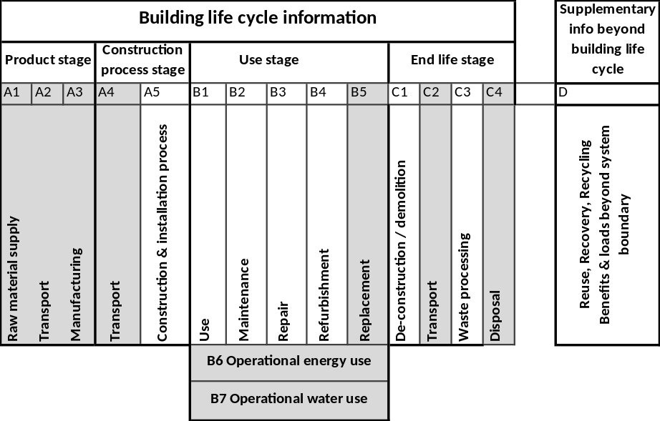
Figure 1 : System boundary of LCA

2.2 Specificity of tropical island territories
Island construction systems are characterized by limited local production capacity and substantial reliance on maritime imports. Transport can therefore be more important than in continental contexts, and the origin of products becomes a relevant modelling parameter. At the same time, local production processes may use an electricity mix that differs strongly from the European average. Regionalization must consequently address both energy and material supply chains.
The Guadeloupe context also imposes technical constraints on decarbonization options. Structural systems must remain compatible with seismic and cyclonic requirements, while materials are exposed to high humidity, marine aerosols, biological degradation and intense solar radiation. For this reason, material substitution scenarios should be interpreted as environmental screening scenarios unless accompanied by a complete structural and durability redesign.

2.3 From operational to embodied-carbon strategies
The literature generally reports a decreasing share of operational impacts as electricity generation becomes less carbon intensive. This does not eliminate the need to reduce energy demand, but it changes the relative weight of construction materials. In Guadeloupe, this transition creates a sequence of complementary actions: decarbonization of electricity supply, reduction of operational demand through passive and efficient design, and reduction of embodied impacts through material efficiency and lower-carbon products.
Concrete and metals are frequently identified as major contributors to embodied impacts. Timber can offer a lower production-stage GWP in structural applications, but its benefit in an island context depends on product origin, transport, biogenic-carbon accounting, durability and structural equivalence. The present work therefore treats timber substitution as a complementary material pathway derived from the production-stage hotspot analysis rather than as the sole decarbonization strategy.

3. Materials and methods

3.1 Case study
The case study is a social-housing development located in the Grand-Camp urban-renewal area in Les Abymes, Guadeloupe. The analysed building is representative of recent collective housing on the island. The reference dwelling floor area used in the model is 11,297.31 m². The load-bearing structure is reinforced concrete; joinery combines aluminium and glazing; the roof uses a timber structure and metal sheets; floor and wall finishes include ceramic tiles; and the energy systems include solar domestic hot-water equipment and mechanical ventilation (Table 1).
The choice of this case study is relevant because it combines common local construction practices with the principal territorial constraints considered in the analysis: a concrete-intensive structural system, imported finishing and joinery products, a tropical electricity system and long maritime supply chains.
The project studied forms part of the urban-renewal programme for the Grand-Camp district in Les Abymes, Guadeloupe. Completed in 2017, the development comprises six-storey social-housing buildings containing 129 dwellings, including 15 enhanced-accessibility units for people with reduced mobility. The dwellings range from T2 to T5 layouts and provide a total usable floor area of 11,297.31 m², corresponding to an average of approximately 87.6 m² per dwelling (Figures 3 and 4).
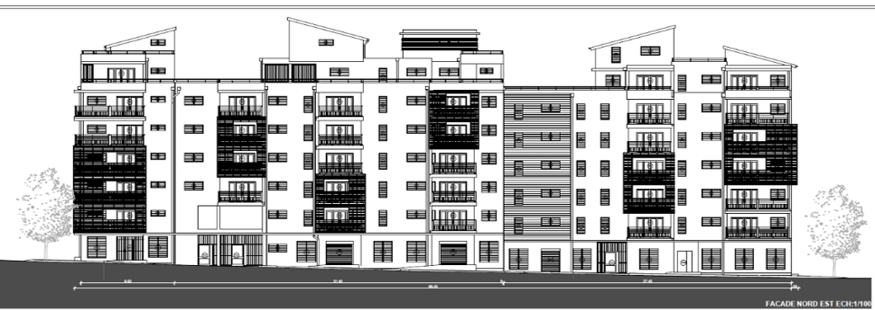
Figure 3 North elevation of the building.
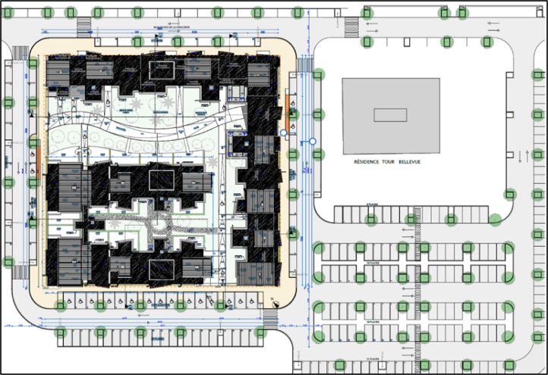
Figure 4 Site plan of the study building

Table 1 Building work packages, materials, and products included in the study
WP | Description | Products / services
1 | Structural works | Concrete, reinforcing steel, timber, anti-termite treatment, mortar.
2 | Roof structure / Roofing | Aluminum sheet, galvanized steel sheet, wood, rock wool.
3 | Joinery | Aluminum, timber, glazing.
5 | Partitions | Plasterboard.
6 | Floor and wall finishes | Tiles, mortar.
9 | Domestic hot water | Solar water heater.

3.2 Goal, functional unit and system boundary
The descriptive objective is to quantify the environmental impacts of the building while representing the Guadeloupe context. The prescriptive objective is to use the resulting hotspot hierarchy to formulate realistic decarbonization strategies for future social-housing projects.
The functional unit is 1 m² of dwelling floor area over a 50-year reference study period. The dwelling floor area includes the floor area of the dwellings and loggias and excludes common circulation areas, staircases and entrance halls.
The whole-life system boundary follows a cradle-to-grave approach and includes A1-A4 for product manufacturing and transport to site; B4 for replacement; B6 for operational energy; B7 for water consumption; and C2 and C4 for transport and final treatment of demolition waste. Household waste generated during occupation is also included as an additional operational flow in order to better represent the actual functioning of the building. Module D is excluded.

3.3 Life-cycle inventory and regionalization
Material quantities were derived from the project’s Décompte de Prix Global et Forfaitaire (DPGF) and available design documents. Because the DPGF did not provide usable quantities for every item, the inventory was restricted to documented flows and is therefore subject to inventory uncertainty. Among the principal quantities represented are 6,870.62 m³ of concrete, 466,848.8 kg of reinforcing steel, 44,107.4 kg of aluminium, 29,082.04 kg of wood and 4,895,900 kg of mortar.
Regionalization was performed where the local context materially affects the inventory. For manufacturing or finishing processes occurring in Guadeloupe, generic electricity inputs were replaced by a reconstructed Guadeloupe electricity mix. Operational electricity was also represented using a territory-specific mix reconstructed from EDF SEI and OREC data (Table 2).
For A4, most construction products were assumed to be imported from mainland France in the absence of supplier-specific origin data. Maritime transport was represented over 6,928.77 km, followed by a 50 km local road leg. Concrete was treated as locally produced and therefore assigned only the local road transport. These assumptions provide a consistent island-supply representation but remain a source of uncertainty.

Table 2 Main modelling assumptions used in the regionalized building LCA.
Parameter | Value | Basis
Reference floor area | 11,297.31 m² | Project plans
Reference study period | 50 years | Study assumption
Occupancy density | 0.033 person/m² | Calculated
Electricity consumption | 4,330 kWh/person/year | OREC-based local ratio
Water consumption | 120 m³/person/year | Local statistical ratio
Household waste | 543 kg/person/year | Local statistical ratio
Maritime transport | 6,928.77 km | France–Guadeloupe assumption

3.4 Modelling tools and impact assessment
The model was implemented in Brightway2 through the Activity Browser graphical interface (version 2.11.2). Ecoinvent 3.12 with the cut-off system model was used as the principal life-cycle inventory database. Environmental impacts were characterized using Environmental Footprint (EF) 3.1. Normalization and weighting were not applied.
Five impact categories were retained for interpretation: global warming potential over 100 years (GWP), fossil resource use (ADP-FF), acidification (AE), particulate-matter formation (PMF) and ozone-depletion potential (ODP). GWP is the principal indicator used to discuss decarbonization, while the additional categories are retained to detect possible burden shifting.
A sensitivity analysis was performed with ReCiPe to test whether the hierarchy of life-cycle stages, hotspots and scenario conclusions depends on the selected LCIA method. The comparison focuses on relative trends rather than absolute values because the two methods use different characterization models and, for some categories, different units.

3.5 Decarbonization scenarios

3.5.1 Electricity-mix scenarios
The reference model uses the reconstructed Guadeloupe electricity mix for 2017, year the project was built. Two prospective scenarios modify only the electricity-production activity, leaving all other inventory parameters unchanged in order to isolate the effect of electricity-system decarbonization.
Scenario 1 represents the observed second-semester 2025 mix reconstructed using the same methodology as the reference. Scenario 2 represents the target 2028 mix associated with Guadeloupe’s energy-programming objective. In each case, the selected mix is applied as a constant mix over the 50-year study period. This is a deliberately static scenario approach: the values should be interpreted as bounding cases rather than as a dynamic forecast of the electricity system.

3.5.2 Material scenario: concrete-to-timber substitution
A complementary material analysis targets the reinforced-concrete superstructure because concrete is one of the principal production-stage contributors. Three parametric scenarios replace an increasing share of the concrete quantity by an engineered-timber alternative: Hybrid25, Hybrid50 and Hybrid75, corresponding to 25%, 50% and 75% substitution levels.
The timber alternative is represented by the ecoinvent glued-laminated-timber production process using European production data because no local engineered-timber inventory is available. These scenarios are restricted to product-stage A1-A3 impacts and are intended as comparative environmental screening scenarios. They do not constitute a complete structural redesign and therefore do not demonstrate mechanical equivalence, code compliance or tropical durability. Transport to Guadeloupe is not included in the reported Hybrid25-Hybrid75 results and should be addressed in a subsequent A1-A4 sensitivity analysis.

4. Results

4.1 Whole-life environmental profile and GWP hotspots
The reference building has a whole-life GWP of approximately 9.73 × 10³ kg CO₂-eq/m² over the 50-year study period (Figure 5). The contribution analysis shows a strongly asymmetric profile: operational electricity is the dominant source of climate impact, while production is the second major life-cycle stage and transport and end of life remain comparatively small. (figure 6)

Figure 6 Distribution of the main hotspots for the GWP indicator
Figure 5 Whole-life environmental profile
For GWP, electricity consumption contributes 86.32% of the whole-life result. The next contributors are household waste (5.02%), structural works (3.57%) and water use contributes (2.37%). While aluminum joinery, replacement, floor and wall finishes, A4 transport, solar domestic-hot-water equipment and end of life each contribute less than 1% individually (Figure 5). This ranking demonstrates that the first decarbonization level is operational electricity, but it also identifies the material hotspots that remain relevant once energy-related emissions are reduced.
Figure 7 presents the contribution of the different materials selected for the study, while Figure 8 highlights the significant contribution of maritime transport to the GWP of module A4.
Figure 8 Contribution of each transport type to GWP
in stage A4
Figure 7 Contribution of the selected materials to the impacts of the production stage

Within structural works, Figure 19further breaks down the contribution of the building’s structural components, enabling the most impactful load-bearing elements to be identified. The superstructure contributes 308.4 kg CO₂-eq/m², corresponding to 87% of the GWP of structural works.
Figure 10 shows the distribution of this impact by building work package. Structural works are the main contributor, accounting for 71.9% of the total production-stage GWP.
Figure 10 Contribution of each building work package to GWP
Figure 9 : Contribution of structural components to the
GWP of structural works
The analysis is further disaggregated by material showing concrete production as the main contributor to the impact of structural works. Based on this contribution analysis, the reinforced-concrete superstructure was selected as the intervention scope for the decarbonization scenarios presented in the following section.

4.2 Production-stage hotspots
Within the production stage, joinery and structural works emerge as the main material-related hotspots. Joinery impacts are driven primarily by aluminum production, whereas structural impacts are dominated by concrete, cement-based products and reinforcing steel. A complementary A1–A3 analysis of the structural works shows that they account for 71.9% of product-stage GWP, with the superstructure representing 87% of structural-work GWP.
This result is important for scenario design. It shows that material decarbonization should not be reduced to concrete substitution alone. Aluminum joinery is the largest production-stage GWP hotspot in the whole-life model, while concrete remains the principal structural hotspot. A complete material strategy should therefore address both mineral structural products and aluminum-intensive envelope components.

4.3 Electricity-mix decarbonization
The electricity scenarios produce the largest reductions in whole-life GWP. The reference 2017 case yields approximately 9,731.54 kg CO₂-eq/m². Substitution of the reconstructed 2025 mix reduces this value to 7,380.68 kg CO₂-eq/m², corresponding to a reduction of about 24.2%. The 2028 target mix reduces GWP to 1,882.30 kg CO₂-eq/m², corresponding to a reduction of approximately 80.7% relative to the reference (Figure 12 and Table 3).
The multicriteria results show that carbon reduction does not necessarily imply improvement in every impact category. Under EF 3.1, the 2025 transition mix reduces GWP, fossil resource use and acidification but increases particulate-matter formation by approximately 11.7% and ozone-depletion potential by approximately 20.7%. The 2028 target mix reduces GWP by 80.7%, fossil resource use by 87.1%, acidification by 81.7% and ODP by 26.9%, while PMF decreases by only about 1.6% because biomass remains present in the target mix.

Figure 12 Whole-life GWP for the reference and electricity-mix scenarios.
Table 3 Whole-life environmental profile under the electricity-mix scenarios (EF 3.1).
Case | GWP  kg CO₂-eq/m² | ADP-FF  MJ/m² | AE  mol H⁺-eq/m² | PMF  disease-inc./m² | ODP  kg CFC-11-eq
Reference 2017 | 9.73E+03 | 1.06E+05 | 1.02E+02 | 6.72E-04 | 9.16E-05
Scenario 2025 | 7.38E+03 | 9.10E+04 | 6.85E+01 | 7.51E-04 | 1.11E-04
Scenario 2028 | 1.88E+03 | 1.37E+04 | 1.87E+01 | 6.61E-04 | 6.70E-05

4.4 Concrete-to-timber product-stage scenarios
The integration of bio-based materials is widely recognized as a means of reducing the carbon impact of buildings. Timber, straw, and other plant fibres can generally reduce embodied emissions while storing biogenic carbon over extended periods (Cascione et al. 2022; Nakano et al. 2018; Schulte et al. 2021). These materials may also provide thermal performance benefits that can reduce cooling demand and therefore impacts associated with the use stage (Ba et al. 2025; Kariuki et al. 2025).
Several studies have demonstrated the benefits of substituting timber for concrete in structural applications (Hart et al. 2021; Hemmati et al. 2024; Lim et al. 2025; Amiri and Junnila 2025). However, these studies were conducted outside tropical island contexts, and their transferability is constrained by cyclone and seismic requirements as well as by specific durability requirements for bio-based materials in humid climates.
Table 4 presents the concrete-to-timber substitution scenarios for hybrid concrete-timber superstructures containing 25%, 50%, and 75% timber, respectively. The resulting GWP reductions are 17.5%, 35.7%, and 53.9% relative to the reinforced-concrete reference case.
Table 4 Relative change in GWP compared with the reference case for each concrete-to-timber substitution scenario
Scenario | GWP
Structure Hybrid 25 | -17.5%
Structure Hybrid 50 | -35.7%
Structure Hybrid 75 | -53.9%

To examine how material contributions change with the substitution rate, Figure 14 presents the GWP contribution of each material for all scenarios considered: the reference case and the 25%, 50%, and 75% timber scenarios. This breakdown shows the progressive decrease in the contribution of concrete and the increasing contribution of glued laminated timber as the substitution rate rises.
Figure 13 Total mass per structural scenario
Figure 14 Contribution of each material to GWP
for each structural scenario

4.5 Displacement-factor analysis
The lower impact of timber relative to concrete is primarily related to the production process of the cement used in concrete. Cement-related impacts are strongly influenced by clinker production, which accounts for nearly 90% of cement-associated emissions and involves both calcination and the combustion of fossil fuels for process heat and electricity generation (Massoumi Nejad et al. 2025). A study of glulam manufacturing shows that process GHG emissions arise mainly from lamella production, transport, and electricity consumption (Nakano et al. 2025). In the scenarios assessed here, these emissions remain substantially lower than those associated with the cement-based reference solution.
To characterize the effectiveness of substitution more precisely, a displacement factor (DF) was calculated for each scenario. This indicator, widely used in the literature on wood-product substitution (Sathre and O’Connor 2010; Amiri and Junnila 2025), relates avoided GHG emissions to the amount of carbon contained in the substituted wood material. A higher DF therefore indicates a greater reduction in GHG emissions per unit of carbon in the substituted wood (Sathre and O’Connor 2010).
The indicator was calculated using Equation 1 (Murray et al. 2024):
$\text{DF=}\frac{\text{GH}{\text{G}}_{\text{nonwood}}\text{-GH}{\text{G}}_{\text{wood}}}{{\text{Carbo}{\text{n}}_{\text{wood}}\text{-Carbon}}_{\text{nonwood}}}$ (eq. 1)
where:
DF: displacement factor (dimensionless)
GHGnonwood: GHG emissions from non-wood products or structures obtained from LCA studies (kg CO₂-eq)
GHGwood: GHG emissions from wood products or structures obtained from LCA studies (kg CO₂-eq)
Carbonwood: amount of carbon contained in the wood material, expressed as CO₂-equivalent (kg CO₂-eq)
Carbonnonwood: 0, unless the non-wood material contains biogenic carbon (kg CO₂-eq)
The carbon content of wood was assumed to represent 50% of oven-dry mass. Calculations used an average oven-dry wood density of 543.2 kg/m³ and a moisture content of 12%, expressed as water mass per oven-dry wood mass (Bowers et al. 2020).
$\text{Carbo}{\text{n}}_{\text{wood}}\text{= Weight of oven-dried wood × 50\% × (44/12)}$ (eq. 2)
Equations 1 and 2 yield the displacement factors reported in Table 5 for the three substitution scenarios.
Table 5 Displacement factor for each concrete-to-timber substitution scenario.
Scenario | DF | interpretation
Hybrid25 Structure | 1.20 | Stable substitution efficiency
Hybrid50 Structure | 1.22 | Stable substitution efficiency
Hybrid75 Structure | 1.23 | Stable substitution efficiency

The displacement factor remains remarkably stable across the three substitution scenarios, increasing slightly from 1.20 for Hybrid25 to 1.22 for Hybrid50 and 1.23 for Hybrid75. This result indicates that the carbon efficiency of concrete-to-timber substitution is maintained as the substitution rate increases. In parallel, GWP reductions increase to 17.5%, 35.7% and 53.9% for the 25%, 50% and 75% substitution scenarios, respectively. The combination of an almost constant displacement factor and an approximately proportional increase in GWP reduction suggests that no substantial diminishing return occurs within the investigated substitution range. Hybrid75 therefore provides the largest absolute GWP reduction while maintaining substitution efficiency comparable to the lower substitution scenarios.

5. Discussion
The regionalized cradle-to-grave LCA identifies operational electricity as the dominant environmental hotspot of the case-study building, accounting for approximately 86.32% of total GWP. This result confirms that, under current Guadeloupe conditions, electricity supply and operational energy demand constitute the primary targets for building decarbonization. The prospective electricity-mix scenarios support this conclusion, with whole-life GWP decreasing from approximately 9,731.54 kg CO₂-eq/m² in the reference case to 7,380.68 kg CO₂-eq/m² under the 2025 mix and 1,882.30 kg CO₂-eq/m² under the 2028 target mix.
The hotspot analysis also identifies significant embodied-carbon reduction opportunities. At the production stage, structural works account for 71.9% of GWP, with the reinforced-concrete superstructure representing 87% of structural-work impacts. Concrete-to-timber substitution therefore provides a targeted response to an identified production-stage hotspot. The Hybrid25, Hybrid50 and Hybrid75 scenarios reduce product-stage GWP by 17.5%, 35.7% and 53.9%, respectively. Their displacement factors of 1.20, 1.22 and 1.23 indicate that substitution efficiency remains relatively stable as the timber share increases.
These results establish a hierarchy of complementary decarbonization pathways. Under current conditions, reducing electricity-related impacts provides the largest whole-life benefit. As the electricity mix decarbonizes, however, embodied impacts become relatively more important, increasing the relevance of material efficiency and lower-carbon structural systems. Passive and bioclimatic measures that reduce cooling and electricity demand represent an additional complementary lever, although they were not quantitatively assessed in this study.
The island context remains an important limitation for material substitution. The timber scenarios cover A1–A3 and use European ecoinvent data; transport to Guadeloupe is therefore not included. Future work should extend the comparison to A1–A4, investigate alternative timber supply chains and local or regional bio-based resources, and verify structural and durability requirements under humid tropical, seismic and cyclonic conditions. These developments would allow the environmental benefits identified at product stage to be assessed within the broader constraints of island construction.

6. Conclusion
This study demonstrates the value of regionalized LCA as a decision-support framework for decarbonizing social housing in tropical island territories. Applied to an actual building in Guadeloupe, the cradle-to-grave assessment first identifies the dominant sources of greenhouse-gas emissions and then uses this diagnosis to prioritize mitigation strategies.
Operational electricity is the dominant whole-life GWP hotspot, making electricity-system decarbonization and energy-demand reduction the primary intervention pathways under current conditions. At the production stage, structural works constitute a major hotspot, and the focused concrete-to-timber analysis shows that progressive substitution can reduce product-stage GWP by 17.5%, 35.7% and 53.9% for the Hybrid25, Hybrid50 and Hybrid75 scenarios, respectively, while maintaining relatively stable displacement factors of 1.20, 1.22 and 1.23.
The results therefore support an integrated decarbonization strategy combining operational-energy decarbonization, demand reduction and embodied-carbon mitigation. Rather than considering these measures independently, their priority should evolve according to the hotspots identified by the LCA. For Guadeloupe, further regionalization of material supply, particularly the inclusion of transport and local or regional bio-based alternatives, will be necessary to translate these environmental gains into robust territorial construction strategies.

7. References
Negriel, Ludiany Olly Bedens. 2026. Modélisation ACV de logements types en Guadeloupe : vers une stratégie de décarbonation. Master 2 thesis in Risks and Environment, Energy Transition track, Université des Antilles, Laboratoire LARGE.
Amiri, Ali, and Seppo Junnila. 2025. “How Much Upfront-Embodied GHG Emissions Can Wooden Buildings Save—Displacement Factors for Wooden Buildings.” Environmental Research: Infrastructure and Sustainability 5 (2): 025012. https://doi.org/10.1088/2634-4505/addc16.
Ba, Labouda, Abdelkrim Trabelsi, Tien Tung Ngo, Prosper Pliya, Ikram El Abbassi, and Cheikh Sidi Ethmane Kane. 2025. “Thermal Performance of Bio-Based Materials for Sustainable Building Insulation: A Numerical Study.” Fibers 13 (5): 52. https://doi.org/10.3390/fib13050052.
Bowers, Tait, Maureen Puettmann, Indroneil Ganguly, and Ivan Eastin. 2020. CORRIM Report: Life Cycle Assessment for the Production of Pacific Northwest Glued Laminated Timbers.
Cascione, Valeria, Matt Roberts, Stephen Allen, et al. 2022. “Integration of Life Cycle Assessments (LCA) in Circular Bio-Based Wall Panel Design.” Journal of Cleaner Production 344 (April): 130938. https://doi.org/10.1016/j.jclepro.2022.130938.
Chevalier, Jean-Luc. 2024. Réaliser l’ACV d’un projet de construction: Concevoir un bâtiment bas carbone - Comprendre l’approche ACV - Réaliser l’ACV d’un produit du bâtiment - Réaliser l’ACV d’un bâtiment Ed. 2. 2nd ed. With Alexandra Lebert and Gwenn Le Seac’H. CSTB.
DEAL de Guadeloupe. 2025. Chapitre 1 L’évolution Du Parc Social | Le Parc Locatif Social En Guadeloupe Au 1er Janvier 2024. DREAL / DEAL et le Service de la Donnée et des Études Statistiques (SDES). https://dreal.statistiques.developpement-durable.gouv.fr/parc_social/2024/guadeloupe/evolparc.html.
Eric Mével, Insee. 2021. Le Nombre de Logements Continue d’augmenter Malgré Le Ralentissement Démographique - Insee Flash Guadeloupe - 154. Rapport Institutionnel No. 154. Insee Flash Guadeloupe. Insee. https://www.insee.fr/fr/statistiques/5401539.
Hart, Jim, Bernardino D’Amico, and Francesco Pomponi. 2021. “Whole-Life Embodied Carbon in Multistory Buildings: Steel, Concrete and Timber Structures.” Journal of Industrial Ecology 25 (2): 403–18. https://doi.org/10.1111/jiec.13139.
Hauschild, and Huijbregts. 2015. “Introducing Life Cycle Impact Assessment.” In Life Cycle Impact Assessment. Pg. 1-16. https://doi.org/10.1007/978-94-017-9744-3_1.
Hemmati, Mahboobeh, Tahar Messadi, Hongmei Gu, Jacob Seddelmeyer, and Moein Hemmati. 2024. “Comparison of Embodied Carbon Footprint of a Mass Timber Building Structure with a Steel Equivalent.” Buildings 14 (5): 1276. https://doi.org/10.3390/buildings14051276.
Kariuki, Richard, Stephen Diang’a, Francis Gachari, and Victoria Okumu. 2025. “Thermal Performance of Vernacular Building Envelope Materials in Hot-Humid Tropics: A Literature Review.” Journal of Agriculture, Science and Technology 24 (October): 143–63. https://doi.org/10.4314/jagst.v24i4.8.
Leslie Ayagapin, and Jean Phillipe Praene. 2020. “Environmental Overcost of Single Family Houses in Insular Context: A Comparative LCA Study of Reunion Island and France.” Sustainability 2020, October 26. https://doi.org/10.3390/su12218937.
Lim, Hyoungwook, Jaehyun Soh, Min-jeong Kim, et al. 2025. “Climate Benefit of Timber Building Compared to Reinforced Concrete Alternative: Impact of Biogenic Carbon Modeling Methods.” Journal of Cleaner Production 524 (September): 146485. https://doi.org/10.1016/j.jclepro.2025.146485.
Massoumi Nejad, Bahman, Sara Enferadi, and Robbie Andrew. 2025. “A Comprehensive Analysis of Process-Related CO2 Emissions from Iran’s Cement Industry.” Cleaner Environmental Systems 16 (March): 100251. https://doi.org/10.1016/j.cesys.2024.100251.
Murray, Lara T., Christopher W. W. Woodall, Andrew J. Lister, et al. 2024. “Quantifying Greenhouse Gas Sources and Sinks in Managed Forest Systems.” In In: Hanson, Wes L.; Itle, Cortney; Edquist, Kara, Eds. Quantifying Greenhouse Gas Fluxes in Agriculture and Forestry: Methods for Entity‐scale Inventory. Technical Bulletin Number 1939, 2nd Edition. Washington, DC: U.S. Department of Agriculture, Office of the Chief Economist. 5-1 – 5-178. Chapter 5., vol. 1939. https://research.fs.usda.gov/treesearch/67710.
Nakano, Katsuyuki, Keisuke Ando, Mitsuo Takigawa, and Nobuaki Hattori. 2018. “Life Cycle Assessment of Wood-Based Boards Produced in Japan and Impact of Formaldehyde Emissions during the Use Stage.” The International Journal of Life Cycle Assessment 23 (4): 957–69. https://doi.org/10.1007/s11367-017-1343-6.
Nakano, Katsuyuki, Nobuaki Hattori, Masahiro Koide, Mai Imago, Yuta Yamada, and Takuya Ogawa. 2025. “Life Cycle Assessment of Structural Glued Laminated Timber Production with Different Dimensions and Exposure Conditions.” Journal of Wood Science 71 (1): 36. https://doi.org/10.1186/s10086-025-02212-1.
OREC. 2023. Bilan de l’énergie 2022. Rapport Technique. Synergile OREC.
Sathre, Roger, and Jennifer O’Connor. 2010. “Meta-Analysis of Greenhouse Gas Displacement Factors of Wood Product Substitution.” Environmental Science & Policy 13 (2): 104–14. https://doi.org/10.1016/j.envsci.2009.12.005.
Schulte, Maximilian, Iris Lewandowski, Ralf Pude, and Moritz Wagner. 2021. “Comparative Life Cycle Assessment of Bio-Based Insulation Materials: Environmental and Economic Performances.” GCB Bioenergy 13 (6): 979–98. https://doi.org/10.1111/gcbb.12825.
UNEP, Global Alliance for Buildings and Construction. 2026. Building Fast. Falling Short. As Climate Risks Rise and Cities Grow, We Must Rethink How We Build to Create Better Lives for All - Global Status Report for Buildings and Construction 2025-2026. Technical Report. Global Status Report for Buildings and Construction 2025–2026. United Nations Environment Programme. https://doi.org/10.59117/20.500.11822/49531.

