EuroSun2026
ENERGY AUDIT AND SOLAR THERMAL FEASIBILITY FOR A COMMERCIAL RESTAURANT IN BOTSWANA: A CASE STUDY OF PARK27 RESTAURANT
Tshegofatso Bianca Lebotse, Wame Moroba, Kevin Nnanye Nwaigwe*
Clean Energy Research Centre, Faculty of Engineering and The Built Environment, University of Botswana
*Corresponding author: nwaigwek@ub.ac.bw
Summary
This paper presents a high-impact energy audit and solar thermal feasibility study for Park27 Restaurant in Gaborone, Botswana. The study integrates utility bill analysis, appliance-level energy modelling, and Sankey-based visualization to quantify energy flows. Results show an average consumption of ~14,000 kWh/month, with thermal loads accounting for ~70% of total demand. Solar thermal simulation indicates a 62% solar fraction, 2,506 kWh annual savings, and 1,669 kg CO2 reduction. The findings position Park27 as an optimal candidate for solar thermal deployment in the commercial sector.

Keywords: Energy audit, Solar thermal, Restaurants, Sankey diagram, Botswana, T*SOL

Field of application: Commercial buildings, hospitality sector

Addressed audience: Engineers, researchers, policymakers

Introduction
The rapid escalation of electricity tariffs, coupled with increasing environmental concerns and grid instability in many developing economies, has intensified the need for sustainable energy solutions within the commercial sector according to (Chitena, 2017) . In Botswana, where solar irradiance levels are among the highest globally, solar thermal technology presents a particularly attractive opportunity for reducing dependence on grid electricity while lowering operational costs and carbon emissions (Kaiser, 2005). Despite this potential, adoption within small-to-medium commercial enterprises remains limited, largely due to insufficient energy consumption data and lack of site-specific feasibility assessments. Restaurants are especially energy-intensive facilities, characterized by continuous operation and significant thermal loads driven by cooking processes, hot water demand, and space conditioning. Unlike other commercial buildings where electrical loads may dominate, restaurant energy consumption is heavily skewed toward heat-based applications, making them ideal candidates for solar thermal integration (Rebecca, Sekiswa, & Prudence, 2025).
This study focuses on Park27 Restaurant, a modern, multi-functional dining establishment located in Gaborone, Botswana. The restaurant’s diverse operational zones—including indoor dining, outdoor seating, and specialized service areas—create a complex energy demand profile with varying thermal and electrical loads. By conducting a structured walk-through energy audit, this research aims to quantify energy consumption patterns, identify dominant thermal loads, and evaluate the technical and economic feasibility of integrating solar thermal technology.
The study contributes to addressing a critical research gap in Botswana by providing empirical, site-specific data for the commercial hospitality sector. Furthermore, it demonstrates how relatively simple audit methodologies can inform high-impact renewable energy decisions, thereby supporting broader national goals related to energy security, cost reduction, and environmental sustainability.

2. Methodology
The methodology adopted in this study is based on a Level I walk-through energy audit, aligned with the principles outlined in the ISO 50002 standard for energy auditing. The audit process began with the collection and analysis of historical electricity consumption data obtained from utility bills covering a typical working period. This included cooking appliances, refrigeration units, water heating systems, lighting, and auxiliary electrical devices. For each piece of equipment, relevant parameters such as power rating, quantity, and estimated operating hours were recorded.
To enhance interpretability, the energy distribution was visualized using Sankey diagrams, which provide a clear representation of energy flows and highlight dominant consumption pathways, particularly thermal loads. Subsequently, the feasibility of solar thermal integration was evaluated using T*SOL simulation software. The model incorporated the derived thermal demand, local climatic conditions, and system design parameters to estimate solar fraction, system efficiency, energy savings, and environmental impact

3. Results and Discussion

3.1 Energy Consumption Profile
The analysis shows that Park27 has an average monthly energy consumption of approximately 14,000 kWh. Appliance-level assessment reveals that cooking equipment (3,000 kWh), water heating (900 kWh), and lighting (600 kWh) are the primary contributors to energy use as shown in Figure 1.

Figure 1: Energy distribution by appliance at Park27

3.2 Sankey Analysis
The Sankey diagram indicates that heating accounts for nearly 70% of total energy consumption, significantly exceeding cooling and auxiliary loads. This dominant thermal demand highlights the strong potential for solar thermal substitution, particularly for hot water and cooking-related processes as shown in Figure 2.
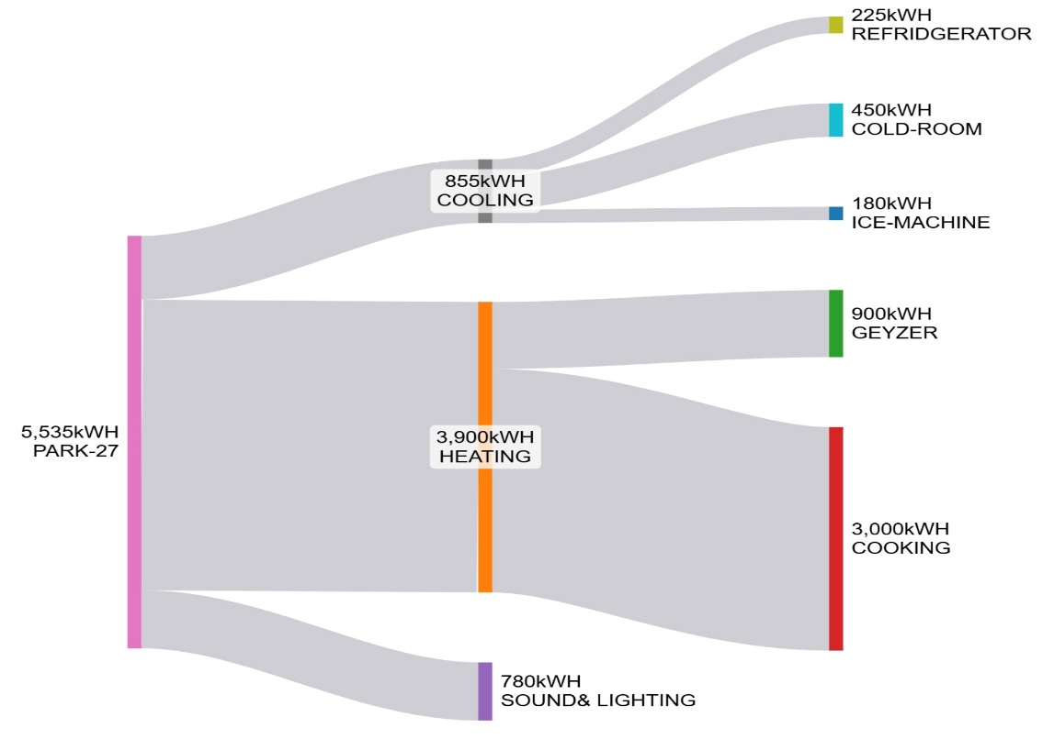
Figure 2: Sankey diagram showing a visualisation of energy demand

3.3 Solar Thermal Performance
Simulation results show that the proposed solar thermal system achieves:
- 62% solar fraction for DHW
- 2,506 kWh annual energy savings
- 1,669 kg CO₂ emissions reduction
- System efficiency of approximately 28%
These results demonstrate consistent performance across seasonal variations, with higher output during periods of increased solar irradiance as in Table 1.
Table 1: Simulation results from T*SOL
Park-27 Restaurant
 |  | Electricity Savings | CO₂ emissions avoided | DHW solar fraction | Efficiency | E Solar - DHW
 | Total Period | 2,506 [kWh] | 1,669 [kg] | 62 [%] | 28 [%] | 1,954 [kWh]
From | To
01/01/27 | 01/02/27 | 181 | 121 | 51 | 27 | 141
01/02/27 | 01/03/27 | 180 | 120 | 56 | 28 | 140
01/03/27 | 01/04/27 | 210 | 140 | 62 | 28 | 163
01/04/27 | 01/05/27 | 213 | 142 | 64 | 28 | 166
01/05/27 | 01/06/27 | 224 | 149 | 69 | 28 | 175
01/06/27 | 01/07/27 | 212 | 141 | 66 | 27 | 166

3.4 Financial Feasibility
The financial analysis indicates that the system achieves long-term profitability within its operational lifespan, with cumulative savings exceeding initial investment costs. This confirms economic viability for small-to-medium commercial establishments as in Figure 3.
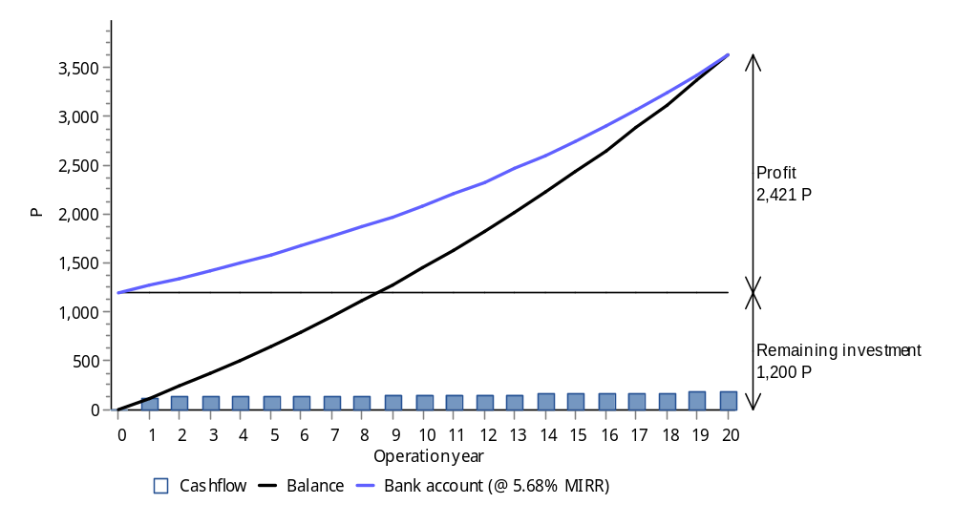
Figure 3: Economic simulation from T*SOL

4. Conclusion
The study confirms that Park27 is an ideal candidate for solar thermal integration. The high thermal load enables substantial energy savings and emissions reduction. This work contributes to bridging the data gap in Botswana’s commercial energy sector.

5. Acknowledgement
Authors are grateful to the SOLTRAIN+ project for supporting the audit, through the Clean Energy Research Centre, University of Botswana.

References
Chitena, D. (2017). Energy audit of a meat p rocessing plant. BIUST Research and Innovation symposium 2017, n,d.
Kaiser , W. H. (2005). Energy audit studies at the Tlokweng College of Education – Gaborone, Botswana. Journal of Energy in Southern Africa, 15-19.
Rebecca, N., Sekiswa, P., & Prudence, K. (2025). Assessing the Impact of Renewable energy adoption on business sustainability: A Case Study of roofings goup Uganda. Metropolitan journal of business & economics, 4(6), 922-932.

