EuroSun2026
AN EFFICIENT WAY TO STORE AND PERENNIALLY USE SOLAR THERMAL ENERGY BY COUPLING WITH HIGH TEMPERATURE HEAT PUMP

LALA ABHINANDAN (corresponding author), ASHOK KUMAR SINHA
Affiliation(s): Retired from Raja Ramanna Centre for Advanced Technology, Indore, India and for author 2, JSW Steel, India
Email: lala.abhinandan@gmail.com

Summary
In this paper, an innovative idea of coupling solar thermal systems to high temperature heat pumps is presented. The design is universally applicable. Two such schemes based on a transparent dome and partially transparent industrial shed are given in good detail. The thermal storage, also coupled to ASHPs is located underground inside the dome whose temperature is in the range of 200 to 250 degrees Celsius. A series of solar trough collector based systems supply the hot liquid for storage. In another proposal, an industrial shed whose roof has been modified to accommodate PV panels is given. Half of the sloping roof is transparent to admit sunlight. A series of ASHPs are located along the length of the shed. The storage temperature is 150 degrees Celsius. The temperature of the liquid stream obtained from ASHP is raised to the maximum temperature by using energy from PV panels. The hot fluid is stored in a series of pipes having proper insulation. Both designs ensure low thermal losses and maximum operation with Solar energy and good for perennial supply of hot water to the heating network.

Keywords: Solar energy, Thermal storage, Parabolic trough collector, ASHP, PV
Field of application for the findings: Heating Network, Solar drying
Addressed audience: Proponents of Solar Thermal Energy
- Introduction and Main objectives
Solar Energy in thermal form is becoming an important source for many applications including heating of residential and commercial buildings. This paper explores the possibility of perennial use of solar thermal energy in spite of its fluctuating nature. Hence, the storing of thermal energy and recharging the system are the two important considerations.
The existing large scale systems are based upon flat plate collectors due to low maintenance and rugged design while evacuated glass tube based collectors are most common for domestic use. Both are generally low temperature systems giving output up to 90 degrees Celsius which is low for long duration storage (Seasonal storage (Reference1). Recently, a sand battery has been developed to store thermal energy at high temperatures (up to 600 degrees Celsius), (Reference 2). The source of energy is surplus electricity from the grid which is used in resistance heaters to give hot air at such high temperatures. It is therefore dependent upon availability of surplus electrical energy. To reduce the heat loss, high thickness of insulation is essential and an economic thickness will be defined taking the cost into consideration.
It is observed that between the traditional low temperature flat plate system and the very high temperature sand battery there is a good potential for systems operating in the intermediate temperature range to make a mark. Thus an alternative seasonal storage is conceivable having technical and economic advantages.
It is the objective of this presentation to find if such a system can be based totally on solar energy and in conjunction with Atmospheric Source Heat Pump which has an overall coefficient of performance greater than one, that is net saving in energy.
This paper describes two such approaches based upon established technology. Both are based on proven subsystems, simple operation, requiring low routine maintenance and easy to scale up. Further deliberation brings out an innovative idea of utilization of the thermal storage housing for low temperature drying of fruits and vegetables. This is proposed as an additional feature without interfering with the stated objective. It is true that some changes are required in the thermal storage system by which the utility and overall output are enhanced. Such rather unconventional addition/integration may be worth looking into by relevant people.
- The main thermal energy sources and storage systems
The first system is based on a typical parabolic trough collector and tubular receiver operating in the medium temperature range (200 to 250 degrees Celsius). The output from the system is fed to an array of large diameter pipes which is the main thermal storage. The details are given in the section below. The setup is covered by a transparent dome. During sunny days, a temperature of about 40 degrees Celsius is maintained by incidence of solar radiation, enough for low temperature drying of fruits and vegetables. Any shortfall is met by controlled heat flow from the storage below. The storage of thermal energy is proposed during the preceding month before the winter season. It is perceived that incorporation of heat pumps will be beneficial during periods of intermittent sunlight. However, electrical energy will be required for their running. Such schemes are also discussed.
There is another system that is proposed based on an entirely different concept. Just as given above, the primary source in this case is Solar Energy. However, it is drawn through Solar Panels in electrical form. This electrical energy is taken during sunny periods even in moderate condition to run the heat pumps directly without any cumbersome battery storage system. It is noted that a major part in this energy exchange is from the atmosphere, irrespective of its temperature. The energy is primarily obtained from solar radiation getting absorbed in the ground which is released to maintain the atmospheric temperature. Overall energy saving appears possible as the heat pump is always operating in high performance mode. The PV panels also supply energy for resistance heating to achieve higher storage temperature.
- Materials, Methods and Details
As stated both the approaches make use of proven materials. The method adopted is fairly straightforward. The details are given for clarity and follow up by interested people. It is perceived that discussions in this regard will certainly help consolidate this approach based on energy saving and reduced dependence on fossil fuels, thereby addressing environmental concerns.
3.1. Thermal Storage System inside Transparent Dome
The hot medium from the Solar thermal system is stored in metallic pipes of about 30 cm in diameter in at least 2 layers, the total length is about 200 meters. Within the space available beneath a 20 metre dome, it will be possible to have a storage volume of about 2000 litres. The dome is placed on the ground and the solar thermal system is located nearby as shown in Figure 1. The heat exchangers and ASHPs are placed on the periphery of the dome.
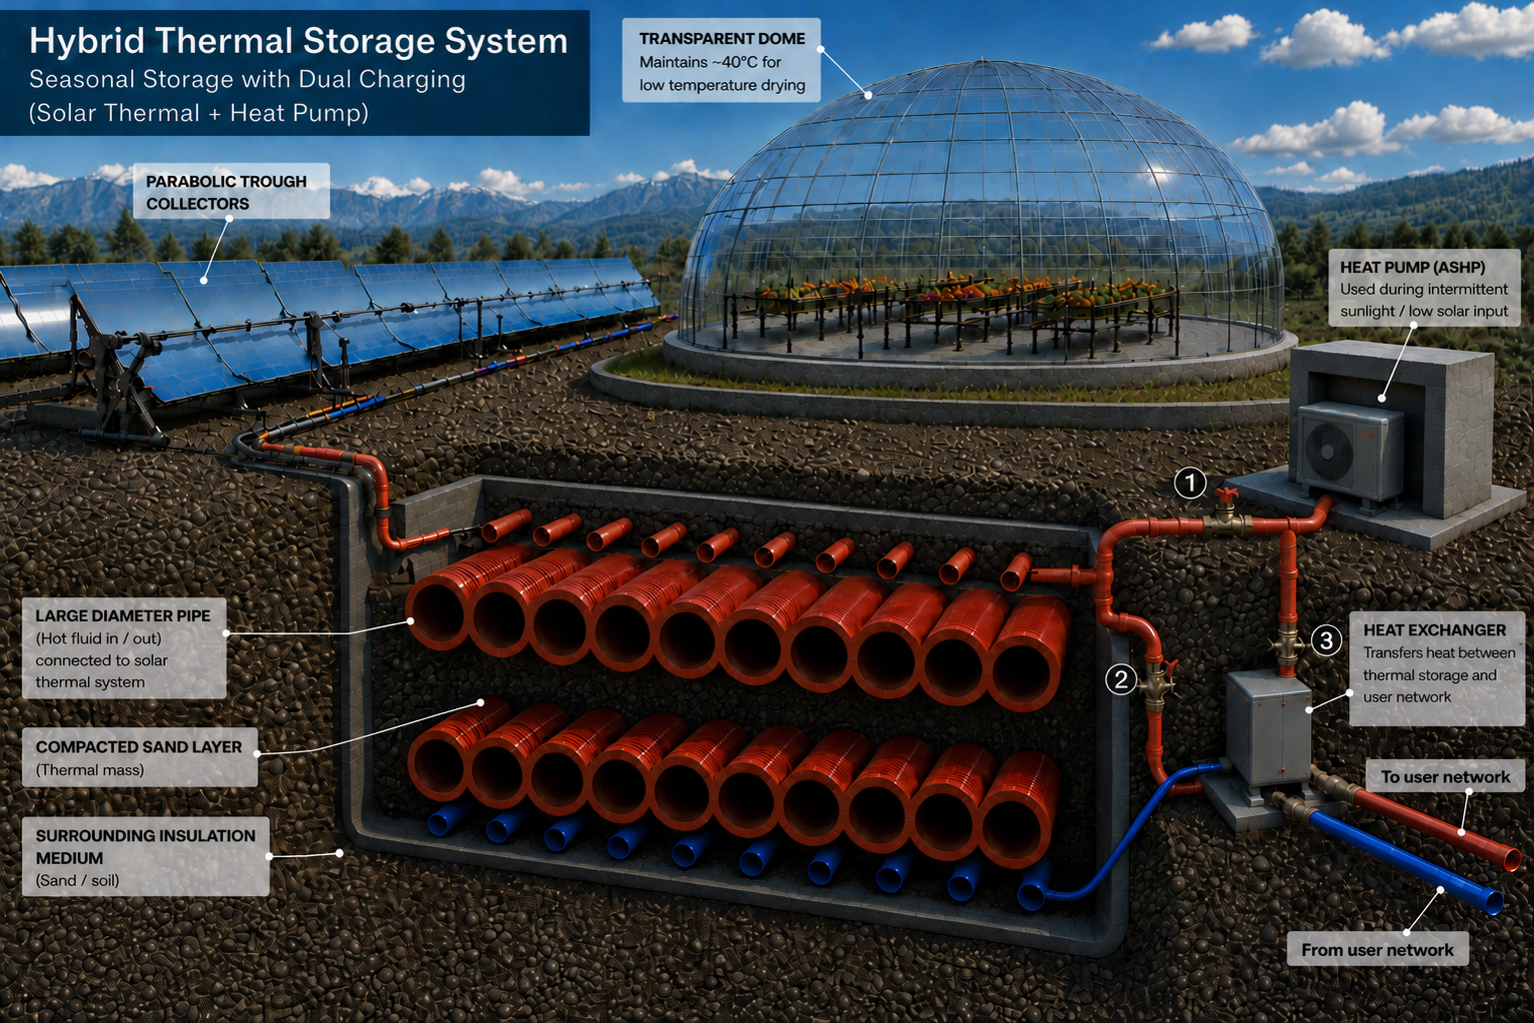

Fig. 1: Hybrid Solar thermal Storage System

The medium inside pipes is maintained at 200 to 250 degrees Celsius which is not directly exchanging heat with any colder stream located above the ground. It is in thermal contact with a bank of 15 cm diameter tubes such that it is maintained at about 90 degrees Celsius. The temperature gradient is achieved by packing the space between the larger and smaller tube banks with compacted sandy soil mixed with iron powder or similar materials as shown in Figure 2.
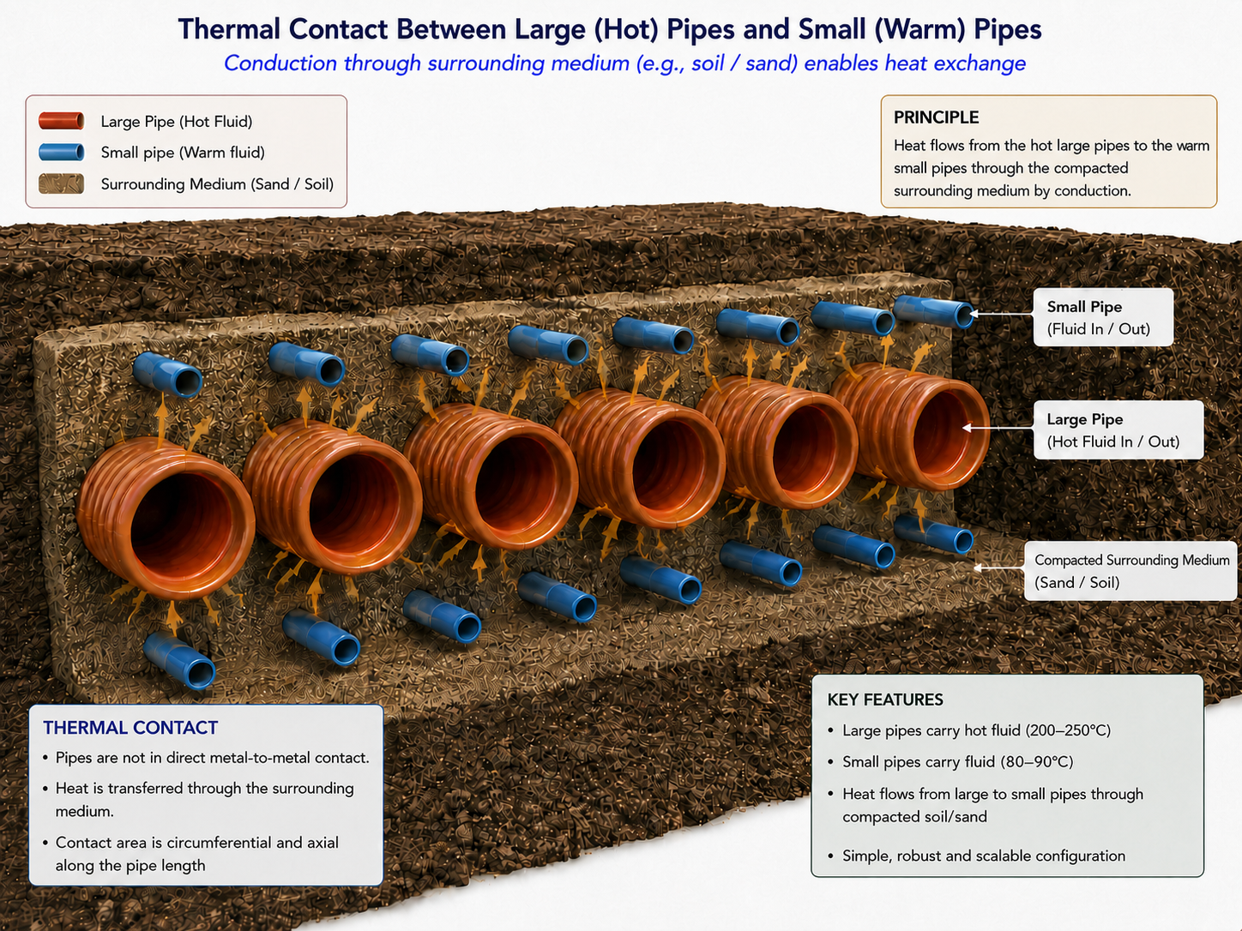

Fig. 2: Thermal contact between large pipes with liquid at high temperature and small pipes carrying liquid at lower temperatures
It will be possible to find the temperature distribution via proper thermal modeling as a function of thickness of densely packed material. The assembly is sitting at the base of the rectangular concrete well covered with proper insulation and surrounded by loose soil mixed with gravel from all sides. The top of the assembly is covered with another insulation arrangement with openings that can be closed or held at an angle to facilitate controlled heat flow into the space inside the dome. A schematic view of such an insulation covering is shown in Figure 3.
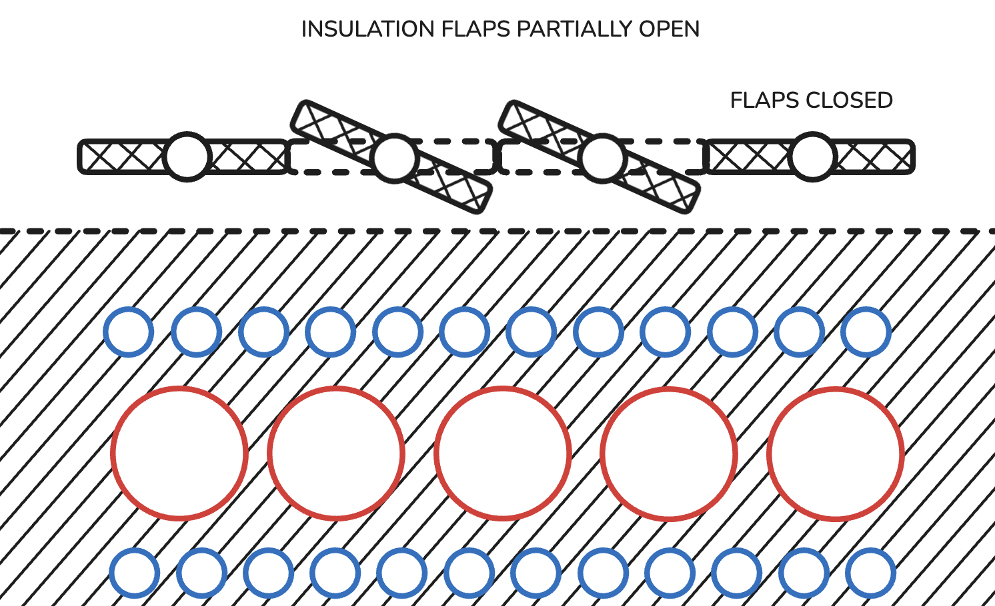

Fig. 3: Concept of tailored insulation

3.2. Thermal Storage inside an Industrial shed
In this approach the space inside a 50 m x 20 m x 10 m Industrial shed is proposed to be utilized for housing ASHPs on the periphery and about 200 m to 400 m of 60 cm well insulated pipes running along the length in multiple layers as shown in Figure 4. The outer boundaries are insulated either by having a double wall with air gap or sufficient insulation thickness from inside. The pipes will store a hot medium at about 150 degrees Celsius.
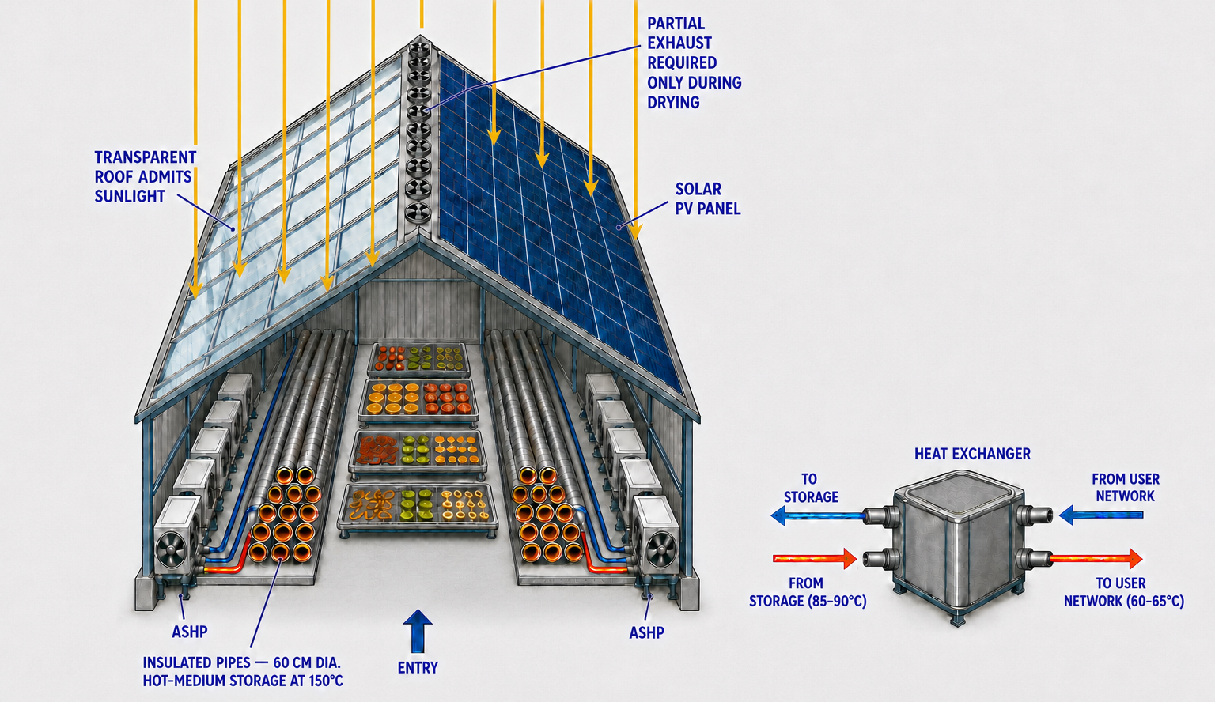

Fig. 4: Thermal Storage inside modified industrial shed

The storage pipes run along the wall of the industrial shed that is covered with Solar Panels and with transparent sheets which also provide adequate thermal insulation. Similar to the space available beneath the dome structure, the enclosed space in the central part of the shed can be utilized for placing the drying modules. ASHPs are mounted (embedded) in the wall along the length. The operation is quite different from the Solar thermal based system. ASHPs are the energy movers, whose running is governed via a smart controller. Thus the pumps are either operated at designed parameters, derated or even switched off depending on outside temperature. It is allowed to do so not only to save energy but to save the equipment as well. The decisions are taken based on Marginal COP data valid for the equipment. The efficient heating provided by the pump is supplemented by electrical resistance heating such that the storage is maintained at high temperature. All ASHPs are rated for giving output at 90 degrees Celsius when the surrounding air is between 15 to 20 degrees Celsius. The COP of the heat pump is expected to be between 3.0 and 3.5. It is understood that COP will be lower at reduced ambient temperatures.
- Discussions
It is better to define the broad outline of discussion.
The central idea behind this scheme is using solar energy for supplying thermal energy perennially to a network of residential or commercial buildings. The major equipment considered are parabolic trough based solar thermal system and ASHP. It is very helpful to couple the mentioned thermal systems to a thermal storage. As conditions vary across locations shown in Figure 5, this discussion pertains to places having solar insolation corresponding to Gaussian distribution or bell curve.
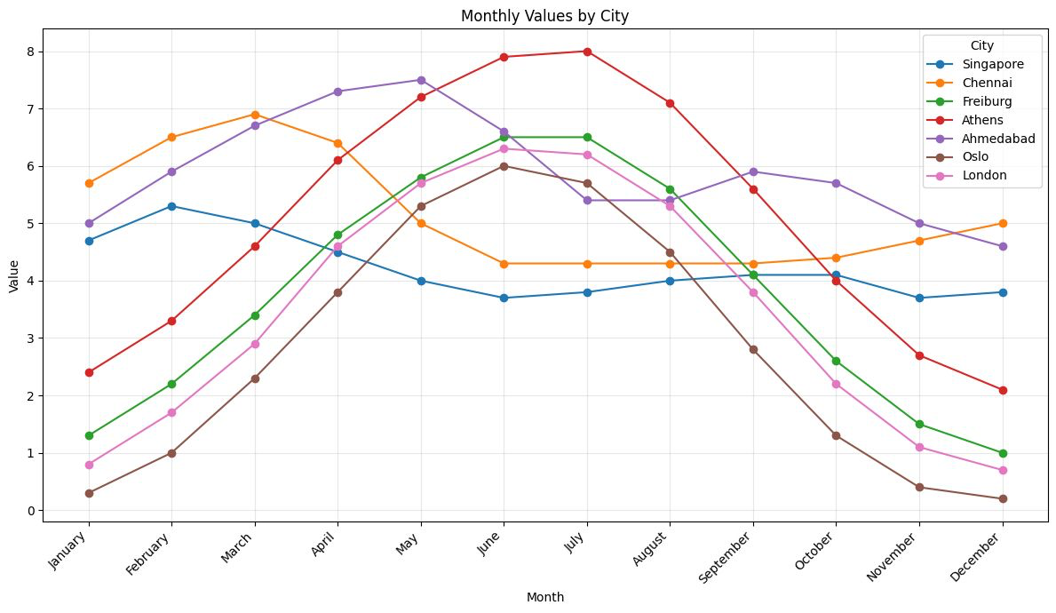

Fig. 5: Plots showing average GHI in various cities

Athens, Freiburg, London and Oslo are the cities having such distribution but certainly not restricted to those places. Many cities are having similar solar insolation. Such places have maximum insolation during the two months period of June and July and minimum values in four months period from November to February. The rising trend starts from March to May and falling values from August to October, the values in these two split periods are nearly the same. The conditions in June and July are best for operating parabolic trough collectors, however, the scheme may not be based on those insolation values. It is proposed to base the design of the solar thermal system on average value from March to May which is about the same as the average value from August to October i.e. a period of six months. Due to the fluctuating nature of solar insolation, adding an appropriate number of ASHPs is helpful in supplying thermal energy at a steady value and also ensuring collection and storing of surplus energy in the storage. This approach is likely to be more balanced to take care of the four months of lean solar insolation. The ASHPs along with thermal storage are most likely to effectively supply the required energy. It is noted that ASHPs may be operating at a much lower COP and require derating/switching off to keep them in best condition.

Tab. 1: Average GHI for Freiburg
Month | Avg. Daily GHI (kWh/m²/day) | Notes
January | 1.3 | Very low (winter)
February | 2.2 | Low
March | 3.4 | Increasing
April | 4.8 | Good spring values
May | 5.8 | High
June | 6.5 | Brightest months
July | 6.5 | Brightest months
August | 5.6 | Still high
September | 4.1 | Decreasing
October | 2.6 | Low
November | 1.5 | Very low
December | 1.0 | Darkest month

Taking the case of Freiburg (Table 1), during the six months period from April to September, the highest Global Horizontal Irradiance is 6.5 kWh/m2/day in June and July and the lowest is 4.1 with an average of about 5.6. Considering a daily collection of 1 MWh, an area of 180 sq.m. is required in this period. However, during December and January, the same area is able to collect just 0.2 MWh on a daily basis or 20%, hence in order to maintain the same amount of collection the daily shortfall of 0.8 MWh must come from Thermal Storage. However, it may not be a good idea to store in June and July to meet the shortfall in December and January as there are losses in storage. The solution may come from employing ASHP. A 5 kW ASHP running for 10 hours (daytime) a day, the thermal energy produced is 50 kWh, hence 16 ASHPs is needed to meet the shortfall. The COP of ASHP operating during daytime even during the coldest month could be as high as 2.0. When the COP goes below 2, it is better to switch off and supply from the Thermal Storage. An arbitrarily selected value of 10 days requirement or 10 MWh of energy storage should suffice for this module, that implies no operation of ASHP in the late evening/night hours. It is also possible to account for the shutdown of ASHPs even for a few days for various reasons. The various modes of operation in such a hybrid solar thermal system with storage is shown in Figure 6.
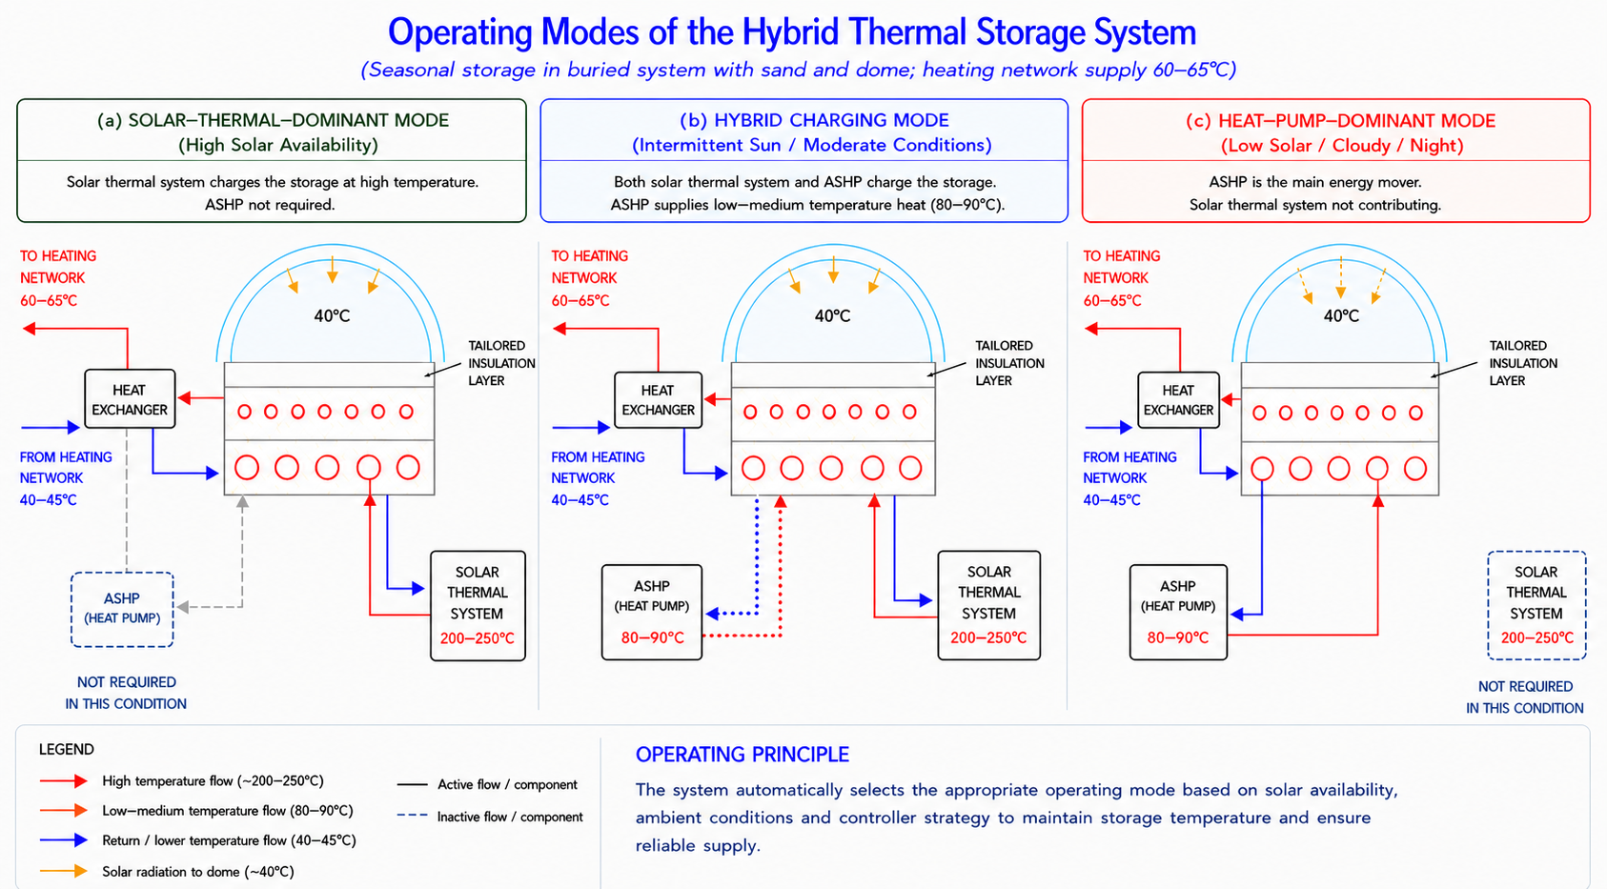

Fig. 6: Operation of Hybrid Solar thermal Storage in varying sunlight conditions

Summing up for this location, the optimum time for storing energy is October and November to minimize the thermal losses from the storage. It is noted that there is surplus energy available from April to September for drying purposes.
The purpose of locating the thermal storage inside a dome or industrial shed is to reduce the thermal losses significantly. Further, they provide space for low temperature drying of fruits and vegetables.
- Conclusion
In this investigation, it is shown that coupling of ASHP and Thermal Storage provides a better alternative to supply uninterrupted thermal energy for space and water heating. Both systems complement each other. Thermal Storage gives respite to ASHPs in extreme weather conditions whereas ASHP allows Thermal Storage to accumulate energy in fair situations. Higher storing temperature obtained during high sunlight incidence (insolation) is helpful in diverting a part of the energy for effective drying of fruits and vegetables. The thermal storage system inside a typical industrial shed may work entirely on Solar Energy even without storing electrical energy from PV panels placed on rooftop in a net metering mode.
It is suggested to carry out detailed economics of this scheme in a practical system.

- References
1. Aleksandrs Zajacs et al, Sustainable Cities and Society 83, Article 103920
2. Sherihan A. El-Ghafour et al, Journal of Energy Storage 179, Part C, Article 123887

