Multi-scale modelling of 3D textile composites with different orthogonal mesostructures including the influence of the composite manufacturing process

D. Vasiukov ^{1,2*}, K.-K. Parvathaneni ^{1,2}, S. V. Lomov ³, C.-H. Park ^{1,2}

¹ IMT Lille Douai, Institut Mines-Télécom, Polymers and Composites Technology & Mechanical Engineering Department, Douai, France
² Université de Lille, France
³ Department of Materials Engineering, KU Leuven, Belgium

*dmytro.vasiukov@imt-lille-douai.fr

Keywords: RTM, 3D textile, voids, multi-scale modelling, X-ray computed tomography

Abstract
A multi-scale modelling of 3D woven glass fabric reinforced composites with voids is presented in this work. Two different types of 3D orthogonal layer-to-layer interlocks textile reinforced composites, which are named for simplicity ‘twill 3D’ and ‘satin 3D’, have been addressed in this study. It includes the manufacturing of composite plates with RTM process, mechanical analysis and numerical simulation of the elastic and non-linear behavior. The reconstruction of the geometry is based on the micro CT scans and incorporates the local changes in geometry due to manufacturing. Moreover, the influence of the variation of the void content on mechanical properties has been investigated.

- Introduction

Composite materials are used in automobiles, aerospace, marine, sport, various engineering domains because of their high specific strength and design feasibility. However, these materials are vulnerable to defects [6], which are almost inevitably induced into part during complex manufacturing processes. Among different manufacturing defects, voids are the most common in processes like Resin Transfer Molding (RTM) and autoclave. In RTM the high void content can be due to improper degassing of resin and high-pressure injection of resin [1]. There has been a growing interest in the research dedicated to the effect of void formation on mechanical properties due to manufacturing processes coupled with textile architecture. This paper is aimed to study the effect of voids created by RTM in 3D interlock glass fabric reinforced composite which is a class of 3D composites that has certain advantages over laminates due its complex architecture.

The presence of voids could have significant effect on elastic properties and strength (mainly matrix dominated) of the composites [8]. A lot of research was dedicated to study the effect of void content on ILSS [9, 10], the effect of a morphology of voids on tensile properties [10, 11, 12]. In [11, 12] authors have also studied the effect of void orientation on the mechanical properties of composites. To the authors’ knowledge, there is a lack of investigation the effect of void content on mechanical properties of 3D interlock fabric reinforced composites.

The recent advancement includes the multiscale simulation has been significantly used for prediction of the linear and non-linear behavior of composite materials. The multiscale analysis can be carried out by using the statistical data of micro void and macro void distribution, as done in [3]. These type of models are unable to replicate the exact architecture of the RVE, for example, the yarn shape and void morphology. To overcome certain limits of the so-called “idealistic” multi-scale strategies, “realistic” models reconstructed from micro CT can be used as emphasized in [5]. Recent developments at the research group from KU Leuven have led to creation of the software VoxTex [2] which have been used for varying range of applications for textile composites (presented in ECCM-18 in paper of I. Straumit et al) to analyse the constituents and generate the mesh in a realistic way. The voids have a complex morphology which has a significant effect on the mechanical properties of the composite. This paper presents investigations of the effect of voids created by RTM in 3D interlock glass fabric reinforced composite. Analysis and numerical simulation of the linear and non-linear behavior is based on the model developed in [5].

2. Manufacturing

2.1. Description of the 3D textile

The interlocks studied in this work are usually classified as 3D orthogonal interlock with through-the-thickness binding (‘satin 3D’ in Fig 1a) and layer-to-layer binding (‘twill 3D’ in Fig 1b) in which binding warp yarns connect through thickness or by two adjacent layers. These textiles were manufactured at ENSAIT (Roubaix, France). Typical geometries of these 3D textiles are shown in Fig 1. The areal density ($ρ_{A}$) is 0.245 and 0.266 g/cm² for Satin 3D and Twill 3D respectively. Yarns are made of E-glass fibers with density $ρ_{f}$ = 2.61 g/cm³, $E$ = 72 GPa and $v$ = 0.3. Textiles were impregnated with thermoset resin (Prime 27) which has the following properties: $ρ_{m}$ = 1.11 g/cm³, $E$ = 3 GPa and$v$ = 0.3.

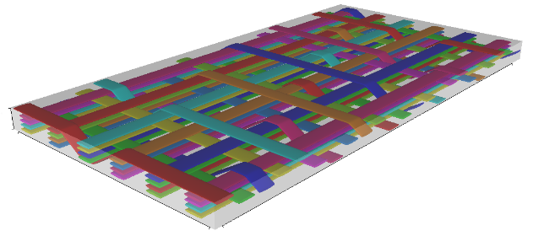 | 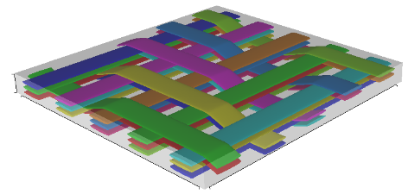
a) | b)
Figure 1. Repetitive Unit Cells: s) Satin 3D and b) Twill 3D textile architecture.

2.2. RTM manufacturing process

RTM is used in producing geometrically complex shapes in a cost-effective way. RTM consists of placing the textile or layers of fabric in mould, then resin mixed with curing agent is injected into the mould with constant injection pressure or with constant resin velocity. The resin flows through the preform and displaces air. Improper selection of injection pressure, vent or injection point sometimes results in dry spots or high void content [4, 13]. The RTM process described in this paper is assisted by constant pressure injection. Tab 2 consists the manufacturing parameters for two textiles described in this paper. Fig 2 describes the adopted manufacturing scheme.

Table 2. Parameters for the manufacturing of the composite plate.

 | Satin – 3D | Twill – 3D
Injection pressure | 2 Bar | 1.5 Bar
Length of injection | 27 cm | 26 cm
Time of injection | 64 s | 585 s
Resin velocity | 4.2 mm/s | 0.5 mm/s

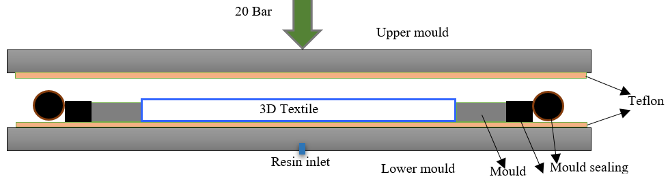
Figure 2. Protocol for RTM.

3 Specimen preparation and testing

Two different strategies were used for void content observation (SEM and micro CT) and mechanical testing (Fig 3). For the tensile specimens, the total plate is divided into two equal upper and lower parts. The 3 specimens of dimensions 15 mm width, 120 mm length and 2.6 mm thickness are extracted from upper and lower part respectively.

Tensile tests were performed on INSTRON 1180 with the load cell on 100kN respectively. The test was aided with digital image correlation technique (DIC). Imager MX was the camera used for image acquisition at a frequency of 110 µs. the frame size was 452 x 1391 pixels. The pixel size was 5.5 µm. The camera was first calibrated for desired focus by using a calibration sheet, later the camera was left untouched and all the experiments were performed. All the tensile specimens were speckled front surface, the area of interest was the zone in between the clip-on.

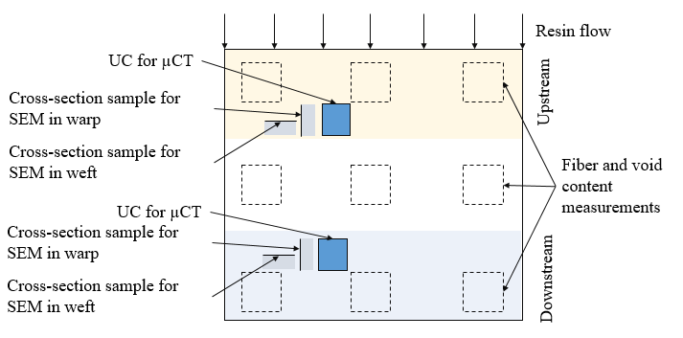 | 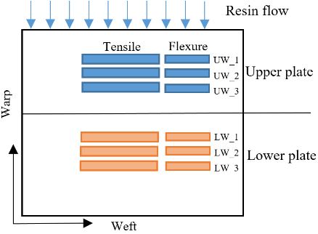
Figure 3. a) Fiber and void content measurements and b) mechanical testing.

3.1. Fiber and void content measurement

The fiber volume fraction and void content have been measured following test procedure described in ISO 1172:1996. For every plate the nine specimens with mass more than 5g ware extracted (location is indicated in Fig 3a). At first, the dry specimens were weighed and then a density test was performed for each specimen separately using Archimedes principle and then composite specimens were placed in the preheated oven at 550°C and left for 5 hours. Finally, the void content is calculated by using the following formula.
$V_{v}=1-(ρ_{f}× M_{f}/ρ_{c}+ρ_{m}×M_{m}/ρ_{c})$ | (1)
Where, $M_{f},M_{m}$mass fractions of the fiber and matrix respectively. The void formation is dependent on the resin velocity [14]. A gradient of velocity along the direction of injection is observed during resin transfer under constant pressure. This results in obtaining the part with different void content. The plate was manufactured with the void content of 2.5 % near injection and 4 % near the vent. There is the increase in the void content with the decrease in the resin velocity. Averaged results are shown in Tab 2.

Table 2. Results of the fiber volume fraction and void content measurements.

Textile | Satin 3D |  |  | Twill 3D
Part | Upper | Lower | Total | Upper | Lower | Total
$V_{f}$ (%) | 34.2 | 34.9 | 34.6 | 35.4 | 37.6 | 36.9
$V_{v}$ (%) | 2.72 | 3.31 | 3.02 | 2.77 | 3.82 | 3.25

3.2. Microtomography observations

Samples for micro CT observations were extracted as indicated in Fig 3a. The tomographic images were acquired over the ISIS4D platform (LML/LaMcube, France). Similar scanning parameters were used for the three samples (Tab 3). Each sample was scanned with 1440 projection images over a 360° rotation. A projection image was the average of 6 frames to reduce the random noises. The spot size of about 2 µm was chosen to achieve the required voxel sizes.

Table 3. Imaging parameters used for the three samples.

Sample | Voxel size (µm) | Tension (kV) | Current (µA) | Frame rate (f/s) | Scan time (min) | Dimension of reconstructed image (mm³)
Satin 3D | 6.45 | 80 | 124 | 10 | 23 | 9.96x3.06x7.17
Twill 3D (U) | 8.79 | 80 | 68 | 10 | 20 | 13.71x3.14x9.99
Twill 3D (D) | 8.78 | 80 | 68 | 10 | 17 | 13.71x3.14x9.99

Three-dimensional images were reconstructed using the software of RXSolution©. Due to the high-density contrast between the glass fibers and epoxy matrix, beam hardening was observed within the reconstructed images (see Fig 4a). Therefore, a beam-hardening reduction algorithm, proposed by the reconstruction software, was applied, leading to the result shown in Fig 4b. Physical filter was not used during the scans but would be another option to reduce the beam hardening effect. The final reconstructed images cover ¼ RUC for satin 3D sample and the whole RUC extracted from upper and lower part of the composite plate for twill 3D interlock samples. Fig 5 shows a comparison between both RUC. Very similar textile architecture is observed between the two samples, with different distributions of porosities.

a) | b)
Figure 4. a) Cross-sectional slice of the reconstructed image of satin 3D without processing the beam hardening. (c) Cross-sectional slice of the reconstructed image of satin 3D after processing the beam hardening.

a) | b)
Figure 5. Cross-sectional slices of the repetitive unit cell at the upper (a) and lower (b) part of the plate twill 3D, showing the similarity in textile architecture and the difference in porosity distribution.

3.3. SEM observations

For the additional information on porosity, the SEM observations were performed according to scheme explained in Fig 6 the direction of observation is represented by the arrow. It is observed that along the direction of injection (warp) variation in inter yarn void percentage is higher than the variation in intra void percentage. Different voids in both warp and weft with respect to their position in the plate are shown in Fig 7.

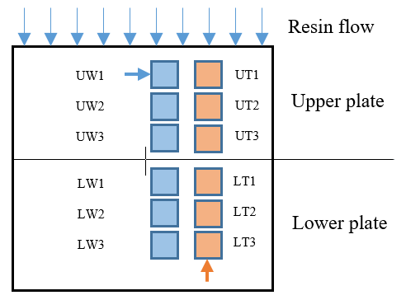 | 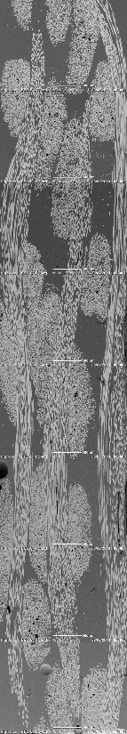
 | b)
 | 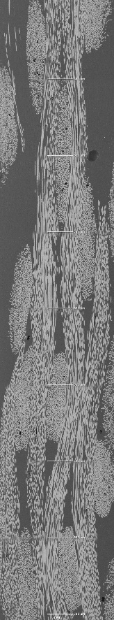
a) | c)
Figure 6. SEM observation for satin 3D: a) scheme for specimen extraction; b) warp yarns cross-section for and c) weft yarns cross-section.

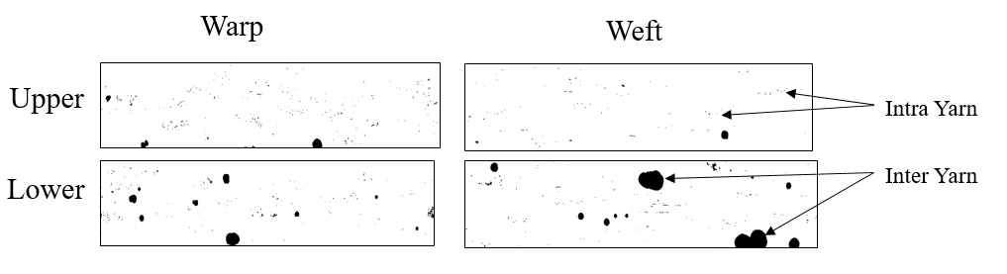
Figure 7: Intra and inter yarn voids.

The observation for intra yarn voids by SEM (see Tab 3) did not follow certain trend. It is due to the fact that, every slice is a local information and very sensitive to cutting position thus the selection of area of interest plays decisive role in results which is recognized as one of the drawbacks. It is necessary to perform large number of measurements in order to obtain statistically confident results. Thereby, for the numerical simulation, the reconstructed from micro CT model will be used. On the other hand, intra yarn void content measurements has been performed for individual yarns in every slice, thus results content data about dozens of individual yarns. It is observed that the variation in local intra yarn void content in all cases higher in upper part of the plate. This information is used for calculation of the homogenized properties of the warp and weft yarns. Additionally, it worth noting that in warp direction intra yarn voids have cylindrical shape while in weft yarns the spherical shape is predominant.

Table 3. Summary of the void content measurements in different type of composite plates from SEM.

Textile | Satin 3D |  |  |  | Twill 3D
Direction | Warp |  | Weft |  | Warp |  | Weft
Part | Upper | Lower | Upper | Lower | Upper | Lower | Upper | Lower
Intra yarn voids (%) | 0.46 | 0.50 | 0.38 | 0.20 | 0.59 | 0.59 | 0.70 | 0.65
Inter yarn voids (%) | 1.82 | 1.02 | 1.56 | 1.27 | 1.49 | 0.76 | 0.58 | 0.51

4. Multiscale modeling

4.1. Geometry reconstruction from µCT

Numerical modeling of elastic properties of the composite material involves of finding a Representative Elementary Model (RVE) or defining a Repetitive Unit Cell (RUC), generation of mesh and developing behavior model. Each step is challenged by complexity of the material which deals with the scale of constituents (fibers, matrix, and defects). The segmentation and realistic geometrical model reconstruction follows steps presented in [2]. This efficient and robust methodology have been compared with classical idealistic approach in [5] reviling high effect of the realistic geometry on the damage initiation and evolution for textile composites. The quality of voxel mesh depends on the size of the pixel and resolution. In Tab 4 the key features that allow to perform supervised segmentation are summarized for three different model. Finally, four material phases were segmented: 1) warp yarns; 2) weft yarns; 3) matrix and 4) voids. It is important to note that in this work the intra yarn porosity could not be integrated explicitly into the reconstructed voxel model. Main reason for that is the final size of FEM model depends directly on chosen voxel element size, in our case for all models is equal to 12 pixels resulting to approximatively 200000 finite elements at most.

Table 4. Main steps for image segmentation and generation of the voxel model of 3D interlocks containing four material phases: weft yarns, warp yarns, matrix, and voids.

 | Satin 3D | Twill 3D upstream | Twill 3D downstream
Histogram | 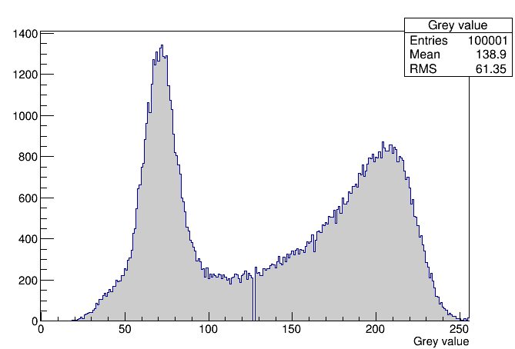 | 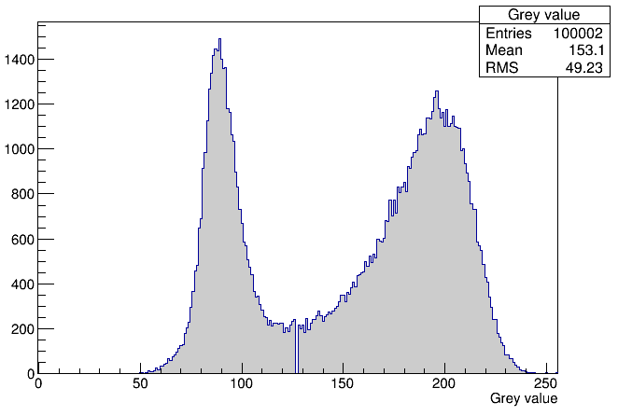 | 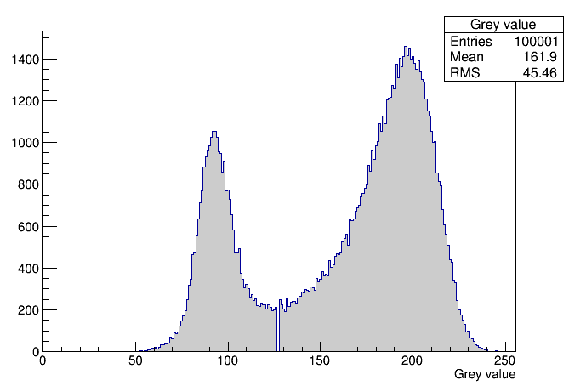
Anisotropy | 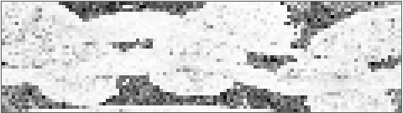 | 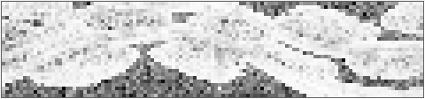 | 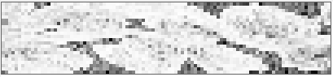
Average grey value | 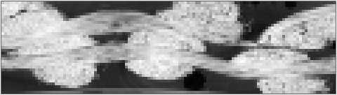 | 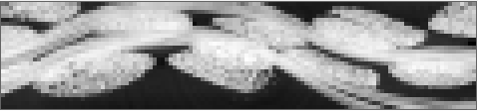 | 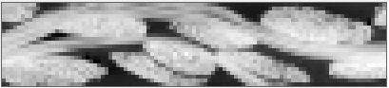
Results of supervised segmentation | 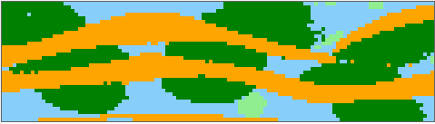 | 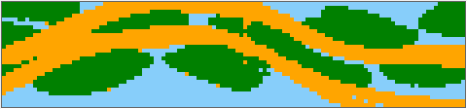 | 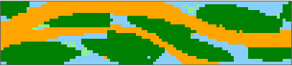

4.2. Material model definition

In order to assign two different intra yarn porosity contents, warp and weft yarns were previously separated in supervised segmentation. Warp and weft yarns are considered as anisotropic, homogenized, damageable materials. Elastic properties of warp and weft yarns have been calculated using the following information: 1) glass fiber and polymer properties (Section 2.1); 2) experimental data about fiber volume fraction (Tab 2); 3) yarn volume fraction calculated in VoxTex from micro CT (Tab 4); 4) void content (see Tab 3) and 5) void shape variation from spherical in weft to cylindrical in warp from SEM. For these calculations, Mori-Tanaka estimate is chosen due to its simplicity in application and capacity to account for different shapes of the voids. Strength properties of yarns have been calculated based on analytical estimation using Rosen’s model for the voids free UD composites, and then, transversal tensile/compression and shear properties were reduced by 25 %, 11 %, and 15% respectively (deduced from results reported in [15]). Matrix material is considered as isotropic and damageable. For more detail, about model definition, the reader is addressed to [5]. Brief results of simulation are presented in Fig 8. It is observed that inter yarn voids played decisive role in concentration of transversal damage in the nearest yarns, as can be seen in Fig 8c.

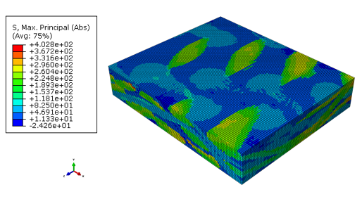 | 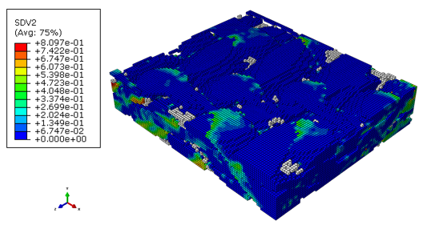 | 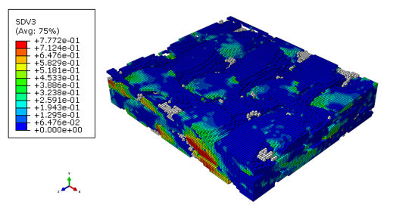
a) | b) | c)

Figure 8. Results of uniaxial tension applied for RUC in the lower part of Twill 3D realistic mesostructures: a) principal stresses at the beginning of the loading (damage free state); b) and c) initiation of the two damage mechanisms in the yarns in transversal direction (matrix is hidden, white color elements represent voids).

5. Conclusions

Two different 3D interlock glass fabric reinforced composite plates were manufactured by RTM under constant pressure condition. In both cases, void content is varying along the resin flow direction. It is observed that there was significant variation in inter yarn porosity, it increase from injection edge to vent but there was no comparable effect on intra yarn porosity. There is difference in intra yarn void morphology which affect elastic and strength properties of the yarns. Both destructive (SEM) and non-destructive (micro CT) were used for intra yarn and inter yarn porosity content quantification. The SEM observation is carried out to get the detail view on the content and shape distribution of voids in the yarn. The presented modeling allows to account a realistic distribution of the inter yarn voids. It is shown that presence of the inter yarn voids leads to higher transversal damage concentration in the adjacent yarns.

Acknowledgments

The Nord-Pas-de-Calais Region and the European Community (FEDER funds) partly funds the X-ray tomography equipment ISIS4D platform (LML/LaMcube, France). S.V. Lomov holds Toray Chair for Composite Materials @ KU Leuven, help of which is gratefully acknowledged.

References

[1] N. Patel, V. Rohatgi, and L. J. Lee. Micro scale flow behavior and void formation mechanism during impregnation through a unidirectional stitched fiberglass mat. Polymer Engineering & Science, 35(10): 837-851, 1995.
[2] I. Straumit, S.V. Lomov, and M. Wevers. Quantification of the internal structure and automatic generation of voxel models of textile composites from X-ray computed tomography data. Composites Part A, 69: 150-158, 2015.
[3] H. Tao, and Gong Y. A multiscale analysis for predicting the elastic properties of 3D woven composites containing void defects. Composite Structures, 185: 401-410, 2018.
[4] T. S. Lundstrom, B. R. Gebart, and C. Y. Lundemo. Void formation in RTM. Journal of reinforced plastics and composites, 12: 1339-1349, 1993.
[5] Y. Liu, I. Straumit, D. Vasiukov, S.V. Lomov, and S. Panier, Prediction of linear and nonlinear behavior of 3D woven composite using mesoscopic voxel models reconstructed from X-ray micro-tomography. Composite Structures, 179: 568-579, 2017.
[6] C. Dong. Effects of process-induced voids on the properties of fibre reinforced composites. Journal of Materials Science & Technology, 32(7): 597-604, 2016.
[7] J. E. Little, X. Yuan, and M. I. Jones. Characterisation of voids in fibre reinforced composite materials. NDT & E International, 46: 122-127, 2012.
[8] A. Shigang, F. Daining, H. Rujie, and P. Yongmao. Effect of manufacturing defects on mechanical properties and failure features of 3D orthogonal woven C/C composites. Composites Part B: Engineering 71: 113-121, 2015.
[9] H. Yoshida, T. Ogasa, and R. Hayashi. Statistical approach to the relationship between ILSS and void content of CFRP. Composites Science and Technology, 25(1): 3-18, 1986.
[10] I. Gagauz, L. F. Kawashita, and S. R. Hallett. Understanding the effect of void morphology and characteristics on laminate mechanical properties. 21st International Conference on Composites Materials (ICCM-21) August 20-25, 2017
[11] H. Huang, and R. Talreja. Effects of void geometry on elastic properties of unidirectional fiber reinforced composites. Composites Science and Technology 65(13): 1964-1981, 2005.
[12] X. Chang, M. F. Ren, T. Li and X. Guo. Evaluation of mechanical behaviour of unidirectional fibre-reinforced composites considering the void morphology. Journal of Reinforced Plastics and Composites, 36(24): 1817-1828, 2017.
[13] V. R. Kedari, B. I. Farah, and K.-T. Hsiao. Effects of vacuum pressure, inlet pressure, and mold temperature on the void content, volume fraction of polyester/e-glass fiber composites manufactured with VARTM process. Journal of composite materials, 45(26): 2727-2742, 2011.
[14] C.-H. Park, and L. Woo. Modeling void formation and unsaturated flow in liquid composite molding processes: a survey and review. Journal of reinforced plastics and composites, 30(11): 957-977, 2011.
[15] Vajari, D.A., C. González, J. LLorca, and B.N. Legarth. A numerical study of the influence of microvoids in the transverse mechanical response of unidirectional composites. Composites Science and Technology, 97: 46–54, 2014.

