EuroSun2026
PVT - Heat Pump Systems with Horizontal Ground Heat Exchangers in Multi-Family Houses: Design, Implementation, and Monitoring

Bharat Chhugani¹*, Peter Pärisch², Daniel Eggert¹, Christoph Büttner¹, Marco Oklitz¹, Federico Giovannetti¹
¹ Institute for Solar Energy Research in Hameln (ISFH), Am Ohrberg 1, 31860 Emmerthal
² proKlima, Glockseeplatz 1, 30169 Hannover

Summary
This study investigates the design, implementation, and initial monitoring of photovoltaic-thermal (PVT)-assisted ground-source heat pump systems for multi-family houses in urban areas with limited space and geological constraints. Two energy-efficient multi-family buildings are equipped with PVT collectors, horizontal ground heat exchangers, and a heat pump. TRNSYS simulations were used to evaluate system performance and to determine the potential to reduce the required ground-exchanger area while maintaining efficient and sustainable operation. The simulations showed that integrating approximately 40 m² of PVT collectors could reduce the required horizontal ground-exchanger area by up to 40% without reducing the seasonal performance factor. Initial monitoring results from February to August 2026 showed stable operation, with an average seasonal performance factor value of 3.4. PVT collectors supplied a significant share of the heat-pump source energy, improved electricity self-consumption, and contributed to ground regeneration during periods of increased solar radiation. These findings indicate that PVT-assisted ground-source heat pump systems can provide a practical solution for multi-family buildings where conventional geothermal systems are restricted by limited land availability, protected vegetation, or geological risks.
Keywords: Photovoltaic-Thermal (PVT) collectors, ground-source heat pumps, multi-family houses, TRNSYS, Monitoring
Field of application for the findings: Heating sector, energy-efficient building design, and renewable integration in urban areas
Addressed audience: Engineers, researchers, urban planners, architects, energy consultants, housing companies, heat pumps and PVT manufacturers
- Introduction
The heat pump market for residential buildings has been growing steadily in Germany for several years. Heat pumps are particularly common in new single-family houses, whilst their market share in multi-family houses (MFH) remains low. Most multi-family houses are located in densely built-up urban areas, which can make access to geothermal sources for heat pumps difficult. Air-source heat pumps, on the other hand, can be problematic to integrate due to noise, distance regulations, or low efficiency. Here, photovoltaic-thermal (PVT) collectors represent a promising solution as a sole or additional heat source with heat pumps and have gained increasing recognition in recent years, both in research projects and on the market.
Previous studies (Hüsing et al. 2016; Mercker et al. 2019) show that ground regeneration enables the installation of more compact horizontal ground heat exchangers (HGHX) in combination with heat pumps. The same applies to borehole heat exchangers (BHE), which are suitable for use in multi-family houses in combination with PVT systems, particularly where space or depth constraints apply (Sommerfeldt and Madani 2019; Chhugani et al. 2023a). There are already demonstration projects (Timilsina et al. 2023) and numerous simulation studies on PVT and geothermal heat pump systems (Schubert et al. 2019; Chhugani et al. 2023b).
In multi-family houses, several aspects such as design, implementation, and operational strategies between PVT and heat pumps pose many challenges. These challenges are addressed in an ongoing joint project conducted in cooperation with other German research institutes and various manufacturers. The overall goal of the project is to establish feasible solutions combining PVT collectors and heat pumps in both multi-family houses and commercial buildings. One work package is dedicated to consulting and supporting real installations of PVT-heat pump systems through all planning and construction phases, from preliminary design to operation.
In this context, we are supporting a housing company with the construction of two energy-efficient multi-family houses. Each building, constructed with a highly insulated, prefabricated wood frame, consists of nine residential units with a total living area of about 580 m². The design of the planned buildings is shown in Fig. 1. Each building has a roof area of approximately 150 m² and around 550 m² of green space. The site is located in the immediate vicinity of a small river and a forest area. The use of borehole heat exchangers was ruled out due to prior groundwater leakage incidents during drilling in another project in the city. Hence, horizontal ground heat exchangers were proposed as an alternative solution, even if their size is limited due to nearby protected old trees and geological risks. To overcome these site-specific limitations, photovoltaic-thermal (PVT) collectors are integrated into the system design. Based on experience from previous projects, the use of PVT allows for a significant reduction in the required area of horizontal ground heat exchangers while achieving the same system performance.
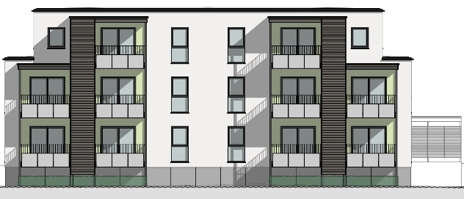 | 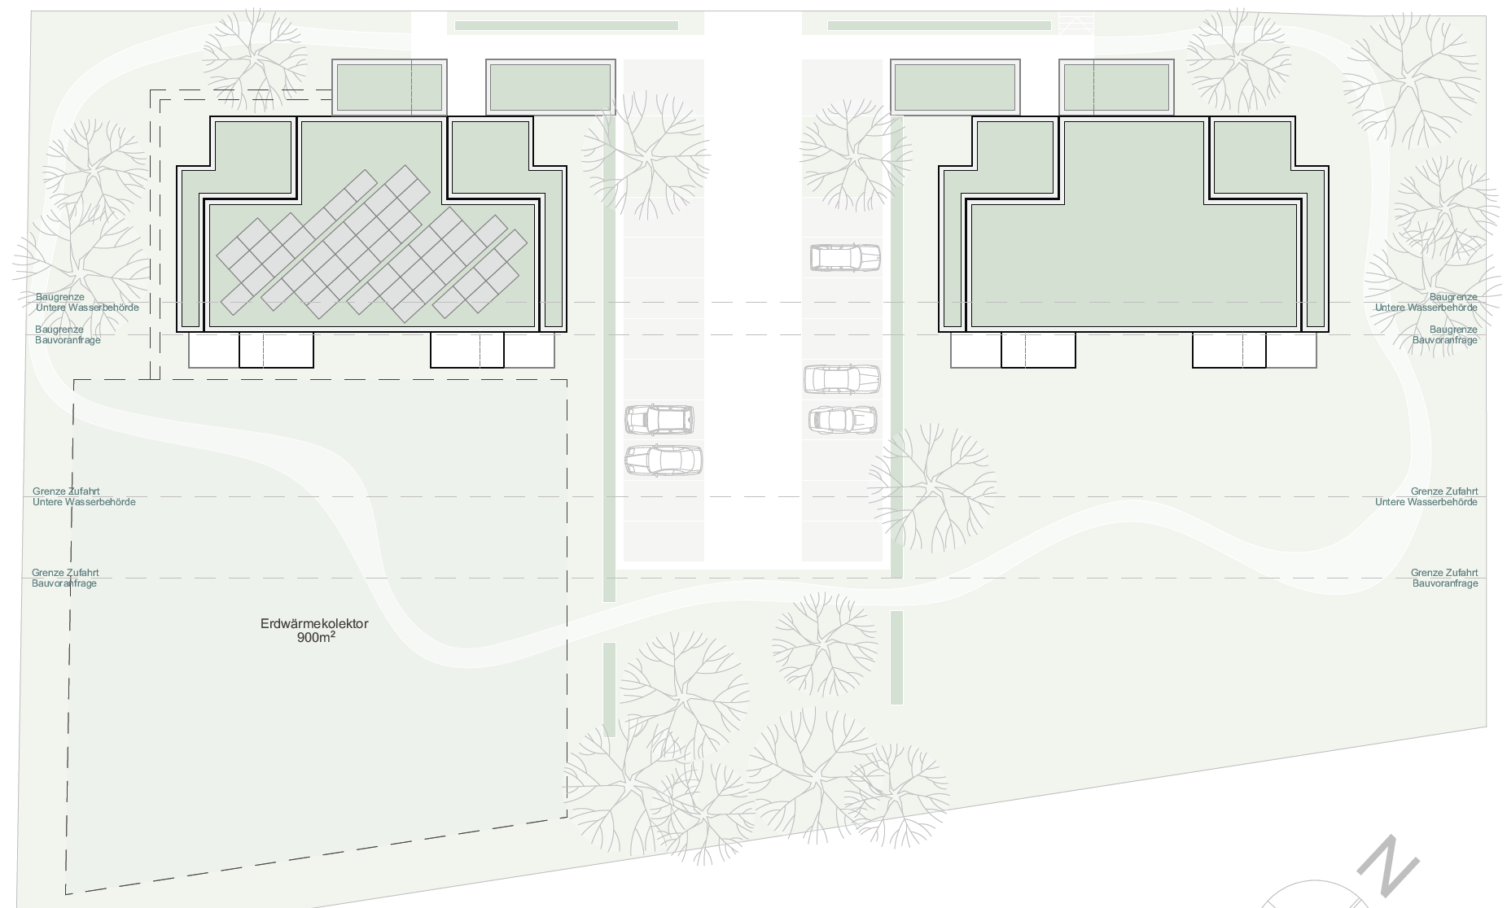
Fig. 1: South-east elevation (left) and floor plan (right) of the planned buildings
- Simulations
The simulation study has been carried out using the TRNSYS software, based on the hydraulic diagram shown in Fig. 2, to investigate the planned heat pump system. The aim is to achieve a simple, efficient, robust, and space-saving combination of ground-source heat pumps and PVT.
The building has an annual heat demand of 8.8 MWh for space heating and 9.9 MWh for domestic hot water. The heating load is 17 kW at a design temperature of -10.8 °C. The flats are occupied by between 1 and 4 people (single people, couples, and families with varying numbers of children and age structures). The average daily hot water consumption is 46 liters per person, based on a total of 16 people. The building has a 4-pipe system designed to achieve higher overall efficiency by separating the flow temperatures for space heating and domestic hot water, and each flat is equipped with heat interface units (HIUs). The system comprises two separate buffer tanks to prevent mixing between the heating and domestic hot water systems: a 600-liter buffer tank for space heating and a 910-liter buffer tank for domestic hot water. The setpoint temperature for the domestic hot water tank is 51 °C with a hysteresis of 5 K. The setpoint for the heating tank varies with outside temperature and is fully deactivated outside the heating season.
The heat pump operates at source temperatures between -15 °C and 30 °C. If the source temperature falls below this range, a 9-kW heating element is activated. The horizontal ground heat exchanger (HGHX) is an essential component for extracting heat from the ground. The operating range comprises a minimum outlet temperature of -5 °C during heat extraction (discharge) and a maximum temperature of 35 °C during ground regeneration (charging). An important operational consideration is preventing ice formation to avoid ground heave and ensure that precipitation can continue to infiltrate the ground. The aim is therefore to combine the HGHX with PVT collectors to reduce the required HGHX area without compromising the system’s efficiency or the installation's sustainable operation.
The control strategy for source management uses a two-point controller with hysteresis. This monitors the temperature of the hydraulic diverter and compares it with the flow temperatures of the PVT collectors and the HGHX to determine which sources to activate. For example, the PVT system switches on when the outlet temperature exceeds the brine storage temperature by 4 K, and switches off when the difference falls below 2 K. This control approach enables the PVT and ground-source heat pump systems to function as combined heat sources whilst ensuring efficient ground regeneration.
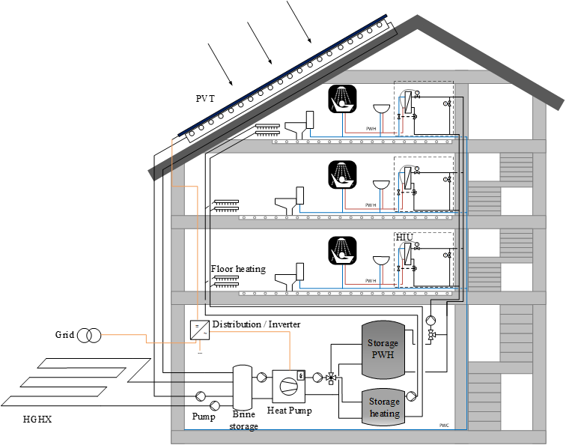
Fig. 2: Simplified diagram illustrating the system configuration of the planned heating system, comprising PVT collectors, horizontal ground heat exchangers, and a heat pump
2.1 Simulation results
The key criteria for evaluating the system configurations under investigation are the seasonal performance factor (SPF) of the heat pump systems and the required area of the horizontal ground heat exchangers. SPF is the ratio of the heat supplied by the heat pump to the storage tanks to the electrical energy consumed by the heat pump and the associated circulation pumps.
SPF used in this analysis is the ratio of the heat quantities supplied to the buffer storage by the heat pump (${\dot{Q}}_{HP}$), the auxiliary heating (${\dot{Q}}_{Backup}$) divided by the electrical energy consumed within this system boundary. The electrical energy of the heat pump, source pumps, and electrical backup auxiliary heater.
After SPF, the following performance indicator is SPF_grid, which considers self-consumed PVT electricity (${\dot{E}}_{PVT_el_Self}$) in the same boundary and is explained in eq. 2. This means that the generated electrical power of PVT is used simultaneously for the electrical consumption of the heating system (simulation time step = 1 sec) without battery storage. The surplus PVT electricity generated is fed into the grid since there is no battery. In the end, this metric only considers the electrical energy the heating system draws from the grid.
(eq. 1)
$$SPF=\frac{\int{{(\dot{Q}}_{HP}}+{\dot{Q}}_{Backup}) dt}{\int{\left({\dot{E}}_{HP}+{\dot{E}}_{Backup}+{\dot{E}}_{Pumps}\right.}) dt}$$

(eq. 2)
$$SPF_grid=\frac{\int{{(\dot{Q}}_{HP}}+{\dot{Q}}_{Backup}) dt}{\int_{ > 0}{\left({\dot{E}}_{HP}+{\dot{E}}_{Backup}+{\dot{E}}_{Pumps}-{\dot{E}}_{PVT_el_Self}\right) dt}}$$
Fig. 3 illustrates the system performance factor (SPF) as a function of the horizontal ground heat exchanger (HGHX) area for a baseline ground-source heat pump configuration. In a well-dimensioned system operating with a large HGHX field of up to 532 m², the performance curve remains relatively flat, yielding a SPF of 3.52. As the HGHX area is gradually reduced down experiences decrease in SPF and at smaller ground collector sizes, the SPF plunges rapidly due to critical frost formation in the surrounding soil and a corresponding spike in heat pump electricity consumption caused by excessively low source temperatures.

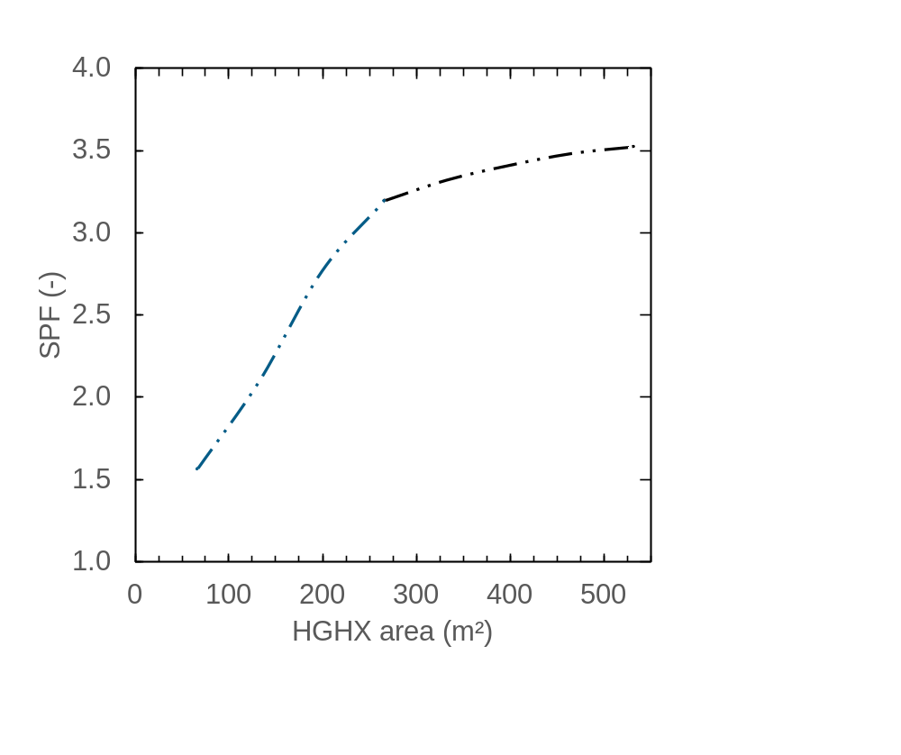
Fig. 3: SPF of the heat pump system as a function of horizontal ground heat exchanger (HGHX) area
However, as mentioned, the restricted land space area is available for a full-dimensioned HGHX. The integration of PVT is ideal for supporting the efficient operation of the heat pump as a direct heat source on sunny winter days and for regenerating the ground in summer. Fig. 4 shows the impact of adding photovoltaic-thermal (PVT) collectors (10 m² to 40 m²) to the HGHX. Integrating PVT collectors consistently elevates system efficiency across all sizing variations, showing the most pronounced benefits when coupled with smaller, undersized ground fields. To achieve the reference baseline SPF of 3.52, equivalent to a 532 m² HGHX system, adding 20 m² of PVT allows the ground collector area to be reduced by 20% to approximately 380 m². In addition, 40 m² of PVT reduces the required ground collector area by 38% down to roughly 330 m². Hence, it is possible to reduce the size of the ground-source heat exchanger without risking critical frost formation in the soil.
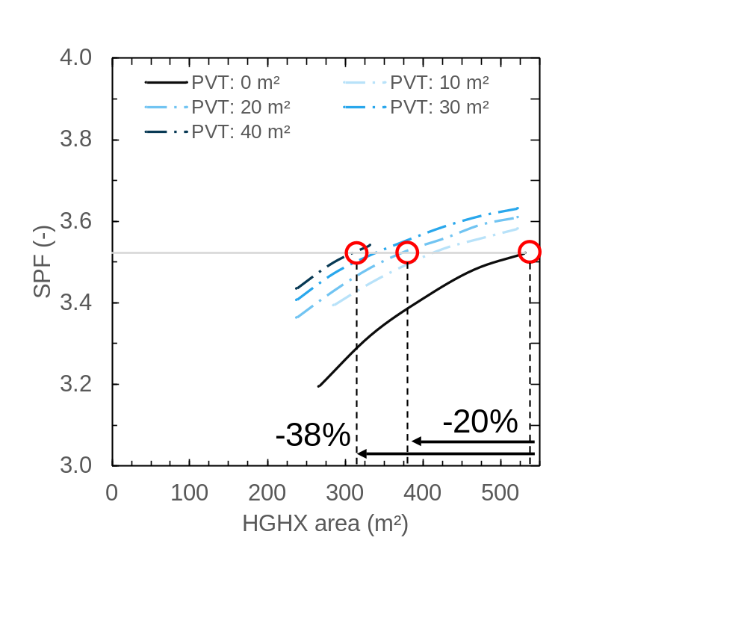
Fig. 4: SPF of the heat pump system over the HGHX area for different sizes of PVT collector fields

- Implementation
The construction of the two blocks of flats began in March 2025. As this was a serial construction consisting of prefabricated timber elements, both buildings could be completed within a few months. The concept was implemented as planned, and the PVT collectors were installed on the rooftops. The plant has been completed and commissioned in accordance with the plans outlined in the previous section, and both buildings are equipped with detailed monitoring. Fig. 5 shows the installed uncovered, backside insulated PVT approximately 48 m² on the roof surfaces, an additional 396 m² of horizontal ground heat exchangers, and a 17-kW heat pump (B0/W35).
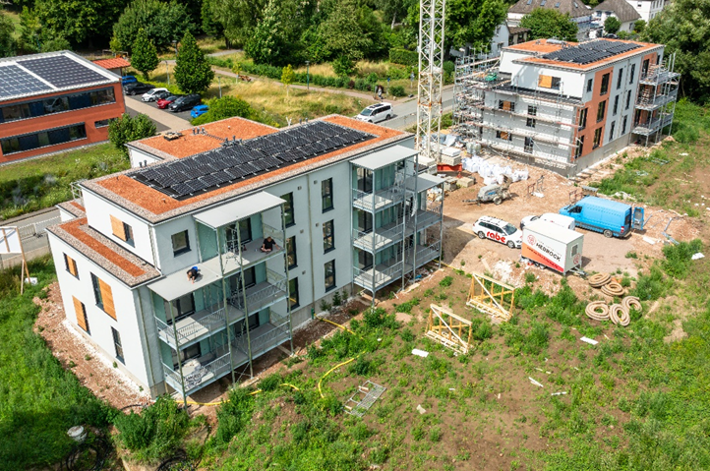 | 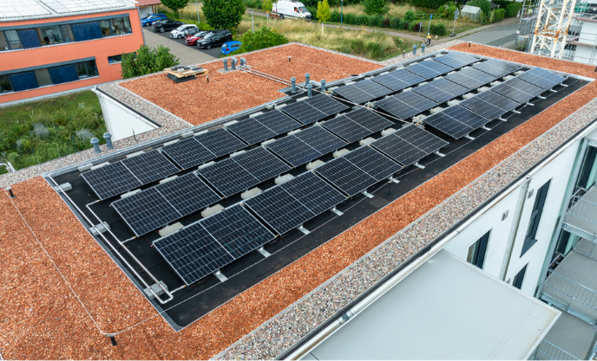
Fig. 5: Completed MFH with PVT collectors on the roof; both buildings (left) and PVT modules/field from the roof (right)
The monitoring system records a comprehensive range of thermal and electrical measurement data for the evaluation of the plant with a temporal resolution of 1 sec. On the generation side, the system records the thermal energy from the PVT and ground heat exchanger (HGHX), the PVT temperature, and the regeneration energy transferred directly from the PVT into the ground. Here, the focus is on the heat pump’s electricity consumption and on the total heat generated. On the consumption side, the system records the flow and return temperatures and the specific energy flows for space heating and domestic hot water.
- Monitoring results
Fig. 6 and Fig. 7 show the first monitoring results for one of the buildings for the months of February and March 2026 during the initial operation and optimization phase. February was relatively cold, with 5-9 cm of snowfall for almost 9 days of the month, an average temperature of 3.4 °C, and low solar radiation. In contrast, March was significantly milder, at 7.9 °C, and had higher total solar radiation.
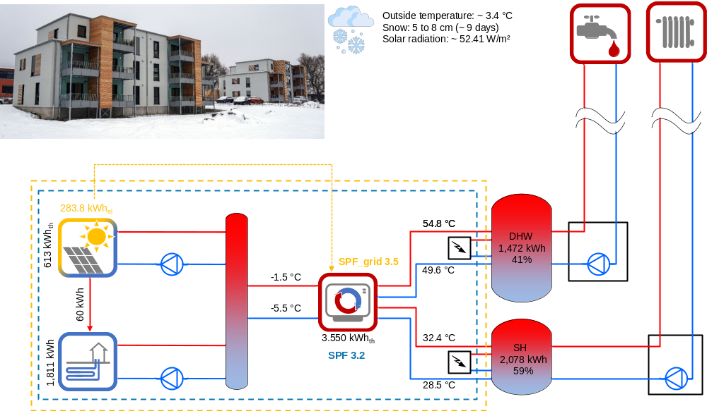
Fig. 6: Monthly measurement results for February 2026
The results for February 2026 (see Fig. 6) illustrate the system’s promising performance at low outdoor temperatures. The total heat demand amounted to 3,550 kWh, with 58.5% attributable to space heating and 41.5% to domestic hot water. A total of 2,424 kWh of thermal energy was consumed by the heat pump, of which 75% (1,811 kWh) was supplied by the HGHX and 25% (613 kWh) by the PVT, resulting in an average flow temperature of –1.5°C. Despite these challenging, cold conditions, the system achieved a seasonal performance factor (SPF) of 3.2 and a SPF_grid of 3.53. The figures are very much in line with expectations and confirm the system’s efficiency even under unfavorable conditions. The proportion of PVT electricity used for self-consumption to power the heat pump system excluding domestic electricity was ~9%.
By comparison, the results for March 2026 (Fig. 7) show an increase in the system’s efficiency during a slightly milder winter period and higher insulation. With an average outdoor temperature 4 K higher than in February, the heat pump utilized the respective energy-source mix to meet a total demand of 33 percent PVT (536 kWh) and 67 percent HGHX (1,095 kWh), resulting in a correspondingly HGHX average flow temperature of 3.9 °C. During this month, the thermal load was primarily driven by domestic hot water demand, with 65.2% of the heat demand attributable to domestic hot water and 34.8% to space heating. These conditions resulted in a SPF of 3.3 and a remarkable SPF_grid of 4.59, driven by a higher solar irradiance and a correspondingly high self-consumption rate of ~28% of the PVT electricity production.
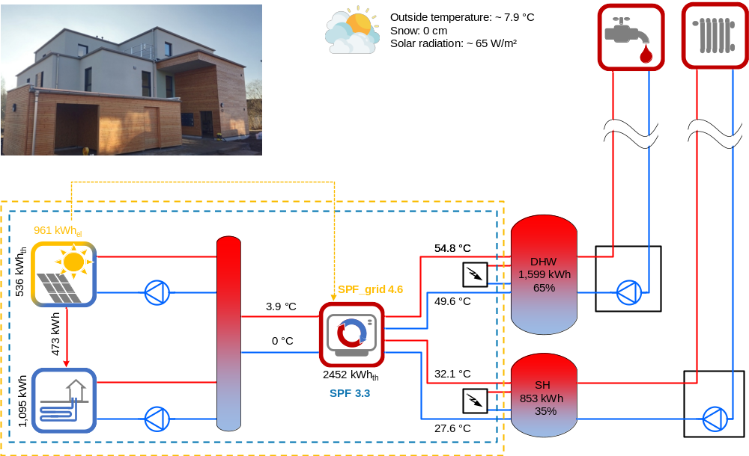
Fig. 7: Monthly measurement results for March 2026
Also noteworthy is the direct comparison of active regeneration of the geothermal heat source: in February, only 60 kWh of solar energy was fed back into the ground, whilst this figure rose to 473 kWh in March. This represents an almost eight-times increase in regeneration capacity within a single month and emphasizes the great potential of PVT collectors for this application if appropriate weather conditions are present.
Fig. 8 Illustrates the monthly energy demand alongside SPF of the system from February to August 2026, including an overall average. Domestic Hot Water (DHW) demand remains consistently high throughout the period, fluctuating between approximately 1,200 kWh and 2,100 kWh. In contrast, Space Heating (SH) demand drops sharply from a peak of nearly 1,500 kWh in February to nearly zero during the summer months. SPF remains quite stable throughout the period, hovering between 3.22 and 3.74, with an average of 3.4. However, SPF_grid exhibits a high variation in dependency of the PVT electricity production, surging from 3.53 in February to a peak of 9.12 in June, yielding an overall average of 6.3.
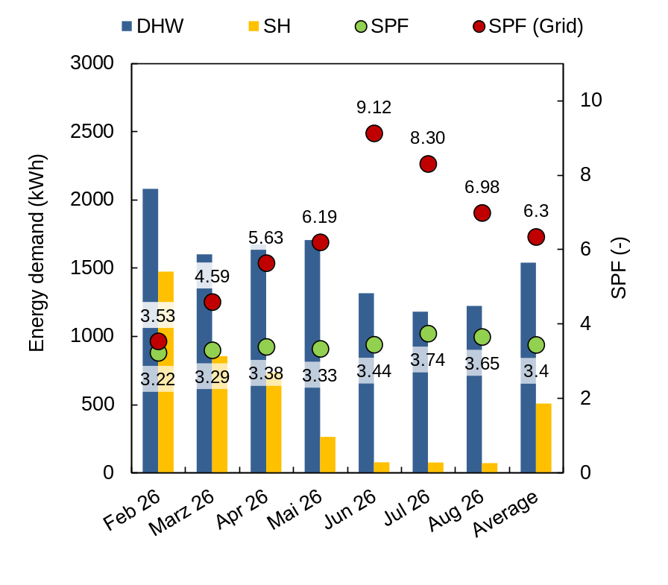
Fig. 8: Monthly energy demand (SH and DHW) as well as SPF and SPF_grid of the system from February to August 2026
- Conclusion
The results demonstrate that integrating photovoltaic-thermal (PVT) collectors with a ground-source heat pump can provide an effective solution for multi-family buildings where the available area for horizontal ground heat exchangers is limited. The investigated PVT system reduced the required ground-exchanger area by up to 40–45% while maintaining comparable system performance and avoiding freezing risks in the ground loop. Initial monitoring confirmed stable operation, with an average seasonal performance factor (SPF) of 3.4. PVT collectors also contributed to higher electricity self-consumption and substantially increased ground regeneration during periods of greater solar radiation.
- References
Chhugani, B., Büttner, C., Pärish, P., Giovannetti, F., 2023a. Photovoltaic-Thermal (PVT) collectors as monovalent or bivalent heat sources for heat pumps in new multi-family houses. Solar World Congress 2023, New Delhi, India. DOI: 10.18086/swc.2023.04.03.
Chhugani, B., Pärisch, P., Helmling, S., Giovannetti, F., 2023b. Comparison of PVT - heat pump systems with reference systems for the energy supply of a single-family house. In: Solar Energy Advances 3, 100031. DOI: 10.1016/j.seja.2022.100031.
Hüsing, F., Hirsch, H., Rockendorf, G., 2016. Combination of Solar Thermal Collectors and Horizontal Ground Heat Exchangers as Optimized Source for Heat Pumps. EuroSun 2016: 11th International Conference on Solar Energy for Buildings and Industry, Palma de Mallorca, Spain. DOI: 10.18086/eurosun.2016.04.18.
Mercker, O., Hüsing, F., Kastner, O., Pärisch, P., 2019. Flächenreduktionspotenzial solarthermisch unterstützter Erdwärmekollektoren zur Beheizung eines repräsentativen Mehrfamilienhauses mit 8 Wohneinheiten. RET.Con 2019: Regenerative Energietechnik-Konferenz, Nordhausen. DOI: 10.22032/dbt.46047.
Schubert, M., Hunziker, M., Sauter, D., Sperr, N., Rohrer, J., 2019. L-Sol – heating system with PVT-collectors as single heat source for a brine-water heat pump. In: J. Phys.: Conf. Ser. 1343 (1), 12081. DOI: 10.1088/1742-6596/1343/1/012081.
Sommerfeldt, N., Madani, H., 2019. In-depth techno-economic analysis of PV/Thermal plus ground source heat pump systems for multi-family houses in a heating dominated climate. In: Solar Energy 190, 44-62. DOI: 10.1016/j.solener.2019.07.080.
Timilsina, K. P., Chhugani, B., Pärisch, P., 2023. In-Situ-Monitoring eines Wärmepumpensystems mit PVT-Kollektoren und Erdwärmequellen für Heizung und Kühlung. 34. Symposium Solarthermie und Innovative Wärmesysteme, Kloster Banz, Bad Staffelstein.

