EuroSun2026
ENABLING REAL-TIME DATA-DRIVEN ENERGY COMMUNITIES THROUGH OPEN AND INTEROPERABLE TECHNOLOGIES

Óscar Puyal, Yolanda Lara, Raquel Simón-Allué, Isabel Guedea
Affiliation: ENDEF, c/P-B 20, Polígono Ciudad del Transporte, 50820, Zaragoza (Spain)
Email(s): oscar.puyal@endef.com, yolanda.lara@endef.com
Summary
Energy Communities, and their integration into the energy networks are gaining momentum in the European Energy Transition roadmap. In order to provide advanced digital solutions to them, a collaborative cloud-based platform designed to host microservices has been developed on OPEN4CEC project. This work addresses the design, deployment, and validation of an open-source microservice devoted to the acquisition and processing of real-time data from meters and sensors, as well as interoperability with generation and consumption platforms, according to the diverse Energy Communities requirements. The developed work integrates scalable, secure, and microservice-oriented architectures, facilitating monitoring, advanced analytics, and energy optimization. The results presented are derived from practical experience in real-world environments, with versions currently in production and under continuous development. The real-time functionality has proven to show each user in an Energy Community their consumption and generation, as if it were an individual self-consumption installation.
Keywords: Energy communities, real-time data acquisition, open-source technologies, microservices architecture, interoperability, energy monitoring, energy data analytics, smart energy systems
Field of application for the findings: Energy Communities, Real-Time Energy Monitoring Systems, Smart Energy Management Platforms, Interoperable Energy Data Platforms, Energy Data Analytics and Optimization.
Addressed audience: Scientific community, EC managers, municipalities, EC users
- Introduction
Energy Communities (ECs) are community-driven initiatives that seek to decentralize and democratize the energy system, prioritizing social and environmental benefits rather than focusing solely on economic profit (Moroni et al., 2019; Roby & Dibb, 2019). Their growing importance in Europe is closely linked to the overall energy transition, as they support the shift from centralized energy systems to more decentralized structures, aligned with the European goal of achieving a carbon-neutral society (Hainsch et al., 2022). ECs have been recognized as collective and citizen-driven energy actions enablers to support the clean energy transition at European level. Under the Clean Energy Package, the European Union legislation recognized two figures; Renewable Energy Communities (RECs) (European Parliament and Council, 2018) and Citizen Energy Communities (CECs) (European Parliament and Council, 2019) providing frameworks to define aspects such as their governance principles; participation models, or their rights and protections when taking part in the energy system. According to the 10th State of the Energy Union report (European Commission, Directorate-General for Energy, 2025), there are more than 8000 Energy Communities across the EU, and the Commission is supporting their developments through initiatives such as the Citizen Energy Advisory Hub or the Energy Communities Facility.
A key aspect of these communities is fostering active consumer participation by transforming homes and buildings from passive consumers into prosumers capable of managing their own energy demand, generation, and storage. Their distinguishing feature is that they promote sustainability by increasing the use of renewable energy sources, which contributes to reducing CO₂ emissions and improving air quality and living standards (Hainsch et al., 2022). On the other hand, ECs strengthen economic resilience by introducing new business models that promote energy savings, allowing communities to reduce costs by optimizing local energy consumption, and help prevent energy poverty (Hansen et al., 2020; Kirli et al., 2022).
Energy communities rely on the deployment of distributed renewable energy generation infrastructure, such as photovoltaic panels, wind turbines, or small-scale hydroelectric systems, to provide local and sustainable energy. On the other hand, Energy Communities must comply with local and regional regulations and maintain interoperability between heterogeneous devices. With specific services, demand response mechanisms that dynamically adjust consumption, increase efficiency and reduce operating costs can be implemented. To a lesser extent, although increasingly important, the integration of energy storage systems is relevant for balancing generation with consumption patterns, thus providing a better balance between generated and consumed energy (Namjoo et al., 2022).
Current networks allow for bidirectional energy flow and participation in ancillary services or local energy markets (Jin et al., 2020). In this sense, scalable service architectures enable community expansion, while mobile applications engage members in energy monitoring and management. Open service infrastructures for Energy Communities facilitate long-term data logging, trend analysis, benchmarking, and continuous improvement.
Among the requirements for Energy Communities are real-time monitoring capabilities, including continuous visualization of energy generation, consumption patterns, and energy allocation among community members. For this reason, a centralized energy management solution is required to collect, analyze, and visualize generation and consumption data (Aboushady & Gowaid, 2019). On these type of solutions, advanced analytics services allow for profiling energy flows, predicting demand, and optimizing resource allocation (Qin et al., 2022). To cover these necessities, accurate, high-frequency data acquisition from distributed assets and smart meters, enabling transparent tracking of self-consumption rates, shared energy distribution, and grid exchanges are required. These capabilities are essential when operational decisions must be taken immediately, such as battery charging management or the activation of heat pumps. For scenarios where real-time decision-making is not required and cost optimization is a priority, there exists options that collect consumption data from smart meters through the energy distribution companies, providing access to validated metering information (Aelec, 2020). Although this approach involves a delay of several days in data availability, it eliminates the need to install and maintain parallel metering equipment, significantly reducing infrastructure and operational costs.
This work is structured as follows: First, section 2 adresses main barriers and common challenges for Energy Communities and the role that digital applications can play to overcome them. Afterwards, section 3 is oriented to explain how a cloud-based platform has been developed in order to accomodate different microservices for ECs; while sections 4 to 6 are devoted to explain the design and development of an open-source, real-time monitoring microservice solution, oriented to cover both technical as well as social Energy Communities requirements.
2. Energy Communities challenges assessment
Energy Communities (ECs), despite their great diversity and the need to adapt to different regulatory frameworks and social environments, share a set of critical challenges, such as the optimal distribution of energy between members; real-time control of loads and distributed resources; or how to provide generation and consumption data in a simple and understandable way, enabling members (prosumers and consumers) to actively manage their energy.
Three main barriers, common to the majority of ECs, that may be addressed through advanced digital solutions, have been identified: (i) low acceptance and participation derived from limited user engagement, privacy concerns, and low technical literacy; (ii) the technological fragmentation among different providers for the energy generation systems in ECs; thus leading to interoperability challenges and cybersecurity risks associated with highly connected systems and (iii) discrepancy between what theoretical models predict and what the community experiences in practice.
A modular microservices platform, designed to provide advanced and competitive services through a cloud-based, scalable, and interoperable architecture is being developed to suit the diverse requirements of the Energy Communities (Cinque et al., 2022). The platform is part of OPEN4CEC (Open4CEC project, 2024), a European collaborative effort aimed at designing and implementing innovative technological solutions for the energy sector (Oprea & Bâra, 2021a), supporting the transition towards more sustainable and decentralized energy systems. Among the modular microservices developed, a real time monitoring solution has been built using a selected set of open-source software components, each of which has been proven for stability, reliability, and efficiency in demanding environments, with the objective to overcome the identified barriers.
- Cloud-based platform
A cloud-based platform has been designed to accommodate different types of EC-oriented microservices. A hierarchical virtualization architecture (Fig. 1.a) is adopted to ensure service flexibility, scalability, portability, and replicability across different deployment environments. This hierarchical architecture is based in three points:
- Two-tier virtualization architecture: The infrastructure is deployed on Proxmox VE, which hosts virtual machines and primarily Linux Containers (LXC) for lightweight operating-system-level virtualization. Within these environments, each platform service is deployed as an independent Docker container, allowing microservices to be developed, updated, maintained, and scaled independently.
- Network and routing configuration: Network connectivity is centrally managed through the /etc/network/interfaces configuration file. The vmbr0 bridge provides external network access with a static IP address, while vmbr2 creates an isolated internal network for communication between containers. External access to internal services is achieved through DNAT (Destination Network Address Translation) rules implemented with iptables, forwarding traffic from the Proxmox host to the corresponding services running inside LXC containers.
- Traffic management and security: A dedicated Nginx reverse proxy acts as the single entry point for all web traffic, routing requests to the appropriate microservices. Secure communications are ensured through HTTPS using SSL/TLS certificates managed with Certbot, while remote access to local devices is provided through an OpenVPN infrastructure. Administrative access relies on SSH public-key authentication, and user authentication is based on secure authorization mechanisms using access tokens and PIN validation.
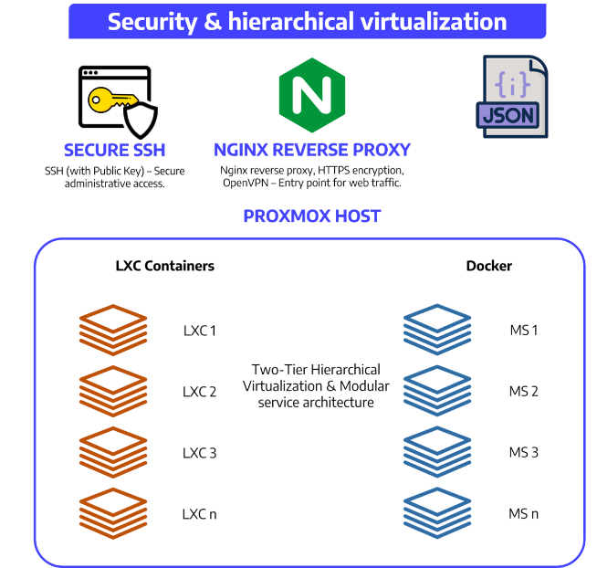 | 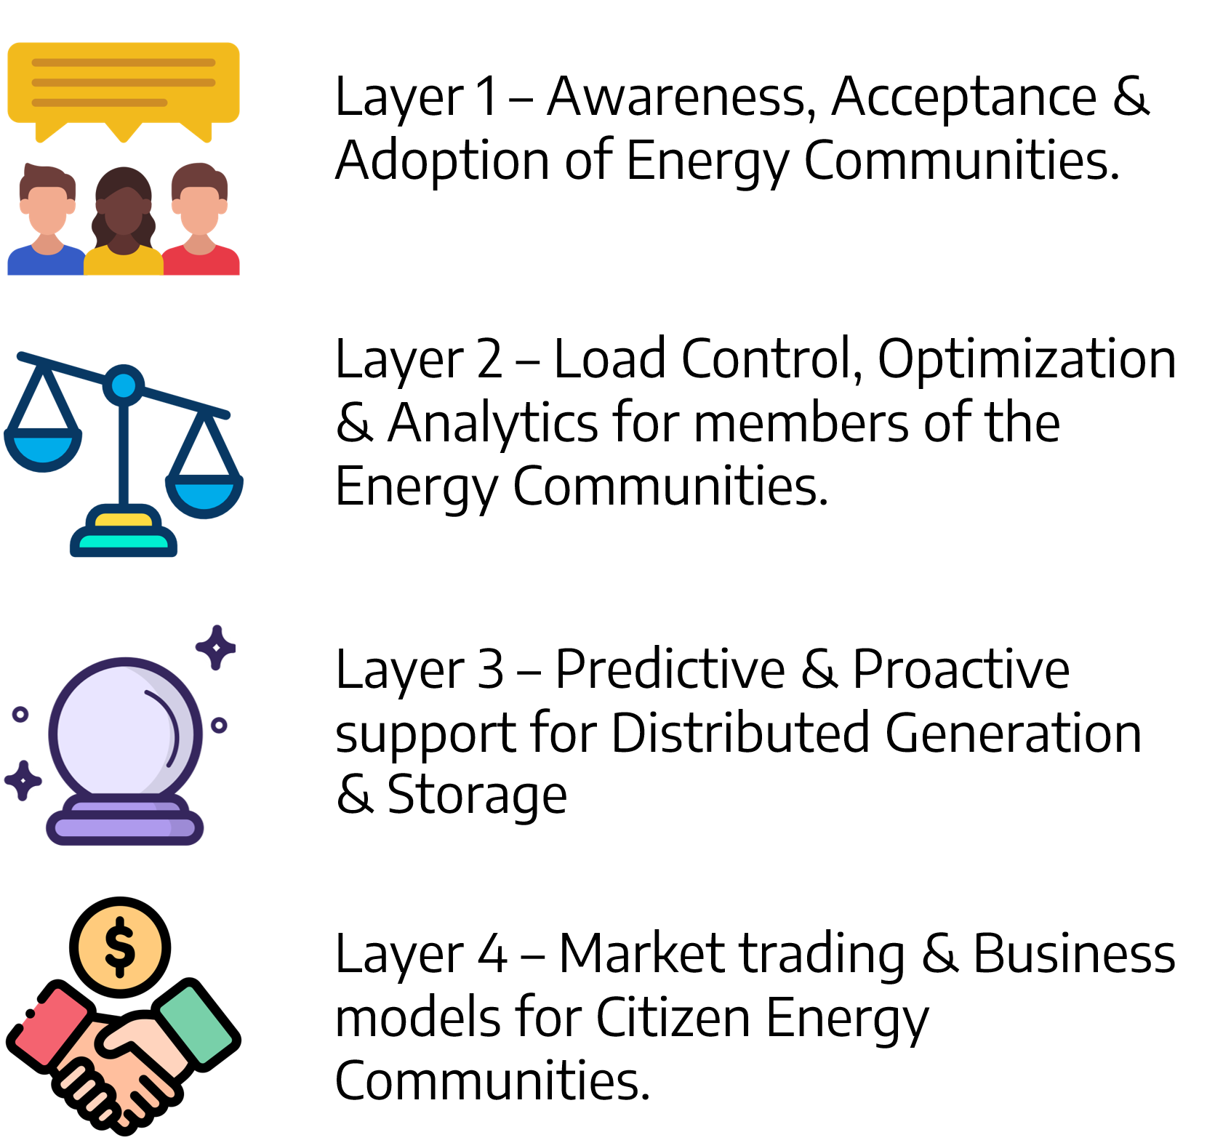
a) Platform’s hierarchical architecture scheme | b) Functional layers
Fig. 1. Platform main characteristics.
The OPEN4CEC platform’s modular design enables flexible deployment and integration of services across multiple providers, facilitating real-time monitoring, adaptive visualization, and infrastructures simulation. By leveraging containerization technologies such as Docker and orchestration tools, the platform ensures robustness, scalability, and seamless interoperability between different components and service providers. In addition, the platform incorporates Internet of Things (IoT) connectivity and artificial intelligence algorithms for predictive analytics, operational optimization, and data-driven decision-making. It is built upon open-source principles, promoting a collaborative ecosystem that encourages innovation, knowledge sharing, and the development of new business models within the community energy sector.
Along the project development, different microservices (MS) have been developed, organized into four functional layers (L1–L4, see Fig. 1.b)), to cover aspects from social acceptance to local energy markets and business models. Up to date, seven microservices (see Tab. 1) have been developed and loaded in the platform (Open4CEC platform, 2025):
Tab.1 Microservices developed
MS Number | Short description | Main objective
MS1 | Technical, economic, and operational energy system assessment tool. | To analyze load and generation behavior, compare baseline vs. optimized scenarios, and support investment decisions regarding solar PV, battery storage, and long-term upgrades.
MS2 | Asset sizing and financial feasibility simulation tool. | To provide detailed insights into the optimal sizing of solar PV, wind turbines, and battery storage systems, evaluating self-sustainability, financial viability, and risks.
MS3 | Photovoltaic generation forecasting tool. | To predict the power output of a solar PV system up to 7 days ahead, based on its location, system size, panel tilt/orientation, and meteorological forecasts.
MS4 | Real-time load monitoring and active demand-side management app. | To optimize household consumption schedules and shift flexible loads in real time to minimize electricity bill costs.
MS5 | Real time measurement | To collect consumption readings from local network analyzers and generation data from diverse inverter APIs (such as Huawei, Sungrow, and Ingeteam), applying collective sharing agreements.
MS6 | Dynamic energy community behavior simulator. | To simulate the collective energy performance and economic flows of the community using consumption profiles and generation models.
MS7 | Technical microgrid design and financial modeling tool. | To determine the optimal configuration of off-grid or grid-connected microgrids (PV, diesel, storage) under deterministic and stochastic scenarios (including solar variability and probabilistic grid outages).

Each of the developed MS have been oriented towards one or more of the functional layers. The platform allows the uploading, downloading and use of the MSs, provided they follow the architecture and containerization principles described above. The design, development and application of MS5, a real-time measurement microservice, is the main outcome presented in this work.
- Real time microservice development
A modular microservice for Energy Communities monitoring in real time has been built using a selected set of open-source software components, each of which has been proven for stability, reliability, and efficiency in demanding environments, with the objective to overcome these barriers. Ensuring resource efficiency is a primary consideration, enabling the system to operate effectively without unnecessary computational or energy overhead. Starting from resource efficiency, the main requirements for the solution have been defined, taking into consideration both, the service capabilities as well as the interoperability with the platform.
3.1. Real time microservice requirements
The real time solution must provide a digital infrastructure that enhances the energy knowledge of members of an energy community through the acquisition, integration, and analysis of electricity generation and consumption data. The main requirements identified are:
- To provide secure and individualized access for each user, guaranteeing data privacy and compliance with data protection requirements.
- To integrate data from multiple heterogeneous sources, including photovoltaic installations, metering equipment at points of consumption, and electricity distribution company platforms.
- To associate the energy generated with each participant by managing the sharing agreements specific to shared self-consumption installations.
- To provide access to both historical information and, where the infrastructure allows it, energy generation and consumption real-time data.
- To facilitate the analysis of energy profiles through visualization and reporting tools that support decision-making and the improvement of consumption habits.
- To enable integration with external energy management and automation systems, promote interoperability with home automation platforms and control systems.
- To support diverse deployment scenarios, such as power generation facilities, private homes, commercial premises or municipal facilities, adapting to varying connectivity and infrastructure availability conditions.
3.2. Communication protocols and software development
The solution designed features a scalable, cloud-based architecture capable of receiving information from distributed devices using standard communication protocols, such as MQTT and Modbus, and seamlessly integrating remote data sources, Fig. 2. It has been designed to collect and integrate data from multiple sources, supporting a wide variety of communication protocols, with MQTT as the central integration backbone, facilitating seamless communication between all parts of the microservice and ensuring real-time data availability. Data collection and flexible visualization capabilities are a core feature of the designed microservice, which takes into account the Energy Communities profiles and user-bases, with a layered approach aimed to ensure that both operational oversight and end-user engagement are fully supported.
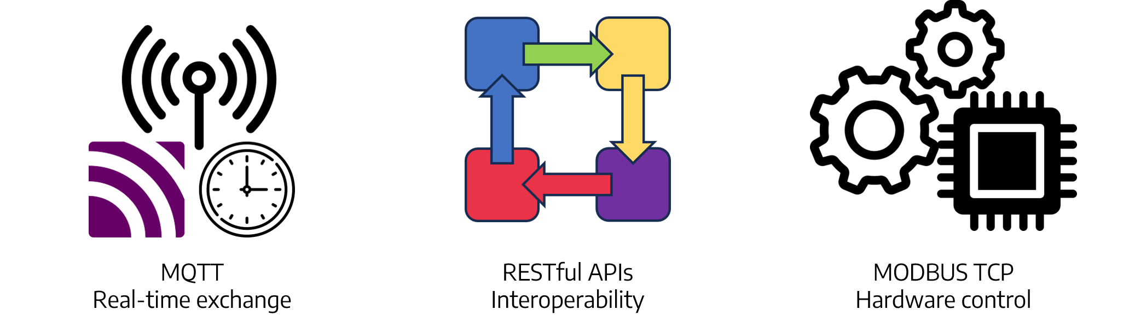
Fig. 2. Unified communication protocols for real-time microservice
The solution uses MQTT as the basis for service messages which provides high-frequency data acquisition, as the primary protocol for real-time data exchange and a RESTful API for interoperability with external systems. Energy assets, including Huawei battery systems and electric vehicle chargers, are controlled through MODBUS TCP and MQTT, using libraries such as pymodbus. Software development is primarily based on Python, with Visual Studio Code as the development environment, Git for version control, and Pytest for automated testing to ensure software quality and reliability.
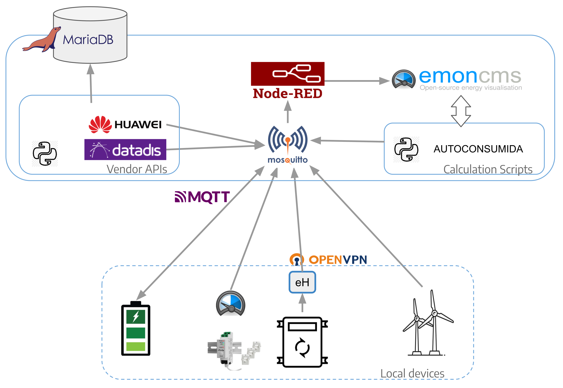
Fig. 4: Real-time solution scheme
Fig. 4 shows the real-time solution scheme and the open-source software modules that comprise it. Following the flow of information, the components of the system, as a solution that meets all the stated requirements, are as follows:
- Vendor APIs allow to gather the data provided by manufacturers for integration into external applications. These APIs facilitate communication using standard protocols such as REST, typically employing authentication mechanisms based on API keys or protocols like OAuth. Examples within the energy sector include APIs provided by inverters manufacturers (i.e. Huawei); data access platforms (i.e. DATADIS (Aelec, 2020)); or IoT monitoring devices (i.e. Shelly EM).
- Mosquitto is a lightweight message broker that implements the MQTT protocol, specifically designed for efficient communication in IoT environments. It enables information exchange using a publisher-subscriber model, facilitating communication between devices with low bandwidth and latency requirements. Its low resource consumption allows for deployment on devices with limited capabilities. Both the data provided by vendor APIs and that provided by independent equipment measuring consumption, temperature, or other variables converge in this broker, where it is accessible to all parts of the solution.
- Node-RED is a development tool based on visual programming using flows, primarily geared towards integrating hardware devices, APIs, and services within IoT environments. It uses a graphical interface where different functional nodes connect to each other to perform real-time data acquisition, processing, and transformation tasks. It is developed on Node.js, which provides an extensible architecture and allows it to run on different platforms. The data that arrives at Mosquitto is processed in Node-RED to be included in the calculation scripts or in the visualization provided by EmonCMS.
- Calculation Scripts developed in Python allow for specific energy data processing and analysis tasks. These programs run on the server and use specialized libraries to perform operations such as calculating self-consumption energy, processing historical measurements, analyzing data, and generating derived results. The results of these calculations are displayed in EmonCMS.
- EmonCMS is an open-source energy data management and visualization system designed for energy monitoring applications. It allows for the collection, storage, and graphical representation of real-time data, integrating with technologies such as MQTT, REST APIs, and databases optimized for time series analysis.
These processes are devoted to provide to the end-users the information they need in order to be aware of their shares in the energy community. By combining modularity, open-source technologies, and protocol versatility, this solution lays the groundwork for subsequent development phases. It ensures interoperability among heterogeneous devices, scalability for expanding communities, and adaptability to evolving energy management requirements.
5. Results and testing
This microservice is currently being tested by three real, differently sized Energy Communities, summing up 276 users. Aspects such as data accuracy; data visualization and the compliance with the initial requirements have been analysed, also gathering feedback from the real users.
4.1. Data accuracy
The quality of data obtained from an energy monitoring solution depends on several factors: the availability of the digital infrastructure, the stability of communications, the metrological quality of the measuring devices, and the mechanisms used to guarantee data integrity.
Overall data availability depends not only on the cloud infrastructure but also on the entire system comprised of the measuring device, the communications network, and the storage platform. Usually, the problems detected in real-world energy monitoring systems are related to the device installed at the end user's site. The main critical point identified in residential installations is the connectivity between the home-installed equipment and the management platform. Most energy IoT devices use home Wi-Fi networks, which do not always provide stable connectivity due to factors such as distance from the router, physical obstacles, radio interference, wireless network congestion, or changes in user configuration.
In the cases analyzed in this work, it was observed that approximately one in eight devices may experience problems related to the WiFi connection. These problems do not necessarily imply a permanent loss of information, since many devices have temporary local memory or communication retry mechanisms, but they can cause interruptions in the recorded time series when the disconnection exceeds the local storage capacity.
During the testing phase it has also been observed that data losses associated with internal failures in the cloud are kept below 1%. This value is achieved through persistent storage mechanisms, service monitoring, automatic failure recovery, and the use of communication protocols designed for distributed environments. In particular, the use of protocols such as MQTT allows for the implementation of different levels of delivery assurance through Quality of Service (QoS) levels, reducing the probability of message losses during communication between devices and servers.
4.2 Data visualization
A user-friendly web responsive interface has been developed with a main goal: to get an adequate balance between providing all the essential technical information regarding energy generation and consumption for each individual EC user; and not to bury the users (with very different backgrounds) with technical information. Keeping the compromise on those two aspects has involved a great deal of work to get user feedback and to provide adequate responses without compromising the quality and accuracy of the information shown.
Several screens of the current version of the interface, adapted to mobile devices, can be seen below. Fig. 5 a). shows the home screen, which displays the real-time data of the solar installation. This initial screen is the same for all EC users. The top section shows the minute-by-minute energy and power details, while the middle section shows historical generation data represented as a daily bar graph. At the bottom, there is a blue button (“Ir a mi consumo”/ “Go to my consumption”) to access each user individual data. Once the user taps this button, a user-login screen appears Fig. 5.b), in order to enter the assigned username and password, allowing to access the individual consumption and the generation that corresponds to you as a member of the Energy Community.

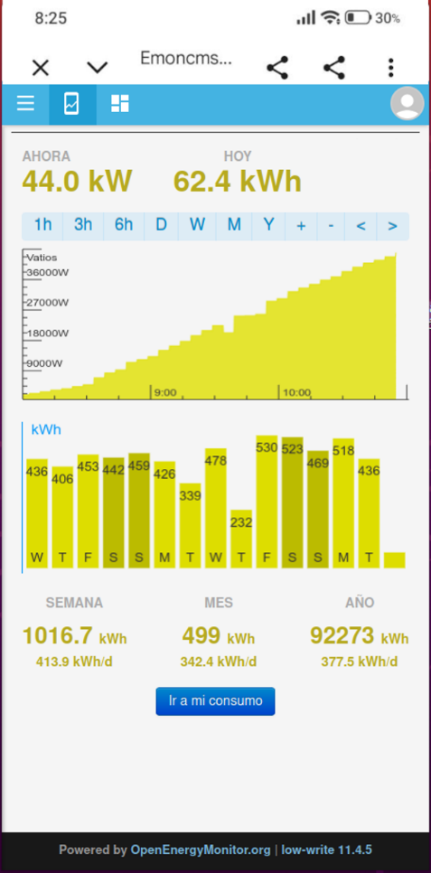 | 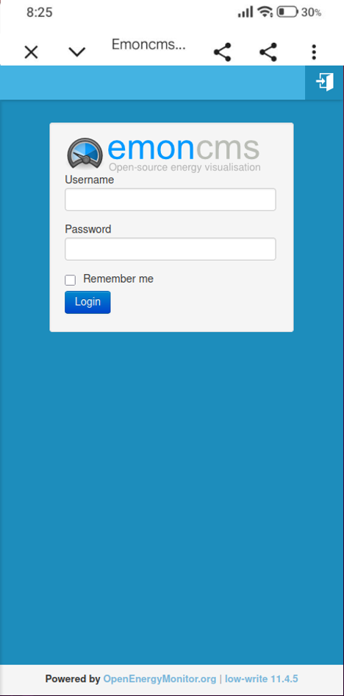
a) Home screen | b) Individual user login screen
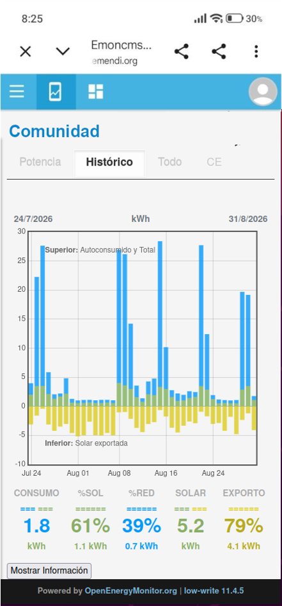 | 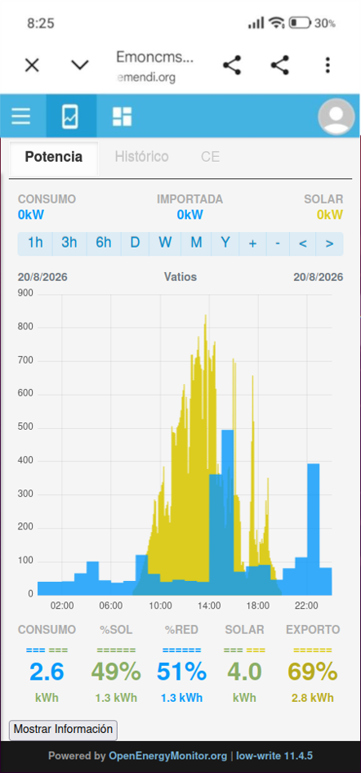
c) Historical individual data | d) Daily real-time individual data
Fig. 5. Data visualization screens
Once in the personal area, the “Histórico”/ “Historical” tab shows a graph with the user daily energy consumption (blue) and what portion of that consumption was supplied by renewable energy generation (green) of the last 35-day period, Fig. 5. c). By clicking in one of the bars, the “Potencia” / “Power” tab is displayed, where the user can access the daily energy consumption and corresponding generation details, Fig. 5. d). In this tab, the top section shows the real-time consumption, grid-provided and solar-provided energy values, respectively. The middle graph and the bottom values show the generation and consumption data for the chosen time period, that can be adjusted through the top bar. Global energy consumption, distribution between solar and grid energy, solar power consumed as well as the amount of solar exported to the grid are shown at the bottom of this screen.
4.3 Requirements’ compliance
The successful development and deployment of the real-time solution have met all established requirements defined in the initial phase. These accomplishments are detailed as follows:
- Secure and Individualized Access for each user: Secure access is provided through a dedicated Nginx reverse proxy acting as a single-entry point, utilizing SSL/TLS certificates for HTTPS encryption and robust authorization mechanisms based on access tokens and PIN validation to guarantee user privacy.
- Heterogeneous Data Integration: The platform effectively integrates data from diverse sources, including vendor APIs (Huawei, Ingeteam, Sungrow), distribution company platforms (Datadis), and IoT metering equipment such as Shelly devices.
- Energy Allocation Management: Using calculation scripts developed in Python, the system processes high-frequency data to accurately associate the corresponding energy generation with each participant based on the specific sharing agreements of the collective self-consumption installation.
- Historical and Real-Time Data Access: Through the integration of MQTT message brokers (Mosquitto) and the EmonCMS visualization system, the solution provides users with access to both comprehensive historical records and live, real-time generation and consumption streams.
- Visualization and Reporting Tools: The solution features user-friendly mobile and web interfaces that facilitate the analysis of energy profiles, providing individualized reports that allow to compare the consumed energy against the corresponding solar generation to support better consumption habits.
- Interoperability and Scalability: A scalable, cloud-based architecture has been implemented using standard protocols such as MQTT, Modbus TCP, and RESTful APIs, enabling seamless integration with external management platforms and home automation systems.
- Diverse Deployment Scenarios: The system's versatility has been validated in real-world pilot environments, adapting to various connectivity conditions in scenarios ranging from private homes and commercial premises to municipal facilities and large-scale power generation sites.
5. Conclusions and future work
An open-source real time solution for ECs has been designed, developed, deployed and tested in a real environment. The developed solution is scalable and can handle different types of ECs. Also, the real-time service has been designed to address and overcome three main barriers common for a wide variety of ECs; while, as shown in the section above, covering an ample set of technical requirements.
First, regarding the low acceptance and participation, the service provides a web-based mobile application that presents generation and consumption data in a simple and understandable way, that has been tested with different types of users. By showing each member their energy usage as if it were an individual self-consumption installation, it empowers citizens and facilitates the adoption of new consumption habits without requiring deep technical knowledge.
Secondly, the solution uses an integration bus based on MQTT and RESTful APIs to communicate with heterogeneous sources, including different inverter’s providers (Huawei, Ingeteam, Sungrow, etc.); data platforms and IoT monitoring devices among others. By implementing this approach the real-time service allows for high-frequency data acquisition from distributed assets regardless of the brand, ensuring the system is both scalable and replicable, thus overcoming the interoperability challenges.
Lastly, while simulation services analyze previous scenarios, the real-time service provides the operational intelligence needed for live monitoring and immediate action. This continuous monitoring helps closing this performance gap by facilitating immediate decisions.
The next steps for the work are focused on the implementation of some of these real-time decisions, such as charging electric vehicles with surplus energy or discharging batteries during peak hours, based on actual rather than projected data, within real ECs, to extend the solution capabilities.
The developed real time solution has proven to be optimal for integrating and processing data from multiple heterogeneous sources, successfully guaranteeing system interoperability. Furthermore, its open and scalable architecture positions it as a highly viable and valuable reference option for future research projects.
7. Acknowledgements
This work was supported by Spanish CDTI under the Driving Urban Transitions Partnership, which has been co-funded by the European Commission; under grant agreement SERA-20231005
8. References
Aelec, 2020. DATADIS: The neutral data gateway of Spanish electricity distributors for consumer empowerment. Asociación de Empresas de Energía Eléctrica. https://aelec.es/datadis/ (accessed 26 August 2026)
Aboushady, A., Gowaid, A.I., 2019. Small Scale Renewable Generation Unlocking an Era of Peer-to-Peer Energy Trading and Internet of Energy. Renewable Energy and Sustainable Development. https://doi.org/10.21622/resd.2019.05.1.00
Cinque, M., Della Corte, R., Pecchia, A., 2022. Microservices Monitoring with Event Logs and Black Box Execution Tracing. IEEE Transactions on Services Computing. https://doi.org/10.1109/TSC.2019.2940009
European Commission, Directorate-General for Energy, 2025. REPORT FROM THE COMMISSION TO THE EUROPEAN PARLIAMENT, THE COUNCIL, THE EUROPEAN ECONOMIC AND SOCIAL COMMITTEE AND THE COMMITTEE OF THE REGIONS State of the Energy Union Report 2025 (pursuant to Regulation (EU)2018/1999 on the Governance of the Energy Union and Climate Action) Available at: https://eur-lex.europa.eu/legal-content/EN/TXT/?uri=CELEX:52025DC0667 (accessed 26 August 2026)
European Parliament and Council, 2018. Directive (EU) 2018/2001 of the European Parliament and of the Council of 11 December 2018 on the promotion of the use of energy from renewable sources (recast). Official Journal of the European Union, L 328, 82–209.
European Parliament and Council, 2019. Directive (EU) 2019/944 of the European Parliament and of the Council of 5 June 2019 on common rules for the internal market for electricity and amending Directive 2012/27/EU (recast). Official Journal of the European Union, L 158, 125–199.
H. Roby and S. Dibb, “Future pathways to mainstreaming community energy,” Energy Policy, 2019, doi: 10.1016/j.enpol.2019.111020.
Hainsch, K., et al., 2022. Energy transition scenarios: What policies, societal attitudes, and technology developments will realize the EU Green Deal? Energy. https://doi.org/10.1016/j.energy.2021.122067
Hansen, P., Morrison, G.M., Zaman, A., Liu, X., 2020. Smart technology needs smarter management: Disentangling the dynamics of digitalism in the governance of shared solar energy in Australia. Energy Research & Social Science. https://doi.org/10.1016/j.erss.2019.101322
Jin, X., Wu, Q., Jia, H., 2020. Local flexibility markets: Literature review on concepts, models and clearing methods. Applied Energy. https://doi.org/10.1016/j.apenergy.2019.114387
Kirli, D., et al., 2022. Smart contracts in energy systems: A systematic review of fundamental approaches and implementations. Renewable and Sustainable Energy Reviews. https://doi.org/10.1016/j.rser.2021.112013
Moroni, S., Alberti, V., Antoniucci, V., Bisello, A., 2019. Energy communities in the transition to a low-carbon future: A taxonomical approach and some policy dilemmas. Journal of Environmental Management. https://doi.org/10.1016/j.jenvman.2019.01.095
Namjoo, A.R., Dashti, R., Dorahaki, S., Shaker, H.R., 2022. A novel enviro-economic three-stage market-based energy management considering energy storage systems and demand response programs for networked smart microgrids. Electrical Engineering. https://doi.org/10.1007/s00202-022-01510-x
Open4CEC project, 2024. https://open4cec.ase.ro/ (accessed 26 August 2026)
Open4CEC platform, 2025. https://ase.open4cec.eu/ (accessed 26 August 2026)
Oprea, S.V., Bâra, A., 2021a. Edge and fog computing using IoT for direct load optimization and control with flexibility services for citizen energy communities. Knowledge-Based Systems. https://doi.org/10.1016/j.knosys.2021.107293
Oprea, S.V., Bâra, A., 2021b. Devising a trading mechanism with a joint price adjustment for local electricity markets using blockchain. Insights for policy makers. Energy Policy. https://doi.org/10.1016/j.enpol.2021.112237
Qin, J., Jiang, H., Lu, N., Yao, L., Zhou, C., 2022. Enhancing solar PV output forecast by integrating ground and satellite observations with deep learning. Renewable and Sustainable Energy Reviews 167, 112680. https://doi.org/10.1016/j.rser.2022.112680

