Microstructure-sensitive Damage Formation/Propagation in Continuous Ceramic Fiber Reinforced Ceramic Matrix Composites

Dipen Patel¹, Daniel Rapking², Triplicane Parthasarathy¹, Michael Braginsky², Jennifer Pierce², Jeff Simmons³, and Craig P. Przybyla^{3*}

¹UES, Inc., Dayton, Ohio, USA
²University of Dayton Research Institute, Dayton, Ohio, USA
³Air Force Research Laboratory, Materials and Manufacturing Directorate, Wright-Patterson AFB, Ohio, USA
*Corresponding Author: craig.przybyla@us.af.mil

Keywords: fiber reinforced composites, microstructure, transverse cracking, damage parameter

Abstract
Continuous ceramic fiber reinforced ceramic matrix composites (CMCs) exhibit hierarchical internal structure with rich details at multiple length scales of interest. In this work, we have sought to quantify the pertinent material structure a SiC fiber reinforced SiC CMC and understand how that structure relates to the transverse cracking strength experimentation and simulation. At the scale of the individual fibers, methods have been developed to image the microstructure at the scale of the individual filaments with and without loading. Damage at the pertinent scales have been observed through in situ observation via optical microscopy. Digital representations of the composite structure at the scale of the fibers has been constructed for micromechanical simulation of damage initiation and progression and the physics of crack initiation and propagation is captured via a discrete damage modeling approach. A parametric finite element model has been developed to assess and quantify the damage accumulation under transverse cracking of CMCs.. Results have shown that local damage formation and propagation is quite complex and depends on a variety of factors including relative strengths of the matrix and fiber coating, the fiber packing, etc. The implications of the findings on the overall composite behavior are summarized and discussed.

1. Introduction

Demand for continuous ceramic fiber reinforced ceramic matrix composites (CMCs) continues to grow as current engineering requirements for improved materials performance in extreme environments cannot be met with other currently available materials. This is particularly true for hot section components of new higher performance gas turbine propulsion concepts and thermal protection for hypersonic vehicles. While a multitude of CMC variants have been developed and studied over the last several decades, much remains to be understood in terms of the fundamental microstructural relationships in these materials that have the greatest influence on damage initiation and progression when these materials are employed in the intended extreme application environments.
In order to better understand how the composite structure at the scale of the individual filaments (i.e., microscale) relate to the damage response, several studies have been conducted to quantify the microstructure. For example, Fast et al. employed topological measures to quantify packing characteristics of individual fibers [1]. Additionally, Bricker et al. developed metrics to quantify the orientation and packing of the fibers in three dimensions [2]. Patel et al. quantified fiber packing using two point statistics and demonstrated microstructures with different distributions in the arrangement of the filaments can easily be separated using only a limited number of coefficiencts derived from principle component analysis of the two point statistics [3].
Work has also been performed to experimentally quantify damage at the pertinate scales. Specifically, damage at the pertinent scales have been observed through in situ observation via optical microscopy, acoustic emission (AE) detection, and full field strain mapping with digital image correlation (DIC) during mechanical testing at room and elevated temperature [4]. Digital representations of the composite structure at the scale of the fibers has also been constructed for micromechanical simulation of damage initiation and progression and the physics of crack initiation and propagation is captured via a discrete damage modeling approach [5].
In this work, material system considered was the HiPerComp™ SiC/SiC CMC produced by GE Aviation. Nominally, the coupons considered here consisted of eight unidirectional plys with a balanced layup according to [0/90]_{2S} with Hi-Nicalon™ fibers. Micrographes of the composite were characterized at the scale of the individual filaments. Small scale samples were loaded in situ under a microscope in a bend fixture to characterize the local cracking. A parametric model based on this material was developed to simulate transverse cracking in the CMCs using the Regularized eXtended Finite Element (RxFEM) [6, 7], approach under uniaxial loading condition for different class of microstructures sampled from the experimental measurements. Different instantiations of microstructure were generated from Uniform [8] and Gaussian [9] distribution to explore the extreme cases between well spaced versus tightly packed fibers. A framework is developed to quantify damage in two-dimensional microstructures of CMCs two-dimensional microstructure. The framework can be easily extended to three-dimensional structure as well.

2. Methods

2.1. Microstructure Characterization

To characterize the local structure, small matchstick samples were cut out of a dogbone specimen from a prior tensile test as seen in Figure 1. The area of interest (i.e., 25x2 mm² cross section) was cut with a diamond sawblade and mounted in an epoxy that dissolves in acetone. After curing, the samples were polished using 9 µm, 6 µm, 3 µm, and 1 µm diamond slurry.

Figure 1. Sample preparation of small matchstick specimens cut from a failed dogbone tensile sample from a previous tensile test.
Once the sample was polished, the epoxy was dissolved and the samples removed and place into a bend fixture for analysis as shown in Figure 2. The images with and without cracks are shown in Figure 3(a) and Figure 3(b), respectively. Quantification of the microstructure at the filament scale has be preformed and is decribed in more detail elsewhere [2, 10-13].
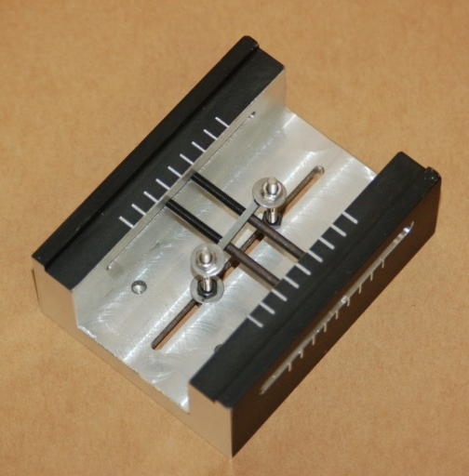
Figure 2 Bend fixture used to open crack in matchstick samples for optical microscopy
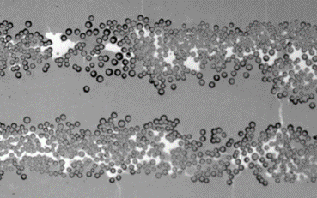 | 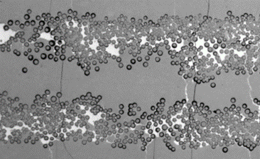
(a) | (b)
Figure 3 Optical images of HyPerComp™ (a) without load) and (b) with load to visualize transverse cracking at the scale of the individual filaments. Nominal fiber diameter is 20 microns.

2.2. Synthetic Microstructures

Based on observations of the commercially produced HyPerComp™ SiC/SiC CMC, synthetic CMCs microstructures were desired to explore the nuances of fiber spacing on the transverse cracking behavior. Here a set or an ensemble of statistical volume element (SVEs) were desired instead of a single large representative volume element (RVE) to reduce computational cost. In other words, an entire set of SVEs dictates the effective property response of the sample material. To further reduce the complexity of the problem at hand, the constituents of CMCs microstructures are idealized to three phases: a homogenized matrix, coating, and fiber. Hence, each SVE must be of sufficient size to capture the local interaction between the key microstructural features/phase of the CMCs (i.e. coating, fiber and the matrix). To determine the appropriate size of SVE, a series of sub-domain ensembles (SVEs) of different sizes were sampled from the available characterized large samples of SiC fiber reinforce SiC matrix CMC sample material at the length scale of interest such as those shown above. Two-point statistics [14-16] of each sub-domain ensemble of varying sizes were evaluated and matched against the two-point statistics of the obtained CMC microstructure to determine the size of SVE which is 1514 x 920 pixels (250 microns x 120 microns). The microstructures are generated by matching the statistical fiber distribution realized in a SiC fiber reinforced SiC matrix CMC sample material. The distribution of the fibers spacing were diversified using a bivariate Gaussian distribution [9] and Uniform distribution [8] function to reflect differences in the spatial distribution of the fiber (see Figure 4).
Each class of SVEs were chosen to reflect wide range of fiber distribution realized in the CMCs sample material and each class consisted of 20 different microstructure instantiation. The radii distribution of the fibers were obtained by fitting a log normal distribution to the SiC fiber reinforced SiC sample material and is assumed to be constant in all classes generated for this study. Further, the coating thickness (~1 micron) and the total number of fiber (i.e. fiber volume fraction of 0.10) in each SVE is assumed to be constant to single out the effect of fiber spacing on the response.
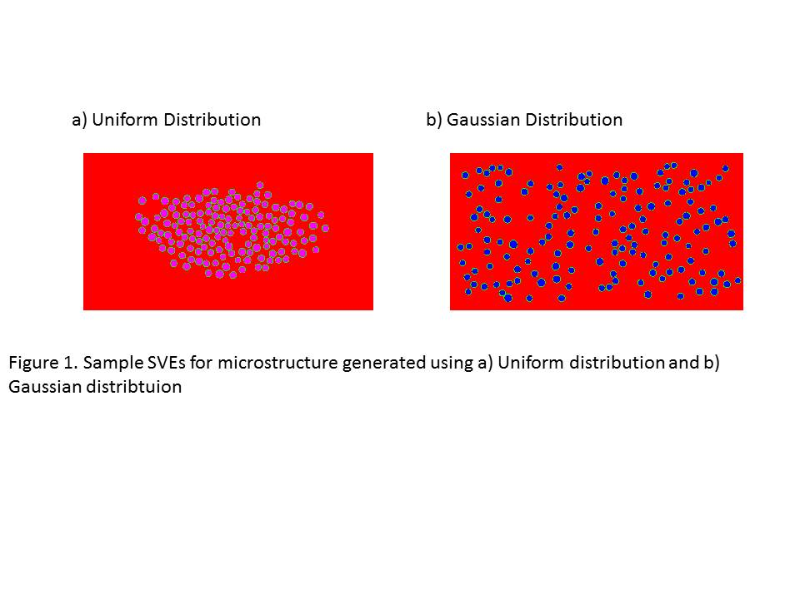

Figure 4. Sample SVEs of CMCs microstructures generated using a) Uniform distribution and b) Gaussian distribution

2.3 Discrete Damage Modeling of CMC Microstructures

A parametric model was developed using the Regularized eXtended Finite Element Approach (Rx-FEM) [6, 7, 17] that models discrete damage propagation without a-priori definition of damage location or path. This methodology is developed as a feature of the general purpose FEM package BSAM created by the AFRL/UDRI team. In the Rx-FEM methodology, a crack is approximated by a continuous approximation of the Heaviside step function, which introduces a displacement discontinuity across a diffuse crack process area in the vicinity of the crack surface. A crack is modeled using a cohesive zone approach. A cohesive surface simulating a closed crack capable of growing and turning has to be predefined. After each simulation step, failure criteria are calculated for all elements. Once the failure criteria in an element are met, BSAM calls the Crack Growth library to perform crack insertion, growth, and turning. Inside the library, crack is represented as encapsulated in a limited zone of elements. Crack propagation starts at a seed element inside this zone and the code then checks all its neighboring elements. When a neighboring element meets criteria for crack propagation, this element is added to the list of damaged elements and its neighboring elements are added to the list of elements in the zone affected by the crack. The crack is propagated until the failure and propagation criteria at the crack tip stop meeting the threshold. At that time, the system with this new crack topology is again equilibrated at the same load level as before to determine the changed due to the newly introduced cracks stress/strain fields, damage variables, and failure criteria. If this newly equilibrated stress/strain state requires additional crack growth, i.e., failure criteria are met at some of the cells, the crack insertion/growth step is performed again. Only when the equilibrium state does not require additional crack insertion or crack growth, the program proceeds to the next loading step.

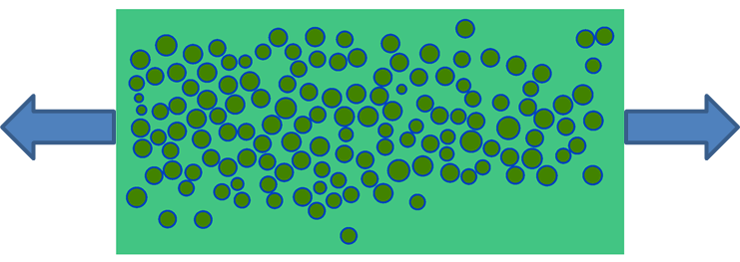
Figure 5. Transverse loading of a microstructure instantiation using BSAM

3. Results and Discussion

3.1 Discrete Damage Models

The simulations presented in this work are performed on synthetic microstructures created based on different statistics of microstructures. The microstructure is loaded in transverse direction under displacement control as shown in Fig. 4 till failure with the material properties corresponding to SiC/SiC composites given in Table 1.

Table 1. Material Properties prescribed in the FE simulations
 |  | units | Fiber | Coating | Matrix
E | Modulus in direction 1-3 | $$\frac{N}{{mm}^{2}}$$ | 3.8x10⁵ | 1.0x10⁴ | 3.6x10⁵
Nu | Poisson’s ratio |  | 0.185 | 0.05 | 0.185
G | Shear modulus | $$\frac{N}{{mm}^{2}}$$ | 3.8x10⁵ | 1.0x10⁴ | 3.6x10⁵
Xt | Max stress | $$\frac{N}{{mm}^{2}}$$ | 2.6x10³ | 75.0 | 800.0
Xc | Max stress | $$\frac{N}{{mm}^{2}}$$ | 2.6x10³ | 75.0 | 800.0
Yt | Max stress | $$\frac{N}{{mm}^{2}}$$ | 2.6x10³ | 75.0 | 800.0
Yc | Max stress | $$\frac{N}{{mm}^{2}}$$ | 2.6x10³ | 75.0 | 800.0
S | Max shear | $$\frac{N}{{mm}^{2}}$$ | 1.0 | 1.0 | 1.0
S13 |  | $$\frac{N}{{mm}^{2}}$$ | 2.0 | 1.0 | 1.0

Example of damage in microstructural instantiation is shown in Figure 6. Red color denotes fully open cracks and delamination.

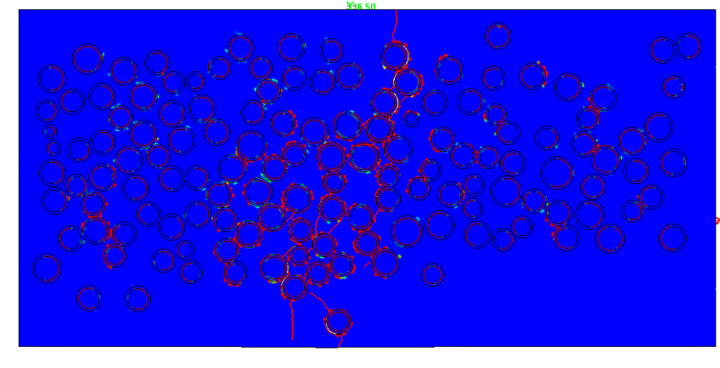
Figure 6. Fracture (cracks) in a transverse loading condition.

The stress-strain curve for Gaussian and Uniform microstructure instantiations are shown in Figure 7. The failure load for each instantiation is considered as the macroscopic characteristic of the macrostructural response. It is important to note that the microstructure with Uniform distribution fails at higher loads compare to Gaussian distribution as expected.

Figure 7. Simulated stress-strain curve under transverse cracking of a selected instantiated microstructure

3.2. Damage Evolution and Quantification

The stress-strain curves history extracted from the previously described finite element (FE) model under transverse loading are then used to extract a scalar damage parameter, D. Assuming effective elastic damage, a constitutive relation can be formulated between stress ($σ_{avg})$ and strain ($ε_{avg}$) defined as

$\frac{σ_{avg}}{E_{eff}}=(1-D)ε_{avg}$ (1)

where $E_{eff}$ is the effective stiffness of the microstructure.
In this manner, the scalar damage parameter, D, defines the loss of stiffness i.e. degradation of the elastic stiffness material. The damage evolution curves obtained using the FE model show three clearly distinguishable regimes: (i) an initial elastic regime where the full field stress evolves linearly with the imposed strain i.e. no damage, (ii) proportional limit (elastic limit) where damage initiates within the microstructure, and (iii) damage accumulation to failure as can be seen in Figure 8.

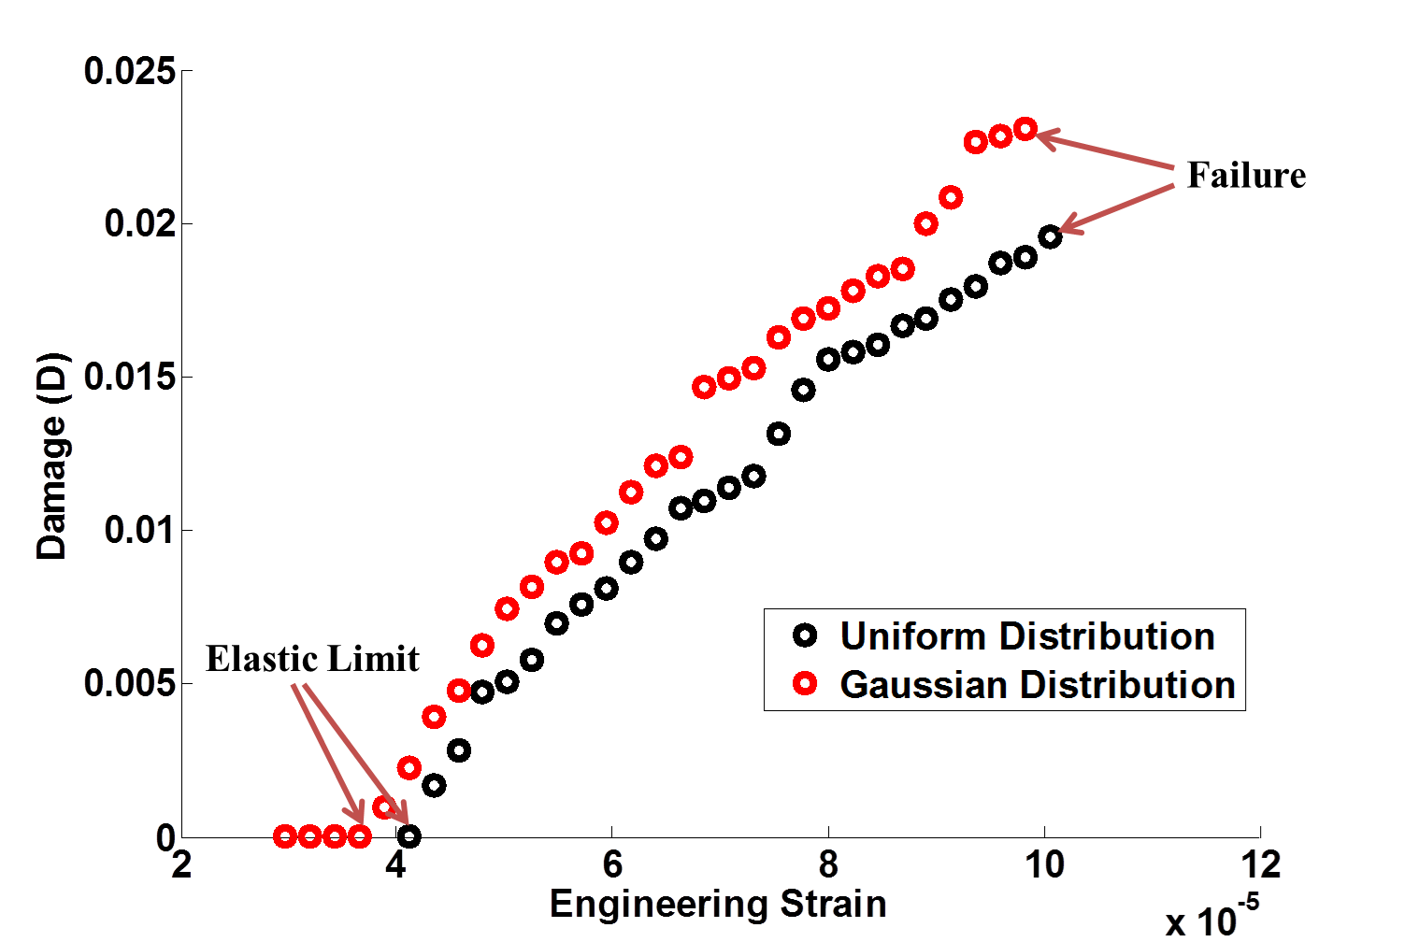
Figure 8. Damage evolution as a function of strain for CMCs microstructures generated using Uniform distribution and Gaussian distribution

3. Summary/Conclusions

Like most structural materials, local damage formation and propagation is dependent on local microstructure. In this work, we have developed in situ experiments to measure and quantify local transverse cracking behavior and continuous fiber reinforced composites. A discrete damage model was develop to simulate local transverse cracking as the scale of the individual plys. Several synthetic statistically representative volume elements or SVEs were generated using both a tightly packed Gaussian and more uniformly distributed random distribution of the local fiber spacing. The simulations seperatly considered the influence of the matrix, fiber coating, and fibers relative to their influence on the local matrix cracking behavior of a unidirectional ply transversely oriented relative to the loading direction. It was showns that tightly packed fibers tended to have a weaker transverse strength than more randomly spaced fibers. This is attributed to the weak fiber coatings applied to promote crack deflection around the primary fiber reinforcement. A damage parameter was introduced to quantify the overall progression of damage

Computationally efficient model for critical identification of ceramic reinforced ceramic matrix composites microstructure will be develop in the future to determin idealized microstructures for optimum performance. More specifically, a data driven approached will be employed to understand the influence of topology of CMCs on transverse cracking strength. The data driven approach will comprise of the following steps:
- Generation of calibration/training microstructure dataset from a representative microstructure and obtaining their mechanical response using physic-based models,
- Quantifying microstructures and employing robust data mining tools to obtained reduce-order representation of microstructures, and
- Develop and validate computationally efficient relationships between the selected reduce-order microstructures and its effective properties using machine learning.

Acknowledgments
This work was supported by the Air Force Office of Scientific Research, Task #17RXCOR441, with Jamie Tiley as the program manager.

References
[1] T. Fast, A. E. Scott, H. A. Bale, and B. N. Cox, "Topological and Euclidean metrics reveal spatially nonuniform structure in the entanglement of stochastic fiber bundles," Journal of Materials Science, vol. 50, no. 6, pp. 2370-2398, 2015.
[2] S. Bricker, J. P. Simmons, C. P. Przybyla, and R. Hardie, "Anomaly detection of microstructural defects in continuous fiber reinforced composites," in Computational Imaging XIII, San Francisco, California, 2015, vol. 9401, pp. 94010A-94010A-10.
[3] D. Patel, T. Parthasarathy, D. Rapking, M. Braginsky, and C. Przybyla, "Quantification and Classification of Continuous Ceramic Fiber Reinforced Ceramic Matrix Composites Microstructures," in 32nd Annual American Society for Composites Technical Conference, West Lafayette, Indiana, 2017.
[4] T. Whitlow, E. Jones, and C. Przybyla, "In-situ damage monitoring of a SiC/SiC ceramic matrix composite using acoustic emission and digital image correlation," Composite Structures, vol. 158, no. Supplement C, pp. 245-251, 2016/12/15/ 2016.
[5] M. Braginsky and C. P. Przybyla, "Simulation of crack propagation/deflection in ceramic matrix continuous fiber reinforced composites with weak interphase via the extended finite element method," Composite Structures, vol. 136, pp. 538-545, 2016.
[6] E. V. Iarve, D. H. Mollenhauer, E. G. Zhou, T. Breitzman, and T. J. Whitney, "Independent mesh method-based prediction of local and volume average fields in textile composites," Composites Part A: Applied Science and Manufacturing, vol. 40, no. 12, pp. 1880-1890, 2009.
[7] D. Mollenhauer et al., "Simulation of discrete damage in composite overheight compact tension specimens," Composites Part A: Applied Science and Manufacturing, vol. 43, no. 10, pp. 1667-1679, 2012.
[8] D. Zwillinger, CRC Standard Mathematical Tables and Formulae, 31st Edition. CRC Press, 2002.
[9] E. W. Weisstein, ""Gaussian Function" From MathWorld," Wolfram Web.
[10] S. Bricker, C. P. Przybyla, J. Simmons, and R. Hardie, "Anomaly Detection and Classification," in Statistical Methods for Materials Science: Data Analytics and Materials Characterization: Taylor and Frances, 2016.
[11] C. P. Przybyla, S. Bricker, J. Simmons, and R. Hardie, "Automated Image Processing Techniques and Fiber Identification for three dimensional characterization of fiber reinforced composites," in American Society for Composites 29th Technical Conference, San Diego, CA, 2014.
[12] C. P. Przybyla et al., "Statistical Characterization of SiC/SiC Ceramic Matrix Composites at the Filament Scale with Bayesian Segmentation, Hough Transform Feature Extraction, and Pair Correlation Statistics," in SAMPE, Long Beach, California, 2013.
[13] S. Wang, H. Yu, Y. Zhou, J. Simmons, and C. Przybyla, "Object Tracking through Image Sequences," in Statistical Methods for Materials Science: Data Analytics and Materials Characterization: Taylor and Frances, 2016.
[14] S. R. Kalidindi, Hierarchical Materials Informatics: Novel Analytics for Materials Data. Butterworth-Heinemann, 2015.
[15] S. Torquato, Random Heterogenous Materials: Microstructure and Macroscopic Properties (no. 16). Springer, 2002.
[16] A. N. Fast, "Developing higher-order materials knowledge systems " Ph.D., Materials Science and Engineering, Drexel University, 2011.
[17] E. Iarve, "Mesh independent modelling of cracks by using higher order shape functions," International Journal for Numerical Methods in Engineering, vol. 56, no. 6, pp. 869-882, 2003.

