EuroSun2026

Cost Drivers of Large Tank Thermal Energy Storage: A Mixed-Methods Analysis of Investment Cost Variability

Richard Lüchinger, Silas Lüscher, Olivier Gisiger, Philipp Schuetz
Lucerne University of Applied Sciences, Engineering & Architecture, Competence Center Thermal Energy Storage (CCTES)
richard.luechinger@hslu.ch
Summary
Early-stage cost assessment of large tank thermal energy storage (TTES) is constrained by substantial project-to-project variation and inconsistent cost reporting. This study examines which structural factors help explain investment-cost deviations after accounting for storage volume and tank type. Investment costs from 39 implemented projects, comprising 23 atmospheric, 11 pressurised, and five two-zone TTES, were harmonised to Swiss 2025 reference conditions and analysed using subgroup-specific power-law models. Residuals from the retained models guided comparative case reconstruction based on project documentation, cost information, and 12 expert interviews. Atmospheric and pressurised TTES showed sublinear cost scaling, with exponents of 0.58 (R² = 0.90) and 0.70 (R² = 0.94), respectively. Leave-one-out cross-validation yielded median absolute percentage errors of approximately 20% and 18%, while the available two-zone sample did not support a stable subgroup-specific cost function. Across the analysed cases, the integrated analysis identified three recurring structural cost drivers: vessel concept and design requirements, foundations and ground conditions, and storage-specific hydraulic and system integration. Cost-boundary and reporting differences formed a separate source of apparent cost variation and should not be interpreted as physical cost drivers. The resulting cost functions provide quantitative references for early-stage assessment, while the residual-based case analysis supports structured interpretation of project-specific deviations rather than deterministic cost prediction.
Keywords: tank thermal energy storage, investment costs, cost scaling, structural cost drivers, residual analysis, district heating
Field of application for the findings: Early-stage cost assessment and techno-economic evaluation of large TTES systems.
Addressed audience: Researchers, district-heating planners, utilities, engineering consultants, tank designers, and energy-system analysts.
- Introduction
The Swiss building stock accounts for approximately 42% of domestic final energy consumption and 22% of CO₂ emissions (BFE, 2024). Decarbonising the heat supply is therefore essential for achieving Switzerland’s climate targets. However, the increased use of renewable heat sources and industrial waste heat requires additional flexibility because their availability often does not coincide with the instantaneous heat demand. Thermal energy storage can compensate for this mismatch and thereby facilitate the integration of renewable and variable heat sources (Guelpa & Verda, 2019). Large tank thermal energy storage (TTES) systems are particularly relevant for district heating networks, industrial applications, and integrated heating systems (Dahash et al., 2019).
Since economic profitability play a central role in thermal energy storage selection, reliable investment-cost estimates are important during the early stages of project development (Lüchinger et al., 2026). At this stage, detailed design data and reliable supplier quotations are usually unavailable. Decision-makers therefore face difficulties in assessing both the expected investment costs and the associated uncertainty. This uncertainty may delay investment decisions and consequently impede the deployment of large TTES systems.
Yang et al. (2021) show in their techno-economic review that the available economic data on seasonal thermal energy storage are limited and often insufficiently transparent. Their study situates TTES within the broader field of seasonal storage technologies but does not establish a harmonised TTES cost database or examine project-specific causes of cost variation. Lüchinger et al. (2025) address this research gap by analysing inflation- and purchasing-power-adjusted investment costs for 51 large thermal energy storage projects, including 17 TTES systems. Their results indicate declining specific costs with increasing system size and substantial differences among the technologies examined. However, the limited number of projects restricts the robustness of the separate TTES models. Moreover, the analysis focuses on cross-technology comparisons rather than on explaining project-specific cost deviations.
A central unresolved question is whether TTES systems can be treated as a homogeneous cost category. Atmospheric, pressurised, and two-zone TTES systems differ in pressure level, design temperature, internal configuration, and other technical characteristics. These differences may affect cost levels and scaling behaviour, while additional variation may result from project-specific characteristics, cost boundaries, and data quality.
This study extends the previous cross-technology cost analysis through a focused investigation of large water-based TTES systems used in district heating networks and comparable centralised heat supply systems. It examines internationally implemented TTES projects and harmonises their investment costs to a Swiss reference context for 2025. The dataset comprises 39 completed TTES projects with storage volumes of at least 250 m³ and distinguishes among atmospheric, pressurised, and two-zone TTES. Subgroup-specific scaling models identify cases with substantial residual cost deviations. Project documentation, cost breakdowns, and 12 expert interviews are then used to examine these cases and identify potential technical, integration-related, and implementation-related cost drivers.
The central research question is: Which structural cost drivers contribute to explaining residual deviations in the investment costs of large TTES projects? The scientific contribution of this study lies in expanding the empirical TTES database, differentiating tank concepts on a technical basis, and combining quantitative cost models with qualitative reconstructions of selected projects. The results provide a more robust basis for interpreting cost ranges during the early planning and techno-economic assessment of large TTES systems.
- Background on Large Tank Thermal Energy Storage (TTES)
TTES stores sensible heat in water (Yang et al., 2021). The amount of heat stored depends primarily on the water volume, the specific heat capacity, and the usable temperature difference between the charged and discharged states. Water is suitable as a storage medium because it has a high heat capacity, is widely available, and is technically straightforward to handle. TTES is used in district heating networks, industrial heating systems, combined heat and power plants, heat pump systems, and other centralised heat supply systems (Guelpa & Verda, 2019). It is generally used for short-term or diurnal storage but may also store heat over longer periods or seasonally (Yang et al., 2021). Its main function is to decouple heat generation from heat demand over time, thereby increasing the operational flexibility and thermal self-sufficiency of the overall system (Lüchinger et al., 2024; Lyden et al., 2022). Yang et al. (2021) and Sträter et al. (2025) classify TTES as a mature form of sensible thermal energy storage. Its technical design is determined by factors including storage volume, temperature range, pressure level, insulation, and system integration (Yang et al., 2021).
Large TTES systems are classified as atmospheric, pressurised, or two-zone systems. Atmospheric TTES operates at or near atmospheric pressure and therefore remains below the atmospheric boiling point of water (Dahash et al., 2019). Such storage systems are generally constructed as cylindrical steel tanks, although reinforced-concrete tanks are also used. The main structural components include the tank shell, roof, insulation, and foundation (IEA-ES Task 39, 2024; Lüchinger et al., 2025).
Pressurised TTES operates as a closed pressure vessel (Trojan et al., 2019). The elevated operating pressure increases the boiling point of water and permits higher storage temperatures and energy densities (Garbai et al., 2026). This results in more stringent structural and safety requirements. Wall thickness, material selection, weld quality, fittings, pressure control, testing procedures, and safety equipment may differ substantially from those used in unpressurised tanks. Pressure and temperature therefore affect not only operation but also vessel construction, installation, and system integration.
Two-zone TTES constitutes a distinct technical concept (IEA-ES Task 39, 2024). An internal insulated structure divides the tank into a colder upper zone and a high-temperature lower zone. The water column in the upper zone exerts hydrostatic pressure on the lower zone. This permits temperatures above the atmospheric boiling point in the lower zone without requiring the entire tank to be designed as a conventional pressure vessel. The concept may increase the usable energy density but requires additional load-bearing structures, thermal separation, further hydraulic connections, and an adapted control system (IEA-ES Task 39, 2024). Two-zone TTES is therefore equivalent to neither a conventional atmospheric tank nor a pressurised storage system.
Depending on the system boundary, the investment costs of large TTES systems include not only the storage vessel but also insulation, internal components, the foundation, and hydraulic connections. These cost boundaries are not defined consistently in the literature. SPF (2023) include charging and discharging equipment in addition to the vessel. (Christidis, 2019) further shows that the shares of the tank, foundation, internal components, and insulation in total investment costs vary substantially between projects. Cost estimates are therefore comparable only when their scope is documented adequately. The TTES concepts also differ considerably in cost. SPF (2023) reports indicative values of CHF 220–400/m³ for unpressurised steel tanks and CHF 500–2’000/m³ for pressurised steel tanks. Lüchinger et al. (2025) likewise identify differences in the cost levels and cost structures of the various TTES concepts. Both Yang et al. (2021) and Lüchinger et al. (2025) use storage volume as the principal reference variable in their cost analyses. Yang et al. compare volume-specific storage costs, whereas Lüchinger et al. model the relationship between storage volume and absolute investment costs using a power function:
$CAPEX=a⋅V^{b}$ (eq. 1)
Here, CAPEX denotes the investment costs, V the storage volume, a the scaling coefficient, and b the scaling exponent. When b < 1, absolute investment costs increase less than proportionally with volume, causing specific costs to decline as storage size increases. However, the scaling exponent is not determined solely by vessel geometry. Pressure level, design temperature, tank material, wall thickness, foundation, internal structures, hydraulic integration, and project-specific fixed costs may affect both the overall cost level and the scaling behaviour. Atmospheric, pressurised, and two-zone TTES systems should therefore be combined in a single cost function only when this aggregation is technically and empirically justified.
- Methodology
The study follows a sequential mixed-methods approach, see Figure 1. First, the investment costs of large TTES are analysed quantitatively. Selected projects are then reconstructed qualitatively to investigate potential causes of the remaining cost deviations. The analysis distinguishes between atmospheric, pressurised, and two-zone TTES.
The analysis is based on a project database of internationally built TTES projects. The data were obtained from scientific literature, project reports, and technical documents and were supplemented through direct contact with planning companies, manufacturers, and operators. The projects were classified by tank type and assessed with respect to data plausibility, implementation status, and cost scope. Conceptual projects and cases with unclear technology classification, non-separable total system costs, or insufficient suitability for cost modelling were excluded.
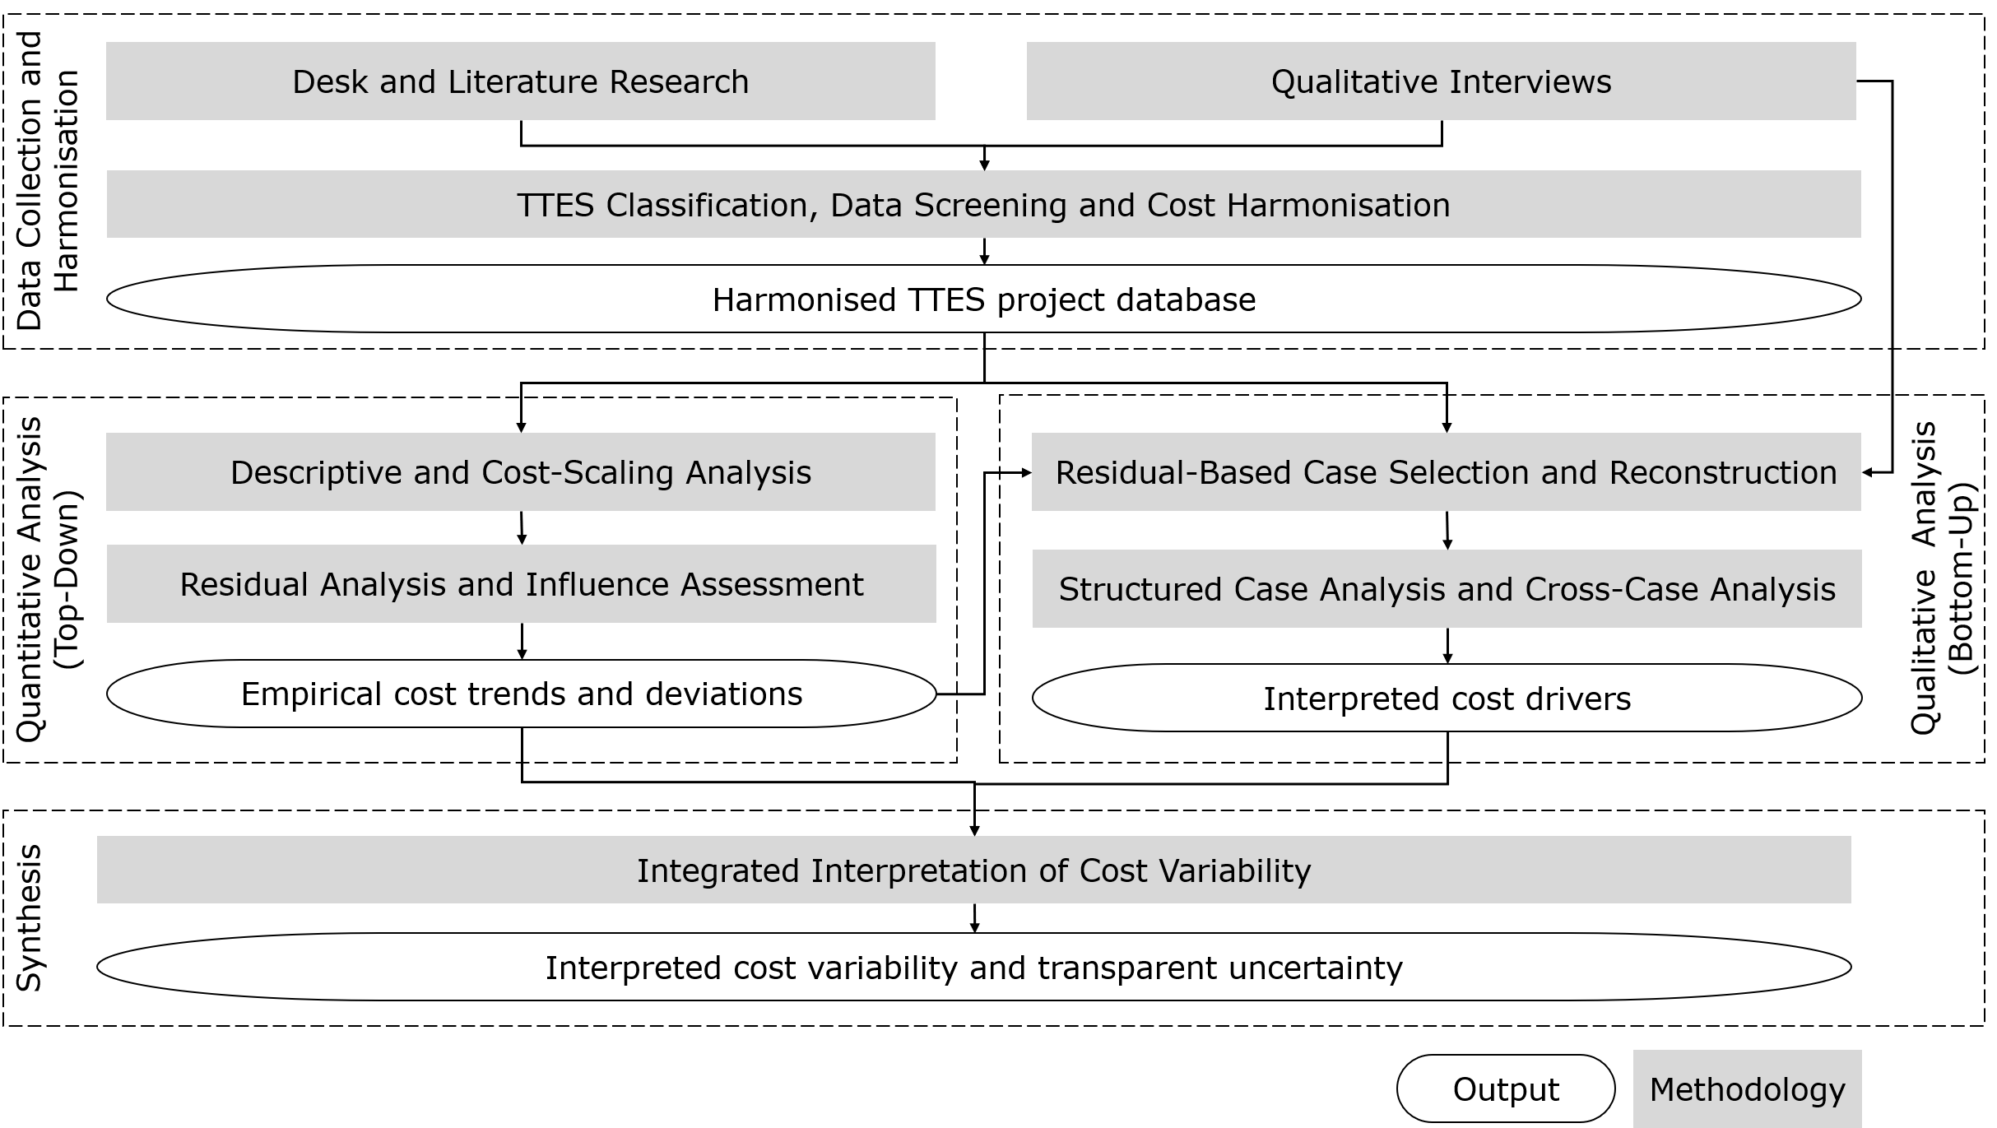
Figure 1: Overview of the sequential mixed-methods approach used to analyse investment cost variability in large TTES projects. Harmonised project data are first used for descriptive cost-scaling and residual analysis; the resulting residuals then guide the selection and reconstruction of qualitative cases. The quantitative and qualitative findings are integrated to interpret structural cost drivers, data-boundary effects, and remaining uncertainty.
The project database comprised 58 TTES datasets, including 49 implemented projects. The quantitative cost modelling includes only implemented projects with documented storage volume, harmonised investment costs, and an unambiguous assignment to a TTES tank type. After excluding incomplete datasets, projects below the defined minimum storage volume of 250 m³, and projects with total system costs that could not be delineated with sufficient reliability, the modelling sample comprises 39 projects: 23 atmospheric, 11 pressurised, and five two-zone TTES. Non-implemented projects, and cases without reliable information on storage volume or investment costs are not included in the regression analysis. The cost boundary includes all investments that can be directly attributed to the TTES. Where documented, these investments comprise the tank and its structural components, storage-specific hydraulic systems, and measurement, control, planning, and installation services. Heat generators, heat pumps, general network extensions, land costs, and other non-storage-specific installations are excluded where these costs are reported separately and can be delineated unambiguously. Remaining differences in cost scope are documented and treated as a source of methodological uncertainty.
The investment costs are harmonised spatially and temporally following the procedure described by Lüchinger et al. (2025). First, costs reported in different currencies and national price contexts are converted to a Swiss reference context using purchasing power parities (World Bank Group, 2025). They are then adjusted to the 2025 price level. The building construction indices of the Swiss Construction Price Index published by the Federal Statistical Office are used for the temporal adjustment (BFS, 2025). The harmonised values facilitate comparisons between projects but do not represent direct Swiss market quotations. To select the primary size variable, exploratory Pearson correlations are calculated for each TTES subgroup between logarithmised investment costs and logarithmised project parameters. Candidate parameters include storage volume, thermal storage capacity, thermal power, tank dimensions, storage temperatures, storage efficiency, and energy density. Correlations are calculated only where at least five complete and positive data pairs are available. The primary scaling variable is selected based on correlation strength, data availability, and its physical relevance to tank size. The relationship between storage volume and investment costs is represented by a power function eq. 1.
The model parameters are estimated by ordinary least squares regression of the logarithmised variables. Separate models are fitted for atmospheric, pressurised, and two-zone TTES. Their suitability for residual analysis is assessed based on sample size, volume range, parameter uncertainty, residual behaviour, influence of individual projects, and predictive performance. Models with insufficient sample support or highly uncertain parameter estimates are not retained for residual analysis. The logarithmic residual is calculated as follows:
$e_{i}=\ln\left(\frac{CAPEX_{actual,i}}{CAPEX_{model,i}}\right)$ (eq. 2)
The additionally reported percentage deviation is calculated as the relative difference between observed and modelled investment costs on the original cost scale. Positive residuals identify projects above the model trend, whereas negative residuals identify projects below the model trend. The projects are ranked by the absolute value of their logarithmic residual. Percentage deviations support interpretation but do not serve as the primary residual measure.
The qualitative analysis follows a residual-based comparative case study logic. Four contrasting core cases were selected based on residual magnitude and direction, TTES subgroup, data quality, cost boundaries, and available project evidence. Supporting cases were used to assess recurring mechanisms, while exploratory cases indicated technical heterogeneity or unresolved deviations. Residual magnitude informed case selection but was not treated as evidence of causality. The selected cases are reconstructed using project reports, technical documents, cost statements, and 12 semi-structured expert interviews. The interviews lasted approximately 20 to 90 minutes and involved experts from planning, manufacturing, operation, and research. The interviews were documented using structured interview protocols and linked to the relevant cases and analytical categories.
The case analysis follows a consistent analytical framework covering technical design, tank concept, pressure and temperature levels, foundations, seismic requirements, insulation, internal structures, hydraulic integration, site conditions, procurement, and cost scope. For each case, the analysis distinguishes between documented project characteristics, expert statements, plausible interpretations, and unresolved uncertainties. Contradictory information is not merged into a single account but is documented as uncertainty. The cases are then compared to identify recurring technical, site-specific, implementation-related, and cost-boundary-related explanatory patterns.
The quantitative and qualitative analyses are integrated in two steps. First, the residuals of the cost models guide the selection of projects for in-depth investigation. Second, the reconstructed case characteristics are linked to the corresponding model deviations and compared across cases. Recurring explanatory patterns are classified as technical, integration-related, implementation-related, or data-related influencing factors. An influencing factor is considered a case-specific explanation where project-specific evidence supports the proposed relationship. It is classified as a recurring structural cost driver only where comparable mechanisms occur across several cases or are supported by consistent statements from multiple experts.
- Results
4.1. Interview-Based Synthesis of TTES-Specific Cost Drivers
This section synthesises evidence from 12 anonymised expert interviews on TTES cost structures, structural cost drivers, system integration, and cost boundaries. The findings represent qualitative expert evidence rather than statistically representative cost shares; reported numerical values are therefore interpreted as indicative benchmarks. The interviews confirm storage volume as the main first-order variable for early TTES cost estimates. However, volume alone captures the cost structure only partly. One expert described a rough cost split of approximately 50% for the vessel, 25% for the foundation, and 25% for hydraulic integration. Actual costs depend on how the storage volume is realised, including tank geometry, operating temperature, pressure requirements, insulation, and installation effort. Pressure and temperature requirements were identified as important sources of cost variation. Compared with atmospheric tanks, pressurised and two-zone systems require more demanding structural designs, safety equipment, and hydraulic integration. High wall thicknesses may also increase welding effort and, in some cases, favour several smaller vessels over one large tank. Site-specific structural requirements can further increase costs. Experts highlighted seismic design as a relevant factor, with indicative cost increases of up to about 50% in extreme cases. Architectural or planning requirements related to enclosure, visibility, greening, or public use were also reported to add costs; one expert estimated additional design-related costs of around 20%. System integration represents a further cost driver that is only weakly linked to storage volume. Cost-relevant elements include piping, pumps, heat exchangers, fittings, pressure-maintenance and control systems, and network separation. The required effort depends on system architecture, pressure level, charging and discharging configuration, water quality, and operating strategy. Similar-sized TTES can therefore differ substantially in investment cost because of different integration requirements.
4.2. TTES specific cost scaling and residual deviations
The quantitative analysis comprises 39 implemented TTES projects: 23 atmospheric, 11 pressurised, and five two-zone systems. The complete project dataset and project-level model results are available from the authors upon reasonable request. Storage volume was strongly associated with investment cost for atmospheric TTES $\left(r=0.95, n=23\right)$ and pressurised TTES $\left(r=0.97, n=11\right)$, see Figure 2. Separate power-law models were retained for these groups. The separate two-zone fit and the pooled pressurised–two-zone fit are reported only as sensitivity analyses and are not used for residual analysis or case selection. For atmospheric TTES, the estimated cost function is:
$CAPEX_{ATM}=30'324⋅V^{0.58}$ (eq. 3)
where $V$ denotes the storage volume in m³ and $CAPEX$ denotes the investment cost harmonised to Swiss price conditions in 2025. The scaling exponent is $b=0.58$, with a 95% confidence interval of 0.49–0.67. The model explains approximately 90% of the variation in logarithmised investment costs $\left(R^{2}=0.90, n=23\right)$. For pressurised TTES, the estimated function is:
$CAPEX_{PRESS}=20'421⋅V^{0.70}$ (eq. 4)
The scaling exponent is $b=0.70$, with a 95% confidence interval of 0.57–0.84. The model explains approximately 94% of the variation in logarithmised investment costs ($R^{2}=0.94,n=11$). Both retained models therefore show sublinear cost scaling. Absolute investment costs increase with storage volume, but less than proportionally, resulting in declining modelled specific costs as volume increases. The pressurised exponent is numerically higher than the atmospheric exponent. However, the confidence intervals overlap, and the available results do not establish a statistically clear difference between the scaling exponents. The separate fit for the five two-zone projects produced an exponent of $b=0.34$, with a wide 95% confidence interval of −1.50 to 2.19, and explained only approximately 10% of the logarithmised cost variation ($R^{2}=0.10,n=5$). This wide interval reflects the small sample and the limited empirical support for the estimated slope.
As an additional sensitivity analysis, the pressurised and two-zone projects were combined. The pooled model shows a strong overall association between storage volume and investment cost ($R^{2}=0.94$, $n=16$). However, its high goodness of fit does not establish a common cost structure or technical equivalence between the two concepts. This interpretation is also consistent with expert evidence, which questioned whether both concepts would be expected to follow the same cost curve. Two-zone TTES include internal load-bearing and thermally separating structures that differ from conventional pressure designs. The pooled relationship is therefore reported only to assess the sensitivity of the results to the grouping decision and is not retained as a primary model.
Figure 2 presents the two retained models together with the supplementary sensitivity fits. Confidence intervals and 90% prediction bands are shown only for the atmospheric and pressurised models. Leave-one-out cross-validation resulted in a median absolute percentage error of approximately 20% for atmospheric TTES and 18% for pressurised TTES. Within the central range of observed storage volumes, the 90% prediction intervals extend from approximately 0.61 to 1.63 times the point estimate for atmospheric TTES and from 0.63 to 1.59 times the point estimate for pressurised TTES. The models therefore provide useful scaling references and indicative cost ranges for early-stage planning but are not sufficiently precise for project-specific budgeting.
Residuals were calculated for the retained atmospheric and pressurised models. Two-zone projects were not included in the residual analysis. On the original cost scale, deviations range from approximately −49% to +55% for atmospheric TTES and from −30% to +34% for pressurised TTES. The wider range in the atmospheric sample should not be interpreted as evidence that atmospheric projects are inherently more variable or less predictable, as the two samples differ in size, volume range, project characteristics, source quality, and reported cost boundaries.
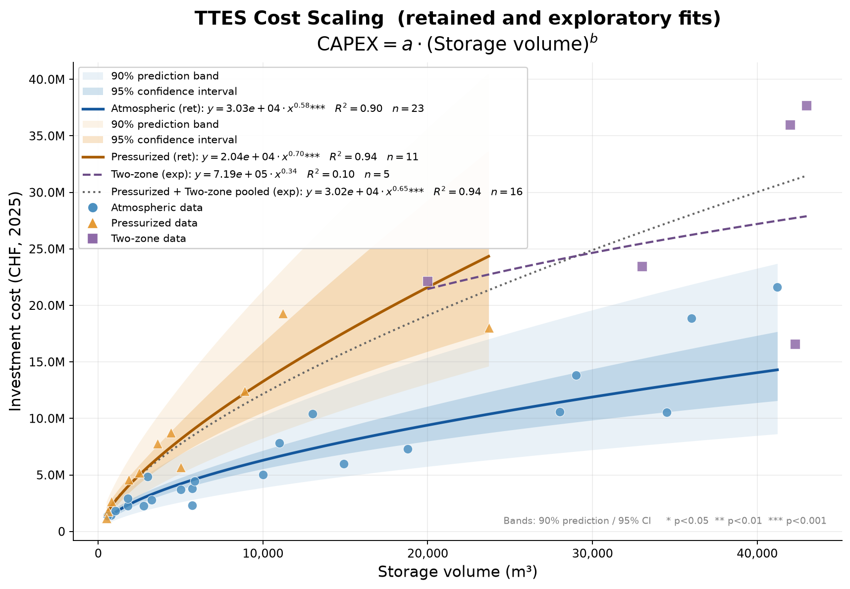
Figure 2: Investment costs of atmospheric, pressurised, and two-zone TTES as a function of storage volume. Solid lines show the retained power-law models for atmospheric and pressurised TTES; shaded areas indicate the corresponding 95% confidence intervals and 90% prediction bands. The dashed line shows the exploratory two-zone fit, and the dotted line shows the pooled pressurised and two-zone sensitivity fit. The sensitivity fits are not used for residual calculation or case selection. Investment costs are harmonised to Swiss price conditions in 2025.
Figure 3 compares the observed and modelled investment costs for the two retained groups. Relevant positive and negative deviations remain after accounting for storage volume, showing that volume does not capture all project-level cost variation. The residuals, together with the available project documentation, informed the case selection presented in Section 4.3. They indicate where additional project-specific influences may be present but do not, by themselves, demonstrate a causal cost driver.
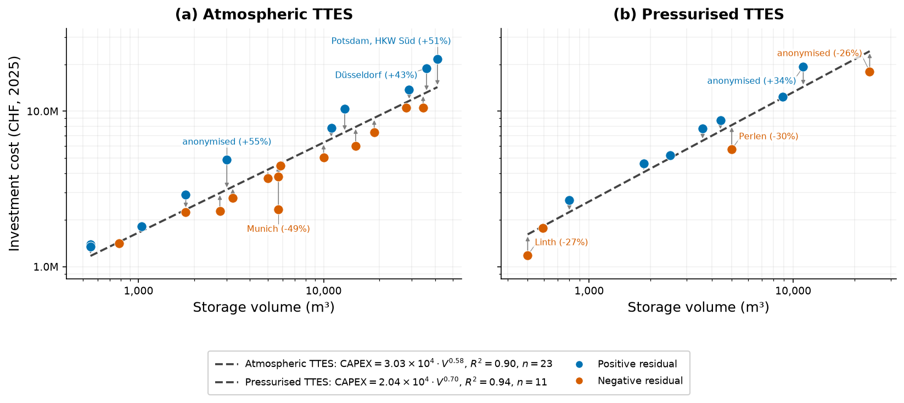
Figure 3: Observed and modelled investment costs for atmospheric TTES (a) and pressurised TTES (b) as a function of storage volume. Both axes are logarithmically scaled. Dashed lines show the retained cost functions, and arrows connect the observed and modelled costs of each project. Blue symbols indicate positive residuals and orange symbols negative residuals. Labels identify the projects with the largest absolute logarithmic residuals within each model.

4.3. Case-Based Interpretation
Four contrasting core cases were selected based on residual magnitude and direction, subgroup coverage, data quality, cost boundaries, and the availability of project-specific evidence. The selected cases represent substantial positive and negative deviations but do not necessarily correspond to the largest residuals within each model. Across the four cases, deviations from the respective model estimates range from −25.9% to +51.3%. The supporting cases serve to examine identified mechanisms using additional project evidence and to illustrate the limitations of residual-based interpretation. Residuals provide the starting point for the case analysis but do not establish a causal effect of any specific cost driver.
Potsdam, with a storage volume of 41’224 m³, lies 51.3% above the atmospheric model estimate. The analysis uses a published total investment cost of EUR 11.6 million, whereas an internal project source reports approximately EUR 5 million for the storage system itself. This difference indicates that the two figures refer to different cost boundaries. As the components included in the total investment are not fully disaggregated, the positive residual is best interpreted primarily as an effect of cost boundary definition. The available evidence does not support a robust conclusion regarding a technical source of additional cost.
Neukölln, with a storage volume of 10’000 m³, lies 20.0% below the atmospheric model estimate. The project converted an existing fuel-oil tank into a thermal energy storage system. This conversion avoided major components of a complete new tank construction. The reuse of existing infrastructure therefore provides a plausible explanation for the negative residual. However, the avoided investment cannot be quantified because no cost estimate is available for a comparable newly built system.
The two atmospheric cases illustrate different causes of residual deviations. In Potsdam, a broad and incompletely disaggregated cost boundary affects the reported capital expenditure. In Neukölln, the reuse of existing infrastructure plausibly reduces the required new investment. The direction and magnitude of a residual are therefore insufficient to distinguish between a genuine technical cost effect and an effect arising from cost boundary definition.
Anonymised I, with a storage volume of 23’700 m³, lies 25.9% below the pressurised model estimate. The storage system operates at temperatures of up to 125 °C and has a flat bottom and a free water surface. According to expert evidence, the foundation forms part of the pressure equipment. This design differs from pressurised vessels with curved bottoms. The selected concept was considered less costly by the interviewed expert. The alternative vessel and pressure-boundary concept therefore provides a plausible explanation for the negative residual. However, the magnitude of the cost effect remains uncertain because no direct comparison with a conventional design is available.
Anonymised II, with a total storage volume of 11’200 m³, lies 34.3% above the pressurised model estimate. The project comprises two pressurised tanks with a combined storage capacity of approximately 850 MWhth and an operating temperature range of about 160/70 °C. According to expert evidence, the recorded capital expenditure consists of a EUR 7.9 million storage contract and an estimated EUR 2.0 million foundation cost. The high temperature and pressure levels increase the structural and safety-related design requirements of the vessels. These requirements may have contributed to the positive residual. However, the available data do not permit their individual cost effects to be quantified.
The two pressurised cases reveal a clear contrast within the same model group. For Anonymised I, the evidence indicates a comparatively low-cost pressure-boundary concept. For Anonymised II, the high temperature and pressure levels, together with the associated structural and safety requirements, indicate greater project complexity and cost. Storage volume does not directly capture these differences.
The supporting cases extend these findings by examining individual mechanisms and illustrating the limits of residual-based interpretation. For Düsseldorf, a documented foundation cost of approximately EUR 2.5 million supports the relevance of challenging ground conditions. At the same time, the reported capital expenditure includes parts of the system integration and potentially additional plant components. The technical cost effect therefore cannot be fully separated from the broad cost boundary. For Anonymised III, strict occupational safety requirements, an additional external steel structure, and complex coordination across technical interfaces were identified as potential cost influences. Owing to limited technical documentation and partly estimated cost components, the contribution of these factors cannot be quantified.
Across both model groups, the cases show that residual deviations may reflect both genuine project-specific differences and variation in cost boundaries and data quality. The identified mechanisms primarily concern vessel and pressure-boundary concepts, operating conditions, foundations, system integration, and the reuse of existing infrastructure. Inconsistent cost boundaries, estimated cost components, and incomplete reporting further affect the residual position. The case analysis therefore supports a structured interpretation of cost deviations but does not provide a complete causal decomposition of investment costs.

4.4. Cross-Case Classification of Cost Drivers
The classification draws on the in-depth reconstruction of the Core Cases and the supplementary Supporting Cases, while Exploratory Cases are used only to contextualise technical heterogeneity (Table 1). It distinguishes between structural Cost Drivers, project-specific Cost Contributors, and Cost Boundary and Reporting Effects. Structural Cost Drivers are recurring technical or construction-related mechanisms that affect actual project expenditure; project-specific contributions relate to individual designs or boundary conditions; Cost Boundary and Reporting Effects affect the comparability of reported CAPEX. The evidence supports three structural Cost Drivers: tank concept and design requirements, foundations and ground conditions, and storage-specific hydraulic and system integration.
The first Cost Driver concerns vessel and pressure-boundary concepts and the structural requirements associated with design temperature and pressure. These factors affect material use, fabrication, supporting structures, safety provisions, and installation effort. The second concerns foundations and ground conditions, including tank loads, soil conditions, settlement risk, and seismic requirements, which may require additional foundations, reinforcement, or remedial measures. The third concerns storage-specific hydraulic and system integration, where system architecture, hydraulic connections, pressure management, controls, technical interfaces, and commissioning influence investment effort. Evidence from several cases and interviews supports all three mechanisms, although their individual cost effects cannot generally be quantified.
Other influences are retained as project-specific Cost Contributors because their effects are heterogeneous or limited to specific project contexts. These include architectural, regulatory, occupational-safety, and other site-specific requirements, as well as the reuse of existing infrastructure. Cost Boundary and Reporting Effects form a separate explanatory level: differences in included components, cost allocation, and reporting quality can shift reported CAPEX and residual positions without reflecting a physical cost mechanism. Such effects must therefore be considered before positive or negative residuals are interpreted as technical cost differences.
Overall, the classification supports a structured interpretation of residual cost deviations but does not permit a complete causal decomposition of TTES investment costs or the derivation of general percentage-based cost adjustments. Some residuals remain unresolved, and the available two-zone sample does not allow residual-based confirmation of the classification for this subgroup.
Table 1: Integrated classification of structural cost drivers, project-specific cost contributors, and cost-boundary effects based on the TTES case analysis and expert interviews.
CLASSIFICATION | CATEGORY | MECHANISM AFFECTING CAPEX OR RESIDUAL INTERPRETATION | INTEGRATED EVIDENCE FROM CASES AND INTERVIEWS | EVIDENCE ASSESSMENT
STRUCTURAL COST DRIVER | Vessel concept and design requirements | Vessel and pressure-boundary concepts affect structural design, material use, fabrication, construction sequence, and site integration. Design temperature and pressure further influence wall and component requirements, safety provisions, pressure management, testing, and installation effort. | Anonymised I uses an alternative flat-bottom pressure-boundary concept that was described as less costly than a conventional curved-bottom design. Anonymised II operates at a high temperature and pressure level. Munich and Hannover-Kronsberg use concrete, partly buried, or building-integrated concepts that differ from conventional above-ground steel tanks. Interviews identified vessel concept, design temperature, and pressure requirements as cost-relevant. | Recurrent and technically well-supported mechanism. The cases represent different expressions of the same broader cost driver, although the individual cost effects are not separately quantified.
STRUCTURAL COST DRIVER | Foundation and ground conditions | Tank loads, the structural concept, difficult ground conditions, and seismic design requirements can increase the need for foundations, anchoring, reinforcement, and subsequent remedial measures. | Düsseldorf provides a documented foundation cost associated with difficult ground conditions. Perlen documents settlement and subsequent structural measures. Foundations were also identified in the interviews as a major TTES cost block. | Recurrent and technically well-supported mechanism. The cost effect is documented for Düsseldorf, while the additional cost in Perlen is unavailable.
STRUCTURAL COST DRIVER | Storage-specific hydraulic and system integration | Hydraulic connections, pressure management, controls, instrumentation, and interfaces with the existing heat system can increase engineering, installation, and commissioning effort. | Düsseldorf, Anonymised II, and Anonymised V provide project-specific evidence of integration effort. Hydraulic and system integration was repeatedly identified in the interviews as cost-relevant. | Recurrent and well-supported mechanism across cases and interviews. Separate integration costs are only partly available.
PROJECT-SPECIFIC COST CONTRIBUTOR | Additional project-specific requirements | Architectural, regulatory, occupational-safety, and site-specific requirements can add structures, planning effort, safety measures, and coordination needs. | Anonymised III, Anonymised V, and Hamburg Peute provide project-specific examples. Similar requirements were also identified in the interviews. | Real cost effects are plausible and supported by project evidence, but the mechanisms are heterogeneous and do not support general cost adjustments.
PROJECT-SPECIFIC COST CONTRIBUTOR | Reuse of existing infrastructure | Reuse of an existing vessel or related infrastructure can avoid parts of a complete new-build storage installation. | Neukölln reused an existing oil tank and thereby avoided parts of a new vessel construction. Interviews also support the relevance of retrofit scope and infrastructure reuse. | Plausible negative cost effect. The avoided new-build cost is not quantified and remains specific to retrofit projects.
COST-BOUNDARY AND REPORTING EFFECT | Cost boundary, allocation, and reporting quality | Inclusion, exclusion, or uncertain allocation of storage-related and broader system costs changes reported CAPEX and residual position. | Potsdam, Düsseldorf, Anonymised IV, Linth, and Perlen show differences or uncertainties in cost scope. Interviews confirm that TTES-specific costs are not always separable from broader project investments. | Strong and recurrent comparability effect. It affects residual interpretation but is not a physical cost driver.

- Discussion
Storage volume explains a substantial share of the observed CAPEX variation in atmospheric and pressurised TTES, with both groups showing sublinear cost scaling. The resulting cost functions therefore provide useful reference values for early-stage planning, while their prediction uncertainty confirms that they should not be interpreted as project-specific estimates. Separate treatment of the TTES subgroups is technically justified, although the estimated exponents do not provide conclusive evidence of different scaling behaviour between atmospheric and pressurised systems. For two-zone TTES, the available sample is too small and heterogeneous to support a stable subgroup-specific cost function.
Residual deviations remain after accounting for storage volume and tank type. Their interpretation requires caution because they may reflect several mechanisms simultaneously and do not establish causality. Across the case studies and expert interviews, the strongest recurring evidence concerns three structural cost drivers: vessel concept and design requirements, foundations and ground conditions, and storage-specific hydraulic and system integration. Other influences, including architectural, regulatory, occupational-safety, and reuse-related effects, appear more project-specific. The residual-based case analysis is therefore useful for identifying plausible mechanisms and recurring patterns, but not for deriving general cost premiums or a complete decomposition of investment costs.
A major limitation concerns cost boundaries, reporting quality, and cost harmonisation. Differences in reported CAPEX may arise from broader system boundaries, estimated cost components, or incomplete documentation rather than from underlying technical differences. Purchasing power parity adjustments and construction cost indices improve comparability across countries and years but cannot reproduce project-specific prices for structural steelwork, pressure vessels, engineering services, or local market conditions. The harmonised values should therefore be interpreted as analytical comparison values rather than direct Swiss tender prices.
Previous studies mainly examined cost-scaling trends across several TES technologies. This study extends that work by focusing on large TTES and combining subgroup-specific cost modelling with residual-based case reconstruction. The results show that storage volume and tank type provide a useful cost baseline, while structural cost drivers and cost-boundary effects help explain part of the remaining variation. The approach therefore supports the interpretation of TTES cost ranges during early planning rather than providing a universal prediction model.
- Conclusions
Storage volume is a primary determinant of investment costs for large TTES. Atmospheric and pressurised systems show clear sublinear cost scaling, resulting in declining specific costs with increasing storage volume. The corresponding models provide useful early-stage cost references, while the available two-zone sample does not support a robust subgroup-specific cost function.
Relevant cost deviations remain after accounting for storage volume and tank type. The case analyses and expert interviews identify three recurring structural cost drivers: vessel concept and design requirements, foundations and ground conditions, and storage-specific hydraulic and system integration. Cost-boundary and reporting differences form a separate source of apparent cost variation and should not be interpreted as physical cost drivers.
Combining cost scaling with residual-based case reconstruction provides a structured basis for interpreting investment-cost variability among large TTES projects. More robust models will require additional realised pressurised and two-zone projects and more standardised cost reporting with clearly defined system boundaries.
- Acknowledgements
This research was funded by the Swiss Federal Office of Energy (SFOE) through the project “FaSTES – Faster Planning of Large and Seasonal Thermal Energy Storage” (contract No. SI/502990-01), by the Swiss National Science Foundation (SNSF) within the research project “Sociotechnological Breakthrough of Thermal Energy Storage – a New Approach of Constructive Technology Assessment” (grant No. CRSII5_202239), and by the Swiss Federal Office of Energy (SFOE) as part of the SWEET EDGE consortium (contract No. SI/502269).

- References
BFE. (2024). Gebäude. https://www.bfe.admin.ch/bfe/de/home/effizienz/gebaeude.html
BFS. (2025). Schweizerischer Baupreisindex - Entwicklung der Baupreise. Detaillierte Ergebnisse - 1.10.2025-31.10.2025 | Daten - Tabelle. Bundesamt Für Statistik. https://www.bfs.admin.ch/asset/de/36269769
Christidis, A. (2019). Thermische Speicher zur Optimierung des Betriebs von Heizkraftwerken in der Fernwärmeversorgung. https://api-depositonce.tu-berlin.de/server/api/core/bitstreams/2d683910-f30b-42e0-8e78-7e98be33e8b9/content
Dahash, A., Ochs, F., Janetti, M. B., & Streicher, W. (2019). Advances in seasonal thermal energy storage for solar district heating applications: A critical review on large-scale hot-water tank and pit thermal energy storage systems. Applied Energy, 239, 296–315. https://doi.org/10.1016/J.APENERGY.2019.01.189
Garbai, L., Santa, R., & Bošnjaković, M. (2026). Analysis of Thermodynamic Processes in Thermal Energy Storage Vessels. Thermo 2026, Vol. 6, Page 5, 6(1), 5. https://doi.org/10.3390/THERMO6010005
Guelpa, E., & Verda, V. (2019). Thermal energy storage in district heating and cooling systems: A review. Applied Energy, 252, 113474. https://doi.org/10.1016/j.apenergy.2019.113474
IEA-ES Task 39. (2024). Large Thermal Energy Storages for District Heating. International Energy Agency - Energy Storage, 1–11. https://www.fw.dk/references/4500-m3-heat-storage-tank-chile/
Lüchinger, R., Adroher, N. D., Worlitschek, J., Walter, H., & Schuetz, P. (2024). An Elementary Approach to Evaluating the Thermal Self-Sufficiency of Residential Buildings With Thermal Energy Storage. ASME Journal of Engineering for Sustainable Buildings and Cities, 5(4). https://doi.org/10.1115/1.4066068
Lüchinger, R., Haase, M., Baumann, M., Walter, H., & Worlitschek, J. (2026). Bridging stakeholder perspectives through deliberation: A participatory approach to weighting decision criteria for seasonal thermal energy storage. Journal of Energy Storage, 160, 121719. https://doi.org/10.1016/J.EST.2026.121719
Lüchinger, R., Hendry, R., Walter, H., Worlitschek, J., & Schuetz, P. (2025). Cost Analysis for Large Thermal Energy Storage Systems. ASME. J. Eng. Sustain. Bldgs. Cities, JESBC-25-1(6(2): 021006), 14. https://doi.org/https://doi.org/10.1115/1.4069122
Lyden, A., Brown, C. S., Kolo, I., Falcone, G., & Friedrich, D. (2022). Seasonal thermal energy storage in smart energy systems: District-level applications and modelling approaches. Renewable and Sustainable Energy Reviews, 167, 112760. https://doi.org/10.1016/J.RSER.2022.112760
SPF. (2023). Forschungsprojekt des SPF Institut für Solartechnik | OST. Institut Für Solartechnik, OST. https://www.ost.ch/de/forschung-und-dienstleistungen/technik/erneuerbare-energien-und-umwelttechnik/spf-institut-fuer-solartechnik/forschung/projekte/details/bigstoredh-grosse-waermespeicher-fuer-waermenetze-1194
Sträter, R., Lüchinger, R., & Zumofen, G. (2025). Exploring the market and community acceptance of seasonal thermal energy storage technologies: Insights from a population survey in Switzerland. Energy Research & Social Science, 121, 103954. https://doi.org/10.1016/J.ERSS.2025.103954
Trojan, M., Taler, D., Dzierwa, P., Taler, J., Kaczmarski, K., & Wrona, J. (2019). The use of pressure hot water storage tanks to improve the energy flexibility of the steam power unit. Energy, 173, 926–936. https://doi.org/10.1016/J.ENERGY.2019.02.059
World Bank Group. (2025). World Development Indicators | DataBank. https://databank.worldbank.org/source/world-development-indicators/Series/PA.NUS.PPP
Yang, T., Liu, W., Kramer, G. J., & Sun, Q. (2021). Seasonal thermal energy storage: A techno-economic literature review. In Renewable and Sustainable Energy Reviews (Vol. 139). Elsevier Ltd. https://doi.org/10.1016/j.rser.2021.110732

