**EXPERIMENTAL INVESTIGATION OF THE EFFECTS OF INFRARED HEATING MECHANISM ON THE MECHANICAL PROPERTIES OF AUTOCLAVE CURED CFRPs**

**Yakup O. Alpay1, Ilyas Uygur1, Fatih E. Oz2**

**1Engineering Faculty, Mechanical Engineering Department, Duzce University, Konuralp campus, Duzce,Turkey**

[**yakupalpay@duzce.edu.tr**](mailto:yakupalpay@duzce.edu.tr)**,**

[**ilyasuygur@duzce.edu.tr**](mailto:ilyasuygur@duzce.edu.tr)

**2 Engineering Faculty, Mechanical Engineering department, Bogazici University, 34342,Bebek,Istanbul**

[**fatiheoz@kordsa.com.tr**](mailto:fatiheoz@kordsa.com.tr)

**Keywords:** Curing, infrared curing, composites

**Abstract**

Autoclave curing method is widely used in manufacturing of aerospace and automotive grade carbon fiber reinforced plastic (CFRP) components. However, both the autoclave operating costs and long curing times yield high component costs and limit the mass production ability. These limitations make researchers to canalize their efforts to cost effective solutions without sacrificing the product quality. These cost effective solutions can be classified into two main groups: reducing the curing times and enhancing the efficiency of the process. In this study, effects of heating mechanism on the curing and mechanical properties of autoclave cured CFRPs were investigated. Infrared and conventional resistance heating were considered and compared. For this purpose, an infrared curing oven was constructed to simulate the autoclave cure cycle without pressure. Infrared heating is a cost effective mechanism than conventional resistance heating because it just heats the material instead of whole autoclave chamber. 75 mm x 250 mm x 3 mm CFRP plates were fabricated in this infrared oven. They were cut into 3 pieces for tensile testing. Results were compared with the ones manufactured by conventional autoclave oven at the same cure cycle. A correlation of the results of the mechanical properties and curing behaviors of the products was obtained. Results showed that infrared can be used for curing of CFRPs instead of resistance heating, especially in plain geometries. But for complex shapes, a homogen heating pattern should be provided by adjusting the location of infrared heaters with regard to the product geometry. In the light of these findings, it can be deduced that hybrid autoclave ovens can be developed which are using both infrared heating and resistance heating so as to enhance the efficiency of the process in composite plate manufacturing.

**1- Introduction**

Composite materials have increasingly used in many industries like automotive, aerospace and marine due to its low strength-to-weight ratio. According to the loading state, the mechanical properties of this materials can be adjusted. These make composite materials to be suitable for many structural parts.

Out of many types of composite materials, carbon fiber reinforced plastics (CFRP) have a particular importance in structural parts which demand superior mechanical properties. Thermosetting resins are widely used as matrix material. Resin is impregnated to the carbon fibers at pre cured state in pre-preg sheets. Curing is one of the most important parameters in the manufacturing processes of thermosetting resin [1] Because during the cure cycle, heating regime ensures the resin to complete the cross linking stage which is a chemical process with internal heat generation. Finite element simulations have been conducted to optimize the cure cycle process [2–6].This kind of materials are cured with temperature and pressure. Most advanced fabrication method of composites made of laminated pre-preg sheets is autoclave curing in which the desired cure cycle is applied to the material. However, autoclave is an expensive manufacturing method due to large amount of energy consumption and high capital costs. Hence, alternative manufacturing methods which return autoclave quality parts is a hot topic recently. Sorrentino and Bellini [7] investigated the manufacturing abilities of hot drape forming process for complex shapes. Single and double diaphragm methods are studied as an out-of-autoclave process [8–10]. Nakouzi et al.[11] Studied the simulation of infrared curing of CFRPs and numerically determined the degree of cure evolution under a given heat flux. Kumar et al. [12] studied on the optimization of the infrared curing parameters like distance from the IR source, volume of the composite and curing schedule

In this work, a novel infrared curing oven was manufactured and pre-preg laminates for autoclave curing were processed at their curing cycle. The tensile testing properties were investigated and compared with the datasheet values.

**Material and Methodology**

In order to simulate the autoclave heating cycle, an infrared oven was designed and manufactured. The oven dimensions are compatible with the maximum heating area of the infrared heater. An 8 mm thick tempered glass is put on the system. The Carbon fiber reinforced Plastic( CFRP) prepreg sheets are stacked on the glass properly. The sealant tape is placed around the material. Then, a teflon sheet, breather and vacuum bag is applied, respectively. Vacuum probe, and a Pt100 temperature sensor are placed at the top of the material.

Twill weaving pattern pre-pregs provided by Kord-sa were used in this study. Density of the pre-preg sheets are 600 gr / m2. 4 pieces of sheets which are 80mm x 260 mm of dimensions were stacked. The total thickness was measured about 3 mm. Three tensile test specimens in 25 mm x 250 mm of dimensions were obtained from this material. The system is controlled by a PLC unit. A data regulator provides the heating cycle of the material for curing by using the temperature sensor data. It adjusts the power of infrared lamb for the given heating rates and dwell times. Infrared source is a short wavelength (1.6 microns) quartz tungsten infrared lamb with 1 kW power.

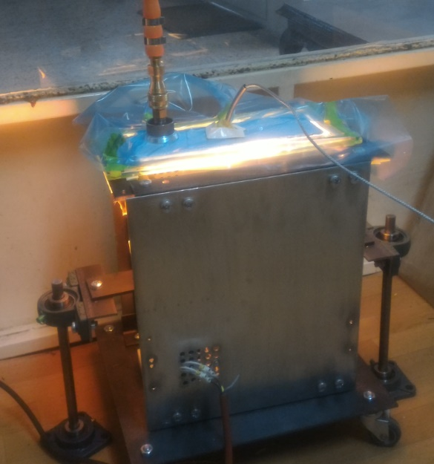 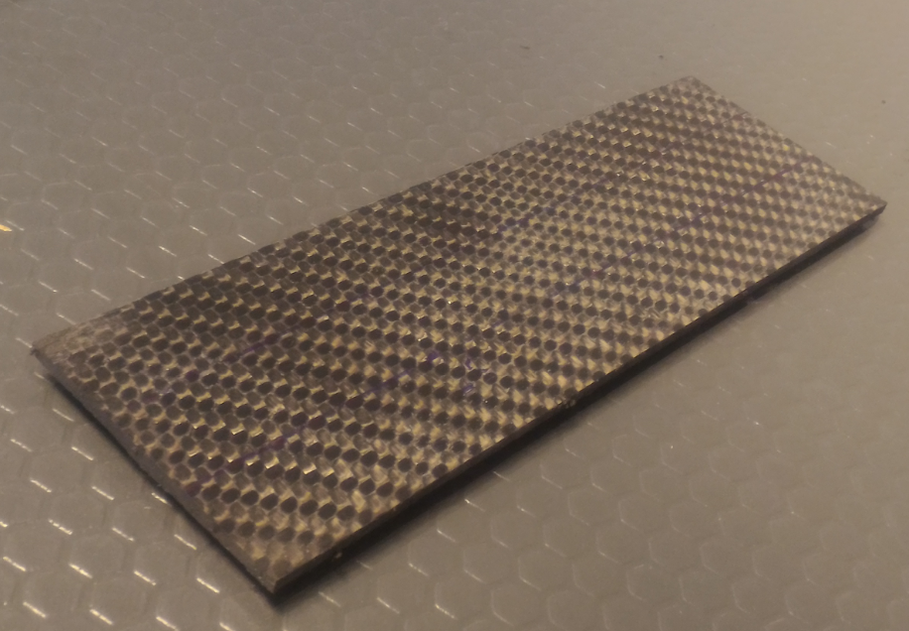

**Figure 1.** **a)** Infrared curing system set up **b)** End product

The oven and test set up is seen in Figure 1. The infrared lamb was placed on an height control mechanism. The distance between the heating source and material was set to 150 mm.

**Results**

Tensile tests were performed to the infrared cured specimens considering ASTM D3039 tensile test standard. The manufacturer’s suggested autoclave cure cycle was imitated (**Figure 2**).

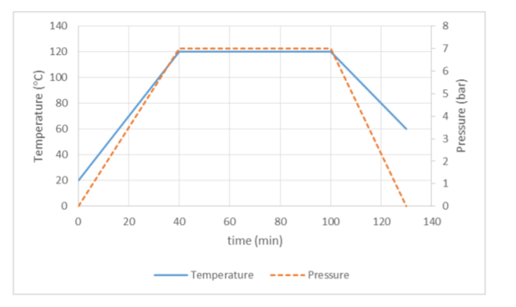

**Figure 2.** Recommended autoclave cure cycle (http://composite.kordsa.com)

However, the outer pressure couldn’t be applied because the structure of the oven did not allow pressure application. The tensile test equipment is UTEST 1000 kN mechanical tensile test device. As seen in the **Figure 3**, the tensile strength of the specimens was found between 659 Mpa and 859 Mpa. These results are in very good agreement with technical data provided by the manufacturer which says 862 Mpa tensile strength.

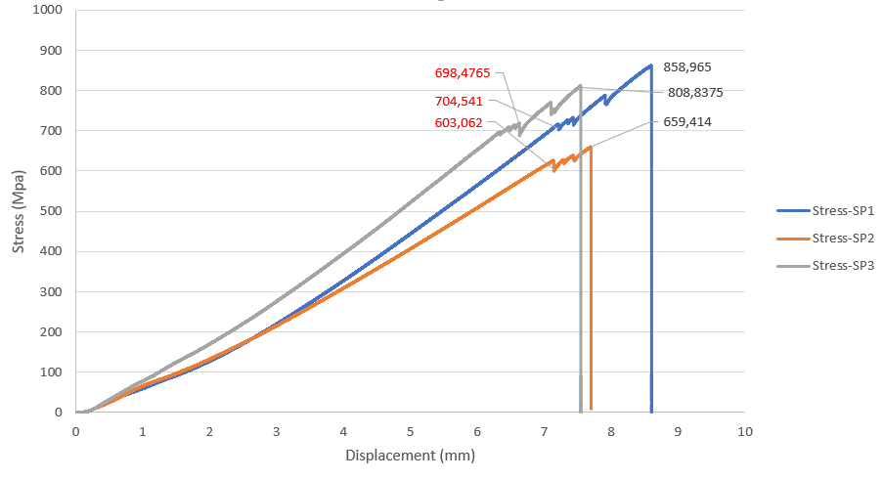

**Figure 3.** Stress-displacement graph of 3 test specimens

Although the ultimate tensile stresses are determined as mentioned, it’s seen that some breaking points have been occurred before final failure. This phenomenon can be attributed to the insufficient consolidation of stacks due to the lack of outer pressure. **Figure 4** shows the specimen after tensile test. It is clearly seen that delamination has been occurred. Therefore, the breaking points can be contented to be related to delamination.

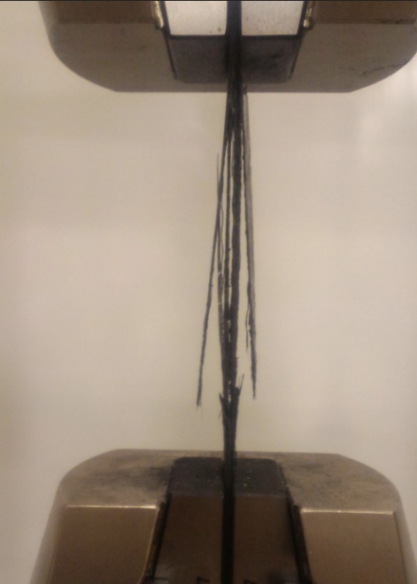

**Figure 4.** Delaminated test specimen

**Conclusions**

A novel infrared composite curing oven was manufactured which is capable of applying vacuum and desired heating rate to the specimen. Tensile tests were performed and according to the results, it can be concluded that infrared curing can be replaced by conventional curing. However, the infrared oven should be properly equipped for outer pressure. Because, although ultimate tensile stresses were found as mentioned, delamination was detected before the final fracture of the fibers. This may be a result of the lack of outer pressure which consolidates the laminates.

**References**

[1] S. Yi, H. H. Hilton, and M. F. Ahmad, “A finite element approach for cure simulation of thermosetting matrix composites,” *Comput. Struct.*, vol. 64, no. 1–4, pp. 383–388, 1997.

[2] G. F. Abdelal, A. Robotham, and W. Cantwell, “Autoclave cure simulation of composite structures applying implicit and explicit FE techniques,” *Int. J. Mech. Mater. Des.*, vol. 9, no. 1, pp. 55–63, 2013.

[3] J. Kakakasery *et al.*, “Cure cycle effect on impact resistance under elevated temperatures in carbon prepreg laminates investigated using acoustic emission,” *Compos. Part B Eng.*, vol. 75, pp. 298–306, 2015.

[4] X. Yan, “Finite element modeling of consolidation of composite laminates,” *Acta Mech. Sin.*, vol. 22, no. 1, pp. 62–67, 2006.

[5] Z. S. Guo, S. Du, and B. Zhang, “Temperature field of thick thermoset composite laminates during cure process,” *Compos. Sci. Technol.*, vol. 65, no. 3–4, pp. 517–523, 2005.

[6] A. Cheung, Y. Yu, and K. Pochiraju, “Three-dimensional finite element simulation of curing of polymer composites,” *Finite Elem. Anal. Des.*, vol. 40, no. 8, pp. 895–912, 2004.

[7] L. Sorrentino and C. Bellini, “Potentiality of Hot Drape Forming to produce complex shape parts in composite material,” *Int. J. Adv. Manuf. Technol.*, vol. 85, no. 5–8, pp. 945–954, 2016.

[8] S. Chen *et al.*, “Double diaphragm forming simulation for complex composite structures,” *Compos. Part A Appl. Sci. Manuf.*, vol. 95, pp. 346–358, 2017.

[9] H. Alshahrani and M. Hojjati, “Experimental and numerical investigations on formability of out-of-autoclave thermoset prepreg using a double diaphragm process,” *Compos. Part A Appl. Sci. Manuf.*, vol. 101, pp. 199–214, 2017.

[10] H. Alshahrani and M. Hojjati, “Influence of double-diaphragm vacuum compaction on deformation during forming of composite prepregs,” *J. Sci. Adv. Mater. Devices*, vol. 1, no. 4, pp. 1–5, 2016.

[11] S. Nakouzi, J. Pancrace, F. M. Schmidt, Y. Le Maoult, and F. Berthet, “Curing simulation of composites coupled with infrared heating,” *Int. J. Mater. Form.*, vol. 3, no. SUPPL. 1, pp. 587–590, 2010.

[12] P. K. Kumar, N. V. Raghavendra, and B. K. Sridhara, “Optimization of infrared radiation cure process parameters for glass fiber reinforced polymer composites,” *Mater. Des.*, vol. 32, no. 3, pp. 1129–1137, 2011.