Self-reinforced poly(lactic acid) composites – processing conditions for industrial applications

Justine Beauson^{1*}, Giacomo Schillani¹, Bo Madsen¹, Lien Van der Schueren², Guy Buyle², Hans Knudsen³

¹ Technical University of Denmark, Department of Wind Energy, Roskilde, Denmark
Email: jube@dtu.dk, Web Page: http://www.vindenergi.dtu.dk/
² Centexbel, Department of Functional Thermoplastic Textiles, Zwijnaarde, Belgium
Web Page: https://www.centexbel.be/fr
³ Comfil ApS, Gjern, Denmark
Web Page: https://www.comfil.biz/

Keywords: self-reinforced polymer composite, bio-composites, manufacturing, poly(lactic acid), sustainable

Abstract
One of the challenges related to the production of self-reinforced poly(lactic acid) (PLA) composites is to define optimal processing conditions. This is required in order to obtain proper melting of the low melting temperature PLA filaments used as matrix, and to maintain the full mechanical properties of the high melting temperature PLA filaments used as reinforcement. This paper focuses on defining the optimal temperature conditions to process self-reinforced PLA composites developed in the European H2020 project BIO4SELF, which aims to use PLA composites in industrial applications. Unidirectional PLA composites were manufactured and characterized using differential scanning calorimetry, mechanical testing and optical microscopy. The results show that 165˚C is the optimal process temperature for consolidation of the PLA composites.

1. Introduction

Due to their attractive properties, combining lightweight properties to high strength and stiffness, composite materials are used in a vast number of applications. Nowadays, the demand is mostly covered by composites made of glass fibres and thermoset matrix [1]. However, as the protection of the environment becomes a major challenge, new legislations make it mandatory for products to be recyclable. As glass fibre reinforced thermoset composites are difficult to recycle, solutions or alternative materials are needed. Self-reinforced polymer composites, where the same polymer material is used for the reinforcement fibres and the matrix, appear as good candidates making composite recycling easier. In this category of materials, self-reinforced poly(lactic acid) (PLA) composites are one of the most promising bio-based materials [2].

In the BIO4SELF project [3], the ambition is to demonstrate the use of bio-based self-reinforced PLA composites in industrial applications. The project covers all the production stages of the materials and aims at bringing self-reinforced PLA composites to prototype products. The work in the project started with the selection of two PLA grades to form the reinforcement fibres and the matrix. An important criterion for the selection of these grades was a significant difference in their respective melting temperature. The two selected PLA grades were compounded, spun into multifilament yarns, and commingled together, forming one multifilament yarn consisting of both reinforcement fibres and matrix. The present paper is focused on manufacturing of composites from the commingled multifilament yarn.

One of the challenges related to the manufacturing of self-reinforced PLA composites is the adjustment of the processing conditions. Optimal processing temperature and time will allow the PLA filaments forming the matrix to melt while leaving the reinforcement PLA filaments un-melted, and with no reduction in mechanical properties. To establish the optimal processing conditions, unidirectional self-reinforced PLA composites were manufactured using different process temperatures. The temperature window to be investigated was selected by analysing the thermal behaviour of the commingled multifilaments with differential scanning calorimetry (DSC). The properties of the composites were analysed by mechanical testing and microstructural observations.

2. Material

The two selected PLA grades will be referred to as PLA_{HM} for the PLA having the highest melting temperature and used as reinforcement fibres and PLA_{LM} for the PLA having the lowest melting temperature and used as matrix. The mechanical properties of the PLA_{HM} and PLA_{LM} filaments are show in Table 1. The two types of PLA were processed into multifilament yarns and thereafter commingled to form a homogeneous multifilament yarn with a mixing ratio of 50% by weight. The linear density of the commingled multifilament yarn was 4000 dtex (= g/10,000 m).

Table 1. Mechanical properties of PLA_{HM} and PLA_{LM} filaments.

 | Stiffness  [GPa] | Strength  [MPa]
PLA_{LM} | 3.9 ± 0.2 | 74 ± 4
PLA_{HM} | 7.4 ± 0.3 | 306 ± 62

3. Methodology

3.1. Thermal analysis of PLA commingled multifilament yarn

DSC measurements were carried out using a Netzsch DSC 214 Polyma (Netzsch, Germany). The thermal properties of interest are the temperature at the melting onset and offset, and the temperature of the melting peak. To determine these properties, three samples of the commingled multifilament yarn were cut into small samples of 6-18 mg and placed into hermetically sealed pans with lids. The used reference sample was an empty aluminium pan. The samples were tested by a single temperature modulated dynamic scan from 5˚C to 200˚C with a heating rate of 5˚C/min. The temperature modulation had a period of 60 seconds and amplitude 0.8 ˚C.

3.2. Manufacturing of unidirectional self-reinforced PLA composites

To produce unidirectional PLA composites, the commingled multifilament yarn was winded on a metal frame in order to get composite plates with dimensions 400 x 250 x 2 mm. The frame with the PLA filament was dried overnight in a vacuum chamber at 35˚C. A press consolidation process was made in two steps using a custom-made press facility. This process is simulating an industrial process where heating and press consolidation/cooling typically are separated to have fast production of parts. The material is first packed and placed in a carrier, see Figure 1, which will move the material to the two sections of the press facility. At the first section, the material is heated up under vacuum to a selected temperature for 10 minutes, see Figure 2. The heating is applied by the contact of two metal plates and controlled by two thermocouples. During this process, the PLA_{LM} filaments forming the matrix are melted. Then, the material is quickly moved by the carrier to the second section, where the material is pressed with 200 kN and cooled down to 30˚C for 1 minute. Considering the dimensions of the material pressed, the equivalent pressure applied is 2 MPa.

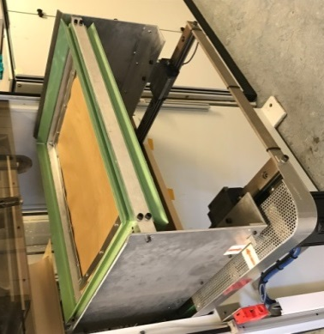 | 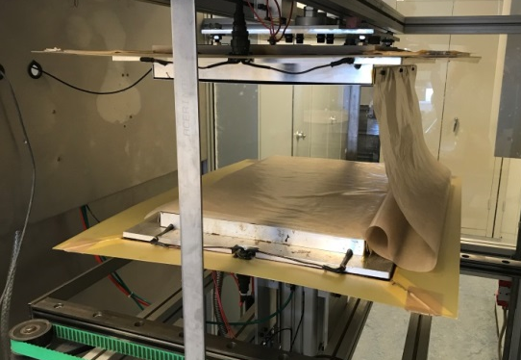
Figure 1. Carrier to transport material between the two sections of the press consolidation facility. | Figure 2. Heating section of the press consolidation facility.

3.3. Thermal analysis of composites

DSC measurements were carried out on the manufactured PLA composites. Samples of 6-18 mg were cut from the composite plates and placed into hermetic sealed pans with lids. The same temperature program was used as described for the analysis of the PLA multifilament yarn.

3.4. Mechanical properties of composites

From the manufactured unidirectional PLA composite plates, specimens for static tensile tests were cut. The specimen dimensions were 180 x 20 mm. The specimens were cut to have different angles between the loading direction, i.e. the long direction of the specimens, and the fibre direction. The angles were 0˚, 15˚, 45˚, 90˚, where 0˚ corresponds to that the loading direction is aligned with the fibre direction. For each angle, 4 test specimens were prepared. The cross-sectional area of the specimens was measured at three different locations, and the averaged cross-sectional area was used for the calculation of stress. Tensile tests were performed with an Instron tensile test machine having a load cell of 25 kN and a cross-head speed of 10 mm/min. Strain was measured by two extensometers centred and aligned on each side of a specimen. Stiffness was determined in the strain range from 0.05 to 0.25 %.

The measured values of composite stiffness were compared to theoretical predictions based on the rule of mixtures model:
$$E_{c}=V_{f}E_{f}+(1-V_{f})E_{m}$$ | (1)

where E_{c} is the composite stiffness, V_{f} is the volume fraction of PLA_{HM} fibres, E_{f} is the stiffness of the reinforcing fibres, i.e. the stiffness of the PLA_{HM} filaments, and E_{m} is the stiffness of the matrix, i.e. the stiffness of the PLA_{LM} filaments.

3.5. Microstructure of composites

Samples for optical microscopy were cut from the manufactured composite plates. The samples were casted in epoxy and polished in the plane normal to the fibre direction. The cross-sections observed were of dimensions 25 x 2 mm². Observations were made using an optical microscope (IM5000, Leica).

4. Results and discussion

4.1. Thermal analysis of PLA commingled multifilament yarn

The results from the DSC measurements performed on the commingled yarn are shown in Figure 3. From the curve, several thermal events can be identified. Around 60˚C, an endothermic peak indicates the glass transition of the PLA_{LM} filaments. Then, at about 80 – 100˚C, an exothermic peak indicates the crystallization of the PLA_{LM} filaments. Such crystallization of the PLA_{LM} filaments is possible during the DSC scan because the applied heating rate is low. However, during the consolidation process of the PLA composites, rapid heating and cooling rates are used, and therefore the PLA_{LM} filaments are not expected to crystallize. Finally, in Figure 3, two endothermic peaks can be seen. The first one at 155.1˚C indicates the melting of the PLA_{LM} filaments, where the melting offset is at 161.4˚C. The second peak is located at 175.1˚C and indicates the melting of the PLA_{HM} filaments, where the melting onset is at 168.2˚C. Given these four determined temperatures for the melting peaks, the temperature window to be investigated for processing of PLA composites was set from 155˚C to 170˚C. In this range, 4 temperatures were selected for the composite manufacturing process: 155˚C, 160˚C, 165˚C and 170˚C. Based on the DSC measurements, it is indicated that at 155˚C and 160˚C, the PLA_{LM} filaments might not be properly melted, but the PLA_{HM} filaments will remain unaffected. At 165˚C, the PLA_{LM} filaments should be properly melted and the PLA_{HM} filaments should still not be affected. However, at 170˚C, the PLA_{HM} filaments could be affected as this temperature is above the melting onset temperature of the PLA_{HM} filaments.

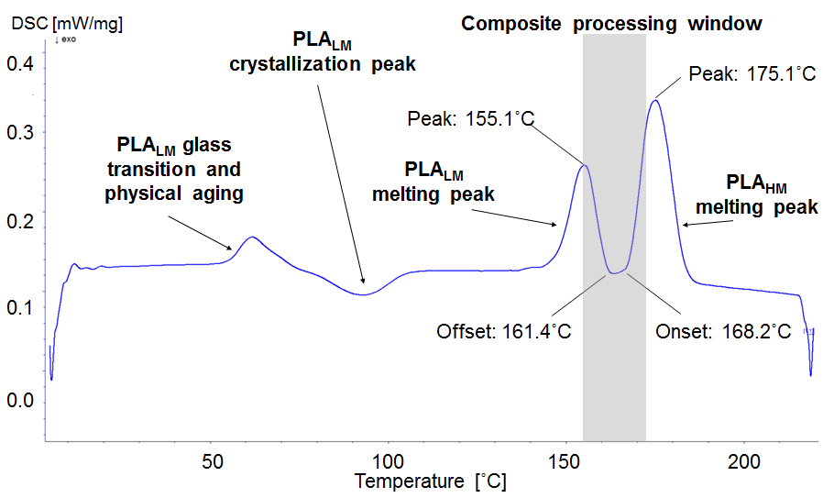  Figure 3. DSC curve of PLA commingled multifilament yarn. | 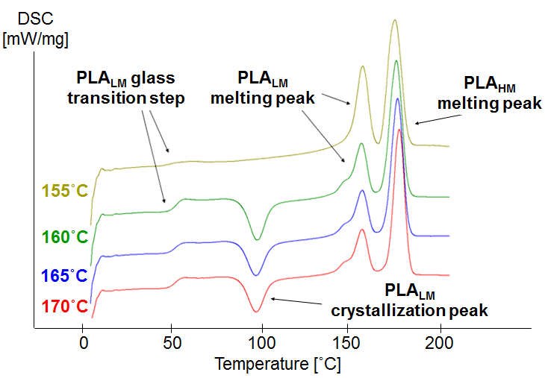  Figure 4. DSC curves of PLA composites manufactured at 155˚C, 160˚C, 165˚C and 170˚C.

4.2 Thermal analysis of PLA composites

The results from the DSC measurements performed on the PLA composites manufactured with the four different temperatures are shown in Figure 4. The DSC curves obtained for the composites manufactured at 160˚C, 165˚C and 170˚C are similar. The first thermal event is the glass transition at around 53˚C, indicating that the composites contain an amorphous phase. This amorphous phase comes from the PLA_{LM} filaments which have not crystallized during the consolidation process. Then at around 99˚C, a crystallization peak (exothermic) indicates the crystallization of the PLA_{LM} matrix material. This thermal event supports that the PLA_{LM} filaments remain amorphous during composite manufacturing. At 155˚C and 177˚C, the curves show two melting peaks, similar to the ones observed for the PLA multifilaments. These peaks correspond to the melting of the PLA_{LM} and the PLA_{HM} filaments. Finally, it can be noted that the areas enclosed by the PLA_{LM} crystallization peak at 99 ˚C and the PLA_{LM} melting peak at 155 ˚C are similar in size, indicating that the matrix PLA in the manufactured composite plate is almost completely amorphous due to the rapid heating and cooling.

In the case of the DSC curve obtained for the composite manufactured at 155˚C, the glass transition event is less clear than for the other curves. This indicates that this composite contains a smaller amount of an amorphous phase. Moreover, the crystallization peak observed at around 99˚C for the other consolidation temperature does not appear. This indicates that the PLA matrix has crystallized during the consolidation process at 155˚C. This could be due to the consolidation temperature not being high enough to properly melt the crystals present in the PLA_{LM} filaments. The presence of some crystals, after the melting step during the composite processing will act as nucleating seeds in the following cooling step accelerating the crystallization. It is reported elsewhere that the crystallization from a melt that contains crystals is significantly faster than a crystallization process from an isotropic melt [4]. Thus, despite the rapid cooling rate applied in the composites manufacturing process, the crystallization process is promoted during cooling thanks to the present crystals. Finally, as for the other curves, the two melting peak of the PLA_{LM} and PLA_{HM} filaments are also visible for the curve at 155 ˚C.

In conclusion, based on the findings of the DSC measurements performed on the PLA multifilament and the PLA composites, it is clear that a composite consolidation temperature of 155˚C is not high enough to properly melt the PLA_{LM} filaments. Regarding the PLA_{HM} filaments, the DSC measurements do not indicate any impact of the consolidation temperatures on these filaments.

4.3 Mechanical properties of PLA composites
Figure 5 shows the measured stress-strain curves of the manufactured composites. The shown curves are for specimens with a 0° loading direction. It can be noted that the first part of the curves until the yielding point is similar for all composites. Table 2 lists the determined mechanical properties. Stiffness is similar for all composites. It is about 5.9 GPa for the composites manufactured at the temperatures 160, 165 and 170˚C, and it is increased slightly to 6.3 GPa for the composite manufactured at 155˚C. It can be seen that the higher the composite manufacturing temperature, the lower is the strength. The strength decreases from 104 to 84 MPa for the same composites. This could be due to thermal degradation of the PLA_{HM}. A similar observation has been reported in a previous study on PLA composites [5].

Using the rule of mixtures model and the filament properties shown in Table 1, the stiffness of the unidirectional PLA composites is predicted to be 5.7 GPa. This value is similar to the one obtained experimentally at 160˚C, 165˚C and 170˚C. The stiffness obtained for the composite consolidated at 155˚C is slightly higher. It was shown from the DSC measurement that the PLA matrix in this composite has crystallized. The presence of a crystalline phase in the matrix will increase the stiffness of the matrix and could explain the higher stiffness properties of the composite consolidated at 155˚C.

Table 2. Mechanical properties of PLA composites manufactured at 155˚C, 160˚C, 165˚C and 170˚C. Loading direction is 0˚.
Consolidation temperature | Stiffness | Strength
[˚C] | [GPa] | [MPa]
155˚C | 6.3 ± 0.1 | 104 ± 5
160˚C | 5.8 ± 0.2 | 106 ± 4
165˚C | 5.9 ± 0.0 | 98 ± 2
170˚C | 5.8 ± 0.1 | 84 ± 7

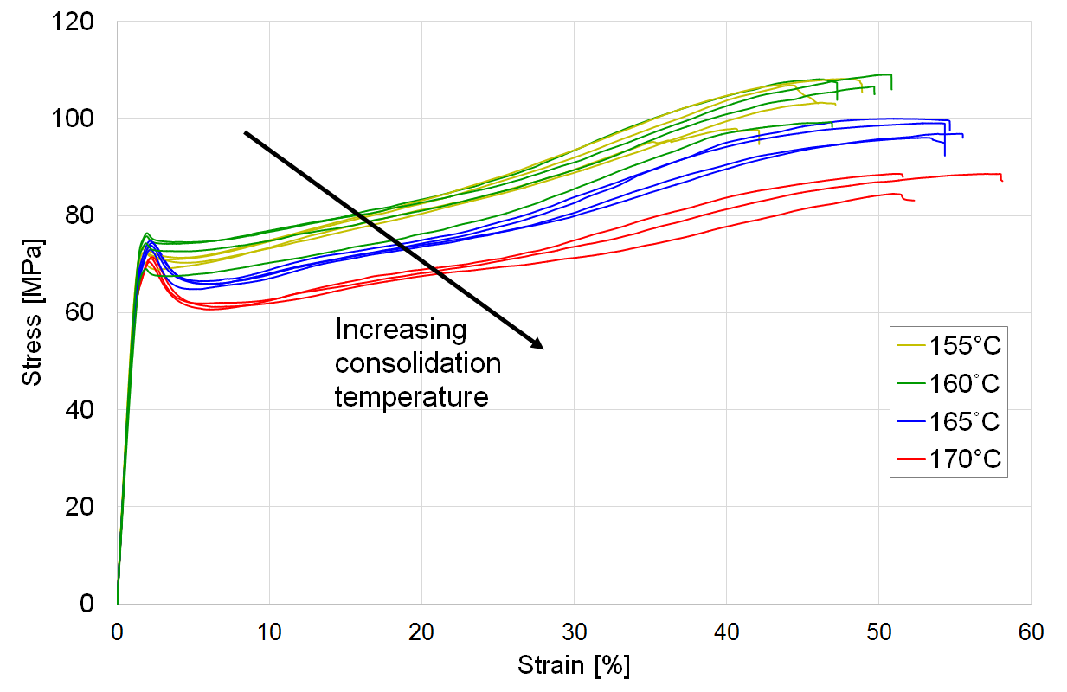

Figure 5. Stress-strain curves of PLA composites manufactured at 155˚C, 160˚C, 165˚C and 170˚C. The loading direction is 0˚.
Figure 6 presents the determined stiffness of the PLA composites as a function of loading direction. The results from such off-axis testing can be used as indication of the level of fibre/matrix adhesion in the composites, in addition to the shear stiffness of the matrix. As presented above, the stiffness of the composites tested with the fibres in the 0˚ direction is similar for all consolidation temperatures. The same can be observed for the composites with the fibres oriented with an angle of 15˚. However, for the larger fibre angles of 45˚ and 90˚, the composite stiffness can be seen to consistently increase when the consolidation temperature is increased, e.g. with a fibre angle of 45˚, the stiffness increases from 2.4 to 3.7 GPa for consolidation temperatures of 155 and 170˚C, respectively. In particular, it can be seen that the off-axis stiffness of the composite consolidated at 155˚C is significantly lower than for the other temperatures. This indicates that the fibre/matrix adhesion is low for the composites consolidated at 155˚C. This is probably due to the fact that the PLA_{LM} filaments are not properly melted leading to poor impregnation of the fibres by the matrix and decreased shear stiffness of the composite. Altogether, the results indicate that the fibre/matrix adhesion is increased when the composite consolidation temperature is increased.

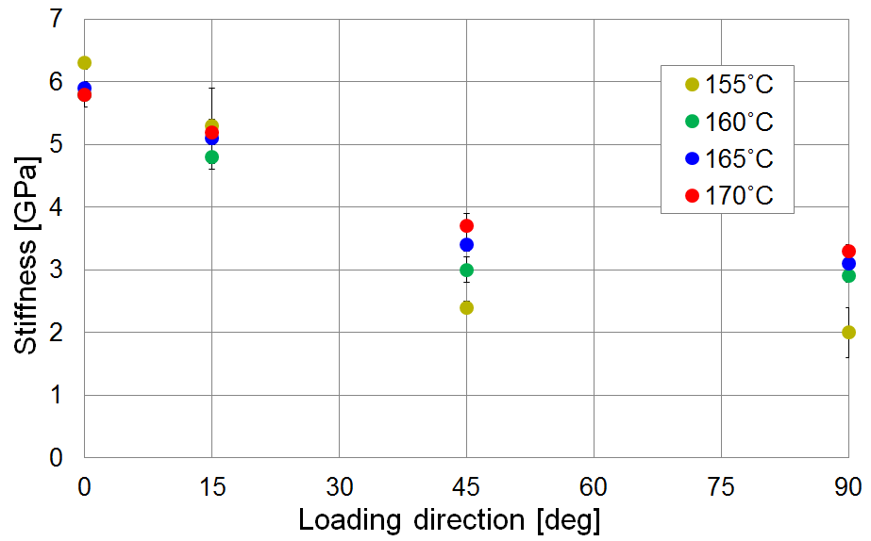  Figure 6. Stiffness of PLA composites tested at different loading directions. The composites are manufactured at 155˚C, 160˚C, 165˚C and 170˚C. | 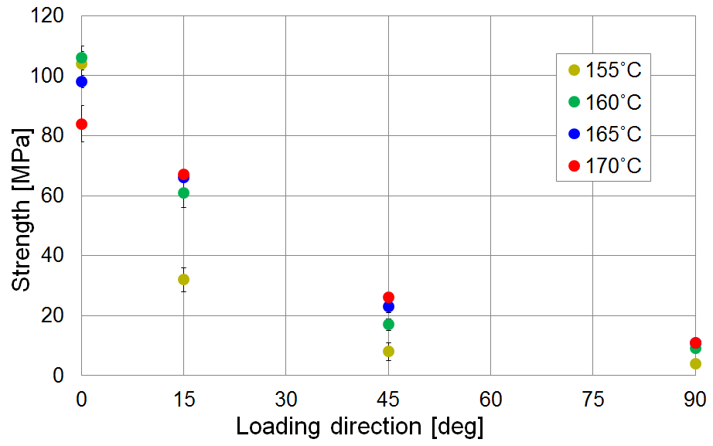  Figure 7. Strength of PLA composites tested at different loading directions. The composites are manufactured at 155˚C, 160˚C, 165˚C and 170˚C.

Figure 7 presents the determined strength of the PLA composites as a function of loading direction. For the 0˚ loading direction, it was observed previously that the composite manufactured at 155˚C had the highest strength. However, already at a fibre orientation of 15˚, the composites manufactured at the higher temperatures show higher strength. The strength of the composites manufactured at 160˚C and 165˚C is measured to be 61 and 66 MPa, respectively, whereas the composite manufactured at 155˚C has a strength of only 32 MPa. For the larger fibre angles of 45˚ and 90˚, similar observations can be made. The higher off-axis strength of the composites consolidated at higher temperature is most likely due to a better melting of the PLA_{LM} matrix, and thereby a better impregnation and bonding of the PLA_{LM} matrix to the PLA_{HM} fibres.

In conclusion, it is shown that 155˚C is not an optimal consolidation temperature for the PLA composites. At this temperature, the PLA_{LM} filaments are not properly melted and this results in poor off-axis properties (stiffness and strength). In addition, in the case where the PLA filaments are aligned with the loading direction of the composite (0°), a consolidation temperature of 170˚C is detrimental to the composite strength properties.

4.4 Microstructure of PLA composites
Regarding the microstructure of the PLA composites, it is shown in Figure 8 that the composite manufactured at 155˚C shows some severe defects, such as dry areas and cracks. At this temperature, it was shown by DSC measurements that the PLA_{LM} filaments were not fully melted. From the microstructure, it can be seen that this has resulted in a poor impregnation of the PLA_{HM} filaments, which explains the poor off- axis properties of this composite. Figure 9 shows a detailed view of a dry area observed in the composite consolidated at 155˚C. Some of the PLA_{LM} filaments are found to still have their original round shape. As shown in Figure 8, the microstructure of the composites consolidated at 160˚C, 165˚C and 170˚C look similar. However, the composites consolidated at 160˚C and 170˚C show some local dry areas. These dry areas could be due to local high concentrations of PLA_{HM} filaments that are difficult to impregnate. Figure 9 shows a detailed view of the composite consolidated at 170˚C. Some fibres are fading and appear with an unclear round shape, which could indicate that these fibres are PLA_{HM} fibres which have started melting. The composite consolidated at 165˚C has a uniform microstructure without any defects. Thus 165 ˚C seems to be the most optimal temperature for consolidating the PLA composites.

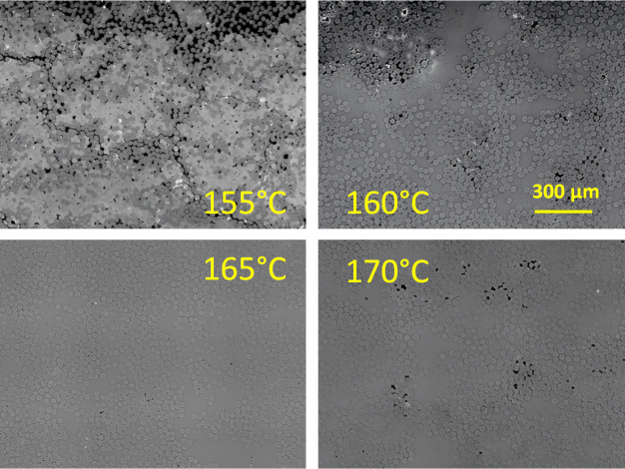  Figure 8. Optical microscope images showing the microstructure of PLA composites manufactured at 155˚C, 160˚C, 165˚C and 170˚C. | 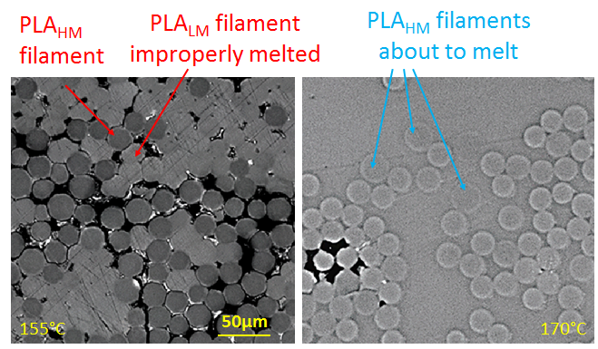  Figure 9. Detailed view of the microstructure in PLA composites.

5. Conclusions

Self-reinforced PLA composites are promising bio-based composite materials, which could be a realistic alternative to fossil fuel based composites. One of the challenges to bring these bio-based PLA materials up to industrial applications is the selection of optimal processing conditions, notably the processing temperature. The processing temperature needs to be finely adjusted in order not to be detrimental to the properties of the reinforcing PLA filaments. The results have shown that the processing temperature affects the microstructure and the mechanical properties of the PLA composites. A processing temperature on 155˚C, which is below the melting offset of the PLA_{LM}, results in an improper melting of the PLA_{LM} filaments leading to porosities in the composites and poor impregnation of the PLA_{HM} filaments. The mechanical properties of composites manufactured at this low temperature are shown to be low in off-axis directions. A processing temperature of 170˚C, which is above the melting onset of the PLA_{HM}, results in a reduction of mechanical properties possibly due to some structural polymer chain re-arrangement in the PLA_{HM} filaments. At this high temperature, the PLA_{HM} filaments in the composite were also found to have melted at some locations. This resulted in poor mechanical properties in the 0˚ direction of the composites. Altogether, it seems that a processing temperature of 165˚C is the most optimal processing temperature. This temperature is located exactly in between the two melting peaks of the PLA_{LM} and PLA_{HM} filaments. The mechanical properties measured for the composite consolidated at this temperature are a good compromise giving good properties for both the measurements made in the 0˚ direction and in the off-axis directions. In addition, the microstructure of the composite shows no defects such as porosities or melted fibres. The results are supporting the ongoing work in BIO4SELF to demonstrate the use of bio-based self-reinforced PLA composites in industrial applications.

Acknowledgements

This work has received funding from the European Union’s Horizon 2020 Research and Innovation Programme under Grant Agreement No 685614

References

[1] E. Witten and M. Sauer. Composites Market Report 2017 – Market developments, trends, outlook and challenges. pp54, 2017.
[2] F. Mai, W. Tu, E. Bilotti, T. Pejs. Preparation and properties of self reinfroced poly(lacti acid) composite. Composite Part A 76: 145-153, 2015.
[3] BIO4SELF project, H2020 Programme of the European Union under Grant Agreement n° 685614, http://www.bio4self.eu/index.html.
[4] R. Androsch. Solid-state reorganization, melting and melt-recrystallization of conformationally disordered crystals (alpha'-phase) of poly (L-lactic acid). Polymer 4932-4941, 2014.
[5] Q.B. Yang and Y. Jun Sun. The Mechanical Property of PLA Fibers Under Heat Treatment. Advanced Material Research 184-187, 2011.

