CFRP Composites Made from Thermoplastic Resin Derived from Cellulose: Chemical Design Targeting Enhanced Fiber-Resin Adhesion

Yoshiro Yasaka¹, Rina Hoshino², Osuke Ishida³, Jyunichi Kitada⁴, Kiyoshi Uzawa⁵, Kenji Takahashi⁶

¹Graduate School of Natural Science and Technology, Kanazawa University,
Kanazawa 920-1192,Japan
Email: yyasaka@se.kanazawa-u.ac.jp
²Graduate School of Natural Science and Technology, Kanazawa University,
Kanazawa 920-1192, Japan
Email: rina09@stu.kanazawa-u.ac.jp
³Innovative Composite Materials Research and Development Center
Kanazawa Institute of Technology, Hakusan 924-0838, Japan
Email: o-ishida@neptune.kanazawa-it.ac.jp Web Page: http://www.icc-kit.jp/
⁴Engineering & Production Group, PROCESS SYSTEMS K.K., Kobe 651-2228, Japan
Email: junichi.kitada@sandvik.com Web Page: http://www.processsystems.sandvik.com/
⁵Laboratory for Integrated Technological Systems, Kanazawa Institute of Technology,
Hakusan 924-0838, Japan
Email: uzawa@neptune.kanazawa-it.ac.jp Web Page: http://www.icc-kit.jp/
⁶Graduate School of Natural Science and Technology, Kanazawa University,
Kanazawa 920-1192, Japan
Email: ktkenji@staff.kanazawa-u.ac.jp
Web Page: http://ktlabo.w3.kanazawa-u.ac.jp/Kenji_Takahashi_Labo/Welcome.html

Keywords: cellulose, thermoplastic, CFRP, flexural strength, elastic modulus

Abstract
CFRP specimens are prepared by hot pressing using a newly synthesized thermoplastic-cellulose-derivative as matrix resins. The cellulose derivative containes furoyl group in addition to normal alkyl groups on the anhydroglucose units to increase the interfacial adhesion of the resin to carbon fibers by chemical bonds. Its viscosity is measured as a function of temperature by a plain plate rheometer to roughly estimate the temperature at which the resin gains enough fluidity for impregnation. Based on the rheology data, several composites are prepared by the hot pressing at constant temperature and pressure (230 °C and 4 MPa) but different pressing time to investigate the progress of the impregnation. It is demonstrated that the pressing time can be as short as 3 min for maximizing the flexural strength of the composite. A longer pressing time does not result in an increase in flexural strength although the apparent density of the composite increased. This is presumably due to a large distortion of the carbon fiber fabric. These results encourage us to make a step forward to continuous production of the CFRP sheets made from thermoplastic cellulose.

1. Introduction

Cellulose, which is a straight-chain polymer of β-glucose, attracts much attention as renewable raw materials [1]. The anhydroglucose unit has three OH groups that can be functionalized by esterification [2,3]. Cellulose derivatives thus obtained possess fluidity at elevated temperatures and thus they have a wide range of potential application as a thermoplastic resin [4]. One of the challenging goals is its application as the matrix of the carbon fiber reinforced plastic (CFRP).
While a large portion of CFRP products are made from thermosetting resin, carbon fiber reinforced thermoplastics (CFRTP) are attracting increasing attention because it can overcome several limitations that conventional CFRPs have, i.e. production (molding) speed, recyclability, etc.[5−7] In particular there have been substantial progress in the double belt pressing (DBP) technique for achieving highly efficient production of stampable plain CFRP sheets. In this manufacturing process, carbon fiber fabric and thermoplastic film are stacked alternatively and fed to the pressing units by moving steel belts. DBP is expected to fascillitate production of very long CFRP sheets compared to the conventional batch pressing.
In order to apply DBP technique for the production of cellulose-based CFRP, several fundamental investigations are necessary. In DBP process, the belt speed is a crucial factor that determines the sheet production speed. As we increase the belt speed we would achieve higher throughput. On the other hand, the mechanical strength of the CFRTP can be negated if the impregnation of the matrix resin to the carbon fiber is insufficient [8]. The impregnation depth of the matrix resin to the plain carbon fiber fabric can be modeled by Darcy’s law [9]:
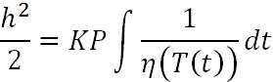 | (1)
where h, t, P, T, η are, respectively, the penetration depth, the time, the pressure, the temperature and the viscosity, respectively and K is a constant. The integral is taken over the time elapsed during the hot pressing. The equation highlights the importance of the pressing time as well as tuning the viscosity (or temperature) of the resin at the time of pressing.
On top of the impregnation, molecular-level interactions between the resin and the carbon fiber also have large impact on the flexural strength of the composite because the fiber-matrix interphase govern the stress transfer between the fiber and the matrix. For example commercial carbon fibers are treated by sizing agents to maximize the adhesion to the epoxy resins. In view of this, our molecular design of cellulose-based resin aims at linking the cellulose backbone and the carbon fiber surface via covalent bonds. Carbon fiber surface is made up with the two dimensional graphene sheet with occasional defects at the edge. These defects are known to have substantial reactivity toward Diels-Alder reaction as a dienophile. Thus our strategy is to introduce dienophile (furoyl group) on the cellulose OH groups via esterification as illustrated in Fig. 1. This molecule expectedly form covalent bonds with the surface of carbon fibers, thereby increasing the mechanical strength of the cellulose-based CFRP.

Figure 1. Chemical structure of the furoyl-functionalized thermoplastic cellulose. R₁ and R₂ are alkanoyl groups (either acetyl, propionyl or butanoyl).

2. Experimental

2.1. Materials

The resin used in this work is a blend of two cellulose esters, namely, cellulose propionate (CP, 95% in weight) and furoyl-functionalized cellulose acetate butyrate (CAB-furoate, 5% in weight). CP was obtained from Scientific Polymer in the form of pellets. CAB-furoate was synthesized in solution phase by using commercial CAB (Eastman) and furoyl chloride. It is to be noted that the commercial CAB has some free OH groups that can react with furoyl chloride. The CP and CAB-furoate were mixed by a kneader and then pelletized. The resultant pellets were reformed into a film (50/100 μm thick, 21 cm wide, 40 m long) by a film molding extruder at DJK Corporation. The carbon fiber fabric used in this work is T700-12k, which is a plain woven fabric obtained from Toray Co., Ltd. We heated the carbon fiber fabric at 240 °C for 8 h to remove the sizing agent, which has negative effects on the impregnation of the cellulose thermoplastics into the carbon fiber bundles (See Sec 3.1).

2.2. Batch press

Batch press was performed using a pressing machine (NSF-37HHC, Shinto Metal Industries Co.) with flat molds. 10 sheets of CAB-furoate/CP film and 9 sheets of carbon fiber plain woven fabric cut in 13.5 cm×13.5 cm were stuck alternatively. The materials were first preheated at 230 °C for 3.5 min to melt the film without applying pressure. Then the materials were pressed at 4 MPa for specified times. The resultant composite was cooled down to 100 °C at an average cooling rate of −65 K/min and was kept at 100 °C for 15 min before the pressure is released.

2.3. Measurements and Characterization

2.3.1. Viscosity.
Viscosity of CAB-furoate/CP was measured by Anton Parr MCR 302 Rheometer at 1 Hz in the temperature range of 170-250 °C.

2.3.2. Flexure test.
Three-point flexure test was performed using a universal testing machine (AG-5kN Xplus, Shimadzu) with 5 mm/min test speed. 5 specimens (15 mm in width, 100 mm in length and ~2 mm thick) were cut from each composite using a diamond cutter.

2.3.3 Density and volume fraction of the composite
Apparent density (ρ) of the composite specimens used for the flexure test was determined from its dimension and weight at room temperature. Apparent volume fraction (V_{f}) was determined by solving the equation below:
(2)
where = 1.80 (density of carbon fiber) and = 1.21 (density of CAB-furoate/CP).

3. Results and Discussion

3.1. Viscosity of the Thermoplastic Cellulose
The aim of this study is to make cellulose-based CFRP spiecemens by the batch press method and measure the flexural strength. In batch press, the resin must penetrate into the carbon fiber bundles while the pressure is exerted to form a good composite. As seen from the Darcy’s law (eq. 1), the impregnation process is mainly governed by the pressing time and the viscosity of the resin. Therefore firstly we measured the viscosity of the CAB-furoate/CP by using rheometer. The results are shown as a function of temperature in Fig. 2. Within the temperature range, the viscosity can be reasonably fitted to an Arrehnius-type function (straight line in the figure). As the viscosity changes by a factor of 3 by an increase/decrease of temperature by 10 K, the impregnation rate is very sensitive to the temperature. In a recent investigation on the DBP process using 6-nylon as the matrix, the impregnation temperature was chosen so that the resin viscosity is less than 100 Pa s [10]. As a first approximation, we decided to take over the same criteria for the CAB-furoate/CP below and set the hot pressing temperature at 230 ºC.
Figure 2. The viscosities of CAB-furoate/CP and pure CP at a frequency of 1 Hz.

3.2. Influence of Sizing Agent
Commercial carbon fibers are often coated with sizing agent. One of its effects is to increase adhesion with the thermosetting epoxy resin, which is probably the most common matrix. However, the identity of the sizing agent is undisclosed and its effect on other matrix resins may vary. In fact, it has been reported that the sizing agent on T700 has negative effect on PA6 (6-nylon) [10].
In view of this we investigated the effect of sizing agent on the cellulose thermoplastic. One composite was made by hot pressing at 230 ºC and 4 MPa for 1 min and another was made in the same manor except that the sizing agent on the carbon fiber had been burnt in advance by a treatment in a furnace (240 ºC, 8 h). The specimens for the flexure tests were obtained from each composite as shown in Fig. 3.

Figure 3. The specimens for the flexure test. The small specimen in the center is used for cross section observation.

The stress-strain curves for the composites with and without sizing agent are compared in Fig. 4. As can be seen there is a qualitative difference between the two samples. In the case of untreated carbon fibers (i.e., fibers coated with sizing agent), the stress-strain curve showed no obvious fracture point. The result suggests that the adhesion between the resin and the fiber is scare. When the sizing agent was removed, the composite showed a distinct fracture point and a larger flexural strength. The results indicate that the sizing agent has negative effect for cellulose-based thermoplastic and it can be effectively removed by thermal treatment.
Figure 4. The stress-strain curve for the composites made of carbon fibers with and without sizing agent. The composites are made by hot pressing at 230 ºC and 4 MPa for 1 min.
(b)
(a)

Figure 5. Comparison of the flexural strength and the elastic modulus of
the composites made of carbon fibers (a) with and (b) without sizing agent. The box bars and the circles are, respectively, for the max stress and the elastic modulus. The sample number denotes to the position in the composite (See Fig. 3) . The horizontal line denotes typical flexural strength and the elastic modulus for the PA6 (6-nylon)-CFRP.

3.3. Effect of Molding Time

To evaluate the time scale of the impregnation of the resin, several composites are prepared by setting various pressing time t (elapsed time while the pressure is applied) at fixed temperature and pressure (230 ºC and 4 MPa). The flexural strengths and elastic modulus of the composites are reported in Fig. 6. The max strength increased with time for t ≤ 3 min but showed no significant change for longer pressing times. The elastic modulus showed a similar trend; it monotonously increased for t ≤ 5 min but nearly constant for larger t. For the production throughput, shorter pressing time is desirable. Therfore hot pressing results suggest that the composite strength and the throughput of the production are maximized when we choose the pressing time between 3-5 min. The max strength and the elastic modulus in this consition are ~600 MPa and ~55 GPa, respectively.
The cross-section images of the composite made by 1 and 2 min of hot pressing are shown in Fig 7. There are observed weft and warp carbon fiber bandles. A horizontal thin gray layer observed in the middle of the pictures indicate where a cellulose film was inserted. The thinkness of the film decreased from 100 μm to typically less than 10 μm after hot pressing because most resin impregnated between the fibers. In zoomed images at the bottom, characteristic circular cross-section of carbon fibers are apparent in white. The horizontal band of gray color is the residual film. The same color tone between the carbon fiber bandles indicate the resin that has been impregnated. On the other hand there are occasional black color in panel a. The black color indicates the absence of the resin; the adjacent carbon fibers are not supported by the resin. To obtaine stronger conmpoistes it is desirable to decrease the void. When the hot pressing time is increased to 2 min, the void siginifacantly decreased (panel b). Concomitatly the flexure strength of the composite increased. These results highlight the importance of impregnation.

Figure 6. Effect of the time of hot pressing on the flexural strength. Circles and squares denote max strength and elastic modulus, respectively. The elastic modulus is determined from the slope (secant) of the stress-strain curve in the range of 20-100 N force.

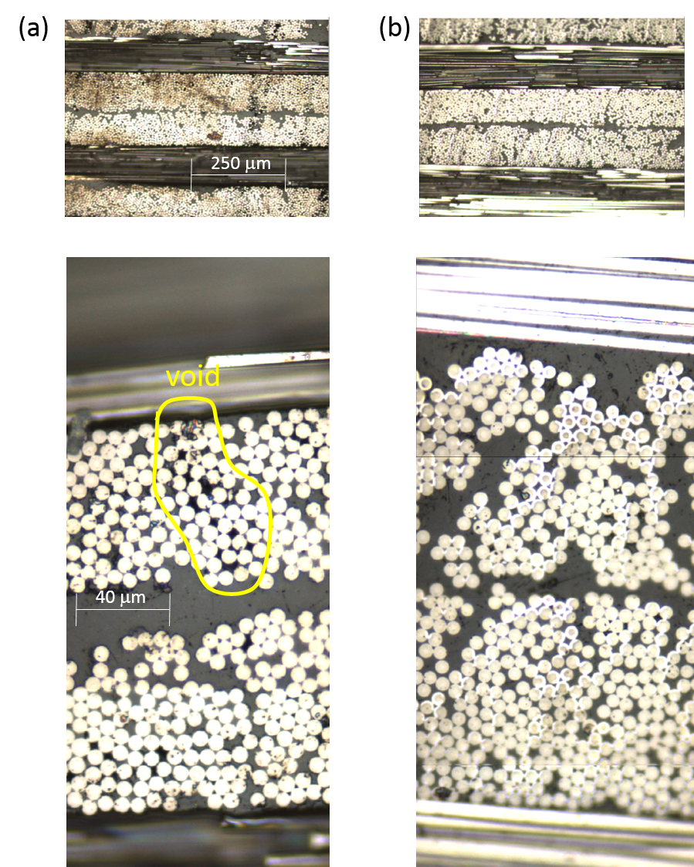

Figure 7. The cross secion images of the composites made by hot pressing for (a) 1 min and (b) 2 min.
The yellow closure in panel a exemplifies the occurance of voids.

From the cross section images of the compsites obtained by the pressing times longer than 2 min (not shown), it was judged that the carbon fibers are somewhat more densly packed for longer pressing times. The observation was consistent with a continuous increase of the apparent fiber volume fraction (V_{f}) of the composite (48 % for 3 min and 54 % for 9 min). The elastic modulus of the composite slightly increased with the imcrease of V_{f}. The max stress, however, was not positively affected by the pressing time presumably because the impregnation is almost saturated within 2 min.

4. Conclusions

The flexural strengths and elastic modulus of the composites made of thermoplastic cellulose and carbon fiber have been evaluated. By tethering normal cellulose ester with a diene functionality by the furoyl group, it is demonstrated that the cellulose-based composites can be nearly as strong as those made from PA6 Nylon. Microscopic observations of the composite cross section have revealed that the resin has sufficiently penetrated between the fiber bundles at mild pressure and short process time. Based on these results we anticipate the applicability of the double belt pressing technique for the continuous production of cellulose-derived CFRPs

Acknowledgments

The authors thank the COI program, "Construction of next-generation infrastructure using innovative materials - Realization of a safe and secure society that can coexist with the Earth for centuries" supported by MEXT and JST. This study was also supported in part by the Advanced Low Carbon Technology Research and Development Program (ALCA) and the Cross-ministerial Strategic Innovation Promotion Program (SIP) of the JST.

References

[1] D. Klemm, B. Heublein, H. P. Fink, A. Bohn. Cellulose: fascinating biopolymer and sustainable raw material. Angew. Int. Ed., 44: 3358-3393, 2015.
[2] R. Kakuchi, M. Yamaguchi, T. Endo, Y. Shibata, K. Ninomiya, T. Ikai, K. Maeda, K. Takahashi. Efficient and rapid direct transesterification reactions of cellulose with isopropenyl acetate in ionic liquids. RSC Adv., 5: 72071-72074, 2015.
[3] R. Kakuchi, R. Ito, S. Nomura, H. Abroshan, K. Ninomiya, T. Ikai, K. Maeda, H. J. Kim, K. Takahashi. A mechanistic insight into the organocatalytic properties of imidazolium-based ionic liquids and a positive co-solvent effect on cellulose modification reactions in an ionic liquid. RSC Adv., 7: 9423-9430, 2017.
[4] K. J. Edgar, C. M. Buchanan, J. S. Debenham, P. A. Rundquist, B. D. Seiler, M. C. Shelton, D. Tindall. Advances in cellulose ester performance and application. Prog. Polym. Sci., 26: 1605-1688, 2001.
[5] J. M. Henshaw, W. Han, A. D. Owens. An overview of recycling issues for composite materials. J. Thermoplast. Compos. Matter, 9: 4-20, 1996.
[6] X. Zhang, H. Xu, X. Fan. Grafting of amine-capped cross-linked polyphosphazenes onto carbon fiber surfaces: a novel coupling agent for fiber reinforced composites. RSC Adv., 4: 12198-12205, 2014
[7] D. Liu, Y. Zhu, J. Ding, X. Lin, X. Fan. Experimental investigation of carbon fiber reinforced poly(phenylene sulfide) composites prepared using a double-belt press. Composites Part B, 77: 363-370, 2015.
[8] A.G. Gibson and J.-A. Manson. Impregnation technology for thermoplastic matrix composites. Composites Manufacturing, 3: 223-232, 1992.
[9] R. Phillips, D.A. Akyuz, J.-A.E. Manson. Prediction of the consolidation of woven fibre-reinforced thermoplastic composites. Part I. Isothermal case. Composites Part A, 29A: 395-402, 1998.
[10] O. Ishida, W. Okumura, H. Saito, M. Kimizu, K. Uzawa, I. Kimpara. Effects of press molding conditions on impregnation and mechanical properties of carbon fiber fabric/PA6 film composite. Proceedings of the 19th International Conference on Composite Materials (ICCM-19), Montreal, Canada, July 29-August 2 2013.

