EuroSun2026
PERFORMANCES OF PVT FIELDS FOR LOW TEMPERATURE DISTRICT HEATING

Elsabet Nielsen, Simon Furbo, Mark Dannemand, Weiqiang Kong
Department of Civil and Mechanical Engineering, Technical University of Denmark
elsa@dtu.dk, sifu@dtu.dk, markd@dtu.dk, weiko@dtu.dk
Summary
An online software tool for calculating the thermal and electrical output of large PVT fields in connection with low temperature district heating systems has been developed. The PVT field produces electricity and heat at low temperatures. The heat is generated by an increase of the temperature of the heat transfer fluid circulating through the PVT field.
The online software tool, which is based on thermal and electrical efficiency equations for PVT panels, has been used to calculate the yearly thermal and electrical performances of PVT fields for four locations in Europe: Stockholm and Gothenburg in Sweden, Copenhagen in Denmark and Lisbon in Portugal. For most temperature levels in the PVT panels, the performances are highest in Lisbon, followed by Copenhagen, Gothenburg and Stockholm. The lower the panel temperature is, the higher the performance will be, both the thermal and the electrical performance.
The heat produced by the PVT field can be transferred to a low-temperature district heating network or a thermonet through a heat exchanger and be used as a source for individual heat pumps which will deliver the temperature level required by the consumers.
Keywords: PVT fields, low temperature district heating, calculations, yearly performances
Field of application for the findings: Preliminary evaluation of suitability of PVT fields connected to low flow temperature district heating systems
Addressed audience: Researchers, consultants, energy planners, decision makers, district heating companies
- Introduction
An online software tool based on efficiency equations for a PVT panel and PVT field has been developed based on the theory described in Dannemand et al. (2025). The simulation tool can calculate the yearly performances of PVT fields installed on the ground with several parallel rows with serial connected PVT panels. The simulation tool is available on https://pvtfield.streamlit.app/. Calculations with the tool, which is similar to the simpler ScenoCalc program, can be used to achieve a quick estimate of expected performances of PVT fields. The PVT fields are assumed to be connected to district heating systems. The PVT fields produce electricity and heat at low temperatures. The heat is generated by a temperature increase of the heat transfer fluid circulating through the PVT fields.
The heat produced by PVT fields can be transferred to the water of district heating networks by means of heat exchangers. The water can be distributed to the consumers via a thermonet or a 5th generation district heating network and used as a source for individual heat pumps which will deliver the temperature level required by the consumers. Another way for district heating companies to utilize the heat produced by the PVT fields is by means of large, centralized heat pumps to increase the temperature in the district heating network to the required level at the district heating plant.
- Method
The calculations assume that the PVT field consists of 25 parallel rows with 20 south facing serial connected unglazed PVT panels installed in each row, and the row distance is 5 m. Both the PV area and the absorber area of each PVT panel is 2 m² resulting in a total panel area of the PVT field of 1000 m². The calculations are based on the following equations for the PVT panel:
Thermal performance:
$\dot{Q}=\left[\begin{aligned}η_{0,b}⋅K_{b}\left(θ\right)⋅G_{b}+η_{0,b}⋅K_{d}⋅G_{d}-a_{1}⋅\left(T_{m}-T_{a}\right)-a_{2}⋅\left(T_{m}-T_{a}\right) abs\left(T_{m}-T_{a}\right) \\ -a_{3}⋅u⋅\left(T_{m}-T_{a}\right) {+ a}_{4}\left(E_{L}-σT_{m}^{4}\right)-a_{6}⋅u⋅\left(G_{b}+G_{d}\right)\end{aligned}\right]$ (eq. 1)
where the incidence angle modifier is determined by:
$K_{b}(θ)=1-\tan^{p}{(}θ/2)$ (eq. 2)
Electrical performance:
$P/A_{G}=G(b_{D}-b_{1}∙Θ_{m}-b_{2}∙Θ_{a}-b_{3}∙G)$ (eq. 3)
The symbols used are shown in the symbol list, table 2.
The height of the PVT panel above the ground is assumed to be 2 m and the mean solar collector fluid temperature of the panels is maintained constant during the year. It is also assumed that the absorber temperature and the PV temperature are equal to the solar collector fluid temperature. Calculations are carried out for four locations: Stockholm - latitude 59.4°, Gothenburg - latitude 58.0°, Copenhagen - latitude 55.7° and Lisbon - latitude 38.7°. The weather data used in the calculations for the four locations are taken from the fifth generation of global climate and weather reanalysis produced by the European Centre for Medium-Range Weather Forecasts (ECMWF), ERA5 for 2023, https://cds.climate.copernicus.eu/datasets/reanalysis-era5-single-levels?tab=overview. For each time step of the year with a duration of 1 h, the heat and electricity production by the PVT panels are calculated by means of equations 1, 2 and 3.
The parameters for the efficiency expressions for the PVT panels are given in Table 1.
Tab. 1: Efficiencies for PVT panel
Thermal efficiency/parameter | Quantity | Electrical efficiency/parameter | Quantity
Peak collector efficiency based on G_{b}, η₀,b | 0.60 | Coefficient for the electric power output, $b_{D}$ ​ | 0.20
Constant in IAM coefficient, p | 4.50 | Coefficient for the electric power output, $b_{1}$ | 0.0005 1/K
IAM for diffuse solar radiation, K_{d} | 0.92 | Coefficient for the electric power output${, b}_{2}$ | 0.0005 1/K
Heat loss coefficient, $a_{1}$ | 15.0 W/(m²K) | Coefficient for the electric power output$, b_{3}$ | 0.000001 m²/W
Temperature dependence of heat loss coefficient, $a_{2}$ | 0 W/(m²K²)
Wind speed dependence of heat loss coefficient, $a_{3}$ | 5.0 J/(m³K)
Sky temperature dependence of heat loss coefficient, $a_{4}$ | 0.85
Wind speed dependence of zero loss efficiency, $a_{6}$ | 0.05 m/s
- Results
Yearly thermal performances and yearly electrical performances are calculated for the four European locations mentioned in chapter 2. The performances for the PVT field with a panel tilt of 35° located in Stockholm and Gothenburg and with a panel tilt of 30° located in Copenhagen and Lisbon are shown in figure 1 and figure 2 as functions of the mean collector fluid temperature.

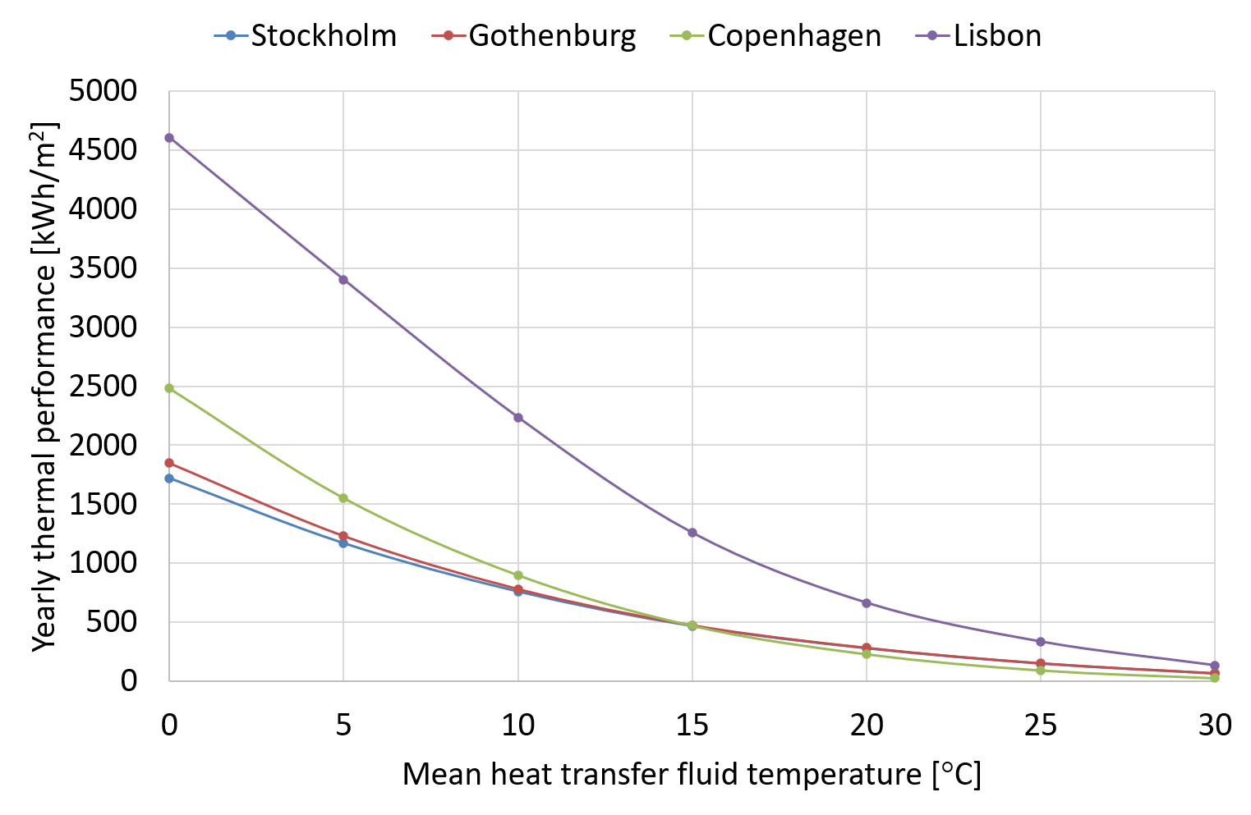

Fig. 1: Yearly thermal performance of PVT field in Lisbon, Copenhagen, Gothenburg and Stockholm as function of the mean collector fluid temperature

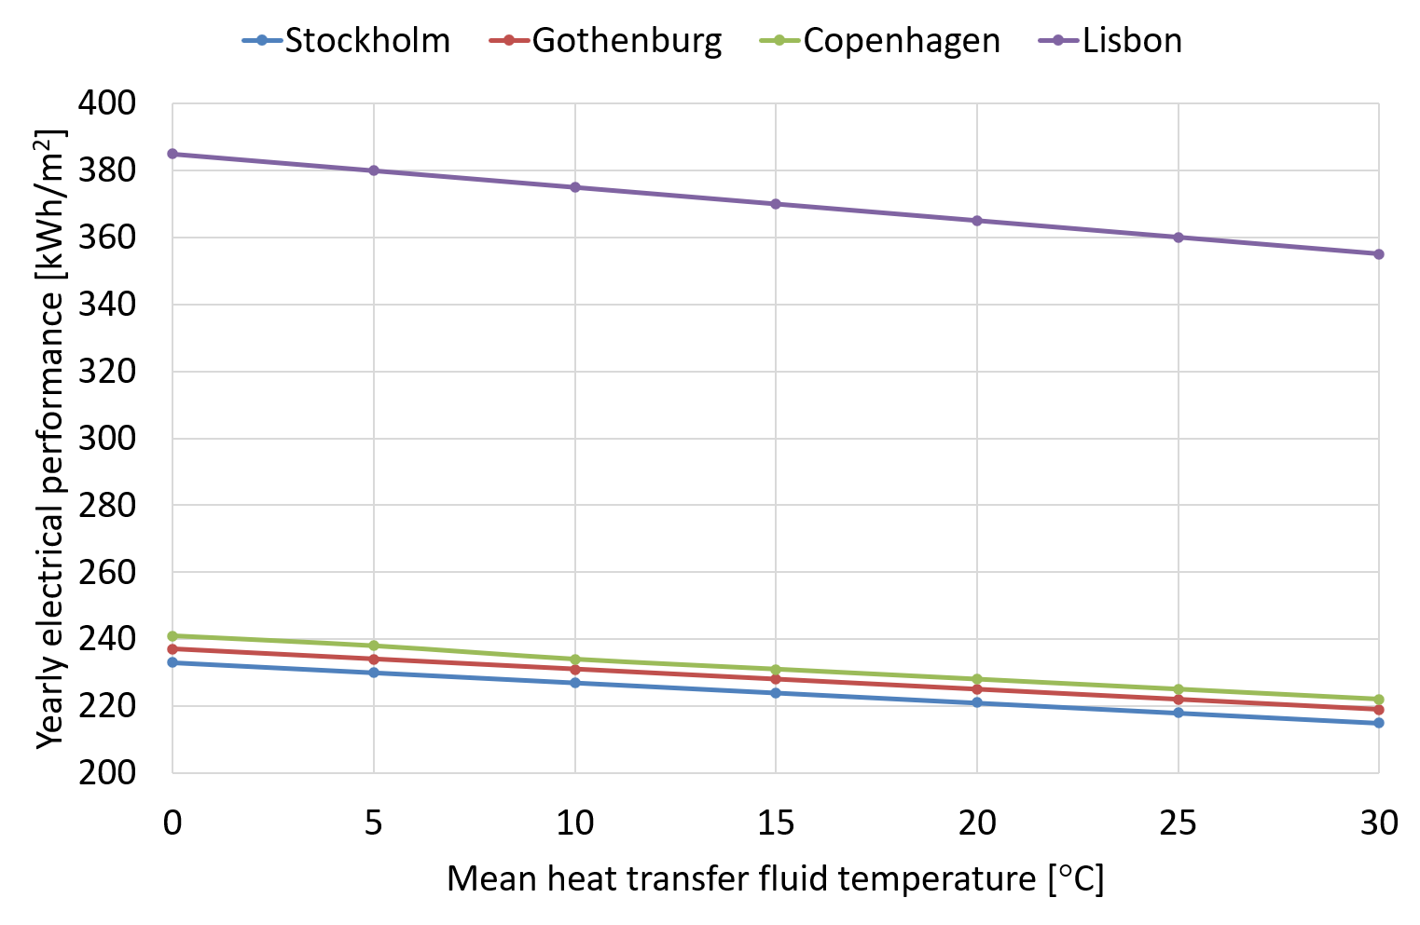

Fig. 2: Yearly electrical performance of PVT field in Lisbon, Copenhagen, Gothenburg and Stockholm as function of the mean collector fluid temperature
For increasing fluid temperature, the performances are decreasing, as expected. The thermal performance is highly influenced by the mean temperature of the heat transfer fluid, while the electrical performance only increased by about 8-9% by decreasing the mean heat transfer fluid temperature from 30°C to 0°C.
The performances are by far highest for Lisbon, both due to the high solar radiation and high outdoor temperature. For the Nordic countries, the thermal performance for low heat transfer fluid temperatures is highest in Copenhagen followed by Gothenburg and Stockholm, while the electrical performances in Copenhagen, Gothenburg and Stockholm are almost the same.
- Discussions
The performances presented in chapter 3 are based on the efficiency equations mentioned in chapter 2. It must be mentioned that the effects of condensation and ice formation on the surfaces of the PVT panels caused by low operation heat transfer fluid temperatures are not considered in the calculations. Further, the influences of rain and snow on the efficiencies of the PVT panels are not included. Consequently, it is estimated that the performance of an actual installation will differ somewhat from the calculations presented in chapter 3, especially for low temperature levels when rain, snow, condensation or ice formation occurs on the panels.
It is therefore recommended to carry out research on how condensation, ice formation, rain and snow influence the efficiency and performances of PVT panels and PVT fields.
- Conclusions
An online software tool for calculating the thermal and electrical output of large PVT fields in connection with low temperature district heating systems has been developed. Both the thermal and electrical performance of PVT fields for low temperature district heating located in four European cities, Lisbon, Copenhagen, Gothenburg and Stockholm, is increasing for decreasing heat transfer fluid temperature. The thermal performance is strongly influenced by the mean temperature of the heat transfer fluid, while the electrical performance only increased by about 8-9% by decreasing the mean heat transfer fluid temperature from 30°C to 0°C.
The performances are by far highest for Lisbon, both due to the high solar radiation and high outdoor temperature. The electrical performances in Copenhagen, Gothenburg and Stockholm are almost the same, while the thermal performance for low heat transfer fluid temperatures is highest in Copenhagen followed by Gothenburg and Stockholm.
- Acknowledgement
The online software was developed, and the calculations were carried under the framework of the PVT4EU project, granted by the Clean Energy Transition Partnership Programme (project ID. CETP-2022-00403). National funds support the work through Sweden: Swedish Energy Agency (P2023-00884); Denmark: Innovation Fund Denmark (3112-00010B); and Portugal: FCT- Fundação para a Ciência e a Tecnologia, I.P. (CETP/0004/2022). The study was also supported by the Swedish Energy Agency (grant number 2021-036454) through the Resilient Competence Center.
- References
Dannemand, M., Furbo, S., Kong, W., Cardoso, J.P., Facão, J., Vilke, G., 2025. PVT4EU, Photovoltaic and Thermal for Europe. D5.1 Report on selected application scenarios and simulation models.
https://cds.climate.copernicus.eu/datasets/reanalysis-era5-single-levels?tab=overview
https://pvtfield.streamlit.app/

Tab. 2: Symbols used
Quantity | Symbol | Unit
Heat production | $$\dot{Q}$$ | W/m²
Peak collector efficiency based on Gb | $$η_{0,b}$$ | -
IAM for direct solar irradiance | $$K_{b}\left(θ\right)$$ | -
Incidence angle | $$Θ$$ | °
Beam irradiance on PVT panel | G_{b} | W/m²
IAM for diffuse solar radiation | K_{d} | -
Diffuse irradiance on PVT panel | G_{d} | W/m²
Heat loss coefficient | $$a_{1}$$ | W/(m²K)
Mean temperature of the heat transfer fluid | T_{m} | K
Ambient air temperature | T_{a} | K
Temperature dependence of heat loss coefficient | $$a_{2}$$ | W/(m²K²)
Wind speed dependence of heat loss coefficient | $$a_{3}$$ | J/(m³K)
Wind speed | u | m/s
Sky temperature dependence of the heat loss coefficient | $$a_{4}$$ | -
Longwave irradiance | $$E_{L}$$ | W/m²
Stefan-Boltzmann constant | $$σ$$ | 5.6704 × 10⁻⁸ W / (m²K⁴)
Wind speed dependence of zero loss efficiency | $$a_{6}$$ | s/m
Constant in IAM coefficient | p | -
Electricity production | P | W
Gross area of PVT panel | $A_{G}$ | m²
Total solar irradiance on PVT panel (G=Gb+Gd) | G | W/m²
Coefficient for the electric power output | $b_{D}$ | -
Coefficient for the electric power output | $b_{1}$ | 1/K
Mean temperature of the heat transfer fluid | $Θ_{m}$ | °C
Coefficient for the electric power output | $b_{2}$ | 1/K
Ambient air temperature | $Θ_{a}$ | °C
Coefficient for the electric power output | $b_{3}$ | m²/W

