EuroSun2026
MITIGATING PV CURTAILMENT THROUGH ENERGY STORAGE IN SOUTH GERMANY: A PYPSA-BASED ANALYSIS
Philip Kozan, Felix Uhrig, Florian Uhrig
Battery and hydrogen systems, Technische Hochschule Nürnberg Georg Simon Ohm, Nürnberg, Germany
philip.kozan@th-nuernberg.de, felix.uhrig@th-nuernberg.de, florian.uhrig@th-nuernberg.de
Summary
This study aims to identify optimal PV curtailment mitigation strategies for a 600 kWp east-west-oriented photovoltaic (PV) system in southern Germany using batteries and electrolysers. The analysis is conducted using the open-source Python framework PyPSA to create the energy storage system model and to identify curtailment mitigation solutions. The model incorporates measured data from the PV system, weather data for the correlating location and day ahead market electricity prices. Three system topologies are investigated: PV with battery storage, PV with an electrolyser, and PV with both battery storage and an electrolyser. Parameter studies are conducted regarding battery capacity, C-rate and electrolyser nominal power. Results show that 100 % of the curtailed energy can be stored by either a 1800 kWh battery with a C-rate of 1 h⁻¹, a 500 kW electrolyser or a combination of a 400 kWh battery with a C-rate of 1 h⁻¹ and a 300 kW electrolyser. These findings indicate that electrolyser nominal power should be prioritised as the electrolyser can utilise most curtailed energy for a prolonged period while batteries are limited to their maximum capacity. In these configurations batteries increase levelised cost which is why these should be kept at lower capacities and be used to store generation peaks and support electrolyser operation. This study shows that storage technologies can be used to eliminate grid side curtailments of PV systems, but increases in cost are to be expected.
Keywords: PV curtailment, energy storage system, PyPSA, electrolyser, battery
Field of application for the findings: decentralised energy systems, energy storage
Addressed audience: grid operators, PV system owners, researchers in the field of energy, techno-economic analysts, energy system modelers
- Introduction
The rapid expansion of photovoltaic (PV) installations has made solar power a significant contributor to renewable electricity generation in Germany. By 2025, installed PV capacity reached around 119 GWp and generated more than 91 TWh of electricity, while system costs have fallen by nearly 90 % since 2010 (Wirth, 2026, p. 6-9). However, the growing share of PV in the grid also creates operational challenges, leading to substantial curtailment of PV systems. In 2024, curtailment in Germany amounted to approximately 1.4 TWh, representing a 97 % increase compared to 2023 (Diermann, 2024). In 2025 PV curtailment amounted to 2.7 TWh, indicating a 93 % increase in PV curtailments compared to the previous year (Energy-Charts.de, 2026). These interventions restrict the effective use of renewable resources and pose a risk to PV system investments. The underlying problem causing PV curtailments is the increasing penetration of PV systems in the electricity grid. As conventional power plants provide less flexibility, when electricity generation exceeds demand, primarily renewable assets are curtailed to maintain grid stability (O’Shaughnessy et al., 2020). Due to varying weather conditions, PV power generation fluctuates, which can strain the electricity grid and lead to curtailment measures aimed at maintaining grid stability (Harag et al., 2023). In Germany PV curtailments are usually financially compensated through the regional grid operators. However, the overall system utilisation is reduced with potential renewable power generation remaining unused. Historically, negative electricity prices provided little incentive for PV system operators to reduce generation, as the compensation under the German renewable energy sources act continued to pay out (Kern et al., 2024). However, as of 25th of February 2025 newly commissioned PV systems in Germany no longer receive remuneration anymore during periods of negative electricity prices (Bundesgesetzblatt, 2025). This in turn incentivises PV system owners and grid operators to adapt energy storage systems to store surplus energy in periods of grid congestion to avoid curtailment.
Consequently, the deployment of storage systems has gained increasing attention to store surplus power generation (Choudar et al., 2015). Due to their high efficiency, long cycle life and high energy density, lithium ion batteries are currently in high demand (Ajibade et al., 2024). Effective integration of PV systems requires batteries to retain sufficient charging capacity around midday in order to store excess generation and reduce feed-in peaks (Wirth, 2026, p. 28). Therapontos et al. (2025) have demonstrated that battery systems can reduce PV curtailments in Cyprus to 10 %.
In addition to batteries, electrolysers have gained increasing attention as a flexibility option for mitigating renewable energy curtailment by converting surplus electricity into hydrogen. Since the launch of the national hydrogen strategy in Germany, installed electrolyser capacities have grown and reached a capacity of 185 MW in 2025 (dena.de, 2026). The strategy aims to reach 55 to 80 GW of operational electrolysers by the year 2045 (Robinius et al., p. 20). The two most common electrolyser types are alkaline water electrolysis (AEL) and proton exchange membrane (PEM) electrolysers. Due to the fast start-up time and dynamic operating characteristics, PEM electrolysers are particularly suitable as flexible loads for fluctuating renewable power generation (Holst et al., 2021). A case study for Germany shows that electrolysers can reduce curtailment of renewable energy sources by 7 to 29 % (Kisse et al., 2024). In storage concepts with batteries and electrolysers, batteries mitigate short-term fluctuations in PV output, while hydrogen-based storage enables long-term and seasonal energy balancing (Bondar, 2025).
Various methods exist for analysing curtailment mitigation potential in renewable energy systems, with optimisation algorithms and simulation software representing the most applied approaches. Such techniques have been used to identify that between 69.5 % and 95.2 % of PV curtailments can be reduced using battery storage with a capacity size twice as large as the installed PV power generation in Japan (Udawalpola et al., 2021). MATLAB based optimisation studies of hybrid energy storage systems (HESS), combining batteries and super capacitors, have shown that fluctuating power generation of PV systems can be smoothed while simultaneously maintaining economic viability (Ma et al., 2019). Storage systems that combine batteries and electrolysers for hydrogen production can reduce curtailments by 36 % for PV plants (Yang et al., 2024). Further studies for storage systems with electrolysers show that batteries can be used to store excess energy, supply the electrolyser and simultaneously reduce curtailments (Mukoni and Garner, 2025). Building on the current state of research, this study seeks to evaluate the impact of battery storage, electrolysers and the combination of the two technologies on complete mitigation of PV curtailments in southern Germany. Given the increasing deployment for renewable energy, batteries and hydrogen in Germany, assessing these technologies for reliable operation under real-world curtailment conditions is therefore relevant. This study develops, models, and optimises storage system configurations integrating PV, battery storage and an electrolyser with the objective of eliminating grid side PV curtailment while accounting for techno-economic performance. The results provide guidelines for the integration of batteries and electrolysers into PV systems.
- Methodology
This study was conducted for a location in southern Germany, characterised by higher solar irradiation and lower average wind speeds than northern Germany (Energydata.info, 2026). These prerequisites render the location particularly well-suited for PV capacity expansion and the analysis of curtailment mitigation through energy storage systems. The simulations and optimisation presented in this study were performed using PyPSA (Python for Power System Analysis), an open-source framework for modelling, simulation, and optimisation of power systems (pypsa.org, 2026). To evaluate the potential of energy storage technologies for mitigating PV curtailment, a PyPSA model was developed using standard network components. The reference system comprises a grid-connected 600 kWp PV plant with equal installed capacities of east-facing and west-facing PV arrays. The PV system does not serve local electricity demand and is therefore analysed as a pure grid-feed-in system. Based on this reference system, battery storage, an electrolyser, and a combination of both technologies are successively integrated, resulting in three alternative system configurations. These configurations are subsequently analysed using optimisation-based simulations. The model is parameterised using power generation data from a PV system at a Bavarian industrial site, with measurements recorded at 15-minute intervals over the course of 2024. Throughout the timeline several days have been identified with PV curtailments. Additionally for arbitrage trade and electricity procurement for the storage components, the day ahead electricity prices from the electricity market for the corresponding year 2024 have been imported from Energy-Charts.de (Energy-Charts.de, 2026). The optimisation employs a 24-hour rolling horizon, enabling dispatch decisions to account for forecasts of PV generation and day-ahead electricity prices. This horizon was selected based on previous research showing a suitable balance between forecast accuracy and computing time (Kyriakidis et al., 2025). Weather data are provided by the python library atlite, which is used to simulate site-specific PV generation (Hofmann et al., 2021). Comparing simulated and measured PV output enables the identification and quantification of grid operator-induced curtailment events. The open-source Python package Linopy is used to build and process the model for optimisation (Hofmann, 2023). For this study, the network is optimized using the HiGHS solver, which supports linear, mixed-integer, and quadratic programming (Huangfu and Hall, 2017). PyPSA networks are optimised based on techno-economic constraints to identify the most technologically and economically efficient solution to the network configuration. The individual network components are modelled using component-specific constraints, as summarized in Table 1.

Table 1: Economic and technological parameters used for the energy system components in PyPSA
 | PV system | Battery | Electrolyser
Investment cost | 900 € kW⁻¹ (Kost et al., 2024) | 600 € kWh⁻¹ (Kost et al., 2024) | 3120 € kW⁻¹ (Ffe, 2025)
Lifetime | 30 a (Kost et al., 2024) | 15 a (Kost et al., 2024) | 10 a (Holst et al., 2021)
Interest rate | 5 % | 5 % | 5 %
Maintenance cost | 13.3 € kW⁻¹ (Kost et al., 2024) | 2 % of investment cost (Kost et al., 2024) | 20 € kW⁻¹ (Holst et al., 2021)
Capacity | 600 kWp | 400 – 1800 kWh | 50 – 500 kW
Efficiency | Based on atlite simulated capacity factor | Round trip efficiency: 90 % (Kurzweil and Dietlmeier, 2018) | Efficiency curve
C-Rate battery |  | 0.25 h⁻¹, 0.5 h⁻¹, 1 h⁻¹ | -
Tilt for PV | - ° | - | -
Azimuth for PV | - ° (east) /  305.15 ° (west) | - | -

The PV system is modelled based on a feed-in tariff of 7.7 ct kWh⁻¹, which corresponds to the current tariff set by the Federal Network Agency for installed PV systems with a maximum output of up to 1000 kW (Bundesnetzagentur.de, 2026). In addition to storing the curtailed PV energy, the battery can also procure electricity from the grid for arbitrage trading. Similarly, the electrolyser is connected to the grid, enabling it to consume both PV generated and grid-supplied electricity. Both the battery and the electrolyser are thus charged the German electricity tax (2.05 ct kWh⁻¹), combined heat power (0.45 ct kWh⁻¹) and offshore levy (0.941 ct kWh⁻¹), concession fees (2 ct kWh⁻¹) and surcharge for special grid usage (1.56 ct kWh⁻¹), resulting in a fixed price of 7 ct kWh⁻¹ plus the day ahead price for the electricity (Netztransparenz.de, 2026). Currently, electrolysers can be exempt from the network fee and tax according to the German federal network agency. However, this only applies to electrolysers that start operation before the year 2030, which is why for this study all network fees and taxes apply equally to the electrolyser, as this exemption is set to be cancelled in the foreseeable future (GW, 2024). Additionally, 0.2 ct l⁻¹ for water consumption of the electrolyser is assumed based on the average German water cost (destatis.de, 2026). The day-ahead electricity prices were smoothed using a rolling mean function to reduce the high volatility in the 15-minute price series and improve computational efficiency. Additionally, parameter studies are conducted regarding battery capacity, C-rate and electrolyser nominal power. The electrolyser is modelled with an efficiency curve (Schmidt 2022, p. 277-282). The results include curtailed energy amount of the PV system that can be stored, equivalent full cycles of the battery, full load hours of the electrolyser and levelised costs. The levelised cost of hydrogen and electricity (LCOH/ LCOE) are calculated using equation 1. The capital expenditures (CAPEX) are annualised using an annuity factor a, which is calculated using the component lifetime n and the interest rate r in equation 2. The operational expenditures (OPEX) entail maintenance cost and for the battery and electrolyser, the network fees and procurement costs. The meaning of the abbreviations for the equations is listed below. The LCOE is calculated based on expenditures of the components contributing to electricity generation and the amount of electricity supplied. Likewise, the LCOH is determined from electrolyser-related cost and the amount of hydrogen generated. Whenever electricity generated within the system is consumed by the electrolyser, the corresponding LCOE is considered as operating cost in the LCOH. When LCOH are converted from ct kWh⁻¹ to € kg_{H2}⁻¹ the higher heating value of 39.4 kWh kg⁻¹ is used.

$$LCOH/LCOE=\frac{a⋅CAPEX+OPEX}{E_{generated}} (eq. 1)$$

$$a=\frac{r}{1-{\left(1+r\right)}^{-n}} (eq. 2)$$

Definition | Abbreviation | Unit
Levelised cost of hydrogen | LCOH | ct kWh⁻¹
Levelised cost of electricity | LCOE | ct kWh⁻¹
Annuity factor | a | -
Capital expenditures (annualised) | CAPEX | € a⁻¹
Annual operational expenditures | OPEX | € a⁻¹
Annual generated energy amount | E_{generated} | kWh a⁻¹
Interest rate | r | %
Component lifetime | n | a

- Results
In the first step, the PV system is analysed without energy storage. This scenario serves as the reference case for the subsequent analyses. The data show that 49.1 MWh were curtailed throughout the year 2024. The total annual energy generation potential of the PV system amounts to 567.6 MWh, indicating that 8.7 % of its generation potential is curtailed. Fig. 1 shows the monthly amount of curtailed PV energy over the course of 2024. Curtailment was exclusively observed between March and September. The highest curtailed PV energy was recorded in June, exceeding 20 MWh and accounting for more than 40 % of the annual curtailed energy. Curtailment predominantly occurs during the summer months due to higher solar irradiance, which increases the generation potential of the PV system and leads to more frequent curtailment events. These curtailments consequentially influence the levelised cost of electricity (LCOE) for the PV system. The LCOE with curtailments are calculated at 8.3 ct kWh⁻¹, while without any curtailments they would decrease to 7.6 ct kWh⁻ 1, showing that curtailments increase LCOE, as less of the PV power generation potential is utilised.
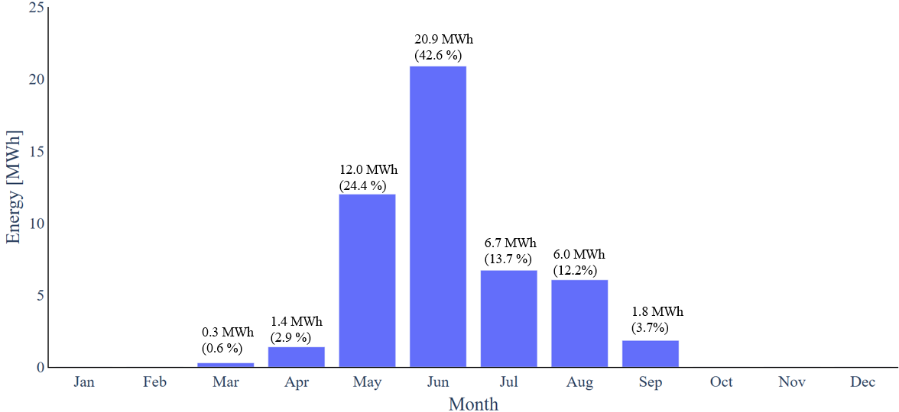
Fig. 1: Monthly accumulated curtailed PV energy for the investigated PV system in 2024
Fig. 2 shows an example of a PV curtailment event by comparing the measured PV power output with the simulated generation potential. While the measured power output drops abruptly to 0 kW, the atlite simulation indicates continued generation potential, confirming that the reduction in power output is caused by grid-induced curtailment rather than adverse weather conditions. The curtailment starts at 12:15 and ends at 16:45, resulting in a duration of 4.5 hours. During this period, 1.4 MWh of energy is curtailed.
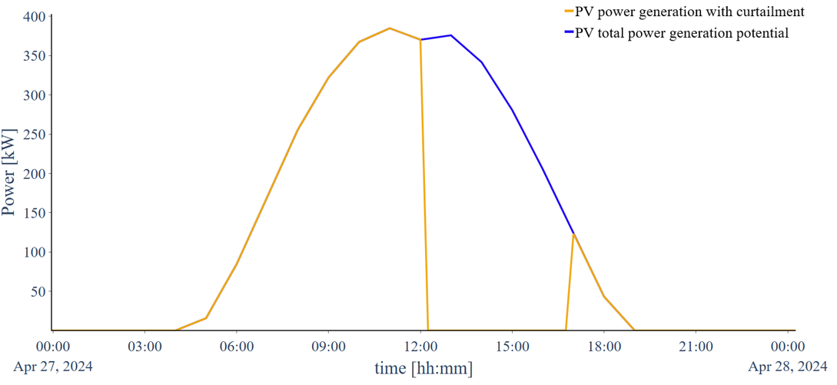
Fig. 2: Comparison of measured PV power output and simulated generation potential during a curtailment event on 27 April
The base model with the PV system is extended by integrating a battery. In the first parameter analysis, battery capacities of 400 kWh, 1200 kWh and 1800 kWh are evaluated, each with a C-rate of 0.5 h⁻¹. The C-rate describes the charging and discharging speed of a battery relative to its storage capacity. For example, a battery with 400 kWh and a C-rate of 0.5 h⁻¹ can charge and discharge at a maximum power of 200 kW and thus be fully charged within two hours. The annual amount of curtailed PV energy that can be stored by the batteries based on capacity size is presented in Fig. 3. The 400 kWh battery stores 17.2 MWh a⁻¹ of otherwise curtailed electricity, corresponding to 35 % of the total curtailed energy. Increasing the capacity to 1200 kWh stores 42.7 MWh a ⁻ ¹ (87 %), while the 1800 kWh battery stores 48.6 MWh a⁻¹, equivalent to 99% of curtailed energy. These results show that higher battery capacities can recover a greater share of curtailed PV generation, thereby substantially reducing PV curtailment.
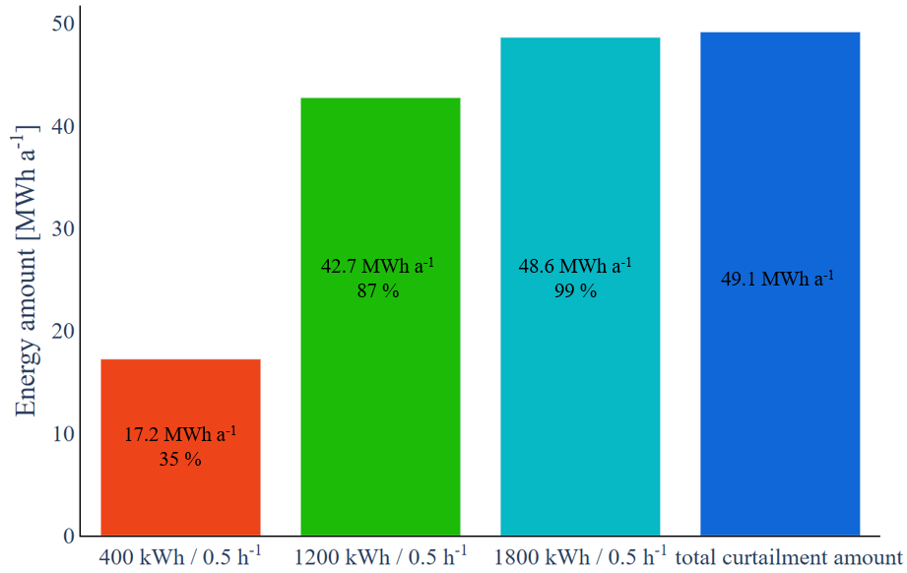
Fig. 3: Annual amount of curtailed PV energy stored by batteries of different capacity (all batteries with 0.5 h⁻¹)
The following parameter analysis examines the impact of the battery C-rate on the utilisation of curtailed PV energy for a constant battery capacity, comparing C-rates of 0.25 h⁻¹, 0.5 h⁻¹, and 1 h⁻¹. Fig. 4 demonstrates that a 1200 kWh battery with higher C-rates can store more curtailed electricity than lower C-rates. For comparison the 1200 kWh battery with a 0.25 h⁻¹ C-rate stores 78.2 % of curtailed energy, 87 % with 0.5 h⁻¹ C-rate and 96.7 % with 1 h⁻¹ C-rate. These results indicate that doubling the C-rate for this battery in this case increases the amount of curtailed energy that can be stored between roughly 8 to 10 %. For the 400 kWh battery this increase lies between 6 to 9 %, while for the 1800 kWh battery between 1 to 4 %. These results show that increasing C-rate benefits lower battery capacities in curtailment mitigation, as this in turn gives the battery with a higher C-rate more flexibility to charge higher PV power outputs. Increasing C-rate with higher battery capacities results in moderate increase in the amount of curtailed energy stored, suggesting that the benefits of higher C-rates diminish beyond a certain level, as most curtailment events appear to provide sufficient time for charging even at lower C-rates when capacity is high enough.
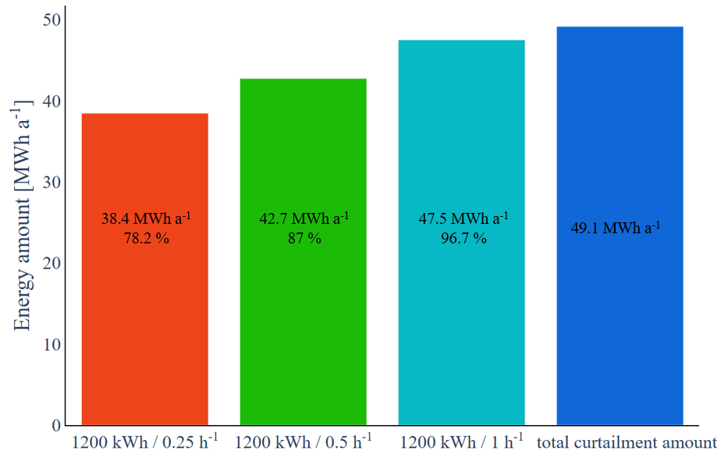
Fig. 4: Annual amount of curtailed PV energy stored by batteries of different C-rate
To illustrate the operating strategy, Fig. 5 presents the charging and discharging behaviour of a 400 kWh battery with a 1 h⁻¹ C-rate on a representative day (27 April 2024). The figure presents the power profiles of the PV system and the battery, together with the corresponding electricity market prices. Negative battery power indicates charging operation. When PV curtailment begins at 12:15, the battery starts charging the maximum power output of the PV of 375 kW and subsequently continues charging at a lower rate of approximately 40 kW to prolong curtailment mitigation. Once curtailment ends at 16:45, the battery stops charging, as it is fully charged. Later during periods of high electricity prices, the battery discharges the stored energy to the grid, thereby generating revenue by arbitrage trade. For comparison, the 400 kWh battery with a C-rate of 0.25 h⁻¹ can only charge at one quarter of its nominal capacity, limiting its ability to store high PV generation peaks around midday. Consequently, less curtailed PV energy can be stored compared to the battery with higher C-rates.
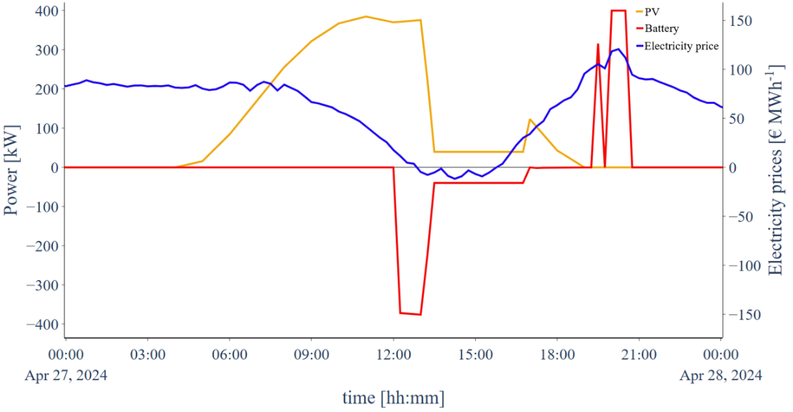
Fig. 5: Time series of PV power output (yellow), battery power (red), and electricity prices (blue) for a 400 kWh battery with a 1 h⁻¹ C-rate
This analysis evaluates the economic performance of the PV battery system. Fig. 6 presents the levelised cost of electricity and the equivalent full cycles (EFC) for all investigated PV battery configurations as heat maps. In the heat map, the LCOE and EFC are visualised using a colour gradient, where dark blue is a low value and bright yellow a high value. The heat maps use 9 simulated data points (marked with x) and a linear interpolation between the points for a clearer visualisation of the results. The results show that the lowest LCOE for this system is achieved with a 400 kWh battery and a C-rate of 1 h⁻¹. These configurations also exhibit the highest EFC, indicating a high utilisation of the battery. As a result, investment and operating cost are distributed over a larger amount of delivered electricity, leading to lower system LCOE. Increasing the battery capacity further reduces PV curtailment. However, the additional capacity is utilised seldom to its full extent. Consequently, EFC decrease while the higher investment costs associated with higher battery capacity leads to an increase in system LCOE. For comparison, LCOE of the standalone PV system is 8.3 ct kWh ⁻¹, increasing to 13.5 ct kWh ⁻¹ with a 400 kWh and 1 h⁻¹ C-rate battery and to 29.2 ct kWh⁻¹ with an 1800 kWh 0.25 h⁻¹ C-rate battery. This shows that batteries effectively mitigate curtailments, but lead to cost increase. These findings are consistent with previous studies, which generally report higher LCOE values for PV systems combined with battery storage (Kost et al., 2024). The EFC in this regard decrease from 507 cycles a⁻¹ with a 400 kWh 1 h⁻¹ C-rate battery to 251 cycles a⁻¹ with an 1800 kWh 0.25 h⁻¹ C-rate battery. Therefore, within the investigated parameter range, batteries with a C-rate of 1 h⁻¹ and relatively small capacities provide the most favourable trade-off between curtailment reduction and economic performance.
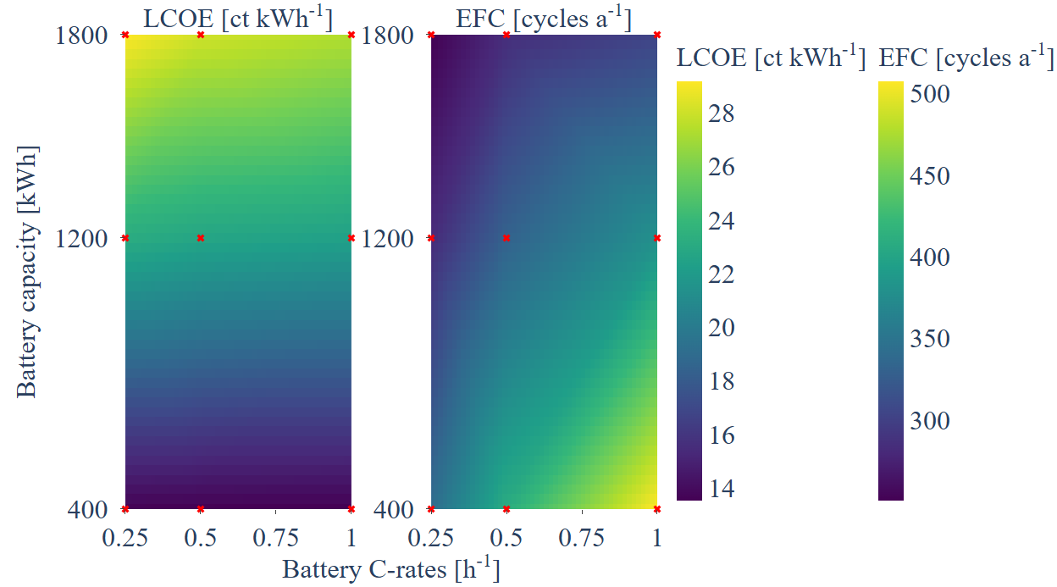
Fig. 6: Heat maps of the PV battery system levelised cost of electricity (LCOE) and battery equivalent full cycles (EFC) as a function of battery capacity and C-rate
In the next step, the battery is replaced by an electrolyser. A parameter analysis is performed to investigate the impact of electrolyser nominal power on the mitigation of PV curtailment. Fig. 7 shows that electrolysers with higher power can recover an increasing share of curtailed electricity. While a 50 kW electrolyser utilises only 20 % of the curtailed energy (9.8 MWh a⁻¹), a nominal power of 300 kW already enables the utilisation of 94.7 % (46.5 MWh a⁻¹). A further increase to 500 kW results in the complete utilisation of the curtailed energy potential (49.1 MWh a⁻¹). These results indicate that the electrolyser power is the primary factor limiting curtailment recovery in the investigated system. Due to their finite storage capacity, batteries may be unable to store all curtailed energy during consecutive days of curtailment events if residual charge from previous days remains in the system. The electrolyser in contrast does not exhibit this problem and can utilise curtailed energy at a constant rate for prolonged periods of time.
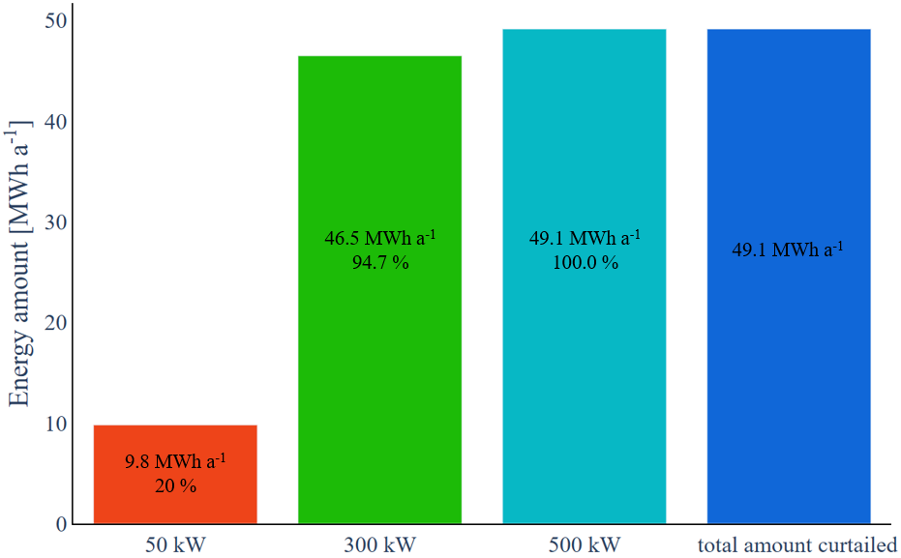
Fig. 7: Amount of curtailed PV energy utilised by the electrolyser depending on its nominal power
The operational strategy for a 50 kW electrolyser on the example day 27 April is illustrated in Fig. 8. It is apparent that, early in the day, before the PV starts generating power, the electrolyser is operating at partial load using electricity procured from the grid. As PV generation starts in the morning due to diffuse solar irradiance, the electrolyser is increasingly supplied with PV electricity until full-load operation is reached. Throughout the day, the electrolyser primarily utilises PV power and utilises curtailed PV energy up to its nominal power of 50 kW. As PV generation decreases towards sunset, the electrolyser gradually switches back to grid electricity. When electricity prices spike operation is suspended until either electricity prices decrease or PV power becomes available. This operational strategy enables the electrolyser to maximise the utilisation of curtailed PV energy while maintaining economic operation through the procurement of low-cost grid electricity, thereby increasing annual full-load hours (FLH).
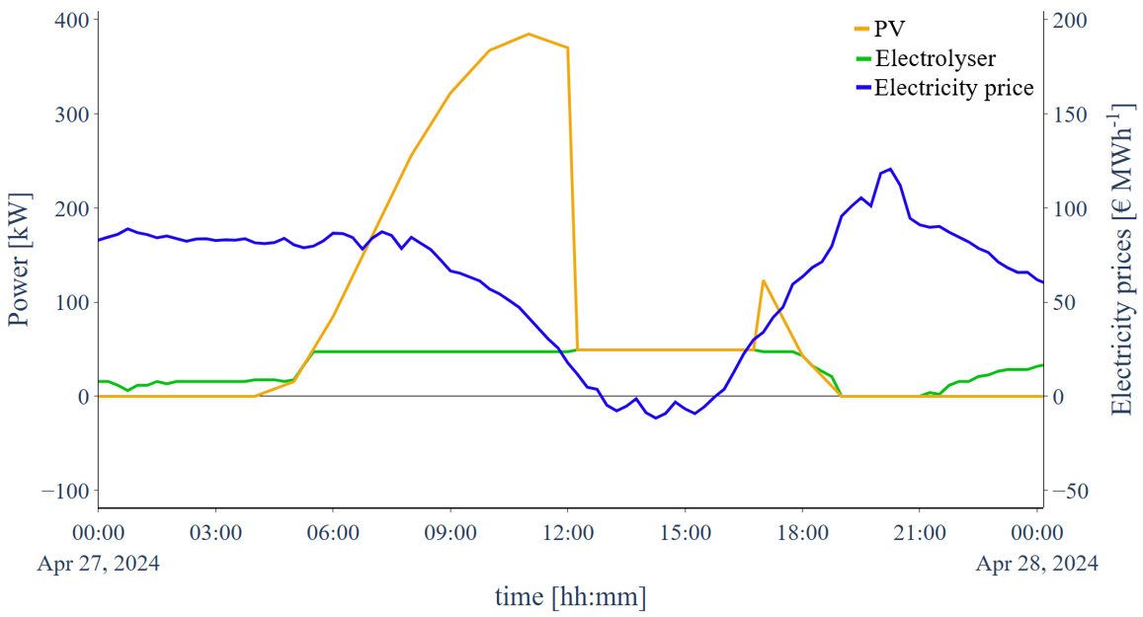
Fig. 8: Time series of PV power output (yellow), electrolyser power consumption (green), and electricity market prices (blue) on a reference day for a 50 kW electrolyser
For comparison, the 50 kW electrolyser achieves 5135 h a⁻¹ of full load hours per year, while the 300 kW and 500 kW systems achieve 4144 h a⁻¹ and 3869 h a⁻¹, when grid electricity procurement is permitted in addition to PV supply. When market access is denied, the 300 kW electrolyser, for example, achieves 1824 h a⁻ ¹ when supplied solely by PV electricity, which is a 56 % decrease. This highlights the important role of grid electricity in increasing electrolyser utilisation. The levelised cost of hydrogen (LCOH) for this configuration decrease with increasing electrolyser nominal power, which with a 50 kW electrolyser results to 19.3 ct kWh⁻¹ (7.6 € kg_{H2}⁻¹), with a 300 kW electrolyser to 18.9 ct kWh⁻ ¹ (7.5 € kg_{H2}⁻¹) and with a 500 kW electrolyser to 18.4 ct kWh⁻¹ (7.3 € kg_{H2}⁻¹). As the electrolyser with higher nominal power withdraws more low-cost PV electricity and generates more hydrogen, the LCOH in turn decrease. For comparison when the 300 kW electrolyser has no market access, LCOH increase from 18.9 ct kWh⁻¹ to 44.1 ct kWh⁻¹ (17.4 € kg_{H2}⁻¹), corresponding to an increase of more than 133.3 %. In contrast the LCOH for a 50 kW electrolyser without grid connection increase by 57.5 %, showing that grid connection becomes more essential for the economic operation of electrolysers with higher nominal power. Even though the lower electrolyser power achieves higher full load hours (FLH) than higher electrolyser power, the LCOH decreases with larger capacities, as greater electrolyser capacities generate more hydrogen. To put this into perspective, the 500 kW electrolyser achieves 24.7 % less FLH than the 50 kW electrolyser, but in turn generates approximately 7.8 times more hydrogen a year with 34.3 t_{H2} a⁻¹ compared to 4.4 t_{H2} a⁻¹. These results indicate that higher electrolyser power should be prioritised, as these configurations can utilise more curtailed PV energy and achieve lower LCOH when connected to the grid.

Having analysed the standalone electrolyser configurations, the final topology combines battery storage and an electrolyser. This analysis focuses on configurations consisting of an electrolyser and a battery with a C-rate of 1 h⁻¹. As shown in Fig. 9, the combination of a 400 kWh battery and a 50 kW electrolyser utilises 30.2 MWh a⁻¹ of curtailed energy, corresponding to 61.5 % of the total annual curtailment. Increasing the battery capacity to 1200 kWh while maintaining a 50 kW electrolyser increases the utilised curtailed energy to 48.8 MWh a⁻¹, equivalent to 99.4 % of the total curtailment. Complete utilisation of the curtailed energy (100.0 %) can already be achieved with a combination of a 400 kWh battery and a 300 kW electrolyser. The 1800 kWh battery and 500 kW electrolyser configurations were excluded from this Figure, as each technology individually achieves full utilisation of the curtailed energy.
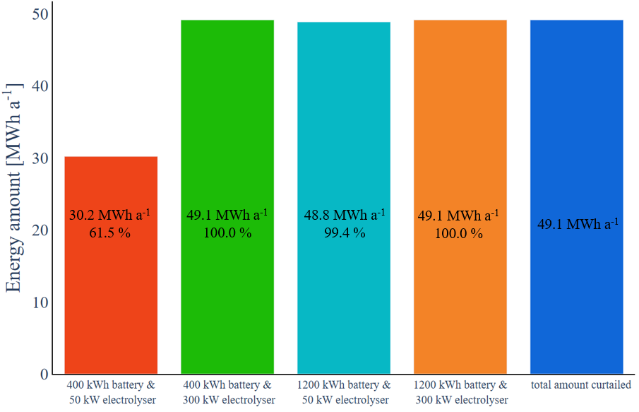
Fig. 9: Utilisation of curtailed PV energy for different battery capacities and electrolyser nominal power (all batteries operated at a C-rate of 1 h⁻¹).

Fig. 10 illustrates the operating strategy of the combined storage system consisting of a 400 kWh battery with a C-rate of 1 h⁻¹ and a 50 kW electrolyser. The electrolyser continuously utilises available PV power, while the battery stores excess generation that cannot be utilised by the electrolyser. As PV power generation decreases due to declining solar irradiance, the battery supplies electricity to sustain electrolyser operation during periods of high market prices, thereby increasing electrolyser FLH and hydrogen production. Any remaining energy stored in the battery is subsequently fed into the grid during periods of elevated electricity prices.
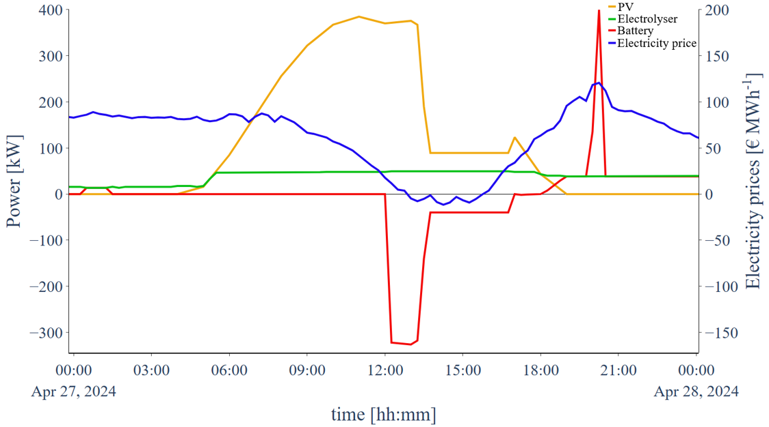
Fig. 10: Time series of PV power generation (yellow), electrolyser power consumption (green), battery power (red), and electricity market prices (blue) on a representative day for a 50 kW electrolyser and a 400 kWh battery with a 1 h⁻¹ C-rate.
LCOH, LCOE, battery EFC and electrolyser FLH for the combined battery electrolyser configurations are presented as heat maps in Fig. 11. Consistent with the results shown in Fig. 6, higher EFC values are observed for lower battery capacity and electrolyser power. Increasing electrolyser power reduces battery cycling, as a larger share of curtailed PV energy is utilised by the electrolyser rather than being stored in the battery. This indicates that the electrolyser increasingly assumes the role as primary flexibility option within the system. In contrast, the lowest LCOE and LCOH for this system are achieved for configurations with higher electrolyser power and lower battery capacity. Unlike batteries, which are limited by their storage capacity, electrolysers can continuously utilise surplus PV generation and convert it into hydrogen, allowing a greater utilisation of higher amounts of curtailed electricity from the system. Increasing battery capacity leads to higher LCOE and LCOH, as additional investment costs outweigh the benefits of recovering the remaining curtailed electricity. FLH of the electrolyser increase with decreasing nominal power and increasing battery capacity, as the battery stores most of the curtailed energy and in turn can supply the electrolyser more frequently. However, as seen in previous results, the difference in FLH is relatively small compared to the difference in nominal power. For example, with a 400 kWh battery the difference in FLH between the 50 kW and 300 kW electrolyser is 23.8 %, with 5696 h a⁻¹ for 50 kW and 4341 h a⁻¹ for 300 kW. With the 1200 kWh battery the difference is 20.3 %, with 5764 h a⁻¹ for 50 kW and 4597 h a⁻¹ for 300 kW. These findings suggest that high FLH alone is not a sufficient indicator of techno-economic performance. Overall, the results demonstrate that electrolyser nominal power has a greater influence on system performance than battery capacity. A combination of a 400 kWh and 1 h⁻¹ C-rate battery and a 300 kW electrolyser achieves complete utilisation of the curtailed PV energy while maintaining comparatively low levelised costs. The LCOE in this system configuration amount to 12.1 ct kWh⁻¹, which are lower than the system with only the battery, as the electrolyser helps further mitigate more curtailment, allowing more electricity to be utilised and in turn lowering the LCOE. However, because LCOE generally rise with batteries, the LCOH increase to 26.2 ct kWh⁻¹ (10.3 € kg_{H2}⁻¹).
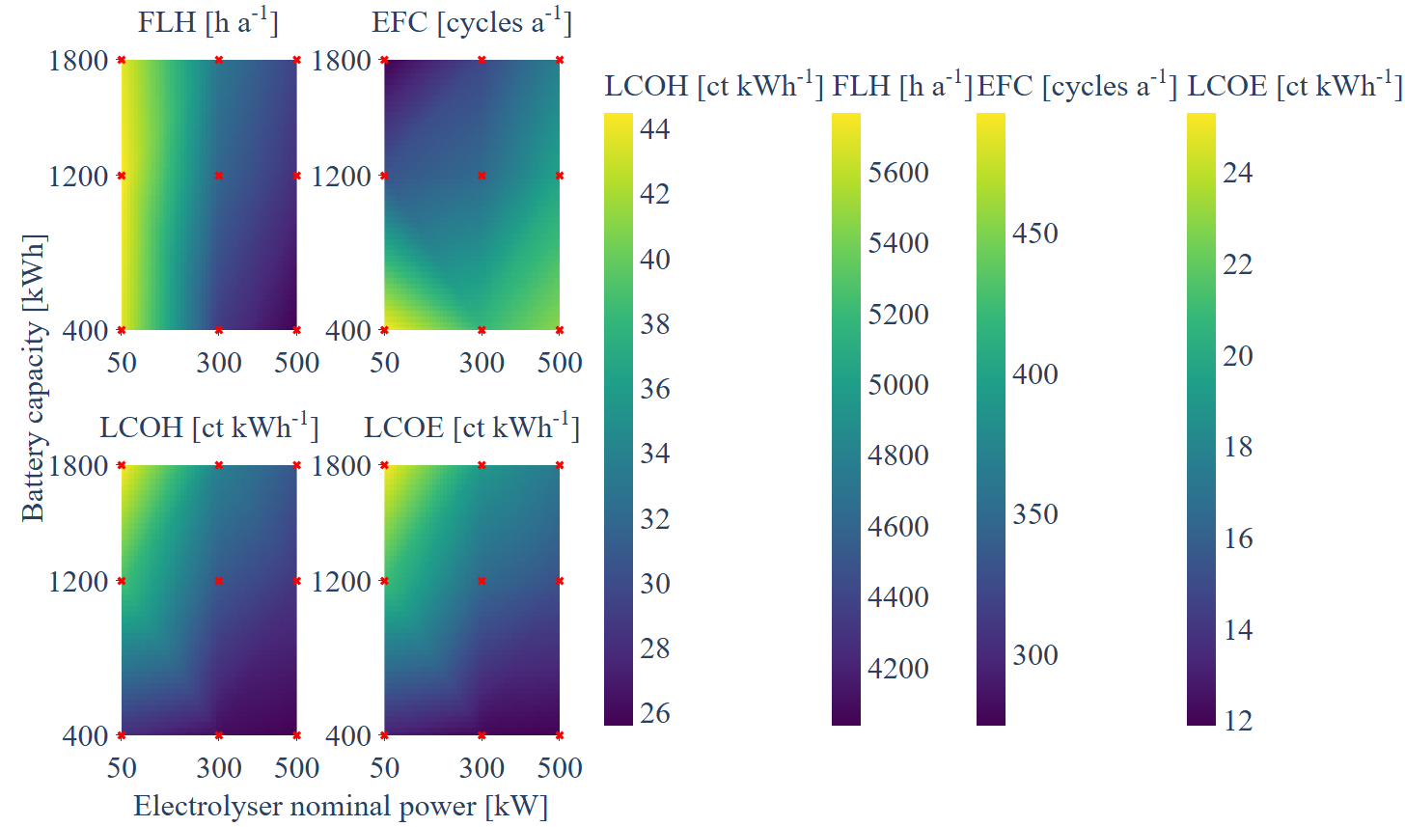
Fig. 11: LCOH, LCOE, battery EFC, and electrolyser FLH as a function of electrolyser nominal power and battery capacity (Battery C-rate = 1 h⁻¹)
- Conclusion
The goal of this study was to identify optimal configurations for battery, electrolyser and combined battery electrolyser storage systems to eliminate curtailment of a 600 kWp PV system in southern Germany. When integrating a battery to store curtailed PV energy, it becomes apparent that batteries with higher capacity increase the amount of curtailed energy that can be stored. However, batteries with higher C-rates and lower capacity lead to higher EFC and lower LCOE for the PV battery system. In contrast, increasing electrolyser nominal power significantly improves curtailment mitigation while simultaneously reducing hydrogen generation costs. In combination the electrolyser utilises most of the curtailed energy while the battery stores PV generation peaks and supports stable electrolyser operation. While the presented results provide valuable insights into the sizing of battery, electrolyser, and hybrid storage systems to avoid curtailments of PV systems, several limitations remain. The economic analysis is currently restricted to levelised cost indicators and does not account for metrics such as return on investment. Furthermore, the influence of local electricity demand and different hydrogen utilisation strategies on system performance and economics will be investigated. The integration of hydrogen storage, and reconversion via fuel cells also represent an important avenue for future work, enabling a more comprehensive evaluation of hydrogen-based storage concepts.
- Acknowledgements
This work was financially supported by the EFRE BaLista project, which is gratefully acknowledged by the authors.
- References

Ajibade, H., Ujah, C. O., Nnakwo, K.C., Kallon, D.V.V., 2024. Improvement in battery technologies as panacea for renewable energy crisis, Discover Applied Sciences, 6

Bondar, Petro. 2025. Analysis of the Impact of Integrated Hydrogen and Battery Energy Storage Systems on the Dynamic Stability and Reliability of Local Power Grids with High Renewable Energy Penetration. World Journal of Advanced Research and Reviews, 27(02), 2192–2198

Bundesgesetzblatt Teil 1. Gesetz zur Änderung des Energiewirtschaftsrechts zur Vermeidung von temporären Erzeugungsüberschüssen. 24.02.2025

Bundesnetzagentur.de. 2026. https://www.bundesnetzagentur.de/DE/Fachthemen/ElektrizitaetundGas/ErneuerbareEnergien/EEG_Foerderung/start.html (Accessed: 16 Juli 2026)

Choudar, A., Boukhetala, D., Barkat, S., Brucker, J.M., 2015. A local energy management of a hybrid PV-storage based distributed generation for microgrids. Energy Conversion and Management, 90

dena.de. 2026. https://www.dena.de/infocenter/elektrolysekapazitaeten-in-deutschland/. (Accessed: 11 June 2026)

destatis.de. 2026. https://www.destatis.de/DE/Themen/Gesellschaft-Umwelt/Umwelt/Wasserwirtschaft/Tabellen/tw-09-entgelt-trinkwasserversorgung-tarifgeb-nach-tariftypen-2023-2025-land-bund.html. (Accessed: 20 August 2026)

Diermann, Ralph. 2024. Abregelung von Photovoltaik-Anlagen stieg 2024 um 97 Prozent. pv magazine. https://www.pv-magazine.de/2025/04/03/abregelung-von-photovoltaik-anlagen-stieg-2024-um-97-prozent/. (Accessed: 3 March 2026)

Energy-Charts.de. 2026. https://www.energy-charts.info/?l=de&c=DE (Accessed: 10 March 2026)

Energydata.info. 2026. https://energydata.info/. (Accessed: 10 March 2026)

Ffe, 2025. Von der Theorie zur Praxis: Warum grüner Wasserstoff teurer ist als gedacht

GW Graf von Westphalen. 2024. https://www.gvw.com/aktuelles/blog/detail/umlagen-abgaben-steuern-und-entgelte-bei-dem-strombezug-fuer-die-wasserstofferzeugung-in-elektrolyseuren (Accessed: 16 July 2026)

Harag, N., Urabe, C. T., Kato, T., 2023. Optimal Allocation of Curtailment Levels of PV Power Output in Different Regions in Consideration of Reduction of Aggregated Fluctuations. IEEE Access. 11

Hofmann, F., Hampp, J., Neumann, F., Brown, T., Hörsch, J., 2021. atlite: A Lightweight Python Package for Calculating Renewable Power Potentials and Time Series. Journal of Open Source Software, 6(62)

Hofmann, F., 2023. Linopy: Linear optimization with n-dimensional labeled variables. Journal of Open Source Software. 8(84)

Holst, M., Aschbrenner, S., Smolinka, T., Voglstätter, C., Grimm, G., 2021, Cost Forecast for Low Temperature Electrolysis- Technology Driven Bottom-Up Prognosis for PEM and Alkaline Water Electrolysis Systems, Fraunhofer ISE

Huangfu, Q., Hall, J. A. J., 2017. Parallelizing the dual revised simplex method. Math. Prog. Comp. 10, 119-142

Kern, T., Wasmeier, L., Bantelmann, P., Wendlinger, C., Johannsen, E., 2024. Negative electricity prices – How many renewable energy systems will run through?. Ffe. ffe.de/en/publications/negative-electricity-prices-how-many-renewable-energy-systems-will-run-through/ (Accessed: 20 August 2026)

Kisse J. M., Hahn, P., Harms, Y., Braun, M., 2024, Flexible Electrolysers as a Tool for Renewable Energy Integration and Congestion Management: Comparison of Different Allocation Methods in a Transmission System Case Study for Germany 2030, Wind & Solar Integration Workshop

Kost, C., Müller, P., Schweiger, J. S., Fluri, V., Thomsen, J., 2024, Stromgestehungskosten Erneuerbare Energien, Fraunhofer ISE

Kurzweil, P., Dietlmeier, O.K., 2018. Elektrochemische Speicher – Superkondensatoren, Batterien, Elektrolyse-Wasserstoff, Rechtliche Rahmenbedingungen, second ed. Springer Vieweg, Wiesbaden

Kyriakidis, L., Kansara, R., Serrano, M. I. R., 2025, Energy Management of Industrial Energy Systems via Rolling Horizon and Hybrid Optimization: A Real-Plant Application in Germany, Energies, 18

Ma, W., Wang, W., Wu, X., Hu, R., Tang, F., Zhang, W., Han, X., Ding, L., 2019. Optimal Allocation of Hybrid Energy Storage Systems for Smoothing Photovoltaic Power Fluctuations Considering the Active Power Curtailment of Photovoltaic. IEEE Access. 7

Mukoni, E., Garner, K. S., 2025. Optimization of a Grid-Connected Hybrid Energy System with Battery Storage for Hydrogen Production in South Africa. Soth African Institute of Electrical Engineers. 116(3)

Netztransparenz.de. 2026. https://www.netztransparenz.de/de-de/ (Accessed: 23 July 2026)

O’Shaughnessy, E., Cruce, J. R., Xu, K., 2020. Too much of a good thing? Global trends in the curtailment of solar PV. Solar Energy, 208, 1068-1077

pypsa.org. 2026. https://pypsa.org/ (Accessed: 30 July 2026)

Robinius, M., Wienert, P., Nigbur, F., Andres, S., Bonnet, J., Gerstein, T., Güttler, V., Nailis, D., Beneke, N., Kamp, L., Hauler, T., Krause, O., Kalwa, S., Riedl, J., HyExperts Region AachenPLUS: Wasserstoffstudie für die Modellregion AachenPLUS, Hydrogen Hub Aachen

Schmidt, T., 2022. Wasserstofftechnik - Grundlagen, Systeme, Anwendung, Wirtschaft, second ed. Hanser, Munich

Therapontos, P., Tapakis, R., Aristidou, P., Charalambides, A.G.. 2025. RES curtailments in Cyprus: A review of technical constraints and solutions. Solar Energy Advances, 5

Udawalpola, R. Masuta, T., Yoshioka, T., Takahashi, K., Ohtake, H., 2021. Reduction of Power Imbalances Using Battery Energy Storage System in a Bulk Power System with Extremely Large Photovoltaics Interactions. Energies. 14

Wirth, H. 2026. Aktuelle Fakten zur Photovoltaik in Deutschland. Fraunhofer ISE

Yang, G., Yang, D., Perez, M. J., Perez, R., Kleissl, J., Remund, J., Pierro, M., Cheng, Y., Wang, Y., Xia, X., Xu, J., Lyu, C., Liu, B., Zhang, H., 2024. Hydrogen production using curtailed electricity of firm photovoltaic plants: Conception, modeling, and optimization. Energy Conversion and Management.
- Nomenclature
Table. 2: Abbreviations and their definitions
Abbreviation | Definition
EFC | Equivalent full cycles
FLH | Full load hours
LCOE | Levelised cost of electricity
LCOH | Levelised cost of hydrogen
PV | Photovoltaic
PyPSA | Python for Power System Analysis

