EuroSun2026
ENERGY SIMULATION OF SHALLOW UNDERGROUND THERMAL ENERGY STORAGE TO RECOVER SOLAR ENERGY
Diane Le Roux*, Thibaut Colinart
IRDL, UMR CNRS 6027, Univ. Bretagne Sud, Bretagne INP, ENSTA, Institut Polytechnique de Paris, Univ. Brest, Lorient, France
* corresponding author: diane.le-roux@univ-ubs.fr

Summary
This study investigates the performance of a Horizontal Underground Thermal Energy Storage (HUTES) using natural materials (water and sand) and a horizontal buried heat exchanger to recover excess low-temperature solar thermal energy for seasonal storage. A dynamic TRNSYS model, combined with a sensitivity analysis based on the Morris and Sobol methods, was developed to identify the most influential design and operational parameters. Three operational scenarios, combining charge and discharge of 3 to 6 months, either under fixed boundary conditions or based on real weather data, were investigated. The results show that conductive heat transfer governs the thermal behaviour of the HUTES. As a result, the insulation properties and the thickness of the soil cover are the dominant parameters determining storage performance. In contrast, the internal diameter of the heat exchanger has a negligible influence, while tube spacing and charging/discharging temperatures require a compromise between thermal performance and hydraulic constraints. These findings provide practical design recommendations for optimising seasonal HUTES coupled with solar thermal systems.
Keywords: Horizontal Underground Thermal Energy Storage, seasonal storage, sensitivity analysis, dynamic numerical modelling, solar thermal collectors
Field of application for the findings: 08 Thermal Energy Storage
Addressed audience: scientific community

- Introduction
The agricultural sector, particularly livestock buildings and greenhouses, requires substantial amount of thermal energy for space heating and domestic hot water. This demand is still predominantly met by fossil fuels, contributing significantly to greenhouse gas emissions. Solar thermal energy has a key role to play in decarbonising this sector, thanks to its maturity, reliability and high thermal conversion (Gambade et al., 2022). However, its large-scale deployment remains limited by its intermittent nature and the mismatch between solar energy availability and heat demand, which limits its efficiency and reliability. While heating needs are highest during autumn and winter, solar energy production reaches its maximum during summer, leading to frequent periods of excess heat that cannot be directly utilised, representing a significant energy loss.
Thermal Energy Storage (TES) is widely recognised as an effective solution for overcoming this mismatch by decoupling supply and demand over timescales ranging from a few hours to several months. Thereby, the use of TES increases both the utilisation rate of renewable energy and the flexibility of thermal systems (Kalogirou, 2009; Rahman et al., 2020). Among existing TES technologies, sensible heat storage using water tanks remains the most widely implemented because of water's favourable thermophysical properties, technological maturity and relatively low investment cost (Li et al., 2018). Nevertheless, seasonal storage applications require very large storage volumes, resulting in increased capital costs, land occupation and integration constraints that may limit their deployment in agricultural environments.
Underground Thermal Energy Storage (UTES) systems constitute an attractive alternative for large-scale and seasonal applications by exploiting the ground as a natural storage medium. Several UTES technologies have been investigated, including Borehole Thermal Energy Storage (BTES), Aquifer Thermal Energy Storage (ATES) and Pit Thermal Energy Storage (PTES), each presenting specific advantages and geographical constraints (Nordell, 2000). Among these concepts, Horizontal Underground Thermal Energy Storage (HUTES) stores thermal energy within a shallow insulated soil volume through buried horizontal heat exchangers (Le Roux et al., 2026). Locating the storage directly beneath the solar collector field considerably reduces the additional land requirement while offering a simple and potentially cost-effective solution for agricultural installations. However, the thermal performance of HUTES strongly depends on the coupled effects of ground heat transfer, soil thermophysical properties, insulation strategy, heat exchanger geometry and operational conditions. These interactions remain insufficiently documented, particularly for long-term storage applications exceeding several weeks
To support the design and optimal sizing of such systems, reliable numerical models capable of predicting transient thermal behaviour under realistic operational conditions are required. In this context, the present work develops a dynamic HUTES model using TRNSYS and investigates the influence of both design and operational parameters through a comprehensive sensitivity analysis. The proposed HUTES is intended to preserve excess solar heat for periods exceeding two months and subsequently preheat the Heat Transfer Fluid (HTF) supplied to the solar thermal collectors during periods of lower solar availability. By reducing summer overheating risks, increasing annual solar utilisation and decreasing fossil fuel consumption, this approach aims to improve the overall performance of solar thermal systems dedicated to agricultural applications. A multi-step methodology, including a literature review (Le Roux et al., 2026), was adopted to assess feasibility. In this study, the numerical work identifies influential parameters, defines operational scenarios and performs sensitivity studies to evaluate the impact of design and operational parameters. The results are intended to provide design guidelines for future optimisation and experimental validation of HUTES.
This paper is organised as follows. First, the HUTES concept, the numerical model and the operational scenarios are presented, together with the sensitivity analysis methodology, including the investigated parameters, the Morris and Sobol methods, and the performance criteria. Next, the results of the parametric study are discussed, and the transient temperature fields within the HUTES are analysed for two representative scenarios to highlight the governing heat transfer mechanisms. Finally, the main conclusions are summarised and perspectives for future work are outlined.
- Materials & Methods
  - Modelling of the HUTES on TRNSYS
An experimental bench, recently installed on a farm in Mayenne (Northwest of France), serves as the inspiration for this case study. The aim is to assess the potential of such a system for utilising heat from a solar field across different seasons. Fig.1 shows a side view (X-Z plane) and a vertical cross-section (Y-Z plane) of the HUTES.
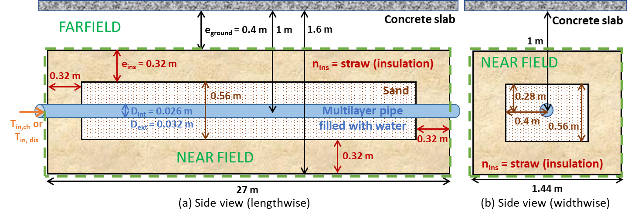

Fig. 1: Simplified diagram of the side view (X-Z plane) (a) and the vertical section (Y-Z plane) (b)

These two views show the main dimensions of the test bench. The main characteristics of this HUTES are:
- Heat exchanger geometry: 1 linear tube, 27 m long and 0.032 m in diameter, on 1 horizontal layer,
- Insulation: top/side/bottom surfaces made of straw with a thickness of 0.32 m,
- Materials: sand (storage material with a theoretical volume of 11.8 m³), multilayer tubes and water (Heat Transfer Fluid (HTF)), the thermophysical properties of which are listed in Tab.1.
Tab.1: Thermophysical properties of the HUTES materials under investigation
 | Density  (kg.m⁻³) | Heat capacity  (kJ.kg⁻¹.K⁻¹) | Thermal conductivity  (W.m⁻¹.K⁻¹) | Dynamic viscosity  (kg.m⁻¹.h⁻¹)
Sand | 2500 | 1 | 2.42 | -
Water | 1000 | 4.19 | 0.55 | 3.0
Multilayer tubes | - | - | 0.42 | -

This HUTES is modelled in TRNSYS using Type 999. Based on an implicit three-dimensional finite-difference approach, this Type models heat transfer by conduction through the ground and convection within the pipes, considering a multi-layered structure (pipes and ground) with thermophysical properties that vary with depth. The main assumptions of this model are: homogeneous, isotropic and porous soil with constant thermophysical properties (independent of moisture); HTF (water) and insulation with constant thermophysical properties. During the solution, the model distinguishes (see Fig.1):
- Near field: an insulated zone around the pipes, thermally active.
- Far field: a boundary zone at constant temperature, limiting edge effects.
Boundary conditions are defined at the boundaries: a conduction condition is set with a fixed temperature in the far field (10°C on the side faces and meteorological data on the top face), and an adiabatic condition is imposed on the bottom face (as it is not possible to explicitly account for the insulation on this face). The initial conditions assume a homogeneous temperature of 10°C for the ground and the HTF.
The functional architecture of the model (HUTES with a pump) is illustrated in Fig. 2. The model’s core (yellow main block) integrates 3 main elements: a weather file for outside temperature and solar radiation (Data), a circulation pump (Pump) and the Type 999 (HUTES). These are managed by a central calculator (Variables) that consolidates key parameters, such as HUTES geometry and thermophysical properties of materials. This setup enables Python integration to automate sensitivity studies and explore various operational scenarios. Downstream (red block), an integrator, calculator and printer process results, convert units and record data. A control subsystem (blue block) manages the six-month charge and standby steps, using solar field output data (Data) to control pump operation based on the following temperature-based rules:
- ON if $\left\{\begin{matrix}T_{out,solar field}-T_{out,HUTES}>5 K and OFF at the previous time step \\ T_{out,solar field}-T_{out,HUTES}>1 K and ON at the previous time step\end{matrix}\right.$, OFF otherwise
The two temperature thresholds introduce a hysteresis effect to prevent frequent pump ON/OFF cycling caused by short-term fluctuations in solar irradiance and temperature. Therefore, this control strategy improves the stability of pump operation and limits excessive switching. In practice, it is only effective in scenario 3. Indeed, in scenarios 1 and 2, the inlet temperatures are prescribed and the system operation is therefore independent of this control law.

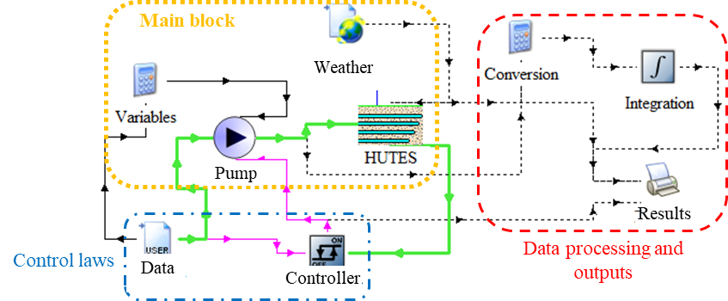
Fig.2: TRNSYS modelling of a HUTES (scenario 3)
Configured in this way, the model calculates surface and subsurface soil temperatures, the outlet temperature of the HTF, the thermal energy transferred between the HTF and the soil and the thermal energy stored in the soil, based on various input parameters:
- Geometric: number of pipes, spacing between pipes, burial depth, internal and external diameters, and number of layers of pipes,
- Thermophysical properties: soil, HTF and insulation,
- Climatic: surface temperature and solar radiation,
- Operational: temperature and flow rate of the HTF, duration of the charging/discharging steps.
The thermal energy exchanged between the HTF and the soil, and the thermal energy stored in the soil are determined as follows:
$E_{HTF-soil}=\int{{\dot{m}}_{HTF}⋅c_{p,HTF}⋅\left(T_{in,HUTES}-T_{out,HUTES}\right)}$ (eq. 1)
$E_{soil}=\int{\sum_{i}{ρ_{soil,i}⋅c_{p,soil}⋅V_{soil,i}⋅ΔT_{soil,i}}}$ (eq. 2)
Where ${\dot{m}}_{HTF}$ is the mass flow rate of the HTF (kg.s⁻¹), $T_{in,HUTES}$ and $T_{out,HUTES}$ are the inlet and outlet temperature of the HTF in the HUTES (K), $ρ_{soil,i}$ is the density of the soil in cell $i$ (kg.m⁻³), $c_{p,HTF}$ and $c_{p,soil}$ are the heat capacities of the HTF and soil (kJ.kg⁻¹.K⁻¹), $V_{soil,i}$ is the volume of cell $i$ (m³) and $ΔT_{soil,i}$ represents the temperature variation of the soil in cell $i$ over the considered period (K). The thermophysical properties of the soil, represented here by sand, and the HTF, represented here by water) are given in Tab.1.
The HTF circulates through the pipes, exchanging heat with the ground depending on the local temperature. The charge and discharge are simulated using temperature and flow rate profiles defined in the following section.
Two complementary performance indicators are considered: (i) the discharged thermal energy, which quantifies the storage capacity, and (ii) the Storage Performance Factor (SPF), which evaluates the energy efficiency of the HUTES by accounting for the pumping electricity consumption. The evaluation criterion is defined as the ratio of the useful thermal energy discharged to the electrical energy consumed by the circulation pump, over the entire operational scenario:
${SPF}_{HUTES}=E_{dis}/E_{pump}$ (eq. 3)
Where E_{dis} is the thermal energy recovered from the HUTES (kWh_{th}), and E_{pump} is the electrical energy (kWh_{e}) consumed by the circulation pump, over the entire operational scenario (charge only (scenario 1) or charging and discharging cycle (scenario 2)). This dimensionless indicator quantifies the amount of useful thermal energy discharged per unit of electrical energy required for HUTES operation, allowing a consistent comparison of HUTES configurations while accounting for both thermal performance and pumping energy consumption.
  - Simulation scenarios
Three scenarios are defined in Tab.2 to assess the robustness of the model and explore different operational conditions during the sensitivity analysis. For scenarios 1 and 2, the simulation start date has no impact on the results, as the boundary conditions are fixed throughout the simulations. In contrast, scenario 3 is driven by field and weather data and is simulated over the entire warm season (charging period), from 15 April to 15 October.
Tab.2: Characteristics of the simulation scenarios studied
Scenario | Operating conditions | Data used | Objective
1 | 3-month charge (8am–5pm) under fixed flow rate (400 kg.h⁻¹) and temperature conditions (70°C) | Fixed inputs | Reference case: long-term charge
2 | 6-month daily charge (8am–5pm) / discharge (5pm–8am) with fixed temperature (70°C for charge / 15°C for discharge) and flow rate conditions (400 kg.h⁻¹) | Fixed inputs | Controlled daily cycle
3 | 6-month charge using measured experimental conditions (dynamic temperature and flow rate profiles) * | Solar field and hourly weather data for climatic conditions | Assessment under climatic and operational variations
* The outlet temperature of the solar field varies approximately from 30 to 75 °C throughout the charging step. The flow rate is 800 kg.h⁻¹ when the circulation pump is operating. Over the 6-month simulation period, the pump operates for 3409.3 hours.
  - Sensitivity study
A parametric analysis is carried out to identify the parameters that have the greatest influence on the energy performance of the HUTES. These parameters include:
- Internal diameter of the heat exchanger tubes (D_{int}),
- Number of tubes on a single level (N_{tube})
- Distance between the centres of the tubes on a single level (d_{tube}),
- Insulation thickness (e_{ins}) and insulation type (n_{ins}),
- Thickness of the floor above the top of the HUTES (e_{ground}),
- Temperatures at the HUTES inlet during charge (T_{in,ch}) and discharge (T_{in,dis}).

The parameter ranges are detailed in Tab.3. In all scenarios, the internal tube diameter (D_{int}) was varied between 0.020 and 0.026 m, corresponding to the largest internal diameters available for the existing multilayer pipes in order to limit pressure losses. Preliminary analyses showed that, within this range, D_{int} has a negligible influence on the thermal performance of the HUTES. The larger diameter (0.026 m) was therefore retained for the subsequent analyses to minimise pressure losses without compromising thermal performance.
The ranges reported for d_{tube} and e_{ins} correspond to the global bounds considered across all configurations. Their actual ranges depend on the number of tubes and are adjusted to preserve the fixed overall dimensions of the HUTES (see Fig.1). Consequently, the ranges shown in the sensitivity plots may differ from those reported in Tab.3.
The insulation materials studied are: straw (0.048 W.m⁻¹.K⁻¹), polystyrene (0.047 W.m⁻¹.K⁻¹), Normalen® (0.04 W.m⁻¹.K⁻¹), rubber/cotton/plastic mixture (0.034 W.m⁻¹.K⁻¹), extruded polystyrene (0.033 W.m⁻¹.K⁻¹), expanded polystyrene (0.029 W.m⁻¹.K⁻¹), polyurethane (0.025 W.m⁻¹.K⁻¹), high-density polyurethane (0.022 W.m⁻¹.K⁻¹), wood (0.15 W.m⁻¹.K⁻¹) and HDPE liners (0.43 W.m⁻¹.K⁻¹) [4].
Tab.3: Parameter ranges considered for the sensitivity analysis
Scenarios | 1, 2, 3 | 1, 2, 3 | 1, 2, 3 | 1, 2, 3 | 1, 2, 3 | 1, 2 | 1, 2
Variable | N_{tube} | d_{tube} (m) | e_{ins} (m) | n_{ins} | e_{ground} (m) | T_{in,ch} (°C) | T_{in,dis} (°C)
Global ranges | 1 to 5 | 0.15 to 1.5 * | 0.01 to 0.35 * | 10 insulations | 0.1 to 0.4 | 30 to 100 | 5 to 25
* Configuration-dependent ranges adjusted according to the number of tubes and the fixed dimensions of the HUTES. Values reported in the table represent the global bounds across all configurations.
Two distinct and complementary methods, drawn from Python’s SALib library (Iwanaga et al., 2022), were used to carry out this parametric study:
- Morris method (Morris, 1991): This computationally efficient screening method is used to identify the most influential parameters (whether linear or non-linear) and eliminate those with a negligible impact on HUTES performance, while limiting the number of simulations. It computes elementary effects by perturbing one parameter at a time throughout the input space. The results are interpreted using two statistical indicators;
- Mean of the absolute elementary effects (µ*) quantifies the overall influence of a parameter on the model output. A high µ* indicates a strong contribution to the criterion of the sensitivity analysis.
- Standard deviation of the elementary effects (σ) reflects the variability of the parameter influence. A high σ reveals the presence of non-linear effects, interactions with over parameters, or both.
Consequently, parameters exhibiting high μ* and low σ have a strong and nearly linear influence, whereas high values of both μ* and σ indicate influential parameters involved in significant non-linearities or interactions.
- Sobol method (Sobol, 2001): This variance-based method quantifies the contribution of each input parameter to the output variance and distinguishes individual effects from interaction effects from interactions and non-linear effects. Three complementary sensitivity indices are considered:
- First-order index (S₁) measures the direct contribution of a given parameter to the variance of the model output.
- Second-order index (S₂) quantifies the interaction effects between pairs of parameters.
- Total-order index (ST) represents the overall contribution of a parameter, including both its direct effect and all its interactions with the other parameters.
A significant difference between ST and S₁ indicates that the parameter mainly affects the model through interactions with other variables.

The sensitivity analyses were automated using Python scripts. For each operational scenario, the number of simulations was determined according to a predefined computational time budget, considering the average duration of a TRNSYS simulation and the available parallel computational resources. Consequently, the sample size was adjusted for each sensitivity method whilst respecting its theoretical sampling requirements. For the Morris method, the number of trajectories (r) was selected such that the total number of simulations was equal to ((k+1)*r), where (k=8) is the number of input parameters. For the Sobol method, the base sample size (N) was chosen as the largest power of two compatible with the available computational budget. A total of (N*(2k+2)) model were evaluated, as required by Saltelli sampling scheme (Saltelli, 2002). This strategy ensures the efficient use of available computational resources whilst providing statistically sensitivity indices.
- Results & Discussions
  - Thermal behaviour of the HUTES
3.1.1. Daily simulation for charging/discharging cycle (scenario 2)
The results presented in this section correspond to scenario 2 and to the reference HUTES geometry currently installed in Mayenne (see Fig.1). The storage geometry consists of a single linear buried heat exchanger, with an internal diameter of 0.026 m, surrounded by 0.32 m of straw insulation, and covered by 0.40 m of soil. The inlet charging and discharging temperatures are set at 70°C and 15°C respectively. Fig.3 shows the temperature evolution in the median horizontal section X-Y of the HUTES during one representative daily charging step (Fig. 3a) and the subsequent discharging step (Fig. 3b). During charge, heat is progressively transferred from the HTF to the sand, leading to the propagation of a thermal front from the inlet towards the outlet of the heat exchanger.
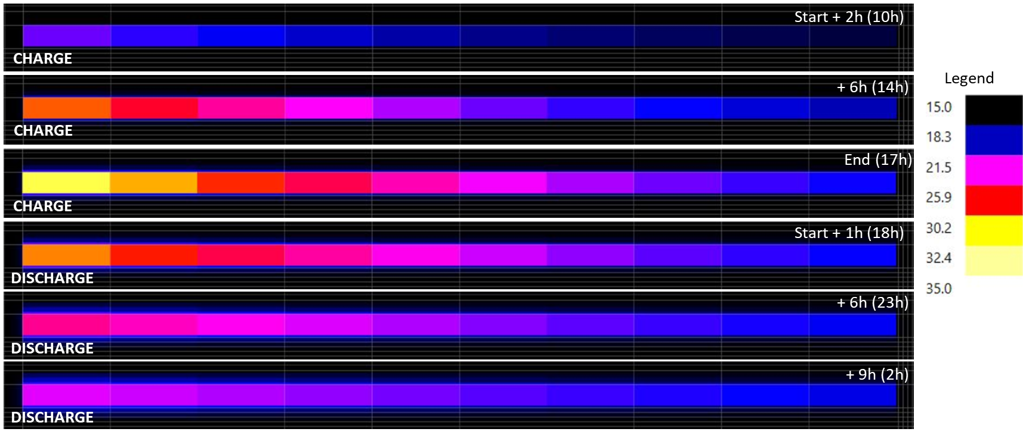
Fig.3: Temperature evolution in the median X-Y section of the HUTES during one representative daily operational cycle (scenario 2): (a) charge (8 am to 5 pm) and (b) discharge (5 pm to 8 am)
Starting from an initial uniform temperature of 10°C, the sand surrounding the inlet section reaches approximately 20°C after 6h of charge, corresponding to a local temperature increase of about 10 K. At the end of the 9h charge, the temperature reaches approximately 32°C close to the inlet tube, corresponding to a temperature rise of 22 K, whereas the outlet region remains close to 20°C (ΔT ≈ 10 K). This pronounced longitudinal temperature gradient illustrates the progressive cooling of the HTF as thermal energy is transferred to the surrounding soil. Only a limited amount of heat reaches the insulation layer during a single charging step. This behaviour indicates that most of the injected thermal energy remains concentrated around the tubes, while conductive heat transfer through the surrounding sand is relatively slow because of its low thermal conductivity. Consequently, the thermal mass of the HUTES cannot be fully thermally activated over a single day, confirming that the storage is inherently suited to medium and long-term TES rather than short-duration cycling.
During the discharge, the opposite behaviour is observed. Heat is rapidly extracted from the sand surrounding the inlet section of the heat exchanger, where temperatures decrease from approximately 28°C after 1h to 21°C after 9h, indicating that the heat previously accumulated around the heat exchanger in progressively recovered. By contrast, the outlet temperature remains almost constant at around 19°C, indicating that the HTF continuously recovers the heat accumulated along the entire length of the tube. This relatively uniform outlet temperature reflects the gradual extraction of the stored thermal energy. During the first daily cycle, the charged and discharged energies amount to 165.6 and 53.3 kWh_{th}. At the end of the three-month simulation, these corresponding energies reach 8374.4 and 9257.9 kWh_{th}.
Overall, these results demonstrate that conductive heat transfer through the sand governs the transient thermal behaviour of the HUTES. As a result, only a limited portion of the storage volume is involved in heat exchange during a single daily charge, whereas successive charges progressively extend the heated zone. After approximately one month of operation, the difference between the cumulative charged and discharged energies becomes limited, indicating the establishment of a quasi-periodic thermal regime. The HUTES outlet temperature subsequently remains within a range of approximately 25–32°C. This behaviour is consistent with the intended operation of the HUTES, in which heat is gradually accumulated and recovered over successive cycles. The slow propagation of the thermal front also indicates that increasing the heat exchange surface may be more effective than increasing the storage volume when improving short-term charging performance.
The SPF increases from 19.3 after one day to 41.2 after 10 days, 47.3 after one month and 51.2 after three months, reflecting the increasing recovery of stored thermal energy relative to the electricity consumed for pumping. The evolution of the SPF further supports the establishment of this quasi-periodic regime. Indeed, the increase in SPF progressively decreases after 10 days, as the storage temperature stabilises over successive cycles.
3.1.2. Discharge after long-term charge (scenario 1)
To illustrate the seasonal operational principle of the HUTES, Fig.4 presents the temperature distribution in the median vertical section X-Z after 6 months of repeated daily charges (see Fig.4a) and during the first 10 days of seasonal discharge (see Fig.4b-i). In contrast to the daily cycle analysed previously (scenario 2), the storage volume has progressively accumulated heat over several months, resulting in a much more homogeneous temperature field (average temperature of the sand of 51°C – yellow zone in Fig.4a). The thermal front has propagated far beyond the vicinity of the buried heat exchanger, demonstrating that conductive heat transfer has gradually mobilised a large fraction of the storage volume.
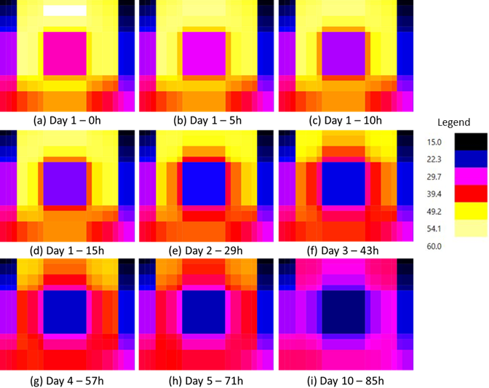
Fig.4: Temperature evolution in the median X–Z section during the first 10 days of seasonal discharge (5 pm to 8 am) following six months of repeated daily charge (8 am to 5 pm) (scenario 1)
At the end of the charge (see Fig.4a), the highest temperatures remain located close to the heat exchanger, and, more specifically, just above it. The surrounding sand also reaches elevated temperatures owing to the cumulative effect of successive charges. The insulation effectively limits heat losses to the sides, preserving a large amount of thermal energy within the HUTES. Consequently, the stored energy is distributed over a significantly larger volume than during a single daily charge (see Fig.3a).
During the first hours of discharge (see Fig. 4a to d), cooling remains confined to the vicinity of the heat exchanger. As the discharge progresses, the cooled region gradually expands into the storage while the surrounding warm sand continuously replenishes the heat extracted by the HTF through conductive heat transfer. The average temperature of the sand decreases from approximately 51°C at the beginning of the discharge to about 46°C after 43h (3 days) (see Fig.4f), highlighting the progressive release of the stored thermal energy. Even after 85h of cumulative discharge (10 days), a significant portion of the HUTES remains at temperatures above 35°C (see Fig.4i), demonstrating its high thermal inertia and its ability to deliver useful thermal energy for several weeks.
In addition to the temperature field analysis, the corresponding energy balance confirms the seasonal capability of the HUTES. After 3 months of charge, approximately 3990 kWh_{th} are stored in the system. During this period, approximately 1158 kWh_{th} are lost through the upper boundary into the surrounding ground, while heat losses through the side and bottom boundaries are negligible. During the first 10 days of seasonal discharge, nearly 980 kWh_{th} are recovered, corresponding to 25% of the energy initially stored. This high recovery rate during the initial discharge demonstrates that a substantial proportion of the stored energy can be delivered whilst maintaining a significant thermal reserve within the HUTES. Thus, this reserve ensures a continuous supply of heat.
Overall, the results demonstrate that the HUTES behaves as a true seasonal TES, where the characteristic conductive heat transfer time greatly exceeds the duration of a daily operational cycle. This behaviour confirms the suitability of the proposed design for seasonal TES applications and explains why parameters controlling conductive heat losses (particularly insulation properties and ground cover thickness) play a dominant role in the sensitivity analysis, which will be discussed in the next section.
3.1.3. Energy balance and performance of the HUTES across the three scenarios
Table 4 summarises the main energy performance indicators of the HUTES for the three operating scenarios. Heat losses occur primarily through the upper boundary, whiles losses through the side and bottom boundaries are negligible. After three months, upper heat losses account for approximately one-third of the stored energy in scenarios 1 and 3, which reach respectively 3990 and 7235 kWh_{th}. In contrast, scenario 2 exhibits a different behaviour, as the stored energy stabilises after approximately one month. This indicates the establishment of a quasi-periodic thermal regime, in which the charged energy is progressively balanced by the discharged energy and thermal losses, thereby limiting net energy accumulation. In scenario 3, the cumulative pump operating time reaches 67.6 days over the 92-day simulation period, corresponding to about 73% of the total period. This intermittent operation reflects the variability of the solar resource and the temperature-dependent control strategy.
Tab.4: Pumping energy consumption, stored thermal energy and heat losses through the upper boundary for the three scenarios
 | Duration | E_{pump} (kWh_{e}) | Pump operating time (day) | E_{stored} (kWh_{th}) | E_{loss,top} (kWh_{th})
Scenario 1 | 1 day | 1.5 | 1 | 167.9 | 0.0
Scenario 1 | 10 days | 19.5 | 10 | 1001 | 9.5
Scenario 1 | 1 month | 61.5 | 31 | 2091 | 143.4
Scenario 1 | 3 months | 179.5 | 90 | 3990 | 1158
Scenario 2 | 1 day | 2.75 | 1 | 167.9 | 0
Scenario 2 | 10 days | 20.75 | 10 | 1364.2 | 3.6
Scenario 2 | 1 month | 62.75 | 31 | 3993.9 | 48.6
Scenario 2 | 3 months | 180.75 | 90 | 11169.7 | 334
Scenario 3 | 1 day | 2 | 1 | 150.6 | 0.0
Scenario 3 | 10 days | 18 | 10 | 1987 | 12.3
Scenario 3 | 1 month | 57.85 | 28.9 | 4337 | 269.6
Scenario 3 | 3 months | 134.5 | 67.6 | 7235 | 2381

  - Sensitivity study
3.2.1 General trends and parameter screening
Fig.5 highlights the variability of the performance indicator for the 5-tube configuration as a function of the main input parameters. Scenarios 2 and 3 are represented respectively by orange and green markers. Scenario 1 is not shown because no energy is extracted from the HUTES. Distinct behavioural patterns emerge among the two scenarios. Scenario 2 shows significantly greater dispersion, reflecting the influence and interactions of the design parameters, such as the thickness and type of insulation. In contrast, scenario 3 presents lower dispersion, with variability primarily governed by climate forcing and coupling with the solar field.
The spacing between tubes (d_{tube}) exhibits a weak but non-negligible influence, with a tendency towards optimal intermediate values depending on the number of parallel tubes. This behaviour reflects a trade-off between conductive thermal interaction in the soil and hydraulic compactness constraints. The optimal distances between tubes, determined to comply with the overall dimensions of the HUTES (see Fig.1), are 0.7–0.8m, 0.42m, 0.3m and 0.22m respectively for 2, 3, 4 and 5 tubes in parallel.
Similarly, a ground cover thickness (e_{ground}) of at least 0.25 m appears to provide a suitable compromise between limiting surface heat losses and excavation costs. The effect of insulation thickness and material are strongly coupled, making their individual influence difficult to isolate. However, polystyrene, polyurethane (standard and high-density) and the rubber/cotton/plastic mix result in lower HUTES performance within the investigated range.
The parameter distributions confirm a uniform sampling of the ranges defined in Tab.3 for both methods. The Morris method requires fewer simulations, allowing parameters with little influence to be quickly eliminated. The Sobol method covers a wide range of values, confirming a thorough exploration of the parameter space. Similar distributions are obtained for all sensitivity analyses.
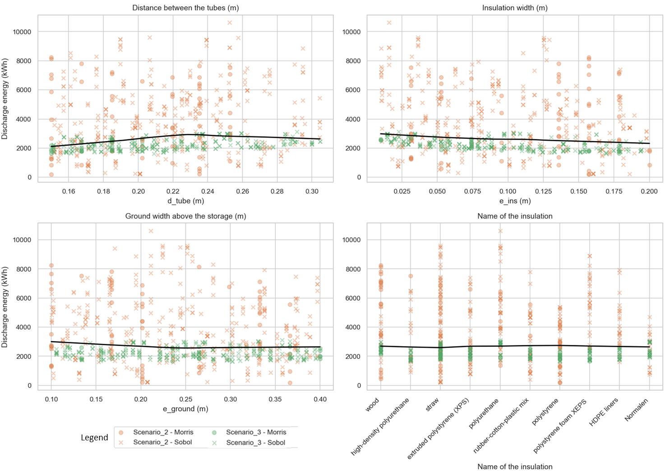
Fig.5: Distribution of the performance indicator as a function of the sensitivity parameters for the 5-tube configuration
3.2.2 Morris and Sobol comparison
The Morris and Sobol analyses provide complementary insights into the governing mechanisms of the HUTES. Both methods identified three parameters that have a particularly significant influence on the performance of the HUTES: the type of insulation (n_{ins}), its thickness (e_{ins}) and the thickness of the overlying soil (e_{ground}). Fig.6 presents the Morris indices (σ and µ*) for the scenarios 1 (a), 2 (b) and 3 (c).
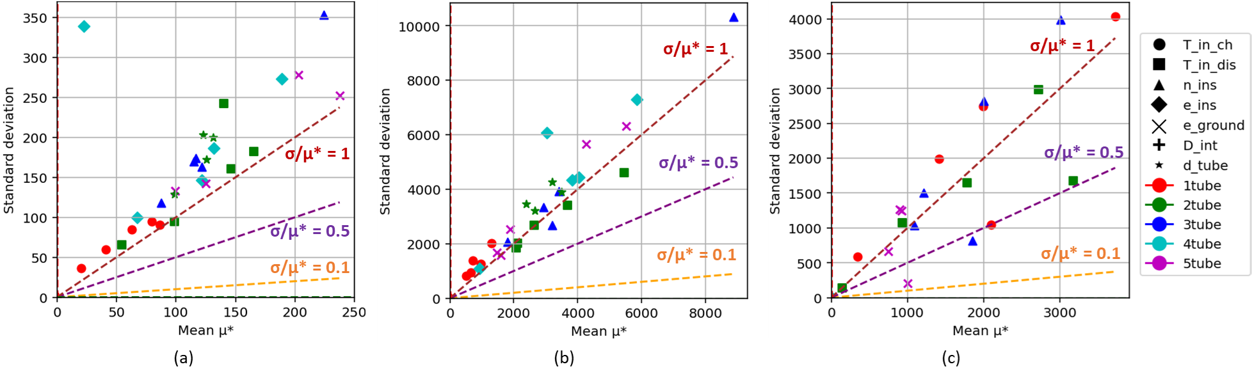
Fig.6: Morris sensitivity indices (μ* and σ) for the 3 operational scenarios: (a) scenario 1, (b) scenario 2 and (c) scenario 3
These most influential parameters consistently exhibit high μ* values, confirming their strong first-order influence on system performance. In addition, elevated σ values for these parameters indicate significant non-linear effects and/or interactions with other parameters. In most cases, the ratio σ/μ* exceeds unity, suggesting that the system response is governed by significant non-linear effects and parameter interactions, in agreement with the previous observations of (Garcia Sanchez et al., 2014).
These findings are further confirmed by the Sobol indices. The differences between first-order (S1) and total-order (ST) indices highlight the importance of interaction effects. For the most influential parameters (n_{ins}, e_{ins}, and e_{ground}), the relative differences between S1 and ST reach approximately 97%, 58% and 446% in scenarios 1, 2 and 3, respectively. These differences indicate that a substantial proportion of the output variance cannot be attributed solely to the individual effects of the parameters, but also results from their interactions. This behaviour reflects the strongly coupled nature of conductive heat transfer in the soil and thermal losses through insulation layers.
This interpretation is fully consistent with the thermal behaviour observed in Fig.3 and Fig.4, where conductive heat transfer through the surrounding sand, rather than heat transfer within the circulating HTF, governs the propagation of the thermal front and the long-term storage dynamics.
3.2.3 Scenario-dependent behaviour
Scenario 1: 3-month steady charge under fixed conditions
Under simplified and steady boundary conditions, the HUTES exhibits a relatively linear response. The Morris and Sobol methods consistently identify the insulation properties and ground cover thickness as the main factors determining performance. The interactions between parameters remain moderate. The limited variability in Fig.4 is consistent with the operational conditions, where dynamic coupling effects are reduced.
Scenario 2: Daily charging/discharging cycles over 6 months under fixed conditions
During a cycle (charge/discharge), the thermal behaviour becomes significantly more complex. Indeed, the Sobol indices reveal a strong influence of inlet temperatures during both charge and discharge. These variables directly control the thermal driving force, thereby amplifying the non-linear interactions with the storage conditions.
The increase in σ/μ* ratios (> 1) for most parameters suggests stronger coupling effects during dynamic operation (see Fig.6b). The thermal gradients induced by cyclic operation accentuate the sensitivity of the system to boundary conditions, leading to a more pronounced divergence between S1 and ST indices.
Scenario 3: 6-month charge under coupled solar field and weather-driven operation
In scenario 3, inlet temperatures are no longer fixed but are determined by solar field data and meteorological conditions. This introduces additional temporal variability and partially smooths out the interactions between the parameters. As a result, the relative influence of geometric parameters, such as tube spacing (d_{tube}), decreases slightly compared with scenarios 1 and 2. The σ/μ* ratios are reduced (see Fig.6c), which suggest weaker interaction effects. This phenomenon can be attributed to the buffering effect of the solar field, which partially decouples the operation of the HUTES from short-term fluctuations in the parameters.
Despite these differences, insulation properties (e_{ins} and n_{ins}) and ground cover thickness (e_{ground}) remain the dominant factors across all scenarios, confirming their fundamental role in controlling long-term thermal losses and storage efficiency.
3.2.4 Physical interpretation
The combined Morris and Sobol analyses highlight a clear physical hierarchy of governing mechanisms in the HUTES for seasonal TES applications. Thermal losses through the surrounding soil constitute the dominant process and are primarily controlled by insulation properties (n_{ins} and e_{ins}) and ground cover thickness (e_{ground}). In contrast, hydraulic and geometrical parameters play only a secondary role under most operational conditions, indicating that the overall system behaviour is driven by conductive heat transfer rather than HTF circulation. Operational temperatures only have an influence under cyclic operational conditions (scenario 2), where they alter the thermal driving force and amplify the interactions between the parameters.
Overall, the results demonstrate that HUTES performance is primarily governed by heat losses to the ground rather than by the hydraulic design. As a result, insulation is the key factor in the efficiency of seasonal TES and should be prioritised over hydraulic optimisation during the design phase.
- Conclusion
A Horizontal Underground Thermal Energy Storage (HUTES) was modelled using TRNSYS (Type 999) to evaluate its potential for seasonal TES in agricultural applications. A parametric study was carried out with the Python SALib library, using the Morris method for global screening and the Sobol method for variance-based sensitivity analysis. Three distinct operational scenarios were investigated: (i) a 3-month charge under fixed operational conditions, (ii) a 6-month charging/discharging cycle under fixed operational conditions, and (iii) a 6-month charge driven by real weather conditions and solar field data. These scenarios enabled the influence of design and operational parameters to be assessed under progressively more realistic operational conditions.
The results highlight that system performance is primarily governed by heat losses to the surrounding soil and the insulation layers. The hydraulic parameters have a secondary influence. Sensitivity analyses consistently identified insulation properties (type and thickness) and ground cover thickness as the dominant parameters in all scenarios, with both the Morris and Sobol methods revealing significant non-linear effects and interactions. Based on the simulation results, several design and operation guidelines are proposed:
- Internal diameter: maximised to minimise pressure losses without affecting thermal performance,
- Spacing between tubes: carefully optimised to balance thermal interactions between the tubes and compactness constraints (0.8, 0.4, 0.3 and 0.22 m for 2, 3, 4 and 5 tubes),
- Soil thickness above the HUTES: 0.25 to 0.3 m recommended to balance heat transfer whilst limiting losses to the surface,
- Insulation thickness: varies depending on configuration, ranging from 0.18 m for a single pipe, to 0.05-0.15 m for multi-pipe configurations to reduce heat losses,
- Recommended insulation materials: straw, extruded polystyrene and high-density polyurethane,
- Optimal inlet temperatures: 90°C for charge; 17–22°C for discharge, although these values remain dependent on boundary conditions and operational strategy.
Overall, this work provides a robust modelling and sensitivity analysis framework for the design of HUTES and demonstrates that improving thermal insulation is the most effective lever for enhancing seasonal HUTES efficiency compared to hydraulic optimisation. These findings offer a solid basis for future experimental validation and system-scale optimisation of HUTES.
- References
Gambade, J., Noël, H., Glouannec, P., Magueresse, A., 2022. In-situ assessment of a solar vacuum tube collectors installation dedicated to hot water production. Energy Rep., 2022 The 5th International Conference on Renewable Energy and Environment Engineering 8, 605–615. https://doi.org/10.1016/j.egyr.2022.10.160
Garcia Sanchez, D., Lacarrière, B., Musy, M., Bourges, B., 2014. Application of sensitivity analysis in building energy simulations: Combining first- and second-order elementary effects methods. Energy Build. 68, 741–750. https://doi.org/10.1016/j.enbuild.2012.08.048
Iwanaga, T., Usher, W., Herman, J., 2022. Toward SALib 2.0: Advancing the accessibility and interpretability of global sensitivity analyses. Socio-Environ. Syst. Model. 4, 18155–18155. https://doi.org/10.18174/sesmo.18155
Kalogirou, S., 2009. Solar Energy Engineering: Processes and Systems: Second Edition. Sol. Energy Eng. Process. Syst. Second Ed.
Le Roux, D., Noël, H., Fuentes, A., Colinart, T., 2026. Review on horizontal underground thermal energy storage (HUTES). J. Energy Storage 147, 119927. https://doi.org/10.1016/j.est.2025.119927
Li, Z., Ma, X., Zhao, Y., Zheng, H., 2018. Study on the Performance of a Curved Fresnel Solar Concentrated System With Seasonal Underground Heat Storage for the Greenhouse Application. J. Sol. Energy Eng. 141. https://doi.org/10.1115/1.4040839
Morris, M.D., 1991. Factorial Sampling Plans for Preliminary Computational Experiments. Technometrics 33, 161–174. https://doi.org/10.1080/00401706.1991.10484804
Nordell, B., 2000. Large-scale Thermal Energy Storage.
Rahman, M.M., Oni, A.O., Gemechu, E., Kumar, A., 2020. Assessment of energy storage technologies: A review. Energy Convers. Manag. 223, 113295. https://doi.org/10.1016/j.enconman.2020.113295
Saltelli, A., 2002. Making best use of model evaluations to compute sensitivity indices. Comput. Phys. Commun. 145, 280–297. https://doi.org/10.1016/S0010-4655(02)00280-1
Sobol, I.M., 2001. Global sensitivity indices for nonlinear mathematical models and their Monte Carlo estimates. Math. Comput. Simul., The Second IMACS Seminar on Monte Carlo Methods 55, 271–280. https://doi.org/10.1016/S0378-4754(00)00270-6

