UREA-FORMALDEHYDE MICROCAPSULES CONTAINING EPOXY RESIN AND MULTI-WALLED CARBON NANOTUBES (MWCNTS)

Maria Kosarli¹, Kyriaki Tsirka², Georgios Foteinidis³, Alkiviadis S. Paipetis⁴

¹Materials Science & Engineering Department, University of Ioannina, Ioannina 45110, Greece,
Email: kosarlimaria@gmail.com
²Materials Science & Engineering Department, University of Ioannina, Ioannina 45110, Greece,
Email: tsirka.kyriaki@gmail.com
³Materials Science & Engineering Department, University of Ioannina, Ioannina 45110, Greece,
Email: georgefotinidis@gmail.com
⁴Materials Science & Engineering Department, University of Ioannina, Ioannina 45110, Greece,
Email: paipetis@cc.uoi.gr

Keywords: self-healing materials, microcapsules, nanomodified, carbon nanotubes

Abstract

This study focused on the preparation of urea-formaldehyde microcapsules containing nanomodified epoxy resin with carbon nanotubes as healing agent through in situ polymerization. Microcapsules rough exterior shell wall and mean diameter were examined with Scanning Electron Microscopy (SEM) and optical microscope. Thermogravimetric analysis confirmed high thermal stability of capsules at about 208ºC. Additionally, the change of electric profile of simple polymer matrix was studied after microcapsule self-healing system incorporation. Although microcapsules and catalyst were incorporated at small percentage at the polymer matrix, a minor drop in the magnitude of the impedance was observed.

Introduction

Self-healing polymers and composites are a special class of smart materials. Inspired from nature, are capable to recover their initial properties almost automatically in case of an undesirable damage. Self-healing materials are classified in two general approaches, intrinsic and extrinsic [1]. Intrinsic materials are based at the inherent capability of the reversibility of bonds of the polymer matrix [2]. The extrinsic approach includes the vascule-based and the capsule-based methods. Vascular self-healing materials are created with the incorporation of vascules at the composites, similar to blood vessels, or the use of hollow fibers, exhibit high healing efficiencies comparing to capsules [3,4].

The second extrinsic approach is the incorporation of micro or nano capsules at the polymer matrix [5]. The healing agent is embedded inside these capsules which in case of a propagating crack, the shell wall erupts so as to triggering release the encapsulated core [6]. Several encapsulation techniques for self-healing materials exist such as in situ polymerization, interfacial and meltable dispersion [7]. Hia et. al. [8] proposed electrosprayed multi-core alginate microcapsules for self-healing materials using biopolymer as shell wall and two epoxy resins as core materials.

The most common method is in situ emulsification polymerization due to easy size control which can be tuned by varying the stirring rate. This method is based in an oil-in-water emulsion and the polymerization of shell wall (usually urea-formaldehyde (UF), melamine-formaldehyde (ME), etc.) takes place at the interface of the droplets of the healing agent [9]. Blaiszik et. al. [10] prepared UF nanocapsules with in situ polymerization containing dicyclopentadiene (DCPD) with capsule fill content 94% and thermally stable to 150ºC.

In this study, we report the synthesis of UF microcapsules containing nanomodified epoxy resin with multi-walled carbon nanotubes (MWCNTs) at low percentage. The mean diameter of capsules was estimated with SEM. The thermal stability of microcapsules was examined through Thermogravimetric Analysis (TGA). Microcapsules then were incorporated at both neat polymer matrix and nanomodified polymer matrix to examine the electric profile of matrix using Electrochemical Impedance Spectroscopy (EIS).

Experimental

Materials and methods

Materials

As healing agent Diglycidyl ether of bisphenol-A (DGEBA, Epikote 828 epoxy resin) was kindly provided by Dichem Polymers, Greece. The nanomodification of resin was accomplished using Multi- Wall Carbon Nanotubes (MWCNT’s), graphistrength C-100 supplied by ARKEMA, France. Their range of length and diameters was from 1 to 10μm and from 10 to 15 nm respectively. The viscosity of the nanomodified resin was decreased using the non-toxic solvent, ethyl-phenylacetate (EPA) at 15 wt%. Urea (NH₂CONH₂) and formalin (37 wt% in H₂O) used as wall-forming materials and ammonium chloride (NH₄Cl) and resorcinol (C₆H₄-1,3-(OH)₂) as stabilizers. As a surfactant, poly(ethylene-maleic-anhydride) (EMA, M_{w}=100.000-500.000 g/mol) copolymer powder was used. All materials were purchased from Sigma-Aldrich and used as received. Same resin Epikote 828 and Epikure 541 (hardener) were used for the preparation of polymer matrix specimens. As catalyst, Aluminium(III) triflate (Al(OTf)₃) was selected and supplied from Sigma-Aldrich.

Encapsulation process

As encapsulation method in situ emulsification polymerization was used. Initially, 2.5 g EMA powder were mixed overnight with 100 mL of deionized water in a warm bath, to create a 2.5% (w/v) aqueous solution as surfactant. For the encapsulation process, in a high shear stirrer (Dispermat AE, VMA-GETZMANN DMBH, Germany) 100 mL of deionized water was placed with 25 mL of 2.5% (w/v) EMΑ solution, under continuous agitation at room temperature. 0.25 g ammonium chloride, 0.25 g resorcinol and 2.5 g urea were placed to this solution. Τhe pH of the mixture was adjusted from 2.7 to 3.5 with sodium hydroxide (NaOH) solution by drop-wise addition. 60 mL of nanomodified epoxy resin/solvent were placed at the beaker and the stirring continued. The dispersion of the MWCNTs at the resin was performed using the same high shear stirrer as previous for 1 hour at 3000 revolutions per minute (rpm) at 25 ºC. The agitation rate which affects the microcapsules size was determined at 200 rpm. 6.33 g of formalin were added after 10 min at the beaker and the temperature was increased to 55 ºC with a rate of 10 ºC/min and the reaction proceeded for 4 hours. Microcapsules were recovered by filtration using a Buchner filter and washed several times with deionized water, after the bath was cooled. Then the microcapsules were placed in an oven at 30 ºC for drying for 48 hours at least.

Characterization techniques

Scanning Electron Microscopy (SEM)

The morphological characterization and size distribution for capsules was performed via SEM images using a JEOL JSM 6510LV, Oxford Instruments, scanning electron microscope while the voltage was selected at 5 kV. Microcapsules were sputter coated with gold to avoid high voltage decomposition and mean diameter was evaluated from 65 measurements.

Thermogravimetric Analysis (TGA)

The thermal stability of the microcapsules was investigated via TGA. TG measurements was performed using a PerkinElmer Pyris Diamond TG/DTA instrument with a heating rate of 10ºC/min under nitrogen atmosphere (N₂) from 27-700ºC.

Electric profile of polymer matrix with embedded microcapsules using Impedance Spectroscopy

The effect of the incorporation of the self-healing system on the electric profile of neat epoxy resin matrix was examined using EIS. Neat epoxy resin specimens (neat system) were manufactured with Epikote 828- Epikure 541 system at a ratio 100:50. The mixture was then degassed 3 times for 2 min using a laboratory oven and casted into silicon molds where curing took place for 24 hours at 25 ºC. After that, microcapsules were dispersed at the polymer matrix (neat-capsule system). At the end of this process, 1.5 wt.% aluminum triflate (Al(Ot)₃) as catalyst and hardener (Epikure 541) were placed to the mixture.

Examination of the electric properties of all systems were performed using the Advanced Dielectric Thermal Analysis System (DETA-SCOPE) supplied by ADVISE, Greece. Figure 1 illustrates the experimental setup of impedance spectroscopy measurements. The specimens were placed between two parallel copper plates and a sinusoidal voltage of 10V was applied to the capacitor. Scans were performed between two frequency values (0.01 Hz to 100 kHz) at 14 different frequencies with the duration of each scan to be approximately 275 seconds.

Results and Discussion

Scanning Electron Microscopy (SEM)/ Size distribution

Figure 2 presents SEM image from microcapsules with nanomodified healing agent produced at 200 rpm. Microcapsules had a desired rough exterior wall. Agglomerations were observed due to high EMA concentration. Mean diameter was calculated at 409.07 μm ± 77.30 μm.

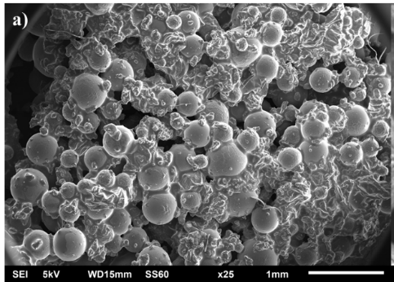

Figure 2. SEM image from microcapsules

Thermogravimetric Analysis (TGA)

To examine the thermal stability of microcapsules, TGA scans were performed from 27-700ºC. Initially, a small drop on capsules with CNTs was observed due to evaporation of excess water. First drop was due to urea-formaldehyde shell wall decomposition (T_{onset}) which is the maximum operating temperature of capsules and the evaporation of solvent and was at 208ºC. Second drop was observed from 330ºC to approximately 440ºC and was attributed to the homopolymerization of the encapsulated epoxy resin.

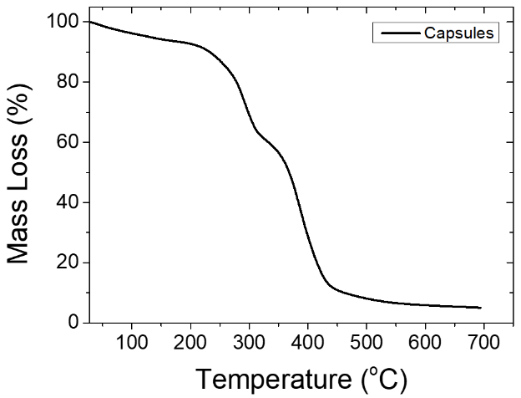

Figure 2. TGA measurements of capsules.

Impedance Spectroscopy

The incorporation of microcapsules containing nanomodified epoxy resin at neat polymer matrix revealed a minor drop in the magnitude of the impedance as seen in figure 3. In detail, the transition from the Ohmic (linear) to non-Ohmic (non-linear) behavior of the material, inside the alternative electric field, occurred at a slightly higher frequency. This behavior can be attributed to the capsule embedding. Although capsules were dispersed at polymer matrix at a small percentage (10 wt%), a slight reduction of the impedance was occurred.

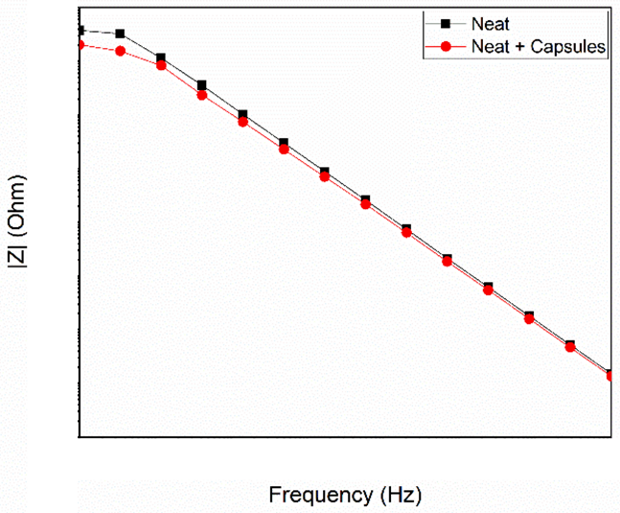

Figure 5. Impedance measurements

Conclusions

The nanomodified epoxy healing agent was successfully encapsulated by in situ polymerization into UF-walled microcapsules. Healing agent was DGEBA epoxy resin modified with 0.1% MWCNTs. The stirring rate which controlled the mean diameter of capsules was at 200rpm. Size distribution of the batch was 409.07 μm ± 77.30 μm. Thermal stability of microcapsules was estimated through Thermogravimetric analysis (TGA). As can be observed, microcapsules exhibited a satisfying thermal stability with T_{onset} approximately at 208ºC. Finally, the effect of the incorporation of a microcapsule-based self-healing system on the electric profile of a neat polymer matrix was estimated via Electrochemical Impedance Spectroscopy. After the system incorporation at the neat polymer matrix, a minor drop of the magnitude of the impedance was observed since the conductive healing agent.

Acknowledgements

The authors would like to thank Dichem Polymers, Greece for the gratis provision of the Epon 828 resin.

References

- Bekas, D. G., Tsirka, K., Baltzis, D., & Paipetis, A. S. (2016). Self-healing materials: A review of advances in materials, evaluation, characterization and monitoring techniques. Composites Part B: Engineering, 87, 92–119.
- Turkenburg, D. H., & Fischer, H. R. (2015). Diels-Alder based, thermo-reversible cross-linked epoxies for use in self-healing composites. Polymer (United Kingdom), 79, 187–194.
- Bekas, D. G., Baltzis, D., & Paipetis, A. S. (2017). Nano-reinforced polymeric healing agents for vascular self-repairing composites. Materials and Design, 116, 538–544.
- Kousourakis, A., & Mouritz, A. P. (2010). The effect of self-healing hollow fibres on the mechanical properties of polymer composites. Smart Materials and Structures, 19(8), 085021.
- Zhu, D. Y., Rong, M. Z., & Zhang, M. Q. (2015). Self-healing polymeric materials based on microencapsulated healing agents: From design to preparation. Progress in Polymer Science, 49–50, 175–220.
- Esser-Kahn, A. P., Odom, S. A., Sottos, N. R., White, S. R., & Moore, J. S. (2011). Triggered release from polymer capsules. Macromolecules, 44(14), 5539–5553.
- White, S. R., Blaiszik, B. J., Kramer, S. L. B., Olugebefola, S. C., Moore, J. S., & Sottos, N. R. (2011). Self-healing polymers and composites. American Scientist, 99(5), 392–399.
- Hia, I. L., Pasbakhsh, P., Chan, E. S., & Chai, S. P. (2016). Electrosprayed Multi-Core Alginate Microcapsules as Novel Self-Healing Containers. Scientific Reports, 6(September), 1–8.
- Brown, E. N., Kessler, M. R., Sottos, N. R., & White, S. R. (2003). In situ poly(urea-formaldehyde) microencapsulation of dicyclopentadiene. Journal of Microencapsulation, 20(6), 719–30.
- Blaiszik, B. J., Sottos, N. R., & White, S. R. (2008). Nanocapsules for self-healing materials. Composites Science and Technology, 68(3–4), 978–986.

