Rheological and Thermal Properties of Graphene/Cyanate Ester Composite

SHI Peiluo*, WANG Yueyou, GUO Hongjun, SUN Hongjie, ZHAO Yunfeng

Aerospace Research Institute of Materials and Processing Technology, Beijing, China
Email: shipeiluo@163.com

Keywords: Cyanate ester, Graphene, Rheology, Thermal conductivity

Abstract
A composite of graphene/cyanate ester (CE) was prepared. Rheological analysis, thermal conductivity and micro-analysis were conducted to assess the rheological and thermal performances of the composite. Results show that the complex viscosity of the composite increased rapidly by about 10E5 times with 10wt% graphene/CE and it decreased significantly with increasing deformation, suggesting the formation and broken processes of graphene network in the CE matrix. Thermal conductivity increased up to 0.46W/(m.K) for 10wt% graphene/CE, being 2 times that of pure CE. Thermal conductivity increased linearly with graphene ratio while complex viscosity increased exponentially with graphene ratio.

1. Introduction

Polymer composites have been increasingly applied as structural materials in aerospace, automotive and sport industries. The addition of well-dispersed micro or nano-fillers into a polymer matrix has been demonstrated to be quite effective in improving the properties of the polymer matrix, including mechanical, electrical and thermal properties. It is known that graphene possess extraordinary electrical, thermal and mechanical properties and, therefore, is promising candidate as fillers in polymer composites.

Cyanate ester (CE) resins are a family of high performance thermosetting resins with outstanding mechanical, thermal and dielectric properties. CE resins are often used in aerospace structures, radomes and microchips [1-2]. Many modified CE resin systems have been developed to meet the requirements of various applications.

In this paper, flake-like graphene/CE resin composites were prepared and structures and properties of the composites were studied. The objective is to explore the use of graphene-based multi-functional structural composites for added toughness and thermal conductivity with minimal loss in strength and stiffness.

2. Experimental

2.1. Material

CE resin system(R701) based on bisphenol E dicyanate ester was supplied by Aerospace Research Institute of Materials and Processing Technology (Beijing, China), and it is liquid-like at room temperature. Flake-like graphene was supplied by No. Six Element Co., Ltd. (Jiangsu, China), and its surface morphology is shown in Fig.1. Silane coupling agent (KH550) was supplied by Hangzhou Yecheng Silicones Co., Ltd., China.

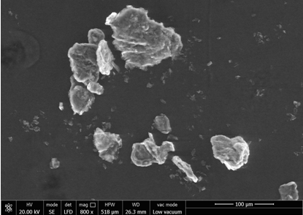

Figure 1. Morphology of flake-like graphene

2.2. Dispersions and preparation of graphene/CE composites

Raw flake-like graphene was mixed with ethanol solution containing KH550(2 wt%) and stirred for 20 min for an uniform distribution. The mixture was dried in a vacuum drying oven at 60ºC for 2 h to remove the solvent and thus graphene coated with KH550 was obtained. Graphene was dispersed in CE by high shear mixing of 1h followed by sonication of 1h. Graphene/CE mixture was degassed in vacuum for 30 minutes at 80 °C before pouring into molds. Cure schedule was 150°C 1hour, 190 °C 2 hours with 1 °C/min ramp rate. Cured samples are shown in Fig.2.

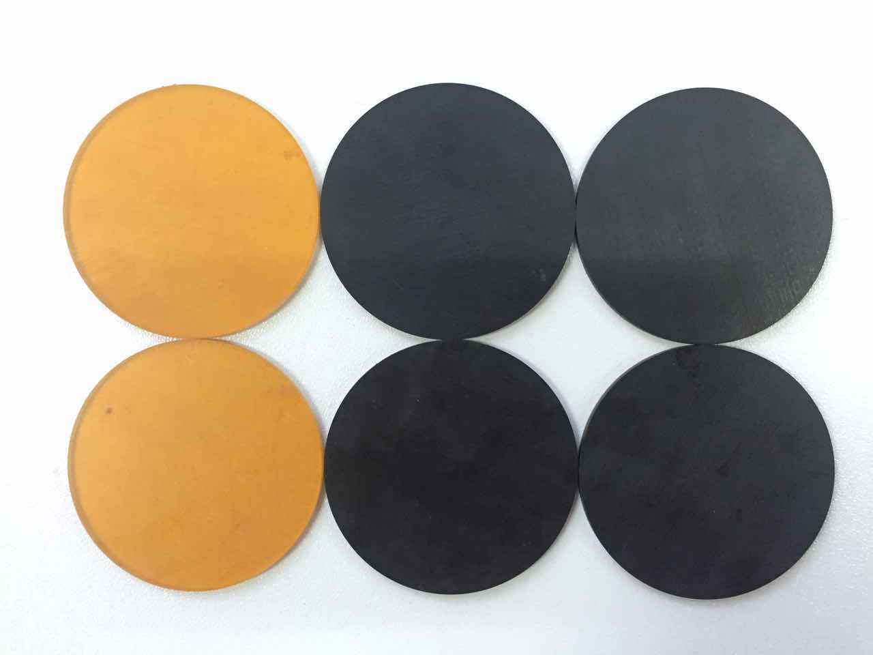

Figure 2. Cured CE (left) and graphene/CE (right)

2.3. Characterization

Rheology properties were analyzed by Physica MCR301 Rheometer (Anton Paar) with a plate-plate geometry and oscillation at various frequency and deformation. DMA test was taken by SIIDMA6100 Dynamic Analysis Instrument. Thermal conductivity was performed by DTC-300(TA instrument) using GB/T 10295-2008 standard.

3. Results and Discussions

3.1. Rheology

Rheology analysis was performed for uncured graphene/CE mixture of various graphene contents as a function of deformation varying from 0.001% to 1000%. Results are shown in Fig.3.

Figure 3. Complex viscosity of graphene/CE as a function of (a) deformation and (b) filler content

Results showed that at low filler contents (<2wt%) the complex viscosity increased slowly. At high filler content (4-10wt%), the initial complex viscosity increased rapidly. For 10wt% graphene/CE mixture, the complex viscosity increased from 0.1Pa.s to 10000Pa.s, by about 10⁵ times.

Strain level was also an important factor. For low filler content, the complex viscosity was almost constant as a function of strain. For high filler content, the complex viscosity was constant only until 0.1% strain level and decreased rapidly beyond 0.1%.

The above observations suggest that for this graphene/CE mixture, there is a rheological percolation threshold at about 2-4wt% filler content. Above this rheological percolation threshold filler content, graphene fillers percolated to form a network and the complex viscosity increased rapidly. At large strain level, the percolation network was broken and the complex viscosity decreased. A schematic view of the formation and break processes of the percolation network is shown in Fig.4.

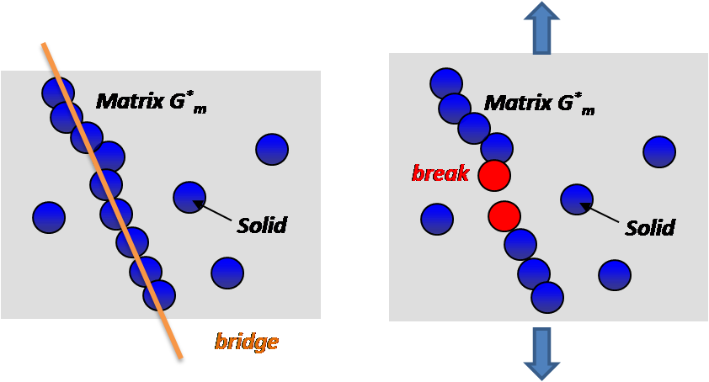

Figure 4. Formation and break of filler percolation network

3.2. Thermal conductivity

Thermal conductivity of graphene/CE composites as a function of graphene filler content was shown in Fig.5. Results suggested that thermal conductivity increased linearly with filler content. Pure CE has a thermal conductivity of 0.23 W/(m.K). 10wt% graphene/CE composite had a thermal conductivity of 0.46 W/(m.K), being 2 times that of pure CE. There seems to have no threshold for thermal conductivity [3-5].

Figure 5. Thermal conductivity of graphene/CE as a function of filler content

3.3. Mechanical Properties

Mechanical properties of pure CE and 10wt% graphene/CE were analyzed and shown in Table 1. It can be seen that both flexural strength and impact strength decreased. Flexural modulus increased 28%, from 2.9GPa to 3.7GPa.

Table 1. Mechanical properties of graphene/CE composite

Type | Flexural strength  (MPa) | Flexural modulus  (GPa) | Impact strength  (kJ.m²)
CE | 152 | 2.9 | 34.5
Graphene/CE | 132 | 3.7 | 15.3

3.4. DMA properties

DMA analysis was performed and results were shown in Fig.6. Graphene/CE composites had a higher storage modulus (6.0GPa) than pure CE (5.6GPa) below T_{g}. The T_{g} (determined by the peak of tanδ) of graphene/CE is 245ºC, and that of pure CE is 260ºC, suggesting that the existence of graphene filler had a negative effect on the thermal resistance properties. This is probably because fillers broke some crosslink structures and thus the crosslink density is reduced.

Figure 6. (a) Storage modulus E’ and (b) tanδ of graphene/CE composites

3. Conclusions

Graphene/CE composites were prepared and analyzed:
- Complex viscosity of the uncured composite mixture increased exponentially with graphene filler content. At 10wt% graphene filler, the complex viscosity is 10⁵ times that of pure CE. There is a rheological percolation threshold at about 2-4wt% filler content.
- Thermal conductivity increased linearly with graphene filler content. It is 0.46W/(m.K) for 10wt% graphene/CE, being 2 times that of pure CE.
- The modulus of graphene/CE composite is higher than that of pure CE, while T_{g} is decreased.

Acknowledgments

Authors gratefully acknowledge the financial supports from the Chinese National 863 Project (Project Number 2015AA03A202) and from General Armament Department (Project Number 41422020208).

References

[1] C. P. Reghunadhan Nair, Dona Mathew;K. N. Ninan, Cyanate Ester Resins, Recent Developments, Advances in Polymer Science. 155 (2001) 1-99
[2] Hamerton I., Chemistry and Technology of Cyanate Ester Resins[M]．London： Blackie Academic & Professional，1994：59．
[3] C.F. Han, A.J. Gu, G.Z. Liang, L. Yuan, Carbon nanotubes/cyanate ester composites with low percolation threshold, high dielectric constant and outstanding thermal property, Composites Part A. 41 (2010) 1321–1328.
[4] L.B. Zhang, J.Q. Wang, H.G. Wang, Y. Xu, Z.F. Wang, Z.P. Li, Y.J. Mi, S.R. Yang, Preparation, mechanical and thermal properties of functionalized graphene/polyimide nanocomposites, Compos. Part A 43 (2012) 1537–1545.
[5] K.G. William, M.R. Kessler, Dynamic mechanical analysis of fumed silica/cyanate ester nanocomposites, Composites Part A. 39 (2008) 761–768.

