EuroSun2026
Electrical charging for enhanced efficiency of thermochemical energy storage

Inga Bürger (corresponding author), Lucas Sotelo, Lynn Koers, Christian Brack, Marc Linder
Affiliation: Institute for Engineering Thermodynamics, German Aerospace Center, Stuttgart, Germany
Email: inga.buerger@dlr.de
Summary
Thermochemical energy storage systems (TCES) are gaining attention as a promising solution to address the intermittency of renewable energy, particularly in Europe’s residential sector, where heating demands a substantial share of total energy consumption. This work focuses on a novel thermochemical energy storage system integrating heat pump functionality during charging, featuring two alternative charging modes for salt hydrate-based systems: First, electrical charging via a resistive heater. Second, an alternative mode based on mechanical vapor compression, where dehydration-generated vapor is extracted, recompressed, and condensed to reuse its heat for the endothermic reaction—reducing reliance on ambient temperatures. Both concepts are introduced by an analytical study focusing on theoretical COP followed by first experimental considerations and the design of a reactor suitable for advective as well as closed system operation.
Keywords: thermochemical energy storage, heat pump functionality, s
Field of application for the findings: Thermal energy storage
Addressed audience: Engineers looking into new ideas for thermal energy storage
- Introduction
The energy transition from fossil fuels to renewable energy sources increases the need for storage systems capable of compensating for the inherent intermittency of these sources, especially in the residential sector, where the energy demand for heating represents a significant share of total energy consumption in Europe (around 25% in 2023 (Eurostat, 2026)). This highlights the need for efficient use of electrical energy for this application, where conversion into thermal energy represents a degradation in energy quality (Allen et al., 2017). Based on the scenario described above, it is essential to develop technologies that efficiently utilize electrical energy from renewable sources to meet residential heating demands, while simultaneously addressing the mismatch between supply and demand arising from the intermittent nature of renewable energy sources. Currently, among the various options to address this scenario, two main technological approaches aim to meet this need (compare Fig. 1).
The first, and most commercially widespread, is the use of heat pumps (IEA, 2022). A heat pump is a cyclic thermal machine that uses mechanical work to supply heat from a cold source to a hot source, operating with a working fluid (Cengel et al., 2006). While this technology enables an efficient use of electrical energy for heating purposes, it lacks intrinsic storage capacity and therefore cannot address the intermittency of renewable energy sources. As a result, it must be complemented with electrical energy storage systems, such as lithium batteries (Baraskar et al., 2024).

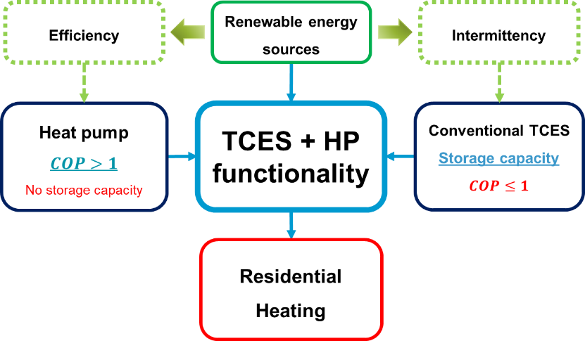
Fig. 1: Method I (PUSH) to charge a thermochemical system using electrical energy.
On the other hand, thermal energy storage systems (TES) also represent a relevant solution. These systems are classified into three types according to the nature of the heat storage mechanism: sensible heat storage, latent heat storage, and thermochemical energy storage (Mahon et al., 2022). Among them, different characteristics make each technology attractive for specific applications. One commonly used property to characterize these systems is the energy storage density (ESD), defined as the amount of energy stored per unit volume or mass of material. TES technologies can be ranked in increasing order of ESD as follows: sensible heat < latent heat < thermochemical storage (N´Tsoukpoe et al., 2009). While TES are well suited to address the mismatch between energy supply and demand, their direct charging using electrical energy—without the integration of a heat pump—typically results in a near one-to-one conversion of electricity into heat. This implies not only limited efficiency gains, but also a degradation in energy quality, as high-grade electrical energy is irreversibly converted into low-grade thermal energy with reduced potential for useful work (Allen et al., 2017).
It is needed to find a solution which addresses both aspects, an efficient use of the electrical energy for household applications and at the same time to compensate the intermittency in the electricity from the renewable energy sources. Thus, the present current work, focuses on the development of a flexible thermochemical storage system for temperature regimes <80 °C that can be easily adapted to varying operating conditions (different countries) as well as to variable charging conditions and reaches energy storage densities for the system > 200 kWh/m³. Regarding system flexibility, a system is envisioned, which cannot only be charged by thermal energy, but also in a very efficient way using electrical energy from renewable sources reaching COPs>>1.
- Thermochemical energy storage with electrical charging
For any energy storage system, the storage efficiency is defined as the ratio between the useful energy released during discharge and the energy supplied to the system. This value can by definition not exceed values of “1”. However, in thermochemical energy storage systems based on the reaction of salt-hydrates with water, the stored energy can be split into two: the energy corresponding to the reaction enthalpy as well as to the energy corresponding to evaporation and condensation of the water. Thus, in case the system boundaries can be extended to a clever gas management, system efficiencies exceeding “1” can be reached. E.g., when the heat of evaporation is not required, as the system can be discharged using moist air. In this case, it is rather appropriate to not use the term efficiency, but to use the definition of a coefficient of performance (COP).
$COP= \frac{Q_{\text{useful}}}{E_{\text{supplied}}}$ (eq. 1)
The present work actually focuses on the increase of the overall COP of the thermochemical energy storage by implementing two different methods for electrical charging, while the basic assumptions is related to a discharging process using moist air. The two different methods can be deduced from the concept of the thermochemical reaction, which can be described based on the reaction equation:
$AB_{(s)}+∆_{R}H=A_{(s)}+B_{(g)}$ (eq. 2)
, and follows a temperature-pressure equilibrium. This implies that to promote the dehydration reaction or the charging process, it is necessary to establish a driving force to initiate the reaction – either by changing temperature or pressure.
Option I – PUSH-concept - increases the system temperature by providing thermal energy at an elevated temperature, thereby pushing the water vapor out of the salt. In contrast, option II – PULL-concept - pulls the water vapor out by reducing the system pressure, which also shifts the operating conditions away from equilibrium state.

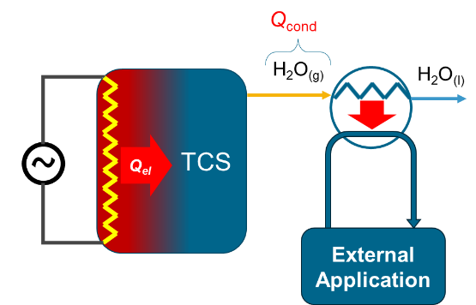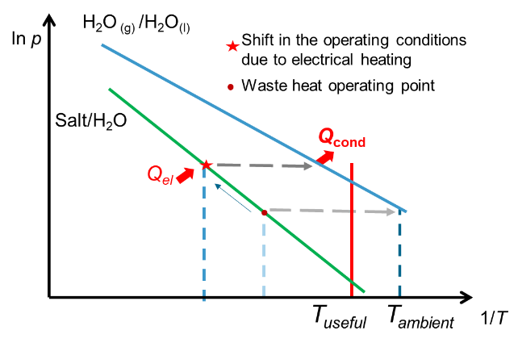
Fig. 2: Left: Method I (PUSH) to charge a thermochemical system using electrical energy.
Right: Schematic TCES process in schematic Van´t Hoff plot
Option I (push) is illustrated in Figure 2. The system is charged using electrical energy, while the water vapor released from the thermochemical dehydration is applied externally. Thus, the latent heat of condensation of this vapor is used as useful energy.

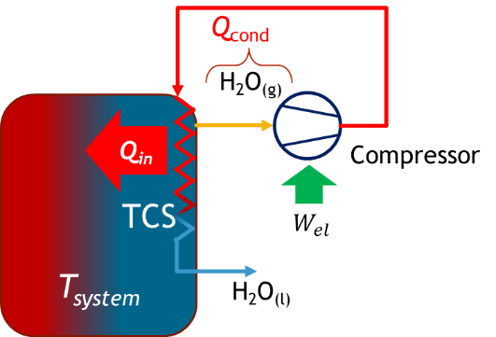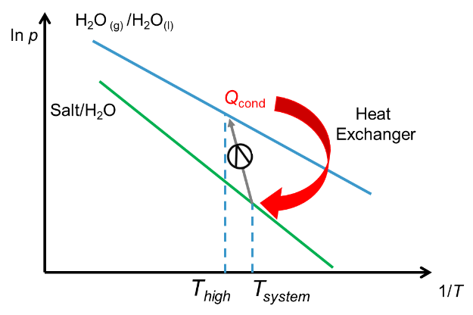
Fig. 3: Left: Method II (PULL) to charge a thermochemical system using electrical energy.
Right: Schematic TCES process in schematic Van´t Hoff plot
Option II is illustrated in Figure 3. In this case, the system is also electrically driven, but the gas is actually pulled out of the material. Then, the temperature and pressure of the water vapor are increased by a concept similar to mechanical vapor recompression, and the latent heat of condensation is internally recovered by an indirect heat transfer to the thermochemical material. The concept of increasing the driving force of a reaction by using internal gas pumps has been demonstrated previously for sorption systems (Zeng, 2022). However, using the heat of condensation internally in the charging process is to the knowledge of the authors a novel concept for TCES.

- Constraints of the Concepts and possible COPs >>1
In the following section, some more detailed consideration regarding the two charging concepts are given focusing on temperature constraints as well as achievable theoretical COP.
The option referred to as the so called “PUSH” concept is based on the assumption that by using electricity for heating, the upper temperature limit is not restricting. Thus, during charging as high temperatures can be supply to the TCES in order to discharge the H₂O-gas at a pressure referring to a condensation temperature > 40 °C (compare Figure 2, right). This implies that with this concept, it is possible to provide “heating during charging”. So overall, by strongly increasing the available temperature difference between advective discharging and temperature driven charging, the common system limitations so TCES charged by waste heat are not valid.
Figure 4 shows the evolution of a theoretically calculated COP of the PUSH concept for the reference material K₂CO₃-sesquihydrate. Assuming a constant enthalpy of reaction as well as condensation, the ratio is independent of temperature. For this configuration, the resulting COP is constant for a selected salt hydrate material and independent of the charging temperature. For K₂CO₃-sesquihydrate as a reference material (Aarts et al, 2022), the theoretical value for this method can be calculated to COP = 1.6. However, there is a lower limit in the temperature, referring to the minimum reaction temperature, which is required to release steam at a pressure higher than corresponding to a condensation temperature > 40 °C. E.g. for K₂CO₃-system this is above 83 °C, according to Aarts et al., 2022.
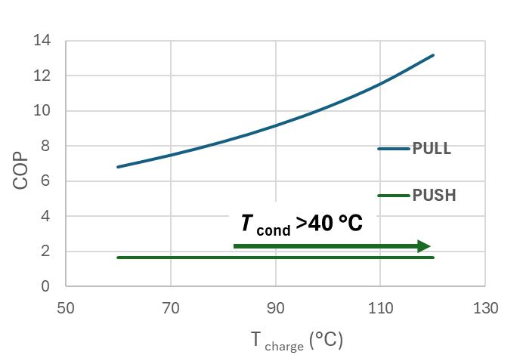
Fig. 4: Theoretical COP versus operating temperature for PUSH and PULL (adiabatic compression) concept.
For the second option, the so called “PULL” concept, the charging process of the TCES is not driven thermally, but the reaction is rather driven by a compression mechanism pulling out the reacting gas and thereby inducing the charging reaction. The intention of this concept is the re-utilization of the heat of condensation of the reacting gas independent of the working temperature (compare Fig.3, right). The principle follows to some extend the concept of mechanical vapor recompression: the gas is pulled out of the material at the operating temperature and corresponding equilibrium pressure of the material. By compression of the gas at constant temperature up to the condensation pressure at the identical temperature, it is possible to condense the reacting gas and redirect the heat of condensation to the charging process. This energy for compression is required as electrical energy and for isothermal compression it can be considered as Δ_{R}H_{react}- Δ_{R}H_{cond}. As main features of this concept, two aspects can be highlighted. First, the thermal energy for charging is reduced by the enthalpy of condensation. Second, in general, the charging process is independent of ambient temperature. This second point emphasizes the distinct differences from state-of-the-art TCES systems charged with thermal energy and achieving lower system COPs: by utilization of the available electricity to drive the compressor, the temperature restrictions between absorption process and desorption process can be reduced.
Figure 4, illustrates the COP versus time, which can be achieved by the PULL concept. Obviously, there is a strong temperature dependence. This correlation is caused by the reduced pressure ratio between reaction pressure and condensation pressure at elevated temperatures, which is influencing the required work for adiabatic compression. In case the two pressures are identical, the theoretical COP is maximum, however, the concept would rather follow a mechanical vapor recompression in this point. Regarding the reference material K₂CO₃-sesquihydrate, a maximum value of 2.7 can be calculated at 20 °C. Thus, it is obvious that this method for charging can be very promising for thermochemical systems in the framework of electricity surplus for storage of thermal energy.
- Experimental setup
4.1. Requirements for the system
In order to experimentally demonstrate the feasibility of these concepts, a flexible test rig is required. Fig. 5 shows a scheme of the setup, which is designed to verify the technical feasibility of the two proposed charging methods, plus discharge in an open configuration. The main challenge is the design of a test rig as well as a reactor, which are able to perform during advective absorption for discharging as well as during closed system configuration with pure water vapor during desorption.
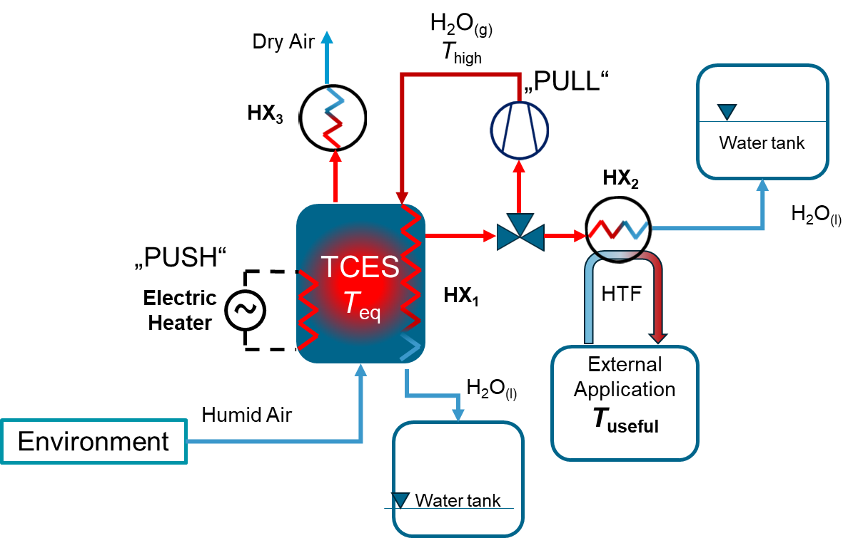
Fig. 5: Schematic concept of experimental test rig.
For the PUSH concept based on the electrical heating with elevated temperatures, the system features a thermostatic bath in which the heat supply for this loading method is indirectly emulated by means of an electric heater. The thermal bath is fitted with a mass flow meter and temperature sensors at the inlet and outlet to assess the energy supplied to the reactor. Furthermore, it must be possible to remove all remaining gas except water vapor at the beginning of the charging process using a vacuum pump, thus the system needs to be pressure tight for pressures in the range of ~200 mbar to ~1,1 bar. Finally, the system features a condenser connected downstream of the reactor to emulate the utilization of heat from the condensation of water vapour resulting from dehydration. Temperature sensors are required at each heat transfer stage, and a level gauge is required in the condenser to assess the volume of condensate. For the PULL concept, a compressor is required, which is able to efficiently compress superheated steam for reutilization of the heat of condensation, by a pressure ratio of ~ 5. Furthermore, a water tank is required at the outlet of the reactor collecting the water, which has been pulled out of the reactor and condensed internally. For this operation it is also required to ensure a pressure tight system to pressures of 200-500 mbar.
In contrast, for the discharging under advective conditions, the constraints for the reactor and system design differ. In this case, high gas flow rates through the reactor are required while pressure loss should still be minimum. Thus, large cross sections for the inlet and outlet as well as stable particle sizes of the material are mandatory for a satisfying performance. The system comprises a steam generator and a nitrogen supply line to establish the environmental conditions for system discharge; both are connected to a mixing chamber, resulting in ‘humid air’. The nitrogen supply is fitted with a controller that sets the volumetric flow rate. Humidity and temperature sensors connected to the reactor’s inlet and outlet determine the amount of water absorbed during hydration. To utilise the heat released during discharge, the extended system can feature a heat exchanger connected to the air flow from the reactor.
The main requirements for the different operation modes are also summarized in Table 1.

Tab. 1: Requirements for experimental setup for different operation modes
Operating Mode | Main Requirements
Charging with PUSH concept (closed) | system withstands temperatures > 100 °C,  partial vacuum conditions ( 200 mbar - 1 bar), external condenser to measure “heating effect” required
Charging with PULL concept (closed) | compressor for superheated steam required with pressure ratio of ~5,  partial vacuum conditions ( 200 mbar – 1 bar), reactor with internal condenser, water tank
Discharging with ambient air (advective system) | ambient conditions– direct gas flow through reactor at ambient pressure, gas flow rate controller, temperature sensors and humidity sensors at inlet and outlet required

4.2. Experimental Setup
Figure 6 shows the version of the setup as well as the reactor concept designed for experiments demonstrating PUSH concept as well as advective discharging. On the left hand side, the water is evaporated and can be mixed with the gas to provide the desired relative humidities in the air flow rate at the inlet of the reactor for the discharging. The evaluation is based on humidity sensors as well as temperature sensors at the inlet and outlet, the water uptake can be determined. To perform the charging in PUSH mode, a thermostatic bath is connected to the reactor, which can heat up the system up to 190 °C to initiate the dehydration reaction. The released water vapor will first push the remaining air out and then it will be condensed to emulate the heating during charging effect.
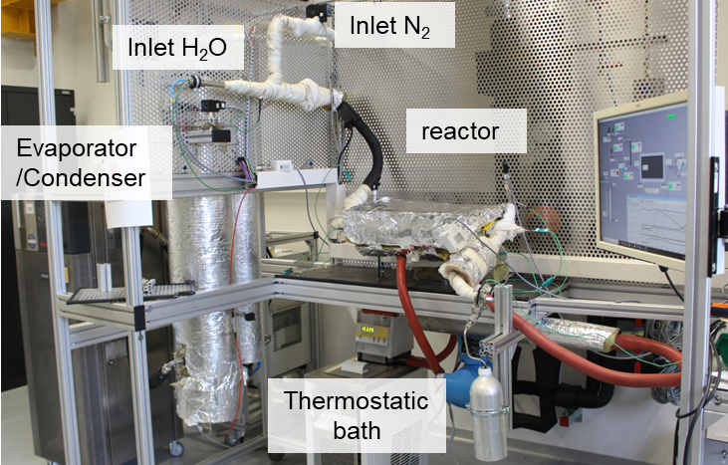
Fig. 6: Picture of experimental test rig.
4.3. Reactor Concept
The developed reactor is presented by a picture and schematically in Figure 7. It is intended to represent a single plate, which can be used in future for a modular stacked design. The main intention of the current design is to enable both operation modes with an optimized performance: the advective discharging as well as the closed charging (PUSH concept).
Figure 7 shows pictures with schematic functionalities. As it can be seen on the right hand side, the powder material is filled in the main void of the reactor. For the gas transfer in the advective system the gas is provided at one side and distributed along the width of the reactor and across the small gap above the material separated by a metallic filter sheet. Then, the gas is flowing through the powder bed and is collected at the bottom of the bulk in the gas channels marked in green. Thus, this concept enables the gas to flow across the overall bulk material guaranteeing direct contact with the material, but at the same time minimize pressure loss. In order to provide the heat during the charging process following the PUSH concept, at the bottom of the reactor heat transfer fluid is flowing by the encorporated microchannels. Thus, heat transfer is realized in vertical direction defined by the thickness of the powder bed. The reactor is manufactured using additive manufacturing technologies and made from AlSi₁₀ material. The area for the powder bed is about 340 mm to 160 mm with a maximum height of about 11 mm.
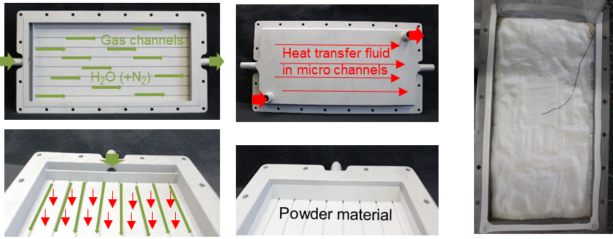
Fig. 7: Schematic concept of reactor concept and filled reactor (right).
This reactor will be used to prove the feasibility of combining advective and closed operation in one design effectively, as this will offer the possibility to operate TCES reaching COPs >>1.
- Conclusions
The contribution presents a detailed analytical study of the calculations for the efficiency of TCES regarding different charging methods based on electrical energy. It has been shown that a main constraint to take advantage of these operation modes is that the corresponding experimental setup as well as reactor need to be able to operate in advective as well as closed operation mode. Next to the implications in the experimental design, a novel reactor concept is presented, which addresses this challenge. Gas transport is realized in a flow through mode with maximum surface area to reduce pressure drop, while heat transfer is realized in perpendicular direction using micro channels for the heat transfer fluid. The feasibility of this reactor for the two operation modes will be proven in a next step. The final goal of this work is to prove the possibility to reach COPs>>1 for TCES charged by electricity.
Acknowledgements:

Part of this project has received funding from the European Union’s Horizon Europe program under grant agreement No 101130021 (4TunaTES).
- References
Aarts, J., de Jong, S., Cotti, M., Donkers, P., Fischer, H., Adan, O., Huinink, H., 2022. Diffusion limited hydration kinetics of millimeter sized salt hydrate particles for thermochemical heat storage, J. of Energy Storage, p 47.
Allen, S.R, Hammond, G.P., and McKenna, R.C. 2017, The thermodynamic implications of electricity end-use for heat and power, Proceedings of the Institution of Mechanical Engineers, Part A: Journal of Power and Energy, 508–525, DOI : 10.1177/0957650917693483.
Baraskar, S., Günter, D., Wapler, J., Lämmle, M., 2024, Analysis of the performance and operation of a photovoltaic battery heat pump system based on field measurement data, Solar Energy Advances 4, p 100047, doi: 10.1016/j.seja.2023.100047.
Cengel, Y.A., and Boles, M.A., Thermodynamics: An Engineering Approach. McGraw-Hill series in mechanical engineering, 2006, isbn: 9780073107684.
Eurostat., 2026, Disaggregated final energy consumption in households– quantities, [nrg_d_hhq] Disaggregated final energy consumption in households - quantities
International Energy Agency, The Future of Heat Pumps. 2022, url: https://www.iea. org/reports/the-future-of-heat-pumps.
Mahon, H., O´Conner, D., Friedrich, D., Hughes, B., 2022, A review of thermal energy storage technologies for seasonal loops, Energy 239 p. 122207, doi: 10.1016/j.energy.2021.122207.
N’Tsoukpoe, K.E., et al., 2009, A review on long-term sorption solar energy storage”, Renewable and Sustainable Energy Reviews 13.9, 2385–2396, doi: 10.1016/j.rser.2009.05.008.
Zeng, T., Li, J., Deng, L., He, Z., Kobayashi, N., Wu, R., Huang, H., 2022, Mechanical Booster Pump-Assisted Thermochemical Mode for Low-Grade Heat Storage and Upgrading: A Thermodynamic Study”, Frontiers in Energy Research, Volume 10, https://doi.org/10.3389/fenrg.2022.851611.

