EuroSun2026
Long-term thermal performance of heating system integrated with heat pump and small-scale seasonal heat storage tank using solar thermal energy for energy saving of greenhouse

Youngsub An¹, Hong-Jin Joo¹, Wang-Je Lee¹, Kyoung-Ho Lee² (corresponding author)
Korea Institute of Energy Research^{1,2}
ysan@kier.re.kr¹, joo@kier.re.kr¹, lwj3116@kier.re.kr¹, khlee@kier.re.kr²
Summary
This study developed a solar thermal-based heating system capable of supplying 100% of the heating energy required for greenhouse horticulture and experimentally verified its long-term energy supply performance over a three-year period. The proposed heating system stores thermal energy generated by solar collectors in a seasonal thermal storage tank and supplies heating energy to a 3,850 ㎡ greenhouse cultivating subtropical crops in combination with a heat pump. The solar collector system was configured as a hybrid system combining flat-plate collectors and evacuated tube collectors operating in the low-temperature range. The seasonal thermal storage system was designed as a small-capacity tank suitable for the scale of the demonstration greenhouse. Heat produced during the summer season was stored in the tank and later used either directly for greenhouse heating in winter or as a heat source for a water-source heat pump. In addition, a shallow-ground thermal storage system was implemented to evaluate its feasibility for thermal storage and its potential use as a heat source for the heat pump. For the system demonstration, part of the existing greenhouse was removed and a new mechanical room was constructed. Solar collectors were installed on the roof of the mechanical room, while the heat pump and shallow-ground thermal storage system were installed below the roof. The seasonal storage tank, buffer tank, pumps, piping, and operation control system were installed inside the mechanical room, resulting in a compact and integrated system configuration. The system was operated continuously for three years, and the energy balance of heat production, storage, and supply for greenhouse heating was analyzed based on long-term measured operational data.
Keywords: Greenhouse space heating, Heat pump, Long-term thermal performance, Solar collector
Field of application for the findings: The findings can be applied to greenhouse horticulture, smart farms, and other facilities with high heating demand. The solar thermal seasonal storage and heat pump system can support energy self-sufficiency, reduce fossil fuel use, and lower carbon emissions in agricultural and building heating applications.
Addressed audience: researchers, engineers, industry professionals, and policy makers related to renewable energy, greenhouse systems, and energy systems
- Introduction
The application of renewable energy in the agricultural sector has very low scalability when considering system size, applicability, and cost, which makes achieving carbon neutrality in agriculture particularly challenging. Conversely, the agricultural sector requires significant technological development, deployment of renewable energy systems, and substantial investment to achieve carbon neutrality. In addition, agricultural land is primarily used for crop cultivation, resulting in very limited available land for installing renewable energy systems. Therefore, considering these site constraints, renewable energy systems should be integrated into a compact mechanical room to maximize land use efficiency. Furthermore, fuel and electricity costs required for greenhouse heating and cooling systems are increasing due to rising energy prices and supply instability, which increases farm operating costs and places a financial burden on farmers. Therefore, technological development to solve these complex problems is urgently needed.
In this study, a solar thermal seasonal storage-based heat pump integrated heating supply system was developed to reduce greenhouse heating energy consumption. A small-scale seasonal thermal storage tank capable of storing hot water produced by solar collectors during the summer was developed. To ensure long-term storage performance, heat loss was minimized and the insulation performance of the storage tank envelope was improved. A small shallow underground thermal storage system combining vertical and horizontal configurations was also applied, and the feasibility of using the stored heat in the horizontal storage as a heat source for a hybrid heat pump system was analyzed. The application of a hybrid heat pump allows the hot water stored in the seasonal storage tank, produced by solar collectors, to be used as a heat source, thereby improving the overall efficiency of the integrated system.
In this study, the developed renewable energy-based heating supply system was demonstrated through long-term operation over a three-year period, and the results confirmed that the developed system can overcome several limitations of conventional greenhouse heating systems.
- System energy balance calculation

2.1 Integrated heating system for greenhouses
This study proposes an integrated heating system for greenhouses that combines solar thermal energy, seasonal thermal storage, and heat pump technologies, as illustrated in Fig. 1. The system includes solar collectors, a seasonal thermal storage tank, shallow ground heat storage, heat pumps, and an operation and control system. Thermal energy collected from the solar collectors is used directly for greenhouse heating during spring, autumn, and winter when heating demand exists. During the summer period, when heating is not required, the collected thermal energy is stored in the seasonal thermal storage tank for later use during the heating season. During winter operation, high-temperature heat stored in the seasonal storage tank can be supplied directly to the greenhouse heating system. In addition, low-temperature stored heat is transferred to the shallow ground heat storage system and used as a heat source for a multi-source heat pump. The multi-source heat pump is designed to utilize low-temperature residual heat (10–35 °C) from the seasonal thermal storage tank as the primary heat source. After this residual heat is depleted, additional heat sources such as an air-source heat pump or shallow geothermal energy are used to maintain stable heating operation. By replacing conventional fossil fuel-based heating systems, the proposed system can significantly reduce greenhouse heating energy consumption. Moreover, the use of heat pump technology allows the electrification of heating energy demand, which can contribute to reducing carbon emissions and improving overall system energy efficiency.
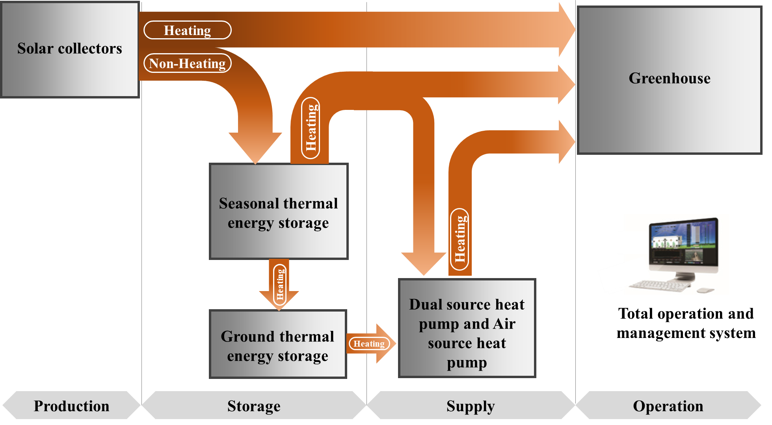
Fig. 1 Concept of a heat supply system combining a solar thermal and seasonal thermal energy storage-based dual source heat pump.
The heat loss of the STES tank was not measured directly but was estimated using an energy balance method based on long-term monitored temperature stratification and measured heat input and output. Although separate static cooling tests or experimental measurements of the heat loss coefficient were not performed, this approach allows thermal losses to be evaluated at the system level under actual operating conditions. The coefficient of performance (COP) for each water and air source heat pump can be computed as:
${COP}_{wshp}=\frac{Q_{wshp}}{P_{wshp}+P_{wshp.pump}}$ (eq. 1)
where $Q_{wshp}$is the thermal energy produced by the ground source heat pump, $P_{wshp }$ is the electrical power consumption of the ground source heat pump, $P_{wshp.pump}$is the electrical power consumption of the circulation pump.

2.2 System components
The main components of the system installed in the machine room are shown in Fig. 2. Because of its relatively small capacity, the seasonal thermal storage tank was susceptible to higher heat loss per unit volume. However, installing the tank inside the mechanical room, rather than outdoors, helped minimize direct exposure to external environmental conditions. This arrangement also improved the overall aesthetic appearance by keeping the storage tank out of sight. An automatic control valve was installed to minimize heat loss caused by natural convection within the pipes. This heat loss could occur because the load-side inlet and outlet pipes (40A) and the heat source-side pipes (80A) connected to the seasonal thermal storage tank remained continuously open. The automatic control valve was connected to both the heat source-side heat production system and the load-side heat supply system, allowing the valve to open and close automatically according to system operation. To further reduce heat loss from the seasonal thermal storage tank, the insulation thickness of the outer shell was maximized within the available space. In addition, a diffuser was employed to improve the temperature stratification of the stored hot water and thereby increase the utilization efficiency of the stored thermal energy. Both disk-type and slot-type diffusers were incorporated into the tank to promote effective thermal stratification. The disk-type diffuser was installed at the hot-water inlet, while the slot-type diffuser was installed at the hot-water outlet.
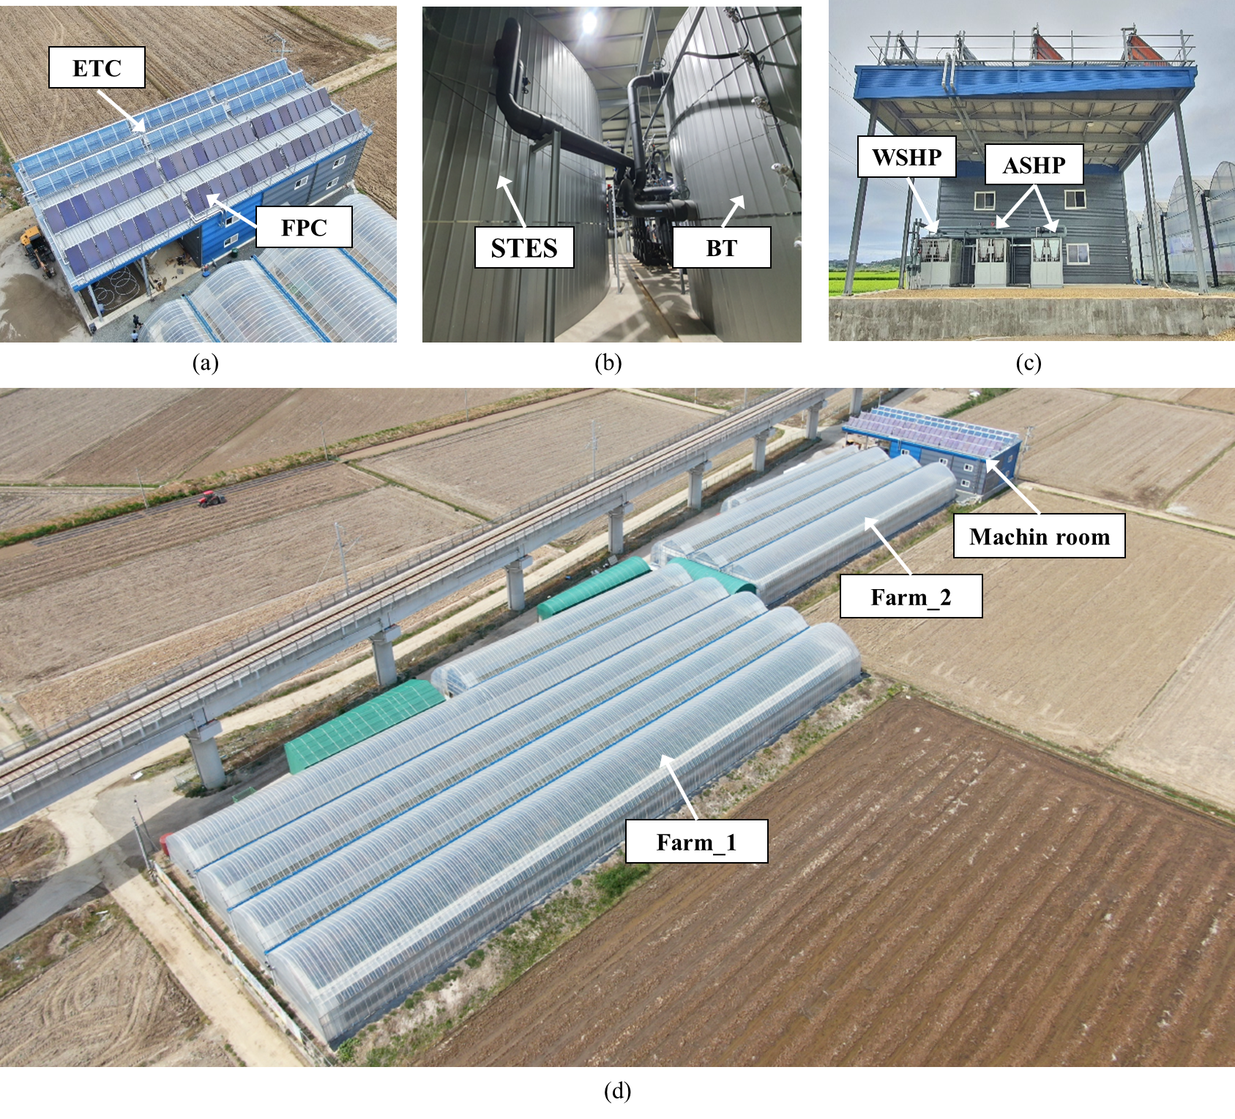
Fig. 2 System components: (a) solar collectors, (b) storage, (c) storage insulation, (d) greenhouse
- Results and Discussion

3.1 Temperature of the seasonal thermal storage tank
Depending on the operating mode of the system, the heat generated by the solar collector was stored in the seasonal thermal storage tank, buffer tank, or shallow ground. During the non-heating period, the generated heat was initially stored in the seasonal thermal storage tank. Once the heat-source temperature in the seasonal thermal storage tank reached the specified setpoint, the excess heat was transferred to the buffer tank. Similarly, when the heat-source temperature of the buffer tank reached its setpoint, the heat was subsequently discharged to the shallow ground for storage. The temperature distribution within the seasonal thermal storage tank during the demonstration period is presented below. As shown in Fig. 3, the maximum temperature measured at the uppermost level (Level_7) of the seasonal thermal storage tank was 74.2 °C on November 10, 2022, at 14:17 in the first year. The corresponding maximum temperatures were 80.5 °C on November 3, 2023, at 15:32 in the second year and 84.9 °C on August 26, 2024, at 14:59 in the third year.
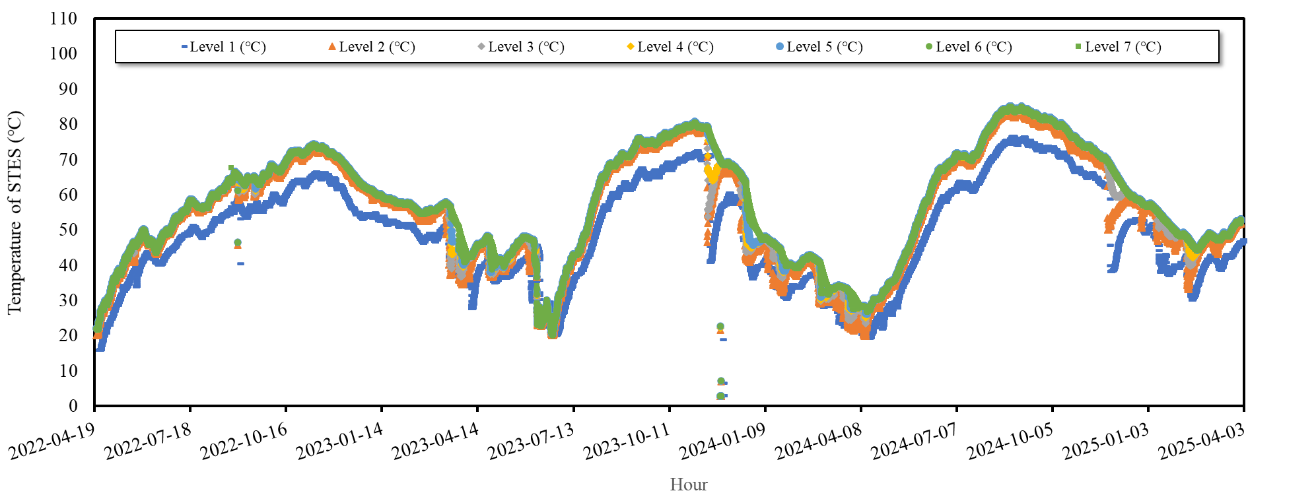
Fig. 3 Temperature of tank flow for total experimental period

3.2 Overall energy balance
During the demonstration period, the multi-source heat pump using the seasonal thermal storage tank as a heat source generated a total of 23.89 MWh of thermal energy. The average COP based on the heat output from the seasonal thermal storage heat source was 4.1. The performance of the multi-source heat pump was strongly influenced by the water source temperature, and the COP increased as the source temperature increased. The air-source heat pump was operated when the temperature of the seasonal storage tank heat source ranged between 35 and 45 °C, corresponding to the H-2 operating mode. In this mode, the heat pump did not directly supply heat to the greenhouse load. Instead, heat was stored in the shallow-ground storage system until the storage temperature decreased to approximately 35 °C or lower, after which the system operated using a combined heat source. Furthermore, the air-source heat pump was also operated during high heating demand periods requiring simultaneous operation of both the combined heat source heat pump and the air-source heat pump, such as in the H-5 operating mode, or when operation of the combined heat source heat pump was not possible, such as in the H-6 mode. During the demonstration period, the combined heat-source heat pump operating in air-source mode produced 37.48 MWh of thermal energy with an average COP of 3.9.
The overall energy balance during the entire demonstration period is presented in Fig. 4. Of the total 316.17 MWh of thermal energy generated by the solar thermal collector, 87.8%, corresponding to 203.87 MWh, was stored, while 31.3%, or 99.11 MWh, was supplied to the greenhouse. In addition, the annual solar fraction, representing the contribution of solar heat to the greenhouse load during the measurement period, was 78.4%.

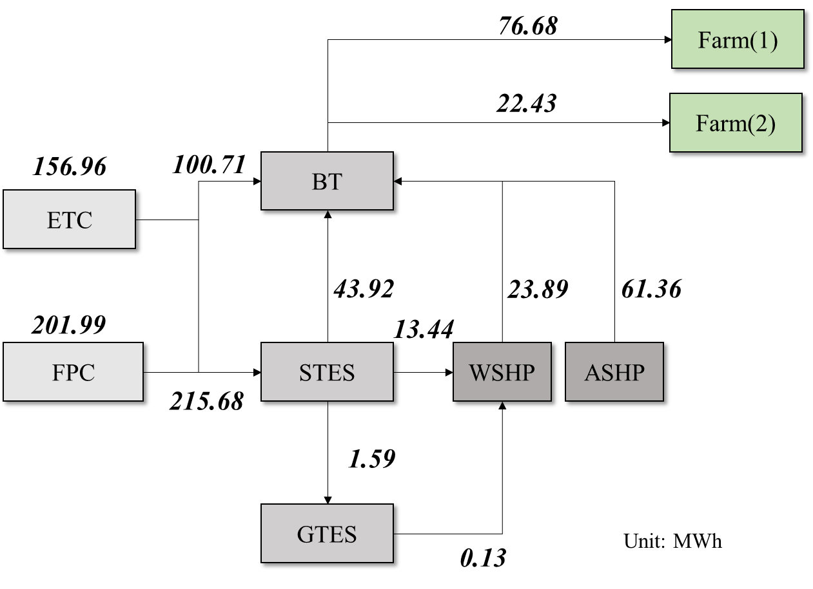
Fig. 4 Total energy balance of the system
- Conclusion
This study developed and demonstrated a hybrid heat supply system combining solar thermal energy, seasonal thermal storage, shallow-ground thermal storage, and heat pumps for greenhouse heating. The three-year field demonstration showed that the system could effectively utilize solar heat while reducing the reliance on conventional heating sources. The solar thermal system achieved an annual average thermal efficiency of 31.8%, while the seasonal thermal storage system achieved an average storage efficiency of 55.1% through improved insulation and optimized valve control. The multi-source heat pump showed an annual average COP of 4.1, and the backup air-source heat pump achieved a COP of 3.9. Although the shallow-ground storage system experienced heat losses due to unfavorable ground conditions, it helped maintain a stable heat-source temperature for the heat pump, particularly during periods of high heating demand. The compact system layout also improved the use of available space by installing the solar collectors on the mechanical room roof and the seasonal storage tank inside the room. This configuration reduced piping length and simplified system installation. Overall, the results indicate that the proposed hybrid system can provide a practical and efficient approach to reducing fossil fuel use in greenhouse heating while making effective use of available space.
- Acknowledgements
This work was supported by the Korea Institute of Planning and Evaluation for Technology in Food, Agriculture and Forestry(IPET) and the Korea Smart Farm R&D Foundation(KosFarm) through the Smart Farm Innovation Technology Development Program, funded by the Ministry of Agriculture, Food and Rural Affairs(MAFRA), Ministry of Science and ICT(MSIT), Rural Development Administration(RDA)(RS-2025-02314149), and supported by the Ministry of Agriculture, Food and Rural Affairs. Project (120093-3)
- References
J. Wang, Q. Luo, J. Cheng, M. Qu, P. Wang, S. Zhao, H. Xu, C. Ma, Study on thermal property of a solar collector applied to solar greenhouse, Appl. Therm. Eng. 244 (2024) 122628.
A. Vadiee, V. Martin, Thermal energy storage strategies for effective closed greenhouse design, Appl. Energy. 109 (2013) 337–343.
A.V. Novo, J.R. Bayon, D. Castro-Fresno, J. Rodriguez-Hernandez, Review of seasonal heat storage in large basins: Water tanks and gravel–water pits, Appl. Energy. 87 (2010) 390–397.
G. Oliveti, N. Arcuri, S. Ruffolo, First experimental results from a prototype plant for the inter seasonal storage of solar energy for the winter heating of buildings, Sol. Energy. 62 (1998) 281–290.

