Compression after impact of carbon/geopolymer sandwich panels

Martin Kadlec¹, František Martaus² and Robin Hron³

¹VZLU – Czech Aerospace Research Centre, Beranovych 130, 199 05 Prague, Czech Republic
Email: kadlec@vzlu.cz, Web Page: http://www.vzlu.cz
²VZLU – Czech Aerospace Research Centre, Beranovych 130, 199 05 Prague, Czech Republic
Email: martaus@vzlu.cz, Web Page: http://www.vzlu.cz
³VZLU – Czech Aerospace Research Centre, Beranovych 130, 199 05 Prague, Czech Republic
Email: hron@vzlu.cz, Web Page: http://www.vzlu.cz

Keywords: geopolymer, carbon, sandwich, impact, compression.

Abstract
Geopolymers are amorphous aluminosilicate materials which combine low temperature, polymer-like processing with high temperature stability and fire resistibility without toxic smoke generation. The aim of the paper is to evaluate the impact resistance of the new material. The sandwich panels were manufactured from foam core and carbon fibre/geopolymer skins. Specimens with dimensions of 150 x 100 mm were extracted from the panels. Half of the panels were conditioned in hot/wet environment (70°C/85%r.h.) for two weeks. The drop weight impact tests were carried out in accordance with ASTM D7136M with two levels of impact energy to apply both VID (visible impact damage) and BVID (barely visible impact damage). Then the specimens were loaded by compression according to ASTM D7137M in room temperature conditions. The results showed significant effect of the environmental conditioning on the compression strength. The performance was also affected by the impact damage energy and skin/core adhesive type. During loading, deformation field was measured using a digital image correlation system. This research can establish new fire resistible sandwich materials to be used in aerospace constructions.

1. Introduction

The first geopolymer resin was defined by J. Davidovits in 1979 [1]. Geopolymers are amorphous aluminosilicate materials possessing ceramic-like features in their structures and properties. The material behaves like a ceramic, but does not require high processing temperatures or pressures, so it can be worked up like common organic resins [2]. The excellent temperature stability, fire resistance with no generation of toxic fumes and smokes, low thermal conductivity and good specific strength are the main advantages of geopolymers [3-5]. These properties are important for the aviation industry where they can prevent fatal damage of fire in case of aircraft accident [6]. Currently used organic matrix composites formally meet requirements such as FAR 25, appendix F; nevertheless, in the event of real fire they quickly deteriorate at temperatures above 300ºC emitting toxic fumes and gases. True non-flammability of present-day composites is limited to minutes [7]. The geopolymer withstands temperatures of over 1000ºC and can be utilized as matrix in fibre reinforced composites. For larger expansion of geopolymer composites into the aircrafts constructions, it is necessary to know effect of impact damage and extreme environment on the material strength which is significantly lower compared to high-end carbon fibre reinforced polymer composites.
Impact damage is a serious damage mechanism in polymer composite laminates that limits the performance and reliability of these laminates. Impact damage can occur during in-service or as a result of handling during manufacture. This accidental damage is compared to the barely visible impact damage (BVID), which is a concept evaluated by the damage tolerance philosophy – JAR25.571 [8, 9]. This low-velocity damage [10] gives rise to surface indentations and other damage below the surface, such as matrix cracking, fibre breakage, delamination, or disbonding. Under compressive loads, these failure mechanisms interact, and compared to the undamaged state, the impact-induced damage propagates to failure at significantly lower load levels [11].
To increase efficiency of geopolymer composite materials in aerospace where the fire resistibility is critical, their incorporation into sandwich panels must be applied and evaluated. The aim of the paper is to evaluate the impact resistance of the new material because the information about impact resistance of geopolymer composites is practically non-existent among scientific literature.

2. Experimental methods

2.1. Material

Two types of panels were tested. First, standard sandwich panels were manufactured from foam core and carbon fibre/geopolymer skins with lay-up according to Fig. 1. The skin consisted of 3 plies of 200g/m² carbon fabric and GPL 30 (VZLU original formula) geopolymer resin. The laminate was cured under vacuum bag at room temperature (RT) for 18+ hours at vacuum of min. -80 kPa. The core was made of the thermoplastic polymer foam Airex R82.60 which was bonded to the edge reinforcement for the purpose of the edgewise loading during the compression test. The bonding of the sandwich core with the skins was done using adhesive GPL 30 at RT for 18+ hours at vacuum of min. -80 kPa. Specimens with dimensions of 150 x 100 mm were extracted from the panels. Then, integrated procedure of surface treatment using neat Dynasylan 40 agent for 48 hrs at 100 °C to improve resistance against environmental effects and post-curing of test specimens was done. Half of the panels were conditioned in hot/wet environment (70°C/85%r.h.) for two weeks.
Second, hybrid sandwich panels were manufactured from foam core and carbon fibre/geopolymer/phenolic film skins with lay-up according to Fig. 2. The skin consisted of 2 plies of 200g/m² carbon fabric and GPL 30 geopolymer resin and one ply of 200 g/m² carbon fabric with LFX 062 phenolic resin film (adhesive layer). The curing parameters were similar to standard panel. The bonding of the sandwich core with the skins was done using adhesive Letoxit LFX 062. Surface treatment, specimen dimensions and conditioning were similar to standard panels.

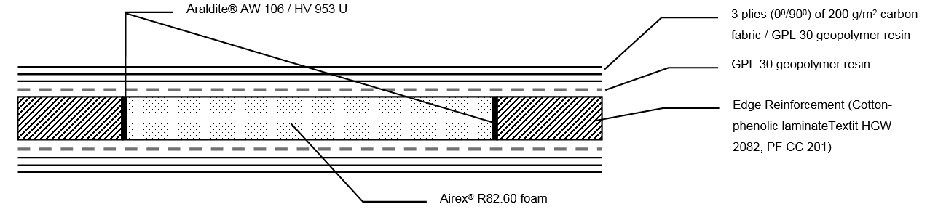

Figure 1. Lay-up of the sandwich specimen with carbon/geopolymer skin and foam core.

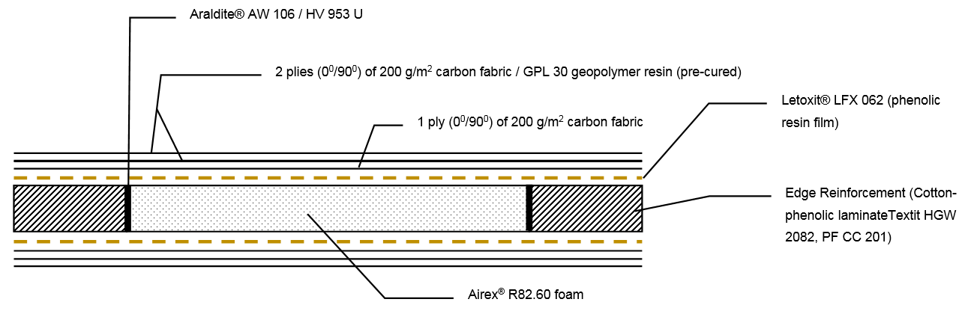

Figure 2. Lay-up of the sandwich specimen with carbon/geopolymer/phenolic film skin and foam core.

2.2. Test setup

The drop weight impact tests were carried out in accordance with ASTM D7136M [12] with two levels of impact energy to apply both VID (visible impact damage) and BVID (barely visible impact damage). Using an impactor diameter of 25.4 mm (Fig. 3a), dents with 0.5 mm depth as BVID and 1.5 mm as VID were created. It corresponded to impact energy of 1.2 J and 2.7 J, respectively. For hybrid skin sandwich, the energies were higher: 2.1 J and 3.6 J, respectively. Then the specimens were loaded by compression according to ASTM D7137M [13] in room temperature conditions (Fig. 3b). For each configuration (reference, BVID, VID), 3 specimens were tested.
Digital image correlation (DIC) makes it possible to measure the displacement fields of a planar surface. A photogrammetric Dantec Q-400 system consisting of two 16 Mpixel cameras was used to monitor the deformation state during loading (Fig. 3b.) The middle region of one side of a specimen was monitored to obtain full-field strain measurements. The displacements of points distributed over the surface of the object were calculated from the grey-level analysis of the images. The image correlation technique can work correctly only with objects with a surface with a sufficiently random texture which was created using a chalk coating and black spray. The proper illumination was provided by a 250 W halogen lamp with heat-reflecting filters.

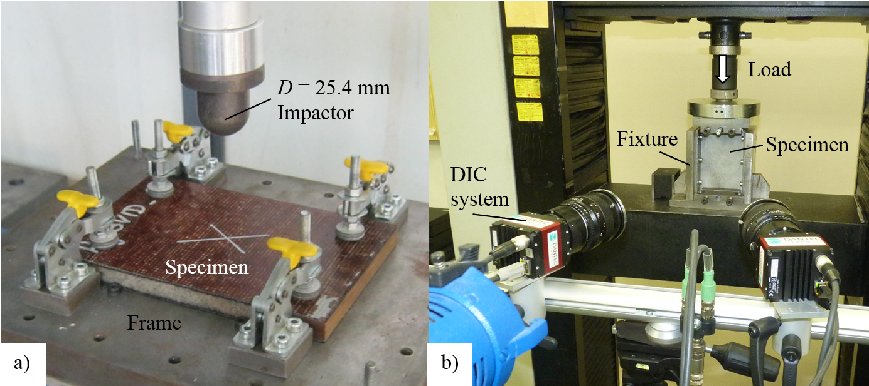

Figure 3. Impact test set-up and compression testing of a specimen with a pattern used for digital image correlation.

3. Results

Table 1 shows a summary of compression after impact strength average values of 3 specimens tested in each configuration. Table 2 summarizes the effects of all three main factors, including their interactions, which were evaluated using analysis of variance (ANOVA). The p-value in the last column represents whether the effect is statistically significant. Usually, effects with p-values below 0.05 are stated as statistically significant. The ANOVA table shows that all of the main factors, A:impact, B:conditioning and C:skin type were significant.

Table 1. Results of compression after impact strength in MPa. Average of 3 specimens for each configuration.

CFRP/Geo | Reference | BVID (1.2 J) | VID (2.7 J)
Ambient | 79.3 | 64.2 | 60.9
Conditioned | 51.7 | 48.3 | 39.9
CFRP/Geo/Phenol | Reference | BVID (2.1 J) | VID (3.6 J)
Ambient | 100.7 | 77.9 | 77.8
Conditioned | 70.0 | 55.9 | 54.1

Table 2. ANOVA Table.

Source of Variation | Degrees of Freedom | Sum of Squares [Partial] | Mean Squares [Partial] | F-Ratio | p-value
Model | 11 | 9254 | 841 | 32.30 | <0.001
A: impact | 2 | 1936 | 968 | 37.15 | <0.001
B: conditioning | 1 | 4765 | 4765 | 182.95 | <0.001
C: skin type | 1 | 2041 | 2041 | 78.34 | <0.001
AB | 2 | 160 | 80 | 3.07 | 0.07
AC | 2 | 129 | 64 | 2.47 | 0.11
BC | 1 | 34 | 34 | 1.31 | 0.27
ABC | 2 | 5 | 2 | 0.09 | 0.91
Residual | 23 | 599 | 26
Pure Error | 23 | 599 | 26
Total | 34 | 9853

No interaction between the factors was found significant; therefore, all the main effects can be averaged and shown in the term effect plot in Fig. 4. The BVID impact significantly decreased the strength by 18%. The VID caused further decrease (23% in total). This is a common result for the laminates where even the small energy causes significant inner damage (delaminations, matrix cracking). The hot/wet environment decreased the strength even more than impact and caused a drop of 31 % in the strength. This is generally caused by the weakening of the fibre/matrix interface by the conditioning. The weak interface cannot prevent the microbuckling failure of the skin fibres and causes premature failure. Finally, the hybrid skin with phenolic resin film was found to significantly enhance the strength by 27%. It shows that the performance of bonding of the skin to the core has significant effect on the overall sandwich strength.

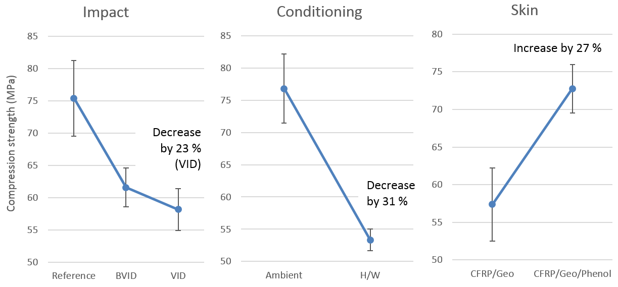

Figure 4. Term effect plot of three main factors.

The optical measurement was used for both dent profile evaluation and strain monitoring during loading. Fig. 5a shows surface deviations revealing the dent shape. The dent depth was evaluated as 1.25 mm for a VID impacted specimen. It was a relaxed depth as the dent depth just after impact was measured as 1.61 mm on the same specimen. The relaxation is usual for polymer matrix laminates.
The result in Fig. 5b is related to the critical deformation state that exists immediately before a major crack occurs and thus significantly affects the strain fields. It shows a strain field in the loading direction that is concentrated at the impact dent and elongated in the horizontal direction. The measured local compressive strain at the dent bottom is marked in this figure. A small positive strain was also observed at the dent edge. This behaviour was observed also on laminates in Ref. [8].

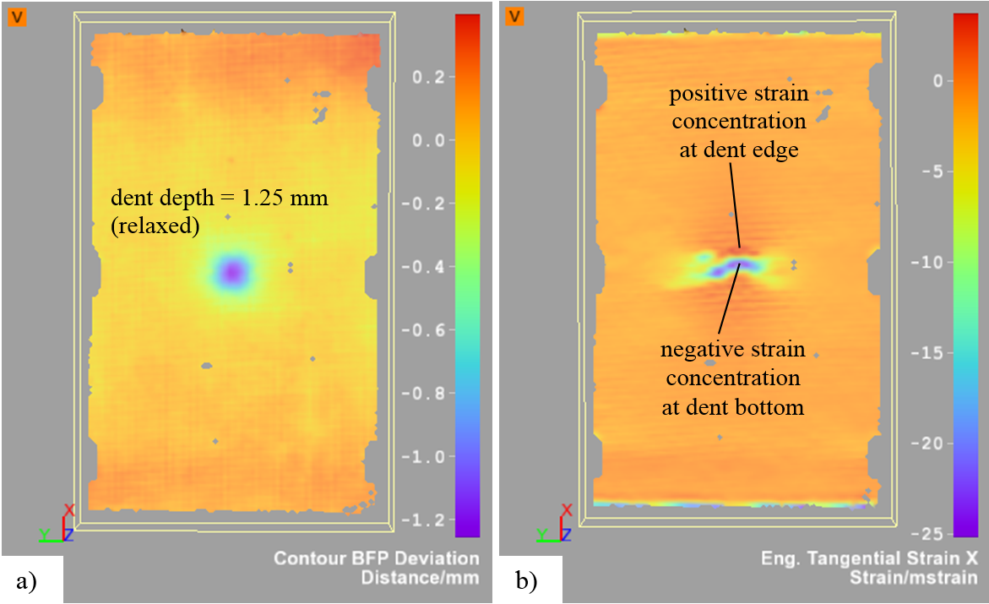

Figure 5. Specimen surface measurement using DIC: a) Dent depth map (unloaded) and b) Strain map in load direction with strain concertation caused by the dent (global strain = -1.5 mm/m at 11.6 kN)

4. Conclusions

The most significant factors that affect the compression strength of the studied geopolymer sandwich were the impact and hot/wet conditioning which caused decrease of strength by approximately 25%. The performance of bonding of the skin to the core had also significant effect on the overall sandwich strength. This research can establish new fire resistible sandwich materials to be used in aerospace constructions.

Acknowledgments

This research was funded by the European Union in the frame of “Future Sky Safety” project, the Joint Research Initiative Safety P7, project “Mitigate risk of fire, smoke and fumes”.

References

[1] J. Davidovits, and J. L. Sawyer. Early high-strength mineral polymer. U. S. Patent 4,509,985. United States, 1985.
[2] J. Davidovits. 30 Years of Successes and Failures in Geopolymer Applications - Market trends and Potential breakthroughs. Proceedings of Geopolymer 2002 Conference, Melbourne, Australia, October 28-29, 2002.
[3] R. E. Lyon, et al. Fire resistant aluminosilicate composites. Fire and materials, 21(2):67-73, 1997.
[4] P. Duxson, et al. Geopolymer technology: the current state of the art. Journal of Materials Science 42(9):2917-2933, 2007.
[5] T. D. Hung, et al. New Generation of Geopolymer Composite for Fire-Resistance. Advanced in Composite Materials, InTechOpen, 2011. DOI: 10.5772/17933.
[6] R. E. Lyon. Fire Safe Aircraft Cabin Materials. Fire and Polymers II. ACS Symposium Series, 599:618-638, 1995. DOI: 10.1021/bk-1995-0599.ch038.
[7] R. E. Lyon. Fire Response of Geopolymer Structural Composites, DOT/FAA/AR-TN95/22, 1996.
[8] M. Kadlec, and V. Kafka. Strain Concentration during the compression of a Carbon/Epoxy Composite after impact. International Journal of Structural Integrity, 6(2):279-289, 2015.
[9] M. Kadlec, and R. Růžek. A Comparison of Laser Shearography and C-Scan for Assessing a Glass/Epoxy Laminate Impact Damage. Applied Composite Materials, 19:393-407, 2012.
[10] L. S. Sutherland, and S. C. Guedes. Impact behaviour of typical marine composite laminates. Comp. Part B, 37(2-3):89-100, 2006.
[11] W. J. Cantwell, P. Curtis, and J. Morton. An assessment of the impact performance of CFRP reinforced with high-strain carbon fibers. Compos. Sci. Technol., 25(2):133-148, 1986.
[12] D7136M-15, Standard Test Method for Measuring the Damage Resistance of a Fiber-Reinforced Polymer Matrix Composite to a Drop-Weight Impact Event, ASTM International, West Conshohocken, PA, 2015,
[13] D7137M-17, Standard Test Method for Compressive Residual Strength Properties of Damaged Polymer Matrix Composite Plates, ASTM International, West Conshohocken, PA, 2017

