EuroSun2026
ECONOMIC, TECHNICAL AND SOCIAL CHALLENGES OF EMERGING RENEWABLE ENERGY COMMUNITIES: EVIDENCE FROM EMILIA-ROMAGNA, ITALY
Da Silva Rabêlo O, Federal University of Bahia (UFBA), Salvador-BA, Brazil, olivanrabelo@gmail.com,
Barroco Fontes Cunha F., AESS, Módena- Italy, felipe.barroco@aessenergy.it;
Alberto Nucci C, University of Bologna,Bologna- Italy, carloalberto.nucci@unibo.it,
Da Silva Santos P. H., Federal University of Bahia (UFBA), Salvador-BA, Brazil, paulosaj22@hotmail.com
Summary
The energy transition, coupled with the pursuit of production and consumption independence by renewable energy communities (RECs)—specifically those utilizing photovoltaic technology—presents a significant and challenging context for hybrid governance involving diverse stakeholders. This study focuses on photovoltaic-based RECs, analyzed through an exploratory descriptive study based on a structured survey in which strengths and weaknesses were identified and synthesized across economic, technical, and social dimensions, drawing on insights from 13 REC leaders in Italy's Emilia-Romagna region during the "Shared Horizons: From Today's RECs to Tomorrow's Communities" event in December 2025. The research is part of a broader activity within the EU-funded ENCOM-HUB project (2024–2025). Key findings indicate a strong reliance on public funding for early-stage RECs; alongside a dependence on external technical professionals; and socioeconomic benefits for cities and territories that are still in the initial stages of development. It is worth noting that the majority of the RECs studied—specifically those in the Emilia-Romagna region of Italy—are at an early stage of organizational maturity. These results contribute to the empirical literature on RECs regarding economic, technical/organizational, and social dimensions and can assist stakeholders in decision-making processes.
Keywords: Photovoltaic Technology, Renewable Energy Communities, Sustainability.
Field of application for the findings: Sustainable and Solar Energy Transition
Addressed audience: Researchers, Entrepreneurs, Governments, and Managers renewable energy community
- Introduction
Renewable energy refers to energy derived from natural resources that continuously regenerate on timescales compatible with human activity, such as solar radiation, wind, water, biomass, and geothermal heat. Compared to fossil-based sources, these sources are characterized by lower environmental impact and significantly reduced greenhouse gas emission intensity (Veloso et al., 2022; Ang et al., 2022). In this context, renewable sources are widely recognized as fundamental pillars for decarbonizing the energy mix and achieving sustainable development goals (Ang et al., 2022).
Renewable energy sources include solar, wind, hydroelectric, biomass, biogas, and geothermal energy. These sources exhibit distinct characteristics regarding geographic availability, intermittency, energy density, and infrastructure requirements, which implies different adoption trajectories and systemic impacts on electrical systems (Ang et al., 2022; Freires et al., 2023; Veloso et al., 2022).
Among renewable energy sources, solar photovoltaic energy represents a technological alternative for generating electricity from solar radiation. Photovoltaic technology is based on the direct conversion of solar radiation into electricity using semiconductor cells, enabling applications ranging from small residential systems to large centralized power plants (Maka et al., 2022).
The literature indicates that solar photovoltaics combine modularity, low operating costs, high scalability, and compatibility with distributed generation, with positive impacts in urban and rural contexts (Maka et al., 2022).
It is from these characteristics that the concept of energy communities emerges, understood as a form of collective organization involving citizens, small businesses, and local authorities for active participation in the energy system through energy generation, consumption, sharing, and management (Caramizaru; Walker; Devine-Wright, 2019). These initiatives are described as socio-technical innovations that combine decentralized energy infrastructure, participatory governance, and new business models aimed at creating environmental, economic, and social benefits at the local level (Caramizaru; Walker; Devine-Wright, 2019; Reis et al., 2021).
Energy communities are potentially relevant instruments for democratizing access to renewable energy, reducing costs for end consumers, and increasing social acceptance of technologies such as photovoltaics (Ahmed; Ali; D’Angola, 2024).
From a technological standpoint, the operational viability of photovoltaic energy communities is directly linked to the availability of enabling technologies, which comprise a chain of technical solutions ranging from energy generation to management, allocation, and distribution processes. These technologies include, among others, smart metering systems, digital platforms for the allocation and accounting of shared energy, Community Energy Management Systems (CEMS), and multi-user billing solutions (Reis et al., 2021; Bukar et al., 2023).
These technologies are considered critical for reducing transaction costs, ensuring transparency in benefit-sharing, and enabling the integration of communities into the electricity market (Bukar et al., 2023). In this context, the success of energy communities depends not only on the maturity of renewable technologies—such as photovoltaics—but above all on the design of energy policies that recognize, regulate, and incentivize these collective arrangements (Reis et al., 2021; Ahmed; Ali; D’Angola, 2024). Regulatory frameworks, economic incentive mechanisms, and market rules act as structural drivers of technology diffusion within energy communities, directly influencing both the adoption rate of community photovoltaic systems and the development of associated digital and management solutions (Barabino et al., 2023; Bukar et al., 2023).
Numerous prior studies rely primarily on concepts and definitions, simulations, or single case studies. Existing studies often focus separately on financing, governance, technological optimization or social acceptance. Less empirical evidence is available on how these dimensions coexist during the early organizational development of RECs. In contrast, the work presented here provides empirical evidence derived from 13 Renewable Energy Community (REC) pilot projects in the Emilia-Romagna region of Italy; data were collected directly from project leaders via structured surveys during the implementation of the ENCOM-HUB project, which was funded by the European Union and other partners. The study identifies the current maturity level of these RECs and highlights key organizational strengths and challenges across three dimensions—economic, technical/organizational, and social—that emerge during the initial implementation phase and can contribute to the consolidation of RECs.
Based on the organizational complexities across the economic, technical/organizational, and social dimensions surrounding Renewable Energy Communities (RECs), this study aims to answer the following research question: What economic, technical-organizational, and social strengths and challenges emerge during the early development of Renewable Energy Communities in Emilia-Romagna?
The Emilia-Romagna region of Italy was selected as the reference context for this study due to the lack of dedicated research examining the Renewable Energy Community (REC) ecosystem simultaneously across economic, technical/organizational, and social dimensions. Although recent studies—such as that by Koltunov, Tricarico, and Bisello (2026)—have approached this perspective by investigating REC funding sources in Italy, they do not outline the evolutionary landscape proposed in the present work, which addresses RECs from economic, technical, and social standpoints.
In addition to this introduction, section 2 presents a summary of REC policy in Italy; part 3 discusses the materials and method adopted in the work, section 04 highlights the results achieved and section 05 presents the main conclusions.
- A concise overview of the policy on Renewable Energy Communities (REC´s) in Italy
In the European Union, the sharing and offsetting of electricity from renewable sources—including solar photovoltaics—are grounded in Directive (EU) 2018/2001 (Renewable Energy Directive – RED II) and its revision, Directive (EU) 2023/2413 (RED III) (European Union, 2018; European Union, 2023). These directives shape European policy on promoting renewable energy, placing strong emphasis on the decentralization of the energy system and the active participation of citizens and communities.
RED II formally introduces the concept of Renewable Energy Communities (RECs), legally recognizing collective arrangements for the generation, consumption, and sharing of renewable energy based on open participation, local control, and a primary focus on generating environmental, economic, and social benefits. This regulatory framework breaks away from the strictly individual model of distributed generation and establishes photovoltaic energy as a collective energy asset capable of being shared among multiple users.
RED III reinforces this direction by raising renewable energy targets and accelerating the deployment of decentralized renewable projects, thereby consolidating the role of energy communities as strategic instruments in the European energy transition (European Union, 2023). Although it does not substantially alter the concept of RECs, the directive reaffirms their central importance within the European Union's regulatory framework.
Within the framework of these directives, the regulatory concept of "energy sharing" is becoming established; this is understood as the sharing of locally generated electricity among different community members, regardless of whether the generation and consumption sites physically coincide. In practice, this mechanism allows photovoltaic energy produced at community installations to be allocated and financially credited among multiple users, even when injected into the distribution grid.
The post-pandemic context for renewable energy in Italy falls within the scope of Italy's Recovery and Resilience Plan—specifically the REPowerEU Plan, launched in response to the energy market disruption caused by Russia's invasion of Ukraine (EU, 2026). A key REPowerEU measure in Italy is the simplification of the permitting process for renewable energy installations. The country also leverages the LIFE Clean Energy Transition sub-programme to implement EU sustainable energy policies—particularly the European Green Deal, the Energy Union (with its 2030 energy and climate targets), and the EU's long-term decarbonization strategy for 2050 (EU, 2026). The implementation of strategies from these plans may explain the rising number of Renewable Energy Communities (RECs); by early 2025, there were approximately 361 RECs in Italy across operational and project phases (Koltunov, Tricarico, and Bisello, 2026). Currently, the total number of RECs in Italy stands at 1,375; of these, only two utilize wind technology and two use hydroelectric power, while the remainder are photovoltaic-based. Specifically in the Emilia-Romagna region, there are around 124 RECs—spanning all stages of maturity and relying exclusively on photovoltaic technology (RSE, 2026).
3. Materials and methods
The study employs an exploratory-descriptive method based on a survey of leaders of Renewable Energy Communities (RECs) in the Emilia-Romagna region of Italy, conducted during the "Shared Horizons: From Today's RECs to Tomorrow's Communities" event in December 2025. Respondents were individuals directly involved in the governance or operational management of their respective RECs. Nineteen questions were administered, highlighting the key aspects of the economic, technical, and social dimensions. —using a 1–5 Likert scale. Responses were obtained from 13 RECs out of the approximately 30 present at the event. Although the convenience sample size is limited, the research provides an initial exploratory assessment of the activities carried out by the studied RECs. The economic dimension examined factors regarding REC economic viability, funding sources, and business model efficiency; the technical/organizational dimension highlighted aspects such as members' technical skills, legal structure, and internal administrative processes; and the social dimension addressed governance, socioeconomic impacts on cities and territories, and the capacity to identify new partners. It should be noted that the results presented are preliminary. The RECs are part of the ENCOM-HUB project—coordinated by AESS with various partners and European Union funding—and the EU's expertise and practices guided the formulation of the survey questions. The project operates in Italy, France, and Spain, with a pilot in Bulgaria, and the research will be expanded to include the other countries where the project operates. The survey was anonymous and objective, administered via Google Forms to REC leaders; the percentages shown in the charts were calculated based on the distribution of responses across the five Likert scale options.
4. Results and discussion
This section presents preliminary results and discussion obtained among the surveyed Renewable Energy Communities (RECs) in the Emilia-Romagna region of Italy, highlighting the key aspects of the economic, technical/organizational, and social dimensions.

4.1. Economic Dimension
4.1.1 Funding Structure

The origin of financial resources is crucial for distinguishing between public, private, and mixed sources. A survey of Energy Community leaders indicated that, for 77% of respondents, the majority of funds used to launch and invest in an Energy Community are public in nature, as shown in Fig. 1. This finding aligns with research on Energy Communities conducted by Arcudi et al. (2023), Candelise and Ruggieri (2017), De Vidovich et al. (2021), Eroe and Polci (2022), and Franzo et al. (2023), but in other countries.

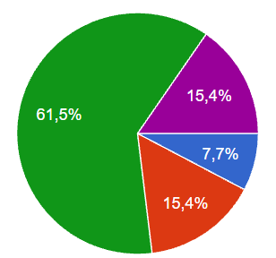
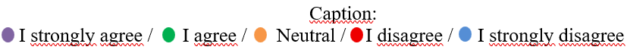
Fig. 1: Funding sources for REC investments

4.1.2 Business model robustness

Business models are often described as conceptual tools that specify what an organization does and how it creates value (Magretta, 2019; Osterwalder & Pigneur, 2010).
Research examined the robustness of REC business models in relation to planned objectives, and 38.5% (see Fig. 2) stated that the business models are robust. This scenario suggests a need for REC´s to align their objectives with their business models. Local pilot projects are crucial to show how community energy systems can work in practice. They provide learning opportunities about these new business and governance models and how to engage citizens (Cunha et.al, 2021).

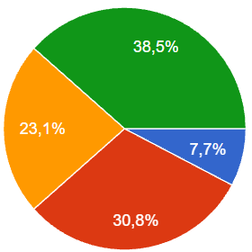
Fig. 2: Robustness of the REC business model
4.1.3 Financial sustainability

The research indicated that over 80% of REC´s need to raise funds from the private sector to finance their activities. This results in reduced reliance on public funds—an attempt to balance financial sources and strengthen economic sustainability, as shown in Fig. 3. Research led by Koltunov, Tricarico, and Bisello (2026) analyzed REC financing mechanisms in Italy and found similar results, suggesting a need for greater security for private investors allocating funds to REC´s, though no clear results were observed for the Emilia-Romagna region.

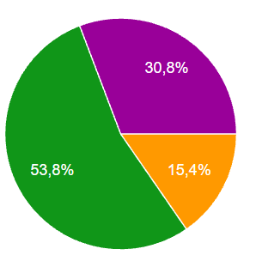
Fig. 3: Need for REC´s to raise private financial resources

4.1.4 Capacity to attract private capital

For 61.6% of the leaders who responded to the survey, they pointed out that the REC's business model presents weaknesses in its economic structure with insufficient resources to maintain operations and low capacity to raise funds, as shown in Fig. 4. This scenario points to the need for robustness of the business model in the aspect of raising funds to reinforce its economic-financial sustainability. In contrast, “In energy communities, their innovative business models result in multiple types of value creation that transcend mere economic considerations” (Barnes, J. et al., 2024). This consideration leads to the understanding that the value created by the REC goes beyond the economic-financial aspect and spills over, for example, into the social sphere with the citizen participation of its members and the environmental sphere with the production of renewable energy.
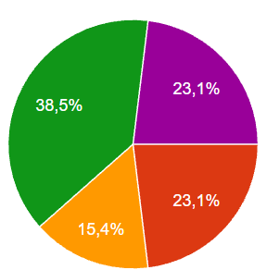
Fig. 4: REC business model with economic fragility

4.2 Technical and organizational dimension

4.2.1 Internal technical capacity

Among the REC´s investigated, 38.5% stated that their members possess the technical competence necessary for their management and development. The Fig. 5 highlights the need to develop technical and managerial knowledge and skills so that the enterprise can be consolidated and achieve its main objectives efficiently.
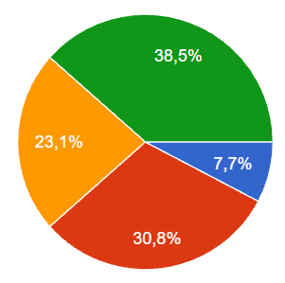
Fig. 5: Technical competence required of members for the management and development of REC´s

4.2.2 Digital management tools

Of the REC´s surveyed, 46.2% (see Fig. 6) have a dedicated platform for energy and financial management. This reveals a need for management and measurement technologies to generate parameters and indicators, with the aim of obtaining data and information to support decision-making.
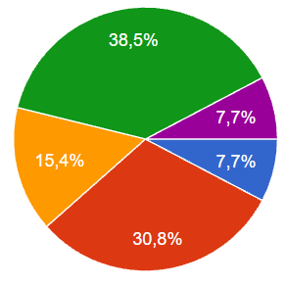
Fig. 6: Availability of a dedicated platform for managing energy and financial flows

4.2.3 Administrative processes

Only 30.8% of REC´s (see Fig. 7) indicate that internal administrative processes are efficient for the development of the business model. This reinforces the need to establish key processes, enabling REC´s to adopt best practices in internal process management to achieve their objectives. Nolden, Barnes, and Nicholls (2020) observed this perspective while analyzing the evolution of energy community business models in England, and Holstenkamp (2021) conducted a similar study on energy communities in Germany.
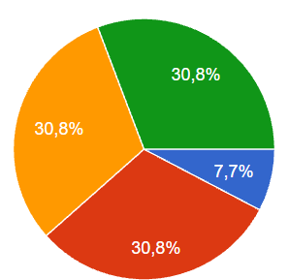

Fig. 7: Efficiency of internal processes for the REC business model

4.2.4 Dependence on external expertise

A survey regarding the limited technical knowledge of Renewable Energy Community (REC) members concerning energy-related aspects indicates that approximately 46.2% perceive limitations in this area (see Fig. 8). A report on financial barriers and existing solutions (2020) also highlighted a lack of knowledge regarding the cooperative model, resulting in a lack of legitimacy for the REC´s.
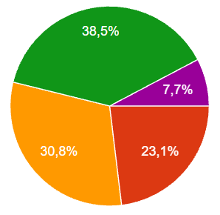
Fig. 8: Limited technical knowledge of REC members

Approximately 46% of REC´s (see Fig. 9) rely heavily on external expertise for technical matters. This highlights the need to enhance the technical qualifications of REC members in order to reduce reliance on external technical support and develop internal competencies.
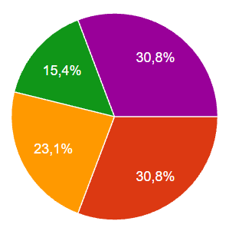
Fig. 9: Reliance on the technical skills of members external to the REC

The suitability of the legal model for Renewable Energy Communities (RECs)—specifically regarding how well it meets their current development needs—was investigated. Approximately 54% of leaders (see Graph 10) indicate that the legal form of RECs is inadequate for their current demands. The majority of Italian RECs are led by the public sector (RSE, 2026), a trend also observed in the Emilia-Romagna region. The second most common organizational model is one based on a pluralistic structure (such as an association or cooperative) (De Vidovich, Tricarico, & Zulianello, 2021). A notable trend regarding REC legal models is the shift toward—or initial formation as—cooperatives, given their advantages, particularly the greater flexibility they offer compared to other existing models.
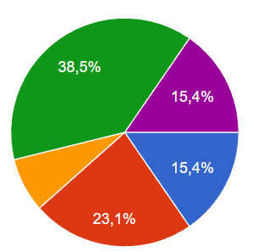
Fig. 10: Legal structure unsuited to REC's current demands

4.3 Social Dimension

4.3.1 The governance model

The governance model meets the operational and strategic needs of 61.6% of the REC´s (see Fig. 11). This suggests that the majority of REC´s need to formalize the processes for establishing their collective enterprise in order to adopt a governance model capable of handling the complexities and addressing the risks inherent in the business model.
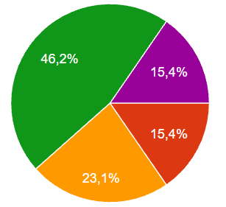
Fig. 11: Robustness of the governance model in relation to operational and strategic needs

4.3.3 The socioeconomic benefits of REC´s

The socioeconomic benefits of REC´s are highlighted in various studies (Adams et al., 2021; Bieling et al., 2022), notably the work of Brummer (2018), which examined these benefits in energy communities across the UK, Germany, and the USA. Local and regional socioeconomic benefits are perceived by only 38.5% of respondents, as shown in Fig. 12. To 38.5% of respondents perceive socioeconomic benefits, while 53.8% report a neutral assessment and 7.7% disagree. The high proportion of neutral responses suggests that socioeconomic impacts may not yet be sufficiently visible or measurable among the surveyed RECs
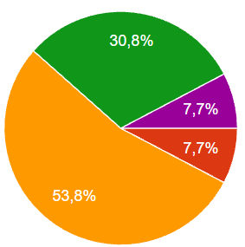
Fig. 12: Socioeconomic benefits of REC´s
4.3.4 Stakeholder engagement

REC's ability to communicate with its stakeholders is fundamental to its institutional strengthening. Approximately 23% (see Fig. 13) indicate that this type of communication is efficient. This evidence points to a need to develop communication competencies regarding REC stakeholders, primarily to foster their engagement with the organizational structure. It is worth noting that 61.5% of respondents rated this aspect as neutral, suggesting that the RECs have a still-nascent structure, lack strategic evaluation and indicators, and rely on informal communication, among other factors.
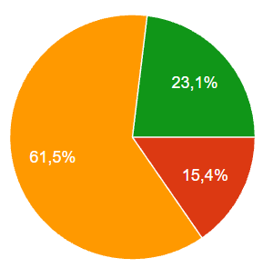
Fig. 13: Effectiveness of REC communication with stakeholders
The REC business model enables social and civic participation by its members. Among the REC´s surveyed, 53.9% align with this perspective, as shown in Fig. 14. In this context, research highlights that the types of value generated by the REC business model depend on the stakeholders involved and their positions within the organizational structure (Mihailova et al., 2022; Barnes and Hansen, 2022).
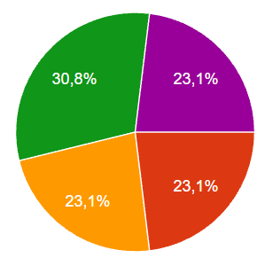
Fig. 14: Social/civic participation of REC members
4.3.5 Ability to attract new members

Regarding the capacity of Renewable Energy Communities (RECs) to attract new members and partners, approximately 15.4% of respondents believe that RECs develop this capacity, as shown in Fig. 15. This ability to attract new members can be evidenced through robust business models that explicitly highlight their value proposition, as demonstrated in the work of Barnes et al. (2024). In contrast, 30.8% of respondents expressed a neutral stance, and 53.9% stated that RECs lack the capacity to attract new members. This points to the need to create robust strategies for RECs to develop the capacity to connect with and retain new members.
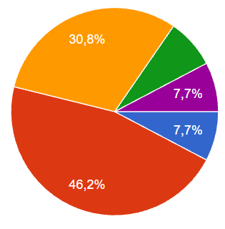
Fig. 15: REC's capacity to attract new members/partners

Relationships based on trust and integration among REC members are cited as important by 15.4% of respondents, as shown in Fig. 16. Most REC governance models consist of associations or cooperatives, a fact that may explain the development of the institutional values ​​identified in the study. Approximately 38.5% of respondents expressed a neutral stance, while 46.2% were of the opinion that RECs do not implement initiatives to foster trust and integration among members.
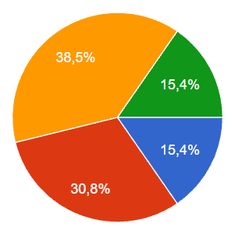
Fig. 16: Relationships of trust and integration among REC members
5. Conclusions
Renewable Energy Communities (RECs) play a fundamental role in community-based energy generation, particularly in areas where energy availability is limited or unreliable, such as rural or mountainous regions. This study examines and discusses the key opportunities and challenges faced by RECs in the Emilia-Romagna region of Italy. The results suggest that the business model relies on public funding, and socioeconomic benefits are not yet clearly perceived by most respondents. The public funding has been important for launching RECs, but it has not necessarily produced self-sustaining economic models; the transition from grant-supported establishment to financially sustainable operation emerges as a central challenge. These findings align with organizational characteristics typically associated with early-stage RECs. The results also suggest that a high number of neutral responses were obtained from REC leadership, potentially indicating an early stage of development, an absence of strategic indicators, benefits that have not yet materialized, limited available information, and difficulties on the part of leadership in assessing performance. The empirical findings presented in this article can serve as reference for policymakers, researchers, government bodies, and other stakeholders involved in developing strategies for Renewable Energy Communities (RECs).
Although this study is limited to the Emilia-Romagna region of Italy, it could be expanded to other regions and countries; furthermore, the methodological framework could be enhanced through the application of more robust statistical or econometric methods.
It is worth noting that the research results are preliminary, as the data are currently being systematized and the sample of RECs under study is being expanded to include the other countries participating in the ENCOM-HUB Project.
6. References
Adams, S.; Brown, D; Pablo, J. Chitchyan, R.; Fell, M.J.; Hahnel, U.J.J.. et al. Social and economic value in emerging decentralized energy business models: a critical review. Energies, 14, 2021, pp. 1-29.
Ahmed, S.; Ali, A.; D’Angola, A. A Review of Renewable Energy Communities: Concepts, Scope, Progress, Challenges, and Recommendations. Sustainability 2024, 16, 1749. https://doi.org/10.3390/su16051749
Cunha, Felipe B. F.; Carani, Claudia; Nucci, Carlo A.; Castro, Celso; Silva, Marcelo S.; Torres, Edinildo A. Transitioning to a low carbon society through energy communities: Lessons learned from Brazil and Italy. Energy Research & Social Science
Volume 75, 2021. https://doi.org/10.1016/j.erss.2021.101994
Arcudi,C.; Bacan, S. ; Pelotti, P. Tieri, S..Modelli per promuovere le comunità energetiche: Un ’ opportunità per le Utilities Indice, 2023.
Barabino, B.; Porru, S.; Misso, R.; Coni, M. Renewable energy communities: Governance models, market integration and regulatory challenges. Energy Policy, Amsterdam, v. 181, p. 113734, 2023.
J. Barnes, P. Hansen.Governing energy communities: the role of actors and expertise in business model innovation. Energy Communities, Elsevier Inc., 2022.
Bielig, M; Kacperski, C. ; Kutzner, F. ; Klingert, S. Evidence behind the narrative: critically reviewing the social impact of energy communities in Europe Energy Res. Soc. Sci., 94, 2022.
Brummer, V. Community energy – benefits and barriers: a comparative literature review of community energy in the UK, Germany and the USA, the benefits it provides for society and the barriers it faces Renew. Sustain. Energy Rev., 94 , 2018, pp. 187-196
Bukar, A. L.; Tan, C. W.; Lau, K. T.; Zaki, S. A. Peer-to-peer electricity trading: A systematic review of technologies, business models and regulatory frameworks. Renewable and Sustainable Energy Reviews, Amsterdam, v. 173, p. 113083, 2023.
Candelise, C.; Ruggieri G. Community Energy in Italy: Heterogeneous Institutional Characteristics and Citizens Engagement, 2017.
De Vidovich, L. ; Tricarico, L. ; Zulianello, M. Community Energy Map. FrancoAngeli S.R.L, 2021.
Eroe, K.; Polci, T.Communita Rinnovabili, 2022.
EUROPEAN UNION. Italy’s recovery and resilience plan. 2026. Acesso em 09 Jul. 2026. Disponível em: <https://reforms-investments.ec.europa.eu/recovery-and-resilience-facility-1/country-pages/italys-recovery-and-resilience-plan_en>
EUROPEAN UNION. Directive (EU) 2018/2001 of the European Parliament and of the Council of 11 December 2018 on the promotion of the use of energy from renewable sources (RED II). Official Journal of the European Union, Brussels, 21 Dec. 2018.
EUROPEAN UNION. Directive (EU) 2023/2413 of the European Parliament and of the Council of 18 October 2023 amending Directive (EU) 2018/2001 on the promotion of the use of energy from renewable sources (RED III). Official Journal of the European Union, Brussels, 31 Oct. 2023.
EUROPEAN UNION. Directive (EU) 2019/944 of the European Parliament and of the Council of 5 June 2019 on common rules for the internal market for electricity. Official Journal of the European Union, Brussels, 14 June 2019
Franzo, S.; Di Lieto, A.; Tamanini, A.; Cuomo, S.; Delle Monache, V; Fumagalli, A.; Sanchini, L.; Schiavoni, F. Electricity Market Short Report Energy & Strategy Group, Politecnico Milano, 2023.
Holstenkamp, L. Community Energy in Germany: From Technology Pioneers to Professionalisation under Uncertainty, 2021.
Koltunov, Maksym ; Tricarico, Luca; Bisello, Adriano. Financing energy communities: Actors, instruments, builders, and ESG ecosystem expectations in Italy, Energy Policy, Volume 215, 2026, 115246, ISSN 0301-4215, https://doi.org/10.1016/j.enpol.2026.115246.
Magni, G. U. Economic incentives for renewable energy communities in Italy: Legal framework and implementation challenges. Energy Policy, Amsterdam, v. 189, p. 114102, 2025.
Magretta, J. Why Business Models Matter. Harvard Business Review, 2019. Disponível em:https://hbr.org/2002/05/why-business-models-matter .
Maka, A.O. and Alabid, J.M. (2022) Solar Energy Technology and Its Roles in Sustainable Development. Clean Energy, 6, 476-483. https://doi.org/10.1093/ce/zkac023
Mihailova, D. ; Schubert, I. ; Burger, P. ; Fritz, M.M.C. Exploring modes of sustainable value co-creation in renewable energy communities J. Clean. Prod., 330, 2022.
Nolden, C.; Barnes, J.; Nicholls, J. Community energy business model evolution: a review of solar photovoltaic developments in England Renew. Sustain. Energy Rev., 2020.
Osterwalder, A,; Pigneur, Y. Business model Generation. John Wiley & Sons, Hoboken, New Jersey, 2010.
Panwar, N.L.; Kaushik, S.C.; Kothari ,Surendra. Renewable and Sustainable Energy Reviews, Elsevier, v.15, Issue 3, p.1513-1524, 2011. https://doi.org/10.1016/j.rser.2010.11.037
Reis, I. F. G.; Gonçalves, A. B.; Costa, M. A.; Silva, F. R. Business models for energy communities: A review of key issues and trends. Renewable and Sustainable Energy Reviews, Amsterdam, v. 144, p. 110955, 2021.
REScoop.eu Report on Financial Barriers and Existing Solutions, 2020.
RSE - Research on the Energy System. Map of Renewable Energy Communities in Italy. Accessed July 9, 2026. Available at <https://geoportale.rse-web.it/#/dashboard/540>

