DECARBONIZING GHANA’S 24-HOUR ECONOMY: INTEGRATING SOLAR PHOTOVOLTAICS WITH THERMAL ENERGY STORAGE AND FINANCIAL INCENTIVES FOR LOW-CARBON INDUSTRIAL PROCESS HEATING FOR A SUSTAINABLE GREEN TRANSITION
Emmanuel Kobina Payne^{1,4*} (corresponding author), Mercy Abaka-Attah², Laud Christian Aninoo³
¹ Dept. of Electrical and Electronic Engineering, Takoradi Technical University, Ghana
² Dept. of Ceramics, Takoradi Technical University, Ghana
³ Minerals Commission, Ghana; ⁴ PelkTec Ltd, Ghana
*Corresponding author: mypaynegm@gmail.com; emmanuel.payne@ttu.edu.gh
Summary
Ghana’s 24-hour economy policy commits the industry to continuous operation. However, cocoa processing still relies on imported fossil fuels for process heat, increasing costs and emissions. This study examines a DC-coupled Solar PV power-to-heat system with Basalt Thermal Energy Storage (TES) that supplies process heat for an SME's cocoa production line at a competitive cost. The model includes a 50-kW Solar PV array, resistive heating, and an 11-ton Basalt TES operating between 80 °C and 300 °C. It is validated with an enthalpy-conservative Schumann solver linked to an hourly dispatch model that considers energy, exergy, economic factors, and GHG emissions. Forty-eight hours of TES boost the solar fraction from 41.7% to 92.9%, yielding 64.8 MWh_{th} and reducing CO₂ emissions by 18.6 tons annually, lowering process heat carbon intensity by 91%. The LCOH drops from 0.225 to 0.0928 USD/kWh_{th} along a five-step incentive scenario, achieving parity with fossil fuels and resistive heating.

Keywords: 24-Hour Economy, Carbon finance, Industrial process heating, Solar PV, Thermal energy storage
Field of application for the findings: Industrial process heat; Decarbonisation of Agro-processing in sub-Saharan Africa; Solar PV power-to-heat systems (design, sizing and financing); Basalt TES.
Addressed audience: Solar PV and thermal process engineering; Industrial energy schemes and management; Development finance institutions; Carbon market practitioners and Energy policy makers.
1. Introduction
Industrial heat constitutes approximately two-thirds of final industrial energy consumption worldwide, with half of this demand attainable at temperatures below 400 °C, within the capabilities of solar technologies (Kumar et al., 2019). In sub-Saharan Africa, this demand is still predominantly satisfied through combustion of imported fossil fuels. Consequently, process heat is simultaneously the largest emitter of GHG emissions. It is the primary drain on foreign exchange reserves and the least scrutinised component of the industrial energy balance. Ghana has explicitly acknowledged this dilemma. The National 24-Hour Economy and Accelerated Export Development Policy (Republic of Ghana, 2025) advocates transitioning manufacturing operations to three-shift schedules to increase both output and employment without additional capital investment. Transitioning to continuous operation fundamentally changes the energy issue. A plant previously operating during a single daytime shift can no longer be supplied solely by daytime resources, as fuel costs and emissions increase proportionally with extended operational hours. This scenario is particularly critical in cocoa processing value chain. As the world's second-largest cocoa producer, Ghana has established domestic grinding targets (USDA FAS, 2025). However, Awafo and Owusu (2022) found that thermal energy for drying, roasting, alkalization, and butter treatment in the Ghanaian cocoa supply chain predominantly relies on liquefied petroleum gas (LPG), diesel, and biomass fuelwood.
Two developments enable alternative solutions. First, solar PV costs have dropped enough that electricity now often replaces tracked solar thermal collector fields for many low-medium temperature tasks. A resistive power-to-heat interface eliminates the heat-transfer fluid, tracking drive, freeze and scaling risks, and most maintenance, which previously limited solar process heat. DC coupling also removes the inverter and nonlinear-load issues. Secondly, thermal energy storage (TES) in natural rock beds is now proven. Nahhas et al. (2019) showed Basalt maintains integrity through high-temperature cycling. El Alami et al. (2025) found mafic rocks better than felsic rocks in capacity and stability. Hrifech and Bennouna (2024) confirmed igneous filler for small plants, while Gautam and Saini (2020) reviewed packed-bed design. Basalt is abundant, crushed for construction, and locally available as an ideal, inexpensive, inert, and durable for this application as TES.
Published studies on Solar PV power-to-heat and packed-bed systems generally address a single duty at a specific temperature. Reports have established only first-law performance and do not consider the financing issues that influence whether such a plant is built in locations where fossil fuels are inexpensive and capital costs are high. Reviews of Solar process heat by Kumar et al. (2019) identify food processing as the most significant near-term market but do not thoroughly analyse the detailed temperature cascade involved. Cocoa processing literature reviews have not addressed bean quality and drying kinetics within Solar PV process-heating thermodynamics Dzelagha et al., (2020).
This paper addresses that gap by contributing a process-heat inventory for an SME cocoa processing line, which is delineated into four temperature blocks that a single process scheme can sequentially serve. It introduces an enthalpy-conservative Schumann solver for a Ghanaian Basalt bed. It is validated against the Anzelius Schumann analytical solution, achieving annual energy-balance closure to machine precision. Furthermore, it presents a development algorithm for synthesis and validation over multiple years, resulting in a reduced order surrogate model suitable for design screening. The study evaluates four scenarios ranging from 90 to 215 °C, with TES system durations of 24 to 72 hours, and includes a comprehensive techno-economic analysis, greenhouse gas emissions assessment, and carbon financing evaluation to determine the incentives required for parity with each incumbent fossil fuel.
2. Method
2.1. Facility and process-heat inventory
The anchor facility constitutes a small to medium-sized enterprise involved in cocoa processing, located in Sekondi-Takoradi (4.93° N, 1.77° W), Western Region, Ghana. It operates three shifts across 330 days annually, processing approximately 0.60 tons of dry fermented beans per day, amounting to an annual processing volume of 198 tons. The bean-to-butter-and-powder processing chain has been segmented into four heat transfer blocks, designated A1 through A4. Each block is characterised by the specific supply and return temperatures required by its heat exchanger, as well as a defined demand per ton of beans based on mass and energy balances for individual unit operations. Table 1 enumerates the inventory; the energy requirement of 352.5 kWh_{th} per ton aligns with the processing stage intensity. These blocks are arranged in a descending cascade, whereby exhaust air leaving the storage at its highest temperature supplies heat to A4, then A3, followed by A2, and ultimately A1, before returning to the bed at 70 °C as illustrated in Fig. 1. The solid lines carry useful energy, whereas the dashed line is the cascade return air and Fig. 2: depicts characteristics of temperature and heat loads cascade of the cocoa processing chain.
Tab. 1: Process-heat inventory of cocoa processing chain, resolved into four cascade blocks.
Block | Unit operations | Specific demand (MJ t⁻¹) | Supply/ return (°C) | Minimum store top temperature (°C) | Share of annual demand (%)
A1 | Bean conditioning, liquor and butter tank heating, powder conditioning, clean-in-place water | 185 | 90 / 65 | 110 | 14.6
A2 | Bean sterilisation, winnowing pre-heat, nib roasting (hot air) | 507 | 150 / 90 | 175 | 39.9
A3 | Nib alkalisation and press pre-heat (saturated steam, 8 bar) | 354 | 180 / 110 | 205 | 27.9
A4 | Cocoa butter deodorisation and steam stripping | 223 | 215 / 150 | 240 | 17.6
Total |  | 1 269 |  |  | 100.0

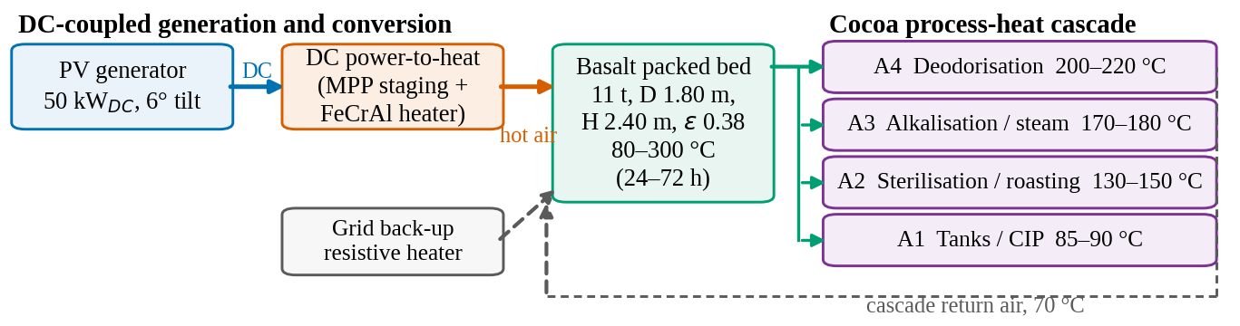
Fig. 1: Configuration of the DC-coupled Solar PV power-to-heat scheme with Basalt TES for four-block process-heat cascade.

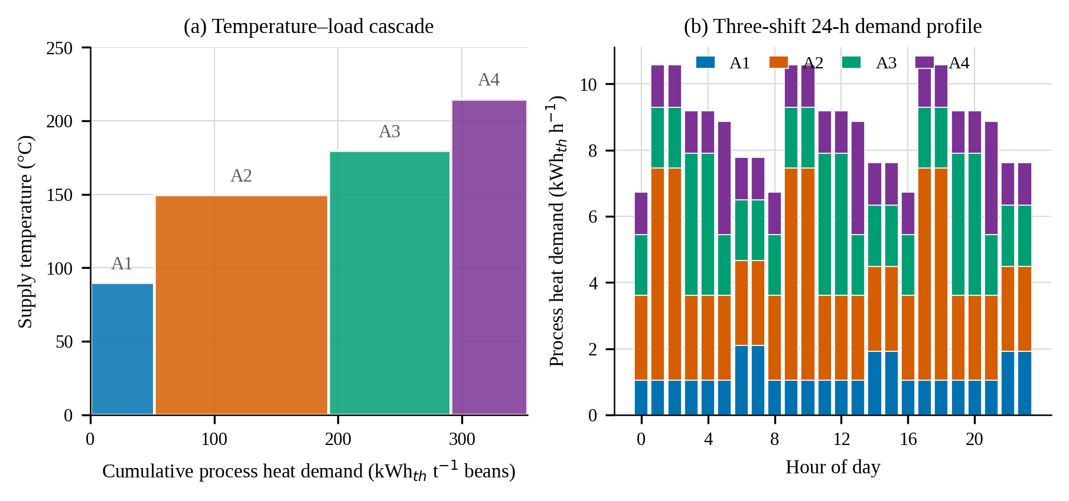
Fig. 2: (a) Temperature–load cascade of the cocoa processing chain; (b) Hourly process-heat demand of 24-hr operating pattern

2.2. System configuration and design
The facility encompasses a 50-kW DC fixed-tilt solar PV generation system installed at a 6° inclination, oriented due south. It incorporates a DC-coupled power-to-heat interface equipped with a staged DC–DC maximum power point tracking controller and a FeCrAl duct heater. Additionally, the system includes a closed-loop medium-temperature air circuit with a variable-speed fan and a Basalt TES packed bed. The TES is charged from the top and discharged from the bottom, ensuring that hot-air buoyancy promotes rather than hampers the thermocline. The TES operates from 80°C to 300°C. The grid supplies backup power for resistive heating, as illustrated in Fig. 1. Table 2 summarises the design parameters.
Tab. 2: Design parameters of the photovoltaic generator, DC power-to-heat interface and basalt packed-bed store.
Parameter | Symbol | Value | Parameter | Symbol | Value
PV rated power at STC | P_{STC} | 50.0 kW_{DC} | Basalt density | ρ_{s} | 2 900 kg m⁻³
Power temperature coefficient | γ | −0.34 % K⁻¹ | Basalt specific heat, 80–300 °C | c_{s} | 780 + 0.62T J kg⁻¹ K⁻¹
Faiman coefficients | U₀, U₁ | 25.0, 6.84 W m⁻² K⁻¹ | Basalt thermal conductivity | k_{s} | 1.9 W m⁻¹ K⁻¹
Soiling, mismatch, DC wiring | η_{s}η_{m}η_{c} | 0.937 | Bed void fraction | ε | 0.38
MPP staging and element | η_{mppt}η_{el} | 0.970 | Equivalent particle diameter | d_{p} | 0.05 m
Module degradation | – | 0.5 % yr⁻¹ | Bed mass (48 h design) | m_{s} | 11.0 t
Charging air set point | T_{ch} | 305 °C | Bed diameter and height | D, H | 1.80, 2.40 m
Cascade return air | T_{ret} | 70 °C | Usable capacity, 80–300 °C | Q_{cap} | 603.5 kWh_{th}
Loop pressure drop excl. bed | Δp_{loop} | 400 Pa | Wall loss coefficient | U_{w} | 0.35 W m⁻² K⁻¹
Fan and heat-exchanger efficiency | η_{fan}, η_{hx} | 0.55, 0.96 | Dead-state temperature | T₀ | 27.0 °C

2.3. Solar resource and PV model
Three independent hourly meteorological years are synthesised from the monthly mean daily global horizontal irradiation climatology for the coastal Western Region. It is consistent with Global Solar Atlas and NASA POWER records (World Bank/ESMAP, 2020; NASA, 2026). Daily clearness indices are generated using a first-order autoregressive process, renormalised to preserve each monthly mean. Hourly global irradiance follows the Collares-Pereira and Rabl distribution. The diffuse fraction follows the Erbs correlation,Erbs et al., 1982, and plane-of-array irradiance is transposed isotropically, as referenced in Duffie et al. (2020), Eq. (1). The realisations differ only in the random seed and yield a shared climate but not a weather sequence.
G_{T} = G_{b}R_{b} + G_{d}(1 + cos β)/2 + Gρ_{g}(1 − cos β)/2 (1)
Module temperature and DC power follow the Faiman model and the standard single-point power correlation, Eqs. (2) and (3), where v_{w} is wind speed:
T_{c} = T_{a} + G_{T} / (U₀ + U₁v_{w}) (2)
P_{dc} = P_{STC} (G_{T}/G_{STC}) [1 + γ(T_{c} − 25)] η_{s}η_{m}η_{c} (3)
Because the heater is a purely resistive load matched by resistance staging, the heat released in the duct is
Q̇_{p2h} = η_{mppt} η_{el} P_{dc} (4)
2.4. Thermal energy storage packed-bed model
The TES is modelled using the two-phase Schumann formulation with a quasi-steady gas phase, which is standard for gas-solid packed beds because the volumetric heat capacity of air is three orders of magnitude smaller than that of the rock (Schumann, 1929; Gautam & Saini, 2020). The governing equations are Eq. (5) and Eq. (6), with axial dispersion incorporated into an effective conductivity and a wall-loss term.
ṁ c_{f} ∂T_{f}/∂x = h_{v}A_{c} (T_{s} − T_{f}) (5)
(1 − ε)ρ_{s}c_{s} ∂T_{s}/∂t = h_{v}(T_{f} − T_{s}) + ∂/∂x(k_{eff} ∂T_{s}/∂x) − (U_{w}P_{w}/A_{c})(T_{s} − T_{a}) (6)
The particle-to-fluid heat transfer coefficient is evaluated using the Wakao correlation, Eq. (7), and is converted to a volumetric coefficient by Eq. (8):
Nu = 2 + 1.1 Re^{0.6} Pr^{1/3} (7)
h_{v} = 6(1 − ε) h_{p} / d_{p} (8)
Each axial node is advanced utilizing the precise exponential solution of the coupled node equations, Eq. (9), with Ċa = ṁcf and NTU = hvVn/Ċa. The solid temperature approaches the local fluid inlet temperature asymptotically and can never exceed it; therefore, the scheme remains unconditionally bounded, as described by the equation.
T_{s}^{n+1} = T_{f, in} + (T_{s}^{n} − T_{f,in}) exp(−Δt/τ), τ = C_{s} / [Ċ_{a} (1 − e^{−NTU})] (9)
Sensible energy is monitored as enthalpy rather than as a temperature difference multiplied by a nominal specific heat, as per Eq. (10), and the wall loss and conduction terms are implemented in flux form on the nodal enthalpy, which is then analytically inverted. This methodology enables the annual energy balance to close precisely, despite the temperature dependence of cs.
h_{s}(T) = c₀(T − T_{ref}) + ½c₁(T² − T_{ref}²) (10)
The TES Bed pressure drop and fan power follow the Ergun equation (Eqs. (11) and (12)):
Δp_{bed} = [150 μ (1 − ε)²u / (ε³d_{p}²) + 1.75 ρ_{f}(1 − ε) u² / (ε³d_{p})] H (11)
P_{fan} = V̇(Δp_{bed} + Δp_{loop}) / η_{fan} (12)
The TES system sizing is based on the required autonomy fault and the daily demand Qd, with a thermocline utilisation factor ηu = 0.75, as per Eq. (13). For Qd = 211.5 kWh_{th,} the system requires 5.2, 10.3, and 15.4 tons of Basalt for 24, 48, and 72 hours, respectively. The design uses a capacity of 11.0 tons, considering 24 to 72 hours throughout the analysis.
m_{s} = f_{aut} Q_{d} / [24 η_{u} (h_{s} (T_{max}) − h_{s}(T_{min}))] (13)

2.5. Dispatch control and cascaded delivery
At each hour, the controller responds to load from the power-to-heat interface, charging the TES with excess energy and discharging to address deficits. Charging and discharging are mutually exclusive. During charging, the fan maintains the heater outlet at 295 °C. During discharging, the cascade is gradually admitted from storage, with the top of the bed above its minimum temperature. Heat is distributed among permissible blocks based on demand, with remaining demand met by the grid backup heater. Discharging depletes the highest-temperature duties first, reflecting a thermocline, as shown in Fig. 5.

2.6. Energy and exergy indicators
First-law indicators are the solar fraction, the system efficiency referred to DC generation, and the storage round-trip efficiency, given by Eqs. (14) to (16):
f_{sol} = Q_{sol} / Q_{dem} (14)
η_{sys} = Q_{sol} / E_{pv} (15)
η_{st} = Q_{dis} / Q_{ch} (16)
Indicators based on the second law employ the dead state T₀ = 300.15 K. The exergy supplied to a system component is computed at the logarithmic mean of its inlet and outlet temperatures, as delineated in Eq. (17). The exergy stored within the bed is quantified in accordance with Eq. (18), and the plant exergy efficiency, as outlined in Eq. (19), is referenced to PV electricity, which represents pure exergy.
Ex_{b} = Q_{b}(1 − T₀/T_{lm,b}), T_{lm,b} = (T_{sup} − T_{ret}) / ln(T_{sup}/T_{ret}) (17)
Ex_{s} = Σ m_{i}[(h_{s}(T_{i}) − h_{s}(T₀)) − T₀c_{s} ln(T_{i}/T₀)] (18)
ψ = Σ Ex_{b} / E_{pv} (19)
2.7. Model development algorithm
The model algorithm was developed using a four-stage pipeline in Fig. 3. Stage 0 gathers input data, then in Stage 1, the training year calibrates the solver and optimises control parameters. It fits two surrogate models: one regularised multiple linear regression (MLR) and a gradient-boosted regression tree ensemble (GBR, 350 trees, depth 3, rate 0.05). This forecast daily solar fraction based on eight predictors: irradiation, ambient temperature, demand, state of charge, and two interaction terms. Stage 2 tests these models on the unseen year, while Stage 3 evaluates performance on an independent year using metrics like RMSE, MAE, MAPE, normalised RMSE, and R². A verification track runs with the solver, benchmarked against the Anzelius–Schumann analytical solution (Eq. 20), including time-step-independence and energy-closure tests.
θ_{s}(Y,Z) = ∫₀^{Y} e^{−(Z+η)} I₀(2√(Zη)) dη, θ_{f}(Y,Z) = e^{−Z} + ∫₀^{Y} e^{−(Z+η)} √(Z/η) I₁(2√(Zη)) dη (20)

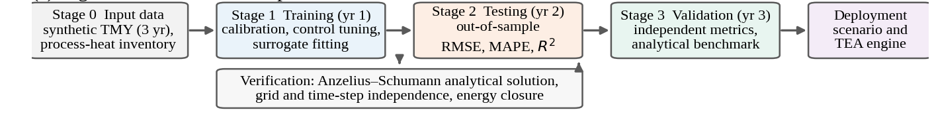
Fig. 3: Algorithm for model development: three data-processing stages use meteorological years with verification track.

2.8. Techno-economic model
All costs are in real 2026 USD per GH¢ at 11.20. Installed capital was built bottom-up and presented in Tab. 5, with a 6% engineering allowance and an 8% contingency. Fixed operation and maintenance are 1.8 % of capital per year, and the economic life is 20 years. The capital recovery factor, LCOH and NPV follow Eqs. (21) to (23), where C_{net} is capital net of grants, C_{om} is annual operation and maintenance, C_{par} is parasitic electricity cost, R_{c} is carbon revenue, and Q_{sol} is annual solar heat delivered:
CRF(r,N) = r(1 + r)^{N} / [(1 + r)^{N} − 1] (21)
LCOH = [CRF·C_{net} + C_{rep} + C_{om} + C_{par} − R_{c}] / Q_{sol} (22)
NPV = −C_{net} + Σ_{t=1}^{N} (B_{t} − C_{t})(1 + r)^{−t} (23)
The current heating costs are determined by the price floors established during the third-quarter of 2026 by the National Petroleum Authority: GH¢ 10.85 per kilogram for LPG (including a 15% industrial delivery margin) and GH¢ 15.60 per litre for diesel. Additionally, these costs are affected by the second-quarter 2026 special load tariff of GH¢ 2.3211 per kWh. According to the reports by NPA (2026) and PURC (2026), the following costs are established: USD 0.1087 per kWh_{th} for LPG, USD 0.1723 per kWh_{th} for diesel, and USD 0.2115 per kWh_{th} for grid power used for resistive heating. The counterfactual scenario uses a 60:40 blend of LPG and diesel, at a cost of USD 0.1341 per kWh_{th}.
Five financial-incentive instruments were subsequently implemented sequentially as a hierarchy. The exemption from import duties and value-added tax on renewable energy equipment, available under the Renewable Energy Act, 2011 (Act 832) as amended by Act 1045 (2020), was considered to represent 21.9% of the 60% import share of capital. The project transitioned from commercial to blended debt; concessional climate-fund debt was secured at a 6% real rate, resulting in a weighted average cost of capital of 8.7%; a capital grant constituting 30%; and carbon revenue was estimated at USD 15 per ton of CO₂ equivalent.

2.9. Environmental, socio-cultural and carbon-finance assessment
Baseline emissions use IPCC factors: 63.1 kg CO₂ for LPG and 74.1 kg for diesel, plus 1.5% for methane and nitrous oxide, adjusted for burner efficiency. Project emissions are based on Ghana's grid factor of 0.39 kg CO₂ per kWh per IEA, (2025), mainly from parasitic and backup electricity. Carbon revenue, under Article 6.2 UNDP, (2024), is evaluated at 15 USD per ton, ranging from 5 to 45 USD.
3. Results and Discussion
3.1. Verification and validation
Figure 4a compares the computed outlet fluid temperature of a step charge with the Anzelius–Schumann solution at a TES bed length Z = 31.6. The curves are indistinguishable over the full breakthrough, with an RMSE of 0.0020, a maximum absolute deviation of 0.0043, and R² = 0.9908. Figure 4b illustrates that the error in stored energy decreases monotonically with the number of axial nodes and increases with the time step; the selected 30 nodes and 120 seconds fall within 0.21% and 0.001% of their respective asymptotes. The annual energy balance exhibits a residual below a total charging energy of 43.8 MWh.
The gradient-boosted surrogate closely replicates the daily solar fraction with an R² of 0.9996 during training, 0.9775 during testing, and 0.9673 during validation. It has a validation MAPE of 1.47% and a bias of 0.0015, per the graphs shown in Fig. 4c and d. The small difference between testing and validation metrics shows effective generalisation. The surrogate's non-linear performance, with an R² of 0.724 during validation, confirms non-linear features of the daily response. Mid-state charge is the key predictor, contributing 71.5% to ensemble importance by capturing resources stored from the previous day.
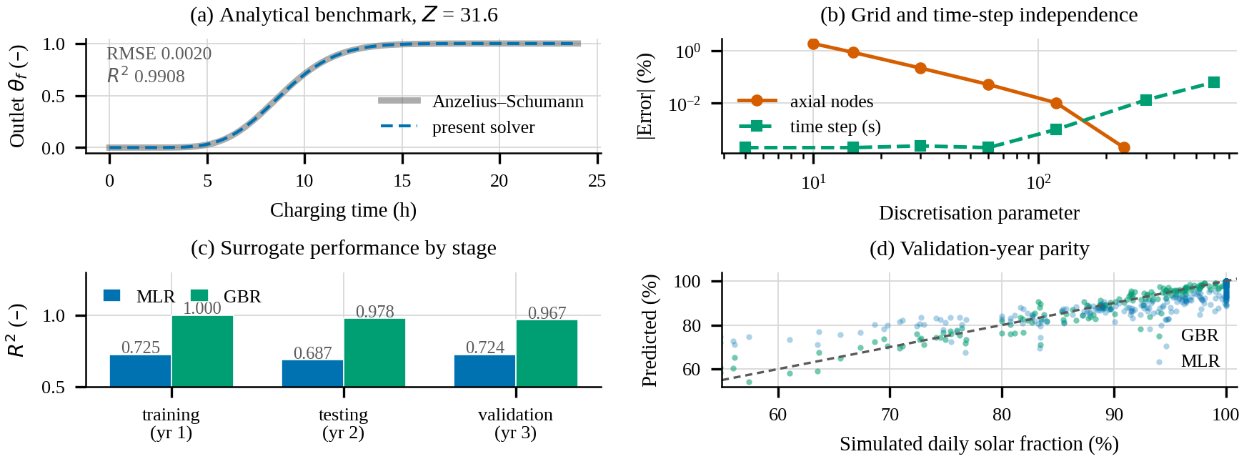
Fig. 4: (a) Step charge outlet temperature (numerical and analytical); (b) Grid and time-step independence; (c) Development-stage surrogate coefficient; (d) Validation year parity (predicted vs simulated) solar fraction.

3.2. Annual performance of the integrated cascade
The plant, with 11.0 tons of Basalt, achieves a solar fraction of 92.9%, 91.9%, and 92.7% during training, testing, and validation, respectively. The one-percentage-point variation reflects weather effects rather than model uncertainty, as shown in Table 3. During training, the array produces 76.3 MWh of DC electricity, of which 29.1 MWh is used directly, and 43.8 MWh is stored in TES. Of the stored energy, 35.7 MWh is recovered during discharge, 6.4 MWh is absorbed through system walls, and 1.1 MWh is curtailed. The total energy delivered is 64.8 MWh, indicating a system efficiency of 84.9% and a storage round-trip efficiency of 81.5%. Parasitic losses are 1.75 MWh annually, with 0.44 MWh for fan work and stable pressure drop.
Figure 5 shows the monthly equilibrium. From October to May, the storage system mainly sustains the plant, with solar fractions between 95% and 100%. The lowest, 79%, occurs in August when coastal clouds reduce irradiation to 115 kWh/m². During the period shown in Fig. 6, the TES bed top fluctuates between 165°C and 297°C daily, while the bottom stays between 68°C and 90°C, maintaining stratification. Backup firing occurs on two less productive days when the top temperature drops below A4 and A3 thresholds, only during contingency activities. Figures 5a and 5b display the charging front reaching the TES bed after 9 hours at the design flow rate, along with a more diffuse discharge front, explaining the 18.5% round-trip energy loss.
Tab. 3: Annual energy and exergy balance of the integrated cascade with 11.0-ton Basalt TES (3-Yr independent simulation)
Quantity | Symbol | Training (yr 1) | Testing (yr 2) | Validation (yr 3) | Unit
PV DC generation | E_{pv} | 76 284 | 75 787 | 75 523 | kWh
Process heat demand | Q_{dem} | 69 739 | 69 739 | 69 739 | kWh_{th}
Solar heat delivered | Q_{sol} | 64 780 | 64 074 | 64 623 | kWh_{th}
Grid backup heat | Q_{bkp} | 4 959 | 5 665 | 5 116 | kWh_{th}
Parasitic electricity | E_{par} | 1 753 | 1 755 | 1 753 | kWh
Exergy delivered | ΣEx_{b} | 16 175 | 15 962 | 16 118 | kWh
Solar fraction/system efficiency | f_{sol} / η_{sys} | 92.9 / 84.9 | 91.9 / 84.6 | 92.7 / 85.6 | %
Storage round-trip/exergy efficiency | η_{st} / ψ | 81.5 / 21.2 | 81.7 / 21.1 | 81.6 / 21.3 | %

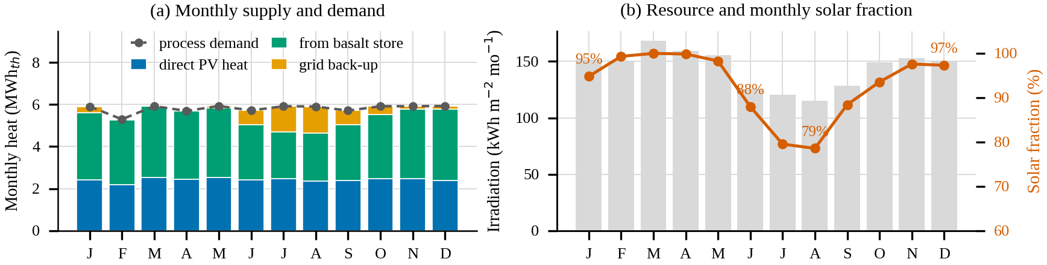
Fig. 5: (a) Monthly process-heat demand from (DC PV heat, TES and Grid back-up); (b) Monthly plane-of-array irradiation and the resulting solar fraction.
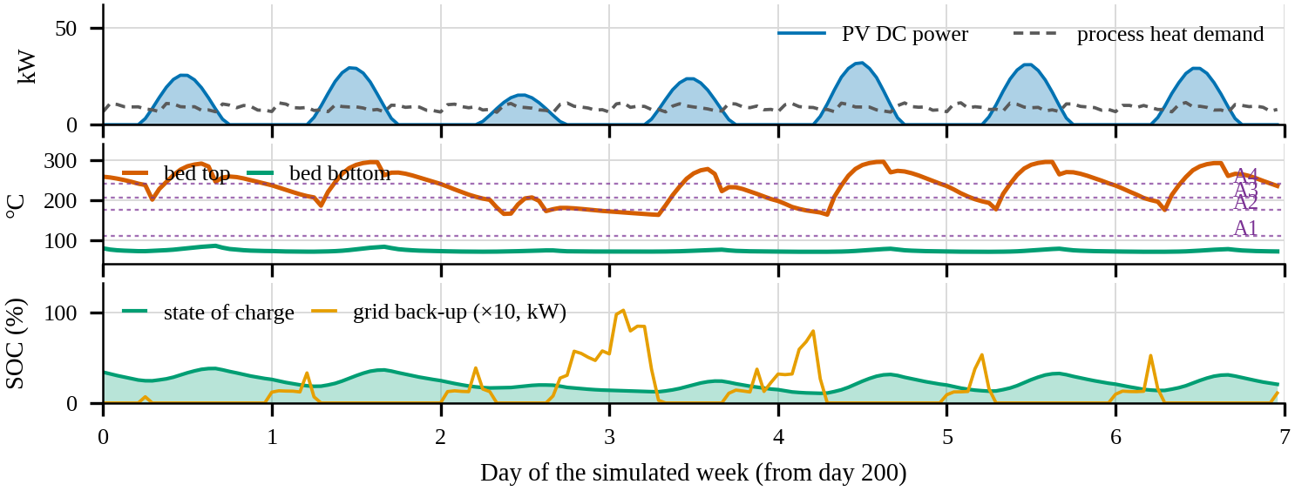
Fig. 6: Simulated operation over a representative period from day 200. (Top: DC array power process-heat demand; Middle: bed top and bottom temperatures against thresholds of the four blocks; Bottom: state of charge and Grid back-up firing).

3.3. Effect of storage duration
The storage durations were consistently maintained at 24, 48, and 72 hours, with all three durations simulated by varying storage costs scaled according to rock, vessel, insulation, and internals. Without storage, the plant achieves only 41.7% efficiency. A 24-hour load cannot be sustained solely by a daytime energy resource. Providing 24 hours of autonomy requires more than doubling this efficiency to 91.0%, while extending to 48 hours increases it further to 92.9%. Extending the duration to 72 hours results in a slight decrease to 92.2%, due to the need for larger vessels for TES surface area, which raises standing losses from 3.2 to 7.9 MWh per year and reduces round-trip efficiency from 87.9% to 78.6%. The LCOH increases monotonically with storage duration because the additional storage capacity contributes minimal extra heat. The 48-hour TES configuration represents the technical optimum; meanwhile, the 24-hour storage constitutes the economic optimum, achieving a 1.9 percentage-point improvement in solar fraction in Fig. 7c.

3.4. Integration application scenarios
To insulate the impact of process temperature, each segment was simulated independently as a separate application of the identical 50 kW module and 11-ton TES system, with throughput scaled to ensure that each scenario maintains an annual load of approximately 69.7 MWh_{th}, as shown in Tab. 4. The solar fraction decreases only slightly with increasing temperature, from 94.2% for A1 to 90.8% for A4, owing to the storage system spending most of its time above the A4 threshold. The corresponding non-linearity appears as standing losses, which increase from 5.8 to 7.5 MWh as the mean TES bed temperature rises. The exergy efficiency more than doubles across this range, from 12.4% to 28.2%. The integrated cascade achieves a solar fraction of 92.9% and an exergy efficiency of 21.2%, effectively fulfilling all four operational tasks within a single containment. Although it does not surpass other configurations in either metric alone, a dedicated A4 plant demonstrates superior exergy efficiency, while a dedicated A1 plant exhibits a higher solar fraction. Nonetheless, the integrated cascade is distinctive in its ability to encompass the entire process chain using a single storage unit, a single air loop, and one control system, which is a crucial consideration for capital expenditure in SMEs. Consequently, the design approach recommends sizing the storage according to the highest-temperature duty and recovering residual enthalpy throughout the cascade.
Tab. 4: Four single-duty scenarios and the integrated cascade (annual thermal load of about 69.7 MWh_{th}, a 50-kW DC array, and an 11-ton TES)
Scenario | Process block | Throughput (t d⁻¹) | T_{sup} (°C) | Carnot factor (–) | f_{sol} (%) | η_{sys} (%) | η_{st} (%) | ψ (%) | Back-up (kWh yr⁻¹)
S1 | A1 conditioning and hot water | 4.12 | 90 | 0.144 | 94.2 | 86.1 | 83.2 | 12.4 | 4 053
S2 | A2 sterilisation and roasting | 1.50 | 150 | 0.235 | 93.3 | 85.3 | 82.3 | 20.1 | 4 659
S3 | A3 alkalisation and press steam | 2.15 | 180 | 0.281 | 92.5 | 84.6 | 81.1 | 23.7 | 5 265
S4 | A4 butter deodorisation | 3.41 | 215 | 0.340 | 90.8 | 83.0 | 79.0 | 28.2 | 6 416
S5 | Integrated cascade A1–A4 | 0.60 | 90–215 | 0.144–0.340 | 92.9 | 84.9 | 81.5 | 21.2 | 4 959

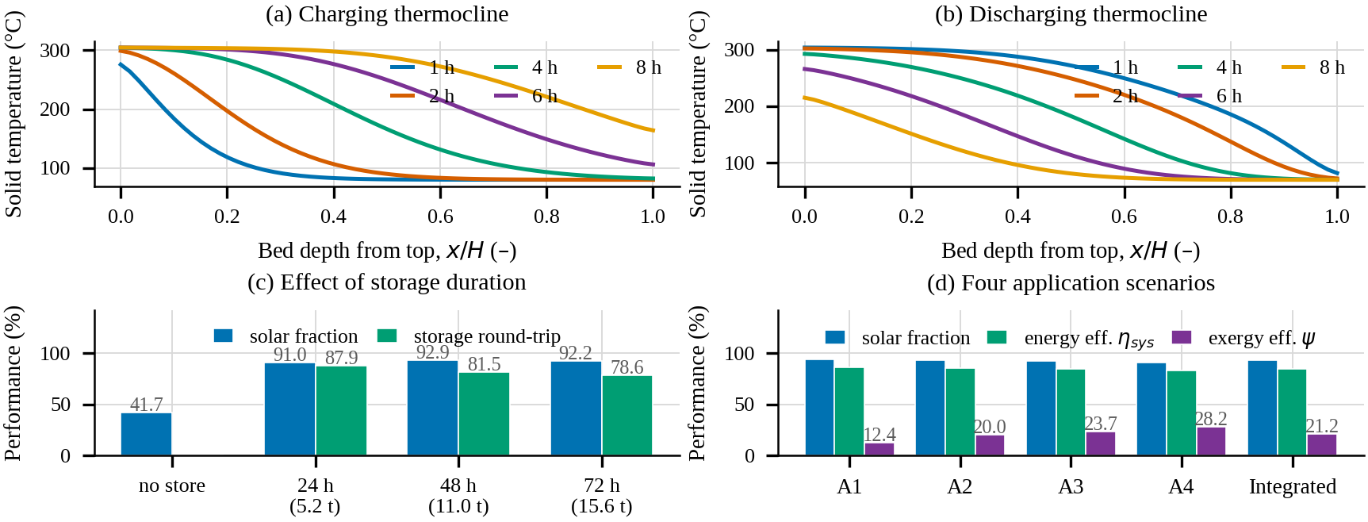
Fig. 7: (a) TES Charging; (b) Discharging thermocline profiles of 11-ton TES bed design flow; (c) Impact of storage duration on solar fraction round-trip efficiency; (d) Solar fraction, energy & exergy efficiencies of integrated four single-duty scenarios

3.5. Exergy performance
The exergy cascade depicted in Fig. 8a shows a first-law efficiency of 84.9% and a second-law efficiency of 21.2%. Of the 76.3 MWh of DC electricity input, 2.3 MWh is dissipated within the converter and wiring components. Additionally, 40.5 MWh is utilised during the resistive conversion of work into heat, and 17.4 MWh is expended in the storage and cascade exchangers, leaving 16.2 MWh as useful process exergy. The resistive interface emerges as the predominant source of irreversibility, which is inherently irreducible for an electrical process heat source. Even at the maximum storage temperature of 300 °C, the Carnot efficiency limit constrains the conversion process to 47.6%. This limitation represents the thermodynamic cost associated with the power-to-heat conversion pathway.
The block-resolved outcome depicted in Fig. 8b is more actionable. The Carnot factors for A1 to A4 are 0.144, 0.235, 0.281, and 0.340, respectively. Although A2 receives the most energy of 6.7 MWh_{th}, A4 converts the largest proportion of its received energy into exergy. Consequently, the exergetic value of a PV-driven storage system increases with process temperature, which is contrary to the conventional understanding derived from flat-plate solar thermal practices.
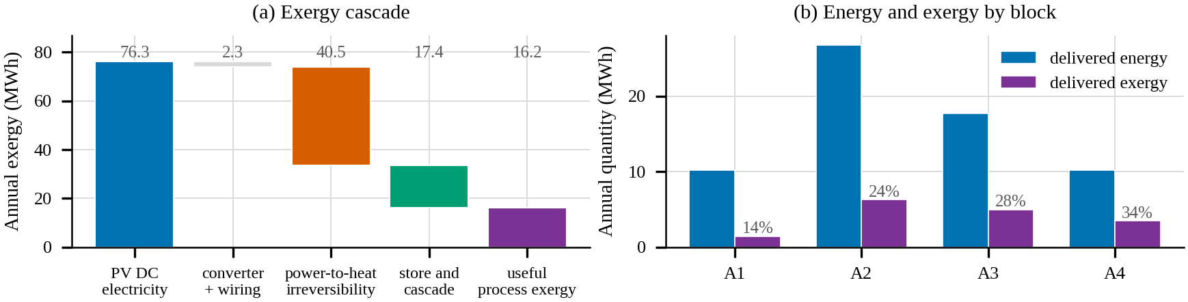
Fig. 8: (a) Annual exergy cascade of the plant; (b) energy and exergy to each process block, with Carnot factor noted.

3.6. Capital cost, LCOH and the incentive prospects
Diesel, serving as the baseline process heat fuel, exhibits a residual rate of 3.2%, with the PV array and storage components assessed independently. The solar fraction increases from 71% at 35 kW to 96.8% at 50 kW, reaching 99.0% at 55 kW and stabilising at 60 kW. Curtailment remains negligible below 45 kW but escalates to 7.9% at 55 kW. The LCOH reaches a minimum of USD 0.0917 per kWh at 50 kW, rising marginally to USD 0.0921 at 55 kW and reducing the residual deficit from 3.2% to 1.0%. This reliability improvement correlates with a three-shift operational model, as illustrated in Table 5 and Fig. 9.
Tab. 5: Breakdown of capital expenditure for the 50-kW Solar PV reference configuration.
Cost item | Cost (USD) | Share (%)
Photovoltaic modules, mounting structure and DC cabling | 24 000 | 46.2
DC–DC controller, resistive heater bank and switchgear | 4500 | 8.7
Basalt storage medium (11 ton, quarried and graded) | 550 | 1.1
Storage vessel, distributor plate and internals | 8200 | 15.8
Refractory liner and thermal insulation | 3600 | 6.9
Air loop: blower, ducting, process heat exchanger, dampers | 6800 | 13.1
Instrumentation, control and SCADA | 2400 | 4.6
Civil works, foundation and installation | 1950 | 3.8
Total capital expenditure | 52 000 | 100.0
Storage subsystem | 12 350 | 23.8
Specific storage cost | 19.1 USD/kWh_{th} | —
Specific photovoltaic and conversion cost | 570 USD/kW | —

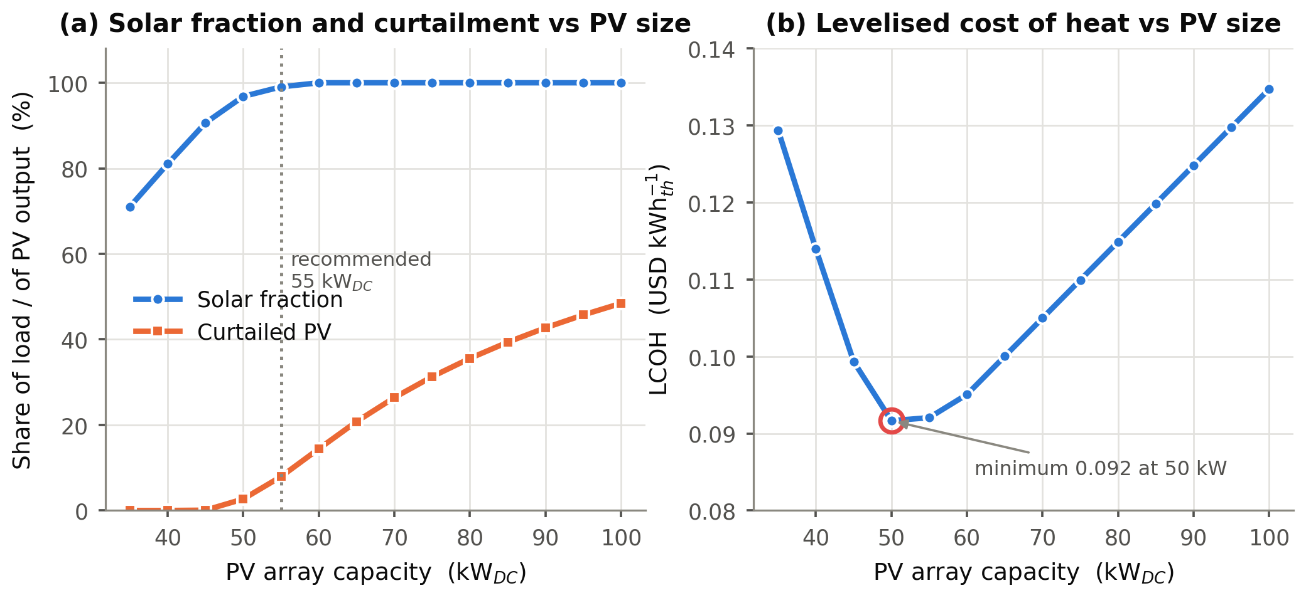.
Fig. 9: Solar PV array sizing at fixed storage (a) Solar fraction and curtailment, (b) levelised heat cost at 50 kW.
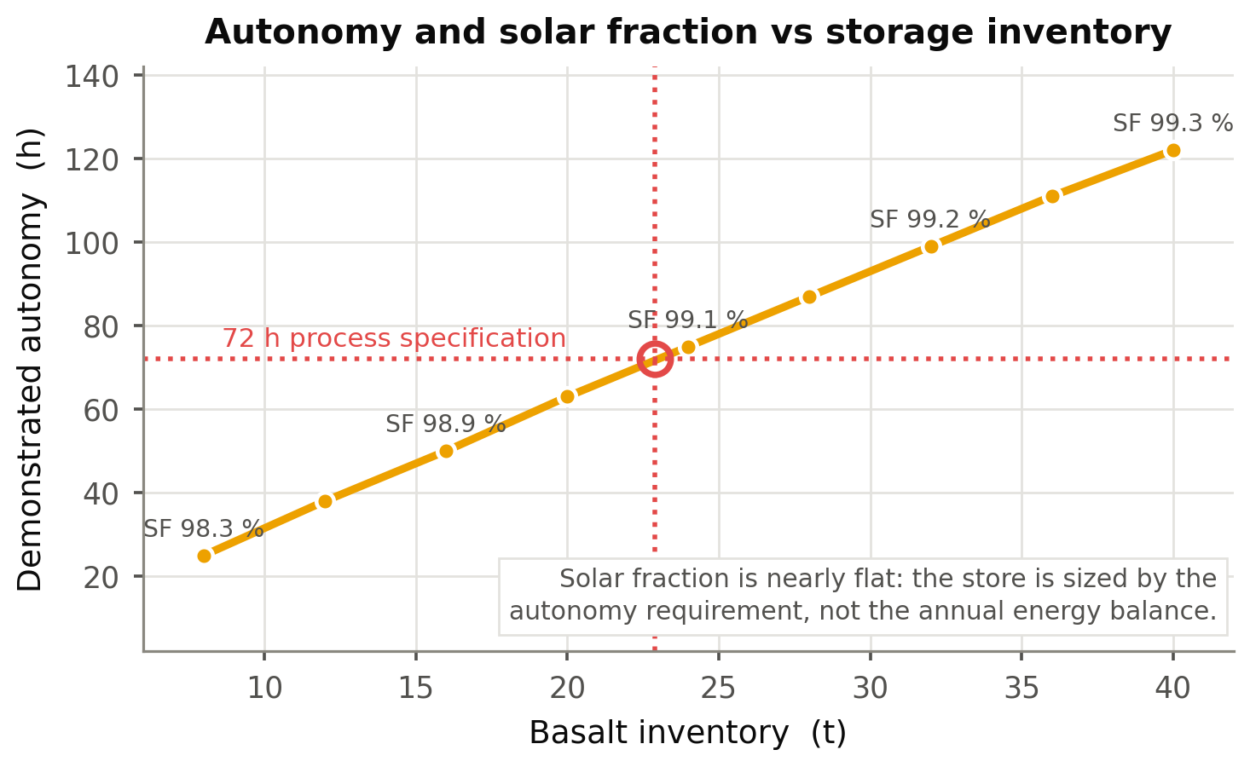
Fig. 10: Storage inventory audit: Autonomy increases with inventory, while the annual solar fraction remains nearly constant

3.7. Economics vs sensitivity and uncertainty
The total capital expenditure amounts to USD 52,000, as detailed in Table 5. The PV array and power-conversion package constitute 55% of this total, at USD 570 per kWp installed. This aligns with the international benchmark of USD 691 per kW, after local labour rates and the absence of an inverter; IRENA, (2025). The storage subsystem is valued at USD 12,350 based on its capacity, while the Basalt itself is valued at USD 550, representing 1.1% of the overall project cost.
The baseline uses 10,332 litres of diesel annually, costing USD 14,155 and producing 27.88 t CO₂e emissions. Residual backup consumes 329 litres, resulting in net avoided emissions of 26.99 t CO₂e annually. At USD 20 per ton, with a 3% adjustment fee under Section 155 of Act 1124, the carbon revenue totals USD 524 per year. Although modest, this figure serves as an important indicator of bankability.
Table 6 shows key economic indicators from the LCOH analysis. Diesel was USD 0.2253 per kWh; Solar PV was USD 0.0989 (no incentive), USD 0.0917 (Article 6.2 carbon revenue), USD 0.0831 (accelerated depreciation), and USD 0.0757 (20% capital grant). These correspond to 56%, 59%, 63%, and 66%. Table 6 and Fig. 11 illustrate this analysis.
Fig. 10 shows, increasing TES above 11 tons slightly raises the solar fraction from 98.3% to 99.3%, with a linear increase in solar hours from 25 to 122. The threshold depends on storage capacity during solar peaks. The annual energy balance remains unaffected by TES bed size, since performance is limited by the generation capacity set by the 72-hour reliability standard. The one-at-a-time analysis ranks the discount rate first, then synthesises the movement of LCOH from 0.075 to 0.129 USD per kWh across a 7–16% rate range, followed by capital cost and PV+TES yield. Diesel price is the weakest driver because it reaches the PV scenario only through the 3.2% residual backup, due to the proposition's economic asymmetry. The asymmetric cost is dominated by a volatile imported fossil fuel. Across 20,000 Monte Carlo trials, the median LCOH is USD 0.102 per kWh, with a 5th-95th percentile range of USD 0.078-0.132, compared with a diesel median of USD 0.235. The Solar PV option is cheaper in 100% of trials, with a 93.5% probability of payback within five years. The base case is the PV+TES system without incentive at a CAPEX of USD 52,000. Solar PV degradation is assessed in the LCOH elasticity analysis. The carbon-financed scenario yields annual savings of USD 14,348, an NPV of USD 72,086, an IRR of 26.9%, a simple payback of 3.6 years, and a discounted payback of 4.8 years. Under the capital grant, these figures improve to an NPV of USD 82,486, an IRR of 33.9%, a simple payback of 2.9 years, and a discounted payback of 3.6 years. Figure 11 presents an economic index analysis.
Tab. 6: Levelised cost of heat and financial indicators across policy scenarios, at a 13 % real discount rate over 25 years.
Indicator | Diesel boiler | PV–TES (No incentive) | PV–TES + Art. 6.2 | PV–TES + Accelerated Depreciation | PV–TES + 20 % CAPEX grant
Capital expenditure (USD) | 15 000 | 52 000 | 52 000 | 52 000 | 41 600
Annual fuel cost (USD) | 14 155 | 451 | 451 | 451 | 451
Annual emissions (t CO₂e) | 27.88 | 0.89 | 0.89 | 0.89 | 0.89
Carbon revenue (USD a⁻¹) | 0 | 0 | 524 | 524 | 524
LCOH (USD kWh_{th}⁻¹) | 0.2253 | 0.0989 | 0.0917 | 0.0831 | 0.0757
Reduction vs diesel (%) | — | 56.1 | 59.3 | 63.1 | 66.4
Annual net saving (USD) | — | 13 824 | 14 348 | 14 348 | 14 348
Net present value (USD) | — | 67 505 | 72 086 | 77 668 | 82 486
Internal rate of return (%) | — | 25.9 | 26.9 | 29.9 | 33.9
Simple payback (a) | — | 3.79 | 3.65 | 3.65 | 2.91
Discounted payback (a) | — | 5.01 | 4.78 | 4.78 | 3.63
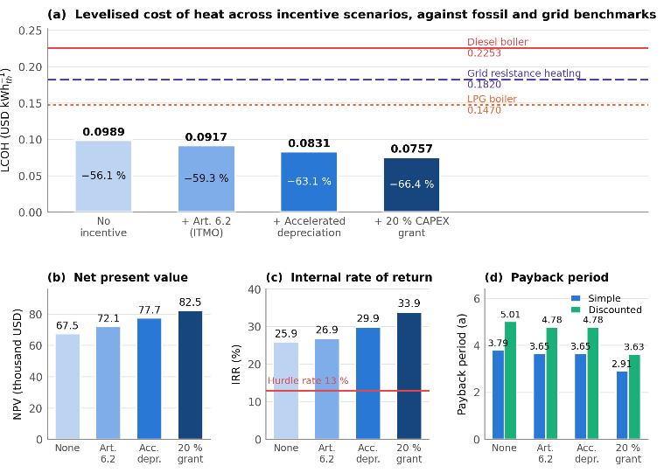
Fig. 11: Solar PV+TES vs. fossil fuels benchmark profile: (a) LCOH; (b) NPV; (c) IRR; (d) Payback period.
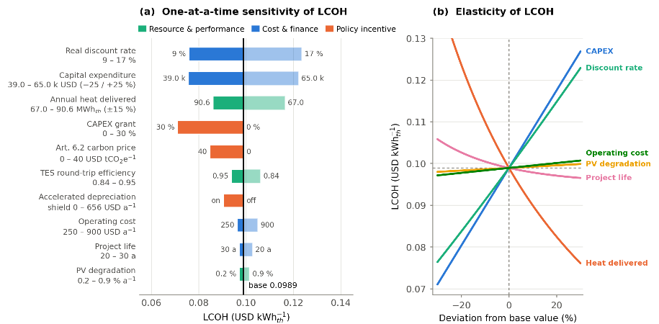
Fig. 12: Sensitivity and uncertainty analysis: (a) One-at-a-time sensitivity of LCOH; (b) LCOH elasticity analysis
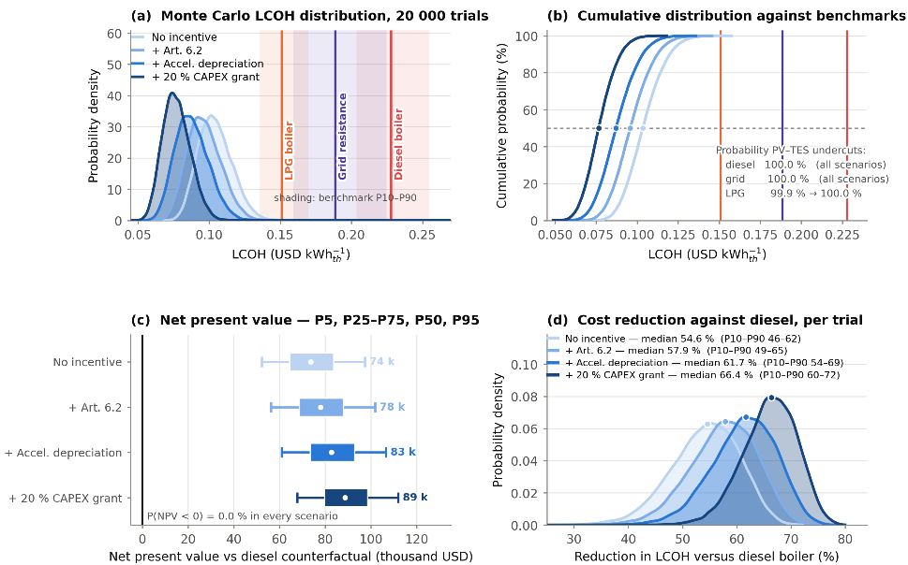
Fig. 13: Monte Carlo analysis of incentive scenario: (a) Monte Carlo distribution over 20 000 trials. (b) Cumulative distribution against benchmarks; (c) Net present value; (d) Cost reduction against diesel, per trial.

3.8. Technical, environmental, and socio-cultural considerations
Three key findings have broad implications. First, in a 24-hour economy, storage duration is more crucial than PV size: doubling storage slightly boosts the solar fraction, which already exceeds half of total generation. A 24-hour TES storage more than doubles the solar fraction at no extra cost. Secondly, returns plateau as the solar fraction increases by 1.9 percentage points between 24 and 48 hours but decline beyond due to standing losses that scale with vessel surface and less frequent energy use. An hourly model is needed to determine optimal storage duration and discourage heuristic sizing. Thirdly, scale matters in a 50-kW DC module matches a 198-ton-per-year line larger unit plant. Since vessel, air loop, and control systems are major costs, replication rather than scale-up reduces unit costs. This divergence in laws shows a 92.9% solar fraction and 84.9% efficiency coexist with a 21.2% exergy efficiency, largely due to irreversibility converting work to heat, which equipment upgrades can't eliminate. A heat pump should be used where possible; the cocoa cascade above 150 °C surpasses commercial high-temperature heat pumps, making power-to-heat suitable. The highest-temperature duty should guide design to maximise exergy per stored energy. The environmental impact exceeds emissions analysis: the storage system uses crushed Basalt in a steel shell, inert, non-flammable, and recoverable—no leak-prone fluids, freeze protection, or water needed. Replacing on-site combustion also reduces nitrogen oxide and particulate emissions.
The socio-cultural aspect in Ghana's cocoa sector involves predominantly female SMEs in sorting, winnowing, packing, and quality control, mainly in A1 and A2 blocks. Storage facilities are highly reliable, with solar fractions of 99.9% and 95.9%, ensuring a consistent heat supply unaffected by fuel issues and protecting vulnerable shifts. Local content is substantial, with Basalt rocks, vessel and ducting fabrication sourced locally. The operation also requires TVET skills, managed by Technical Institutes and Universities, including CSIR.
4. Conclusions
A 50-kW DC-coupled Solar PV power-to-heat system with 11.0 tons of Basalt storage supplies continuous industrial heat between 80 °C and 300 °C in SMEs. In the cocoa production chain, at an LCOH of USD 0.092 per kWh, including Article 6.2 carbon finance, it is cheaper than a USD 0.225 per kWh diesel boiler. It covers 96.8% of a 64.8 MWh_{th} annual load, rising to 96.0% with a 55-kW array, and offers 72 hours of autonomy. NPV is USD 72,086, IRR 26.9%, payback 3.6 years, discounted payback 4.8 years. In 20,000 Monte Carlo trials, it’s consistently cheaper than diesel. Key findings include the importance of loss-inclusive dynamic sizing, Basalt's suitability for storage at the specified temperatures, inventory based on reliability, and integrating Act 1124 for financial modelling. The system’s viability doesn’t rely on carbon finance alone; even without incentives, it costs less than diesel. Ghana's 24-Hour Economy could triple industrial heating hours, with locally sourced sunlight and Basalt offering a cost-effective alternative to imported diesel.
Recommendations include extending tax exemptions, establishing low-interest finance, recognising process-heat storage as infrastructure, developing methodologies for distributed process-heat integration, and launching a demonstration project with efficiency validation.
5. References
Awafo, E.A., Owusu, P.A., 2022. Energy and water mapping of the cocoa value chain in Ghana. Sustainable Production and Consumption. 29, 341–356.
Duffie, J.A., Beckman, W.A., Blair, N., 2020. Solar Engineering of Thermal Processes, Photovoltaics and Wind, fifth ed. Wiley, Hoboken.
Dzelagha, B.F., Ngwa, N.M., Bup, D.N., 2020. A review of cocoa drying technologies and the effect on bean quality parameters. International Journal of Food Science. 2020, 8830.
El Alami, K., Ouabid, M., Asbik, M., Koukouch, A., Chater, H., Bennouna, E.G., 2025. In-depth experimental and numerical investigations of a rock-bed thermal energy storage system: insights from mafic versus felsic igneous rocks. Energy. 317, 134531.
Erbs, D.G., Klein, S.A., Duffie, J.A., 1982. Estimation of the diffuse radiation fraction for hourly, daily and monthly-average global radiation. Solar Energy. 28, 293–302.
Ergun, S., 1952. Fluid flow through packed columns. Chemical Engineering Progress. 48, 89–94.
Faiman, D., 2008. Assessing the outdoor operating temperature of photovoltaic modules. Progress in Photovoltaics: Research and Applications. 16, 307–315.
Gautam, A., Saini, R.P., 2020. A review on sensible heat-based packed-bed solar thermal energy storage system for low-temperature applications. Solar Energy. 207, 937–956.
Hrifech, S., Bennouna, E.G., 2024. Experimental validation of igneous rocks as filler material for packed bed system dedicated to small CSP plants 1 MWel. Journal of Energy Storage. 86, 111343.
IEA, 2025. Emission Factors 2025. International Energy Agency, Paris. https://www.iea.org/data-and-statistics/data-product/emissions-factors-2025 (accessed 3 September 2026).
IPCC, 2019. 2019 Refinement to the 2006 IPCC Guidelines for National Greenhouse Gas Inventories. Institute for Global Environmental Strategies, Hayama.
Kumar, L., Hasanuzzaman, M., Rahim, N.A., 2019. Global advancement of solar thermal energy technologies for industrial process heat and its future prospects: a review. Energy Conversion and Management. 195, 885–908.
Nahhas, T., Py, X., Sadiki, N., 2019. Experimental investigation of basalt rocks as storage material for high-temperature concentrated solar power plants. Renewable and Sustainable Energy Reviews. 110, 226–235.
NASA, 2026. POWER Data Access Viewer, Prediction of Worldwide Energy Resources. NASA Langley Research Center, Hampton. https://power.larc.nasa.gov (accessed 3 September 2026).
NPA, 2026. Indicative maximum prices and price floors for petroleum products, pricing window commencing 1 September 2026. National Petroleum Authority, Accra. https://www.npa.gov.gh (accessed 3 September 2026).
PURC, 2026. 2026 Second Quarter Tariff Review Decision for Electricity and Water. Public Utilities Regulatory Commission, Accra. https://www.purc.com.gh/attachment/288818-20260313090334.pdf (accessed 3 September 2026).
Republic of Ghana, 2020. Renewable Energy (Amendment) Act, 2020 (Act 1045), amending the Renewable Energy Act, 2011 (Act 832). Parliament of Ghana, Accra.
Republic of Ghana, 2021. Ghana’s Updated Nationally Determined Contribution under the Paris Agreement (2020–2030). Ministry of Environment, Science, Technology and Innovation, Accra.
Republic of Ghana, 2025. National 24-Hour Economy and Accelerated Export Development Policy. Office of the President, Accra.
Schumann, T.E.W., 1929. Heat transfer: a liquid flowing through a porous prism. Journal of the Franklin Institute. 208, 405–416.
UNDP, 2024. Ghana, Vanuatu and Switzerland launch world’s first projects under the new carbon market mechanism set out in Article 6.2 of the Paris Agreement. United Nations Development Programme, Geneva. https://www.undp.org/geneva/press-releases (accessed 3 September 2026).
USDA FAS, 2025. Ghana: Cocoa Sector Overview 2025, GAIN Report GH2025-0008. United States Department of Agriculture Foreign Agricultural Service, Accra.
Wakao, N., Kaguei, S., Funazkri, T., 1979. Effect of fluid dispersion coefficients on particle-to-fluid heat transfer coefficients in packed beds. Chemical Engineering Science. 34, 325–336.
World Bank/ESMAP, 2020. Global Solar Atlas 2.0 Technical Report. World Bank, Washington, DC. https://globalsolaratlas.info (accessed 3 September 2026).

