EuroSun2026
PERFORMANCE OF A POLYGENERATION SYSTEM USING CPVT SOLAR COLLECTORS: CASE STUDY FOR AN OFFICE BUILDING

Jesús Castro¹ (corresponding author), Joaquim Rigola¹, Eugenio Schillaci¹, Giorgos Papakokkinos²
¹ Heat and Mass Transfer Technological Center (CTTC) Universitat Politècnica de Catalunya-BarcelonaTech (UPC), Terrassa (Barcelona) (Spain)
² Energy, Environment and Water Research Center, The Cyprus Institute, Cyprus
jesus.castro@upc.edu
Summary
The main objective of the ECOSun project is to reduce the cost of electricity and heat co-generation via a concentrated photovoltaic/thermal (CPVT) system by applying low-cost materials and advanced industrial manufacturing methods. In this work, a study of the performance of a poly-generation system based on this technology coupled with an absorption chiller is carried out based on system simulations. The polygeneration system will be connected to an office building and simulated using a building simulation model. The calculations are performed using the NEST numerical platform, which allows for linking different components (solar collectors, pumps, valves, heat exchangers, buildings, etc.) with high flexibility. The simulations give information on the main performance indicators of the system, e.g., solar fraction, collectors’ efficiency, PV modules’ efficiency, and thermal and electrical COP of the absorption chiller, using consolidated performance data of the new CPVT, estimating the electrical expenses of the auxiliary components (pumps, fans, etc.).
Keywords: CPVT, Solar Cooling, Absorption machine, Building simulation
Field of application for the findings: solar thermal energy, absorption cooling machines
Addressed audience: solar heating & cooling researchers
- Introduction
Concentrated hybrid PhotoVoltaic/Thermal (CPVT) solar collector is an option of interest due to its flexibility, manufacturability, and high efficiency. This technology has to face economic, technical and market barriers.
From an economic point of view, this technology still has a high initial installation cost and, together with relatively low market maturity and standardization, results in high CAPEX (Hosouli et al, 2025). Moreover, it requires double maintenance of the electrical and hydraulic circuits, resulting in higher OPEX than other solar collectors (Molepo, 2024). From a technical perspective, this technology involves a trade-off between thermal and PV efficiencies (Bandaru, 2021), and in many applications, such as residential buildings, there is a mismatch with user demand (Countinho, 2026).
The main objective of the ECOSun project is to overcome economic, technical, and market barriers to PVT systems by radically reducing the cost of electricity and heat co-generation via a CPVT system through the use of low-cost materials and advanced industrial manufacturing methods. In this new hybrid solar collector, solar radiation is captured in a parabolic trough by a concentrator based on a novel support structure fabricated by injection molding and focused onto a Co-Generation Absorber Module, where special c-Si PV cells are operated under concentration.
In this work, an assessment of the energy produced by a polygeneration system (for heating, cooling, and power generation) during the summer time, based on this technology and employing an absorption chiller, is carried out using system simulations with fast-transient calculation models to enable seasonal simulations. The absorption chiller model incorporates empirical heat and mass transfer information and pressure drop in the heat exchangers. This approach allows scalability studies, as the input data for the chiller are geometrical data of the machine, including heat exchangers, the mass of the refrigerant, absorbent, and solid parts, thermophysical properties, and characteristics of pumps and valves, avoiding an ad-hoc experimental test campaign to characterize the absorption machine and allowing the estimation of the electrical expenses of the auxiliary components. The present work presents calculations of overall performance indicators for a case study: a polygeneration system in an office building within the CTTC facilities in Terrassa (Barcelona), and a detailed assessment of the summer season performance. The model used for the CPVT is described, and the control strategy is explained. The cooling load is estimated using a building simulation model that accounts for heat (conduction, convection, and radiation) and mass transfer (humidity transport) phenomena.
- Mathematical modelling and implementation
For performing the simulations, a modular object-oriented simulation platform (NEST) (Lopez et al., 2012) developed in MPI C++ is used, which enables linking between the different components of a particular system (e.g., solar collectors, pumps, valves, heat exchangers, etc.), allowing high flexibility in configurations. In this numerical platform, each component is an object that can be either an empirically based model or a more detailed CFD model, if necessary. In the NEST platform, parallel computing is allowed. For numerical resolution, each component is treated as a separate object, coupled with its neighboring objects/elements via a global algorithm based on implicit iteration, performed component by component. At each iteration, inputs (e.g., pressure, temperature, etc.) are taken from the neighbors, the governing equations of the element are solved, and the outputs (e.g., pressure, temperature, etc.) are set as boundary conditions for the resolution of the neighbor elements. Iterations continue until convergence is reached at the present time step; then, the next time step calculation starts after updating the variables in a Gauss–Seidel iteration procedure.
  - Energy capture system
For the CPVT collector, a simple model is employed (Jonas et al. 2018), i.e., a steady-state efficiency curve is used to calculate the instantaneous overall efficiency (thermal+electrical, η) applied to the incoming solar energy (see eq.1):
$=a_{0}+a_{1}∆T/G+a_{2}∆T/G^{2}$ (eq. 1)
Where $∆T$ is the temperature difference between the collector inlet and ambient, and G is the direct normal irradiance. For calculating the electrical efficiency of the PV module (η_{el}), another steady-state linear efficiency curve is applied (see eq. 2):
η_{el} $=b_{0}+b_{1}T_{cell}$ (eq. 2)
Where $T_{cell}$ is the PV module temperature. The electrical efficiency takes into account that not all the absorber is covered by the PV modules. Therefore the thermal efficiency (η_{th}) is obtained by extracting eq. 2 from eq. 1 (η_{th}=η-η_{el}). In this way, an estimated value of the collector outlet (T_{co, out*}) is calculated using η_{th}:
$T_{co, out}^{*}=T_{co, in}+$η_{th·}G·A/$\dot{m}C_{P}$ (eq. 3)
where T_{co} is the collectors‘ inlet temperature, A is the solar collector area, and $\dot{m}{,C}_{P}$ are the mass flow and the heat capacity of the heat carrier fluid, respectively. The definitive outlet temperature of the solar collector stream (T_{co, out}) is calculated through a delay response (τ) function to take into account thermal inertia effects. The PV module temperature (T_{cell}) is calculated using an overall heat transfer coefficient (α_{cell}):
$T_{cell}=\left(T_{co, in}+T_{co, out}\right)/2+\dot{q}/{}_{cell}$ (eq. 4)
Where $\dot{q}$ is the captured solar radiation by unit area. For the storage tanks, an overall energy balance is performed assuming a complete mixing of the liquid, i.e., no stratification effects are considered. The auxiliary heat for the hot water tank is introduced as an internal heat source.
  - Load: building model
For the sake of conciseness, the building model is commented on briefly. For a detailed presentation of the mathematical formulation of the building model, the reader is referred to Souaihi (2017). The building model considers the following physical phenomena: heat transfer by conduction, convection, and radiation at the walls, floor, and roof through the windows. Moreover, heat and mass transfer related to ambient air fluxes due to ventilation and infiltrations are also considered.
  - Absorption chiller
A lumped parametric transient model based on mass, momentum, and energy balances applied to the internal components of the absorption machine has been used, see Castro et al. 2020. Transient models (Kohlembach and Ziegler 2008, Evola et al. 2013, Marc et al. 2015) achieve higher prediction capabilities than steady-state modelling (Yang et al. 2014, Castro et al. 2007). The model depends on heat and mass transfer coefficients obtained through fundamental empirical correlations. The model has been extended to estimate pressure drops in the secondary streams (Churchill 1977, Kim et al. 1997), so pumping power is calculated. The thermal and mass accumulation in each of the components is considered in the transient calculation. Indeed, the model is helpful in obtaining detailed information on the overtime evolution of the solar cooling system, which will depend on the control strategy applied, anticipating possible failure operations: e. g. crystallization, cavitation, etc.
For each component, overall balances of mass, species and energy have been established under transient conditions, including a momentum balance for the two expansion valves. Indicatively, the equations for the desorber are the following:
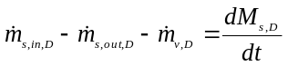 (eq. 5)
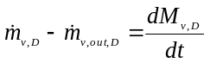 (eq. 6)
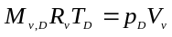 (eq. 7)
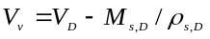 (eq. 8)
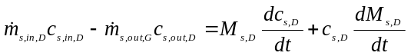 (eq. 9)
(eq. 10)
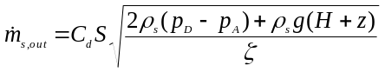 (eq. 11)
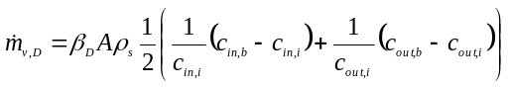 (eq. 12)
Where eq. (1) and eq. (2) are the mass balances in the liquid solution and vapour phases, respectively, eq. (3) the state equation of the vapour, eq. (4) is the volume conservation, eq. (5) and eq. (6) are the LiBr and the energy balance in the liquid solution, respectively, eq. (7) is the momentum balance at the desorber-absorber line (see Köhlenbach and Ziegler (2008)), and eq. (8) is the calculation of the mass transfer rate. A similar set of equations are defined for the absorber, condenser, and evaporator. The heat at the primary and secondary streams are calculated in the following way, respectively:
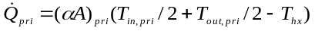 (eq. 13)
(eq. 14)
The volumetric flow of solution is imposed according to solution pump characteristics. The mass transfer rates (eq. 12) are calculated using basic empirical coefficients (Seban, 1978, Jani et al., 2020), taking into account the geometry of a prototype developed (Castro et al, 2020). To calculate the heat and mass transfer rates, LiBr concentrations and temperatures at the interface have been defined (c_{i}, T_{i}). The heat at the interface is related to the mass transfer at the interface through the following relation, assuming thermodynamic equilibrium (McNeely,1979):
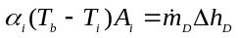,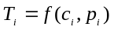 (eq. 15)
Where the interface heat transfer coefficient (α_{i}) is calculated through a Nu/Sh analogy (Yuksel et. al 1987).
Another important component in this system is the fan-coil (air-to-water heat exchanger), used for the conversion of the waste heat from air to water, i. e. the heat transfer fluid from the evaporator of the absorption cooling machine to the process. Condensation may occur in this component, if the temperature drops below the dew point of the air. In fact, this is how the water recovery is achieved. Thus, the fan-coil model should take into consideration such phenomena. Its modelling is based on the methodology proposed by Braun (1988). For the convective heat transfer coefficient between the air and the heat exchanger, the relations proposed by Madi et al. (1998) and Wang et al. (1997) were used for the dry and wet case, respectively. The fan-coil model was previously employed in (Papakokkinos et al., 2021).
- Description of the case study
The case study is an office building (CTTC-UPC facilities) located at Terrassa (Barcelona province, latitude 41.56° N). Fig. 1 shows the plan and elevation views and a picture of the central corridor. There are a total of 15 rooms: 8 for working, i.e., a laboratory, a lunch room, a meeting room, a cluster room, stairs, a central corridor, and a WC. The three latest are not acclimatized; 392 m2 in total. In the working and laboratory rooms, 450 W of heat generation has been included for personal computers, and the presence of occupants, 31 in total, is distributed in the working rooms and at times according to the office schedule (see Souaihi 2017 for details of their characterization). In the central corridor, there is an internal garden, so some moisture generation is accounted for, estimated at 45 liters of water per day. Special mention should be made of the cluster room, which generated about 32 kW of heat, necessitating a special climatization requirement. The facades are glazed, with a double glass in the exterior, an air chamber of about 0.5 width, and a second interior glass. To take into account radiation heat transfer, analytical expressions have been used for calculating the view factors for the parallelepiped rooms.
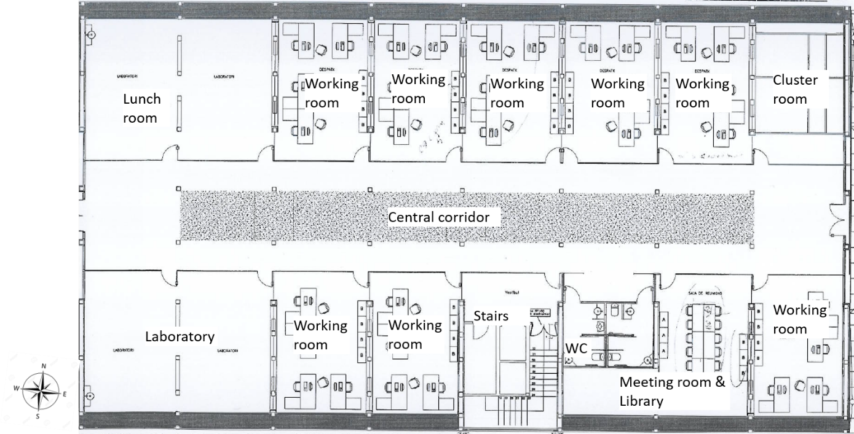

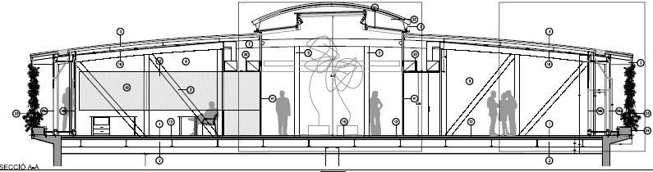
Fig. 1: Plant (top left), picture of the central corridor (top right) and elevation plan (bottom) of the office building at CTTC-UPC facilities
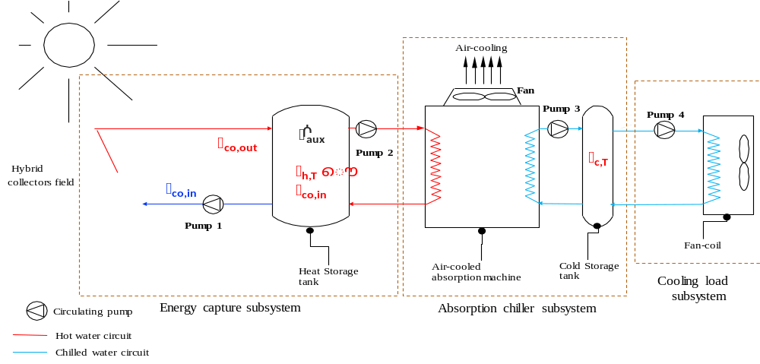
Fig. 2: Polygeneration system studied with the principal control signals, consisting in three parts: i) energy capture systems; ii) absorption chiller subsystem; iii) cooling load subsystem
Fig. 2 shows a scheme of the system object of analysis. It consists of three main parts: i) energy capture systems, i. e., CPVT collector field, and hot water tank; ii) absorption chiller subsystem (in this case direct air-cooled without cooling tower); iii) cooling load subsystem. The data for the absorption chiller is obtained from a 10 kW prototype (Castro et al, 2020), but was scaled to 50 and 60 kW, approximately. The efficiency curves of the CPVT collectors have been extracted from Santos et al, 2025. In the simulations are considered also the case of a high efficiency pure thermal collector (Zheng et al, 2024) for comparison. The meteorological data has been obtained using MeteoNorm software.
Table 1 summarizes the principal data of the case. The hot tank has been sized for energy storage sufficient to supply energy to the absorption chiller during nighttime. Otherwise, the cold tank has been sized according to the absorption chiller's capacity, and the back-up heater has been sized according to the m² solar collector field. The cases simulated for the CPVT and the flat-plate solar collector have different m² (150 vs. 200) to ensure equivalence, given the higher performance of the CPVT.
Table 1 – Main data of the case study
Concept | Data | Units
Solar collector area | 150; 200 | [m²]
Maximum capacity of the absorption chiller | 52; 62 | [kW]
Collector’s transient response (τ) | 5; 1200 | [s]
Collector’s overall efficiency parameter (a₀) | 0.747; 0.715 | [-]
Collector’s overall efficiency parameter (a₁) | -1.283, -2.221 | [Wm⁻²  C⁻¹]
Collector’s overall efficiency parameter (a₂) | -0.0043; -0.0001 | [Wm⁻²  C⁻²]
Collector’s electrical efficiency parameter (b₀) | 0.04; - | [-]
Collector’s electrical efficiency parameter (b₁) | -0.00016; - | [  C⁻¹]
Hot tank volume | 20; 24 | [m³]
Cold tank volume | 5; 6 | [m³]
Back-up heat source | 175; 233 | [kW]
Heat transfer coefficient PV cell – carrier fluid (U) | 1200; - | [Wm⁻²  C⁻¹]
Maximum electrical consumption of auxiliary components | 2480; 2976 | [W]
- Control strategy addressed
  - Energy capture subsystem
The solar collectors are activated/deactivated (pump 1, see Fig. 2) through a differential temperature controller between the input and output of the collector field. Moreover, an overheating protection system based on the disconnection of the solar tracker is applied. This switch is activated by a two-step controller that limits the temperature of the PV cell to 120ºC. In addition to this, the maximum temperature of the hot water tank is limited to 96ºC (deactivating pump 1). On the other hand, the backup heat source is activated for temperatures lower than 75ºC in the hot water tank.
  - Cooling load
For this part of the system, pump 4 is deactivated if the cold water temperature is above 17ºC, i.e., if it is too high to meet the cooling load. Under these periods, it is considered a fail time for the cooling system. Then, pump 4 is reactivated if the cold water temperature is under 13ºC. Moreover, a special strategy is considered for the cluster room, with free cooling in mind. In this room, the mass flow provided by the fan coil depends linearly on the average temperature. In the case of free cooling, an important mass flow equivalent to 75 hourly renewals is required. The external mass flow is opened if the external temperature is below 24ºC (if the ambient is not very humid, with a relative humidity below 80%). It is closed at ambient temperatures above 26ºC.
  - Absorption chiller
The generator pump is activated for temperatures over 75ºC in the hot water tank (activation of pump 2). On the other hand, the chilled water pump (pump 3) is activated when the temperature of the cold water tank is over 8ºC. There are also two emergency controls in the absorption chiller: i) first, crystallization prevention: in this case, the temperature difference between generator and absorber (activation on the fan and pump 3), and between evaporator and condenser (deactivation of pump 2 and fan) is maintained under 40ºC; ii) second, freezing prevention: the temperature of the evaporator is maintained over 2.5ºC (deactivation of pump 2 and activation of pump 3). Partial load operation is controlled through a fuzzy interference rule applied according to the cold tank water temperature, affecting pump 2 and fan (Castro et al, 2024).
- Results
  - Performance indicators
Table 2 shows the principal integrated performance indicators of the system, from left to right (starting at the 5th column): thermal COP (COP_{th}) and electrical COP of the chiller (COP_{el}, i.e. the cooling capacity divided by the electrical consumption of auxiliary components), overall efficiency of the hybrid collector (η), PV modules’ performance (η_{el}, in %), the solar fraction, and finally the fail time percentage, i.e. the time the pump4 is not activated. Cases 1-8 are based on a 1-week simulation (July), cases 9-12 are based also on a 1-week simulation (May), while cases 13-15 on a complete summer season.
Table 2 – Main performance indicators of the cases studied (* means free cooling activated)
Nº Case | Collector area (m²) | Hot tank capacity (m³) | Max. chiller capacity (kW) | Collector type | COP_{th}  (-) | COP_{el} (-) | η  (-) | η_{el}  (%) | Solar Fraction  (-) | Fail time  (%)
1 | 200 | 20 | 52 | Flat Plate | 0.793 | 23.9 | 0.511 | - | 0.639 | 16.0
2 | 150 | 20 | 52 | CPVT | 0.783 | 29.3 | 0.580 | 2.9 | 0.721 | 13.7
3 | 200 | 24 | 62 | Flat Plate | 0.776 | 28.8 | 0.510 | - | 0.627 | 0.0
4 | 150 | 24 | 62 | CPVT | 0.769 | 35.0 | 0.531 | 2.9 | 0.688 | 0.0
5* | 200 | 20 | 52 | Flat Plate | 0.787 | 24.9 | 0.510 | - | 0.655 | 0.0
6* | 150 | 20 | 52 | CPVT | 0.778 | 29.8 | 0.582 | 2.9 | 0.785 | 0.0
7* | 200 | 24 | 62 | Flat Plate | 0.770 | 29.4 | 0.508 | - | 0.646 | 0.0
8* | 150 | 24 | 62 | CPVT | 0.759 | 40.7 | 0.531 | 2.9 | 0.794 | 0.0
9 | 200 | 24 | 62 | Flat Plate | 0.772 | 63.1 | 0.479 | - | 0.628 | 0.0
10 | 150 | 24 | 62 | CPVT | 0.756 | 85.5 | 0.084 | 2.9 | 0.282 | 0.0
11* | 200 | 24 | 62 | Flat Plate | 0.745 | 54.4 | 0.355 | - | 0.764 | 0.0
12* | 150 | 24 | 62 | CPVT | 0.728 | 73.3 | 0.081 | 2.9 | 0.584 | 0.0
13* | 200 | 24 | 62 | Flat Plate | 0.768 | 29.7 | 0.557 | - | 0.577 | 2.7
14* | 150 | 24 | 62 | CPVT | 0.756 | 39.3 | 0.349 | 2.9 | 0.405 | 2.5
15 | 150 | 24 | 62 | CPVT | 0.767 | 40.1 | 0.407 | 2.7 | 0.400 | 2.5
Reviewing overall results, it can be observed that COP_{th} of the absorption chiller is rather independent of the system considered. On the other hand, COP_{el} values are quite high due to the control strategy implemented for the absorption chiller (Castro et al., 2024), which optimizes electrical consumption under partial load. It is also noteworthy that the low electrical performance of the PV modules in the CPVT collector (below 3%) is mainly due to the fact that not all of the area is covered by the PV modules (see Santos et al., 2026, for details).
Two sizes of the absorption chiller have been simulated (52 and 62 kW). After reviewing the results of the 1-week July simulation, it can be concluded that a 52 kW absorption chiller is not sufficient to meet the cooling demand, as a failure time of about 15% was detected (see section 5.2 for details). Adding free cooling to the cluster room has a significant impact by increasing the solar fraction, as the overall cooling demand is reduced (see also section 5.2 for details).
In weekly simulations for May, higher COP_{el} values are observed, as the absorption machine is operating mainly at partial load. For the CPVT solar collector, the solar fraction is lower than that of the flat-plate solar collector because the solar tracker has to be defocused to protect the PV modules, as May has high solar radiation but low cooling demand (see section 5.2 for details). This defocusing of the solar tracker also significantly reduces the integrated collector efficiency.
For complete summer season simulations (May-September, cases 13-16), residual periods of fail time (under 3%) have been detected. For the CPVT collector, a low integrated efficiency is also detected due to the overheating protection strategy for the PV cells. The overheating protection also affects the solar fraction, which is significantly reduced compared with the flat-plate collector. The free cooling slightly improves the solar fraction, as cooling demand is reduced.
  - Detailed assessment
For a detailed assessment, 1-week simulations are analyzed. Fig. 3 shows temperatures of selected rooms (see Fig. 1 for details), hot/cold tanks, and cooling capacity for cases 2 and 4 (see Table 2), which are cases in which the CPVT solar collector is simulated in July. The difference between cases 2 and 4 is the cooling capacity of the absorption chiller. On the other hand, Fig. 4 shows analogous results for a 1-week simulation period in May, which corresponds to cases 10 and 12 (see Table 2), with additional information corresponding to the solar collector field. The difference between case 10 and 12 is the activation of the free cooling for the cluster room, with the same absorption chiller cooling capacity.
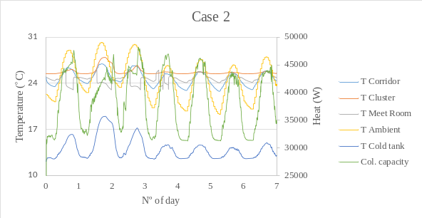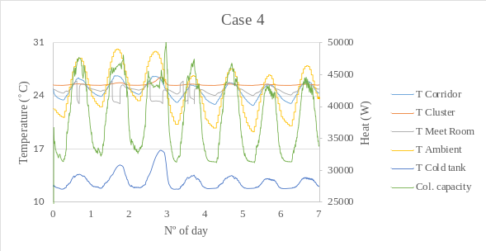
Fig. 3: Detailed results (temperatures and cooling provided) for July weekly simulations (cases 2, left and 4, right)
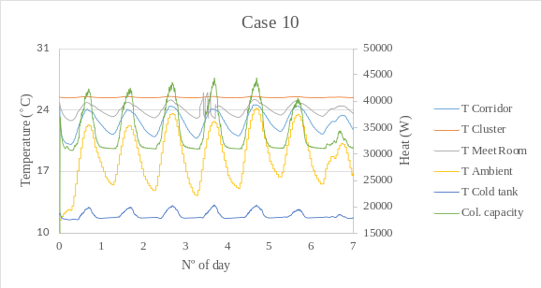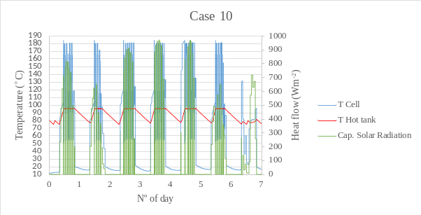
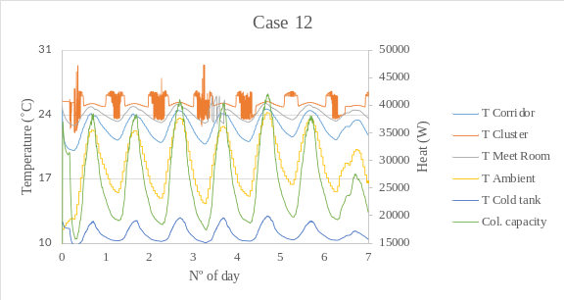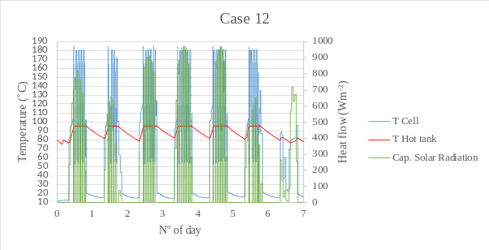

Fig. 4: Detailed results (temperatures and cooling provided) for May weekly simulations (cases 10, up and 12, down)
From the room temperature profiles, it can be observed that when the fan coils are activated, the rooms' temperatures suddenly decrease; see the meeting room's temperature (see Meet Room temperature). In Fig. 3 on the left, some failed time periods can be observed when the cold tank temperature exceeds 17ºC (day 2), affecting room temperatures (e.g., the cluster room) that are at levels of discomfort (over 26ºC). The cooling capacity fluctuates between day and night, maintaining a minimum of 30 kW due to the cluster room climatization requirements. In case 4 (Fig. 3 on the right), with a 62 kW absorption chiller, the cold tank temperature is maintained within limits, eliminating fail time periods.
In May simulations (cases 12 and 14, see Fig. 4), all temperatures are kept within limits because cooling demand is much lower than during July. However, it is remarkable that the solar tracker is continuously switched off (as evidenced by fluctuations in T_{cell}, see graphics on the right) to protect PV modules from overheating. However, due to the short response time (t = 5 s), it is not possible to avoid high stagnation temperatures, as the overall controller is actuating every 60 s. This period in May is especially critical for this aspect due to the high irradiation and low cooling demand. This overheating protection strategy clearly affects the overall energy captured by the system. Therefore, alternative control strategies should be tested in the future.
When cases 12 and 14 are compared, many differences in the results are evident. In case 12, the cluster room temperature is stable, reaching an equilibrium between the cooling load and the cooling provided by the fan coil. This equilibrium can be reached because the fan coil's mass flow rate depends on the room temperature (see section 4.2). Otherwise, in case 14, the temperature of the cluster room fluctuates significantly due to the activation/deactivation of free cooling via differential control. This control strategy is worth improving to avoid temperature peaks. It is also remarkable that the absorption chiller's cooling capacity is significantly reduced while maintaining the cold water tank at lower temperatures.
- Conclusions
In this work, transient simulations over the summer period of a solar-assisted absorption cooling installation have been performed. The cooling load has been simulated using a building model that accounts for the different heat transfer mechanisms (conduction, convection, and radiation) and humidity transport. This model provides average temperature and moisture content results for different rooms, walls, roof, floor, etc. Simulations have been useful as a first step in correctly sizing the installation, i.e., the absorption chiller capacity and the solar collector field. It has been compared between two types of collectors, CPVT and high-performance flat plate, and the influence of the free cooling in a cluster room, with huge cooling demand.
From the simulations, several conclusions can be extracted:
- Compared with the high-performance flat-plate collector, the CPVT collector has a clear advantage in overall efficiency, making it possible to reduce the area of the solar collector field. Further analysis should be conducted from an economic perspective. However, its overall performance is affected by overheating protection of PV modules.
- Free cooling for the cluster room significantly reduces cooling demand, especially in spring and late summer (May and September).
- There is a need for an alternative control strategy (e.g., heat dissipaters) to optimize the performance of the CPVT collector, especially in the springtime, when irradiation is high and cooling demand is low. This will be explored in future actions.
- Future actions
The following points will be developed as future actions:
- Implementation of alternative overheating protection strategies for the PV modules.
- Simulations will be extended to the complete year. Therefore, a control strategy will be implemented to disconnect the absorption chiller from the system during the winter period, thereby supplying heat directly to the solar collectors.
- Alternative configurations for the winter period will be tested, using the absorption chiller as a heat pump to optimize the available solar energy. The use of antifreezing agents in the evaporator will be considered to prevent disconnections in the absorption machine (Zhen et al., 2021).
- An additional relevant point is assessing the influence of the increase in the average ambient temperature due to climate change, estimated at 1.7 ºC in Barcelona, as the MeteoNorm data used do not take this into account.
- Finally, a detailed economic analysis will be conducted, considering the most promising scenarios.
- Acknowledgment
This project has received funding from SOLAR-ERA.NET Cofund 2 joint call undertaking under the European Union’s Horizon 2020 research and innovation programme.
- References
Bandaru, S. H., Becerra, V., Khanna, S., Radulovic, J., Hutchinson, D., Khusainov, R. A Review of Photovoltaic Thermal (PVT) Technology for Residential Applications: Performance Indicators, Progress, and Opportunities (2021). Energies 2021, 14, 3853.
Braun, J. E. (1988). Methodologies for the Design and Control of Central Cooling Plants. PhD thesis, University of Wisconsin - Madison.
Castro, J., Oliva, A., Pérez-Segarra, C. D. and Cadafalch, J. (2007), Evaluation of a Small Capacity, Hot Water Driven, Air-Cooled H₂O-LiBr Absorption Machine, HVAC Research 13 (1) 59-75.
Castro, J., Farnos, J., Papakokkinos, G., Zheng, J. and Oliet, C. (2020). Transient model for the development of an air-cooled LiBr-H₂O absorption chiller based on heat and mass transfer empirical correlations. International Journal of Refrigeration 120, 406-419.
Castro, J., Farnós, J., Papakokkinos, G., Zheng, J., Torras, S. (2024). A multivariable control strategy based on fuzzy logic interference rule for a solar-driven, direct air-cooled H2O-LiBr absorption chiller. Solar Energy 274, 112579.
Churchill, S. W. (1977). Friction-factor equation spans all fluid-flow regimes, Chemical Engineering 84(24) (1977) 91-92.
Coutinho, C. R., Fiorotti, R., Vieira Segatto, M. E., Farias Fardin, J. de Oliveira Rocha, H. R. (2026). Experimental Performance Comparison of a Modular Water-Based Photovoltaic–Thermal System Under Multiple Hydraulic Operating Modes in a Tropical Climate. Sensors 2026, 26, 3108.
Evola, G., Le Pierres, N., Boudehenn, F., Papillon, P. (2013). Proposal and validation of a model for the dynamic simulation of a solar-assisted single stage LiBr-water absorption chiller. International Journal of Refrigeration 36, 1015-1028.
Hosouli, S., Aliakbari, M., Raeisi, F., Jahangir, M. T., Gomes J., Murali, D., Acosta Pazmiño, I. P. Photovoltaic-Thermal (PVT) Solar Collector and System Overview, Energies 2025, 18, 5643.
Jani, S. Simulation of heat and mass transfer process in falling film single tube absorption generator (2012). International Science and Engineering Investigations 1(3):79-84.
Jonas, D., Theis, D. and Frey, G. (2018). Implementation and Experimental Validation of a Photovoltaic-Thermal (PVT) Collector Model in TRNSYS. ISES EuroSun Conference – 12th International Conference on Solar Energy for Buildings and Industry.
Kim N. H., Yun J. H., Webb R. L., Heat Transfer and Friction Correlations for Wavy Plate Fin-and-Tube Heat Exchangers, Journal of Heat Transfer - Transactions of ASME 119(3) (1997) 560—567.
Kohlenbach, P., Ziegler, F. (2008). A dynamic simulation model for transient absorption chiller performance. Part I: The model. International Journal of Refrigeration 31, 217-225.
Lopez, J., Lehmkuhl, O., Damle, R., Rigola, J. (2012). A parallel and object-oriented general purpose code for simulation of multiphysics and multiscale systems. In: Proceedings of the 24th International Conference on Parallel CFD. Atlanta
McNeely, L. (1979). Thermodynamic properties of aqueous solutions of Lithium Bromide, ASHRAE Transactions (85)1:413-434.
Marc, O., Sinama, F., Praene, J., Lucas, F. (2015). Dynamic modelling and experimental validation elements of a 30kw LiBr-H2O single effect absorption chiller for solar application. Applied Thermal Engineering 90, 980-993.
Madi, M.A., Johns, R., Heikal M. (1998). Performance characteristics correlation for round tube and plate finned heat exchangers, Int. J. Refrig. 21 (7) 507–517.
Molepo, P., Ntsiki, T., Mathaba, D., Aboalez, K. (2024). Barriers to the adoption of solar and wind energy technologies: a systematic literature review. International Journal of Energy Sector Management 1–28.
Papakokkinos, G., Castro, J., Capdevila, R., Damle, R. (2021). A comprehensive simulation tool for adsorption-base solar-cooled buildings–Control strategy based on variable cycle duration. Energy and Buildings 231, 110591
Santos, D., Castro, J., Kizildag, D., Rigola, J., and Oliva, A. (2022). Numerical modeling and simulation comparisons of a cost efficient novel CPVT Solar Collector ISES EuroSun Conference – 14th International Conference on Solar Energy for Buildings and Industry.
Seban, R.A. (1978). Transport to falling films. International Heat Transfer Conference, 6th, Toronto, Canada, August 7-11, 1978, Gen. Papers, vol. 6. (A79-43012 18-34), Hemisphere Publishing Corp., 417-428.
Souaihi, O., Multiphysics simulation in buildings, Ph.D. thesis, Universitat Politecnica de Catalunya (2017).
Wang, C., Hsieh, Y., and Lin, Y. (1997). Performance of plate finned tube heat exchangers under dehumidifying conditions. J. Heat Transf., 119(1):109–117.
Yang, Z. Tang, X., Qu, M., Abdelaziz, O. and Gluesenkamp K. (2014). Development of updated absorption simulation software (ABSIM), in: Proceedings of the International Sorption Heat Pump Conference.
Yuksel, M.L. and Schlünder, E.U. (1987). Heat and Mass Transfer in non-isothermal absorption of gases in liquid falling liquid films. Part I: Experimental determination of heat and mass transfer coefficients. Chem. Eng. Process, 22:193-202.
Zheng, J., Castro, J., Oliva, A., Oliet, C. (2021). Energy and exergy analysis of an absorption system with working pairs LiBr-H₂O and Carrol-H₂O at applications of cooling and heating. International Journal of Refrigeration 132, 156-171.
Zheng, J., Febrer, R., Castro, J., Kizildag, D., Rigola, J. (2024). A new high-performance flat plate solar collector. Numerical modelling and experimental validation. Applied Energy 355, 122221.

Symbols

Quantity | Symbol | Unit
Heat transfer coefficient | α | (W m⁻² K⁻¹)
Mass transfer coefficient | β | (m s⁻¹)
Performance | η | (-)
Pressure drop parameter | ζ | (-)
Density | ρ | (kg m⁻³)
Time response | τ | (s)
Area | A | (m²)
Efficiency parameter | a₀ | (-)
Efficiency parameter | a₁ | (m²W⁻¹K⁻¹)
Efficiency parameter | a₂ | (m⁴W⁻²K⁻¹)
Electrical efficiency parameter | b_{k} | (-)
LiBr concentration | c | (-)
Discharge coefficient | C_{d} | (-)
Heat capacity | c_{p} | (J kg⁻¹ K⁻¹)
Gravity acceleration | g | (m s⁻²)
Solar irradiation | G | (W m⁻²)
Specific enthalpy | h | (J kg⁻¹)
Height difference desorber/absorber | H | (m)
Mass | M | (kg)
Mass flow | $$\dot{m}$$ | (kg s⁻¹)
Pressure | p | (Pa)
Captured solar radiation | $$\dot{q}$$ | (W m⁻²)
Heat | $$\dot{Q}$$ | (W)
Section | S | (m²)
Time | t | (s)
Temperature | T | (K)
Specific internal energy | u | (J kg⁻¹)
Volume | V | (m³)
Free surface height at the desorber | z | (m)

Subscripts and superscripts

A | absorber
b | bulk
cell | related to PV cell
co | related to solar collector
el | electrical
D | desorber
hx | heat exchanger
i | interface
in | inlet
loss | related to heat losses
out | outlet
pri | primary
s | solution
sec | secondary
th | thermal
v | vapour

