EuroSun2026
Vacuum-Based Experimental Set-Up and Methodology for Simultaneous Thermal–Electrical Characterization of Hybrid Energy Conversion Devices up to 100 °C
Eliana Gaudino^{1,2}, Annalisa Di Napoli^{1,2}, Enrico Di Natale¹, Mara Pesapane^{1,2}, Alessandro Vitaliano Anacreonte^{1,2}, Benedetta Catalano^{2,3}, Antonio Caldarelli^{4,} Carmine D’Alessandro⁵, Fabio Capolupo^{1,2}, Emiliano Di Gennaro^{2,3}, Roberto Russo², Marilena Musto^{1,2}

Affiliations: ¹ Industrial Engineering Department, University of Napoli “Federico II”, Piazzale Vincenzo Tecchio, 80, 80125 Napoli, Italy
² Institute of Applied Sciences and Intelligent Systems, National Research Council of Italy, via Pietro Castellino 111 80131 Napoli, Italy
³ Physics Department, University of Napoli “Federico II”, Via Cinthia, 21, Napoli, 80126, Italy
⁴CNR-SPIN Napoli, c/o Complesso Universitario di Monte Sant'Angelo - Via Cinthia, 21 - Building 6, 80126, Napoli, Italy
⁵ TVPSOLAR SA, 10 rue du Pr`e-de-la-Fontaine, 1242 Satigny, Geneva Switzerland

Emails: eliana.gaudino@na.isasi.cnr.it; annalisa.dinapoli@na.isasi.cnr.it; en.dinatale@studenti.unina.it; marapesapane@icloud.com; alessandro.anacreonte@na.isasi.cnr.it; benedetta.catalano@na.isasi.cnr.it; antonio.caldarelli@na.isasi.cnr.it; carmine.dalessandro@na.isasi.cnr.it; fabio.capolupo@na.isasi.cnr.it; emiliano.digennaro@unina.it; marilena.musto@unina.it.-
Summary
This work presents the development of a vacuum-based experimental set-up for the simultaneous thermal and electrical characterization of energy conversion devices up to 100 °C under controlled thermo-radiative conditions. The system integrates a stainless-steel vacuum chamber with a calibrated solar simulator (1000 W/m²), enabling repeatable indoor testing with suppressed convective losses. The device under test is mounted on an actively temperature-controlled support, ensuring precise thermal regulation and reduced parasitic effects. Electrical performance is assessed through I–V measurements, while thermal output is quantified using a calibrated thin-film heat flux sensor. The methodology is applied to integrated photovoltaic-thermal (IPVT) devices at different temperatures up to 100 °C. Results show stable operation under prolonged thermal stress and good measurement reproducibility. The proposed approach provides a reliable framework for coupled thermal–electrical characterization of hybrid energy conversion devices in vacuum environments
Keywords: Solar energy, Energy conversion devices, Hybrid Photovoltaic- Thermal collectors, Thermal characterization , Electrical characterization , Vacuum- based characterization
Field of application for the findings: Characterization and testing of hybrid solar energy conversion devices for photovoltaic-thermal (PVT) applications.
Addressed audience: Researchers, engineers, and industry professionals in solar energy. Introduction

- Introduction
The integration of thermal energy recovery into photovoltaic modules has driven the development of photovoltaic–thermal (PV/T) technologies (Diwania et al., 2020), which enable the simultaneous generation of electrical and thermal energy from the same active surface. Within this framework, high-vacuum photovoltaic–thermal (HV-PVT) systems represent an advanced technological evolution designed to drastically reduce convective heat losses and sustain operation at moderate-to-high temperatures, up to 100 °C (Mellor et al., 2018). Unlike conventional PV/T systems, where design strategies typically prioritize electrical performance and treat thermal recovery as a secondary output (Kang et al., 2022; Kramer et al., 2023), HV-PVT concepts are specifically engineered to enhance thermal energy production at elevated temperatures while still maintaining concurrent electricity generation (De Luca et al., 2023a). By operating in a high-vacuum environment, these systems shift the current state of the art in PV/T technology toward applications where medium-temperature heat recovery is a primary objective, expanding their potential use in industrial processes, building integration, and hybrid energy systems (De Luca et al., 2023b). Accurate characterization of HV-IPVT devices requires simultaneous measurement of electrical and thermal outputs under controlled conditions. This presents experimental challenges, including reliable heat flux quantification and precise temperature control to isolate conductive and radiative contributions. To address these issues, this work presents the development and validation of a dedicated experimental setup capable of measuring the I–V characteristics of IPVT devices while simultaneously recording heat flux at controlled operating temperatures up to 100 °C. The setup enables the assessment of both electrical performance and thermal efficiency, providing a comprehensive framework for device evaluation and comparison.
- Methodology
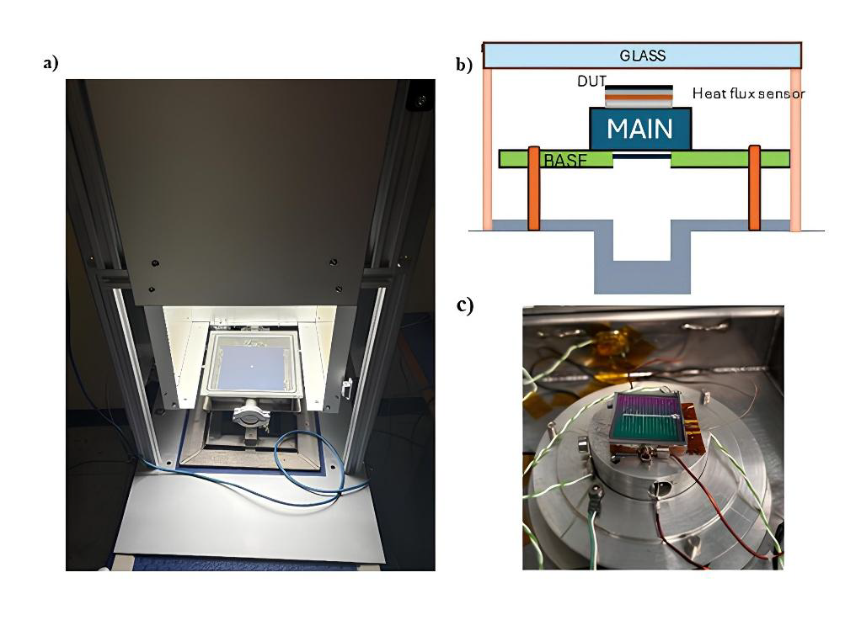
The dedicated experimental setup for the simultaneous electrical and thermal characterization of IPVT devices is designed to reproduce the operating conditions of a photovoltaic-thermal panel under high vacuum and controlled illumination. The system consists of a stainless-steel vacuum chamber (Mini Test Box) capable of reaching pressures below 10⁻⁴ mbar through a dedicated pumping system. The chamber is sealed by a transparent glass window, which enables controlled irradiation of the device under test (DUT). A calibrated solar simulator provides uniform and reproducible irradiance over the DUT, closely replicating standard solar conditions and ensuring a well-defined thermo-radiative operating environment (Fig. 1a). The DUT is mounted on a custom dual-stage support designed to ensure precise thermal control while minimizing parasitic losses. The primary stage consists of a cylindrical aluminum disk with an embedded heater (MAIN), while the secondary stage allows independent adjustment of height and temperature (BASE). A calibrated thin-film heat flux sensor is positioned directly beneath the DUT, with thermal contact ensured through high-conductivity grease enabling accurate measurement of the heat flux delivered by the device (Fig.1 b).
Figure 1: (a) Internal view of the experimental setup featuring the vacuum chamber and calibrated solar simulator; (b) Cross-sectional schematic of the dual-stage support assembly: the DUT is placed on the heat flux sensor embedded in the cylindrical MAIN disk, which is supported by the adjustable BASE; (c) Close-up photograph of the DUT mounted on the MAIN disk, showing electrical connections and thermocouples for simultaneous measurement of electrical output and heat flux.
Electrical contacts are established via a copper block that supports the cell (Fig.1 c). The back of the cell is secured with a thin layer of silver paste while the while the front contact is connected through fine copper wires to the vacuum feedthrough. The copper block is electrically insulated and thermally coupled to the heat flux sensor using thermal conductive silicon paste. This arrangement ensures stable and reliable electrical connections without compromising thermal measurements.
The temperatures of the DUT and surrounding components (glass window, chamber walls, support base, MAIN) are monitored using type-K thermocouples. The heat transferred from the DUT is measured using a thin-film heat flux sensor, whose voltage output is converted into heat flux through prior calibration. Temperature is actively controlled using embedded heaters, allowing the DUT to operate across a range of conditions representative of typical photovoltaic-thermal applications. I–V measurements are performed to evaluate electrical performance, while the heat flux is simultaneously monitored to quantify thermal output. Thermal efficiency is derived from the measured heat flux, corrected for system-related losses, and normalized to the incident solar irradiance, providing an accurate assessment of device performance under realistic conditions.
The experimental setup was validated using a reference IPVT cell, demonstrating reproducibility, stable operation, and reliable integration of electrical and thermal measurements. This methodology establishes a robust framework for comprehensive characterization of high-vacuum photovoltaic-thermal devices.
- Results
A reference silicon-based IPVT device was experimentally characterized through simultaneous electrical and thermal measurements to evaluate its performance under controlled operating conditions. Measurements were performed at different cell temperatures, namely room temperature (RT), 60 °C, 80 °C, and 100 °C, while the heat flux transferred from the device was continuously monitored using a calibrated thin-film heat flux sensor.
During the tests, the device under test (DUT) was illuminated using a solar simulator with an incident irradiance of 1000 W/m² and heated by means of integrated heaters located at the base and main support. The heaters were operated until the target temperature was reached and stable thermal conditions were established. Initially, an I–V characterization was performed at room temperature to determine the baseline electrical performance of the reference cell. Subsequently, the DUT was heated to the selected temperature setpoints. Once thermal equilibrium was reached, a second I–V measurement was performed at each temperature to determine the corresponding maximum power point (MPP). The DUT was then operated at the MPP voltage, while the heat flux was continuously monitored under steady-state conditions.
Figure 2a presents the measured current–voltage (I–V) characteristics and the corresponding power–voltage (P–V) curves of the reference IPVT cell at the investigated temperatures. As expected for a silicon photovoltaic device, increasing the cell temperature results in a progressive reduction in electrical performance. In particular (see Tab.1), the open-circuit voltage decreases from 710 mV at room temperature to 570 mV at 100 °C, while the maximum power decreases from 65.6 mW to 51.2 mW. The short-circuit current remains comparatively stable over the investigated temperature range, varying between 149 mA and 147 mA. The electrical parameters of the IPVT cell, including the electrical efficiency (η_{el}), maximum power (P_{max}), open-circuit voltage (V_{OC}), short-circuit current (I_{SC}), and fill factor (FF), were extracted from the measured I–V characteristics and are reported in Table 1.
The electrical efficiency decreases from 18% at room temperature to 14% at 100 °C, confirming the expected temperature dependence of the photovoltaic conversion efficiency. The reduction in maximum power is mainly associated with the decrease in open-circuit voltage at increasing temperature, whereas the relatively limited variation in short-circuit current indicates that the photocurrent is only weakly affected within the investigated temperature range. The fill factor remains relatively stable, ranging from 61.3% to 63.6%, indicating that the main temperature-induced degradation in electrical performance is associated with the reduction in voltage.
Figure 2b shows a representative time-resolved measurement for the reference IPVT cell operated at a setpoint temperature of 100 °C. The temperature of the cell and surrounding components, together with the heat flux, were continuously monitored throughout the experiment. The blue, purple, and green curves represent the cell, glass, and base temperatures, respectively, while the red curve corresponds to the measured heat flux. The yellow shaded region indicates the period during which the I–V characterization was performed, whereas the green shaded region corresponds to subsequent operation at the electrical MPP. The figure shows that, following the thermal transient associated with the I–V measurement, the heat flux reaches a relatively stable value during MPP operation, demonstrating the capability of the experimental setup to simultaneously monitor the electrical and thermal behavior of the device under controlled conditions.
The heat flux, $q$, was calculated from the output voltage of the thin-film heat flux sensor, $V_{HFS}$, according to:
$q \left(W/m^{2}\right)= \frac{VHFS}{Ct }$; $(eq.1)$
where $C_{t}$ is the calibration sensitivity of the heat flux sensor. The thermal efficiency was subsequently calculated from the measured heat flux and the incident solar irradiance, taking into account the relevant system-related thermal losses. The resulting thermal efficiency at 100 °C during electrical MPP operation was 31%.
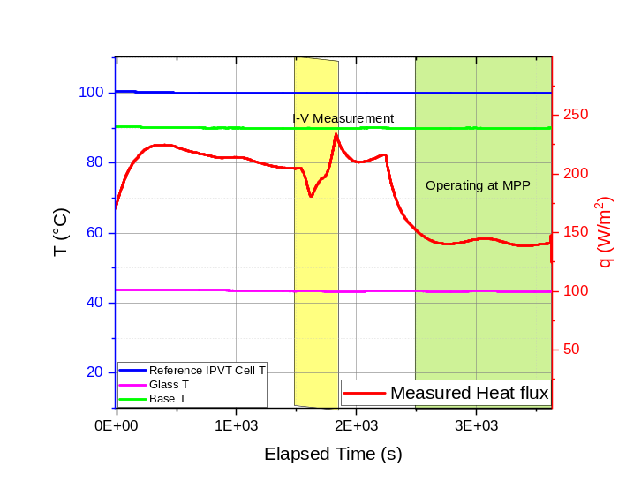
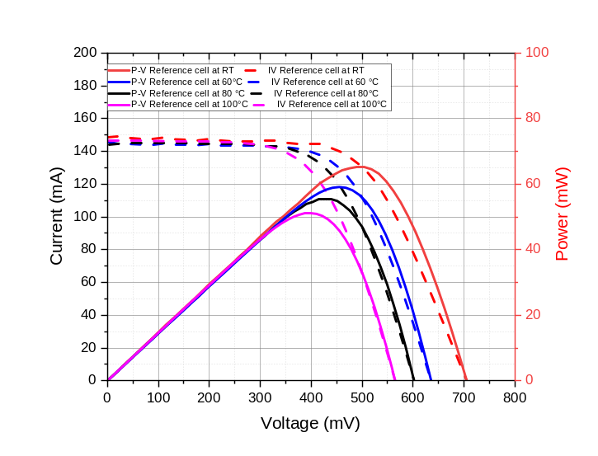
a)
b)
Table 1 Electrical performance parameters of the investigated IPVT device measured at different operating temperatures (from room temperature RT to 100 °C).
IPVT cell | T(°C) | η_{el} | P_{max}(mW) | V_{OC} (mV) | I_{SC} (mA) | FF
Reference cell | RT | 18 % | 65.6 | 710 | 149 | 61.5 %
Reference cell | 60 | 16 % | 59.2 | 635 | 147 | 63.3 %
Reference cell | 80 | 15% | 55.5 | 602 | 145 | 63.6 %
Reference cell | 100 | 14% | 51.2 | 570 | 147 | 61.3%
Figure 2: (a) Current-voltage (I–V) and power-voltage (P–V) characteristics of the silicon-based reference IPVT cell measured at different temperatures (room temperature, 60 °C, 80 °C, 100 °C); (b) Example time-resolved measurement of cell temperature (blue), glass temperature (purple), base temperature (green), and collected heat flux (red) at a setpoint temperature of 100 °C. The highlighted areas indicate the periods of I–V characterization (yellow) and operation at the Maximum Power Point (MPP) (green).

- Conclusions

A dedicated high-vacuum experimental setup was developed for the controlled characterization and optimization of integrated photovoltaic devices intended for the realization of high-vacuum photovoltaic–thermal (HV-PVT) panels. The platform combines controlled solar-simulator illumination with active cell-temperature regulation, enabling the electrical and thermal response of the devices to be systematically investigated as a function of both temperature and irradiance up to 100°C. A key feature is the simultaneous measurement of electrical output and thermal recovery under the same operating conditions, including operation at the maximum power point (MPP). The reference IPVT measurements confirm the expected temperature dependence of the electrical performance and demonstrate a thermal efficiency of 31% at 100 °C. The high-vacuum environment further improves the control of the thermal boundary conditions by strongly suppressing convective heat transfer from the surrounding air, enabling a more accurate assessment of thermal recovery. Overall, the proposed setup provides a controlled and reproducible experimental tool for optimizing integrated devices and identifying suitable operating conditions for their subsequent integration into HV-PVT panels, supporting the development of efficient medium- and high-temperature solar-energy systems.
- Acknowledgements
The authors thank Vitaliano Tufano and Mauro Feliù for their technical support during the preparation of the experimental set-up. They also acknowledge Prof. Umberto Scotti di Uccio for stimulating scientific discussions, Paolo Strazzullo for his initial contribution to the early stages of the work, and Domenico Passaro for technical support in the development of the data acquisition system.
This research was partially supported by the Italian Ministry of University and Research (MUR) under the EECOPVT project (Project Code P2022L7X9R, CUP E53D23018410001).
- References
De Luca, D., Caldarelli, A., Gaudino, E., Di Gennaro, E., Musto, M., Russo, R., 2023a. Modeling of energy and exergy efficiencies in high vacuum flat plate photovoltaic–thermal (PV–T) collectors. Energy Reports 9, 1044–1055. https://doi.org/10.1016/j.egyr.2022.11.152
De Luca, D., Strazzullo, P., Di Gennaro, E., Caldarelli, A., Gaudino, E., Musto, M., Russo, R., 2023b. High vacuum flat plate photovoltaic-thermal (HV PV-T) collectors: Efficiency analysis. Applied Energy 352, 121895. https://doi.org/10.1016/j.apenergy.2023.121895
Diwania, S., Agrawal, S., Siddiqui, A.S., Singh, S., 2020. Photovoltaic–thermal (PV/T) technology: a comprehensive review on applications and its advancement. Int J Energy Environ Eng 11, 33–54. https://doi.org/10.1007/s40095-019-00327-y
Kang, A., Korolija, I., Rovas, D., 2022. Photovoltaic Thermal District Heating: A review of the current status, opportunities and prospects. Applied Thermal Engineering 217, 119051. https://doi.org/10.1016/j.applthermaleng.2022.119051
Kramer, K.S., Mehnert, S., Munz, G., Helmling, S., Lämmle, M., 2023. Photovoltaic Thermal Technology Collectors, Systems, and Applications. Energy Tech 11, 2300378. https://doi.org/10.1002/ente.202300378
Mellor, A., Alonso Alvarez, D., Guarracino, I., Ramos, A., Riverola Lacasta, A., Ferre Llin, L., Murrell, A.J., Paul, D.J., Chemisana, D., Markides, C.N., Ekins-Daukes, N.J., 2018. Roadmap for the next-generation of hybrid photovoltaic-thermal solar energy collectors. Solar Energy 174, 386–398. https://doi.org/10.1016/j.solener.2018.09.004

