EuroSun2026
PVT NEXUS – RESEARCH NETWORK ON PHOTOVOLTAIC-THERMAL TECHNOLOGIES AND SYSTEMS
Gintare Vilke¹, Ivan Acosta-Pazmiño^{1*}
¹MG Sustainable Engineering AB, 753 21 Uppsala, Sweden
*Corresponding author: ivan@mgsust.com
Summary
PVT Nexus – the Research Network on Photovoltaic-Thermal (PVT) Technologies and Systems was established within the PVT4EU project to address the fragmentation of PVT research and strengthen collaboration across disciplines, institutions, and countries. At its core, the initiative is built around a structured mentorship program designed to support early-stage researchers, helping them develop technical expertise, expand professional networks, and contribute meaningfully to the advancement of PVT technologies. By connecting master's and doctoral students with experienced mentors from academia and industry, PVT Nexus fosters a collaborative environment that accelerates learning, encourages interdisciplinary exchange, and nurtures the next generation of PVT specialists.
In parallel, PVT Nexus collaborates with IEA SHC Task 73 – ‘PVT Heating Systems’ to enhance visibility and coordination within the broader international PVT community. Through this collaboration, the network contributes to shared activities such as the Research and Infrastructure Radar, which maps categorized PVT-related research and available infrastructure worldwide. This combined effort strengthens knowledge exchange, highlights emerging trends, and supports evidence-based decision-making, while ensuring that early-stage research gains visibility within an international context. Together, these activities position PVT Nexus as a central platform for mentorship, collaboration, and strategic knowledge mapping in the evolving PVT research landscape.
Photovoltaic thermal, research network, mentorship program, research, and infrastructure.
Field of application for the findings: General audience working in PVT technologies and systems.
Addressed audience: academia within the PVT research field, industry stakeholders, policy/decision makers, and stakeholders involved in renewable energy integration.
- Introduction
Photovoltaic-thermal (PVT) systems offer a unique opportunity to simultaneously generate renewable electricity and thermal energy from a single collector (Herrando, 2023). Since the 1970s, PVT systems have marked an important evolution in solar energy; however, despite their strong potential, PVT technologies remain underutilized and relatively unknown in many regions worldwide (Chow, 2010). Bridging this knowledge and awareness gap is crucial to unlocking the role of PVT in the global energy transition. Because the long-standing barriers inhibiting this technology are not only economic but also deeply educational, systematic efforts to increase awareness of PVT systems should begin at early educational stages (PVT4EUb, 2026).
A key challenge is that PVT research remains highly fragmented, with activities dispersed across different disciplines, countries, and technology approaches. This fragmentation limits knowledge exchange, slows innovation, and reduces opportunities for cross-fertilization between research groups working on complementary aspects of PVT design, modelling, testing, and deployment. Strengthening collaboration and creating shared structures for visibility is therefore essential for accelerating technological progress and increasing global awareness, responding to the technology-awareness gaps highlighted by a previous task cycle IEA SHC Task 60 Application of PVT Collectors (IEA SHC, 2021). To address these challenges, the PVT Nexus, a dedicated Research Network on Photovoltaic Thermal Technologies and Systems, was established in August 2025 within the framework of the EU-funded PVT4EU project (PVT4EUa, 2026).
The initiative is designed to connect and empower the PVT community by fostering collaboration, knowledge exchange, and long-term scientific development. The network brings together early-stage researchers (ESRs) working on PVT technologies and links them with experienced mentors from academia and industry, creating a supportive environment for scientific growth, skills development, and career advancement.
Beyond mentorship, PVT Nexus serves as a central hub for mapping and understanding the evolving PVT research landscape, helping to reduce fragmentation and strengthen connections across research groups worldwide. A collaboration with IEA SHC Task 73 – “PVT Heating Systems” has been established to enable PVT Nexus to contribute directly to the work of the Task (IEA SHC Task 73, 2025). This initiative also addresses technology awareness challenges identified by IEA SHC Task 60 (Technology position paper, 2020).
The PVT Nexus also serves as a strategic catalyst to strengthen global collaboration within the PVT community, fostering the co-creation of innovative project proposals and driving technological advancements both within and outside the European Union.
- Methodology
The PVT Nexus initiative is designed to bridge the gap between ESRs and experienced mentors, creating a collaborative framework to advance PVT technologies. By establishing a structured ecosystem for knowledge exchange and mutual support, the network aims to accelerate technical innovation and stimulate market uptake across Europe and beyondtionalize these objectives, the initiative is structured into five core pillars: (i) a mentorship program and membership framework, (ii) a centralized digital collaboration platform, (iii) a comprehensive research and infrastructure mapping tool, (iv) coordinated sync activities, and (v) dissemination strategy and community outreach.
The overarching execution of these five pillars relies heavily on international institutional synergy and dedicated regional project backing. Strategically synchronized with the global working groups of IEA SHC Task 73, data aggregated through the network directly feeds into subtasks to ensure local insights contribute to international standardization. While IEA SHC Task 73 provides this global scientific context, the EU-funded PVT4EU project serves as the concrete execution and funding vehicle. PVT4EU provides the financial resources and administrative support required to build the digital platform, maintain the mentorship architecture, and deploy the collaborative tools. This dual approach ensures the initiative achieves global relevance while maintaining actionable execution within European solar energy networks. The operational components and structural details of these five pillars are elaborated in the following subsections.
2.1. A mentorship program and membership framework
Participation in the mentorship program requires a formal application process, open to both established mentors and Early-Stage Researchers (ESRs) acting as mentees. The Mentee profile is defined as an ESR who is an MSc or PhD student, or a researcher within two years of completing their degree. Applicants to the PVT Nexus mentorship program must submit a CV and a motivation letter, along with relevant information about their research topic and approach related to PVT technologies. Meanwhile, Mentors provide information about their field of expertise and preferred time availability for collaboration. Overall, the mentorship program is structured into 6-month periods, each followed by a corresponding application phase.
After completing the application process, accepted applicants receive all necessary information and instructions to begin the matchmaking process before starting mentorship. To ensure meaningful collaboration, the matching process is based on clearly defined research approaches that reflect the main thematic areas within PVT development. These include materials and manufacturing for PVT collectors, performance modelling and simulation, integration with heat pumps and district heating, solar heat for industrial processes (SHIP), policy, market development and business models, and life cycle assessment (LCA). Each mentee indicates the research approach most relevant to their current work or training needs, while mentors identify the areas in which they could provide guidance and expertise. Using these thematic areas, mentees submit their expression of interest for up to five mentors they would like to be mentored by. Meanwhile, mentors then select up to two mentees they would like to mentor.

After the matchmaking between Mentors and Mentees, individual meetings, ideally once per month, are scheduled to discuss research topics and initiate collaboration. For each meeting, the mentee completes meeting minutes, ensuring a clear record of the discussion that supports continuity in future conversations and topic development.
The overall approach allows the mentorship program to create targeted, topic-specific collaborations and ensures that the interactions are technically relevant, well-focused, and beneficial for both sides. Mentorship sessions are designed to complement, not replace, the supervision activities of institutional supervisors. Students must inform their supervisors about their participation in the mentorship program and maintain clear, timely communication with all involved parties.
The third option for joining the network is to become a PVT Nexus member, which means not being a part of the mentorship but being engaged in a collaborative space where one can exchange expertise, develop joint funding proposals, stay informed about the latest PVT research, and participate in an international community advancing PVT technology across Europe and beyond. To join as a member, individuals complete an application providing relevant information about their field of expertise, interest in selected activities, and availability for collaboration and networking (PVT Nexus, 2026). Members are also encouraged to provide relevant data for the Research and Infrastructure Radar described below in section 2.3.
2.2. A centralised digital collaboration platform
A centralised digital collaboration platform - the PVT Nexus platform, hosted on MS Teams, serves as a dedicated environment for communication, collaboration, and knowledge exchange among participants. The platform includes separate channels for Members, Mentors, and Mentees, each containing the corresponding group’s profiles and enabling targeted interaction within and across these groups, as shown in Figure 1.

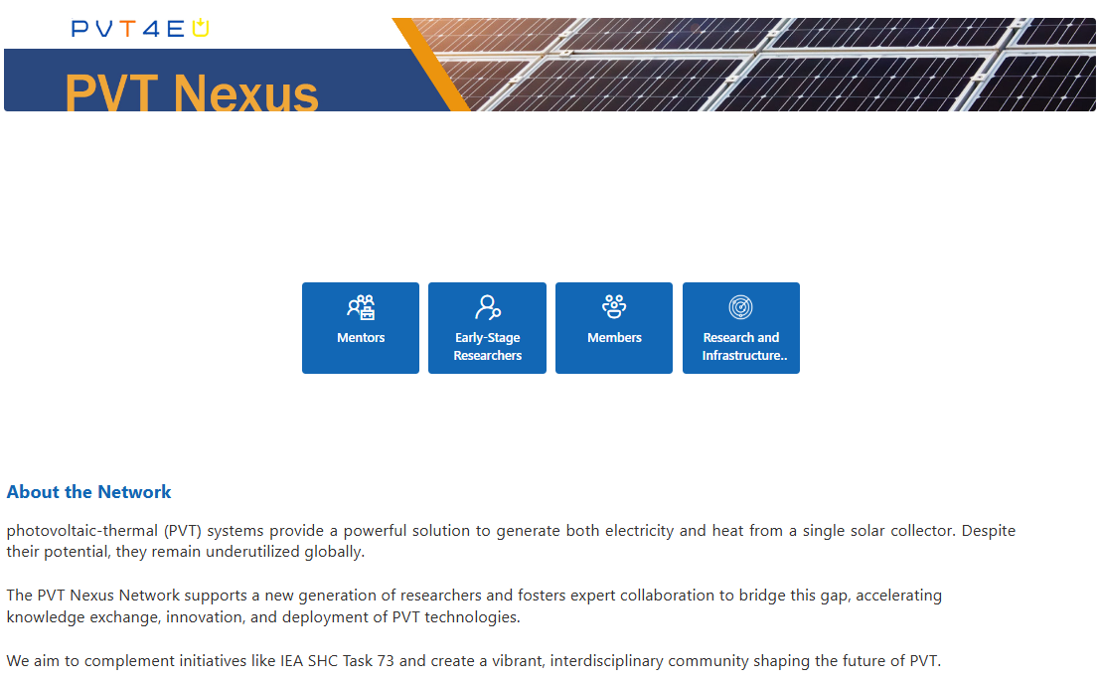
Fig. 1: PVT Nexus platform on MS Teams
Every Member, Mentor, and Mentee has an individual profile (Figure 2) with relevant professional and research information, making it easier to identify expertise, connect with peers, and initiate collaboration. During matchmaking in the mentorship program, mentees submit expressions of interest to different mentors (up to five) using mentors' profile cards.

Fig. 2: Example of PVT Nexus Mentor’s, Mentee’s or Member’s profile card
The integrated calendar on the platform supports the scheduling of mentorship meetings and allows organizers to monitor progress throughout each mentorship cycle. A shared files space provides a central repository for presentations, documents, and other materials, ensuring that key resources remain accessible to all participants.
2.3. A comprehensive research and infrastructure mapping tool – PVT Nexus Research and Infrastructure Radar
A dedicated channel (Figure 3) has been established for the Research and Infrastructure Radar, an initiative designed to complement IEA SHC Task 73 “PVT Heating Systems”, specifically Subtask C: PVT Awareness and Policy. This channel provides a structured space to systematically collect and organise information from PVT Nexus members and make it available initially to members and ultimately to the PVT community worldwide, leveraging the dissemination channels of Task 73 to maximise its outreach
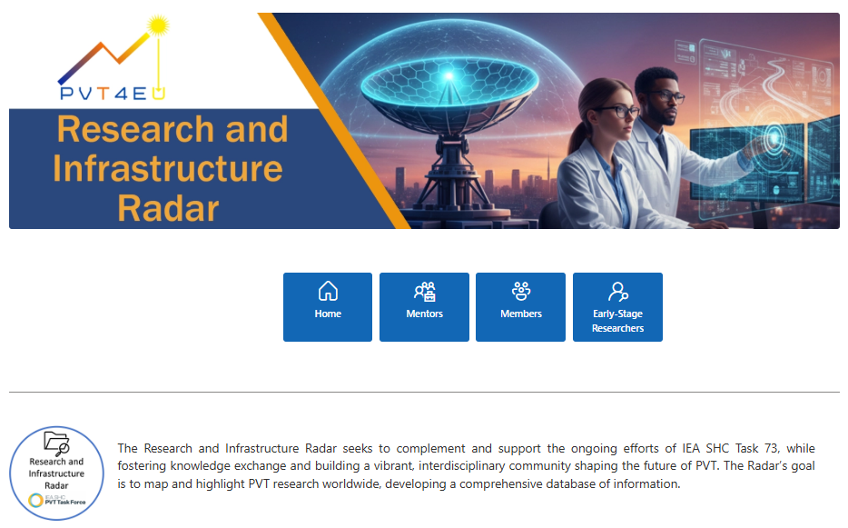
Fig. 3: A channel on the PVT Nexus MS Teams platform dedicated to collecting relevant information from members for the Research and Infrastructure Radar
The Radar maps both ongoing and completed research activities related to PVT technologies, capturing details such as research themes, methodological approaches, and geographical distribution across participating institutions. In addition, it compiles information on available research infrastructures, including laboratories, test facilities, demonstration sites, and specialised equipment that support PVT development. By consolidating these inputs, the Radar provides a comprehensive overview of the current PVT research landscape and highlights opportunities for collaboration, knowledge exchange, and resource sharing within the network, addressing research fragmentation in the field.
This structured approach not only increases visibility of PVT-related work but also supports evidence-based decision-making and contributes to the broader objectives of Task 73 by strengthening awareness, accessibility, and international coordination in the PVT field.
2.4. Coordinated sync activities
Regular coordination meetings are a core methodological element of PVT Nexus, ensuring structured communication, progress monitoring, and alignment across the network. General meetings are scheduled every four months, bringing together all members to review the status of the mentorship program, discuss ongoing activities, and outline future steps for network development. These meetings provide a platform for assessing collective progress, exchanging experiences, and identifying emerging needs within the community.
Alongside these general gatherings, PVT Nexus conducts round-specific introductory sessions at the start of each mentorship round. These sessions are designed to onboard newly accepted mentees, introduce the rules and expectations of the mentorship program, and clarify the structure of the six-month cycle. A key component of these introductory meetings is familiarizing participants with the PVT Nexus MS Teams platform, including navigation through dedicated channels for Members and Mentors, and use of the integrated calendar for scheduling mentorship meetings. A particular emphasis is placed on completing the required fields for the Research and Infrastructure Radar, as gathering comprehensive and up-to-date information is essential for mapping ongoing research activities and available infrastructures across participating institutions. Highlighting this requirement early in the process ensures higher data completeness and supports the Radar’s role as a shared knowledge resource. This structured onboarding ensures that all participants can effectively use the platform’s features and fully engage in the program. Meanwhile, the Nexus is primarily organized and managed mainly by its members to minimize administrative workload and ensure long-term sustainability.
2.5. Dissemination strategy and community outreach
As PVT Nexus was established within the framework of the PVT4EU project, dissemination activities have been carried out through the project’s existing communication channels. The project’s LinkedIn page and website (Figure 3) serve as the primary outlets for sharing updates, announcing opportunities, and communicating progress related to the network. These channels ensure continuous visibility and enable outreach to researchers, institutions, and stakeholders engaged in solar thermal and PVT technologies.
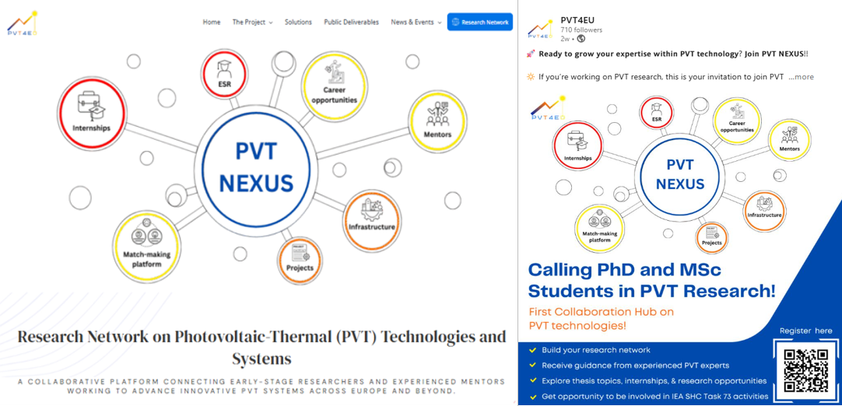
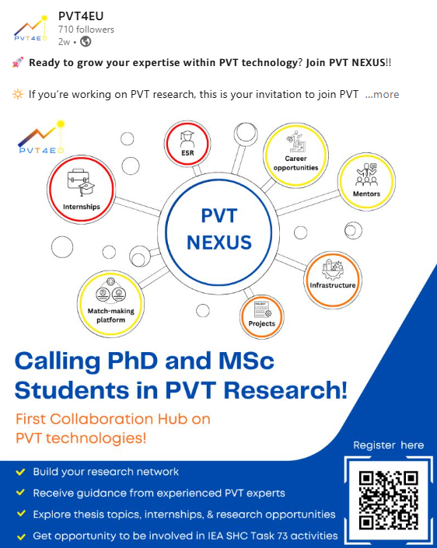
Fig. 4: PVT Nexus section on PVT4EU website (left) and on PVT4EU LinkedIn page (right).
In addition to online dissemination, information about PVT Nexus has been integrated into project-related events. Workshops organised by the PVT4EU project regularly included short presentations introducing the network, its objectives, and participation pathways. Furthermore, as part of IEA SHC Task 73, PVT Nexus is present at the Task’s regular meetings, allowing the initiative to reach an international community already active in PVT heating systems research.
Furthermore, PVT Nexus has been featured in several press releases, including the International Solar Energy Society’s article announcing the launch of the initiative (ISES, 2025) and news published by Solar Thermal World presenting PVT Nexus through the PVT4EU project (Solar Thermal World, 2025). An article about PVT Nexus has also been published by We Don't Have Time - the global climate-action network and media platform (We Don't Have Time, 2026).
Mentors also play a key role in dissemination. Through their affiliations with universities and research institutions, mentors help raise awareness of PVT Nexus among early-stage researchers, promote the advantages of participating in the mentorship program, and encourage new applicants. This peer-driven outreach strengthens the network’s visibility within academic environments and supports the continuous expansion of the mentorship cohort.
Together, these dissemination actions increase awareness of PVT Nexus and support the onboarding of new members, early-stage researchers, and mentors. This coordinated approach strengthens the network’s visibility and facilitates its continued growth within the broader PVT research landscape.
- Results, Discussion and Future Work
3.1. Mentorship progress
PVT Nexus was officially launched on 27th August 2025. The first application period closed on 1st October 2025 and resulted in a strong initial group of members, including 22 Mentors (4 women and 18 men) and 15 ESRs. The first mentorship round inspired five mentees to continue with the program and thus to reapply for the second round. Furthermore, a strong highlight of the PVT Nexus success is an arranged research stay for 2 months for a mentee- Ph.D. student in one of the mentors’ research institutions–the National Laboratory of Energy and Geology in Portugal to explore a certified laboratory for PVT testing, get involved in performance characterization activities of a PVT collector and learn about European testing standards like ISO 9806 (Figure 5).

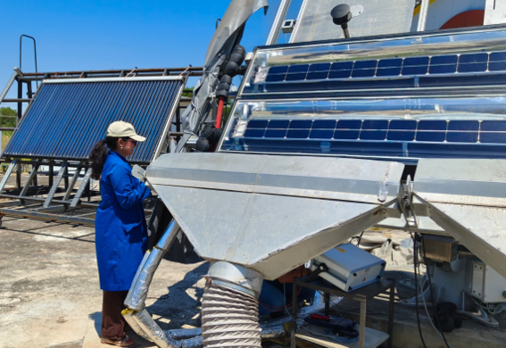
Fig. 5: PVT Nexus mentee’s research stay in LNEG. Performance characterization of a low-concentrating PVT collector.

The second mentorship round (April - September 2026) brought together 23 mentors and 11 mentees (2 women and 9 men), resulting in one confirmed 6-month Research stay (starting in October 2026) at MG Sustainable Engineering in Sweden for a Master's student at the University of Padua. The student will participate in the European project SPECTRUM, where the primary objective is to develop an exergoeconomic model to evaluate the economic viability of innovative polygenerating solar collectors. Both research stays have been supported by the Erasmus+ Programme aimed to send students and staff abroad to study, teach, or train at participating institutions, or to take part in a traineeship (Erasmus+, 2025).
Across both mentorship rounds, PVT Nexus meetings were held to update all members on the progress of the mentorship program, the development of the Research and Infrastructure Radar, and to discuss future steps and emerging collaboration opportunities.
The structural evolution and quantitative performance metrics of the first two consecutive PVT Nexus mentorship cycles are summarized in Table 1.

Tab. 1: Operational Metrics and Performance Comparison Across PVT Nexus Mentorship Cycles.
Metric | Round 1 (Oct 2025 – Mar 2026) | Round 2 (Apr – Sep 2026)
Active Mentors | 22 | 23
Total ESRs: | 15 | 11
- M.Sc. Students | 7 | 8
- Ph.D. Candidates | 8 | 3
Completed Mentorship Meetings | 13 | 16
Program Retention (Re-applicants) | — | 5 Mentees (from Round 1)
International Academic Mobility | 1 Research stay (2 months at LNEG, Portugal) | 1 Research stay (6 months in Sweden)
General Network Assemblies | 3 Plenary Meetings (Across both cycles)
During the initial two rounds of mentorship, the program implemented modifications based on lessons learned and feedback received from both mentees and mentors. For example, after the first round, the thematic research areas (described in Section 2.1) were unified for both mentees and mentors to streamline the matchmaking process. Additionally, in response to mentors’ feedback, meeting minutes were incorporated into the second round to document and track the topics discussed during mentorship meetings, ensuring continuity and consistency between mentor and mentee.
3.2. Research and Infrastructure Radar
The Research Radar findings, gathered from all PVT Nexus members over the previous ten months following the deployment of the Radar, delineate a swiftly growing and geographically diverse spectrum of PVT research endeavours. (Figure 6). With 22 projects across 9 countries, the network demonstrates a solid international footprint, although participation remains concentrated in Europe. This distribution suggests that PVT research is gaining traction globally but still has significant potential for broader regional engagement.
Data from PVT Nexus members show that master's theses (36.36%) and institutional research projects (27.27%) form the backbone of current activity. This indicates that PVT research is strongly driven by early-career researchers and academic institutions, reflecting both educational interest and the accessibility of PVT topics for student-led work. The relatively smaller share of PhD theses (18.18%) and academic research projects (13.64%) suggests that long-term, high-depth investigations are less common, pointing to an opportunity for strengthening advanced research pathways within the network.
The thematic distribution highlights where research capacity is currently strongest. Modelling and monitoring (11 projects) and PVT liquid systems (10 projects) dominate the landscape, reflecting a focus on performance optimisation and hydronic applications. In contrast, materials and manufacturing (4 projects) and market, awareness, and policy (3 projects) remain underrepresented, and PVT air systems appear only once. These gaps indicate that while technical modelling is well established, socio-economic aspects and alternative technological pathways require more systematic attention to support broader deployment.
The Funding Scheme radar shows that local funding is the dominant source, with 6 projects (50%) supported at the local level. European funding accounts for 5 projects (41.67%), while regional funding is limited to 1 project (8.33%). This distribution indicates that PVT activities are already anchored in local contexts such as municipalities, local utilities, or local programs. At the same time, the strong share of European funding highlights that PVT is recognised within broader EU research and innovation agendas. The very small regional share suggests that intermediate governance levels (regions, provinces) are not yet systematically mobilised for PVT, which may represent an untapped opportunity for future program design and network engagement.

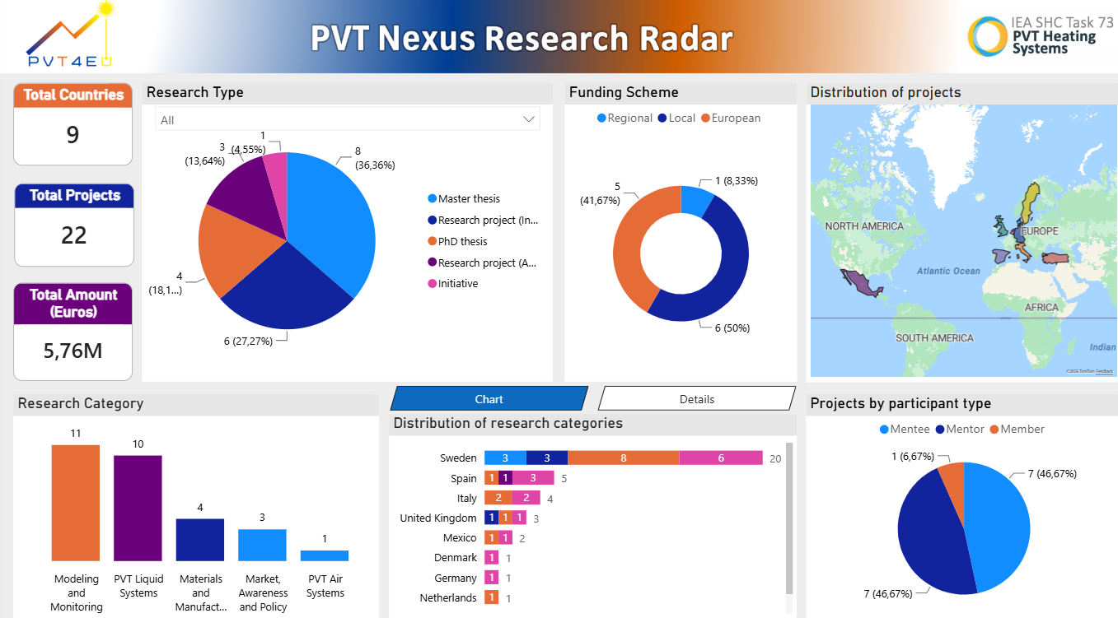
Fig. 6: PVT Nexus Research Radar Dashboard
The participant structure, equal numbers of mentors and mentees (46.67% each), demonstrates that the network functions not only as a research mapping tool but also as a capacity-building infrastructure. The small share of general members (6.67%) suggests that the network is still expanding and has significant potential to grow.
The PVT Nexus Infrastructure Radar (Figure 7) identifies 12 infrastructures across 9 countries, showing that the network already has a solid physical base for both research and real-world testing. Most infrastructures are pilot sites (67%), indicating that PVT technologies are increasingly being validated under operational conditions rather than only in laboratory environments. Labs represent 33%, mainly hosted by universities, which confirms the strong academic foundation of the network.
The geographical spread is broad but balanced: countries such as Spain and Sweden host two pilot sites each, while others maintain a combination of one lab and one pilot site. This decentralised distribution supports cross-country learning and ensures that no single country dominates the infrastructure landscape.
Universities lead institutional participation (41.67%), followed by industry (33.33%) and research institutes (25%). The strong academic presence drives experimentation and early-stage innovation, while industry involvement, especially in pilot sites, signals growing interest in commercial validation and future deployment.

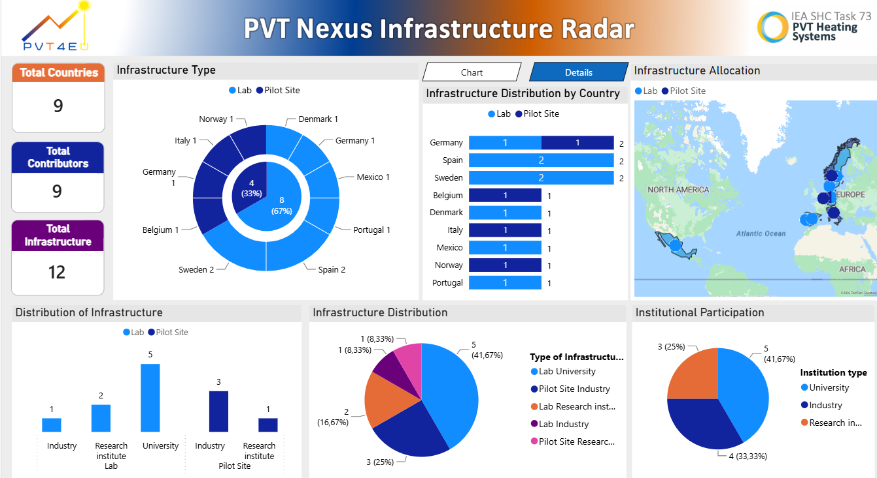
Fig. 7: PVT Nexus Infrastructure Radar Dashboard
Overall, the infrastructure radar shows a network that combines academic research capacity with practical testing environments, positioning PVT Nexus as an effective connector between researchers and real‑world practice to accelerate technology development, validation, and future scale‑up.
It is important to emphasize that these preliminary conclusions are derived from the data collected thus far through the radar methodology. However, given the limited number of responses and participation at this early stage of the initiative, these findings may not fully represent the broader reality or overall trends. Therefore, caution should be exercised in interpreting these results until further data can be gathered to substantiate or refine these initial insights.
3.3. Contribution to IEA SHC Task 73
The operational integration between the PVT Nexus initiative and the international working groups of IEA SHC Task 73 yielded concrete data products and methodological insights during its first two cycles. A primary milestone contributing directly to Subtask C (Awareness and Policy) was the successful development and deployment of the Research and Infrastructure Radar. This specialized mapping tool successfully identified, cataloged, and visualized global PVT research projects, networks, commercial laboratories, and institutional infrastructure capacities. By serving as an open decision-support mechanism, the radar enables policymakers and industrial stakeholders to easily pinpoint regional resource clusters, track emerging design trends, and foster targeted cross-border collaborations while significantly minimizing redundant research activities and infrastructure needs across the international solar sector.
PVT Nexus was formally introduced during the second IEA SHC Task 73 meeting held on 22 October 2025. During the third Task meeting on 14 April 2026, the Research and Infrastructure Radar and the first outcomes of it were introduced to task members with the aim of soliciting their inputs. Members were invited to contribute additional data on ongoing research activities and available infrastructures within their institutions. This engagement was intended to broaden Radar’s coverage, enhance its accuracy, and strengthen its role as a shared resource supporting collaboration across the Task.
Additionally, the network has supported the standardization goals of Subtask D (Modelling and Monitoring) by executing a comprehensive user-level survey designed to evaluate ESR experiences with active PVT simulation tools. Rather than evaluating simulation software packages in mathematical isolation, the empirical dataset successfully captured how emerging scientists utilize available modeling tools in real-world engineering and scientific workflows. The survey results show the common challenges, knowledge gaps, and practical barriers encountered during modelling tasks. By gathering user-level feedback from emerging researchers, the study contributes to a better understanding of how existing tools are applied in practice and where methodological improvements are most needed.
Building on the foundational milestones of its first year, the PVT Nexus initiative has established a clear roadmap to scale its operational impact and systematically address the research gaps identified by the tracking radars. A primary immediate priority is the formal expansion of the mentorship framework into its third consecutive cycle, utilizing targeted recruitment to expand the network beyond Europe, improving gender balance, and explicitly incentivizing long-term Ph.D.-level investigations to deepen advanced research pathways. Operationally, the network will focus on the public rollout and feature expansion of the digital platform, transitioning the Research and Infrastructure Radars from static databases into an interactive, user-updating global map. Finally, to address the funding deficits identified at the regional governance level and ensure long-term structural sustainability beyond the current funding cycle of the PVT4EU project, the network will leverage its combined academic and industrial infrastructure footprint to actively draft and submit collaborative grant proposals for upcoming European calls and cross-border innovation funding schemes.
- Conclusions
The establishment of PVT Nexus marks a major step toward strengthening coordination, visibility, and collaboration within the global PVT research community. The results of the first two mentorship rounds demonstrate strong engagement from both early-stage researchers and experienced mentors, leading to productive exchanges, continued participation, and concrete outcomes such as research stays and traineeships. These activities confirm the value of structured mentorship in supporting emerging researchers and accelerating scientific development and awareness in the PVT field.
The Research and Infrastructure Radar further reveals a dynamic but uneven research landscape. With 22 projects and 12 infrastructures across nine countries, the network shows a solid international footprint, though participation remains concentrated in Europe. By consolidating these insights, PVT Nexus contributes directly to the objectives of IEA SHC Task 73, particularly in Subtasks C and D. The Radar supports awareness-raising and policy-relevant mapping, while the survey on students’ modelling experience provides valuable input for improving modelling guidelines and training resources. Overall, PVT Nexus demonstrates that coordinated networks can play a crucial role in reducing fragmentation, enhancing knowledge exchange, and supporting the transition from academic research to real-world deployment. Continued expansion of the network, broader geographical participation, and targeted support for underrepresented research areas will further strengthen the impact of PVT Nexus and contribute to the wider adoption of PVT technologies in the global energy transition.
- Acknowledgement
This study has been done under the framework of the PVT4EU project, granted by the Clean Energy Transition Partnership Programme (project ID. CETP-2022-00403). National funds support the work through Sweden: Swedish Energy Agency (P2023-00884); Denmark: Innovation Fund Denmark (3112-00010B); and Portugal: FCT- Fundação para a Ciência e a Tecnologia, I.P. (CETP/0004/2022). The study was also supported by the Swedish Energy Agency (grant number 2021-036454) through the Resilient Competence Center.
PVT Nexus gratefully acknowledges IEA SHC Task 73 - PVT Heating Systems for its collaborative framework and the valuable exchange fostered among its members. PVT Nexus will continue to support the Task's ongoing activities.
The authors express their gratitude to Yasaman Rahmani from MG Sustainable Engineering for her significant contribution to the development of the PVT Nexus platform.
- References
Chow, T.T. (2010) A review on photovoltaic/thermal hybrid solar technology, Applied Energy, 87(2), pp. 365–379. doi:10.1016/j.apenergy.2009.06.037.
Erasmus+. Funding for higher education mobility projects, 2025. Available at: https://erasmus-plus.ec.europa.eu/opportunities/organisations/learning-mobility-of-individuals/higher-education-students-and-staff (Accessed: 27 August 2026).
Herrando, M. et al. (2023) A review of solar hybrid photovoltaic-thermal (PV-T) collectors and Systems, Progress in Energy and Combustion Science, 97, p. 101072. doi:10.1016/j.pecs.2023.101072.
IEA SHC, 2021. Task 60: Application of PVT Collectors and New Solutions in HVAC Systems. International Energy Agency Solar Heating and Cooling Programme. Available at: https://task60.iea-shc.org/ (Accessed: 24 August 2026).
IEA SHC Task 73, 2025. Article: PVT Nexus Research Network: bridge the gap between academia and practice. Available at: https://task73.iea-shc.org/article?NewsID=585 (Accessed: 21 August 2026).
International Solar Energy Society, 2025. Article: PVT Nexus - Growing Europe’s Research Community in Photovoltaic-Thermal. Available at: https://www.ises.org/what-we-do/publications/sunburst-blog/pvt-nexus-growing-europes-research-community-photovoltaic-0 (Accessed: 27 August 2026).
PVT4EU, 2026a. PVT4EU: Photovoltaic Thermal for Europe. Available at: https://pvt4eu.eu/ (Accessed: 24 August 2026).
PVT4EU, 2026b. Deliverable D6.4: Deliverable D6.4: Communication guide for PVT4EU social awareness and acceptance. PVT4EU Consortium, Clean Energy Transition Partnership (CETPartnership). Available at: https://pvt4eu.eu/public-deliverables/ (Accessed: 24 August 2026).
PVT Nexus, 2026. PVT Nexus Research Network. Available at: https://pvt4eu.eu/research-network/ (Accessed: 24 August 2026).
Solarthermalworld, 2025. Article: PVT NEXUS: Dedicated research network set to advance PVT innovation. Available at: https://solarthermalworld.org/news/pvt-nexus-dedicated-research-network-set-to-advance-pvt-innovation/ (Accessed: 27 August 2026).
Technology position paper (2020) IEA SHC. Available at: https://www.iea-shc.org/technology-position-papers (Accessed: 20 August 2026).
We Don’t Have Time, 2026. Article: PVT NEXUS - to strengthen collaboration and knowledge exchange across the PVT community. Available at: https://app.wedonthavetime.org/posts/aabfe363-00a2-476c-9fed-c73e741d1ba6?utm_source=x&utm_medium=social&utm_campaign=PVTNexus (Accessed: 27 August 2026)

