EuroSun2026
Dynamic modelling of a multi-technology hybrid renewable system with dish-Stirling generation: A case study at PROTEAS

Joaquín Vargas-Palomo^{1,2}, Mario Biencinto¹, Lourdes González¹, Javier Muñoz-Antón², Giorgos Papakokkinos³, Kypros Milidonis³, Marios C. Georgiou³
¹CIEMAT-Plataforma Solar de Almería, Av. Complutense 40, 28040 Madrid, Spain
²Universidad Politécnica de Madrid (UPM), José Gutiérrez Abascal 2, 28006 Madrid, Spain
³The Cyprus Institute, Energy, Environment and Water Research Center, 20 Konstantinou Kavafi Street, 2121, Nicosia, Cyprus
joaquin.vargas@ciemat.es
Summary
The increasing penetration of variable renewable technologies is driving growing interest in hybrid renewable energy systems (HRES) combining complementary generation and storage technologies. However, many HRES models focus on long-term sizing, limiting their ability to represent sub-hourly dynamics of heterogeneous technologies such as concentrated solar thermal (CST). This work presents a dynamic, physics-based modelling framework for the electrical subsystem of the PROTEAS experimental facility (The Cyprus Institute), integrating photovoltaic (PV), wind, dish-Stirling and battery storage within an object-oriented environment at a 5-minute temporal resolution in Python. PV generation is modelled using pvlib, and dish-Stirling through a novel thermal and mechanical model developed to capture receiver and engine dynamics. Individual experimental validation shows good agreement for both PV and dish-Stirling generation models, while wind generation is represented using an experimentally measured power curve. Integrated multi-day simulations demonstrate the capability of the framework to represent the dynamic interaction between heterogeneous renewable generation, storage, demand and grid exchange. The hierarchical and modular architecture provides a flexible and reproducible methodology for adapting the framework to different locations and system configurations, using satellite-based meteorological data inputs compared with in-situ measurements at PROTEAS.
Hybrid renewable energy systems, dynamic modelling, dish-Stirling, meteorological data, energy storage.
Field of application for the findings: dynamic modelling, simulation, and operation of renewable energy systems.
Addressed audience: researchers and engineers working in renewable energy systems modelling and simulation.
- Introduction
The fast deployment of renewable energy sources (RES) is transforming the structure and operation of modern energy systems. According to the International Energy Agency (IEA, 2025), global renewable power capacity is expected to increase by almost 4600 GW between 2025 and 2030, with solar photovoltaic (PV) accounting for the largest share of this expansion. The increasing penetration of variable renewable technologies, particularly PV and wind which are variable and non-dispatchable, is consequently changing the operational requirements of power systems and increasing the need for flexibility, coordinated operation and efficient integration of renewable generation.
Hybridization of renewable generation technologies and energy storage provide a means of exploiting complementary resource characteristics while improving RES generation flexibility. Hybrid renewable energy sources (HRES) can be implemented across different scales. At the large-scale generation level, Marinescu et. al (2022) introduce the concept of dynamic virtual power plants (DVPP) as a means of improving the coordination and control of electricity dispatch by aggregating dispatchable and non-dispatchable RES generation and taking advantage of energy storage. In this concept, heterogeneous generation and storage units are coordinated through an overarching control framework so that their aggregated behaviour can be managed as a flexible power resource.
Apart from generation, electricity distribution and transmission also become an important aspect in modern grids. Distributed generation has consequently become an increasing area of research (Nadeem et al., 2023). Distributed energy systems (DES) aim to produce energy closer to the consumer, potentially reducing transmission losses and relieving stress on distribution networks. DES are particularly relevant in remote, isolated, or weakly interconnected regions, where the combination of complementary renewable resources and energy storage can increase the utilization of locally available renewable energy and reduce dependence on external electricity supply.
The increasing heterogeneity of hybrid and distributed renewable energy systems has led to the development of modelling approaches for their design and operation (Deshmukh and Deshmukh, 2008). HRES models have been widely applied to assess system performance, sizing, and optimal operation. Tulu et al. (2026) used HOMER software to optimize the configuration of an HRES combining PV, wind, diesel, and batteries in rural areas. Khan et al. (2026) studied a similar configuration with PV, wind, hydrogen, and batteries, including a techno-economic analysis to evaluate different configurations using Python software. Abbass (2025) also used Python to develop a custom model for different diesel-wind-solar configurations and highlighted that most studies overlook geographical limitations. Munoz-Pincheira et al. (2025) used GNU Octave software and a fixed-seed genetic algorithm to study the complementarity of PV and wind under different load scenarios.
Much of the HRES literature focuses on sizing, optimization, techno-economic assessment, and long-term energy performance, typically using relatively large time steps in their simulations. On the other hand, Wang et al. (2025) address complex stability dynamics using electromagnetic transient simulations with adjustable sub-second time resolution. These two modelling perspectives address different objectives, leaving a gap between long-term energy system simulations and high-frequency control-oriented simulations. This highlights the need for modelling approaches that can capture the dynamic interaction of heterogeneous renewable technologies and storage systems, each characterized by distinct physical behaviour, control strategies and temporal dynamics.
In this context, the present work develops a dynamic, physics-based modelling framework for the electrical subsystem of the PROTEAS experimental facility of the Cyprus Institute, integrating photovoltaic, wind, battery storage and dish-Stirling generation within a common simulation environment and temporal resolution. While PV and wind generation are widely represented in energy system models through established resource-to-power models, concentrated solar thermal (CST) technologies introduce additional thermal dynamics that must be considered when modelling their interaction with other renewable generation technologies. Within CST technologies, dish-Stirling systems present an additional modelling challenge due to the coupling between solar radiation, receiver thermal behaviour, thermodynamic engine operation, mechanical dynamics, and electrical generation. Moreover, compared with PV and wind, modelling approaches for dish-Stirling systems are less extensively reported in the literature. This motivates the development of an integrated modelling approach capable of representing heterogeneous renewable and storage technologies within a common dynamic framework using time-dependent meteorological data from both satellite-based datasets and measurements at the PROTEAS site.
- PROTEAS facility grid
The PROTEAS facility is an experimental infrastructure operated by The Cyprus Institute (CyI, 2026) and located in Pentakomo, Cyprus. The facility was developed as a testbed for the research, development and testing of RES with emphasis on CST, Thermal Energy Storage (TES) and Seawater Desalination (DSW). The aim of this infrastructure is to bridge the gap between fundamental research and industrial needs by testing technologies and their integration under real environmental conditions.
The complete PROTEAS HRES configuration includes a central solar tower system, molten-salt TES, PV generation, wind generation, battery energy storage system (BESS) and two dish-Stirling units. This complete infrastructure forms a renewable energy network capable of supplying electrical and thermal energy, reflecting the combination of energy requirements typically found in industrial applications. In particular, the DSW subsystem represents a relevant thermal and electrical load, with thermal energy constituting the main energy requirement while electricity is also required for its operation. The electrical subsystem is connected to the Cyprus electricity grid, allowing electricity generated by the renewable technologies to be exchanged with the grid. The complete PROTEAS configuration is shown in Figure 1.

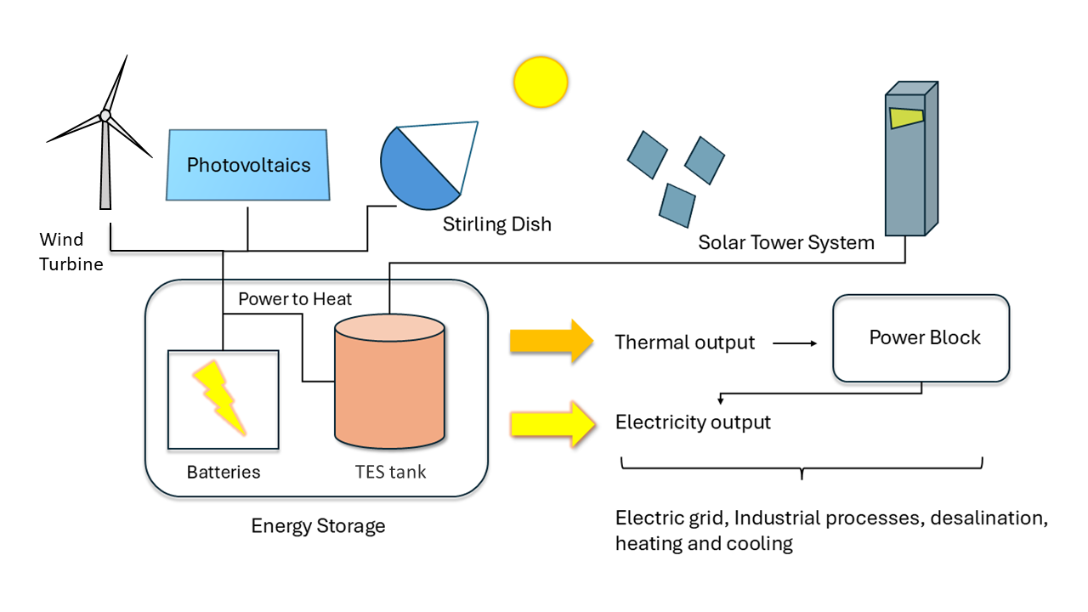
Fig. 1: Schematic representation of the complete PROTEAS hybrid renewable energy configuration
The present work focuses on the electrical subsystem of PROTEAS, comprising PV, wind, dish-Stirling, and BESS. The thermal subsystem of the facility comprises the heliostat field, solar receiver, and TES. Its control architecture is described by Stokos et al. (2018). Although dish-Stirling is inherently a CSP technology, the thermal energy is directly converted to electrical energy by the engine with no possibility to store thermally. Therefore, from the system-level perspective adopted in this work, dish-Stirling is included in the electrical subsystem, as its generated energy can only be managed through the electrical network. The thermal subsystem is outside the scope of the present work and is considered as a potential extension towards a fully integrated model of the facility. Figure 2 presents the electrical configuration considered in the present study and the main energy flow represented in the model.
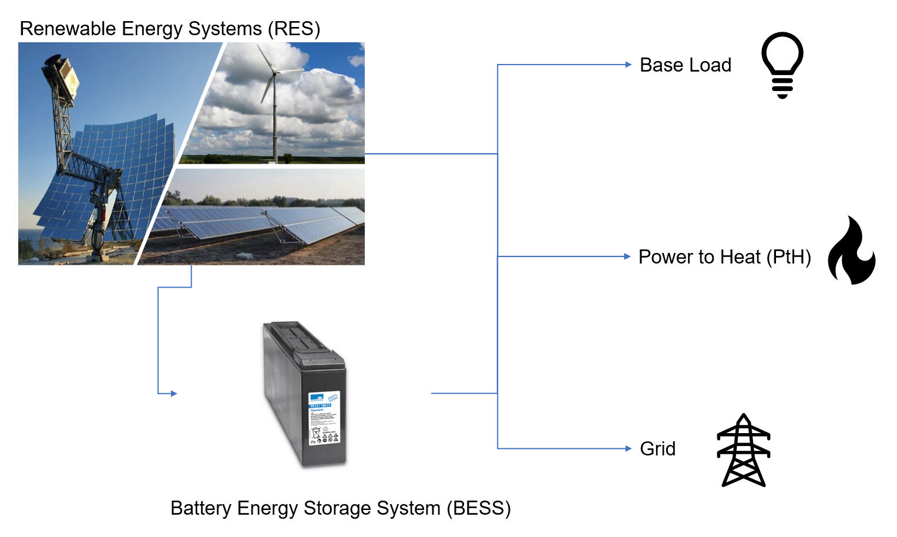

Fig. 2: Electrical subsystem of the PROTEAS facility considered in the present study
The renewable generation units can supply the electrical loads directly or charge the BESS, while stored electricity can subsequently be used to supple the loads. Three electrical pathways are considered: the facility base load; a power-to-heat (PtH) load, which is the communication between the electrical and thermal subsystems; and exchange with the electricity grid. The model therefore represents the interaction of renewable generation, electrical storage, and energy demand, allowing different operating conditions and energy management strategies.
The PV generation consists of three installations with different nominal capacities, module technologies, orientations, and locations within the PROTEAS site. These differences provide heterogeneous PV generation profiles under the same environmental conditions and are considered in the model through the corresponding system-specific parameters. The total installed PV capacity is 63.12 kWp, distributed among the three installations: 31.25 kWp in PV System 1, 21.87 kWp in PV System 2, and 10 kWp in PV System 3.
Wind generation is provided by a single small-scale horizontal-axis wind turbine. The turbine is characterized by a nominal power of 10 kW, a hub height of 6 m, and a diameter of 8 m, together with an experimentally obtained power curve by the PROTEAS team. The measured power curve is used to represent the electrical output of the turbine as a function of wind speed under the operating conditions of the installation.
The dish-Stirling solar generation system consists of two 10 kW nominal electrical power units with a combined nominal power of 20 kW. Each unit uses a parabolic dish concentrator to focus direct solar radiation onto a receiver coupled to the hot side of a Stirling engine. The concentrated solar energy is converted into thermal energy at the receiver and subsequently into mechanical work through the thermodynamic cycle in the engine, which is finally converted into electricity by an electrical generator.
Finally, the electrical storage subsystem consists of a lead-acid BESS with a total capacity of 256 kWh. The BESS enables excess renewable generation to be stored and subsequently supplied to the facility loads, exchanged with the grid, or transformed to thermal storage by a PtH conversion. The demand and the BESS levels are crucial to the energy flow decision-making.
- Dynamic modelling framework and meteorological data
A dynamic modelling framework was developed in Python programming language (2026) to represent the electrical subsystem of the PROTEAS facility within a common simulation environment. The framework adopts a modular object-oriented structure in which each generation or storage technology is represented as an individual component through defined classes and individual objects while sharing a common simulation framework. At each simulation time step the model executes a sequential update in which the state of each component is updated, including the exchange of the information required to determine their interactions and operating states. The model architecture is separated from the specific configuration of the installation, which is defined through parameter sets containing the characteristics of the simulation, geographical location, renewable generation units and BESS. This approach allows the same modelling methodology to be adapted to different locations, system sizes and technology configurations without modifying the underlying simulation architecture. In the present implementation, the configuration parameters are provided through structured JSON files.
A common temporal resolution of 5 min is adopted throughout the model, providing an intermediate level of resolution between conventional energy-system simulations, which often rely on hourly time steps, and control-oriented approaches requiring sub-second resolution. This resolution provides sufficient temporal detail to represent relevant variations in renewable generation, storage, and energy flows. This is particularly important in HRES modelling that include CST technologies. The framework is therefore designed to capture both the energy performance of individual components and their dynamic interaction within the integrated HRES.
Once the model configuration and architecture are defined, meteorological data are a key input driving the simulation, providing the environmental conditions required by each generation component at every simulation time step. The meteorological inputs are therefore required at the same temporal resolution as the model, with direct normal irradiance (DNI) and ambient temperature driving the dish-Stirling model, global horizontal irradiance (GHI), diffuse horizontal irradiance (DHI), DNI and ambient temperature providing the meteorological inputs to the PV models, while wind speed determines the wind turbine output.
For the PROTEAS site, meteorological measurements are available from an in-situ measurement system. However, to preserve the geographical flexibility of the proposed modelling framework, meteorological data were also obtained from satellite-based datasets. The use of satellite products allows the same methodology to be applied to other geographical locations where equivalent local measurements may not be available.
Satellite meteorological data were obtained from the Copernicus Climate Data Store (CDS) and Atmosphere Data Store (ADS). Solar radiation data, including GHI, DNI and DHI, were obtained from the Copernicus Atmosphere Monitoring Service (CAMS; Schroedter-Homscheidt et al., 2022) at a native temporal resolution of 15 min. Ambient temperature at 2 m and wind components at 10 m were obtained from the ERA5 single-level reanalysis dataset (Hersbach et al., 2023). The meteorological data were retrieved for the geographical coordinates of the simulated installation and processed using dedicated Python functions, including the wind speed calculation from its components. The resulting time series were stored in Pandas dataframes and resampled to the simulation time step defined in the model configuration. The meteorological data source is not intrinsically linked to the model architecture, allowing different datasets to be used depending on the availability and requirements of the target location and time.
In the present study, CAMS and ERA5 data are compared against the in-situ measurements available at PROTEAS, providing a direct comparison between externally sourced and locally measured meteorological conditions. Figure 3 presents a representative two-day comparison of the meteorological data obtained from both sources.
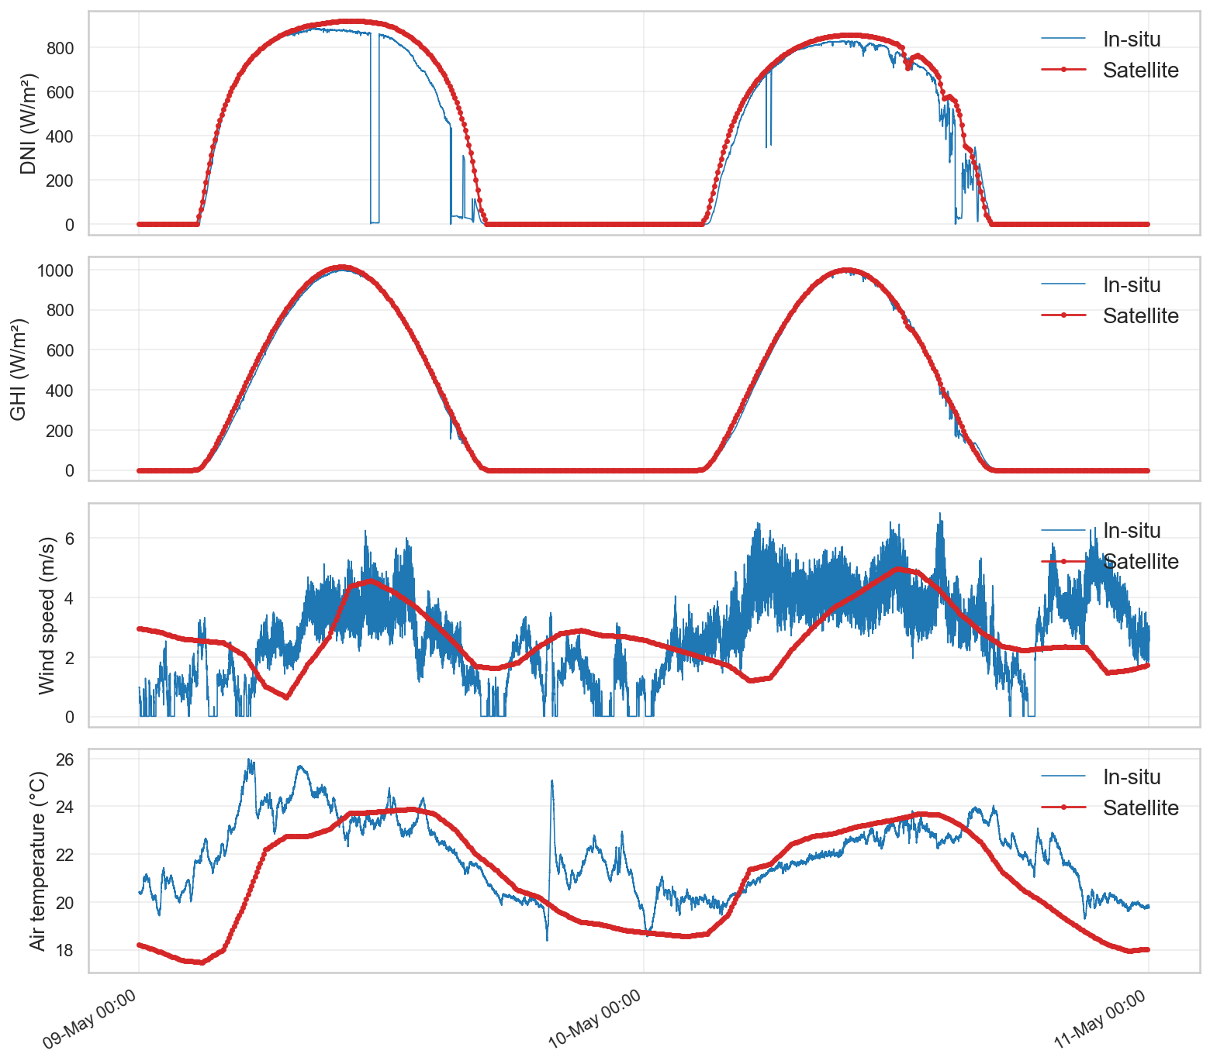

Fig. 3: Comparison of meteorological data: CAMS/ERA5 vs in-situ measurements
GHI shows the closest agreement between the two sources, with the satellite derived values closely tracking the in-situ measurements. DNI generally follows a similarly good agreement although the in-situ measurements occasionally exhibit sharp drops not captured by the satellite derived data, likely associated with localized cloud events not resolved at the satellite spatial or temporal resolution. Ambient temperature also shows a good overall agreement, although larger deviations are occasionally observed, this is considered of comparatively lower relevance given the lower sensitivity of the generation models to temperature. Wind speed agreement also considered good although it is clearly the largest discrepancy found between the two data sources, reflecting its higher spatial and temporal variability and the greater sensitivity of near surface wind to local site conditions. This aspect will be a key factor for wind turbine model uncertainty. Overall, despite these individual differences, the satellite derived meteorological data show good agreement with the in-situ measurements, supporting their use as a reliable input for the proposed modelling framework in locations where local meteorological stations are not available.
- Component models
This section describes the modelling approach adopted for each generation technology of the electrical subsystem. Each component is implemented as an individual object within the simulation framework, receiving the corresponding meteorological inputs at each 5-minute time step and returning its instantaneous electrical output.
The PV generation model is implemented using the open source pvlib Python library (Anderson et al., 2023), which provides validated implementations of the standard modelling chain used to convert meteorological inputs into AC electrical power. Each of the three PV installations at PROTEAS is represented as an independent model instance, parameterized according to its own tilt, azimuth, nominal DC capacity, and inverter characteristics, while sharing the same modelling structure.
At each time step, the plane of array (POA) global irradiance is obtained from the GHI, DNI and DHI meteorological inputs, using the Perez sky-diffuse transposition model (Perez et al., 1990). This is done for every system tilt and azimuth configuration. The Perez model was selected over simpler isotropic formulations for its improved representation of circumsolar and horizon-brightening effects under variable sky conditions. The cell temperature is then obtained from the resulting POA irradiance, ambient temperature and wind speed using the Sandia Array Performance Model (SAPM) thermal model (King et al., 2004):
$$T_{cell}= f\left(G_{POA},T_{amb}, v_{wind},a,b,∆T\right) (eq. 1)$$
where $G_{POA}$ is the POA irradiance, $T_{amb}$ is the ambient temperature, and $v_{wind}$ is the wind speed; $a$ and $b$ are empirical coefficients depending on the module mounting configuration, and $∆T$ accounts for the temperature difference between the cell and the module back surface at reference irradiance. These model parameters were individually fitted corresponding to the specific module technology and mounting configuration of each PV system. Next, an effective irradiance is obtained by applying a lumped loss factor to the POA irradiance, representing soiling, reflection and mismatch losses. The DC power output is computed using the PVWatts DC model (Dobos, 2014):
$$P_{DC}= P_{DC, 0}\frac{G_{eff}}{G_{ref}}\left[1+γ_{P}\left(T_{cell}-T_{ref}\right)\right] (eq. 2)$$
where $P_{DC}$ is the DC power output of the PV array, $P_{DC, 0}$ is the nominal DC power of the array, $G_{eff}$ is the effective irradiance on the POA, $G_{ref}$ is the reference irradiance (1000 $W/{m^{2}}$), $γ_{P}$ is the power temperature coefficient of the modules, $T_{cell}$ is the cell temperature, and $T_{ref}$ is the reference cell temperature (25 ⁰C). Finally, the AC power delivered to the electrical subsystem is also obtained by PVWatts, in this case by the inverter model (Dobos, 2014), accounting for the nominal inverter efficiency. After applying this modelling chain to each of the three PV installations, the AC outputs are aggregated to obtain the total PV generation at each simulation time step.
The wind turbine electrical output is modelled directly from an experimentally obtained power curve, measured in situ at the PROTEAS installation, rather than through an analytical aerodynamic power model, thereby capturing the real performance of the specific turbine. As the satellite derived wind speed is referenced to 10 m while the turbine hub height is 6m, it is first extrapolated to hub height using the power-law (Hellmann profile):
$$v_{hub}= v_{ref}{\left(\frac{h_{hub}}{h_{ref}}\right)}^{α} (eq. 3)$$
where $v_{hub}$ is the wind speed at the turbine hub height, $v_{ref}$ is the wind speed at the reference height, $h_{hub}$ is the turbine hub height, $h_{ref}$ is the reference height (10 m), and α is the Hellman wind shear exponent. The resulting wind speed at hub height is then converted to electrical power by direct linear interpolation on the measured power, curve, with zero output assigned below cut-in and above cut-out wind speeds.
Unlike PV and wind, dish-Stirling systems remain comparatively underrepresented in the HRES modelling literature, and the available modelling approaches are largely oriented towards detailed representation of the thermodynamic cycle itself, such as Schmidt-type or Iwamoto-type analyses, or towards transient system-level tools such as TRNSYS. For instance, Vahidi Bidhendi and Abbassi (2020) couple an Iwamoto-type cycle model, internally resolved at a much finer time step to capture the pressure and volume evolution within the thermodynamic cycle, with a system-level simulation reporting hourly and daily performance. Neither of these two perspectives, cycle-resolved thermodynamic detail on one side, hourly system-level averaging on the other, is well suited to the present work, which requires capturing the sub-hourly thermal and mechanical dynamics of the dish-Stirling unit while remaining computationally compatible with a 5-minute HRES simulation running over extended periods. This approach is deliberately chosen as a balance between physical fidelity and computational cost: it is detailed enough to capture the dominant thermal time constants and their coupling with the pressure control strategy, yet light enough to be evaluated at every 5-minute step across long simulation horizons without the cost of cycle-resolved integration, remaining compatible with the temporal resolution of the rest of the HRES model. The two PROTEAS dish-Stirling units employ a single-action, alpha-configuration Stirling engine using Helium as the working gas at 650 ⁰C and 150 bar and 1500 rpm of nominal rated power conditions. The developed model is presented in the following, starting with the optical efficiency of the dish and the thermal model of the receiver.
The optical efficiency of the parabolic dish ($η_{opt}$) is determined from its peak optical efficiency ($η_{opt,peak}$), a measured value that accounts for mirror reflectance, and is subsequently penalized by the tracking efficiency ($η_{tracking}$) and mirror cleanliness factor ($η_{clean}$). The tracking efficiency is represented using a set of model parameters, including a wind speed dependent term.
$$η_{opt}= η_{opt,peak}∙η_{tracking}(v_{wind})∙η_{clean} (eq. 4)$$
The thermal power absorbed by the receiver (${\dot{Q}}_{abs}$) is then calculated from the DNI, the dish aperture area ($A_{dish}$), accounting for the receiver surface absorptance ($α_{rec}$):
$${\dot{Q}}_{abs}=DNI∙A_{dish}∙η_{opt}∙α_{rec} (eq. 5)$$
The receiver energy balance, comprising the absorbed heat, ambient heat losses and heat transferred to the engine hot-side gas, is expressed as a first-order lumped capacitance differential equation:
$$C_{eff}\frac{{dT}_{rec}}{dt}={\dot{Q}}_{abs}- U_{loss}(T_{rec}-T_{amb})-U_{gas}(T_{rec}-T_{gas}) (eq. 6)$$
where $C_{eff}$ is the effective thermal capacity of the receiver, $U_{loss}$ and $U_{gas}$ are the ambient and gas-side heat transfer coefficients, and $T_{rec}$ and $T_{gas}$ are the receiver and hot-side gas temperatures. Given the constant coefficients within each time step, this formulation admits an analytical solution, expressed in terms of the steady-state receiver temperature ($T_{rec,∞}$):
$$T_{rec}=T_{rec,∞}+ (T_{rec,old}-T_{rec,∞})∙exp\left[{-U_{gas}(T_{rec}-T_{gas})∙∆t}/{C_{eff}}\right] (eq. 7)$$
where $∆t$ is the time resolution, 5 min in this work, and $T_{rec,old}$ the receiver temperature in the previous time step. This update avoids numerical integration at every time step while still capturing the transient thermal response of the receiver. Given the resolution used in this work, the engine startup phase is not modelled explicitly. In the actual system, startup begins at a receiver temperature of approximately 450 ⁰C using external electrical power and last less than 5 min. Instead, the control logic initializes the engine at near nominal operating temperatures (700 ⁰C at the receiver and 650 ⁰C in the working gas), resulting in a slight delay in the simulation transition to the operating state without requiring a dedicated startup model.
Once in the operating conditions, the mechanical power output ($P_{mech}$) is obtained from the cycle averaged mean effective pressure ($p_{mean}$). Since the model resolution is substantially longer than the engine cycle period at 1500 rpm, the transient pressure evolution within individual cycles is not resolved. Instead, $p_{mean}$ is used as a macroscopic representation of engine performance and can be directly compared with experimental measurements:
$$P_{mech}={π∙f∙α^{2}∙V}_{eng}∙p_{mean} (eq. 8)$$
where $f$ is the engine cycle frequency (25 Hz), $V_{eng}$ is the total engine volume, and $α$ is an effective volume ratio between the swept and total engine volumes. Rather than being derived from engine geometry alone, $α$ is treated as a calibrated effective parameter, fitted against PROTEAS operational data; this allows it to implicitly absorb the deviation of the actual pressure-volume cycle from the idealized sinusoidal approximation underlying equation. The thermal power of the cycle extracted from the hot side gas (${\dot{Q}}_{cycle}$) is obtained from the mechanical power and the thermodynamic cycle efficiency ($η_{cycle}$):
$${\dot{Q}}_{cycle}={P_{mech}}/{η_{cycle}} (eq. 9)$$
The hot side gas temperature is then updated using the same lumped capacitance approach as for the receiver (equations 6-7). In this case, the heat input is given by the heat transfer from the receiver, $U_{gas}(T_{rec}-T_{gas})$, while ${\dot{Q}}_{cycle}$ represents the thermal power extracted by the engine cycle.
To finish the interconnected variables chain calculation, the pressure control logic must be implemented to update the $p_{mean}$ each time step. The engine pressure is regulated through He injection from a pressurized reservoir, with the control system targeting the nominal engine speed and gas temperature. The target mean pressure is calculated as a function of the available DNI and the deviation of the gas temperature from its nominal value:
$$p_{mean}=p_{mean,min}+f_{DNI}\left(p_{mean,nom}-p_{mean,min}\right)+c_{temp}\left(T_{gas}-T_{gas,nom}\right) (eq. 10)$$
where $f_{DNI}$ increases linearly from 0 at a minimum control threshold of 300 W/m² to 1 at the DNI required for nominal power (900 W/m²), and $c_{temp}$ is a temperature correction coefficient, set to 0.05, which regulates the response of the gas temperature. As solar irradiance increases, the controller increases the engine pressure, thereby increasing both the mechanical power output and the thermal power extracted by the cycle. The resulting increase in heat extraction counteracts the heat transferred from the receiver and drives the gas temperature towards its nominal value. Finally, electrical losses of the generator and auxiliaries are characterized empirically from the PROTEAS validation dataset.
The renewable generation models are complemented by a BESS, which represents the temporal storage and subsequent delivery of excess renewable electricity. The BESS is modelled through a state-of-charge (SOC) balance. The model accounts for the rate-dependent available capacity characteristic of lead-acid electrochemistry, known as the Peukert effect (Doerffel and Sharkh, 2006). During discharge, the instantaneous discharge current ($I_{dis}={P_{dis}}/{V_{nom}}$) is used to determine the effective discharge capacity ($C_{p}$) according to the Peukert relationship, penalizing discharge rates faster than the manufacturer’s reference discharge current ($I_{ref}$):
$$C_{p}=E_{nom}{\left({I_{ref}}/{I_{dis}}\right) }^{k-1} (eq. 11)$$
where $E_{nom}$ is the nominal capacity (256 kWh) and k is the Peukert exponent, a parameter fitted from operational data. The SOC is subsequently updated at each simulation time step according to:
$$SOC\left(t\right)=SOC\left(t- ∆t\right)-{I_{dis}∙∆t}/{C_{p} } , discharging$$
$$SOC\left(t\right)=SOC\left(t- ∆t\right)+{P_{ch}∙η_{ch}∙∆t}/{C_{p}} , charging (eq. 12)$$
where $P_{ch}$ is the charging power and $η_{ch}$ is the charging efficiency. The SOC is constrained between a minimum and a maximum level to prevent excessive discharge and overcharge. The charging and discharging power at each time step are determined by the system level energy management strategy, which allocates the net renewable surplus or deficit among the BESS, the facility loads, and the electricity grid.
- Model validation
Experimental operational data from PROTEAS facility were used to calibrate the developed generation models. Model performance is assessed using the mean bias error (MBE) and the root mean square error (RMSE). The validation focuses primarily on the solar generation technologies, with particular emphasis on the dish-Stirling system, for which a dedicated physics-based and dynamic model has been developed in the present work. The PV and dish-Stirling models are assessed against experimental measurements from the PROTEAS facility. Wind generation is represented using the experimentally measured power curve of the installed turbine, providing a direct experimental basis for its input-output relationship. The BESS model is not included in the experimental validation presented here, and its behaviour is instead assessed through the integrated system simulations presented in Section 6.
The dish-Stirling model was evaluated using experimental measurements from a test campaign at the PROTEAS facility, with two representative days selected for detailed comparison in figures 4 and 5. Simulated and measured electrical power and mean engine pressure are compared. Gas temperature provides limited additional information as its evolution follows the nominal value in operating conditions, therefore it is not shown. In contrast, engine pressure directly influences the electrical power through the mean effective pressure used in the thermodynamic model. Accordingly, both experimental and simulated pressure and power exhibit consistent temporal trends.
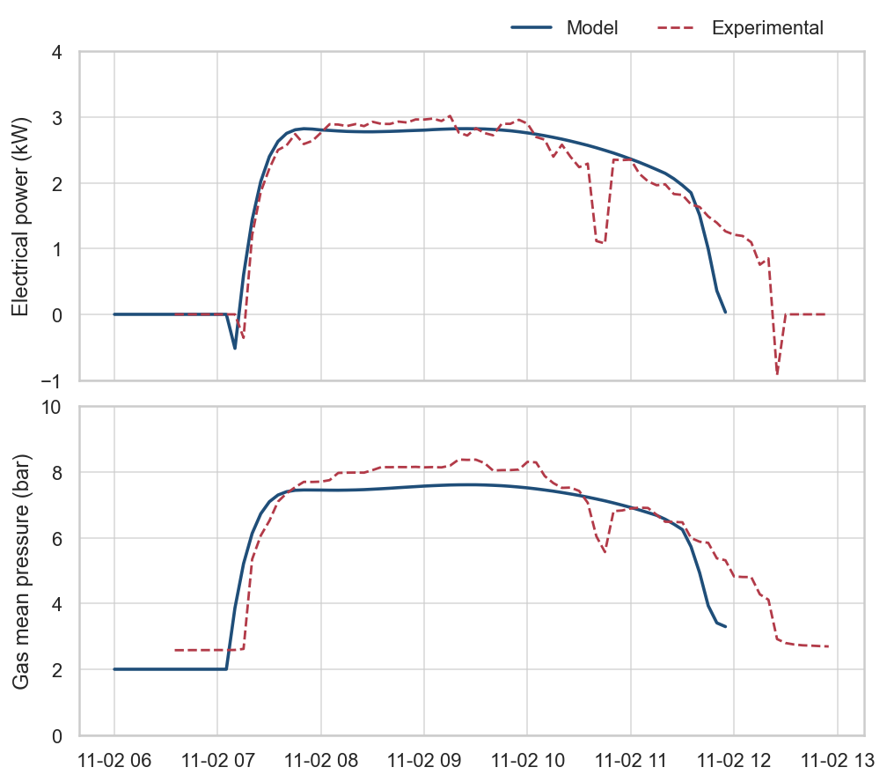

Fig. 4: Comparison of simulated and measured dish-Stirling power and engine pressure on 02 November 2022
For the selected validation period, the model achieves an MAE of 0.22 kW and an RMSE of 0.38 kW in electrical power. A second validation day, characterized by more variable DNI and more pronounced transients is also considered to assess the model performance under less stable operating conditions.
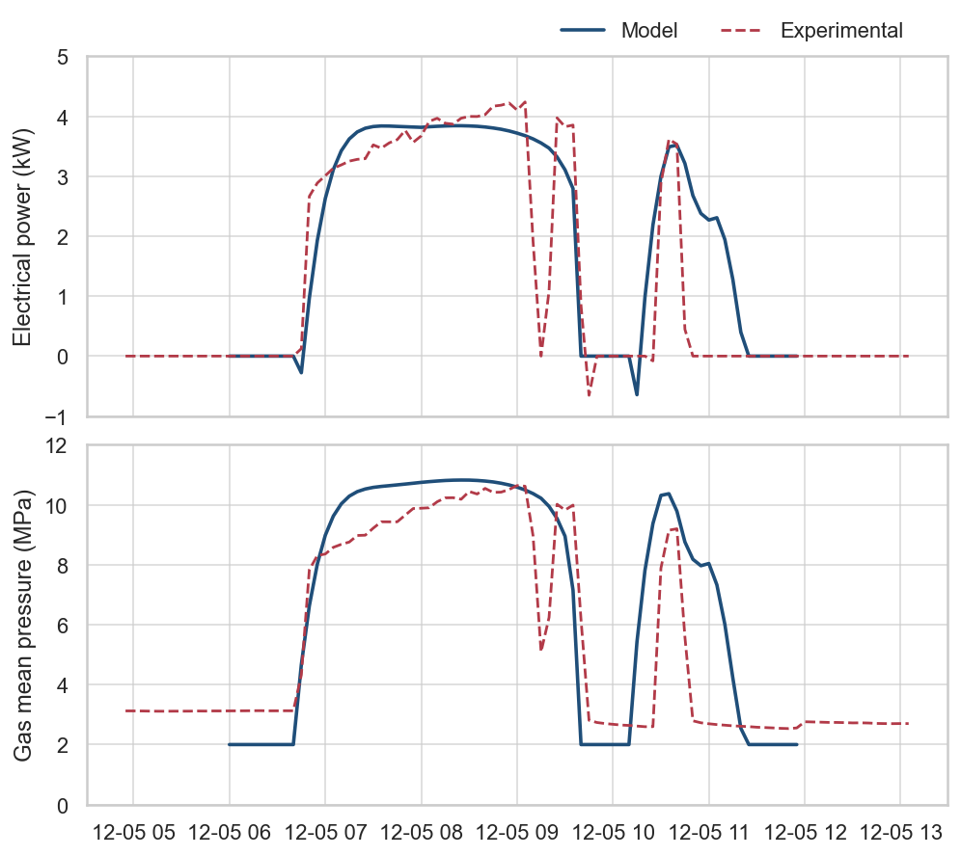

Fig. 5: Comparison of simulated and measured dish-Stirling power and engine pressure on 05 December 2022
For the selected validation period, the model achieves an MAE of 0.58 kW and an RMSE of 1.01 kW in electrical power. This second validation day, characterized by pronounced transients, provides a more demanding test of the model. The main variations in electrical power and engine pressure are reproduced, although larger deviations occur during transient periods. Overall, the results support the ability of the model to reproduce the main dish-Stirling behaviour, capturing dynamics at the 5-min simulation resolution.
The PV model was validated using six days of experimental measurement from the three PV installations at the PROTEAS facility. Each system was calibrated individually using its corresponding orientation, nominal capacity, and performance parameters. For clarity, figure 6 presents the comparison between the simulated and measured total PV electrical power, obtained by aggregating the three installations. For the representative day shown, the model achieved an MAE of 0.52 kW and an RMSE of 0.94 kW, while the overall validation presented an MAE of 0.59 kW and an RMSE of 1.16 kW.

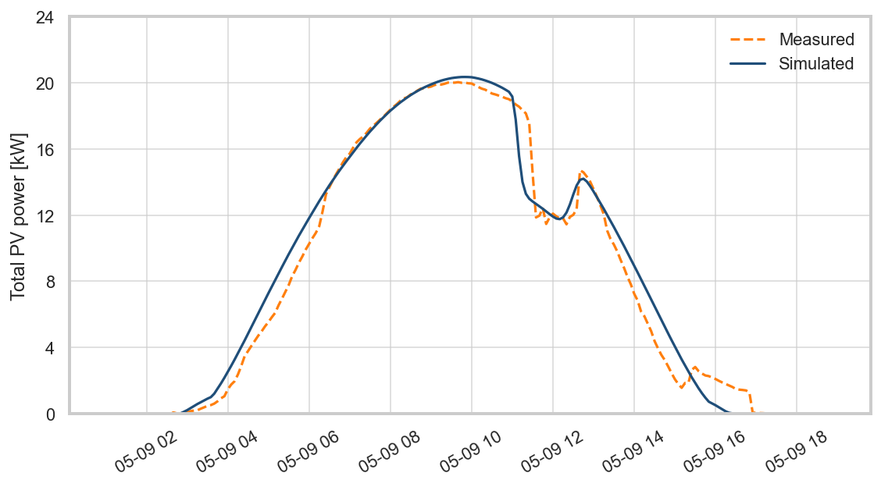

Fig. 6: Comparison of simulated and measured total PV power on 09 May 2026
The comparison shows good agreement between simulated and measured PV generation, accurately reproducing both the overall daily production profile and the short-term power variations associated with changes in irradiance.
- Integrated hybrid system simulation
Having validated each generation component individually, the complete electrical subsystem model is exercised over a multi-day period to illustrate the dynamic interaction between renewable generation, the BESS, the facility loads and the electricity grid. The base load is served with priority (with grid import covering any shortfall), renewable surplus charges the BESS, and any renewable surplus remaining after charging is exported to the grid; conversely, when generation falls short of demand, the BESS is discharged with priority given to the base load over the PtH load.
Figure 7 shows the simulation results over a representative 3-day period at 5-minute resolution. Panel (a) shows the individual contribution of PV, wind, and dish-Stirling generation, illustrating their complementary temporal profiles and combined variability. Panel (b) shows the resulting BESS charge/discharge power, the total facility demand (base load and PtH), and the net exchange with the grid. A synthetic but representative demand profile is used, based on a constant base load and a daytime PtH window. The BESS shifts the daytime renewable surplus, dominated by PV and dish-Stirling, towards periods of higher demand, reducing but not eliminating grid dependence overnight, while no grid export occurs as the BESS consistently absorbs the available surplus.
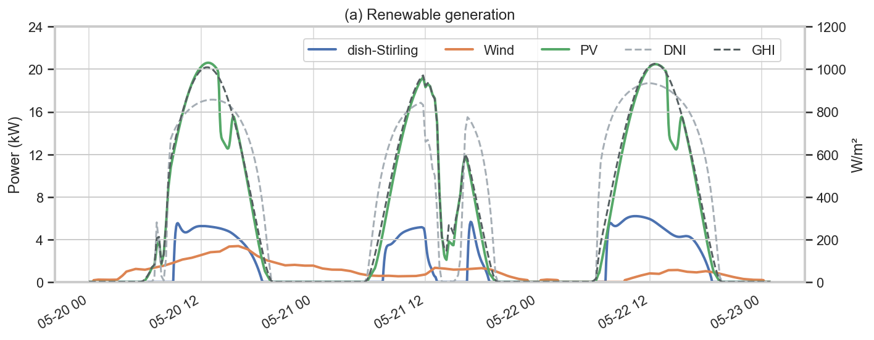
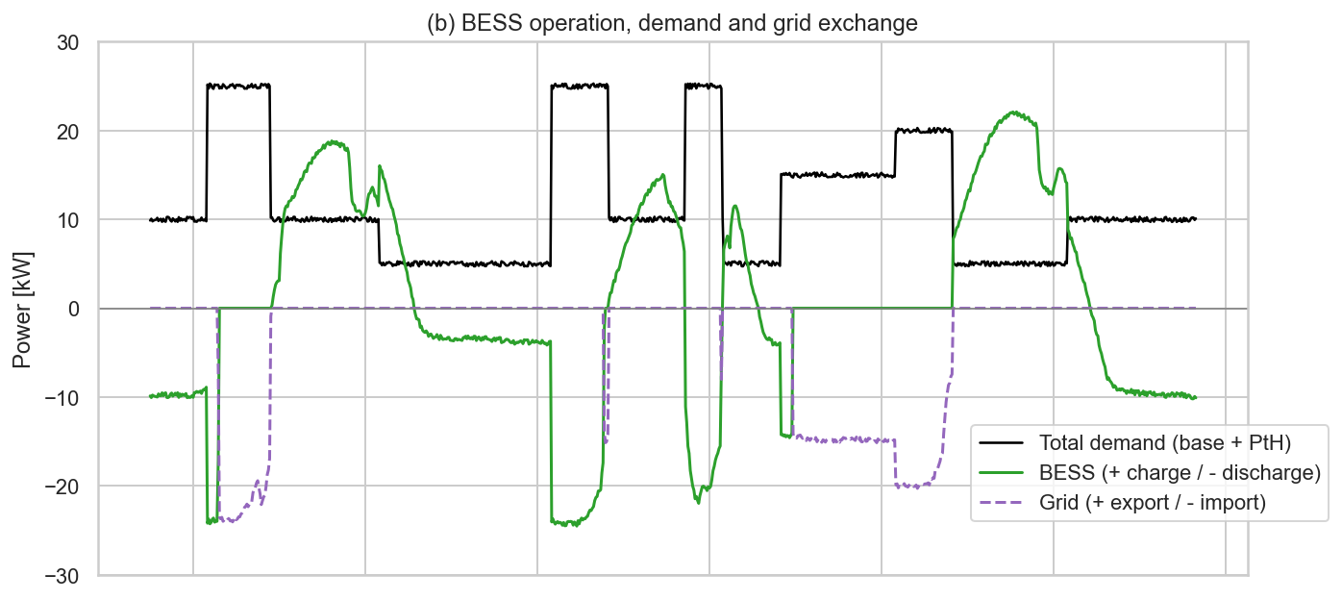

Fig. 7: Integrated simulation of the PROTEAS electrical subsystem over 3 days of May 2026.
- Conclusions
This work presented a dynamic, physics-based modelling framework for the electrical subsystem of the PROTEAS facility, integrating PV, wind, dish-Stirling, and BESS within a common simulation environment at a 5-min temporal resolution. The modular, object-oriented architecture, combined with satellite-based meteorological data, allows the same methodology to be applied to other locations and technology configurations without modifying the underlying model structure. The meteorological comparison supported the use of satellite-driven data (CAMS and ERA5 in this work) as inputs for the proposed modelling approach. The PV and dish-Stirling solar technologies showed good agreement with experimental measurements, capturing well the transient conditions. The integrated simulations further demonstrated the capability of the framework to capture the sub-hourly interaction between heterogeneous renewable generation, storage, and electrical demand. Future work will focus on further improving the components models through calibration and validation against additional experimental data, as well as incorporating grid electricity price signals for techno-economic analysis and dispatch strategy.
- Acknowledgments
This work is part of a project that has received funding from the European Union’s Horizon Europe research and innovation programme under grant agreement No 101131793. We appreciate the support of the RISEnergy Horizon Europe project and the PROTEAS RI from the RISEnergy member The Cyprus Institute.
The authors also want to thank “Comunidad de Madrid” for the financial support to ACES4NET0-CM project (TEC-2024/ECO-116), through the R&D activities programme “Tecnologías 2024”.
- References
Abbass, A., 2025. Hybrid renewable energy microgrid optimization: An analysis of system performance and cost-efficiency using Python-generated custom code for diesel-wind-solar configurations. Energy Storage and Saving 4, 392-403.
Anderson, K., Hansen, C., Holmgren, W., Jensen, A., Mikofski, M., Driesse, A., 2023. pvlib python: 2023 project update. Journal of Open Source Software 8(92), 5994.
Cyprus Institute, 2026. PROTEAS. Energy, Environment and Water Research Centre (EEWRC), Nicosia, Cyprus.
Doerffel, D., Sharkh, S.A., 2006. A critical review of using the Peukert equation for determining the remaining capacity of lead-acid and lithium-ion batteries. Journal of Power Sources 155, 395-400.
Deshmukh, M.K., Desmukh, S.S., 2008. Modeling of hybrid renewable energy systems. Renewable and Sustainable Energy Reviews 12, 235-249.
Dobos, A.P., 2014. PVWatts Version 5 Manual. National Renewable Energy Laboratory (NREL), Golden, CO.
Hersbach, H., Bell, B., Berrisford, P., Biavati, G., Horányi, A., Muñoz Sabater, J., Nicolas, J., Peubey, C., Radu, R., Rozum, I., Schepers, D., Simmons, A., Soci, S., Dee, D., Thépaut, J.-N., 2023. ERA5 hourly data on single levels from 1940 to present. Copernicus Climate Change Service (C3S) Climate Data Store (CDS).
IEA, 2025. World Energy Outlook 2025. International Energy Agency, Paris.
Khan, W.A., Pakseresht, A., Chua, C., Yavari, A., 2026. Energy resilience and decarbonization via hybrid renewable energy systems: A techno-economic study. International Journal of Hydrogen Energy 217, 153765.
King, D.L., Boyson, W.E., Kratochvill, J.A., 2004. Photovoltaic Array Performance Model. Sandia National Laboratories, Albuquerque, NM.
Marinescu, B., Gomis-Bellmunt, O., Dörfler, F., Schulte, H., Sigrist, L., 2022. Dynamic virtual power plant: A new concept for grid integration of renewable energy sources. IEEE Access 10, 104980-104995.
Munoz-Pincheira, J.L., Salazar, L., Sanhueza, F., Lüer-Villarga, A., 2025. Optimizing the design of stand-alone hybrid renewable energy systems with storage using genetic algorithms: Analysis of the impact of temporal complementarity of wind and solar sources. Energy Conversion and Management 341, 120016.
Nadeem, T.B., Siddiqui, M., Khalid, M., Asif, M., 2023. Distributed energy systems: A review of classification, technologies, applications, and policies. Energy Strategy Reviews 48, 101096.
Perez, R., Ineichen, P., Seals, R., Michalsky, J., Stewart, R., 1990. Modeling daylight availability and irradiance components from direct and global irradiance. Solar Energy 44, 271-289.
Python Software Foundation, 2026. Python Language Reference, version 3.13.9.
Schroedter-Homscheidt, M., Azam, F., Betcke, J., Hanrieder, N., Lefèvre, M., Saboret, L., Saint-Drenan, Y.-M., 2022. Surface solar irradiation retrieval from MSG/SEVIRI based on APOLLO Next Generation and HELIOSAT-4 methods. Meteorol. Z. 31.
Stokos, K.G., Stiliaris, E.G., Bonanos, A.M., Georgiou, M.C., Guillen, E., Montenon, A.C., Papanicolas, C.N., 2018. The control system at the PROTEAS. AIP Conference Proceedings 2033, 210019.
Tulu, T.K., Bulti, D.A., Shawul, A.A., Atnaw, S.M., 2026. Modeling of hybrid renewable energy systems for remote rural village electrification and machine learning employment. Next Energy 12, 100635.
Vahidi Bidhendi, M., Abbassi, Y., 2020. Exploring dynamic operation of a solar dish-Stirling engine: validation and implementation of a novel TRNSYS type. Sustainable Energy Technologies and Assessments 40, 100765.
Wang, Q., Xu, J., Wang, K., Li, G., 2025. An adjustable resolution modelling and layered hybrid decoupling method for renewable energy power systems. International Journal of Electrical Power & Energy Systems 166, 110586.

