EuroSun2026
SENSITIVITY OF OFFICE BUILDING ENERGY USE AND ROOFTOP BIFACIAL PV GENERATION TO DESIGN AND THERMAL-BOUNDARY PARAMETERS
Zhonggui Xu¹, Rui Guo^{1*}, Haibin Chen¹, Julian Wang²
¹School of Environmental Science and Engineering, Huazhong University of Science and Technology, Wuhan 430074, China
²Department of Architectural Engineering, The Pennsylvania State University, PA 16802, USA
*Email: guorui@hust.edu.cn
Summary
Rooftop bifacial photovoltaic (bPV) systems can generate on-site electricity while modifying the roof thermal boundary and thereby affecting building heating and cooling demand. Identifying the importance of relevant design and thermal-boundary parameters can facilitate the coordinated design of the rooftop and bPV system.
This study used a building–bPV framework in EnergyPlus to simulate PV generation and building energy use for a three-storey office building in Chongqing, China. Seven geometric, optical, and thermal-boundary parameters were selected, and Latin Hypercube Sampling cases were generated under new and existing building envelope scenarios, followed by uncertainty analysis and global sensitivity analysis using the regression method. The results showed that annual PV generation varied from 21.4 to 32.9 MWh within the 5th–95th percentile range, with little difference between the two building scenarios. In contrast, annual heating, ventilation, and air-conditioning (HVAC) electricity use intensity was substantially lower for the new building, decreasing from 23.3–26.6 kWh m⁻² for the existing building to 15.8–16.4 kWh m⁻². The global sensitivity analysis further showed that, on the PV side, annual PV generation was most sensitive to PV tilt angle and roof albedo. Increasing PV tilt reduced annual PV generation, whereas increasing roof albedo increased it. The prescribed PV front- and rear-side convective heat transfer coefficients (CHTCs) had a greater influence on array-side direct-current peak power than on annual PV generation. On the building side, roof albedo was the dominant parameter for annual HVAC and cooling electricity use intensities, followed by roof exterior CHTC. Higher roof albedo reduced annual HVAC and cooling electricity use intensities but increased annual heating electricity use intensity. These findings can provide a basis for coordinated rooftop and bPV system design.
Keywords: bifacial photovoltaic, uncertainty analysis, sensitivity analysis, parametric simulation, convective heat transfer coefficient, design and thermal-boundary parameters
Field of application for the findings: Building energy efficiency, solar energy systems
Addressed audience: Building energy engineers, solar energy researchers, architects, and building designers

1. Introduction
The buildings and construction sector accounts for a substantial share of global energy use and CO₂ emissions. According to the 2024/2025 Global Status Report for Buildings and Construction, the sector consumes about 32% of global energy and contributes about 34% of global CO₂ emissions (United Nations Environment Programme, 2025). Reducing these impacts requires both demand-side energy reduction and the integration of on-site renewable energy systems in buildings. Among emerging renewable energy technologies, bifacial photovoltaic (bPV) panels have attracted increasing attention due to their ability to generate electricity from both front and rear surfaces. For rooftop applications, the performance of bPV systems depends not only on front-side solar irradiance, but also on the availability of rear-side irradiance reflected from the roof surface, which is affected by roof albedo, module arrangement, and installation geometry (Zhong et al., 2023).
Most previous studies on rooftop or building-applied bPV systems have focused on improving electrical output through optical and geometric optimization, such as module mounting height, roof albedo, tilt angle, and installation configuration. Beyond electrical generation, however, rooftop bPV arrays also modify the thermal boundary above the roof. Their geometry and surface temperatures affect roof shading, reflected radiation, longwave radiative exchange, and local convective heat transfer, while the roof temperature and radiative environment can in turn influence the rear-side thermal condition of bPV modules. These interactions are important because roof heat balance and exterior convective heat transfer coefficients (CHTCs) can affect heating, ventilation, and air-conditioning (HVAC) electricity use and peak demand. This creates a need for a modelling framework that explicitly links rooftop PV generation, roof heat balance, roof-side and PV-side CHTC uncertainty, and building HVAC demand within a unified building energy simulation context.
To support this need, this study develops an EnergyPlus-based building–bPV coupled modelling framework implemented through the PythonPlugin interface for an office building with an elevated rooftop bPV array in Chongqing, China. Based on 400 Latin Hypercube Sampling (LHS) cases, uncertainty analysis and standardized rank regression coefficient (SRRC)-based global sensitivity analysis are conducted to examine seven design and thermal-boundary parameters, including PV tilt angle, row spacing, mounting height, roof albedo, roof exterior CHTC, PV front-side CHTC, and PV rear-side CHTC. Their effects are evaluated in terms of annual PV generation, array-side direct-current (DC) peak PV power, annual HVAC electricity use intensity, annual cooling and heating electricity use intensities, HVAC peak electric power density, and the annual PV-to-building electricity use ratio under new and existing building envelope scenarios.

2. Methodology

2.1. Case-study building and rooftop bifacial PV system

2.1.1. Office building model and climate conditions
The case-study building was adapted from the EnergyPlus office building model developed by Zhuang et al. (2021) for Chongqing, China. The building represents a three-storey office building with a rectangular plan of 29.36 m × 14.36 m and a total height of 9 m. The footprint area, which is also used as the available roof area for the rooftop bPV layout, is approximately 420 m². The window-to-wall ratio is 0.17. The long axis of the building is oriented in the east–west direction, so that the main façades face south and north. Chongqing is located in the hot-summer and cold-winter climate zone, where both cooling and heating demands are relevant for office buildings. The simulations were conducted using EnergyPlus version 24.2 (U.S. Department of Energy, 2024), and the Chinese Standard Weather Data (CSWD) weather file for Chongqing Shapingba 575160 in EnergyPlus Weather Format was used as the weather input (U.S. Department of Energy, n.d.).
Internal heat gains from occupants, lighting, and office equipment were considered in the simulations. The internal load densities, occupancy, lighting and equipment schedules, HVAC operation schedules, and thermal set points were defined according to MOHURD (2015). The HVAC system was modelled as a packaged terminal heat pump system, with rated cooling and heating COPs of 3.20 and 3.67, respectively. The indoor cooling and heating set-point temperatures were 26 °C and 20 °C, respectively. The HVAC system operated from 07:00 to 18:00 on weekdays, representing a typical office operation schedule (MOHURD, 2015).

2.1.2. New and existing building envelope scenarios
Two building envelope scenarios were considered to examine how building envelope thermal performance modifies the coupled response of building energy use and rooftop PV generation. The existing building case retained the building envelope thermal properties of the original EnergyPlus model, whereas the new building case was modified to satisfy the prescriptive requirements of MOHURD (2015) for the hot-summer and cold-winter climate zone. All other model inputs and the LHS matrix were identical. The paired cases differed only in the selected envelope U-values of the exterior wall and roof. The floor and exterior window U-values were kept unchanged at 0.85 and 3.24 W m⁻² K⁻¹, respectively, and are therefore not listed as modified building envelope parameters in Table 1.
Tab. 1: Modified building envelope thermal transmittance values in the two scenarios
Building envelope component | New building (W m⁻² K⁻¹) | Existing building (W m⁻² K⁻¹)
Exterior wall | 0.53 | 2.10
Roof | 0.31 | 4.07

2.1.3. Rooftop bifacial PV array configuration
The rooftop bPV system was arranged above the roof of the case-study office building. In the EnergyPlus model, the PV array was represented by elevated exterior surfaces with defined front- and rear-side irradiated faces, allowing EnergyPlus to calculate the incident solar radiation on both sides of the modules and the shading cast on the roof. A schematic of the case-study building and rooftop bPV layout is shown in Fig. 1.
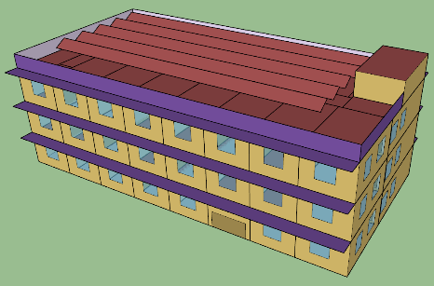
Fig. 1: Case-study building and rooftop bPV system schematic
The selected module was the LONGi Hi-MO 9 LR7-72HYD-645M bifacial module (LONGi Green Energy Technology Co., Ltd., 2024), with a rated power of 645 W, dimensions of 2382 mm × 1134 mm × 30 mm, a module efficiency of 23.9%, and a nominal bifaciality factor of 0.70. The reference parameters and temperature–irradiance translation relationships required by the five-parameter single-diode model were adopted from the modelling approach of Gu et al. (2020), rather than being directly provided by the manufacturer datasheet. The array consisted of five rows with ten modules per row, giving 50 modules, an installed capacity of 32.3 kWp, and a total module area of 135.1 m². The sampled ranges of tilt angle, row spacing, and mounting height were defined so that the five-row by ten-module array remained within the available roof footprint and satisfied the adopted roof-edge, row-spacing, and maintenance-access constraints for all simulated cases. An initial south-facing array geometry, with a tilt angle of 30°, a row spacing of 2.0 m, and a mounting height of 0.5 m above the roof, was used only for model setup and illustration and was not treated as a separate baseline case. In the subsequent parametric analysis, tilt angle, row spacing, mounting height, and roof albedo were varied within the prescribed ranges, while the number of modules, total module area, and installed capacity were kept constant. Therefore, the sampled parameters altered the irradiance, shading, and roof thermal-boundary conditions without changing the rated PV capacity.

2.2. Building–bifacial PV coupled modelling framework
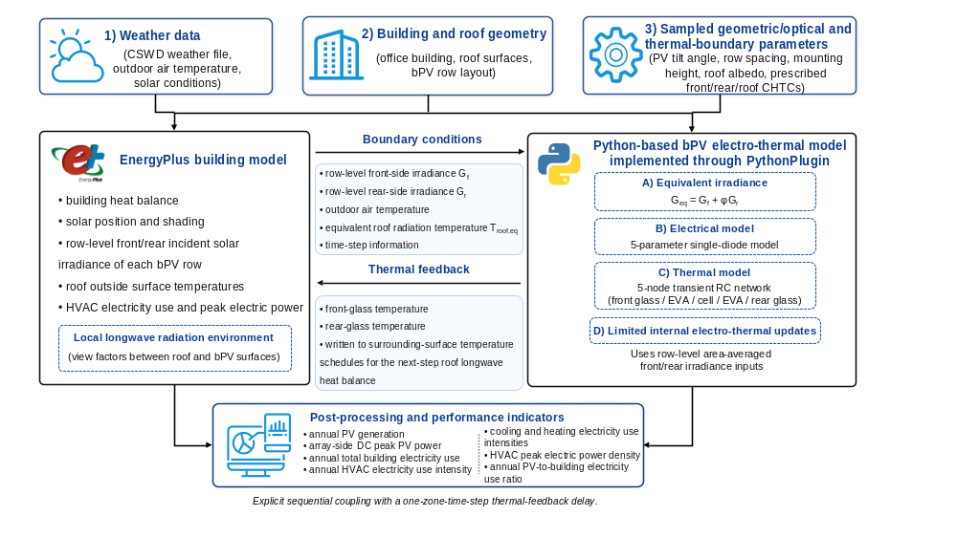
Fig. 2: Building–bPV coupled modelling workflow implemented through the EnergyPlus PythonPlugin interface
A sequentially coupled building–bPV modelling framework was implemented in EnergyPlus through the PythonPlugin interface. EnergyPlus calculated the building heat balance, HVAC electricity use, roof shading, roof exterior temperatures, and row-level front- and rear-side irradiances. These outputs were passed to the Python-based bPV electro-thermal model to calculate equivalent irradiance, module temperatures, maximum-power-point (MPP) DC power, and time-step electricity generation. The calculated front- and rear-glass temperatures were returned to EnergyPlus through surrounding-surface temperature schedules to represent roof–bPV longwave radiative coupling. The overall workflow and exchanged variables are shown in Fig. 2.

2.2.1. Time-step implementation
The EnergyPlus simulations and the Python-based electro-thermal calculations used a 10-min time step. At each time step, the PythonPlugin retrieved the required boundary conditions from EnergyPlus and solved the electro-thermal model using a maximum of 30 iterations and a relative-change tolerance of 10⁻⁵. The converged glass temperatures were then written back to EnergyPlus and affected the roof longwave heat balance during the following time step. No same-time-step outer iteration was performed.

2.2.2. Solar-shading treatment and roof–bPV longwave exchange
The rooftop bPV rows were explicitly represented as elevated exterior surfaces in the EnergyPlus Input Data File model. Solar position, module tilt, row-to-row shading, roof albedo, and building geometry were therefore evaluated using the same radiation and shading calculations used for the building model. The resulting front- and rear-side irradiances were passed to the PythonPlugin as optical boundary inputs for the bPV electro-thermal model. Longwave radiative coupling between the roof and bPV surfaces was represented using local external environments in EnergyPlus. For each sampled geometry, the tilt angle, row spacing, and mounting height were first applied to regenerate the bPV geometry. The corresponding roof–bPV view factors were then recalculated before the annual simulation. For two finite surfaces i and j, the view factor was evaluated as
$${\text{F}}_{ \text{i} \text{→} \text{j}}\text{=}\frac{\text{1}}{{\text{A}}_{\text{i}}}\int_{{\text{A}}_{\text{i}}}{\int_{{\text{A}}_{\text{j}}}{\frac{\text{cos}{{\text{θ}}_{\text{i}}\text{cos}{{\text{θ}}_{\text{j}}}}}{\text{π}{\text{r}}^{\text{2}}}\text{d}{\text{A}}_{\text{j}}}}\text{d}{\text{A}}_{\text{i}}$$ | (eq.1)
where ${\text{F}}_{\text{i} \text{→} \text{j}}$​ is the view factor from emitting surface i to surface j, ${\text{A}}_{\text{i}}$​ is the area of surface i, r is the distance between two differential surface elements, and ${\text{θ}}_{\text{i}}$​ and ${\text{θ}}_{\text{j}}$​ are the angles between the connecting line and the outward normal directions of surfaces i and j, respectively.
The roof and bPV polygons were triangulated, and the surface integrals in Eq. (1) were evaluated numerically. The resulting view factors satisfied the summation and reciprocity relationships, were assigned to the corresponding EnergyPlus SurfaceProperty:SurroundingSurfaces objects, and remained fixed during each annual simulation. Inter-row obstruction of longwave radiation and complete bPV-to-bPV longwave exchange were neglected.
The roof exterior surface was linked to a local surrounding-surface environment that included the sky, ground, and the front and rear sides of the bPV rows. The Python-calculated glass temperatures were supplied through the corresponding surrounding-surface temperature schedules. They were not used to overwrite the EnergyPlus outside-surface temperatures of the geometrical bPV surfaces directly. The roof longwave heat exchange was calculated as
$${\text{q}}_{\text{LW,roof}}^{\text{''}}\text{=}{\text{ε}}_{\text{roof}}\text{σ}\sum_{\text{j}}{{\text{F}}_{\text{roof} \text{→} \text{j}}}\left({\text{T}}_{\text{j}}^{\text{4}}\text{-}{\text{T}}_{\text{roof}}^{\text{4}}\right)$$ | (eq.2)
where ${\text{q}}_{\text{LW,roof}}^{\text{''}}$ is the net longwave radiative heat flux received by the roof, ${\text{ε}}_{\text{roof}}$​ = 0.90 is the roof longwave emissivity, $\text{σ}\text{=}$ 5.6704×10⁻⁸ W m⁻² K⁻⁴ is the Stefan–Boltzmann constant, ${\text{F}}_{\text{roof→j}}$​ is the view factor from the roof to surrounding surface j, and ${\text{T}}_{\text{roof}}$ and ${\text{T}}_{\text{j}}$​ are absolute temperatures.
When multiple roof surfaces were viewed by the bPV array, their outside-surface temperatures were combined into a radiative-equivalent roof temperature using an area-weighted fourth-power average.
$${\text{T}}_{\text{roof,eq}}\text{=}{\left(\frac{\sum_{i=1}^{N_{r}}{{\text{A}}_{\text{i}}{\text{T}}_{\text{i}}^{\text{4}}}}{\sum_{i=1}^{N_{r}}{{\text{A}}_{\text{i}}}}\right)}^{{\text{1}}/{\text{4}}}$$ | (eq.3)
where ${\text{T}}_{\text{roof,eq}}$​ is the radiative-equivalent roof temperature, N_{r} is the number of roof surfaces included in the calculation, and ${\text{A}}_{\text{i}}$​ and ${\text{T}}_{\text{i}}$​ are the area and absolute outside surface temperature of roof surface i, respectively. In the present model, N_{r} ​= 20.
On the EnergyPlus side, the rear surface of each bPV row was assigned a row-specific radiative environment consisting of sky, ground, and roof components. The rear-side longwave heat flux was represented as
$${\text{q}}_{\text{LW,rear}\text{,EP}}^{\text{''}}\text{=}{\text{ε}}_{\text{rear}}\text{σ}\left[{\text{F}}_{\text{rear→sky}}\left({\text{T}}_{\text{sky}}^{\text{4}}\text{-}{\text{T}}_{\text{rear}}^{\text{4}}\right)\text{+}{\text{F}}_{\text{rear→ground}}\left({\text{T}}_{\text{ground}}^{\text{4}}\text{-}{\text{T}}_{\text{rear}}^{\text{4}}\right)\text{+}{\text{F}}_{\text{rear→roof}}\left({\text{T}}_{\text{roof,eq}}^{\text{4}}\text{-}{\text{T}}_{\text{rear}}^{\text{4}}\right)\right]$$ | (eq.4)
where ${\text{q}}_{\text{LW,rear}\text{,EP}}^{\text{''}}$​ is the EnergyPlus-side rear-surface longwave heat flux, ${\text{ε}}_{\text{rear}}$= 0.85 is the rear-glass emissivity, and${\text{T}}_{\text{rear}}$ is the rear-surface temperature. The terms ${\text{F}}_{\text{rear→sky}}$​, ${\text{F}}_{\text{rear→ground}}$​, and ${\text{F}}_{\text{rear→roof}}$​ are the rear-side view factors to the sky, ground, and roof, respectively. EnergyPlus represented the rear-side radiative environment using row-specific sky, ground, and roof view factors, as shown in Eq. (4), whereas the Python thermal model used the corresponding equivalent rear-side radiative temperature.

2.2.3. Bifacial PV electro-thermal model
The bPV electro-thermal model was adapted from the five-parameter electrical model and five-node resistance–capacitance (RC) thermal network proposed by Gu et al. (2020). EnergyPlus-calculated row-level irradiances replaced the original independent optical model, ensuring consistent treatment of building geometry, roof reflection, and row-to-row shading. Sub-module irradiance non-uniformity and the associated electrical mismatch losses were neglected.
The row-averaged front- and rear-side irradiances were converted into the equivalent irradiance of the bifacial module according to Gu et al. (2020),
$${\text{G}}_{\text{eq}}\text{=}{\text{G}}_{\text{f}}\text{+φ}{\text{G}}_{\text{r}}$$ | (eq.5)
where${ \text{G}}_{\text{eq}}$​ is the equivalent bifacial irradiance, ${\text{G}}_{\text{f}}$​ and ${\text{G}}_{\text{r}}$​ are the EnergyPlus-calculated front- and rear-side irradiances, respectively, and φ = 0.70 is the nominal bifaciality factor of the selected LONGi Hi-MO 9 module.
The electrical output was calculated using the five-parameter single-diode model adapted from Gu et al. (2020),
$$I\text{=}{\text{I}}_{\text{ph}}\text{-}{\text{I}}_{\text{0}}\left[\text{exp}\left(\frac{{\text{V}}/{{\text{N}}_{\text{s}}\text{+I}{\text{R}}_{\text{s}}}}{{\text{V}}_{\text{t}}}\right)\text{-1}\right]\text{-}\frac{{\text{V}}/{{\text{N}}_{\text{s}}\text{+I}{\text{R}}_{\text{s}}}}{{\text{R}}_{\text{p}}}$$ | (eq.6)
where V is the module terminal voltage and I is the module current. The selected module contained N_{s} = 72 series-connected cells, and V / N_{s} therefore represents the average voltage across one cell. In Eq. (6), R_{s}​, R_{p}​, and V_{t​} are expressed on an equivalent single-cell basis. R_{s}​​ and R_{p}​​ are the equivalent series and shunt resistances, ${\text{V}}_{\text{t}}\text{​=n}{\text{k}}_{\text{B}}{\text{T}}_{\text{c}}\text{​​/q}$ is the diode thermal voltage, n is the diode ideality factor, k_{B} is the Boltzmann constant, q is the elementary charge, and T_{c} is the cell temperature. The corresponding module-equivalent resistances are N_{s}R_{s} ​ and N_{s}R_{p}. The principal module parameters under standard test conditions were P_{max,ref} = 645 W, V_{oc,ref} = 54.12 V, I_{sc,ref} = 15.06 A, V_{mp,ref} = 44.77 V, I_{mp,ref} = 14.41 A. Under non-standard conditions, the five electrical parameters were translated with equivalent irradiance and cell temperature following the relationships adopted from Gu et al. (2020):
$${\text{I}}_{\text{ph}}\text{=}\frac{{\text{G}}_{\text{eq}}}{{\text{G}}_{\text{ref}}}\left[{\text{I}}_{\text{ph,ref}}\text{+}{\text{α}}_{\text{Isc}}\left({\text{T}}_{\text{c}}\text{-}{\text{T}}_{\text{ref}}\right)\right]\text{ ,}$$ | (eq.6a)
$${\text{I}}_{\text{0}}\text{=}{\text{I}}_{\text{0,ref}}{\left(\frac{{\text{T}}_{\text{c}}}{{\text{T}}_{\text{ref}}}\right)}^{\text{3}}\text{exp}\left[\frac{{\text{E}}_{\text{g}}}{{\text{k}}_{\text{B}}}\left(\frac{\text{1}}{{\text{T}}_{\text{ref}}}\text{-}\frac{\text{1}}{{\text{T}}_{\text{c}}}\right)\right]\text{ ,}$$ | (eq.6b)
$${\text{R}}_{\text{s}}\text{=}{\text{R}}_{\text{s,ref} }\text{, } {\text{R}}_{\text{p}}\text{=}{\text{R}}_{\text{p,ref} }\frac{{\text{G}}_{\text{ref}}}{{\text{G}}_{\text{eq}}} \text{, }{\text{V}}_{\text{t}}\text{=}{\text{V}}_{\text{t,ref}} \frac{{\text{T}}_{\text{c}}}{{\text{T}}_{\text{ref}}}\text{ . }$$ | (eq.6c-6e)
Here, G_{ref} = 1000 W m⁻², T_{ref} = 298.15 K, α_{Isc} = 7.53×10⁻³ A K⁻¹, and E_{g} = 1.7936×10⁻¹⁹ J. The temperature dependence of power output was represented through this single-diode parameter translation. No additional linear maximum-power temperature correction was applied.
At each electro-thermal update, the implicit single-diode equation was solved using Newton iteration at 500 uniformly spaced voltage points between zero and V_{oc,ref}. The voltage–current pair producing the maximum value of VI was selected as the module MPP.
The thermal model represented the bPV module as a lumped five-node transient RC network consisting of front glass, upper ethylene-vinyl acetate (EVA), the PV cell layer, lower EVA, and rear glass, following Gu et al. (2020). The model accounted for inter-layer conduction, solar absorption by the two glass layers, transmitted irradiance absorbed by the cell layer, electrical power extraction from the cell-layer heat balance, convective heat exchange at both module surfaces, front-side longwave radiation to the sky, and rear-side longwave radiation to the equivalent roof radiative environment.
The effective module area used in the thermal model was 2.7 m². The glass emissivity, solar absorptivity, and solar transmittance were 0.85, 0.018, and 0.95, respectively. The thicknesses and thermophysical properties of the glass, EVA, and silicon-cell layers were adopted from Gu et al. (2020).
The transient heat balance of the PV cell layer was represented as
$${\text{C}}_{\text{c}}\frac{\text{d}{\text{T}}_{\text{c}}}{\text{dt}}\text{=}{\text{Q}}_{\text{abs,c}}\text{-}{\text{P}}_{\text{PV}}\text{-}\frac{{\text{T}}_{\text{c}}\text{-}{\text{T}}_{\text{EVA,u}}}{{\text{R}}_{\text{c-u}}}\text{-}\frac{{\text{T}}_{\text{c}}\text{-}{\text{T}}_{\text{EVA,l}}}{{\text{R}}_{\text{c-l}}}$$ | (eq.7)
where C_{c} =1761.5 J K⁻¹ ​is the lumped thermal capacitance of the cell layer, Q_{abs,c} ​is the solar heat absorbed by the cell layer, P_{PV} is the electrical power output, T_{EVA,u} and T_{EVA,l} ​are the upper- and lower-EVA temperatures, and R_{c−u} and R_{c−l} ​=2.6505×10⁻⁴ K W⁻¹ are the conductive thermal resistances between the cell layer and the two EVA layers. The remaining node equations followed the same transient heat-balance form. The five-node thermal network was evaluated using an implicit Euler scheme with a time increment of 600 s.

2.3. Sampling-based uncertainty and global sensitivity analysis framework

2.3.1. Input parameters and uncertainty ranges
Seven input variables were selected to represent the main geometric, optical, and thermal-boundary pathways through which the rooftop bPV array interacts with the building roof, including four geometric or optical design parameters and three CHTCs. The geometric and optical parameters were roof albedo, module mounting height, row spacing, and tilt angle. The thermal-boundary parameters were the CHTCs of the PV front-side, PV rear-side, and roof exterior surface beneath the PV array. The adopted ranges are summarized in Table 2.
The roof albedo range of 0.1–0.9 was selected to represent roof surfaces from conventional dark roofs to highly reflective cool-roof coatings (Guo et al., 2020). The mounting height was varied from 0.25 m to 1.50 m, covering low-clearance and elevated mounting conditions reported for bPV modules (Ganesan et al., 2024). The row spacing ranged from 1.53 m to 2.54 m. The lower bound was determined by combining the module width with the minimum maintenance pathway requirement specified in MOHURD (2019), while the upper bound was constrained by the available roof width and setback distance. The module tilt angle was varied from 0° to 90°, covering the full range from horizontal to vertical mounting, consistent with recent PV tilt angle studies (Basak et al., 2025).
Unlike the geometric and optical variables, the three CHTCs were treated as uncertain thermal-boundary inputs rather than directly controllable design parameters. For each LHS case, the sampled PV front-side, PV rear-side, and roof exterior CHTCs were held constant throughout the annual simulation rather than calculated using wind-speed-based empirical correlations. For the PV front and rear surfaces, this treatment differs from the wind-dependent formulation adopted by Gu et al. (2020). In rooftop bPV systems, local convection is affected by wind conditions, module inclination, row spacing, mounting height, and array-induced airflow shielding. Since most exterior CHTC correlations were developed for bare building surfaces, isolated plates, or roof-mounted collectors, their applicability to PV-covered rooftops remains uncertain. Previous studies have shown that exterior CHTC model selection can strongly affect building energy predictions, and that conventional correlations may misrepresent PV-panel and PV-shaded-roof convection under non-uniform array-induced airflow (Mirsadeghi et al., 2013; Tian et al., 2025). Therefore, the PV front-side, PV rear- side, and roof exterior CHTCs were sampled independently to isolate their relative contribution to thermal-boundary uncertainty. This independent sampling assumption represents a screening setting for uncertainty and sensitivity analysis, rather than measured probabilistic distributions. In real rooftop bPV systems, these CHTCs may be correlated with wind conditions and geometric parameters such as tilt angle, mounting height, and row spacing.
The adopted CHTC ranges were derived from reported numerical and experimental values for rooftop PV arrays, PV panels, and roof-mounted inclined plates. The PV front-side CHTC was set to 5–25 W m⁻² K⁻¹, the PV rear-side CHTC to 2–20 W m⁻² K⁻¹, and the roof exterior CHTC beneath the PV array to 2–15 W m⁻² K⁻¹, with reference to Tian et al. (2025), Sharples and Charlesworth (1998), and Wang et al. (2025). Accordingly, the SRRC values of these three CHTCs should be interpreted as uncertainty-importance measures for thermal-boundary modelling rather than direct design-control effects.
Tab. 2: Input parameters and uncertainty ranges used in the sampling analysis
Parameter | Unit | Range
Roof albedo | - | 0.1–0.9
Mounting height | m | 0.25–1.5
Row spacing | m | 1.53–2.54
PV tilt angle | ° | 0–90
PV front-side CHTC | W m⁻² K⁻¹ | 5–25
PV rear-side CHTC | W m⁻² K⁻¹ | 2–20
Roof exterior CHTC | W m⁻² K⁻¹ | 2–15

2.3.2. Performance indicators
The simulation outputs were grouped into PV-side, building-demand-side, and integrated annual energy-balance indicators. The PV-side indicators included annual PV generation reported on the DC side and array-side DC peak power. The reported array-side DC peak power refers to the array-side DC output calculated by the bPV electro-thermal model, without considering inverter clipping, DC-to-alternating-current (AC) conversion losses, or AC-side power constraints. The building-demand-side indicators included annual HVAC electricity use intensity, annual cooling electricity use intensity, annual heating electricity use intensity, and HVAC peak electric power density. The annual HVAC, cooling, and heating electricity use intensities were calculated by normalizing the corresponding annual electricity use by the conditioned floor area of 1264.8 m² and are reported in kWh m⁻². HVAC peak electric power density was calculated using the same conditioned floor area and is reported in W m⁻². Annual total building electricity use, comprising HVAC, lighting, and equipment electricity use under the same simulation boundary, was retained on an absolute-energy basis for the integrated annual energy-balance assessment.
To provide a simple annual comparison between rooftop PV generation and building electricity use, the annual PV-to-building electricity use ratio was defined as
$${\text{R}}_{\text{PV-}\text{elec}}\text{=}\frac{{\text{E}}_{\text{PV,DC,ann}}}{{\text{E}}_{\text{bldg,elec,ann}}}\text{×100\%}$$ | (eq.8)
where E_{PV,DC,ann} is the annual DC electricity generation predicted by the bPV model and E_{bldg,elec,ann} is the annual total building electricity use, including HVAC, lighting, and equipment electricity use. The annual PV-to-building electricity use ratio therefore represents the ratio of annual rooftop PV generation to annual building electricity use on an energy-balance basis. Because both quantities were aggregated annually, temporal matching between PV generation and building electricity use was not considered. Grid export, energy storage, inverter clipping, and DC-to-AC conversion losses were also excluded. Therefore, this indicator should not be interpreted as an operational PV self-sufficiency ratio.

2.3.3. Latin Hypercube Sampling and simulation design
LHS was adopted to generate the input combinations for the uncertainty and sensitivity analyses. LHS was selected because it provides an efficient stratified sampling scheme and ensures that the full range of each input variable is represented with a limited number of simulations, which is advantageous for building performance analysis (Tian, 2013). A total of 400 samples were generated for the seven input variables. This sample size satisfies the commonly used requirement that the number of model executions should be higher than 10 times the number of input variables for regression-based sensitivity analysis (European Commission - IPSC, 2008). In the absence of measured probability distributions, all input variables were assumed to be independent and uniformly distributed within the ranges listed in Table 2.
The same (400 × 7) LHS matrix was applied to both the new and existing building envelope scenarios. Each sampled combination was therefore simulated once for the new building and once for the existing building. This paired design ensured that differences between the two building envelope cases were attributable to building envelope thermal performance rather than to sampling variability. The simulation outputs were then used for the subsequent uncertainty analysis and SRRC-based global sensitivity analysis.

2.3.4. Uncertainty analysis and global sensitivity analysis
Output uncertainty was summarized using raincloud plots, which combine individual simulation results, kernel-density distributions, and embedded percentile-based box summaries (Allen et al., 2019). In each embedded box, the box spans the 25th–75th percentiles, the central line denotes the median, and the whiskers indicate the 5th–95th percentiles, representing the central 90% uncertainty range.
Global sensitivity analysis was conducted to identify the input parameters that mainly contributed to the variability of each performance indicator. The SRRC was adopted as the sensitivity index because it is suitable for monotonic but potentially nonlinear input–output relationships, which are commonly observed in building energy and solar performance simulations (Helton et al., 2006; Tian, 2013). For each performance indicator, inputs and outputs were rank-transformed, and a multiple linear regression model was fitted to the ranked variables. The sign of the SRRC indicates the direction of influence, while its absolute value reflects relative importance within the sampled range. The rank-regression R² was used to assess the reliability of SRRC interpretation. Since SRRC does not explicitly quantify interaction effects, the results were interpreted as global monotonic sensitivity indicators rather than full variance-decomposition indices. For the annual PV-to-building electricity use ratio, the SRRC values represent integrated sensitivity measures because this indicator depends on both annual PV generation and annual building electricity use.

3. Results and Discussion

3.1. Uncertainty distributions of annual and peak building–bPV performance indicators
Fig. 3 summarizes the annual and peak performance indicators from the 400 LHS cases. The PV-side indicators show substantial variability across the sampled rooftop bPV-related parameters, but little dependence on the building envelope scenario. Annual PV generation varies from 21.4 to 32.9 MWh within the 5th–95th percentile range, while array-side DC peak power ranges from 35.5 to 46.9 kW. The peak power can exceed the nominal installed capacity of 32.3 kWp because it represents the array-side DC output under bifacial irradiance before inverter clipping and DC-to-AC conversion losses are considered. The two building envelope cases show almost overlapping PV distributions, with mean annual PV generation of 28.1 MWh in both cases. This indicates that PV-side uncertainty is mainly governed by the optical, geometric, and array-side thermal conditions of the rooftop bPV array rather than by building envelope thermal performance.
In contrast, the HVAC-side indicators differed between the two building scenarios. Within the 5th–95th percentile range, annual HVAC electricity use intensity was 15.8–16.4 kWh m⁻² for the new building scenario and 23.3–26.6 kWh m⁻² for the existing building scenario. This indicates that the sampled rooftop bPV-related parameters introduced relatively limited demand-side variability, whereas building envelope thermal performance primarily shifted the overall level of HVAC electricity use. The difference was particularly evident for heating electricity, whose mean annual electricity use intensity increased from 3.6 kWh m⁻² in the new building scenario to 10.2 kWh m⁻² in the existing building scenario. The existing building scenario also showed a substantially higher mean HVAC peak electric power density of 58.0 W m⁻², compared with 22.1 W m⁻² for the new building scenario. The upper tail in the new building HVAC peak electric power density distribution was caused by the 23 cases whose annual peaks occurred during the morning heating start-up rather than during the summer cooling event, as discussed in Section 3.4.
The annual PV-to-building electricity use ratio provides an annual energy-balance comparison between rooftop PV generation and total building electricity use. Its 5th–95th percentile ranges were 26.0–40.2% for the new building scenario and 22.6–36.0% for the existing-building scenario. Because the two building envelope scenarios showed nearly identical annual PV generation, the higher ratio in the new building scenario was mainly attributable to its lower annual building electricity use. Thus, improving the building envelope did not directly increase PV generation but increased the relative contribution of the same rooftop bPV system to annual building electricity use.
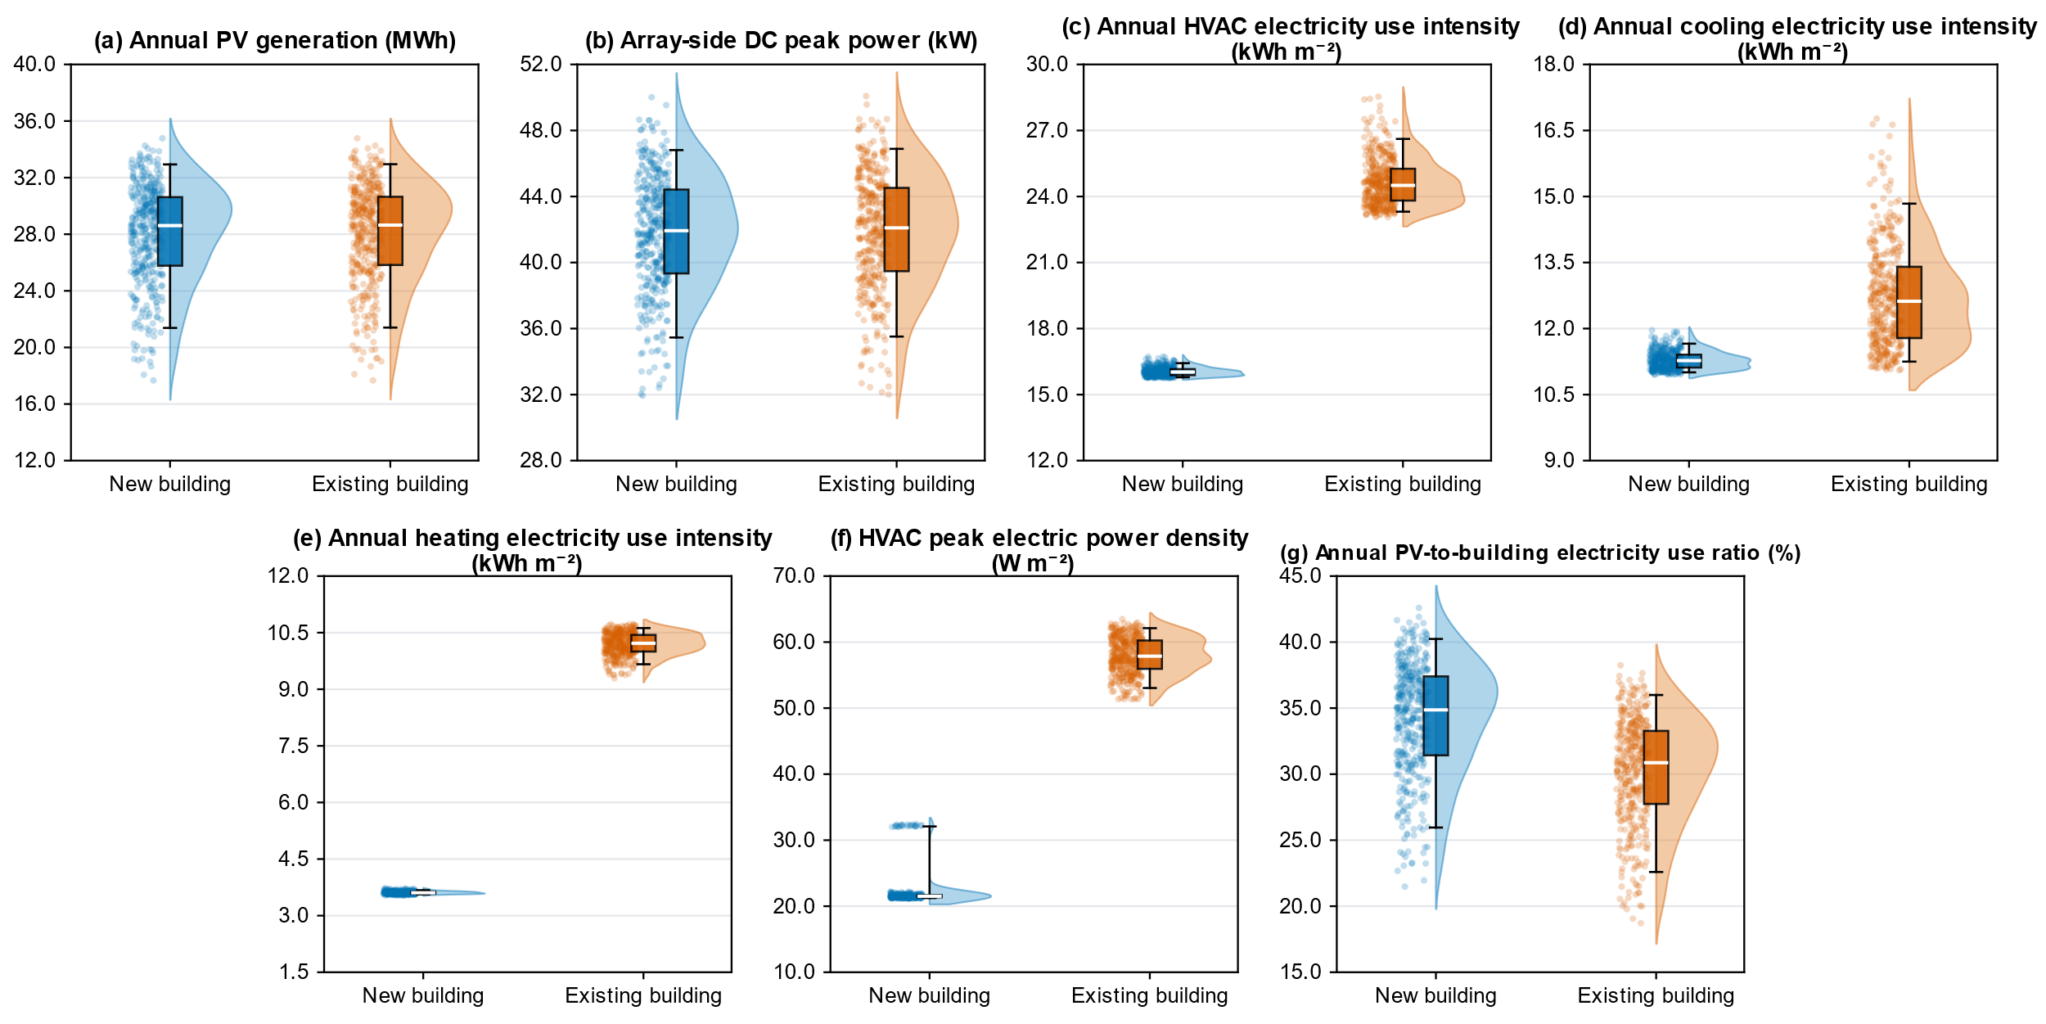
Fig. 3: Uncertainty distributions of annual and peak building–bPV performance indicators

3.2. Sensitivity of annual PV generation, array-side DC peak power, and annual PV-to-building electricity use ratio
Fig. 4 presents the signed SRRC values for annual PV generation, array-side DC peak power, and the annual PV-to-building electricity use ratio. Across the three indicators, PV tilt angle and roof albedo were consistently the dominant parameters, while mounting height, row spacing, and roof exterior CHTC generally showed weaker effects. The PV front- and rear-side CHTCs were more relevant to peak power than to annual PV generation. Similar rankings were obtained for the two building envelope scenarios, and the rank-regression models achieved R² values of 0.85–0.92. For annual PV generation, PV tilt angle was the most influential parameter, with an SRRC of −0.73. Roof albedo ranked second, with SRRCs of 0.62 and 0.63 for the new and existing building scenarios, respectively. The negative PV tilt angle SRRC indicates that generation generally decreased with increasing tilt over the sampled range of 0°–90°. This should not be interpreted as evidence that a horizontal array is universally optimal, because the optimum tilt depends on local solar conditions, array geometry, and rear-side irradiance. The positive roof albedo effect mainly resulted from increased rear-side irradiance, consistent with previous bPV studies (Basak et al., 2025; Gu et al., 2021; Patel et al., 2019).
For array-side DC peak power, PV tilt angle and roof albedo remained the two dominant parameters, while the PV front- and rear-side CHTCs became more influential than for annual PV generation. The front-side CHTC had SRRC values of 0.17 and 0.16 for the new and existing building scenarios, respectively, compared with 0.03 and 0.02 for annual PV generation. Similarly, the rear-side CHTC had an SRRC of 0.13 in both scenarios for DC peak power, compared with 0.02 for annual PV generation. The positive coefficients indicate that stronger convective cooling reduced module temperature and increased instantaneous DC output. Because the CHTCs were treated as uncertain thermal-boundary inputs, these sensitivities represent modelling uncertainty rather than direct design-control effects.
The annual PV-to-building electricity use ratio broadly followed the sensitivity pattern of annual PV generation. PV tilt angle remained the strongest negative parameter, whereas roof albedo remained the strongest positive parameter. Although roof albedo affected both PV generation and annual building electricity use, the similarity of the sensitivity ranking to that of annual PV generation suggests that PV-generation-side variability played an important role within the sampled ranges. The new building scenario showed a higher annual PV-to-building electricity use ratio because of its lower annual building electricity use, while the overall sensitivity ranking remained largely unchanged.
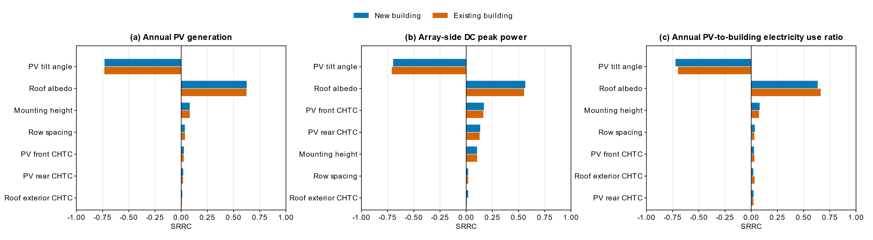
Fig. 4: Global sensitivity of annual PV generation, array-side DC peak power, and annual PV-to-building electricity use ratio

3.3. Sensitivity of annual HVAC electricity use intensity and its cooling and heating components
Fig. 5 compares the SRRC values for annual HVAC, cooling, and heating electricity use intensities. For annual HVAC electricity use intensity, roof albedo was the dominant sampled parameter in both building envelope cases, with negative SRRC values of −0.87 for the new building and −0.92 for the existing building. Roof exterior CHTC was the second most important factor, whereas mounting height, row spacing, and PV-side CHTCs had weaker effects. The rank-regression models for the annual HVAC electricity indicators showed high goodness of fit, with R² values ranging from 0.94 to 0.96.
Annual cooling electricity use intensity exhibited nearly identical sensitivity rankings in the two building envelope scenarios. Roof albedo was the dominant parameter, with SRRC values of −0.91, followed by roof exterior CHTC. In the coupled model, roof albedo simultaneously affected absorbed solar radiation at the roof, rear-side bPV irradiance, module temperatures, and roof–bPV longwave radiative exchange. Therefore, the negative SRRC should be interpreted as the net response of these coupled pathways within the sampled parameter ranges, rather than as the isolated effect of reduced roof solar absorption. The net result was lower annual cooling electricity use intensity at higher roof albedo. Annual heating electricity use intensity showed the opposite net response, with roof albedo SRRC values of 0.93 for the new building scenario and 0.88 for the existing building scenario. Within the sampled ranges, higher roof albedo was associated with lower useful solar heat gains during the heating season and consequently higher annual heating electricity use intensity. Roof exterior CHTC should be interpreted as a thermal-boundary uncertainty parameter rather than a directly controllable design variable.
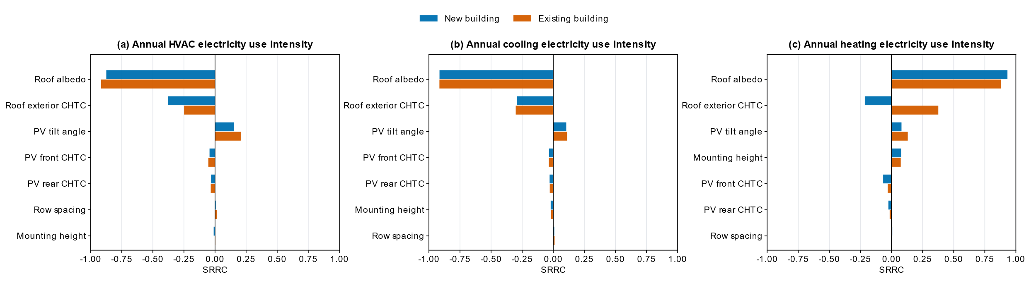
Fig. 5: Global sensitivity of annual HVAC, cooling, and heating electricity use intensities

3.4. Sensitivity analysis of HVAC peak electric power density
Fig. 6 presents the SRRC results for HVAC peak electric power density. Unlike annual HVAC electricity use intensity, this indicator is determined by the specific time step at which the maximum HVAC electric power occurs. Therefore, its sensitivity should be interpreted together with the peak-event category and timing. The annual HVAC peak occurred during the morning heating start-up period on 5 February in all 400 existing building cases, with a mean peak electric power density of 58.0 W m⁻². Roof albedo was the dominant parameter, with a positive SRRC of 0.95, followed by the roof exterior CHTC, with an SRRC of 0.21. The high rank-regression R² of 0.96 further suggests that the existing building peak response was well represented by a monotonic sensitivity structure. For the new building, the annual peaks occurred in two different event categories. Among the 400 LHS samples, 377 cases reached their annual peak during the late-morning cooling event on 16 August, with a mean peak electric power density of 21.5 W m⁻², whereas 23 cases peaked during the morning heating start-up period on 5 February, with a higher mean value of 32.2 W m⁻². The presence of these less frequent but higher heating peaks explains the upper tail observed in the new building peak-power distribution and helps explain the lower rank-regression R² of 0.67. Therefore, the SRRC values for new building peak power should be interpreted as indicative rather than fully explanatory. The opposite SRRC signs of roof albedo therefore reflect different peak-load mechanisms rather than inconsistent model behaviour. The existing building is consistently heating-dominated, whereas the new building is mainly cooling-dominated but includes a small number of high-magnitude heating-peak cases. This highlights the need to report peak-event timing and end-use category when interpreting sensitivity indices for HVAC peak demand.
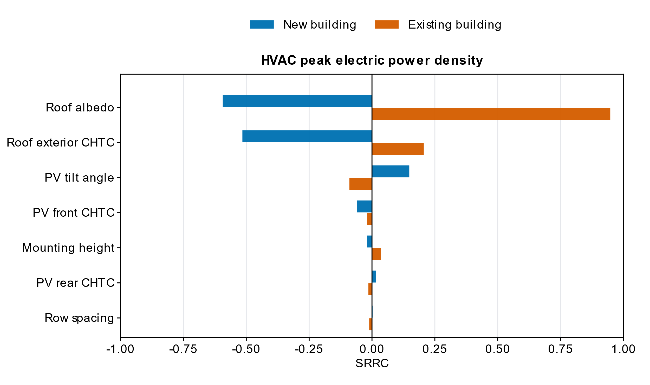
Fig. 6: Global sensitivity of HVAC peak electric power density

4. Conclusion
This study applied uncertainty analysis and global sensitivity analysis using the regression method to identify the importance of relevant design and thermal-boundary parameters in a coupled building–bifacial photovoltaic (bPV) system under new and existing building envelope scenarios. The results showed that annual PV generation varied from 21.4 to 32.9 MWh within the 5th–95th percentile range, with the same mean value of 28.1 MWh in both scenarios, indicating that building envelope performance had little influence on PV generation. In contrast, annual heating, ventilation, and air-conditioning (HVAC) electricity use intensity decreased substantially from 23.3–26.6 kWh m⁻² for the existing building to 15.8–16.4 kWh m⁻² for the new building. Within the adopted parameter ranges, annual PV generation was most sensitive to PV tilt angle, with standardized rank regression coefficients (SRRCs) of −0.73 in both scenarios, followed by roof albedo, with SRRCs of 0.62 and 0.63 for the new and existing building scenarios, respectively. Increasing PV tilt generally reduced annual PV generation, whereas increasing roof albedo increased it. The prescribed PV-side convective heat transfer coefficients (CHTCs) were more influential for array-side direct-current (DC) peak power than for annual PV generation. For example, the front-side CHTC had SRRCs of 0.17 and 0.16 for DC peak power, compared with 0.03 and 0.02 for annual PV generation in the new and existing building scenarios, respectively. On the building side, annual HVAC electricity use intensity was most sensitive to roof albedo, with SRRCs of −0.87 and −0.92 for the new and existing building scenarios, respectively, followed by roof exterior CHTC. Higher roof albedo reduced annual HVAC and cooling electricity use intensities but increased heating electricity use intensity. For HVAC peak electric power density, all 400 existing building cases peaked during morning heating start-up, with a mean value of 58.0 W m⁻². In contrast, 377 of the 400 new building cases peaked during summer cooling, with a mean value of 21.5 W m⁻², while the remaining 23 cases peaked during morning heating start-up. Overall, PV tilt primarily affected annual PV generation, whereas roof albedo influenced both PV generation and HVAC electricity use. PV-side convective heat transfer uncertainty was more relevant to DC peak power than to annual PV generation. Future work could extend the framework to other climates and building types and investigate multi-objective rooftop bPV design.

5. References
Allen, M., Poggiali, D., Whitaker, K., Marshall, T.R., Kievit, R.A., 2019. Raincloud plots: a multi-platform tool for robust data visualization. Wellcome Open Res. 4, 63. https://doi.org/10.12688/wellcomeopenres.15191.1
Basak, A., Chakraborty, S., Behura, A.K., 2025. Tilt angle optimization for bifacial PV module: Balancing direct and reflected irradiance on white painted ground surfaces. Appl. Energy 377, 124525. https://doi.org/10.1016/j.apenergy.2024.124525
European Commission - IPSC, 2008. Simlab 2.2: Reference manual.
Ganesan, K., Winston, D.P., Sugumar, S., Prasath, T.H., 2024. Performance investigation of n-type PERT bifacial solar photovoltaic module installed at different elevations. Renew. Energy 227, 120526. https://doi.org/10.1016/j.renene.2024.120526
Gu, W., Li, S., Liu, X., Chen, Z., Zhang, X., Ma, T., 2021. Experimental investigation of the bifacial photovoltaic module under real conditions. Renew. Energy 173, 1111–1122. https://doi.org/10.1016/j.renene.2020.12.024
Gu, W., Ma, T., Li, M., Shen, L., Zhang, Y., 2020. A coupled optical-electrical-thermal model of the bifacial photovoltaic module. Appl. Energy 258, 114075. https://doi.org/10.1016/j.apenergy.2019.114075
Guo, R., Gao, Y., Zhuang, C., Heiselberg, P., Levinson, R., Zhao, X., Shi, D., 2020. Optimization of cool roof and night ventilation in office buildings: a case study in Xiamen, China. Renew. Energy 147, 2279–2294. https://doi.org/10.1016/j.renene.2019.10.032
Helton, J.C., Johnson, J.D., Sallaberry, C.J., Storlie, C.B., 2006. Survey of sampling-based methods for uncertainty and sensitivity analysis. Reliab. Eng. Syst. Saf. 91, 1175–1209. https://doi.org/10.1016/j.ress.2005.11.017
LONGi Green Energy Technology Co., Ltd., 2024. Hi-MO 9 LR7-72HYD 625–660M Product Datasheet.
Mirsadeghi, M., Cóstola, D., Blocken, B., Hensen, J.L.M., 2013. Review of external convective heat transfer coefficient models in building energy simulation programs: Implementation and uncertainty. Appl. Therm. Eng. 56, 134–151. https://doi.org/10.1016/j.applthermaleng.2013.03.003
MOHURD, 2019. Technical standard for application of photovoltaic system of buildings (Standard No. GB/T 51368-2019). Ministry of Housing and Urban-Rural Development of the People’s Republic of China, Beijing.
MOHURD, 2015. Design standard for energy efficiency of public buildings (Standard No. GB 50189-2015). Ministry of Housing and Urban-Rural Development of the People’s Republic of China, Beijing.
Patel, M.T., Khan, M.R., Sun, X., Alam, M.A., 2019. A worldwide cost-based design and optimization of tilted bifacial solar farms. Appl. Energy 247, 467–479. https://doi.org/10.1016/j.apenergy.2019.03.150
Sharples, S., Charlesworth, P.S., 1998. Full-scale measurements of wind-induced convective heat transfer from a roof-mounted flat plate solar collector. Sol. Energy 62, 69–77. https://doi.org/10.1016/S0038-092X(97)00119-9
Tian, W., 2013. A review of sensitivity analysis methods in building energy analysis. Renew. Sustain. Energy Rev. 20, 411–419. https://doi.org/10.1016/j.rser.2012.12.014
Tian, X., Yin, Y., Wang, J., Jiang, F., Ji, W., Zhou, J., 2025. Research on non-uniform distribution characteristic and correction of convective heat transfer in the rooftop photovoltaic array. Sustain. Energy Technol. Assess. 83, 104571. https://doi.org/10.1016/j.seta.2025.104571
United Nations Environment Programme, 2025. Not just another brick in the wall: The solutions exist - Scaling them will build on progress and cut emissions fast. Global Status Report for Buildings and Construction 2024/2025. United Nations Environment Programme. https://doi.org/10.59117/20.500.11822/47214
U.S. Department of Energy, 2024. EnergyPlus Input Output Reference: Version 24.2 (Input Output Reference). U.S. Department of Energy.
U.S. Department of Energy, n.d. EnergyPlus weather data: Chongqing, Chongqing, Shapingba 575160 (CSWD). EnergyPlus. https://energyplus.net/weather-location/asia_wmo_region_2/CHN/CHN_Chongqing.Chongqing.Shapingba.575160_CSWD (accessed 6.22.26).
Wang, J., Jiang, F., Lin, X., Yousif, C., Ji, W., Yuan, Y., Zhou, J., 2025. Field measurement on the wind and thermal microenvironment of distributed PV array. J. Build. Eng. 105, 112492. https://doi.org/10.1016/j.jobe.2025.112492
Zhong, J., Zhang, W., Xie, L., Zhao, O., Wu, X., Zeng, X., Guo, J., 2023. Development and challenges of bifacial photovoltaic technology and application in buildings: A review. Renew. Sustain. Energy Rev. 187, 113706. https://doi.org/10.1016/j.rser.2023.113706
Zhuang, C., Gao, Y., Zhao, Y., Levinson, R., Heiselberg, P., Wang, Z., Guo, R., 2021. Potential benefits and optimization of cool-coated office buildings: A case study in Chongqing, China. Energy 226, 120373. https://doi.org/10.1016/j.energy.2021.120373

