EuroSun2026
LONG-TERM THERMAL PERFORMANCE OF HEATING SYSTEM INTEGRATED WITH HEAT PUMP AND SMALL-SCALE SEASONAL HEAT STORAGE TANK USING SOLAR THERMAL ENERGY FOR ENERGY SAVING OF GREENHOUSE

Summary
This study developed a solar thermal-based heating system capable of supplying 100% of the heating energy required for greenhouse horticulture and experimentally verified its long-term energy supply performance over a three-year period. The proposed heating system stores thermal energy generated by solar collectors in a seasonal thermal storage tank and supplies heating energy to a 3,850 ㎡ greenhouse cultivating subtropical crops in combination with a heat pump. The solar collector system was configured as a hybrid system combining flat-plate collectors and evacuated tube collectors operating in the low-temperature range. The seasonal thermal storage system was designed as a small-capacity tank suitable for the scale of the demonstration greenhouse. Heat produced during the summer season was stored in the tank and later used either directly for greenhouse heating in winter or as a heat source for a water-source heat pump. In addition, a shallow-ground thermal storage system was implemented to evaluate its feasibility for thermal storage and its potential use as a heat source for the heat pump. For the system demonstration, part of the existing greenhouse was removed and a new mechanical room was constructed. Solar collectors were installed on the roof of the mechanical room, while the heat pump and shallow-ground thermal storage system were installed below the roof. The seasonal storage tank, buffer tank, pumps, piping, and operation control system were installed inside the mechanical room, resulting in a compact and integrated system configuration. The system was operated continuously for three years, and the energy balance of heat production, storage, and supply for greenhouse heating was analyzed based on long-term measured operational data.
Keywords: Greenhouse space heating, Heat pump, Long-term thermal performance, Solar collector
Field of application for the findings: The findings can be applied to greenhouse horticulture, smart farms, and other facilities with high heating demand. The solar thermal seasonal storage and heat pump system can support energy self-sufficiency, reduce fossil fuel use, and lower carbon emissions in agricultural and building heating applications.
Addressed audience: researchers, engineers, industry professionals, and policy makers related to renewable energy, greenhouse systems, and energy systems
- Introduction
The application of renewable energy in the agricultural sector has very low scalability when considering system size, applicability, and cost, which makes achieving carbon neutrality in agriculture particularly challenging. Conversely, the agricultural sector requires significant technological development, deployment of renewable energy systems, and substantial investment to achieve carbon neutrality. In addition, agricultural land is primarily used for crop cultivation, resulting in very limited available land for installing renewable energy systems. Therefore, considering these site constraints, renewable energy systems should be integrated into a compact mechanical room to maximize land use efficiency. Furthermore, fuel and electricity costs required for greenhouse heating and cooling systems are increasing due to rising energy prices and supply instability, which increases farm operating costs and places a financial burden on farmers. Therefore, technological development to solve these complex problems is urgently needed.
In this study, a solar thermal seasonal storage-based heat pump integrated heating supply system was developed to reduce greenhouse heating energy consumption. A small-scale seasonal thermal storage tank capable of storing hot water produced by solar collectors during the summer was developed. To ensure long-term storage performance, heat loss was minimized and the insulation performance of the storage tank envelope was improved. A small shallow underground thermal storage system combining vertical and horizontal configurations was also applied, and the feasibility of using the stored heat in the horizontal storage as a heat source for a hybrid heat pump system was analyzed. The application of a hybrid heat pump allows the hot water stored in the seasonal storage tank, produced by solar collectors, to be used as a heat source, thereby improving the overall efficiency of the integrated system.
In this study, the developed renewable energy-based heating supply system was demonstrated through long-term operation over a three-year period, and the results confirmed that the developed system can overcome several limitations of conventional greenhouse heating systems.
- System energy balance calculation
This study proposes an integrated heating system for greenhouses that combines solar thermal energy, seasonal thermal storage, and heat pump technologies, as illustrated in Fig. 1. The system includes solar collectors, a seasonal thermal storage tank, shallow ground heat storage, heat pumps, and an operation and control system. Thermal energy collected from the solar collectors is used directly for greenhouse heating during spring, autumn, and winter when heating demand exists. During the summer period, when heating is not required, the collected thermal energy is stored in the seasonal thermal storage tank for later use during the heating season. During winter operation, high-temperature heat stored in the seasonal storage tank can be supplied directly to the greenhouse heating system. In addition, low-temperature stored heat is transferred to the shallow ground heat storage system and used as a heat source for a multi-source heat pump. The multi-source heat pump is designed to utilize low-temperature residual heat (10–35 °C) from the seasonal thermal storage tank as the primary heat source. After this residual heat is depleted, additional heat sources such as an air-source heat pump or shallow geothermal energy are used to maintain stable heating operation. By replacing conventional fossil fuel-based heating systems, the proposed system can significantly reduce greenhouse heating energy consumption. Moreover, the use of heat pump technology allows the electrification of heating energy demand, which can contribute to reducing carbon emissions and improving overall system energy efficiency.

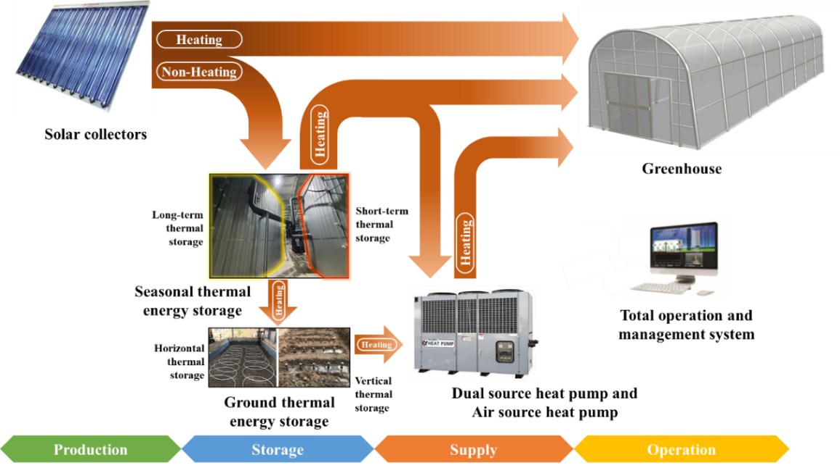
Fig. 1 Concept of a heat supply system combining a solar thermal and seasonal thermal energy storage-based dual source heat pump.
The heat loss of the STES tank was not measured directly but was estimated using an energy balance method based on long-term monitored temperature stratification and measured heat input and output. Although separate static cooling tests or experimental measurements of the heat loss coefficient were not performed, this approach allows thermal losses to be evaluated at the system level under actual operating conditions. The coefficient of performance (COP) for each water and air source heat pump can be computed as:
${COP}_{wshp}=\frac{Q_{wshp}}{P_{wshp}+P_{wshp.pump}}$ (1)
where $Q_{wshp}$is the thermal energy produced by the ground source heat pump, $P_{wshp }$ is the electrical power consumption of the ground source heat pump, $P_{wshp.pump}$is the electrical power consumption of the circulation pump.
- Results and Discussion
During the demonstration period, the multi-source heat pump using the seasonal thermal storage tank as a heat source generated a total of 23.89 MWh of thermal energy. As presented in Fig. 2, the average COP based on the heat output from the seasonal thermal storage heat source was 4.1. The performance of the multi-source heat pump was strongly influenced by the water source temperature, and the COP increased as the source temperature increased. The air-source heat pump was operated when the temperature of the seasonal storage tank heat source ranged between 35 and 45 °C, corresponding to the H-2 operating mode. In this mode, the heat pump did not directly supply heat to the greenhouse load. Instead, heat was stored in the shallow-ground storage system until the storage temperature decreased to approximately 35 °C or lower, after which the system operated using a combined heat source. Furthermore, the air-source heat pump was also operated during high heating demand periods requiring simultaneous operation of both the combined heat source heat pump and the air-source heat pump, such as in the H-5 operating mode, or when operation of the combined heat source heat pump was not possible, such as in the H-6 mode. During the demonstration period, the combined heat-source heat pump operating in air-source mode produced 37.48 MWh of thermal energy with an average COP of 3.9.
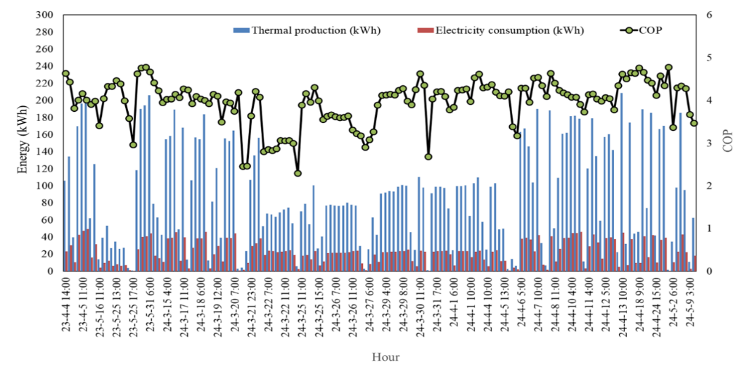
Fig. 2 The COP of the multi-source heat pump.
- References
J. Wang, Q. Luo, J. Cheng, M. Qu, P. Wang, S. Zhao, H. Xu, C. Ma, Study on thermal property of a solar collector applied to solar greenhouse, Appl. Therm. Eng. 244 (2024) 122628.
A. Vadiee, V. Martin, Thermal energy storage strategies for effective closed greenhouse design, Appl. Energy. 109 (2013) 337–343.
A.V. Novo, J.R. Bayon, D. Castro-Fresno, J. Rodriguez-Hernandez, Review of seasonal heat storage in large basins: Water tanks and gravel–water pits, Appl. Energy. 87 (2010) 390–397.
G. Oliveti, N. Arcuri, S. Ruffolo, First experimental results from a prototype plant for the inter seasonal storage of solar energy for the winter heating of buildings, Sol. Energy. 62 (1998) 281–290.
Appendix: NOMENCLATURE

ASHP: Air source heat pump
BT: Buffer tank
COP: Coefficient of Performance
ETC: Evacuated tube solar collector
FPC: Flat plate solar collector
FCU: Fan coil unit
GTES: Ground thermal energy storage
GTES_Hor: Horizontal type ground thermal energy storage
GTES_Ver: Vertical type ground thermal energy storage
NH: Non-Heating
H: Heating
SOL: Evacuated tube solar collector
SOL2: Flat plate solar collector
STES: Seasonal thermal energy storage
WSHP: Water source heat pump

