EuroSun2026
EVALUATION OF MACHINE-LEARNING-BASED SITE ADAPTATION FOR SATELLITE-DERIVED SOLAR IRRADIANCE IN A HOT DESERT CLIMATE
Dunia Bachour, Abdulwahab Ziaullah
Qatar Environment and Energy Research Institute, Hamad Bin Khalifa University, Doha, Qatar
dbachour@hbku.edu.qa, awahab@hbku.edu.qa

Summary
Accurate satellite-derived solar irradiance is essential for solar-resource assessment where dense ground-monitoring networks are difficult to maintain. This study builds on a recently published benchmark of five site-adaptation approaches spanning distribution-based, linear-regression, and nonlinear machine-learning methods, using five years of 1-min GHI and DNI measurements from 13 stations in Qatar. Models were trained on 2020-2022 observations and independently evaluated over 2023-2024 against synchronized CAMS-Rad data. Feed-Forward Neural Network (FFNN) achieved the lowest overall rRMSE and was therefore examined further using all 8,191 possible station combinations. For each network size, the median and interquartile range of rRMSE were analysed together with the fraction of configurations that did not improve raw CAMS-Rad, allowing both typical performance and sensitivity to station selection to be assessed. The strongest sensitivity occurred for two-station networks, after which the non-improving rate decreased rapidly, reaching zero from seven stations onward for DNI and from eight stations onward for GHI. The two-station behavior was not reproduced by Gradient Boosting Machine (GBM), while a separate spatial analysis showed that geographic separation alone does not explain the poorly performing two-station FFNN configurations. The change in median rRMSE between successive network sizes further showed that improvements become progressively smaller as the network grows. For the Qatar network, seven calibration stations therefore represent a practical point of diminishing returns: performance is already highly robust to station selection at this size, while further network expansion provides only small additional reductions in median error.
Satellite irradiance, site adaptation, CAMS-Rad, machine learning, GHI, DNI, arid climate
Field of application for the findings: Solar resource assessment, satellite irradiance site adaptation, and solar monitoring-network planning in arid regions.
Addressed audience: Solar-resource researchers, project developers, monitoring-network operators, and engineers using satellite-derived irradiance in desert climates.
- Introduction
Satellite-derived irradiance products are widely used for solar-resource assessment because they provide continuous spatial coverage and long temporal records. Their direct use can still be problematic in hot desert regions, where aerosol loading, dust events, cloud-screening uncertainty, high clear-sky frequency, and pixel-to-point mismatch can produce systematic errors in surface irradiance estimates. Ground-based site adaptation is therefore required when satellite data are used for bankable resource assessment, plant design, or operational performance evaluation.
Existing site-adaptation methods range from distribution mapping to nonlinear machine-learning correction (Maraun, 2015; Friedman, 2001). Multi-site studies have demonstrated the value of local adaptation and statistical learning (Polo et al., 2020; Verbois et al., 2023). Using same configuration of Qatar monitoring station network, Bachour et al. (2026) showed that spatial behavior is component-dependent: the global horizontal irradiance (GHI) is comparatively uniform, whereas the direct normal irradiance (DNI) is more spatially variable and its extrapolation error increases more sharply with station separation. That result is relevant to station placement, but it does not answer whether a small set of stations forms a representative training domain for a regional machine-learning correction. This distinction motivates the present ground monitoring station network-robustness analysis.
The present study extends the previous cost-error optimization framework reported by Ziaullah et al. (2026) by evaluating the robustness of satellite-irradiance site adaptation to calibration-station selection. Rather than only identifying the best-performing adaptation model, the analysis examines how consistently that model performs when different subsets of calibration stations are used. The main research questions addressed are:
- How sensitive is FFNN performance to station selection at a fixed calibration-network size?
- How does the typical adaptation error change as the calibration network increases in size?
- At what network size do additional calibration stations provide only limited further improvement?
- Can the anomalous behavior of sparse two-station FFNN networks be explained by model choice or by station-pair separation?
- Data & Methods
2.1. Ground network and satellite product
The study uses 1-min GHI and DNI observations from 13 ground-monitoring stations distributed across Qatar. The data cover 2020-2024 and are synchronized with CAMS-Rad satellite-derived irradiance after the quality-control procedure described in Perez-Astudillo et al. (2018). The training period is 2020-2022, and the independent test period is 2023-2024. The full dataset contains 12,677,886 synchronized records after filtering, with 7,602,458 records in training and 5,075,428 records in testing. All station configurations were evaluated using the same independent test dataset covering the 13 stations, ensuring that comparisons among configurations were not affected by changes in the evaluation sample.
2.2. Site-adaptation models
Five site-adaptation methods are considered: empirical quantile mapping (EQM), linear regression (LR), random forest (RF), gradient boosting machine (GBM), and feed-forward neural networks (FFNN). EQM provides a distribution-based correction baseline, LR provides a simple regression benchmark, and RF, GBM, and FFNN represent nonlinear machine-learning approaches. The dynamic calibration framework and baseline cost-error optimization have been reported in (Ziaullah et al., 2026). The five-model comparison is retained to identify the strongest correction method, while the subsequent station-combination analysis focuses on FFNN because it provides the lowest overall rRMSE for both GHI and DNI.
2.3. Station-combination analysis
For the network-design analysis, all possible station combinations containing between 1 and 13 stations were considered, giving 8,191 configurations. Each configuration is trained using only its selected stations but is evaluated against the same independent 2023-2024 test dataset covering all 13 stations, following Ziaullah et al. (2026). For each network size (k), all possible combinations of stations are selected i.e. all k-subsets from a total of 13-station. The corresponding FFNN rRMSE values are used to characterize the variability in performance across alternative station selections of the same size. This allows the analysis to distinguish the effect of network size from the sensitivity to which particular stations form the calibration set.
Station-selection robustness is characterized by using two complementary measures. First, the rRMSE distribution at each network size is summarized by its median and interquartile range (IQR = Q75 - Q25). The median represents the typical rRMSE at a given network size, while the IQR shows the range over which the middle 50% of station combinations perform. These statistics are used to summarize the central tendency and spread of the results across station configuration. Second, the percentage of station configurations for which FFNN does not improve the CAMS-Rad baseline was calculated at each network size and expressed as the non-improving configuration rate, R_{non-improving,k}, defined in Equation 1 as:
$R_{non-improving, k}(\%)=100* \frac{n_{bad,k}}{n_{k}}$ (Eq. 1)
where n_{bad,k} is the number of k-station configurations for which the rRMSE exceeds the corresponding raw CAMS-Rad rRMSE, and n_{k} is the total number of configurations at that network size.
A narrow IQR shows that different station selections of the same size give similar FFNN performance, while a wider IQR means that the result depends more on which stations are chosen. The non-improving configuration rate adds a second perspective by showing how often a given network size fails to improve the CAMS-Rad baseline. Together, the two measures indicate how robust the FFNN is to station selection.
To quantify how typical accuracy changes with network size, the change in median rRMSE between consecutive network sizes is defined in Equation 2 as:
${∆E}_{k}= E_{k-1}- E_{k}$, (Eq. 2)
where E_{k} is the median rRMSE across all k-station configurations and E_{k-1} is the corresponding median for the immediately preceding network size. A positive ∆E_{k} indicates that the median rRMSE is lower at network size k, whereas a negative value indicates an increase in median error. Because the station combinations at successive network sizes are not matched one-to-one, ∆E_{k} represents the change in typical performance with network size rather than the benefit of adding a particular station to an existing network. The analysis also includes a follow-up spatial diagnostic for configurations that departed from the general network-size trend.

3. Results and Discussion

3.1. Five-model benchmark
The independent 2023-2024 benchmark is summarized in Fig. 1. Raw CAMS-Rad rRMSE is 19.14% for GHI and 35.44% for DNI. All five adaptation methods reduce the residual error, with FFNN providing the lowest rRMSE: 11.43% for GHI and 23.78% for DNI, corresponding to improvements of 40.28% and 32.90% relative to CAMS-Rad. GBM is the strongest boosting alternative, with rRMSE values of 12.05% and 24.83% for GHI and DNI, respectively.

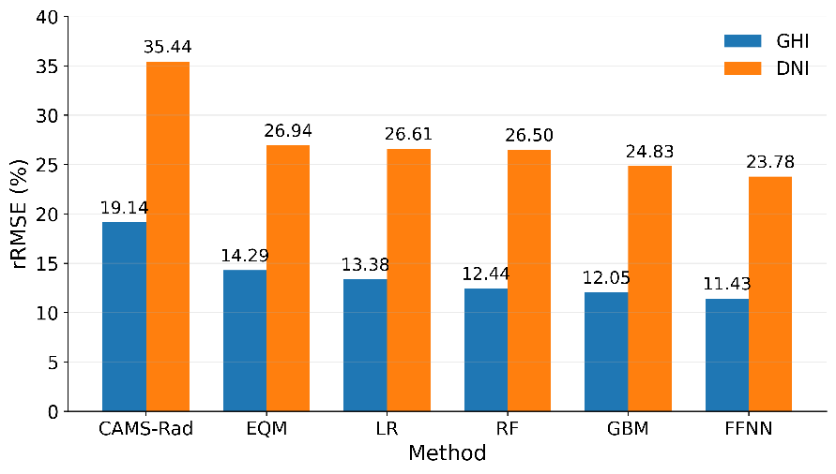
Fig. 1: rRMSE improvement relative to CAMS-Rad for the five site-adaptation methods.

These benchmark results identify FFNN as the best-performing adaptation method and justify its use in the subsequent combination-level network analysis

3.2. Station-selection robustness
Figure 2 shows, for each network size from 1 to 13 stations, the median rRMSE across all available configurations together with the IQR. The median represents the typical error at that network size, while the IQR indicates how much performance varies across the middle 50% of station combinations. The CAMS-Rad baseline provides a direct reference for assessing whether the FFNN adaptation improves the uncorrected satellite estimates. This analysis therefore shows how robust FFNN performance is to the choice of calibration stations at a given network size.
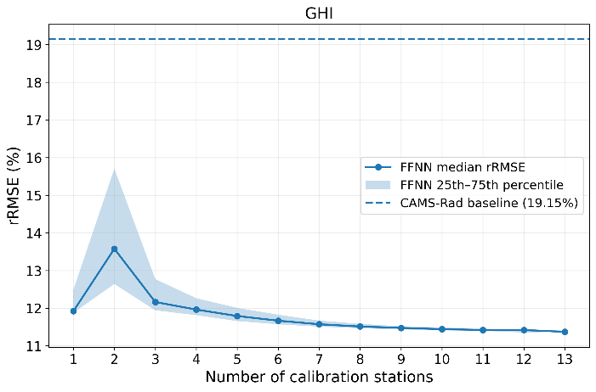 | 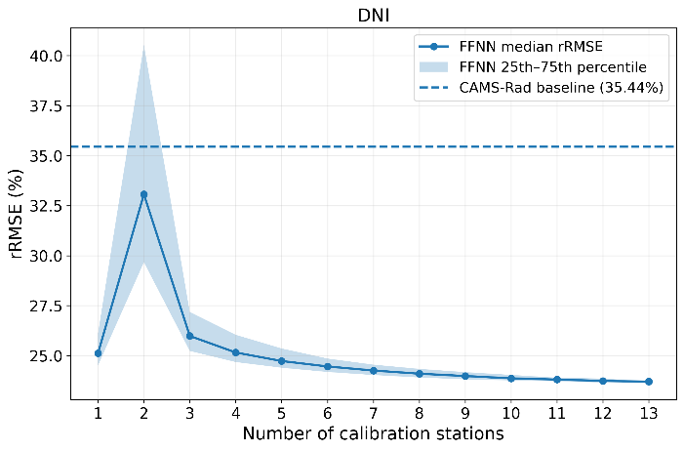
Fig. 2: Median FFNN rRMSE and IQR across station combinations by network size for GHI and DNI; dashed lines shows CAMS-Rad baseline rRMSE.
At small network sizes, FFNN performance does not improve monotonically with station number. For GHI, the median rRMSE rises from 11.92% for one-station configurations to 13.58% for two-station configurations, with an IQR of 3.06 percentage points, before falling to 12.16% at three stations. The effect is stronger for DNI: the median rises from 25.11% to 33.07% at two stations, with an IQR of 10.87 percentage points, and then falls to 25.98% at three stations. The spread decreases rapidly as the network size increases; by seven stations, the IQR is about 0.16 percentage points for GHI and 0.52 percentage points for DNI. The two-station networks behave differently from the surrounding network sizes: their median error is higher than for both one- and three-station networks, and the wider IQR indicates that performance depends more strongly on which pair of stations is selected. To explain the two-station deterioration observed for FFNN, the GBM model was subsequently examined as an additional comparison to determine whether the unusual behavior observed for sparse FFNN networks also occurred with a different nonlinear learning method. However, the deterioration observed for the FFNN when using two calibration stations was not reproduced by the GBM in the corresponding model comparison (data not shown). Therefore, this two-station behavior should not be interpreted as evidence that two calibration sites are inherently insufficient. Moreover, the distance between stations were examined to explain which pairs performed poorly. The distributions for improving and non-improving pairs are compared in Figure 3. Larger station-pair separation was not associated with poorer FFNN performance. For GHI, the median separation was 41.6 km for non-improving pairs and 65.2 km for improving pairs. For DNI, the corresponding medians were 46.5 and 73.3 km. The DNI results make this pattern particularly clear: 12 of the 20 pairs in the closest-distance quartile were non-improving (60%), compared with 14 of the remaining 58 pairs (24.1%). At the same time, the most extreme-error configuration was separated by about 109.3 km. Poor performance therefore occurs among both relatively close and widely separated pairs, indicating that geographic separation alone does not explain the two-station behavior.

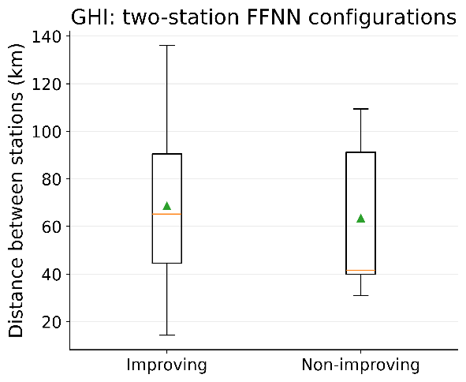 | 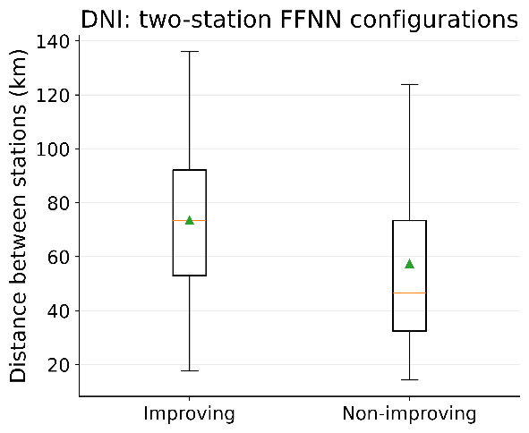

Fig. 3. Distance between improving and non-improving two-station configurations using FFNN for GHI and DNI.

The fact that the same deterioration is not observed with GBM suggests that the effect may be related to how the FFNN responds to very limited spatial information in the training data. In particular with only two calibration sites, latitude and longitude vary at only two locations while the trained model is evaluated across the full 13-site network. This may make the learned spatial dependence sensitive to the specific pair used for training. Further analysis, including repeated FFNN training and examination of the role of the spatial input features, would be needed to establish the underlying mechanism.
A complementary measure of robustness is the fraction of station configurations for which FFNN does not improve upon the raw CAMS-Rad rRMSE. This quantity, calculated using Equation 1, is reported in Table 1 for each network size $k$.

Tab. 1: FFNN configurations with rRMSE higher than the uncorrected CAMS-Rad baseline at each network size.
k | GHI non-improving, n/N (%) | DNI non-improving, n/N (%) | k | GHI non-improving, n/N (%) | DNI non-improving, n/N (%)
1 | 0/13 (0.00%) | 0/13 (0.00%) | 8 | 0/1287 (0.00%) | 0/1287 (0.00%)
2 | 7/78 (8.97%) | 26/78 (33.33%) | 9 | 0/715 (0.00%) | 0/715 (0.00%)
3 | 2/286 (0.70%) | 9/286 (3.15%) | 10 | 0/286 (0.00%) | 0/286 (0.00%)
4 | 3/715 (0.42%) | 2/715 (0.28%) | 11 | 0/78 (0.00%) | 0/78 (0.00%)
5 | 5/1287 (0.39%) | 2/1287 (0.16%) | 12 | 0/13 (0.00%) | 0/13 (0.00%)
6 | 1/1716 (0.06%) | 2/1716 (0.12%) | 13 | 0/1 (0.00%) | 0/1 (0.00%)
7 | 1/1716 (0.06%) | 0/1716 (0.00%)

The results confirm the pattern seen in the median and IQR analysis. For GHI, 7 of the 78 two-station pairs (8.97%) are non-improving; this falls below 1% at three stations and reaches zero from eight stations onward. For DNI, 26 of 78 pairs (33.33%) are non-improving, compared with 3.15% at three stations, less than 0.3% from four to six stations, and zero from seven stations onward. Beyond this point, expanding the network to all thirteen stations has little additional effect on reducing rRMSE.

3.3. Change in median error with network size
To examine more directly how the typical error changes as the network grows, Figure 3 shows the change in median rRMSE between successive network sizes, calculated using Equation 2. Positive values indicate a lower median error at the larger network size, while negative values indicate a higher median error. The comparison is based on the median performance across all configurations at each network size and therefore does not represent the effect of adding a particular station to a specific network.

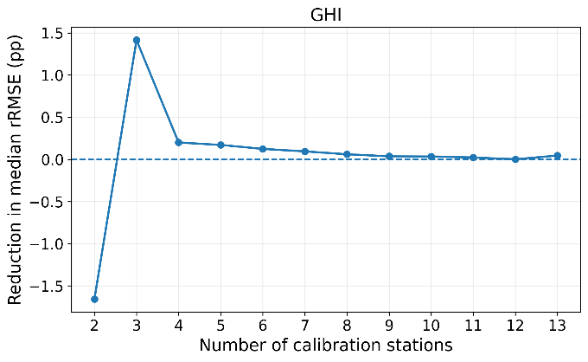 | 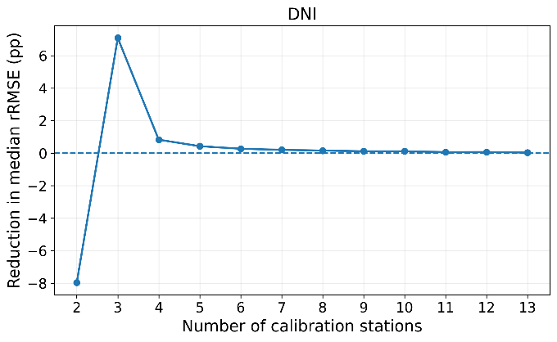

Fig. 4: Change in median FFNN rRMSE between successive calibration-network sizes for GHI (left) and DNI (right).
Figure 3 shows the same sparse-network reversal from a different angle. Moving from one to two stations increases the median error by 1.66 percentage points for GHI and 7.95 percentage points for DNI, while moving from two to three stations reduces it by 1.41 and 7.08 percentage points, respectively. Beyond three stations the changes remain positive overall but become progressively smaller. From three to seven stations, median rRMSE falls by 0.59 percentage points for GHI and 1.73 percentage points for DNI. Expanding further from seven to thirteen stations produces only another 0.20-percentage-point reduction for GHI and 0.55-percentage-point reduction for DNI. For GHI, every subsequent network-size gain is below 0.10 percentage points from seven stations onward; for DNI, the same condition is reached from eleven stations onward.

4. Conclusions
This study builds on the five-model benchmark and exhaustive FFNN station-combination analysis to examine site adaptation from the perspective of monitoring-network robustness. FFNN achieved the lowest overall rRMSE in the independent 2023–2024 evaluation, with values of 11.43% for GHI and 23.78% for DNI. Robustness was then assessed across all network sizes using the variation in error among station combinations and the fraction of configurations that did not improve the raw CAMS-Rad estimates. The strongest sensitivity to station selection occurred for the two-station networks, where 8.97% of GHI pairs and 33.33% of DNI pairs were non-improving. This behavior was not reproduced by the GBM model, indicating that the deterioration is not an inherent consequence of using two calibration stations. The spatial analysis further showed that geographic separation alone does not explain which FFNN station pairs perform poorly.
As the calibration network grows, two clear trends emerge. The spread in performance among different station selections decreases substantially, while non-improving configurations become increasingly rare. At the same time, the reduction in median rRMSE obtained by further increasing the network size becomes progressively smaller. These results complement the cost-error analysis of Ziaullah et al. (2026), which identified a seven-station solution under the operational weighting scheme used in that study. Here, the seven-station case is also shown to be highly robust to station selection, with only small variation in rRMSE among the possible configurations.
For the 13-site Qatar network, seven calibration stations therefore represent a practical point of diminishing returns. At this network size, the IQR is only about 0.16 percentage points for GHI and 0.52 percentage points for DNI, indicating little variation among the 1,716 possible seven-station configurations. All seven-station configurations improve CAMS-Rad for DNI, while only one is non-improving for GHI. Expanding the network from seven to all thirteen stations reduces the median rRMSE by only about 0.20 percentage points for GHI and 0.55 percentage points for DNI. From eight stations onward, every configuration improves CAMS-Rad for both components. Within the existing Qatar monitoring network, these results show that a moderate-size calibration network can provide both reliable adaptation and low sensitivity to the particular stations selected, while further expansion yields comparatively small additional gains in accuracy.

Acknowledgements
Research reported in this work was supported by the Qatar Research Development and Innovation Council (Grant: ARG01-0523-230304). The content is solely the responsibility of the authors and does not necessarily represent the official views of Qatar Research Development and Innovation Council.
- References
Bachour, D., Perez-Astudillo, D., Ziaullah, A., 2026. A decision-support system for solar energy resource planning in arid desert regions. Sustainable Energy Technologies and Assessments 86, 104884. https://doi.org/10.1016/j.seta.2026.104884
Friedman, J.H., 2001. Greedy function approximation: a gradient boosting machine. Annals of Statistics 29, 1189-1232.
Maraun, D., 2015. Bias correction, quantile mapping, and downscaling: revisiting the inflation problem. Journal of Climate 28, 6710-6722.
Perez-Astudillo, D., Bachour, D., Martin-Pomares, L., 2018. Improved quality control protocols on solar radiation measurements. Solar Energy 169, 425-433. https://doi.org/10.1016/j.solener.2018.05.028.
Polo, J., Fernandez-Peruchena, C., Salamalikis, V., Mazorra-Aguiar, L., Turpin, M., Martin-Pomares, L., Kazantzidis, A., Blanc, P., Remund, J., 2020. Benchmarking on improvement and site-adaptation techniques for modeled solar radiation datasets. Solar Energy 201, 469-479.
Verbois, H., Saint-Drenan, Y.-M., Libois, Q., Michel, Y., Cassas, M., Dubus, L., Blanc, P., 2023. Improvement of satellite-derived surface solar irradiance estimations using spatio-temporal extrapolation with statistical learning. Solar Energy 258, 175-193.
Ziaullah, A.W., Bachour, D., Perez-Astudillo, D., 2026. Dynamic machine learning calibration of satellite-derived solar irradiance in arid climates with accuracy-cost tradeoffs. Solar Energy 317, 114939. https://doi.org/10.1016/j.solener.2026.114939

