EuroSun2026
Operational analysis for an air PVT collector with an optimized design for easy integration

Summary
This study investigates the development and experimental evaluation of a novel air-based hybrid photovoltaic–thermal (PVT) solar collector designed for standardized installation on common roof typologies, priorizing versatility and cost-effectiveness. To enhance thermal performance, two internal airflow modification strategies were implemented: linear and wavy obstacles. The prototype was experimentally evaluated under natural environmental conditions using a dedicated testing bench with six panels installed on a tilted roof. Results show stable electrical efficiency, averaging 20.76%, but a highly variable thermal efficiency, ranged between 5.6 – 19.7 %, particularly depending on airflow rate and external wind speed. The insertion of internal obstacles results in an average improvement of 16% in the thermal efficiency. The system is capable of heating the ambient air by an average range of 3.3 and 7.3 °C depending on the indoor airflow, reaching maximum gain values between 8.5 and 22 °C during peak sunshine hours. These findings suggest the collector is highly suitable for preheating ventilation air and supporting residential or industrial space heating. Future phases of the research will involve field testing in demonstrator buildings at different locations to assess long-term performance in real-world scenarios.
Keywords: Air PVT, experimental, thermal and electrical efficiency, obstacles,
Field of application for the findings: Sustainable Building Integration
Addressed audience: Energy researchers, Architects, Structural Engineers, solar planners

- Introduction
The advancement of renewable energy sources is undeniable. Recent reports indicate that the share of renewable energy has reached 13.5% of final energy consumption (REN21, 2025), with solar and wind power standing out over the past decade. However, despite the increasing share of renewable energy in total energy generation, global energy demand grew by 2.2% in 2024 (IEA, 2025). Consequently, it becomes necessary to explore solutions that reduce the energy demand of buildings or enable energy generation at the point of consumption, as is the case with solar self-consumption systems.
Photovoltaic solar energy has experienced the greatest growth in recent years due to the reduction in costs and the ease of installation. However, solar thermal technology still presents higher energy conversion efficiencies. Combining both technologies into a single module (hybrid photovoltaic-thermal, PVT) optimizes the utilization of the available solar surface, generating a higher energy output per square meter while simultaneously supplying thermal and electrical energy for direct on-site consumption in buildings. Consequently, PVT technology emerges as a promising alternative to fossil fuels, as highlighted by initiatives such as IEA SHC Task 73 (IEA SHC, 2025).
Although water is the most commonly used heat transfer fluid, recent research has also explored the use of air as working fluid, specially for building integration (Maghrabie et al., 2021). While this configuration results in lower thermal efficiency, it offers several advantages, such as simpler installation, lower costs, and reduced maintenance requirements (Aspetakis & Wang, 2025).
The potential application range of air-based photovoltaic-thermal (PVT) technology is remarkably broad, although it has not yet converged on a single definitive reference application (Aspetakis & Wang, 2025; Chaibi et al., 2021). In the residential and commercial sectors, their primary implementation focuses on space heating and preheating fresh ventilation air, which significantly reduces the thermal load in cold climates and enhances the performance of heat recovery ventilation (HRV) systems (Abdelrazik et al., 2022; Ahn et al., 2015; Shahsavar & Khanmohammadi, 2019). Furthermore, these systems are increasingly integrated with heat pumps to support domestic hot water (DHW) production or utilized in peak shaving strategies to mitigate high energy demand periods (Choi et al., 2020; Delisle & Kummert, 2016). Beyond building environments, air-based PVT collectors are highly effective in agricultural applications, such as the drying of crops, fruits, and medicinal plants, where they provide both the necessary heat for dehydration and the electricity required to operate circulation fans (Kong et al., 2020; Pirasteh et al., 2014). Their implementation in industrial processes and low-temperature heating configurations establishes them as a critical technology for achieving net-zero energy building (NZEB) requirements and advancing global decarbonization goals.
Although the solar air collector industry has been established for several decades, with various companies operating in Canada, Australia, and Northern Europe (Epp, 2026), the implementation of actual air-based PVT systems remains scarce, with a small number of air-based PVT collectors available on the market (AEE INTEC, 2025; Epp, 2026). Over the last decade, research dedicated to this technology has increased significantly, but it has been focused primarily on the prototype stage. Currently, there is a lack of reference panels on the market, as well as medium-to-long-term operational data. Experts emphasize the urgent need to work on the transfer of laboratory results to real-world installations to inform practitioners and ensure long-term viability (Simón-Allué et al., 2023).
With the objective of supporting this transition this study presents a novel design of a hybrid solar air collector aimed at facilitating and homogenizing its installation on standard roof typologies. In addition, experimental performance data obtained from its operation in a test bench is presented. The proposed design is oriented toward an industrial warehouse use case, with the objective of partially covering both electricity and heating demands.
- Material & methods
2.1. Description of PVT system
A new air-based PVT system has been developed including cutting-edge PV technologies, enhancing thermal performance and standardizing the external design for its installation in main types of residential and industrial roofs. To that end, versatility (capable of being installed with minimal modification on different types of roofs: flat, sloped, sheet metal, tile, etc.) and low cost (competitive with other technologies on the market and with a slight increase over the cost of the standalone PV) have been among the fundamental design criteria applied.
The resulting PVT panel is composed by a PV laminate on the frontal side and an in-house designed tray attached at the rear, allowing air circulation in between (see Fig. 1). The rear tray has been designed to fit the height of common solar structure profiles, enabling an easy installation in flat as well as in tilt roofs. PV laminate has a nominal power of 445Wp and incorporates a double-glass N-type TOPCon cell technology (full description in Tab. 1), which provides better electrical performance at high temperatures and lower degradation rates, expanding the lifetime of the panels. The first prototype of this panel is shown in Fig. 2.
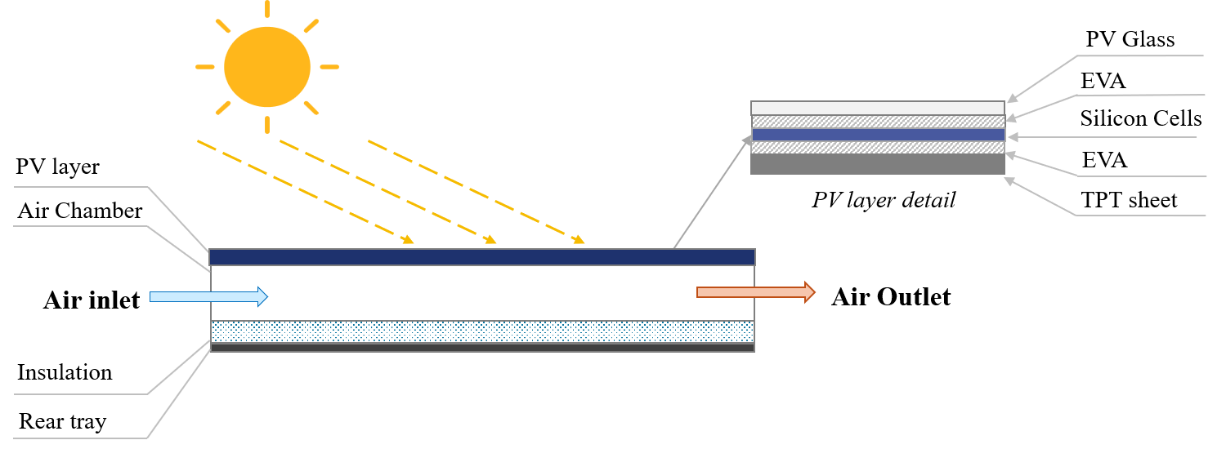
Fig. 1: Air-based PVT cross section
Tab. 1: Technical characteristics of the PV panel
Description |  | Unit | Value
General characteristics PV | Length x Width x Height | [mm] | 1762×1134×30
General characteristics PV | Gross area | [m²] | 2
General characteristics PV | PV Weight | [kg] | 21
Main electrical characteristics STC | Cell type | [-] | N-type i-TOPCon
Main electrical characteristics STC | Efficiency STC ⁽¹⁾ | [%] | 22.3
Main electrical characteristics STC | Power at maximum power point (PMPP) | [W] | 445
Main electrical characteristics STC | NOCT ⁽²⁾ Temperature | [°C] | 43±2
Main electrical characteristics STC | Power temperature coefficient | [% . K⁻¹] | -0.29%
General characteristics PVT | Length x Width x Height | [mm] | 1762×1134×65
General characteristics PVT | Thermal conductivity of back insulation | W/mK | 0.041
General characteristics PVT | PVT Weight | [kg] | 26
⁽¹⁾ STC: Standard Testing Conditions; ⁽²⁾ NOTC: Normal Operation Cell Temperature
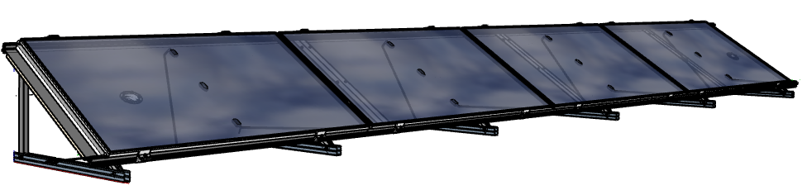 | 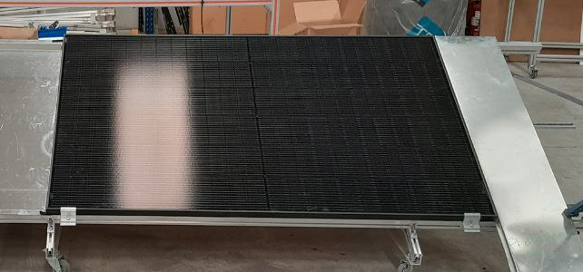
Fig. 2: Air-based PVT from paper to reality.
To maximize the thermal output, two alternatives for the internal channel geometry have been explored, consisting on the insertion of transverse obstacles along the path so that its trace is modified; thus upgrading the heat exchange. The first type of obstacle (Obst. A) consists of linear obstructions, which divide the air section in half twice per panel, resulting in six narrowings along the channel. The second type (Obst. B) involves the insertion of a corrugated plate with a wave pattern, continuously redirecting the air toward the photovoltaic laminate.
In both cases, priority was given to a simple and robust installation that does not lead to a significant increase in either cost or labor.
2.2. Testing installation
The prototype has been tested following the procedure indicated in ISO 9806 (Solar Energy - Solar Thermal Collectors - Test Methods. Second Edition, 2017) for air solar thermal collectors in open loop. To that end, a testing bench has been built on a tilt roof with capacity for 6 PVT panels, forming a 3x2 matrix (see Fig. 3). Panels are located over the roof, which has a tilt of 11º, and are oriented to south with 5º deviation to west. The matrix configuration allows to test two individual channels simultaneously, where the air enters from the bottom side, heats up as it passes through the panels and is extracted from the upper side through a collector pipe. This pipe is connected to a heliocentric fan, model TD-EVO ECOWATT, operating in suction mode. For the electrical part, the 6-panel field has a nominal power of 2.67kW and is connected to the same string of a Huawei SUN2000 3KTL inverter.
In terms of monitoring, the installation is equipped with a flow meter, a differential pressure gauge, 11 temperature probes and an environmental station (measuring solar radiation, ambient temperature and wind speed). Disposition of the magnitudes measured is shown in Fig. 4 while detail of the monitoring devices is included in Tab. 2. Electrical generation (voltage, current and power) is acquired through the inverter web platform.
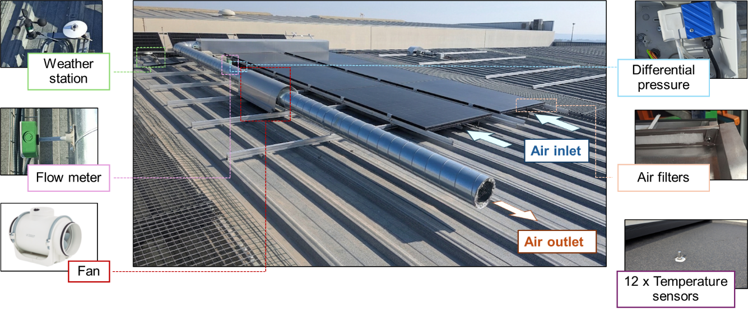
Fig. 3: Testing bench built in ENDEF facilities 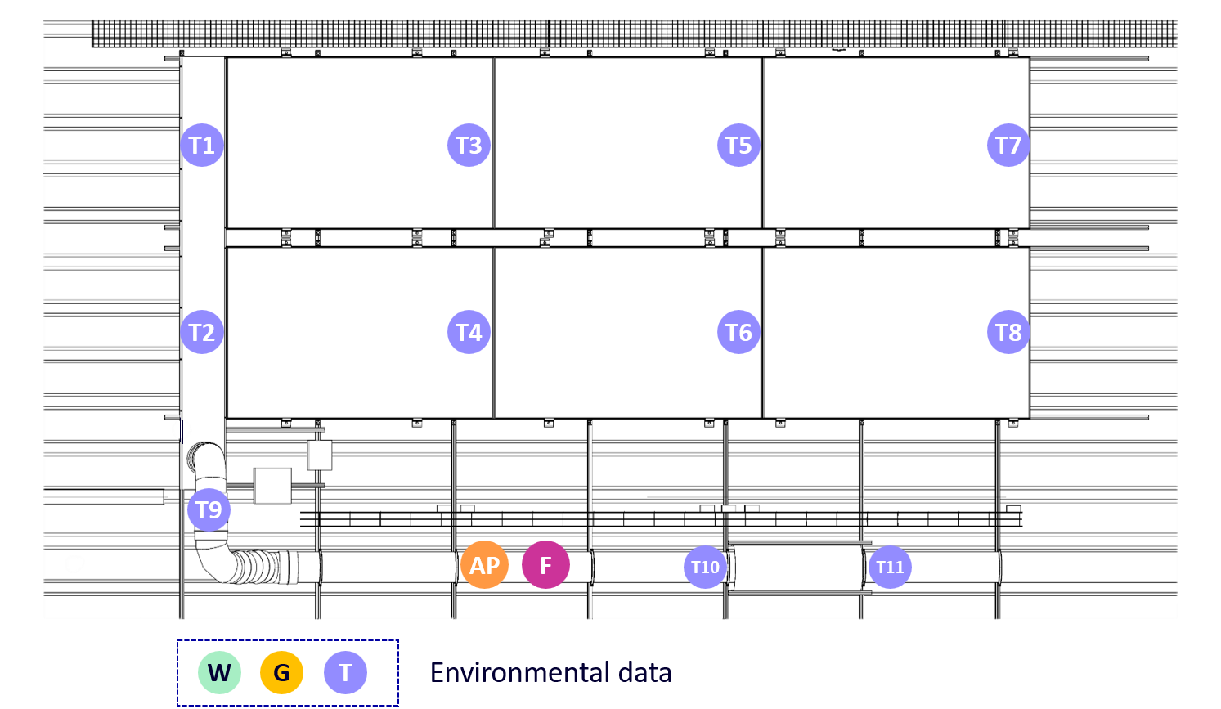
Fig. 4: Monitoring scheme on the testing bench
Tab. 2: Technical characteristics of the main monitoring devices
Magnitude | Sensor model | Amount | Range | Accuracy
Temperature | DS18B20, digital | 12 | -55 - 125 °C | ± 0.5°C
Pressure | 526610CLBHT1C-RS, Gems | 1 | ± 1000 Pa | ± 1%
Air velocity | EE650, Elektronic | 1 | 0 – 10 m/s | 0.2 m/s ±3 vm%
Wind speed | FST200-1000 | 1 | 0.5 – 50 m/s | ± 0.5 m/s
Irradiance | LP PYRA 03 AC | 1 | 0-2000 W/m² | 0.025 W/m²
Fan consumption | Shelly 1PM Gen3 | 1 | 0-3.68 kW | ± 1%
- Results
3.1. Main general results
The PVT testing bench has been working in a 24/7 operation from October to March, covering main winter months. Four air flow velocities have been analyzed: 50, 100, 175 and 300 m³/h per channel. In this work, sections 3.1 to 3.4 refer to the performance data measured on the 3x2 matrix with bare channels, i.e. without obstacles inside, while the section 3.5 analyzes the influence of obstacles.
For the bare channel and the period measured, electrical efficiency remained relatively stable, with an average value of 20.76%, which is close to the nominal cell efficiency (22.3%) measured at STC conditions. In contrast, the thermal efficiency exhibited significant variations, mainly influenced by two key variables: the airflow rate circulating through the PVT panel and the external wind speed. Daily average values ranged between 3% (low flow rate in windy days) and 30% (high flow rate in calm days).
3.2. Dependency on internal flow rate
It is observed that the most determining variable for thermal performance is the flow rate of the circulating fluid, with which the efficiency varies proportionally. The system reached daily average values of 5.6% for the lowest tested flow rate (50 m³/h, 0.26 m/s inside the collector) and 19.7% for the highest (300 m³/h, 1.68 m/s inside the collector). This correlation can be observed in Fig. 5, whose environmental conditions are shown in Tab. 3. Due to this strong dependency, the performance results are grouped with regard to the internal flow rate, distributed in the main four air flow velocities analyzed: 50, 100, 175 and 300 m³/h per channel.
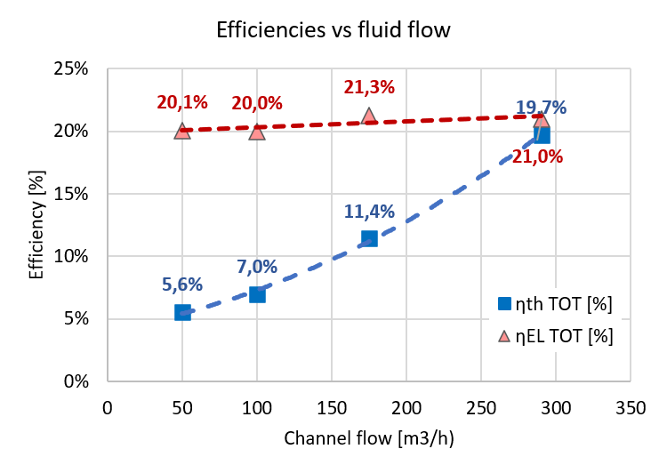
Fig. 5: Performance results of air-PVT field measured on testing bench: average daily electrical and thermal efficiencies as a function of internal flow rate.
Tab. 3: Performance values of air-PVT field and main environmental conditions measured on testing bench. Data refer to average daily values measured during sunlight. Tcell is calculated numerically, not measured.
Q [m³/h] | ηTH TOT [%] | ηEL TOT  [%] | H  [kWh] | Tamb [ºC] | Wsp  [m/s] | Tcell  [ºC] | Tout  [ºC]
50 | 5.58% | 20.07% | 35.41 | 20.23 | 1.46 | 32.17 | 27.47
100 | 6.97% | 19.99% | 30.88 | 12.06 | 2.83 | 23.12 | 16.53
175 | 11.42% | 21.26% | 21.01 | 10.19 | 1.76 | 18.94 | 13.22
300 | 19.69% | 20.99% | 32.68 | 15.42 | 1.63 | 26.53 | 19.87
* H: Solar daily radiation [kWh]; Tamb: ambient temperature [°C]; Wsp: wind speed [m/s]; Tcell: theoretical cell temperature [°C]; Tout: temperature of the air in the outlet of the third panel [°C].
The thermal efficiency increases proportionally with the internal airflow rate, shifting from a thermal-to-electrical efficiency ratio of 0.25:1 at low flow rates to 1:1 at high flow rates. However, it is observed that the higher the flow rate the higher the pressure drop, thus needing a larger fan with greater power consumption and noise levels. In this study, the PVT system was designed to minimize assembly complexity and reduce pressure losses. At a flow rate of 300 m³/h circulating through a channel, the system exhibits a pressure drop of 160 Pa and a power consumption of 36 W, which represents 8% of the nominal electrical power of a single panel.
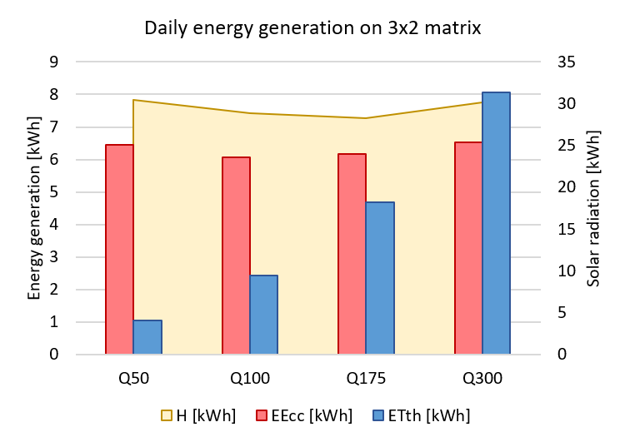 | 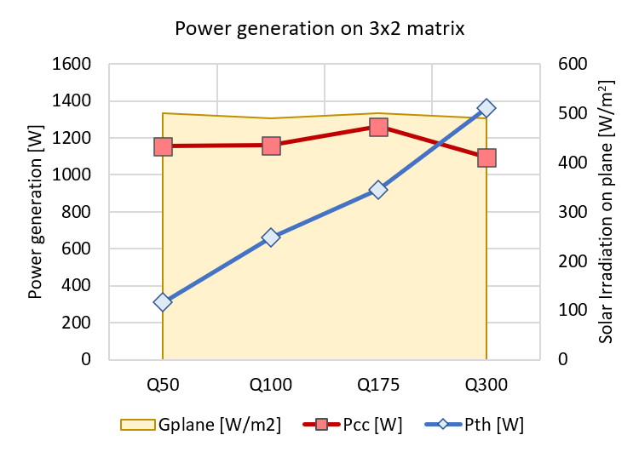
(a) | (b)
Fig. 6: Energy and power production values of the 3x2 matrix as a function of the internal flow rate: daily energy production for days with similar environmental conditions (solar radiation ⋍28kWh and wind speed ⋍1m/s) (a) and power generation at similar winter solar irradiation on plane (G⋍500 W/m²)
Fig. 6 shows the average production data for each studied flow rate. To compare the production of the four groups, data under similar environmental conditions are presented: Fig. 6 (a) displays the average daily energy generation for each group, under similar values of solar radiation (H ⋍ 28 kWh) and wind speed (Wsp ⋍ 1 m/s), and Fig. 6 (b) shows the power generated at instances with an in-plane irradiance (nearly horizontal) close to G ⋍ 500 W/m².
Both energy and power production show a trend similar to that of the efficiencies, remaining stable for the electrical part and varying proportionally with the flow rate in the thermal part. The slight variations observed in the electrical trend can be explained by the influence of other parameters, such as ambient temperature and wind speed. As a reference, the 6-panel system is capable of producing 6.5 kWh of electrical energy and 8 kWh of thermal energy per day, at high flow rates on sunny Mediterranean winter days. During the central hours of the day, with an in-plane (nearly horizontal) irradiance close to 500 W/m², the system produces approximately 1150 W of electrical power and 1400 W of thermal power.
3.3. Dependency on external wind speed
The second most influential variable on the thermal performance is external wind speed, which has a negative effect on thermal performance for all the internal airflow rates studied (see Fig. 7 (a)). This trend is more visible for clear days, as days with very low radiation make it difficult to obtain reference efficiency values. Because of this, days with very low radiation (< 10kWh) have been removed from the Fig. 7.
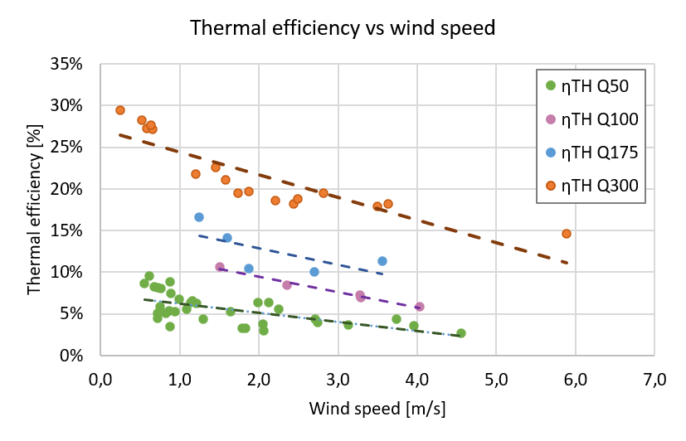 | 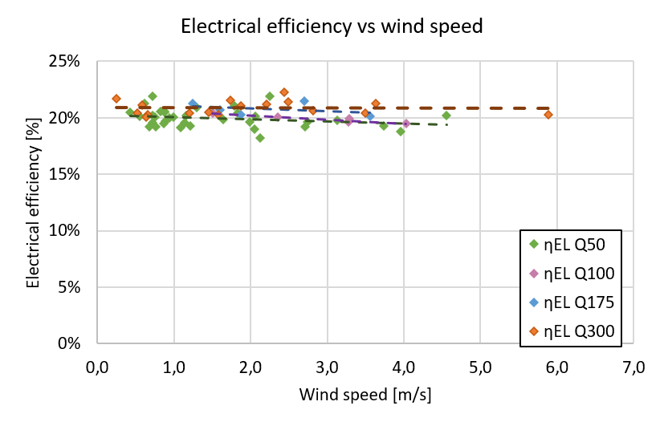
(a) | (b)
Fig. 7: Average daily thermal (a) and electrical (b) efficiencies as a function of the external wind speed.
According to the data measured, external wind may reduce the thermal efficiency of the system by up to 50% at high wind speeds (>4 m/s) compared to the same configuration at low ones (~1 m/s). This is because the wind dissipates heat from the front surface of the panel, thereby increasing convection losses to the environment.
On the other hand, data do not show a clear trend of wind effect on electrical efficiency. In principle, higher wind speeds should lower the PV temperature, thus improving its efficiency. However, highly windy days are also associated with higher direct radiation, which would conversely increase the operating temperature. No clear dependency was observed in this study.
3.4. Output temperatures
The benefits of an air-based PVT system largely depend on the maximum temperature to which the circulating air can be heated, which, in turn, can be adjusted by varying the number of panels connected in series. In addition, the PV laminate temperature limits the maximum gain of the air through the panel (Simón-Allué et al., 2023). Increasing the number of panels in series allows for a higher final temperature; however, it reduces the overall efficiency of the system, as the unit thermal efficiency decreases with each additional panel. Conversely, reducing the number of panels increases the thermal efficiency of the entire system but lowers the final temperature obtained, which will likely limit its end-use applications. This work presents the results for a configuration of three panels in series, as it represents the optimal balance between temperature and efficiency.
According to the experimental data, this three-panel configuration yields an average daily temperature gain between 7.3 °C and 3.3 °C for the low and high flow rates tested, respectively, reaching maximum values of 22 °C and 8.5 °C during peak solar hours on days with optimal conditions (see Fig. 8).
It is observed that the variables directly influencing the panel outlet temperature are the inlet (ambient) temperature and solar radiation, both showing a positive correlation (see Fig. 9). Secondarily, the outdoor wind speed also affects the results, as it conditions the panel's thermal efficiency. During the autumn-winter months at the test location, outlet temperature values of up to 34 °C and 28 °C were obtained at the last panel for the low and high flow rates, reaching maximums of 48 °C and 38 °C during peak solar hours.
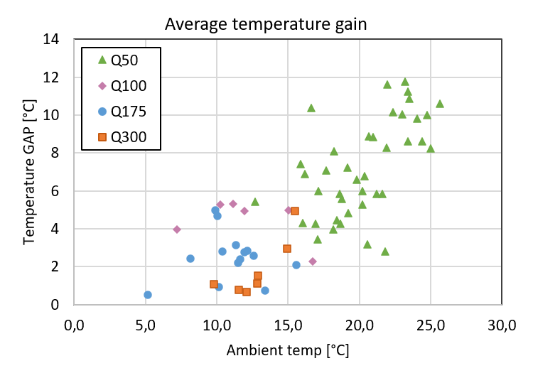 | 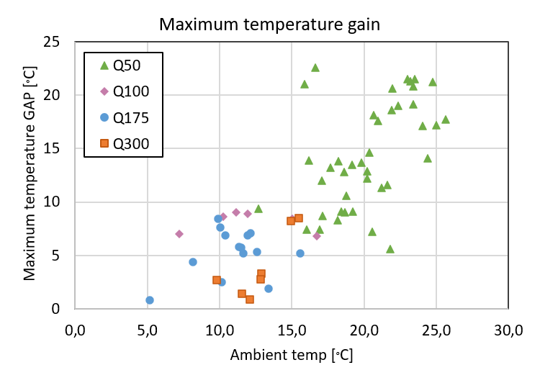
(a) | (b)
Fig. 8: Temperature gain in the air channel with respect to the ambient temperature: average daily values (a) maximum daily values (b)
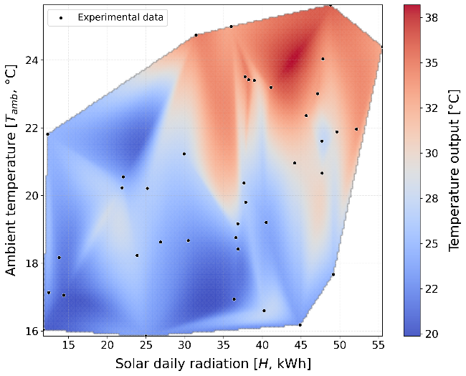 | 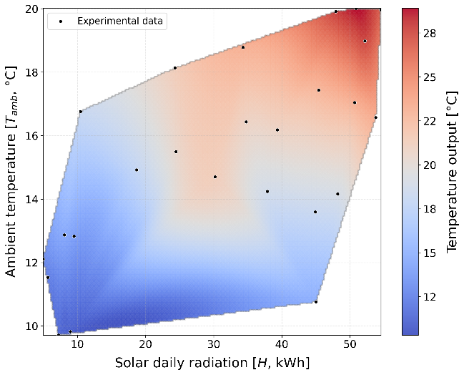
(a) | (b)
Fig. 9: Average daily temperature values at the output of the air channel with respect to the ambient temperature and solar radiation: low flow rate 50m³/h (a) high flow rate 300m³/h (b).
3.5. Influence of obstacle insertion
To evaluate the effect caused by the obstacles, they were introduced into one of the matrix channels while leaving the other empty (baseline conditions), allowing for a comparison of their performance under identical ambient conditions and with the same flow rate circulating through both channels.
In general terms, it is observed that the linear obstacles (Obst. A) lead to an average improvement of 10% in thermal efficiency compared to the bare channel, whereas the introduction of the corrugated pattern (Obst. B) increases the improvement to 16%. The performance enhancement of obstacle A remains homogeneous across all studied days, showing no clear relationship with variations in ambient conditions (radiation, wind speed) (see Fig. 10). However, this is not the case for obstacle B, which exhibits a clear trend with respect to both variables, concentrating its improvement on days with medium-to-low radiation and low wind speed (see Fig. 11).
In this case, it was observed that cloudy days (daily radiation < 10 kWh) yielded a 100% improvement thermal efficiency but, due to the low solar resource, the energy generation was negligible. For this reason, these days were filtered out from the analysis, leaving days with solar radiation > 10 kWh plotted in Fig. 11, where the previously mentioned trend can be better observed.
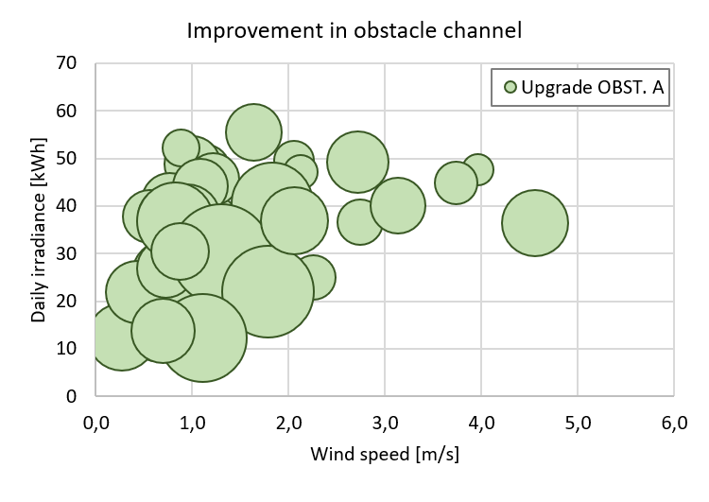 | 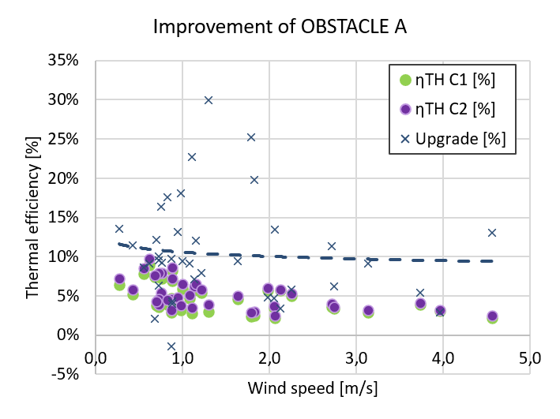
(a) | (b)
Fig. 10: Improvement of Obst. A (linear obstacle): relation with environmental data (a) and influence on thermal efficiency (b).
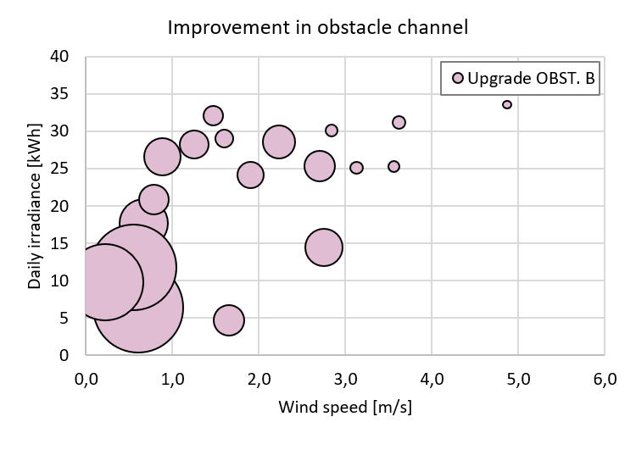 | 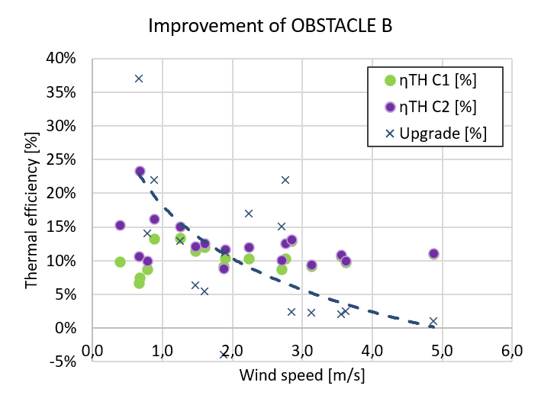
(a) | (b)
Fig. 11: Improvement of Obst. B (wavy pattern): relation with environmental data (a) and influence on thermal efficiency (b).
3.6. Examples of performance on typical days
Below are examples of three typical days corresponding to the bare channel case operating with low flow rate (50m³/h, Fig. 12) and high flow rate (300m³/h, Fig. 13). The days correspond to a sunny windless day, a sunny windy day, and a cloudy day.
In both cases, the first figure displays the key system temperatures and wind speed, while the second presents the solar irradiation, power generation and system efficiencies.
3.6.1 Low flow rate
At low flow rates on sunny, low-wind day, a clear temperature increase is observed across the first two panels (T5, T3), whereas thermal gains plateau at the third module (T1). In this scenario, the ambient temperature rises unnaturally high due to heat accumulation on the roof surface. On windy day, external wind causes an overall temperature drop (both ambient and outlet), shifting the thermal gain almost entirely to the first panel, with the second panel showing only a residual increase. On cloudy days, the overall temperature rise is significantly reduced and highly sensitive to fluctuations in solar irradiance.
Redarding power production, it is observed that the system operates at average electrical and thermal efficiencies of 20% and 6%, respectively, with the thermal efficiency dropping to 4% as wind speed increases. Under similar values of radiation, it is clearly visible how thermal production is decreased because of the wind effect. Regarding electrical efficiency, the system clearly displays the characteristic "molar tooth" profile driven by PV voltage dynamics, showing a noticeable drop during midday peak temperatures, slighly smoothed in the second day because of the external wind.
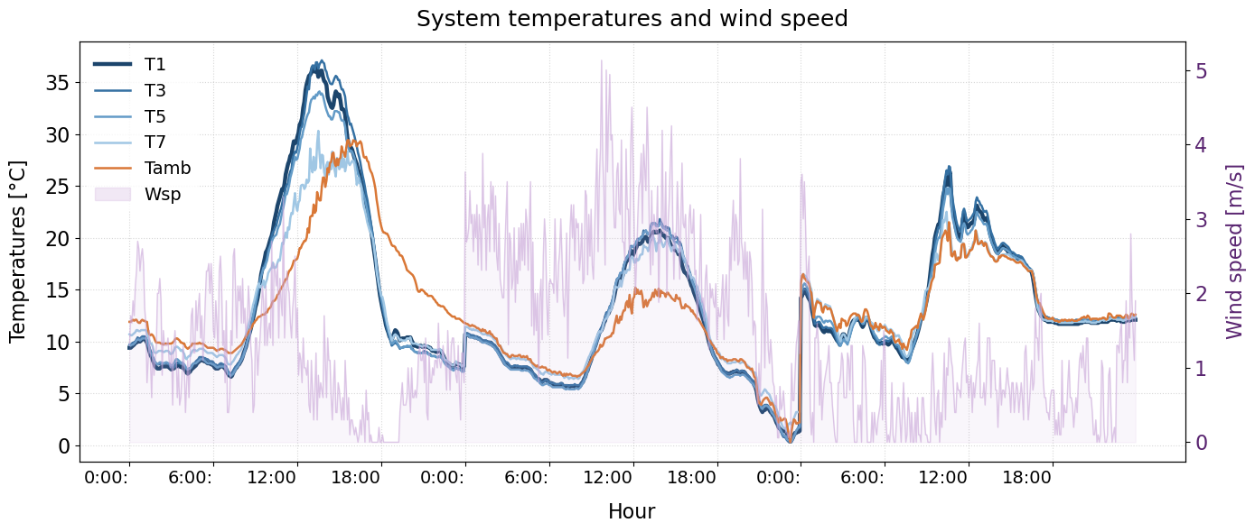
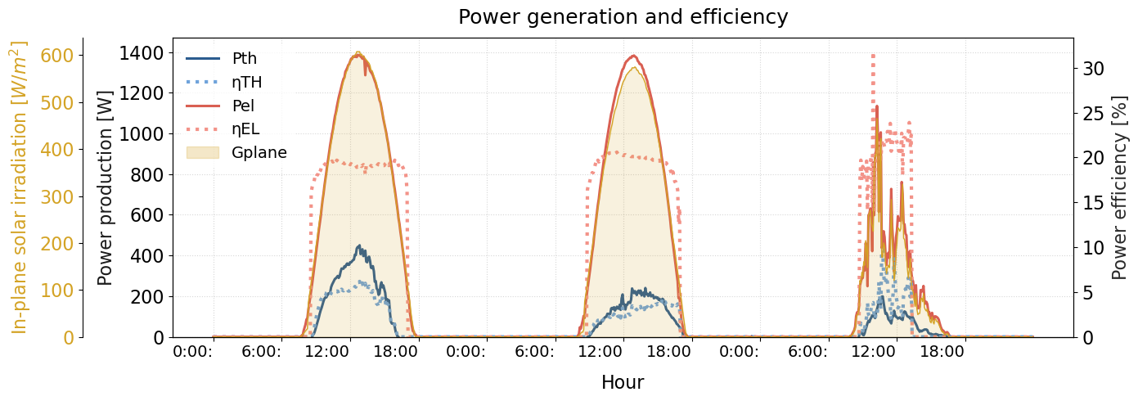
Fig. 12: Performance during 3-typical days for the 3x2 matrix with bare channel, operating at low flow rate: sunny windless day (left), sunny windy day (center), and cloudy day (right).

3.6.2. High flow rate
At high flow rates, the primary difference in thermal behavior lies in the temperature distribution across the panels. On low-wind days, although the first panel provides the largest temperature lift, subsequent modules continue to contribute to the overall thermal gain. As wind speed increases, heat gain once again concentrates within the first panel, exhibiting a trend similar to that observed at low flow rates.
Due to the higher mass flow rate, the thermal output of the system increases considerably under these conditions. While average electrical efficiency remains virtually unchanged (~20%), thermal efficiency reaches 25% on calm, sunny days and drops to 18% as wind speed increases.
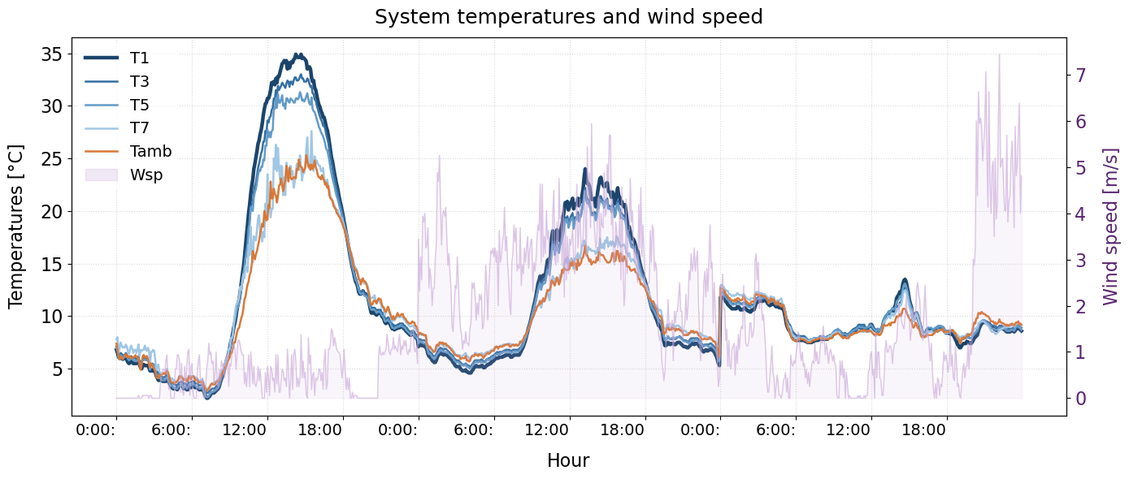

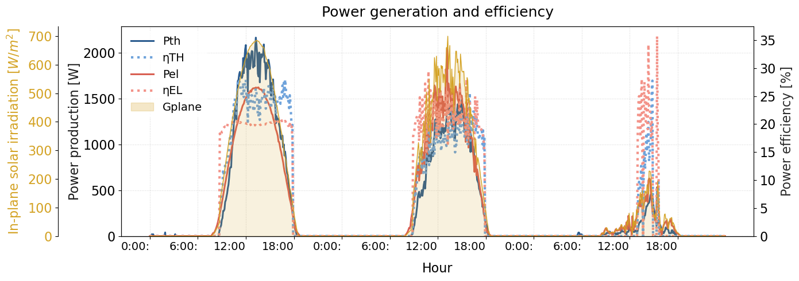
Fig. 13: Performance during 3-typical days for the 3x2 matrix with bare channel, operating at high flow rate: sunny windless day (left), sunny windy day (center), and cloudy day (right).
- Conclusions & future work
This paper presents the experimental operation of a novel air-based PVT solar system design, optimized for simple manufacturing and easy, versatile installation. In line with this premise, experimental data collected at a custom-built test bench under real environmental conditions during the winter months of the test location are presented. The main conclusions are the following:
- During the testing period, electrical efficiency remained relatively stable, with an average value of 20.76%, close to the nominal cell efficiency (22.3%). On the contrary, thermal efficiency exhibited significant variations, ranged between 5.6 – 19.7 % (average daily values) and mainly influenced by two key variables: the airflow rate circulating through the system and the ambient wind speed.
- The thermal efficiency increases proportionally with the internal air flow rate, shifting from a thermal-to-electrical efficiency ratio of 0.25:1 at low flow rates (⋍50 m³/h) to 1:1 at high flow rates (⋍300 m³/h). However, the increase in internal flow rate reduces the useful temperature at the system outlet.
- The efficiency improvement achieved when operating at higher internal flow rates outweighs the penalty in output temperature. Determining the optimal operating point depends on the specific thermal requirements of the application. However, as a general guideline to prevent excessively low thermal efficiency, it is recommended to operate the system at a flow rate of no less than 150 m³/h, which corresponds to a thermal-to-electrical generation ratio of approximately 0.6:1.
- The insertion of internal obstacles leads to a clear improvement in the thermal efficiency of the PVT system, increasing it by approximately 16%.
- With this configuration of three panels in series, daily average temperature gains of 3.3 and 7.3 °C are obtained, depending on the internal flow rate. At midday, with peak radiation values, the temperature gain reaches a maximum of 8.5 and 22 °C. Based on these results, its integration as a backup for space heating systems proves feasible, while being highly recommended as a supply-air preheating system for ventilation.
- The system exhibits a low pressure drop even at the highest tested flow rate, allowing the use of a compact, low-power fan. In this case, the electrical consumption at maximum flow rate did not exceed 36 W, representing 8% of the nominal power generation of one single panel.
Future work involves installing the panel equipped with obstacles in two real buildings with different climates and roof typologies, where its operation will be evaluated in a real-world environment.
- References
Abdelrazik, A. S., Shboul, B., Elwardany, M., Zohny, R. N., & Osama, A. (2022). The recent advancements in the building integrated photovoltaic/thermal (BIPV/T) systems: An updated review. Renewable and Sustainable Energy Reviews, 170(September), 112988. https://doi.org/10.1016/j.rser.2022.112988
AEE INTEC. (2025). Solar Heat Worldwide - Global Market Development and Trends 2024. https://doi.org/10.18777/ieashc-shww-2025-0001
Ahn, J. G., Kim, J. H., & Kim, J. T. (2015). A study on experimental performance of air-type PV/T collector with HRV. Energy Procedia, 78, 3007–3012. https://doi.org/10.1016/j.egypro.2015.11.705
Aspetakis, G., & Wang, Q. (2025). Critical review of Air-Based PVT technology and its integration to building energy systems. Energy and Built Environment, 6(1), 121–135. https://doi.org/10.1016/j.enbenv.2023.10.001
Chaibi, Y., El Rhafiki, T., Simón-Allué, R., Guedea, I., Luaces, S. C., Gajate, O. C., Kousksou, T., & Zeraouli, Y. (2021). Air-based hybrid photovoltaic/thermal systems: A review. Journal of Cleaner Production, 295. https://doi.org/10.1016/j.jclepro.2021.126211
Choi, H. U., Kim, Y. B., Son, C. H., Yoon, J. I., & Choi, K. H. (2020). Experimental study on the performance of heat pump water heating system coupled with air type PV/T collector. Applied Thermal Engineering, 178. https://doi.org/10.1016/j.applthermaleng.2020.115427
Delisle, V., & Kummert, M. (2016). Cost-benefit analysis of integrating BIPV-T air systems into energy-efficient homes. Solar Energy, 136, 385–400. https://doi.org/10.1016/j.solener.2016.07.005
Epp, B. (2026). Product overview showcases the global evolution of solar air collectors. Solarthermalworld.Org. https://solarthermalworld.org/news/product-overview-showcases-the-global-evolution-of-solar-air-collectors/
IEA. (2025). Global Energy Review 2025. https://www.iea.org/reports/global-energy-review-2025
IEA SHC. (2025). Task 73 - PVT Heating Systems. https://task73.iea-shc.org/
Kong, D., Wang, Y., Li, M., Keovisar, V., Huang, M., & Yu, Q. (2020). Experimental study of solar photovoltaic/thermal (PV/T) air collector drying performance. Solar Energy, 208(April), 978–989. https://doi.org/10.1016/j.solener.2020.08.067
Maghrabie, H. M., Elsaid, K., Sayed, E. T., Abdelkareem, M. A., Wilberforce, T., & Olabi, A. G. (2021). Building-integrated photovoltaic/thermal (BIPVT) systems: Applications and challenges. Sustainable Energy Technologies and Assessments, 45(January), 101151. https://doi.org/10.1016/j.seta.2021.101151
Pirasteh, G., Saidur, R., Rahman, S. M. A., & Rahim, N. A. (2014). A review on development of solar drying applications. Renewable and Sustainable Energy Reviews, 31, 133–148. https://doi.org/10.1016/j.rser.2013.11.052
REN21. (2025). Renewables 2025 Global Status Report: Global Overview. https://www.ren21.net/Renewables-2025-Global-Status-Report-Global-Overview/
Sancho, J., Riesco, J., & Jiménez, C. (2012). Atlas de Radiación Solar en España utilizando datos del SAF de Clima de EUMETSAT. In Agencia Estatal de Meteorología. http://scholar.google.com/scholar?hl=en&btnG=Search&q=intitle:Atlas+de+Radiación+Solar+en+España+utilizando+datos+del+SAF+de+Clima+de+EUMETSAT#0
Shahsavar, A., & Khanmohammadi, S. (2019). Feasibility of a hybrid BIPV/T and thermal wheel system for exhaust air heat recovery: Energy and exergy assessment and multi-objective optimization. Applied Thermal Engineering, 146(July 2018), 104–122. https://doi.org/10.1016/j.applthermaleng.2018.09.101
Simón-Allué, R., Villén, R., Brun, G., Lara, Y., & Guedea, I. (2023). Design, Development, and Performance Evaluation of a New Photovoltaic-Thermal (PVT) Air Collector: From Lab Testing to Field Measurements. Processes, 11(2). https://doi.org/10.3390/pr11020588
Solar Energy - Solar Thermal Collectors - Test Methods. Second Edition, Pub. L. Second Edition, 130 (2017).

Average winter radiation in the testing location, according to Spanish National Meteorological Agency (AEMET)(Sancho et al., 2012)

