EuroSun2026
First-year real monitoring results for a hybrid solar collectors heat pump system (PVT-HP) providing a single-family house heating and domestic hot water demands in a cold region in France

Mohamad Ali Jaafar¹ (corresponding author), Laetitia Brottier¹
¹ Dualsun, Marseille, France
ma.jaafar@dualsun.com
Summary
This paper presents and discusses the first-year real monitoring results for an innovative solar assisted heat pump including Photovoltaic Thermal hybrid solar collectors (PVT). The energy system was installed in February 2025 in replacement of an old oil boiler in a single-family house located in one of the coldest regions in France. It is designed to provide both domestic hot water and space heating through the existing water radiators in the house. The results obtained show that thermal comfort has been ensured even by -11°C outside without any activation of the electric backup heater (100% of thermal coverage by the heat pump). The measured energy seasonal performance factor considering all auxiliary components and the energy used for PVT defrosting is 3,2 for this first year of operation. This demonstrates the system’s competitiveness. The monthly performance factors reaching up to 4,6 in hot months show the potential benefit of the system thanks to the solar energy absorbed by the PVT collectors in addition to the heat extracted from ambient air. Less than 0,5% of the produced energy was needed to defrost the PVT collectors proving the high thermal effectiveness of the used finned PVT collectors as a heat source. The seasonal performance factor is enhanced and boosted to 4,2 thanks to the solar photovoltaic production which can be directly self-consumed by the heat pump.
Keywords: hybrid PVT solar collectors, solar assisted heat pump, energy performance, real monitoring results
Field of application for the findings: Sustainable Heating and Cooling Systems for Buildings
Addressed audience: energy efficiency researchers and engineers, building energy systems designers
- Introduction
Global warming and climate change represent major challenges for the environment. The primary cause behind is the increasing concentration of greenhouse gases in the atmosphere, which is resulting predominantly from human activities. The building sector is a major contributor to these gases emissions, accounting for more than 20%. Half of it comes from space heating in buildings according to the estimation of the IEA in 2024. Therefore, it is important to decarbonize this high energy demand sector by developing environmentally friendly and energy-efficient solutions. Also, in accordance with European Union directives, the fossil fuel heating generators must be replaced by renewable energy driven systems.
In this context, heat pump systems offer an extremely promising alternative as they can extract most of the heat produced from a low-temperature source. This interesting concept can substantially reduce the environmental impact, especially when they are powered by low-carbon electricity. Many configurations exist according mainly to the heat source of the heat pump. Recently, an attractive heat pump solution has emerged: hybrid solar assisted heat pump in which Photovoltaic Thermal (PVT) solar collectors are the sole heat source (Miglioli et al., 2023; Ozgener and Hepbasli, 2007; Vaishak and Bhale, 2019). In addition, they can cover part of the electric consumption of the system, further reducing its grid consumption and enhancing significantly the global performance factor.
The PVT solar-assisted heat pump was the object of many research studies from different European countries. Chhugani et al. (Chhugani et al., 2023) compared numerically the PVT heat pump with different heating systems for a single-family house in the German city of Wuerzburg. They considered two different WISC PVT collectors in comparison with gas heating systems, air source and geothermal heat pumps. The results show that the PVT heat pump system reduces CO2 emissions by up to 57% compared to gas boilers. The comparison with the air source heat pump showed that the seasonal performance factor of the PVT heat pump is 14% higher than the air source heat pump.
A numerical study performed by Jaafar and al. (Jaafar et al., 2022) showed that the most influencing parameter is the first order heat losses coefficient compared to the optical efficiency of the PVT collectors. It has been shown that the overall system performance is enhanced when the heat losses coefficient of PVT is increased. Later on, Jaafar and Chhugani (Jaafar and Chhugani, 2024) demonstrated numerically that an inverter heat pump performs 9% better than a fixed speed heat pump with PVT collectors. They showed also that for both types of heat pump the lower temperature limit of the evaporator inlet is a crucial parameter for the system operation: for the city of Strasbourg the SPF decreased respectively by 22% and 32% when this temperature limit passes from -15°C to -10°C and -5°C.
Del Amo et al. (Del Amo et al., 2019) showed that the PVT solar-assisted heat pump is a very attractive alternative of conventional boilers for heating need. They showed that when the system is correctly designed the economic payback period is about six years.
In addition to these many numerical studies treating the PVT-HP system, a real monitoring analysis of PVT operating with heat pumps was done by Helmling et al. (Helmling, 2022). The work has been done in the framework of the European Integrate project. They considered different integration configurations of PVT in HP system. Three of them used geothermal heat sources, one with condensing gas and one with an air heat exchanger. The study showed that the obtained seasonal performance factor varied between 3,4 and 4,9. These results highlight the potential of integrating PVT collectors into HP system.
As far as we know there is no published in-situ monitoring analysis for a whole year of operation of a direct combination of PVT collectors and heat pump where the PVT collectors supply the evaporator of the heat pump without any additional heat source or any intermediate hydraulic component. The aim of this paper is to present and discuss the operation of PVT solar assisted heat pump during a complete year in one of the coldest regions in France. The energy system used will be described in the following section. Then, before conclusions and perspectives, the results obtained are presented and discussed.
- Case study
The energy system studied herein is illustrated in Fig. 1. It is a direct combination of hybrid Photovoltaic Thermal (PVT) solar collectors and a brine to water heat pump (HP). Hybrid PVT solar collectors are the sole heat source of the heat pump. They extract heat from mainly ambient air (day and night) and solar radiation (day). The heat is then transferred to the evaporator of the HP by the antifreeze heat transfer fluid. A mixing valve, between the outlet of PVT collectors and the inlet of the HP evaporator, is required to make sure that the temperature driven from the solar field does not exceed the maximum admissible limit of the HP. The mixing valve setpoint is set to 25 °C since the maximum limit of the used heat pump is 35 °C.
The HP rises the low-temperature heat caught by its evaporator thanks to its R454C thermodynamic refrigeration cycle including gas-compression. The high-temperature heat is then release through the HP condenser in the house to provide both space heating and domestic hot water needs. The hydraulic configuration consists of two hot water tanks: one of 185 l for the domestic hot water and another of 100 l for space heating. The existing medium water radiators are used to distribute heat throughout the house. One cycle of domestic hot water is scheduled in the heat pump controller at 3:00 p.m. in the afternoon.
The studied single-family house of 100 m2 is constructed in 2000 and located in the Vosges department in the East North region of France. The location height is 325m above sea level and the reference temperature is -15°C. The used heat pump has an inverter compressor and a maximum thermal power of 9,6 kW at B0/W35. It includes a three-stages electric backup heater of 6 kW for space heating. It is partially or completely activated when needed heat cannot be provided by only the heat pump. The domestic hot water electric backup heater of 1,5 kW is integrated directly in the hot water tank. It is also controlled by the HP and activated when it cannot heat up the domestic hot water. The heat pump is reversible: it can be used to defrost the heat source when needed in very cold conditions. Indeed, it is able to inverse its thermodynamic cycle to extract heat from hot water tanks and transfer it to PVT collectors when they are covered of frost which can impact significantly their efficiency (Lopez et al., 2024).
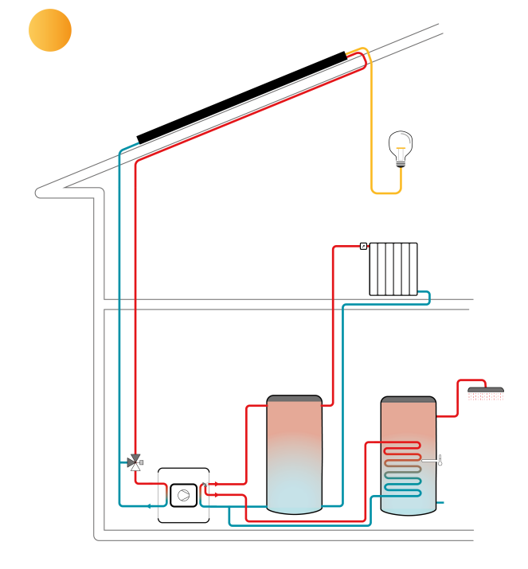 | 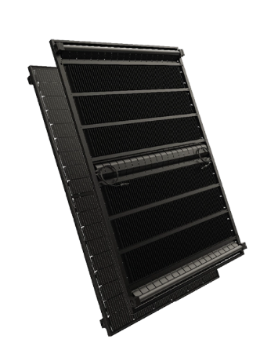
Fig. 1: PVT solar-assisted heat pump diagram | Fig. 2: The used MAX finned PVT collector Dualsun©

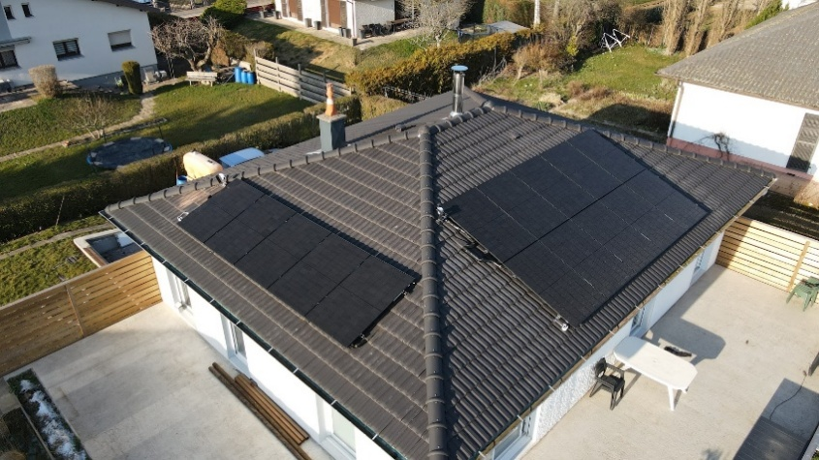
Fig. 3: 15 PVT collectors’ implementation on the house roof Dualsun©
As shown in Fig. 3, 15 PVT solar collectors are installed on the house roof. 10 PVT are oriented to the South and 5 PVT are oriented to the West. The used solar collector has a 1,95 m2 of total surface and is specifically developed to be the only heat source of a heat pump (Delachaux, 2026). It has fins on its backside to improve the heat transfer with ambient air during cold time (see Fig. 2) (Nicholson et al., 2024). The peak power of each solar collector is 425 Wp. The thermal coefficients of PVT collectors according to Solar Keymark are provided in table 1.
Tab. 1: PVT collectors Solar Keymark thermal coefficients.
Coefficient | Description and [unit] | Value
η_{0,b} | Optical efficiency [-] | 0,38
a₁ | Heat loss coefficient [W/m²K] | 37,44
a₃ | Wind dependence heat loss coefficient [J/m³K] | 7,31
a₅ | collector capacity [kJ/m²K] | 29,46
a₆ | Wind dependence conversion factor [s/m] | 0,046
- Results
In this section the results are presented and discussed according to different indicators. The operation of the energy system was monitored from April 1, 2025, to March 31, 2026. Both evaporator and condenser circuits are equipped with a flowmeter as well as an inlet and outlet temperature sensor. An energy meter is also installed to measure the electric consumption of the heat pump. It includes the circulators electric consumption since they are supplied and controlled directly by the heat pump. Temperature sensors are used for the outside air temperature, water tanks temperatures and inside room temperature. The measurements are extracted with a time interval of 5 minutes. A numerical code developed on Python is used to analyse and process the extracted data. It identifies the operation mode of the heat pump (heating, domestic hot water and defrosting) and compute thermal powers and performances of the energy system. It checks also the different services setpoints and compares them continuously with the measured temperatures.
The performance factor (PF) over a given period is calculated using the following equation:
$$PF=\frac{\left(HP heat production\right)+(backups heat production)-(PVT defrosting heat)}{\left(HP electric consumption\right)+(backups electric consumption)}$$ | (eq. 1)
To analyse the impact of the photovoltaic production, the grid performance factor (PF_{Grid}) considering the self-consumption of the heat pump is calculated using the following equation:
$${PF}_{Grid}=\frac{\left(HP heat production\right)+(backups heat production)-(PVT defrosting heat)}{\left(HP electric consumption\right)+\left(backups electric consumption\right)-(HP selfconsumption)}$$ | (eq. 2)
As mentioned in section 2, while operation in cold conditions, PVT may frost since they are exposed to ambient air. The frosting phenomena on the collector surface impacts its thermal efficiency in extracting heat from ambient air. The heat pump is configured to inverse its cycle and defrost the PVT collectors when their efficiency is significantly reduced. This is determined by measuring the temperature difference between the PVT outlet and the ambient air. Defrosting cycles are energy costly since the heat pump draws energy from the storage tanks it had already heated. Defrosting cycles shouldn’t be frequent when the heat source is efficient and well designed. For the studied energy system, the energy used for defrosting cycles was measured and subtracted from the heat production to estimate correctly the performance factors (see equations 1 and 2).
3.1. Thermal comfort
The most important indicator is the thermal comfort. It allows to check if the studied energy system achieved its goals each day in the entire year. The box plot of the Fig. 4 provides the statistical distribution of the temperature difference between the measured indoor room and the space heating setpoint. Negative values correspond to indoor room temperatures below the setpoint, whereas positive values correspond to indoor room temperatures above the setpoint. The heating setpoint varies throughout the day between 19 °C and 21 °C. The hysteresis is set to 1K, meaning that the heating system target is to maintain the room temperature in the following range: setpoint – 1K < room temperature. Since the box contains 90% of the measurements, the figure shows that 96% of the room temperature measurements are within the target so that the thermal comfort is ensured for the entire heating period. In addition, the median temperature deviation is approximately +0,5K, which is a positive thing since it demonstrates a slight positive bias relative to the heating setpoint. This result and the predominance of positive temperature deviations can be also explained by the inclusion of the intermediate-season periods where the heating system is activated. For the remaining 4% of measurements out of the box, it corresponds to a room temperature below the heating target. This is judged to be negligible and can be attributed to the heating system start-up phases, which occur following an increase in the heating setpoint.
  - Annual energy balance and performance
The figure 5 shows the annual energy balance of the HP through different colour bars chart. Both space heating and domestic hot water are combined here. It can be directly observed that electric backup heaters were not used: both space heating and domestic hot water were exclusively met by the heat pump.
PVT defrosting thermal energy is shown by the blue bar subtracted from the total heat production (green bar). This reflects the reality that the defrosting uses the energy already produced and stored by the heat pump. Over the monitored year, the cumulated energy used for defrosting cycles was calculated to be only 51,92 kWh. It represents less than 0,5% of the total energy produced by the heat pump since it is estimated to 10,5 MWh. This is negligible and considered to be an extremely good result for the studied system and the behaviour of the used PVT collectors as the sole heat source of heat pump.
The seasonal performance factor is calculated using the equation 1. The obtained result for the whole year is 3,2. This shows the relevance of the studied energy system since each 1 kWh of electricity consumed resulted in approximately 3,2 kWh of useful thermal energy delivered to the building. This is attributed mainly to the absence of the electric heater use. It is an interesting achievement in such a cold region as the Vosges in France (with -15°C of base temperature). The operation details of the energy system are provided in the following sub-sections.

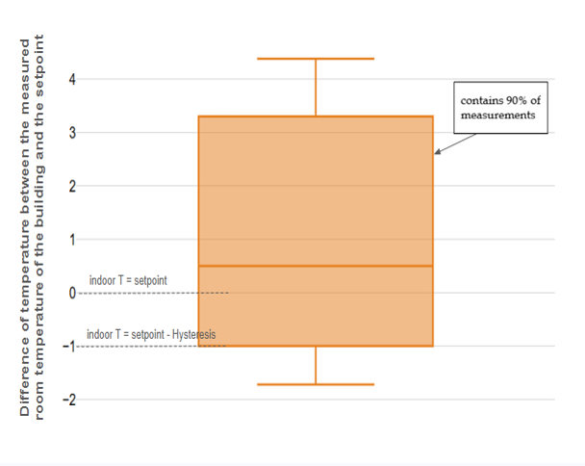
Fig. 4: Distribution of the temperature difference between the measured indoor room and the setpoint
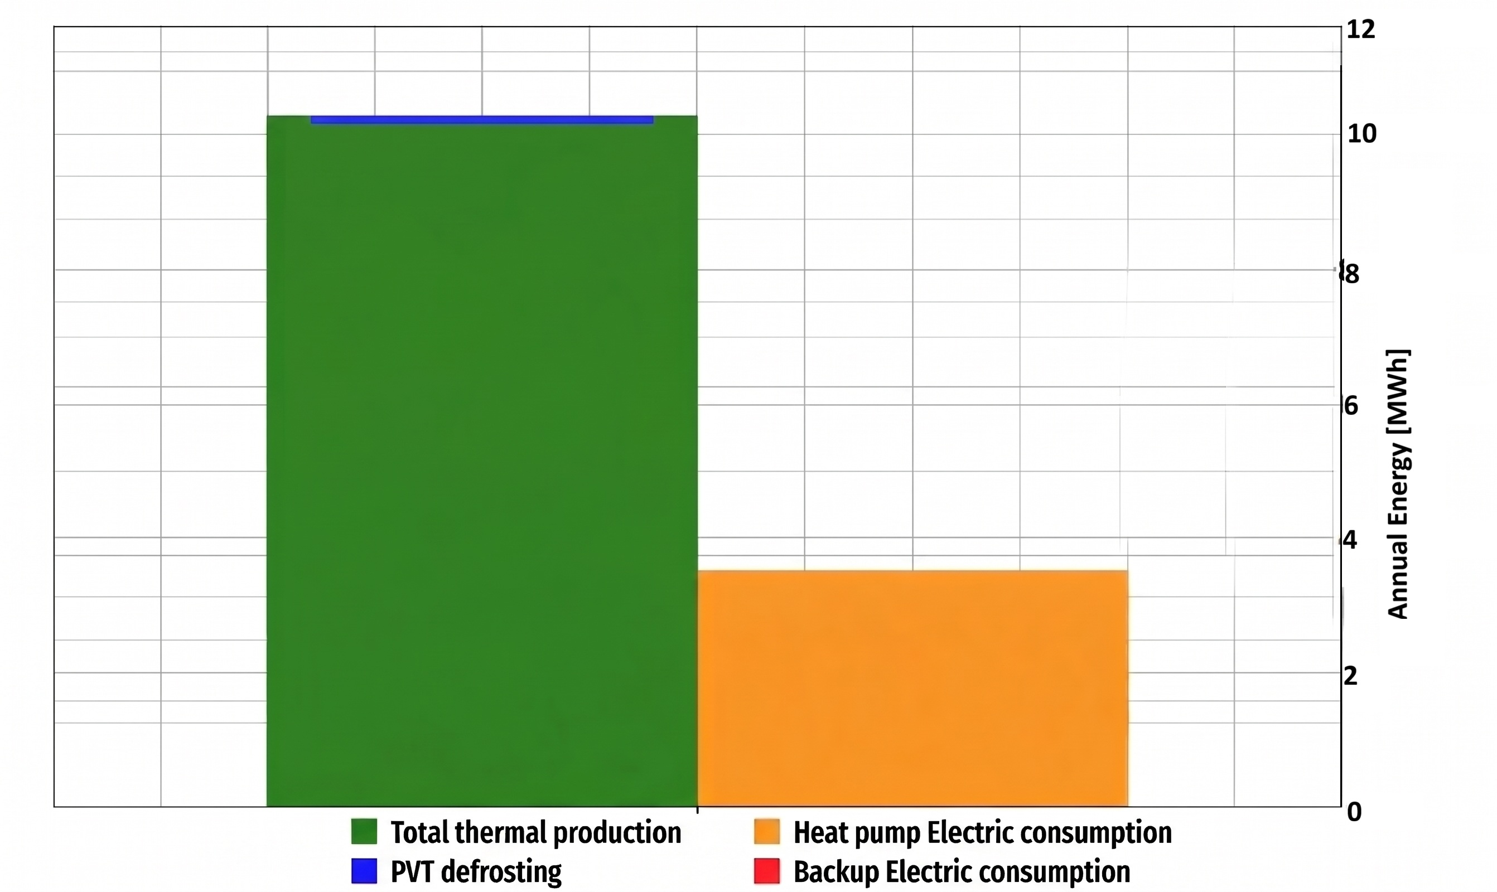

Fig. 5: Annual energy balance
  - Monthly energy balances and performances
Figure 6 provides monthly energy balances (heat production, heat used for PVT defrosting and electricity consumption) and performances of the studied energy system, together with the condenser production temperature averages and the lowest measured outside temperatures. Space heating and domestic hot water are also combined here.
As expected, the total thermal energy production exhibits a marked monthly pattern, closely related to the outdoor temperature conditions and the resulting heating demand. The highest production is observed during months marking lowest outdoor temperatures. It reaches approximately 2335 kWh in January, recording the lowest measured outdoor temperature (-11 °C). For the other months, as the lowest outdoor temperature (blue curve) increases, the total thermal energy production decreases. The three warmest months (June, July and August) recorded almost the same amount of heat production. This is due to the absence of the space heating demand during these three months: only domestic hot water demand was met.
A similar trend is observed for the electric consumption, although the reduction in electricity consumption is proportionally greater than the reduction in thermal production. This behaviour is consistent with the improvement in heat pump performance under less demanding outdoor conditions coupled with the complete absence of electric backup heaters use. This means that the heat pump provides the entire required heating energy over the monitored period, which is a very interesting point knowing that the lowest temperature reached in winter is – 11 °C.
Interestingly, the average heat pump production temperature remains among a relatively stable range throughout the year, between 44 and 51°C, despite the seasonal variation in outdoor temperatures. During summer months, the production temperature is higher than 50 °C according to the domestic hot water setpoint. When heating system is met, the average production temperature decreases with a slight seasonal variation following the outdoor conditions. This is explained by the heating water law defined in the heat pump controller and the medium temperature water radiators. It is interesting to note here that the heat pump could operate over a relatively constrained supply-temperature range while the temperature of the heat source varies considerably.
It is observed also that the system required defrosting cycles only in January and Decembre of the monitored year. The energy used for defrosting cycles is 32,12 kWh and 19,8 kWh respectively in January and December. This is considered as negligible since it is only 1,36% and 1,19% from the total energy produced during these high-energy consumed months, respectively. It is worth reminding here (see sub-section 3.2), the cumulated energy used for defrosting represents only 0,5% of the yearly total heat produced. As mentioned before, this is considered as negligible and shows that the used PVT collectors, despite the low outdoor temperatures, are a very efficient heat source for heat pump system.
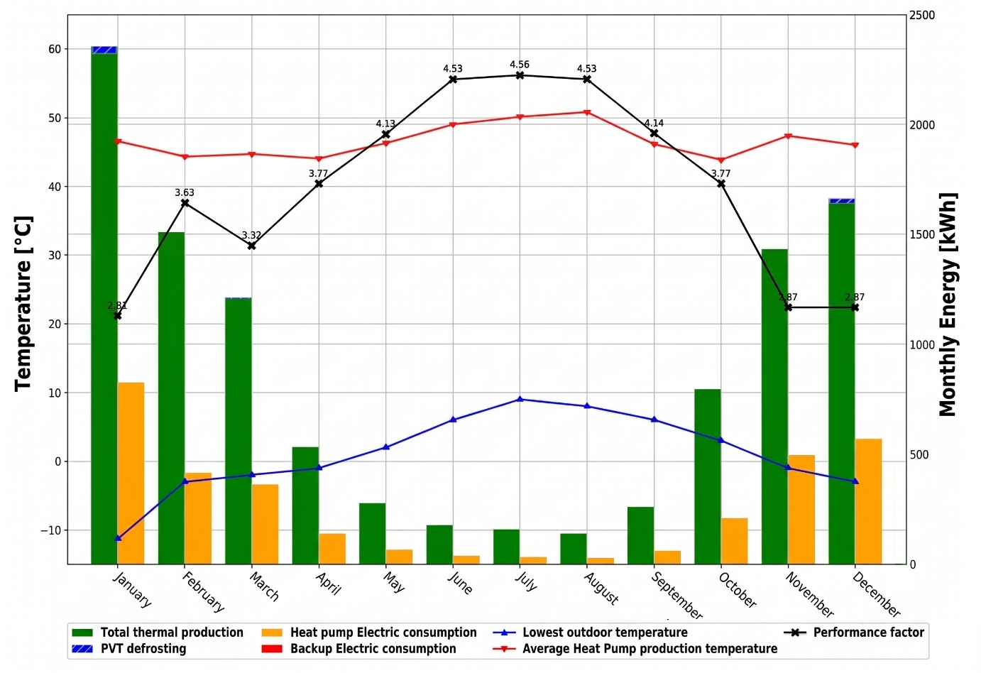
Fig. 6: Monthly energy balances and performances
Finally, the monthly variation of the performance factor shows clearly a seasonal dependence. It reaches 4,56 in July (the warmest month) and decreases to 2,81 in January (the coldest one). It is noticeable that the performance factor is higher than 3,77 for all months with lowest outdoor temperature above 0 °C (from May to October). Expect for the three coldest months, the performance factor exceeds 3. The minimum values are reached in the coldest months (approximately 2,81). These performance factors show the ability of the studied system to provide heat to the building at relatively stable temperatures at good performance levels. The key factor behind is the thermal efficiency of the heat source which was able to extract the required heat from environment during all the year despite the very variable and sometimes extremely cold outdoor conditions.
  - Daily performances
For the full monitored year, the daily performance of the energy system was measured and is shown in figure 7. Each marker represents one day performance factor, calculated according to the equation 1, as a function of the average of outdoor air temperature in that day. The markers are distinguished according to the services provided by the system. Thick markers represent the days with only domestic hot water demand (summer days). Thin points represent the other days during which both space heating and domestic hot water demands were met. The size and the colour of the marker correspond, respectively, to the daily operation duration of the system and the temperature average of the condenser outlet.
Overall, the daily performance factor exhibits a positive near-linear relationship with ambient air, increasing from approximately 2 at -5 °C to up to 4,8 above 15 °C. This linearity is expected since the heat source (connected to the HP evaporator) is warmer at higher outdoor temperatures while the condenser temperature remains comparatively stable. The operation duration (point size) decreases drastically as the outdoor temperature average increases. It is due to the decreasing space heating demand which is completely absent during summer days (thick points with only domestic hot water demand is provided).
In accordance with the previous sub-section, it can be observed from thick points, that the setpoint of domestic hot water is almost constant at 55 °C. This temperature is globally higher than the space heating supply temperatures, which vary according to the heating water curve implemented in the heat pump controller depending on the type of water radiators, ranging from 40 to 53 °C.
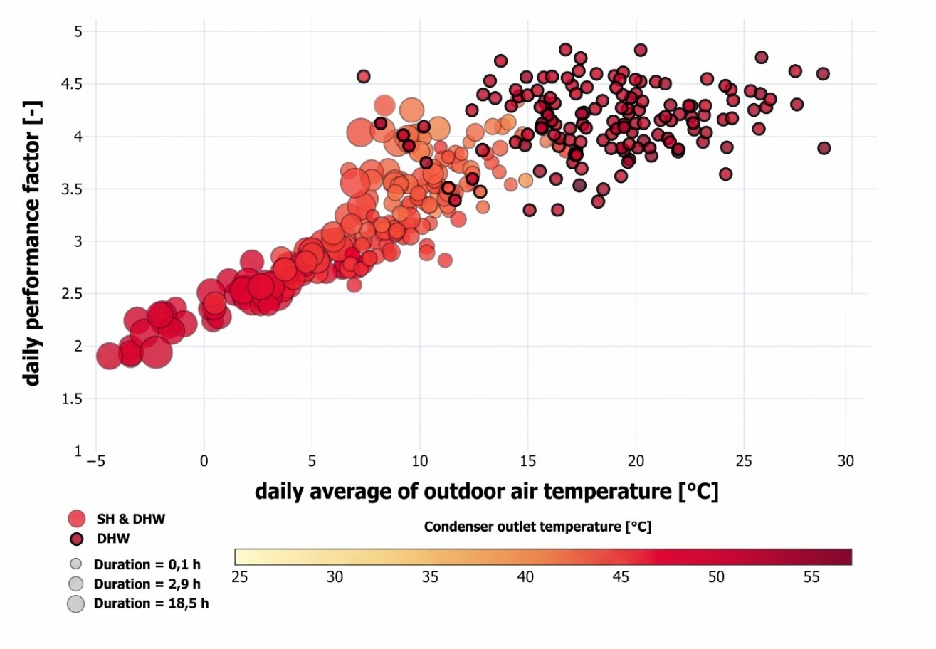
Fig. 7: Daily performance map of the PVT-HP energy system

Three distinct trends can be observed in the data of figure 7. The first corresponds to winter days, characterized by daily average outdoor temperatures below 7 °C. For these days, the condenser temperature average is stable ranging between 47 and 53 °C. The performance factor is varying between 1,9 and 3 following a strong and clear linear relationship with the daily average outdoor temperature. The points size indicates relatively long run durations exceeding 5 hours per day. This is due to the high and almost continuous space heating demand during these cold days and the almost similar weather conditions with almost no sun.
The second trend corresponds to the intermediate seasons with daily average outdoor temperature ranging from 7 to 13 °C. During this period, the system continues to provide both services (space heating and domestic hot water) but with higher performance factors ranging from 3 to 4,3. This is mainly due to the lower average condenser temperatures varying between 40 and 47°C. The operating durations are shorter than those observed in the first regime, typically ranging from 1 to 5 hours. This is due to the lower space heating demand during these days depending on the weather conditions. This second trend still marks a positive linear relationship between performance factors and outdoor temperatures, although with greater data dispersion. This can be explained by the variability of the weather conditions during these days, mainly the solar radiation energy and the wind speed influencing the thermal performance of the solar collectors.
The third trend corresponds to summer days, during which no space heating demand is recorded (thick points). The system operated exclusively to meet domestic hot water, with a relatively high and nearly constant condenser temperature (above 53 °C) and a short operating duration of less than 1 hour per day. The measured performance factors tend to reach a plateau, with most values lying between 4 and 4,8. It is due to the single scheduled domestic hot water cycle of the heat pump in the afternoons, during which the weather conditions are favourable for the heat pump operation. This explains the high-performance factors observed in this regime despite the high condenser outlet temperatures. This behaviour also highlights the potential benefit of using solar collectors as a heat source for the heat pump. In addition to heat extracted from ambient air, the solar collectors absorb the heat from solar radiation, which can improve the overall performance of the energy system. It is worth noting here that when the outdoor temperature averages increase, the performance factor seems to stabilize and not to increase constantly as in the first two trends. This is attributed to the effect of the mixing valve which limits the outlet PVT collectors when its too high.
  - Daytime vs night-time operation
Figure 8 shows the distribution of the performance factor for daytime and nighttime operation according to the produced thermal energy at the heat pump condenser. The distributions are presented as histograms, with the corresponding boxplots shown above. The performance factor ranges from approximately 1 to 10 for both operating periods, although most observations are concentrated between 2 and 4. The daytime distribution extends over a wider range of performance-factor values, with a pronounced concentration around 2,5–3,5 and a long tail extending to 7. The nighttime distribution is similarly concentrated in the lower range, with its highest frequency occurring around 2,5–3,0 and exhibits a long upper tail extending to approximately 6.
The upper boxplots show a clear difference between daytime and nighttime operation. The daytime conditions are associated with a higher median performance factor and a broader distribution towards high-performance values compared with nighttime operation. In contrast, nighttime operation is characterized by lower performance factors and a greater concentration of observations at relatively low values. These results indicate that the system operates more efficiently under daytime conditions, suggesting that daytime operation is generally more favourable for achieving high energy production.
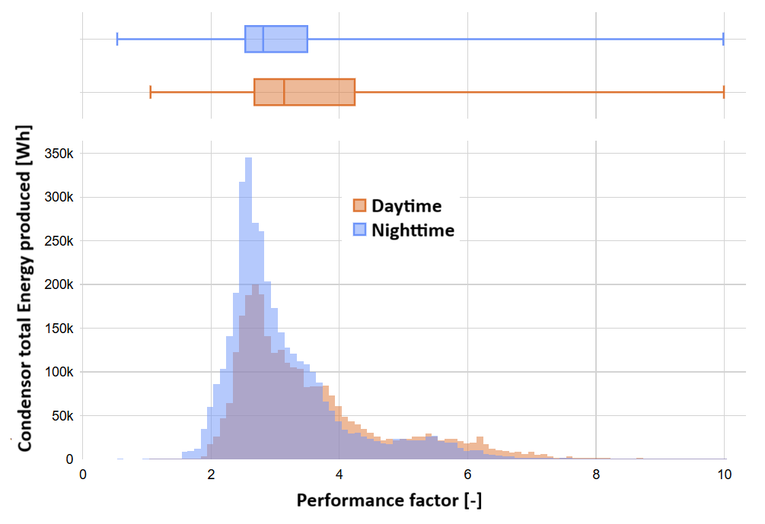
Fig. 8: The distribution of the performance factor (daytime vs night-time operation)

This difference suggests a potential opportunity for performance optimization through operational control. If the system could be preferentially operated during periods corresponding to daytime conditions, while limiting or avoiding operation during nighttime periods associated with lower performance factors, its overall performance could potentially be improved. In other words, a control strategy designed to favour operation during high-performance periods could increase the effective performance of the system at the system level.
  - Photovoltaic production
As mentioned previously, PVT collectors produce both heat and electricity. In addition to the produced heat feeding the evaporator of the heat pump, the produced photovoltaic energy can cover a part of the electric consumption of the heat pump compressor. The photovoltaic production is measured and compared to the electric consumption of the heat pump system. When they are both positive values, the photovoltaic production can cover a part or all the electric consumption decreasing the energy system consumption from the grid. During the monitored period, the total photovoltaic production of the solar collectors is 6,7 MWh. The monthly evolution, together with the estimated self-consumption of the heat pump system, are shown in figure 9. The total self-consumption during the monitored year was 792,5 kWh, which represents 24,2% of the total electric consumption of the heat pump.

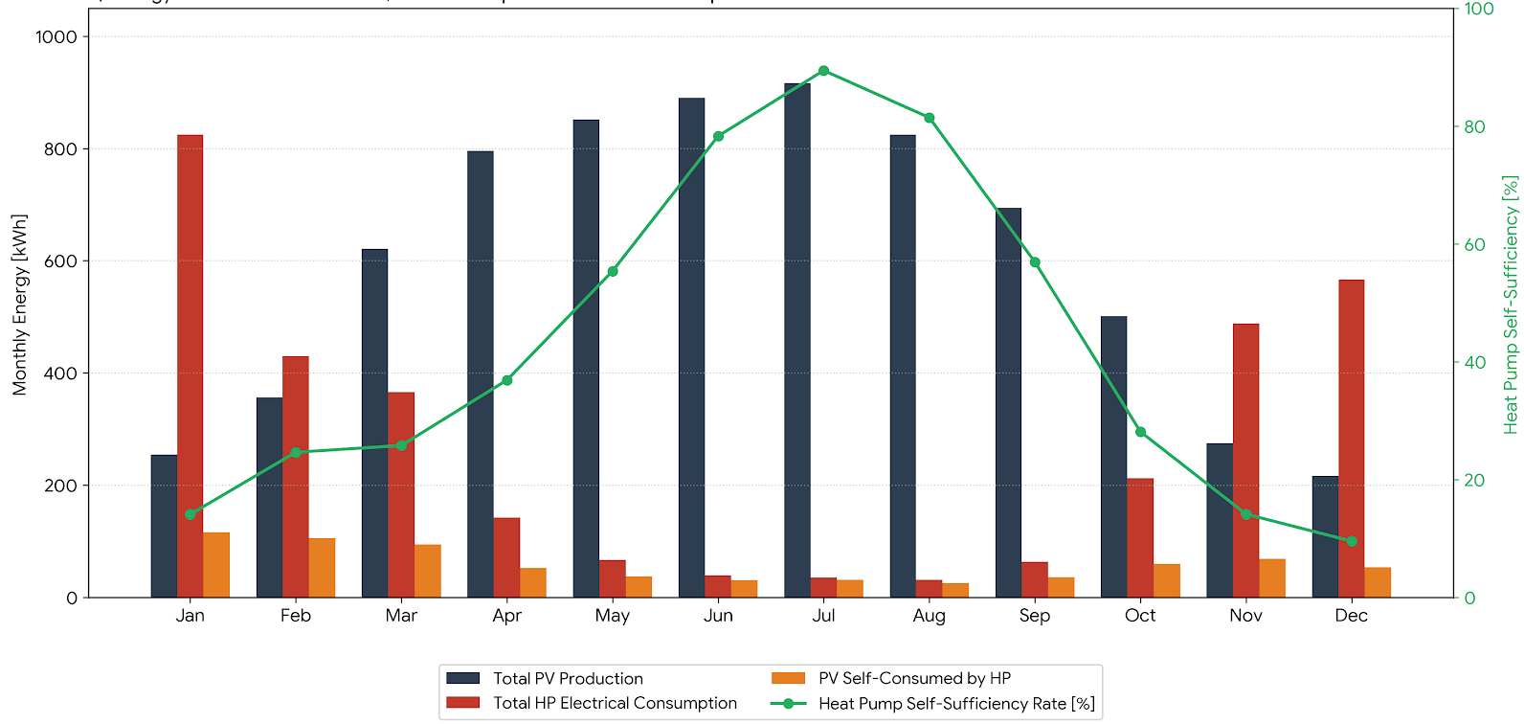
Fig. 9: Monthly evolution of total PV production and self-consumption by the heat pump system

The obtained grid seasonal performance factor of the studied energy system is equal to 4,23. This means that the PV self-consumption of the heat pump improved the overall performance factor by 32%. This improvement is significant and highlights the potential benefit of using hybrid solar collectors in combination with heat pump system. It is worth noting here that no PV-based controller was used in the studied system to increase the self-consumption of the heat pump. Despite the mismatch between PV production (higher in summer months) and the heat pump electric consumption (higher in cold months) the use of a PV-based specific controller allows to increase the self-consumption of the heat pump and then to improve more the performance factor of the heat pump system.
The remaining photovoltaic production can be self-consumed by other electric equipment in the house to reduce the global electric consumption on the grid. The portion of the PV production which cannot be self-consumed by the house it can be stored or send to the electric grid which all together reduces the energy bill of the user.
- Conclusions
This paper presented the first-year real in-situ monitoring results of an innovative solar-assisted heat pump system directly coupled with Photovoltaic Thermal (PVT) solar collectors as the sole heat source. The system was installed in a single-family house in a cold region of France (Vosges) to replace an old oil boiler for space heating and domestic hot water.
The key findings from this one-year operational monitoring study are summarized below:
- Thermal comfort and reliability: Thermal comfort was successfully maintained throughout the monitoring period, with 98% of indoor temperature measurements remaining within the target setpoint range. Even at ambient temperatures as low as -11 °C, 100% thermal coverage was provided by the heat pump without any activation of the electric backup heaters.
- System seasonal performance: The system achieved a seasonal performance factor (SPF) of 3.2, delivering 10.5 MWh of thermal energy. Energy consumption for defrosting cycles amounted to 51.92 kWh, representing less than 0.5% of total annual production, proving the high thermal effectiveness of finned PVT collectors as a heat source in cold conditions.
- Operational dynamics: Monthly performance factors ranged from 2.81 in January to 4.56 in July. Analysis comparing daytime and nighttime performance demonstrated higher efficiency during daytime operation, suggesting significant potential for optimization through intelligent control strategies.
- Photovoltaic self-consumption impact: Out of the 6.7 MWh generated by the PVT field, 792.5 kWh was directly self-consumed by the heat pump, covering 24.2% of its annual electricity demand. This self-consumption raised the seasonal grid performance factor (SPF_Grid) to 4.23, representing a 32% enhancement in overall system efficiency.
In conclusion, direct PVT solar-assisted heat pump systems represent a highly efficient, reliable, and competitive solution for replacing fossil fuel heating in cold climates. Future work will explore smart control strategies prioritizing daytime operation and solar self-consumption optimization.
References
Chhugani, B., Pärisch, P., Helmling, S., Giovannetti, F., 2023. Comparison of PVT - heat pump systems with reference systems for the energy supply of a single-family house. Solar Energy Advances 3, 100031. https://doi.org/10.1016/j.seja.2022.100031
Del Amo, A., Martínez-Gracia, A., Bayod-Rújula, A.A., Cañada, M., 2019. Performance analysis and experimental validation of a solar-assisted heat pump fed by photovoltaic-thermal collectors. Energy 169, 1214–1223. https://doi.org/10.1016/j.energy.2018.12.117
Delachaux, V., 2026. Concepts and design optimisation of a liquid-based photovoltaic-thermal solar panel to be the source of a heat pump as a field.
Helmling, S., 2022. Operational Analysis of 5 PVT Heat Pump Systems Based on Field Measurement Data, in: Proceedings of EuroSun 2022 - ISES and IEA SHC International Conference on Solar Energy for Buildings and Industry. Presented at the EuroSun 2022 - ISES and IEA SHC International Conference on Solar Energy for Buildings and Industry, International Solar Energy Society, Kassel, Germany, pp. 1–10. https://doi.org/10.18086/eurosun.2022.14.04
Jaafar, M.A., Chhugani, B., 2024. Numerical Study of the Effect of the System Specifications on the Performance of a Brine/Water Heat Pump in Combination with Photovoltaic Thermal Solar Collectors, in: Proceedings of EuroSun 2024. Presented at the EuroSun 2024: 15th International Conference on Solar Energy for Buildings and Industry, International Solar Energy Society, Limassol, Cyprus, pp. 1–10. https://doi.org/10.18086/eurosun.2024.07.09
Jaafar, M.A., Chhugani, B., Brottier, L., 2022. Numerical Study of the Effect of Hybrid Solar Collectors on the Performances of the System Combining PVT With Heat Pumps, in: Proceedings of EuroSun 2022 - ISES and IEA SHC International Conference on Solar Energy for Buildings and Industry. Presented at the EuroSun 2022 - ISES and IEA SHC International Conference on Solar Energy for Buildings and Industry, International Solar Energy Society, Kassel, Germany, pp. 1–8. https://doi.org/10.18086/eurosun.2022.08.06
Lopez, A.C., Beltran, F., Nicholson, E.L., Sommerfeldt, N., Delachaux, V., Mohamad Ali Jaafar, 2024. Experimental Assessment of the Effects of Cold Climate Weather Patterns on Novel PVT Collector Designs for Low Temperature Heat Pump Integration, in: Proceedings of EuroSun 2024. Presented at the EuroSun 2024: 15th International Conference on Solar Energy for Buildings and Industry, International Solar Energy Society, Limassol, Cyprus, pp. 1–12. https://doi.org/10.18086/eurosun.2024.07.11
Miglioli, A., Aste, N., Del Pero, C., Leonforte, F., 2023. Photovoltaic-thermal solar-assisted heat pump systems for building applications: Integration and design methods. Energy and Built Environment 4, 39–56. https://doi.org/10.1016/j.enbenv.2021.07.002
Nicholson, E.L., Beltran, F., Lopez, A.C., Sommerfeldt, N., Delachaux, V., Jaafar, M.A., 2024. Fins vs No Fins: A Comparative Experimental Analysis of Novel Box-Channel Photovoltaic/Thermal Collector Prototypes for Ground Source Heat Pump Integration, in: Proceedings of EuroSun 2024. Presented at the EuroSun 2024: 15th International Conference on Solar Energy for Buildings and Industry, International Solar Energy Society, Limassol, Cyprus, pp. 1–11. https://doi.org/10.18086/eurosun.2024.07.02
Ozgener, O., Hepbasli, A., 2007. A review on the energy and exergy analysis of solar assisted heat pump systems. Renewable and Sustainable Energy Reviews 11, 482–496. https://doi.org/10.1016/j.rser.2004.12.010
Vaishak, S., Bhale, P.V., 2019. Photovoltaic/thermal-solar assisted heat pump system: Current status and future prospects. Solar Energy 189, 268–284. https://doi.org/10.1016/j.solener.2019.07.051

