**INTERFACE INVESTIGATION OF CFRP AND CFR HYBRID POLYMER COMPOSITES**

Nikos Koutroumanis1, Anastasios C. Manikas2, Panagiotis Nektarios Pappas3 and Costas Galiotis4

1Institute of Chemical Engineering Sciences, Foundation of Research and Technology Hellas, Platani St., Patras, Greece. Deparment of Chemical Engeeniring, Univercity of Patras, Hellas, University Campus 26504 Rio Achaia

Email: nickkoutrou@iceht.forth.gr

2Institute of Chemical Engineering Sciences, Foundation of Research and Technology Hellas, Platani St., Patras, Greece

Email: a.manikas@iceht.forth.gr

3Institute of Chemical Engineering Sciences, Foundation of Research and Technology Hellas, Platani St., Patras, Greece

Email: ppappas@iceht.forth.gr

4Institute of Chemical Engineering Sciences, Foundation of Research and Technology Hellas, Platani St., Patras, Greece. Deparment of Chemical Engeeniring, Univercity of Patras, Hellas, University Campus 26504 Rio Achaia

Email: c.galiotis@iceht.forth.gr

**Keywords:** carbon fibres, interface, graphene, composite, Raman spectroscopy

**Abstract**

The critical role of the interfacial region between the matrix and the reinforcing medium on the performance of carbon fiber reinforced composites, is known and very well-documented in the relative literature. In this work, we aim to present a study of the interfacial quality in carbon fibre reinforced composites from two distinct point of views: a) after surface modification of the fibre by means of epoxidaton, and b) after modifiacation of the host epoxy matrix by means of mixing with graphene nanoparticles. The first modification method has been extensively presented elsewhere by the authors [3]. This novel method of CF surface treatment at room temperature resulted to a significant improvement of the interface up to 130%, using the β-parameter as a criterion. The second proposed method directly introduces graphene nano-platelets (GNPs) dispersed in the host epoxy system and exhibits an interface enhancement in the range of 50% provided an addition of 2 wt% GNPs into the epoxy resin occurs. For the single filament interface evaluation Raman spectroscopy has been adopted along with the basic principles of the shear lag theory and the calculated shear lag parameter (β-parameter) was used as a criterion in each of the abovementioned cases.

1. Introduction

During the past few decades carbon fibre reinforcement composites have replaced metal counterparts in a wide range of high performance automotive and aerospace structural applications, as they show –among other benefits- high strength and stiffness to weight ratios [1]. The role of interface-interphase has been traditionally one of the most important subjects of study in the field of advaned polymeric composites. It is well enstablished that the level of interfacial adhesion between the host material and the inclusions dominates the transfer mechanism of stresses from the ‘weak’ matrix to the ‘strong’ reinforcing phase. Also, it is widely accepted that a composite with good mechanical properties and environmental stability requires an optimum interface [2]. A lot of work has been done on the modification of the fibre surface in order to improve the interfacial quality. Most surface treatment techniques aim to modify the ‘weak’ outer layer of the fiber by increasing the number of surface active groups. In generally, these methods either implant chemical groups onto the surface where free valences of the graphite carbon atoms have not been saturated or lead to surface roughening, resulting to interfacial strength enhancement when these groups are of sufficiently high concentration [3].

Graphene nanoplatelets (GNPs) are short stacks of individual (or very few) layers of graphite. GNPs are recently developed and their production requirements does not classify them as high cost material. Inclusion of graphene nano-platelets (GNPs) in epoxy has been shown to improve mechanical and electrical properties with respect to the un-reinforced epoxy, thus triggering the research on using epoxy/GNP systems as a host matrix in several composite applications. The resulting hybrid composite can potentially exhibit enhanced mechanical properties in respect to traditional carbon fiber composites .[4-5]. It has been demonstrated that the effect of GNPs on GNP/polymer composite mechanical properties is governed by the amount of GNPs added to the polymer and the dispersion efficiency of the GNPs into the matrix [4-6]. Furthermore, multiscale reinforcement, containing fibers together with graphene into the matrix or on the surface of the fibers, can enhance the interface properties (e.g., fatigue life) of fiber reinforced composites. The intrinsic Van de Waals interactions existing between graphene nanoplatelets force them to aggregate, contributing to the development of local stress when an external force is applied on the composite part. This can significantly affect the mechanical properties of the composite [7].

The first modification route is based on the mild surface epoxidation of CFs at RT [3]. The adopted technique can be considered novel, energy-saving, environmental friendly and easy to handle in the lab scale. Briefly, carbon fibers are immersed into suitable chemical solution for short time (1 to 5 minutes) resulting to the formation of epoxide rings on the surface of the CF. Generated epoxide rings can interact with the host polymer (especially with epoxy resins) and thus to enhance the adhesion between the fiber and the matrix [Fig. 1]. The second modification route is related to altering the properties of the host matrix instead of those of the reinforced fibres by controlled dispercing of graphene flakes into epoxy resin. Commercialy available carbon fibres are embedded into epoxy films containing graphene flakes in different volume fractions varying from 0.2 to 2 wt%.

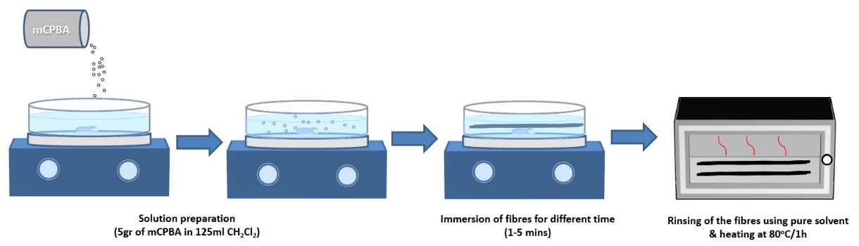

**Figure 1.** CF epoxidation procesidure.

The preparation of the modified epoxy matrix follows a rather simple but effective path of mixing graphene nanoparticles in a two step procedure. Initially, GNPs are dispersed into the ‘hardener’ agent of the two-component epoxy system by discrete steps of magnetic steering and bath sonication for suitable timings. Following the above the GNP/hardener compound is mixed with the required quantity of epoxy resin under magnetic steering of the solution. The modified epoxy system is then used to fabtricate the sibgle filament model coupons as described in the following section. In figure 2 a simplified sketch of the adoptede mixing method is presented.

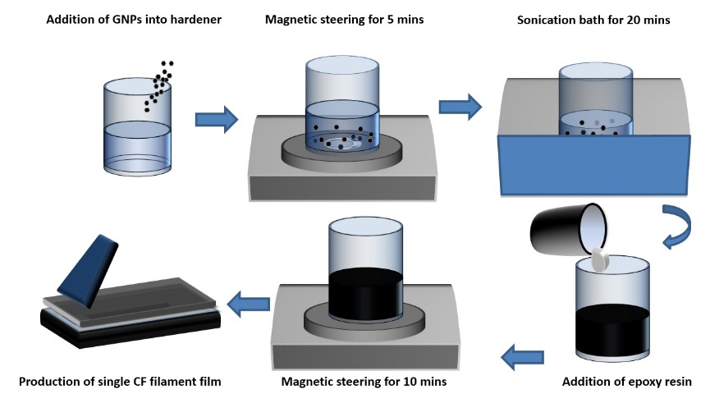

**Figure 2.** CF epoxidation procesidure.

Raman spectroscopy has been successfully adopted to study the stress-transfer characteristics in carbon fibre/epoxy systems, since the Raman lines of the reinforcing carbon fibres exhibit distinct and reproducible shifts when subjected to axial load in the fibre direction [8]. Point by point Raman spectra of the embedded single fiber filaments under axial tension were acquired, starting from the break points or the edges, until a total fibre length of approximately 1 mm was covered. Raman shift was converted to strain and then subsequently to axial stress, as derived from the calibration and mechanical testing data. In the present work the effect of the surface (or fibre) modification on the interface properties was studied by measuring the corresponding interfacial shear stress (ISS) at the interface region certain levels of applied strain using a balance-of-forces approach [9]. The ISS distribution is obtained by the following equation:

$τ_{rx}=-\frac{rβσ_{f,∞}}{2}e^{-βx}$ (1)

Where, r is the radius of CF, $σ_{f,∞}$ is the far field stress and β is a fitting parameter, which equals to the inverse transfer length value. The shear-lag parameter, β, [9] can effectively serve as a stress-transfer efficiency index.

**2. Experimental**

***2.1. Preparation of model composites***

In the first case of surface modification of CFs, Low Modulus PAN based Carbon Fibres provided by Courtaulds Grafil (EX-AIM) were used. Fibres were unsized and untreated in 6k tows with a mean diameter of 4.8 μm. In the second case of matrix modification via dispersion of graphene particles, high modulus PAN based Toray M40 fibres with a diameter of 7 microns were used. . In both cases the host medium consisted of a two-part ‘water clear’ (base agent: R2820 / hardener: H8390, ratio: 2:1) epoxy system provided by Fibermax. The resin system is mixed and cured at Room Temperature (RT) and an additional post-curring at 40-80oC is implemented for achieving the final mechanical properties. Graphene powder consisted of 5 to 7 layer and 5 μm diameter flakes, provided by Thomas Swain.

The fabrication of CF reinforced resin ‘model’ composites was carried out by pouring a small quantity (in order to form a thin layer) of resin over the CFs, which were placed and aligned on a flat polished surface. The flat substrate was covered by stretched release film to ensure proper removal without damaging the cured coupon. In this way, fibres were embedded close to the outer surface of the matrix in order to be optically accessible to Raman Microscope. Films were cured for 24 h at RT and then for 24 h at 40o C. The aforementioned procedure resulted to the fabrication of single fibre reinforced coupons with dimensions 6cm x 5mm x 0.1 mm. The single filament coupon fabrication method was kept constant for both examined cases herein.

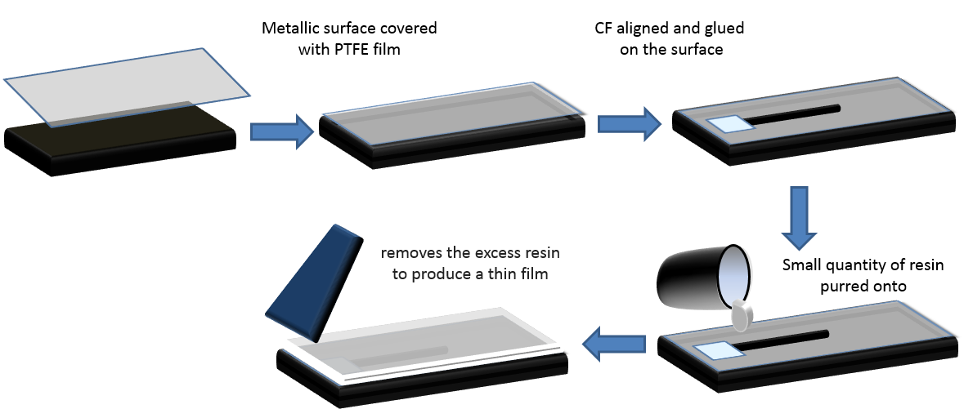

**Figure 3.** Model composite fabrication

**2.2. Raman Spectrocopy under tension**

Raman spectra were acquired for both free and embedded CF filaments at 785 nm using a Micro Raman (Invia Reflex, Renishaw, UK) set-up. The laser power was kept below 1 mW on the sample to avoid laser induced local heating. A 100x objective with numerical aperture of 0.85 was used, and the spot size was estimated to be ~1 μm. A 3-axis motorized stage provided the ability to focus, monitor and map the desired regions on the samples. . The applied strain was induced by using a tailor made straining apparatus with an estimated accuracy in the axial deformation of 125 μm, in 0.20% strain incremental steps up to failure. Normally, for both free and embedded filaments the failure occurs at approximately 1-1.3% strain on the fibre. Spectrum acquisition was performed in 2x30 seconds sessions for each measurement. All the Raman frequency values were derived by fitting Lorentzian routines to the charge coupled device (CCD) raw data. Three measurements were averaged at each step.

**3 Results and discussion**

**3.1 Interface investigation for epoxidized at RT CFs**

In Fig. 4 the normalized calculated axial stress for both treated and pristine fibres, is presented. As shown, the stress built-up rate is higher for the treated fibres compared to the pristine ones. It is also clear that the rate is higher for CFs treated for longer time (5min).

The ISS values for the three different cases were calculated and presented in Fig. 5. As shown, the stress transfer response of the pristine and the two epoxidized CF/epoxy systems are considerably different. The epoxidized for 5 mins fibre/epoxy specimen exhibits much higher ISS value at the discontinuity (x=0) but simultaneously the reduction rate is much higher compared to the pristine and the 2 minutes epoxidized samples. The predicted values of the ISS for the maximum measured far field stress (Table 1) were found to be 3.3 MPa for the pristine, 4.7 MPa for the 2 minutes epoxidized and 7.7 MPa for the 5 minutes epoxidized CF/epoxy composites, respectively. The shear-lag parameter, β, was also determined and presented in Table 1.

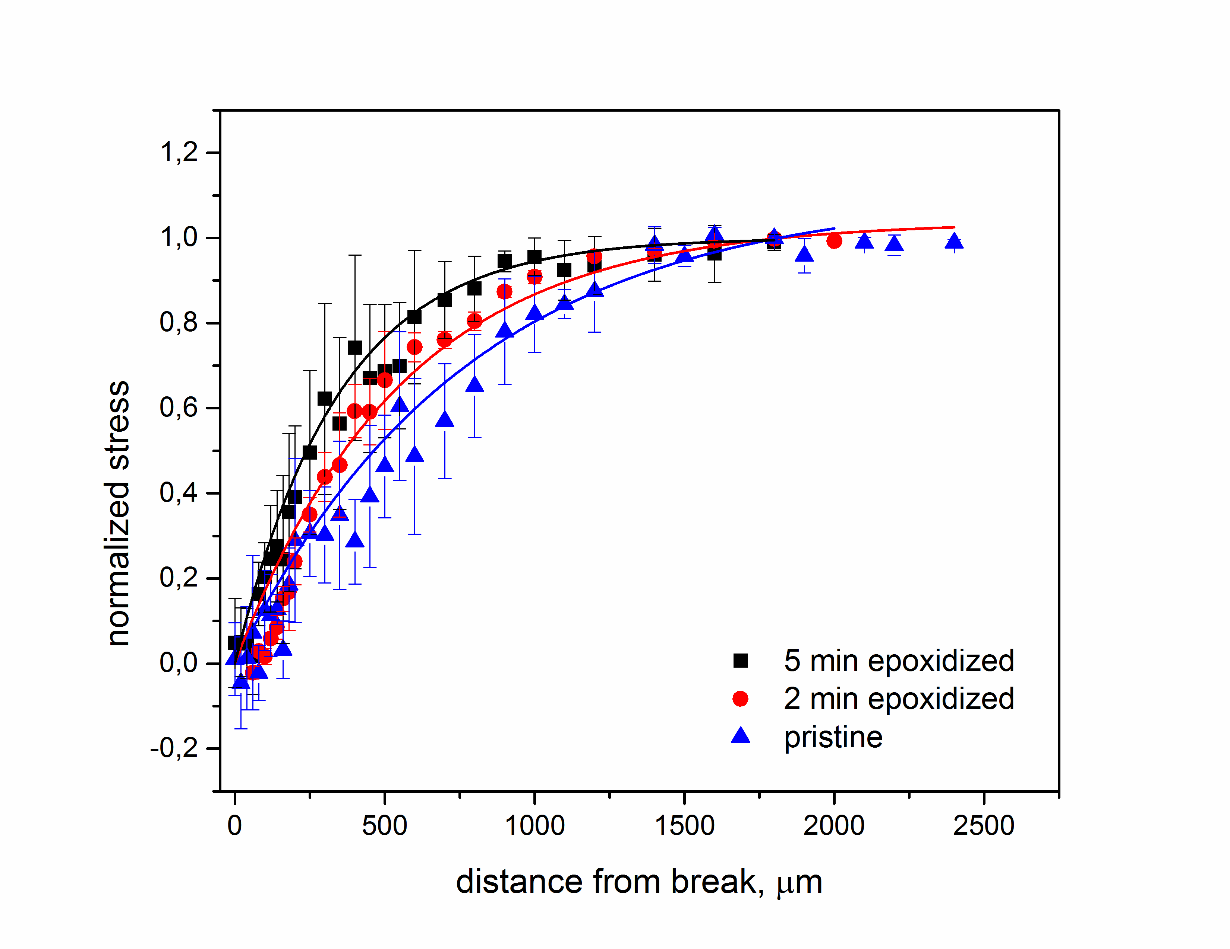

**Figure 4.** Normalized axial stress ) versus the distance from the discontinuity of CF embedded in the epoxy resin for different epoxidation time.

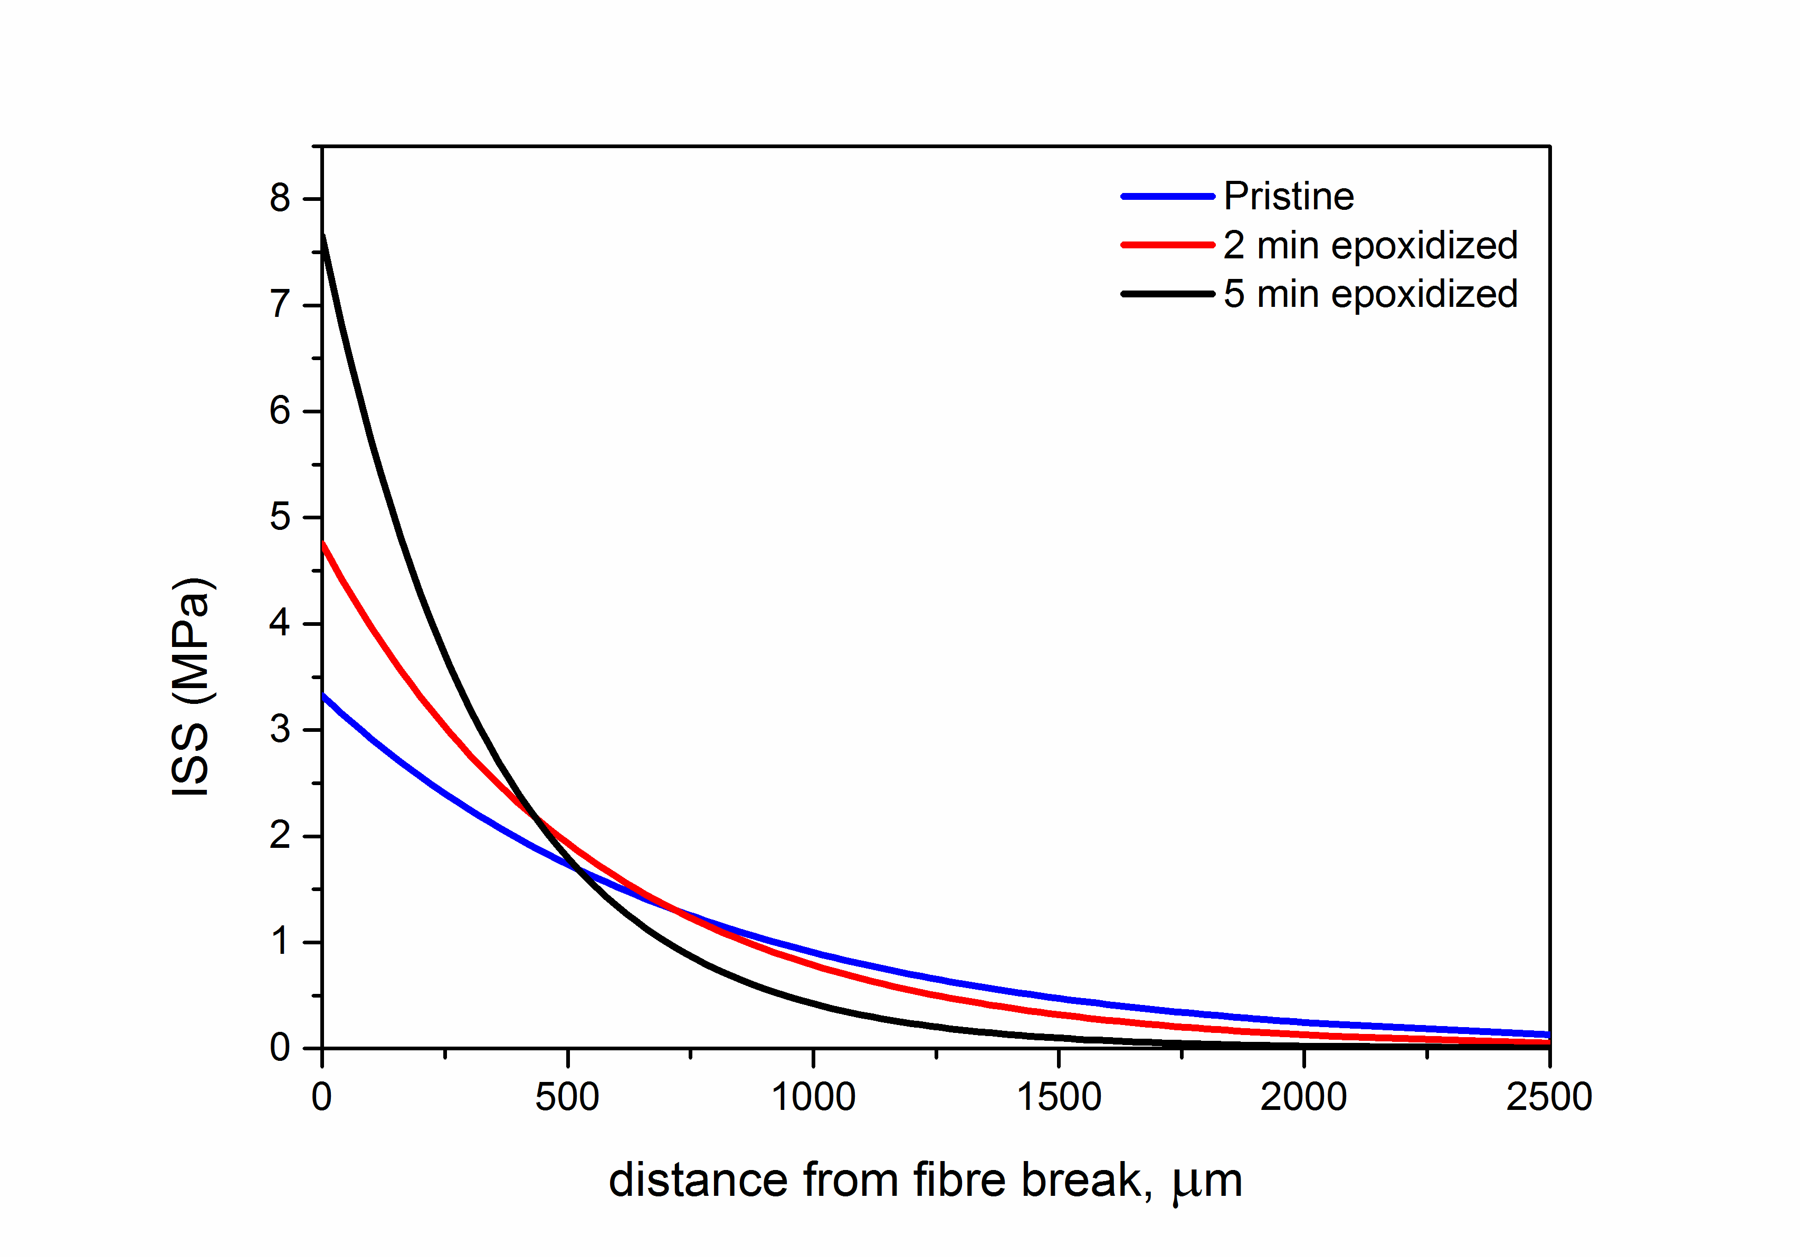

**Figure 5.** ISS versus the distance from the discontinuity of CF embedded in the epoxy resin for different epoxidation time.

**Table1.** Maximum ISS and the the shear-lag parameter, β, at different treatment times.

|  |  |  |
| --- | --- | --- |
| epoxidation time | β | ISS (MPa) |
| pristine | 0.0013 | 3.3228 |
| 2 minutes | 0.0018 | 4.752 |
| 5 minutes | 0.0029 | 7.656 |

Based on the abovementioned experimental results we can denote that the proposed epoxidation method delivers CF filaments with enhanced interface properties, exhibiting more efficient stress build up along the fibre axis and lower transfer length values than the pristine samples. The proposed method, using the β-parameter as a criterion, exhibited a significant improvement of 130 % in the interface efficiency.

**3.2 Interface investigation for GNP-modified epoxy matrix**

In Figure 6 the normalized axial stress for 0.2 to 2 wt% GNPs samples vs. the pristine material is presented. It is apparent that the axial stress build-up rate is increasing with the wt% of GNPs exhibiting a plateu for concentrations greater than 1 wt%. Although a more extended experimental work in even higher concentrations is under development, we can safely assume that additional quantities of graphene inclusions cannot further enhance the interfacial behavior.

In Figure 7 the calculated ISS values for each case are presented. Again it is obvious that higher graphene inclusion concentrations lead to higher obsereved initial ISS values at the edge of the fibre, while the shear stress reduction rate is also increased. The shear lag parameter, β, as well as the initial ISS values for each case are calculated and presented in Table 2.



**Figure 6.** Normalized axial stress versus the distance from the discontinuity of CF embedded in the epoxy resin for different GNP consentrations.

The interfacial evaluation results in case of GNP-modified epoxy matrix show a noticeable improvement compared to the pristine unmodified system, since the axial stress build-up rate is increased along with the initial ISS values, in accordance with the concentration of the graphene inclusions. The first experimental approach gives strong evidence of a concentration threshold above which no further enhancement is achieved. Using the β-parameter as a criterion, a maximum improvement of the interfacial quality in the range of 65% was observed.

C:\Users\koutroumanis\Desktop\Graph1.tif

**Figure 7.** Calculated ISS values versus distance from the discontinuity for different GNP concentrations.

**Table 2.** Maximum interfacial shear stress and the the shear-lag parameter, β, values for different GNPs concentrations.

|  |  |  |
| --- | --- | --- |
| GNPs Concentration (%) | β (μm-1) | ISS (MPa) |
| 0 | 0.00702 | 13.20 |
| 0.2 | 0.00802 | 14.74 |
| 0.5 | 0.00927 | 15.89 |
| 1.0 | 0.01106 | 18.97 |
| 2.0 | 0.01154 | 20.20 |

**4. Conclusion**

In the present work authors demonstrate the effect of two distinct modification methods in the interfacial behavior of single filament model composites using the shear lag parameter –as derived from combined mechanical/spectroscopic experimental procedure- as a criterion. The first proposed method aims to modify the outer surface of the CF and has been extensively presented by the authors elsewhere [REF], while the second method aims to modify the host matrix by dispersing graphene nano-inclusions in certain concentrations.

In both cases the improvement of the interfacial parameters is noticeable and both methods seem capable of producing composite materials with enhanced mechanical properties.

In case of epoxidation at RT a maximum improvement of the β-parameter in the range of 130% was observed, while the corresponding improvement in the case of matrix modification with graphene reached 65%.

The aim of the presented results is not to perform a quantitative comparison of the two modification paths, but to provide enough qualitative evidence of enhanced properties in the interacial zone of the composite. Although the host resin system is the same in both modified systems, the CFs used exhibit significant differences, constituting a serious drawback for direct comparison.

Based on the observed signifiacant interfacial improvement, the next step is the fabrication of large scale composite samples using the modified CFs / epoxy resin, in order verify the expected mechanical properties enhancement.

Acknowledgments

The authors acknowledge financial support from the Horizon 2020 “SMART-FAN” programme No. 760779 ‘Smart by Design and Intelligent by Architecture for turbine blade fan and structural components Systems’.

References

[1] Amar C. Garg, Yiu-wing Mai. Failure mechanisms in toughened epoxy resins-A review. *Composite Science and Technology,* 31:179-223, 1988.

[2] Miguel A. Montes-Moran, Robert J. Young. Raman spectroscopy study of high-modulus carbon fibres: effect of plasma treatment on the interfacial properties of single-fiber epoxy composites, Part II Characterization of the fibre-matrix interface. *Carbon,* 40:857-875, 2002.

[3] N. Koutroumanis, A. C. Manikas, P. N. Pappas, F. Petropoulos, L. Sygellou, D. Tasis, K. Papagelis, G. Anagnostopoulos, C. Galiotis. *Composite Science and Technolofy*, 157:178-184, 2018.

[4] Rafiee MA, Rafiee J, Wang Z, Song HH, Yu ZZ, Koratkar N. Enhanced Mechanical Properties of Nanocomposites at Low Graphene Content. *ACS Nano*, 3:3884-3890, 2009.

[5] King JA, Klimek DR, Miskioglu I, Odegard GM. Mechanical properties of graphene

nanoplatelet/epoxy composites. *J Appl Polym Sci*, 128:4217-4223, 2013.

[6] Tang LC, Wan YJ, Yan D, Pei YB, Zhao L, Li YB, et al. The effect of graphene dispersion on the

mechanical properties of graphene/epoxy composites. *Carbon*, 60:16-27, 2013.

[7] Zhang XQ, Fan XY, Yan C, Li HZ, Zhu YD, Li XT, Yu LP. Interfacial microstructure and properties of carbon fiber composites modified with graphene oxide. *ACS Appl Mater Interfaces,* 4:1543-1552, 2012.

[8] Melanitis N, Galiotis C, Tetlow PL, Davies CKL. Interfacial shear-stress distribution on model composites .2. Fragmentation studies on carborn-fiber epoxy systems*. J Compos Mater*, 26:574-610, 1992.

[9] Galiotis C, Paipetis A. Definition and measurement of the shear-lag parameter, beta, as an index

of the stress transfer efficiency in polymer composites. *J Mater Sci*, 33:1137-1143, 1998.