MORPHOLOGICAL AND MECHANICAL PROPERTIES OF LDPE FILM INCORPORATED WITH SWEET BASIL OIL

Poonsub Threeponatkul^{1,*}, Amnard Sittattrakul¹, Chanin Kulsetthanchalee², Jutiporn Sukata¹, Thitiporn Daowadueng¹ and Phooreerat Tawai¹

¹Department of Material Science and Engineering, Faculty of Engineering and Industrial Technology, Silpakorn University, Nakhon Pathom, 73000, Thailand
²Event and Exhibition Design Department, Suan Dusit University, Bangkok 10300, Thailand
*Email: poonsubt@yahoo.com

Keywords: Film packaging, LDPE, Sweet basil oil

Abstract
The consumption of the plastic materials for packagings in everyday life has been increased. Low density polyethylene (LDPE) is a primary polymer for film packaging production. One of the innovative film developments is fragrant film with essential oil as additive. However, essential oil is easy to evaporate during process and thus β-cyclodextrin is required for retaining the essential oils. In addition, compatibilizer such as polyethylene-graft-maleic anhydride (PE-g-MA) is necessary to enhance the miscibility between polymer and additives. The effect of compatibilizer on morphological and mechanical of LDPE thin films incorporated with sweet basil oil is investigated. The β-cyclodextrin, sweet basil oil and PE-g-MA as compatibilizer are compounded with LDPE using twin-screw extruder. Miscibility of LDPE and β-cyclodextrin is studied by Fourier transform infrared spectroscopy. It is confirmed that interaction between β-cyclodextrin and PE-g-MA has taken place. Films are produced by cast-film extruder and then are characterized by universal testing machine. Young’s modulus, tensile strength and elongation at break of LDPE film with sweet basil oil has been increased compared with neat LDPE film.

1. Introduction

Traditionally, packaging films are produced from thermoplastic such as high density polyethylene (HDPE), low density polyethylene (LDPE), linear low density polyethylene (LLDPE). LDPE is the most popular choice to be used as plastic bag because of its ductility, high impact and transparency property. Presently, the demand usage of plastic packaging is inclined to be higher as well as the more technology developments in film properties are in place in order of customer satisfaction. Among those, one of the new film development is fragrant film by the addition of a number of essential oils during film processing. Essential oil can be anti-oxidant, anti-bacterial [1-4], insect repellent properties [5]. In the past, ethylene vinyl alcohol (EVA) film incorporated with oregano oil [3] and LDPE/EVA copolymer incorporated with the combination of essential oils [6] had problems due to the essential oils volatilization. The effectiveness of oil on the film property depends on oil existence in the film. Therefore, during the film processing, the addition of the release control agent would be necessary.

Cyclodextrins are carbohydrate which are produced from starch by enzymatic conversion. Pharmaceutical and Medical care use it to conduct the treatment and control of the release medicine in the human body. With three nomenclatures varying on the amount of glucosyl unit, the six glucosyl units would be called α-cyclodextrin. While the seven and eight glucosyl units would be β-cyclodextrin and γ-cyclodextrin respectively. Among three of them, β-cyclodextrin is the cheapest yet the most popular type [7]. Additionally, the efficiency of release control depends on the size of essential oil component. In this research, β-cyclodextrin is chosen as the release control agent
for retaining the sweet basil oil in LDPE film. The structure of cyclodextrin looks like truncated cone [8], having 6-8 molecules of cyclic glucosyl unit and cavity in the center of its structure is hydrophobic part whereas the outer is hydrophilic counterpart. However, due to the different on the polarity of β-cyclodextrin and LDPE. It is a necessity to use PE-g-MA as the compatibilizer for increasing miscibility between them. Therefore, the purpose of this research is to investigate the morphological and mechanical properties of LDPE film incorporated with sweet basil oil and β-cyclodextrin in the presence of PE-g-MA.

2. Experimental

2.1. Materials

Low-density polyethylene (LDPE 2426K) with melt flow index of 4 g/10 min was purchased from Innoplus (Thailand). β-cyclodextrin (≥97 %purity) was used for retaining the sweet basil oil during process and PE-g-MA as a compatibilizer with MA content of 0.5 % were purchased from Sigma Aldrich Chemical Company, Singapore. Sweet basil oil (SB) was supplied from Chemipan Corporation, Thailand. LDPE and β-cyclodextrin were dried at 60 °C for 24 hours before the melt processing was done. PE-g-MA was grinded for sizing purposes and dried at 60 °C for 24 hours.

2.2. Film preparation and characterization

Sweet basil oil 0.5 ml was added into 1 g of β-cyclodextrin. LDPE, PE-g-MA and β-cyclodextrin with sweet basil oil were compounded by twin screw extruder at set-up temperatures from hopper to die of 110 - 150 ^{º}C and screw speed of 300 rpm. Films were processed by cast film extruder at set-up temperature from hopper to die of 130 - 175 ^{º}C at screw speed of 40 rpm and nip roll speed of 2.2 m/min. The films width and thickness were 11.5 cm and 0.95 micron, respectively.

2.3. Characterization

The interaction between β-cyclodextrin and PE-g-MA was identified by Fourier transform infrared (FT-IR) Bruker Vertexc70 spectrometer. FTIR Spectrum ranged from 4000 cm⁻¹ to 400 cm⁻¹ and recorded repeatedly of total 32 scans. Each sample was directly embedded into a KBr pellet and measured in transmittance mode.
Morphological properties of film were observed by scanning electron microscope (SEM) (HITACHI TM3030) at voltage of 15 kV and magnification of 2000. The samples were cryo-fractured in liquid nitrogen, then the morphology of cross-section was studied. Thin-layerd of gold was sputter coated on each sample surface before the test.
The mechanical properties of film sample were measured with Instron 5969 testing machine equipped with a load cell of 5 kN at speed 500 mm/min. according to ASTM D882 standard. At least five specimens from each film were tested, and concentrate on average values of Elongation at break, Tensile strength and Young's modulus.

3. Results and discussion

  - Fourier transform-infrared spectroscopy (FT-IR)

FTIR spectrums showed the characteristic bands of the individual polymers for the change of functional groups. Figure 1 (Left) (a) LDPE showed peak of CH stretching around 2920 cm⁻¹ and 2850 cm⁻¹. Figure 1 (Left) (b) showed peak of β-cyclodextrin, OH stretching around 3376 cm⁻¹, hydrocarbon stretching around 2925 cm⁻¹ and C-O stretching around 1050-1150 cm⁻¹ and Figure 1 (Left) (c) showed PE-g-MA appeared at the characteristic peaks of hydrocarbon stretching around 2920 cm⁻¹, 2850 cm⁻¹ and C-O stretching around 1375 cm⁻¹ and C=O stretching around 1715 cm⁻¹.
Figure 1 (Right) (b) showed FTIR spectra of LDPE mixed β-cyclodextrin, the OH stretching of β-cyclodextrin appeared around 3440 cm⁻¹ and hydrocarbon stretching of LDPE around 2920 cm⁻¹, 2850 cm⁻¹. The result confirmed finding β-cyclodextrin in LDPE film. In the other case, when adding PE-g-MA to the film Figure 1 (Right) (c), FTIR spectrum showed characteristic peak of β-cyclodextrin and LDPE. Spectrum of PE-g-MA are shown around 1370 cm⁻¹ for C-O stretching and 1635 cm⁻¹ for C=O stretching. Moreover, the peak of OH group is shifted from 3440 cm⁻¹ to 3450 cm⁻¹. This peak shift could be attributed to the existence of some intermolecular interaction between β-cyclodextrin and PE-g-MA as presented in Figure 2.

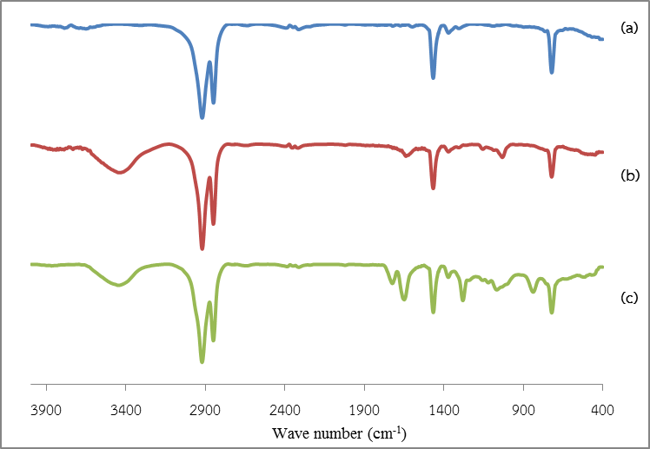 | 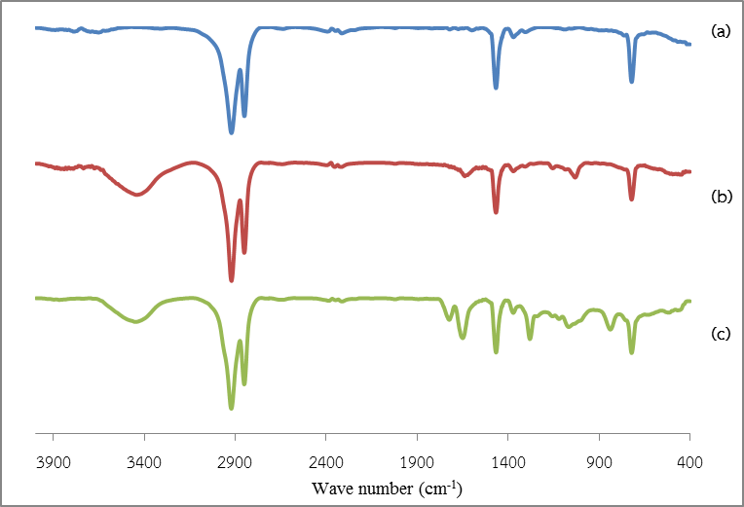

Figure 1. Spectrum FTIR of (Left) (a) LDPE, (b) β-cyclodextrin, (c) PE-g-MA,
(Rigth) (a) LDPE, (b) LDPE/β-CD, (c) LDPE/β-CD/MA0.2.

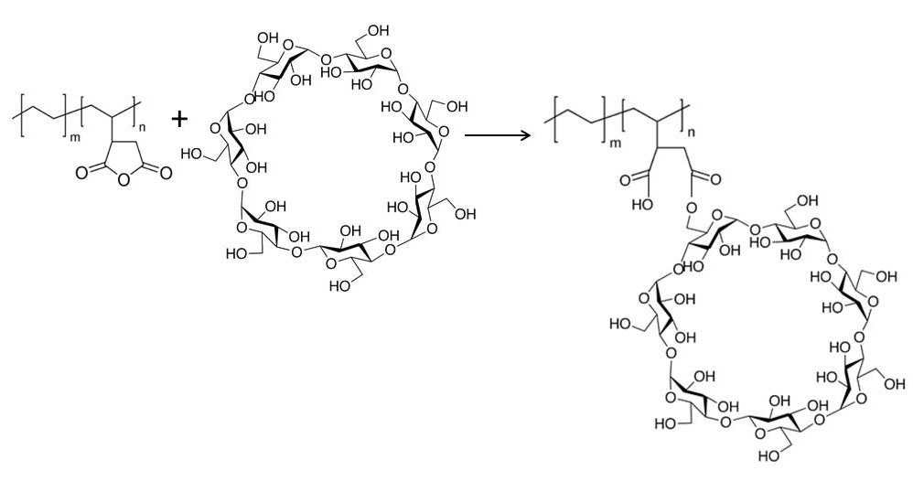

Figure 2. Interaction between β-cyclodextrin and PE-g-MA.

  - Morphology

Figure 3(a) showed morphology of fracture surface of LDPE films. It was smooth fracture surfaces of neat LDPE. The morphology of β-cyclodextrin cluster was showed in Figure 3(b). Fracture surface of LDPE films mixed with β-cyclodextrin illustrated the heterogeneous phase between LDPE and β-cyclodextrin as seen in Figure 3(c) because of the polarity difference. β-cyclodextrin is the most contained of OH group thus it possessed high polarity but low polarity for LDPE. Figure 3(d) depicted the morphology of fracture surface of LDPE films mixed with β-cyclodextrin and PE-g-MA. The results showed some parts of β-cyclodextrin which could be miscible with LDPE. The addition of PE-g-MA would bring in the polarity and nonpolarity to the structure. Figure 3(e) showed the morphology of fracture surface of LDPE films mixed with β-cyclodextrin and sweet basil oil. The results displayed the heterogeneous phase among them because of no compatibilizer.

Figure 3 (f, g, h and i) showed the morphology of the surface of LDPE films mixed between β-cyclodextrin, SB and varied content of PE-g-MA at 0.2, 0.6, 1.0, and 1.4 %wt. When the amount of PE-g-MA was increased, it could raise the miscibility between β-cyclodextrin and LDPE. The content of compatibilizer that showed the best miscibility was PE-g-MA 1.4 %wt.

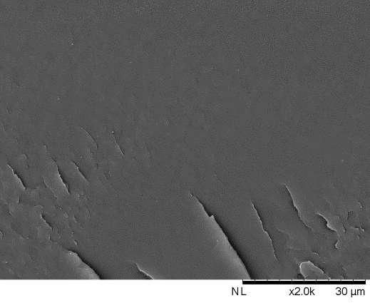  a | 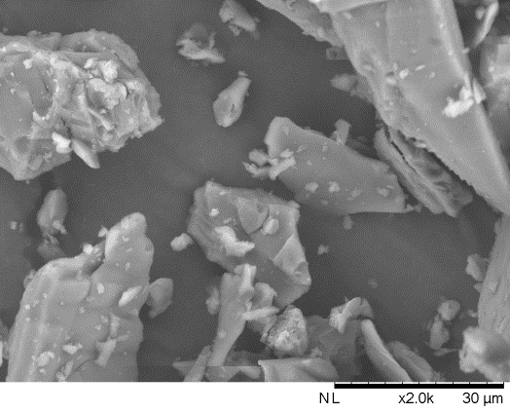  b | 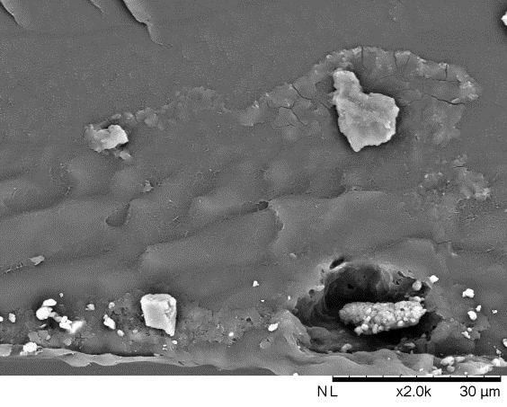  c
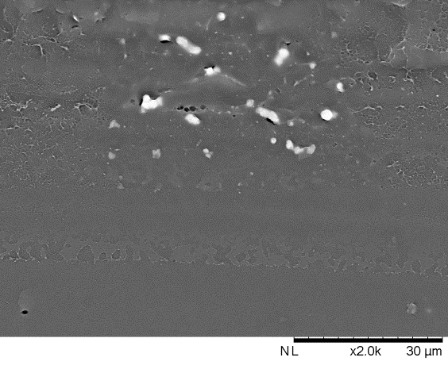  d | 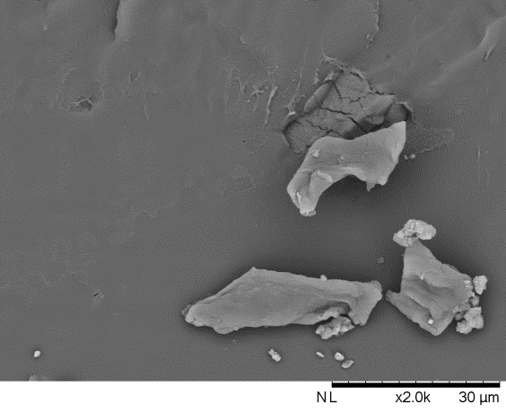  e | 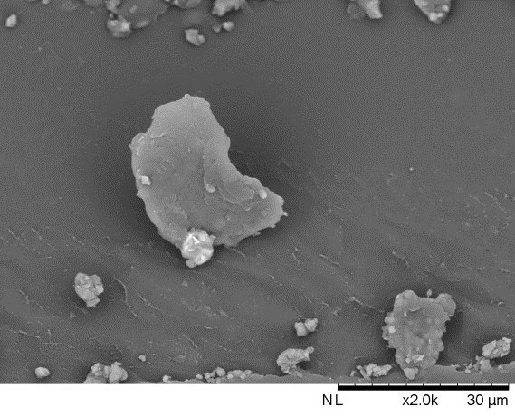  f
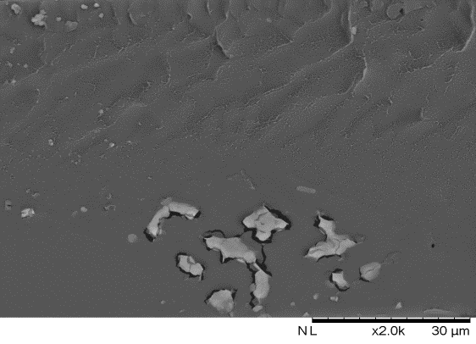  g | 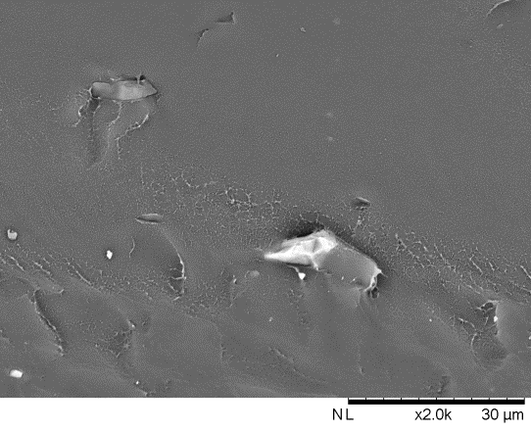  h | 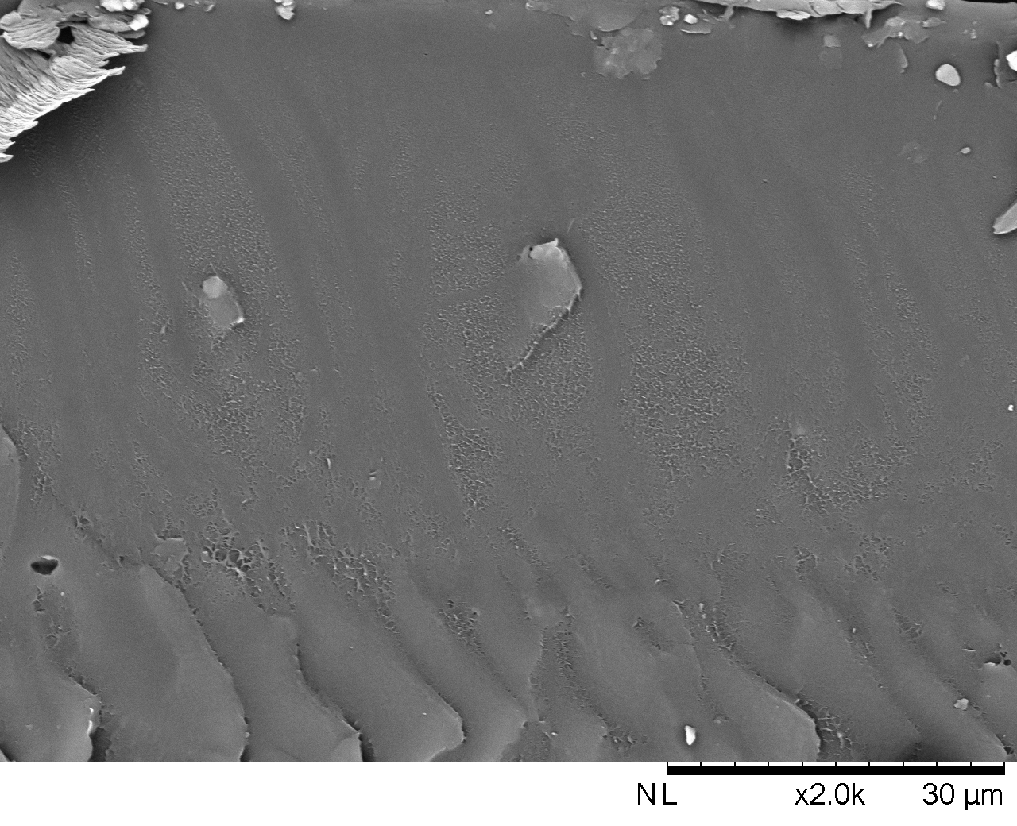  i

Figure 3. SEM micrograph of fracture surface of (a) LDPE, (b) β-cyclodextrin, (c) LDPE/β-CD, (d) LDPE/β-CD/MA0.2, (e) LDPE/β-CD/SB/MA0, (f) LDPE/β-CD/SB/MA0.2, (g) LDPE/β-CD/ SB/MA0.6, (h) LDPE/β-CD/SB/MA1.0 and (i) LDPE/β-CD/SB/MA1.4.

  - Mechanical properties

Figure 4 presented Young’s modulus, tensile strength, and elongation at break of the following LDPE; LDPE/β-cyclodextrin and LDPE/β-cyclodextrin/MA0.2 films. And the study found that LDPE/β-cyclodextrin was the weakest in terms of mechanical properties because the immiscibility between polymer matrix phase and β-cyclodextrin might decrease the movement and orientations of polymer chain. Mechanical properties of LDPE/β-cyclodextrin/MA0.2 was increased because PE-g-MA could improve the miscibility among them.

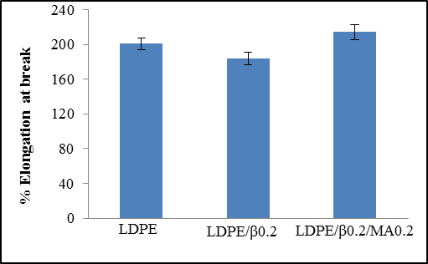 | 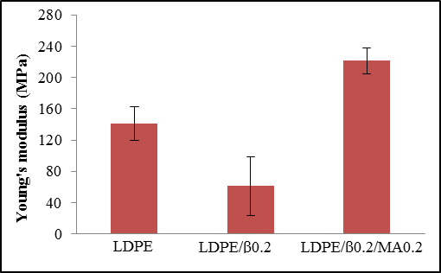
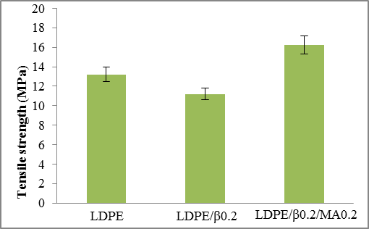

Figure 4. Mechanical property of LDPE, LDPE/β-cyclodextrin and LDPE/β-cyclodextrin/MA0.2.

Increase the amount of PE-g-MA could impact the mechanical properties. Figure 5 LDPE/β-CD/SB/MA1.0 illustrated better properties than other formulation because of less debonding in this case as confirmed in Figure 3 (h). Regarding the LDPE/β0.2/SB/MA1.4, the mechanical properties were lowest. It could be the effect of PE-g-MA which increased the mobility of polymer chain and reduced the crystallinity of polymer [9].

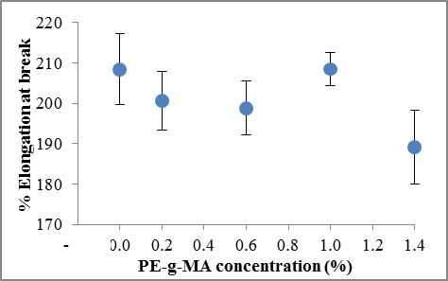 | 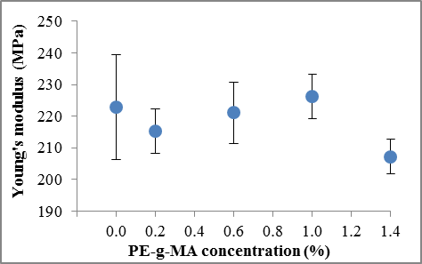
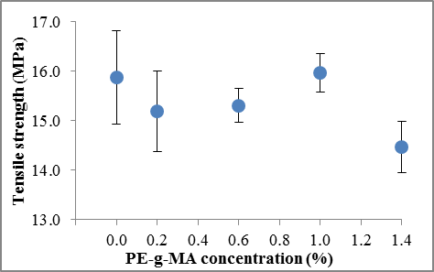

Figure 5. Effect of PE-g-MA content on mechanical property of LDPE/β-cyclodextrin/SB/MA.

4. Conclusions

β-cyclodextrin was used as the release control agent for retaining the sweet basil oil in LDPE films. The proper ratio of β-cyclodextrin and sweet basil oil was 2:1 w/v. The addition of PE-g-MA as compatibilizer into the blending between LDPE and β-cyclodextrin incorporated with sweet basil oil could improve miscibility of LDPE and β-cyclodextrin. The mechanical properties of the blend mentioned above would be relatively higher than LDPE film without compatibilizer. The addition of PE-g-MA up to 1.0 % wt into LDPE film incorporated with sweet basil oil led to the tensile properties improvements.

Acknowledgments

The authors gratefully acknowledge the financial support and materials of the following: SURDI (Silpakorn University Research and Development Institute, Thailand) and Department of Materials Science and Engineering, Faculty of Engineering and Industrials Technology, Sipakorn University.

References

[1] H. Koerber, J. Xavier, P.P. Camanho, Y.E. Essa, and F. Martín de la Escalera. High strain rate behaviour of 5-harness-satin weave fabric carbon-epoxy composite under compression and combined compression-shear loading. International Journal of Solids and Structures, 54:172–182, 2015.

[1] T. Ma, J. Luo, C. Tian, X. Sun, M. Quan, C. Zheng ,L. Kang, and J. Zhan. Influence of technical processing units on chemical composition and antimicrobial activity of carrot (Daucus carrot L.) juice essential oil. Food Chemistry, 170: 394-400, 2015.
[2] C. Han, J. Wang, Y. Li, F. Lu, and Y. Cui. Antimicrobial-coated polypropylene films with polyvinyl alcohol in packaging of fresh beef. Meat Science, 96:901–907, 2014.
[3] V. Muriel-Galet, J. R. Cerisuelo, G. López-Carballo, S. Aucejo, R. Gavara, and P. Hernández-Muñoz. Evaluation of EVOH-coated PP films with oregano essential oil and citral to improve the shelflife of packaged salad. Food Control, 30:137-143, 2013.
[4] A. Synowiec, M. Gniewosz, K. Krasniewska, J.L. Przybył, K. Baczek, and Z. Weglarz. Antimicrobial and antioxidant properties of pullulan film containing sweet basil extract and an evaluation of coating effectiveness in the prolongation of the shelf life of apples stored in refrigeration conditions. Innovative Food Science & Emerging Technologies, 23:171–181, 2014.
[5] H. Jo, K. Park, J.H. Na, S.C. Min, K.H. Park, P. Chang, and J. Han. Development of anti-insect food packaging film containing a polyvinyl alcohol and cinnamon oil emulsion at a pilot plant scale. Journal of Stored Products Research, 61:114-118, 2015.
[6] K. Wattananawinrat, P. Threepopnatkul, and C. Kulsetthanchalee. Morphological and thermal properties of LDPE/EVA blended films and development of antimicrobial activity in food packaging film. Energy Procedia, 56:1–9, 2014.
[7] J. Alongi, M. Poskovic, A. Frache, and F. Trotta. Role of β-cyclodextrin nanosponges in polypropylene photooxidation, Carbohydrate Polymers, 86:127-135, 2011.
[8] M. Kfourya, L. Auezova, H. Greige-Gerges, and S. Fourmentinb. Promising applications of cyclodextrins in food: Improvement of essential oils retention, controlled release and antiradical activity. Carbohydrate Polymers, 131:264–272, 2015.
[9] M.K.A. Wahab, H. Ismail, and N. Othman. Compatibilization Effects of PE-g-MA on Mechanical, Thermal and Swelling Properties of High Density Polyethylene/Natural Rubber/Thermoplastic Tapioca Starch Blends. Polymer Plastic Technology and Engineering, 51:298-303, 2012.

