CHARACTERISATION AND MODELLING OF THE TEMPERATURE AND RATE DEPENDENT SHEAR BEHAVIOUR OF A NON-CONSOLIDATED POWDER IMPREGNATED FABRIC

T. Baumard^{1,2}, G. Menary¹, O. De Almeida², F. Schmidt² and J. Bikard³

¹School of Mechanical and Aerospace Engineering, Queen’s University Belfast, Stranmillis Road, Belfast BT9 5AG, United Kingdom
Web Page: https://www.qub.ac.uk/
²Institut Clément Ader, Université de Toulouse, CNRS, Mines Albi, UPS, INSA, ISAE-SUPAERO, Campus Jarlard, 81013 Albi, France
Web Page: http://www.institut-clement-ader.org/
³Solvay R&I, 85 Avenue des Frères Perret, 69190 Saint-Fons, France
Emails: T. Baumard : tbaumard01@qub.ac.uk
G. Menary : g.h.menary@qub.ac.uk
O. De Almeida : olivier.dealmeida@mines-albi.fr
F. Schmidt : fabrice.schmidt@mines-albi.fr
J. Bikard : jerome.bikard@solvay.com

Keywords: Thermoplastic composites, Semipreg, Bias extension test

Abstract
The shear behavior of a non-consolidated powder impregnated PA66/glass woven semipreg is investigated through bias extension tests at different temperatures and testing speeds in the thermoforming processing range, and compared to the behavior of the same material after a preconsolidation step. Results show in both cases an increase of the shear modulus with lower temperatures, as expected from the thermodependance of the matrix viscosity. In contrast with the preconsolidated samples, the semipreg does not present a dependence on shear rate, which is attributed to different friction configurations between the yarns. A model based on multiplicative decoupling allows for a good prediction of the shear behavior of the semipreg material.

- Introduction

The thermoforming process, as used in the manufacturing of thermoplastic composites parts, consists in heating a consolidated preform above the melting temperature of the matrix, and subsequently transferring it into a press where it is shaped. A potential way of reducing the cycle time would be to form directly from a non-consolidated semi-product. This has been experimentally studied for commingled prepregs [1]. In the case of powder-impregnated fabrics, previous studies have been focused mostly on the forming of flat or single-curvature parts [2].

In order to allow the development of numerical tools to predict process induced defects, the mechanical behaviour of the powdered semi-preg has to be characterised and modelled (with in-plane shear being the main mode of deformation during the forming of parts with complex geometries). This work focuses on the experimental characterisation of a powder impregnated PA6.6/glass twill ²/₂ fabric. Bias-extension tests have been conducted on both the non-consolidated and pre-consolidated material, at various temperatures and shear rates representative of the forming conditions.

- Material and experimental procedure

2.1 Material characteristics

The material used in this study is a powder-impregnated PA66/glass twill 2/2 fabric, provided by Solvay. In its as-supplied state, the matrix is distributed on both faces of the fabric as a network of coalesced droplets (as shown in Figure 1).

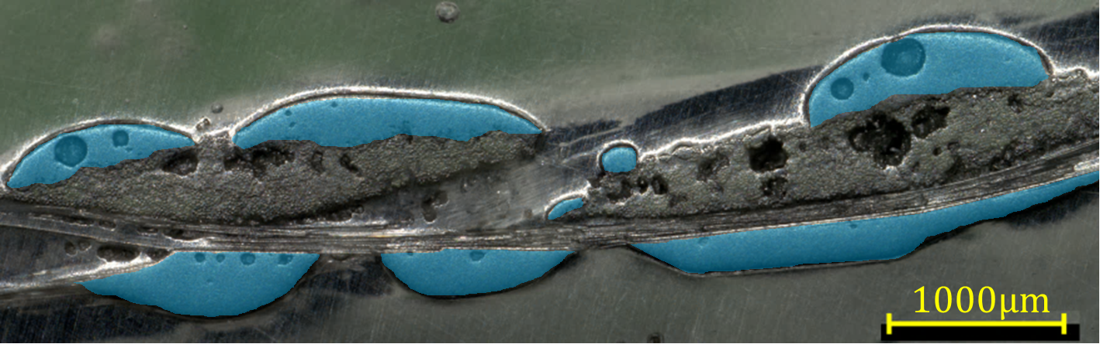

Figure 1. Semipreg fabric cross-section; the PA66 droplets are highlighted in blue

The main characteristics of the fabric are summed up in Table 1. The PA66 used is a high fluidity grade, with dynamic melt viscosity of 30Pa.s at 10s⁻1 and presents a melting temperature of 260°C and a crystallization temperature of 225°C as determined by DSC at a heating/cooling rate of 20°C/min. In addition to the semipreg material, samples of 320x300mm² were preconsolidated by thermocompression at 2bars, 295°C to be used as a reference material in the bias extension tests. The resulting plates have a thickness of 0.51±0.02mm.

Table 1. Main material properties

Weave type | Twill 2/2
Warp/weft ratio | Balanced
Yarn count | 2.6 ends per cm
Semipreg style | Powdered, 2 faces
Areal weight (glass fabric) | 600g/m²
Areal weight (semipreg) | 960g/m²

  - Bias-extension tests

The bias-extension test is one of the main experimental test used to characterize the shear behavior of woven materials, and consists in a tensile test on a sample of aspect ratio >2 in which the yarns are initially oriented at ±45° relative to the direction of the applied tension. This leads to a state of pure shear in the center of the sample. The setup used is more compact than picture frame tests and can therefore easily be implemented in an environmental chamber for high-temperature testing.

Samples of 250x100mm² with a ±45° orientation were cut out of the semipreg roll and the preconsolidated plates. Bias-extension tests were conducted with a MTS250kN universal testing system equipped with a MTS651 environmental chamber at speeds of 10, 100 and 1000mm/min and temperatures of 265°C and 280°C. The evolution of shear angle in the central region during testing was recorded in each test with an AVT Pike camera.

The resulting averaged shear stress versus shear angle curves for the preconsolidated and semipreg material at each test condition are presented in Figure 2. The curves present the typical phases expected from bias extension tests: an initially high modulus due to static friction between the yarns, followed by a phase in which the yarns are free to rotate around their crossover point. As the yarns come in contact, transverse compaction leads to a gradual increase in the shear stiffness. Intra-ply slippage mechanisms then become preponderant modes of deformation to accommodate the displacement. In the case of the semipreg, these crossover and inter-tow slip leads to the formation of dry zones with resin-rich boundaries which might lead to dry spots after consolidation as the matrix impregnation needs to occur in the plane rather than mainly through-the-thickness..

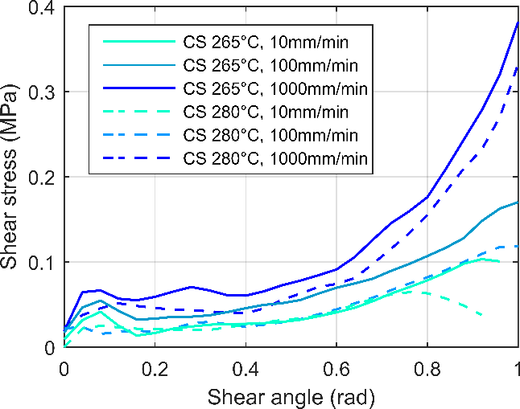 | 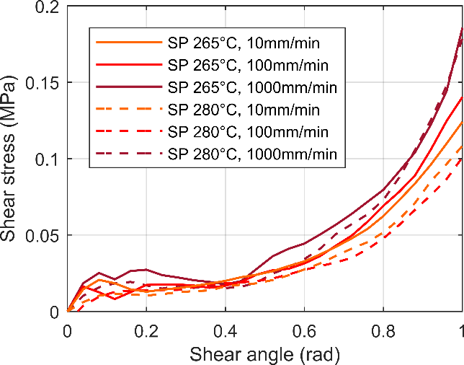
(a) | (b)
Figure 2. Shear stress versus shear angle results for (a) preconsolidated material, (b) semipreg

Decreasing the test temperature leads to an increase of the measured shear stress both for the preconsolidated and the semipreg material. This is due to an increase in the viscosity of the matrix as the temperature gets closer to the crystallization temperature; the mobility of the yarns is therefore affected as they are either fully impregnated (in the case of the preconsolidated) or sandwiched between polymer rich layers in the case of the semipreg. In the same fashion, increasing the test speed (and thus the shear rate) increases the measured shear stress for the preconsolidated material. Other studies also report this effect for various thermoplastic composites [3]; this behavior is attributed to the shear rate dependent lubricated friction behavior at the yarn/yarn interfaces.

The semipreg material shows a much lower dependence on shear rate. This can be explained by the differences in terms of spatial distribution of the matrix in the woven fabric. In contrast with the preconsolidated material, the contact between the yarns is not lubricated as the matrix is only present on the outer surfaces of the fabric. Results on dry fabric/fabric or fabric/tool friction coefficient as a function of velocity presented in the literature are consistent with those obtained in this study, with limited effect of the shear rate on friction coefficient in dry friction when compared to lubricated contact [4].

3. Modeling

The approach used here is an extension of the work presented by Pierce et al [5] in which the material is modeled as a continuum, and based on a hypoelastic formulation:

$$σ^{∇}=C:D$$ | (1)

Where σ is the Cauchy stress tensor, D the strain rate tensor and C a fourth order constitutive tensor expressed in the frame of the fiber. $∇$ is an objective derivation operator based on the deformation tensor. The constitutive relation is expressed in a frame fixed with the material directions

A rate- and temperature- dependent model proposed by Machado [6] to represent the shear behavior of preconsolidated woven composites is used. The shear modulus assumes multiplicative decoupling between the effects of temperature, speed and the non linear shear response as shown in Equation 2. The shear rate dependence is modelled through a Cowper-Symonds overstress law (power law) and the thermal dependence is given by an exponential temperature factor.

$$G_{12}\left(γ,\dot{γ},T\right)=\left(a_{1}+2a_{2}γ+3a_{3}γ^{2}\right)\left(1+{\left(\frac{\dot{γ}}{D}\right)}^{\frac{1}{P}}\right)\left(e^{A\frac{T-T_{0}}{T_{0}}}\right)$$ | (2)

The model parameters have been determined for the PA66/glass fabric in both configurations by non linear optimization on the shear stress versus shear angle data using MATLAB; the non constant shear rate during the bias extension test is considered during the optimization. A comparison between the experimental results and the model prediction is given in Figure 3. The proposed model provides a good description of the behavior in both cases, in terms of temperature and rate dependence.

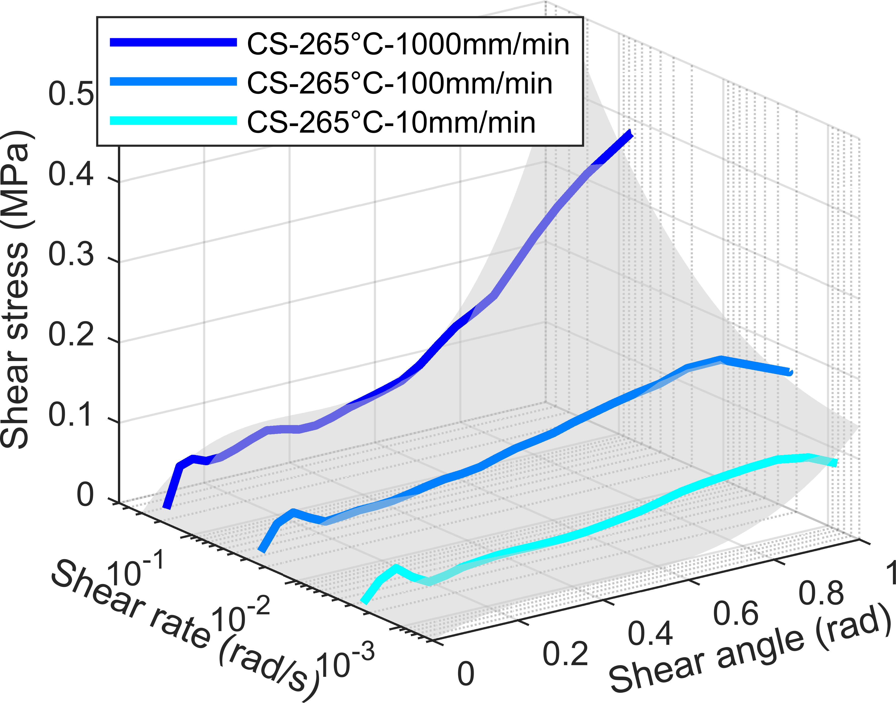 | 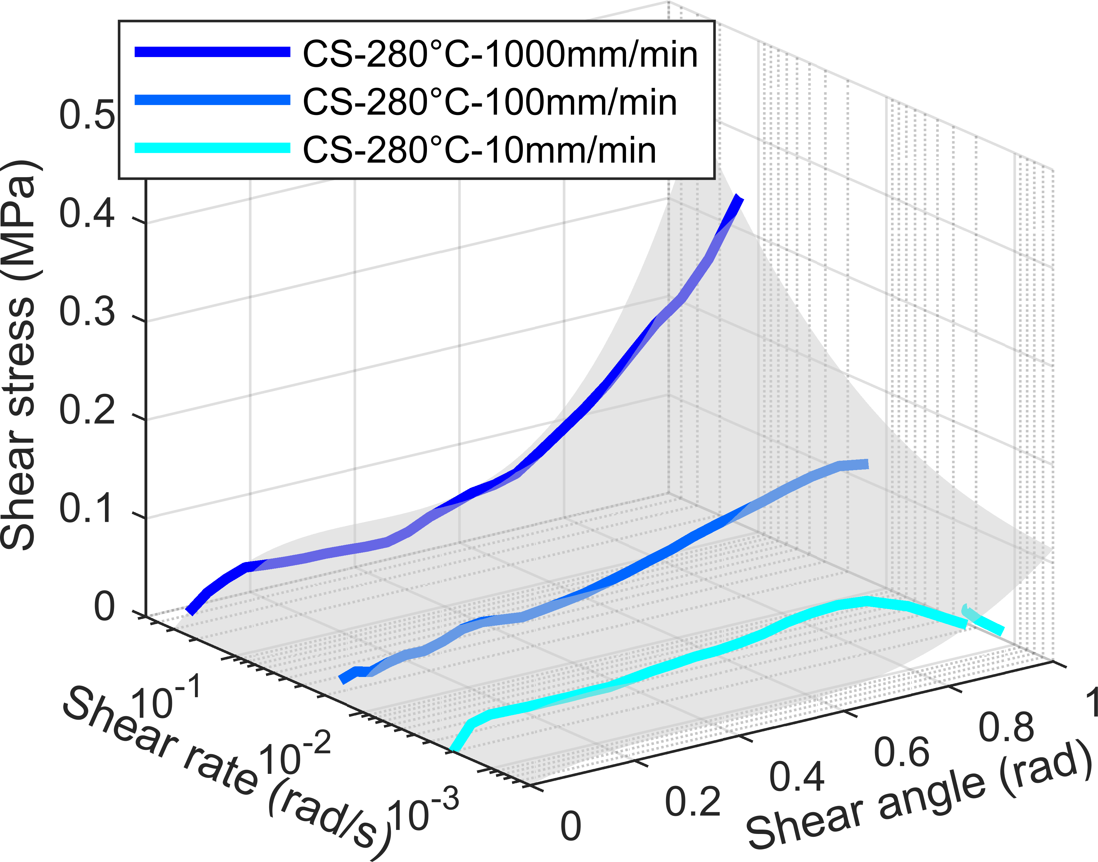
(a) | (b)
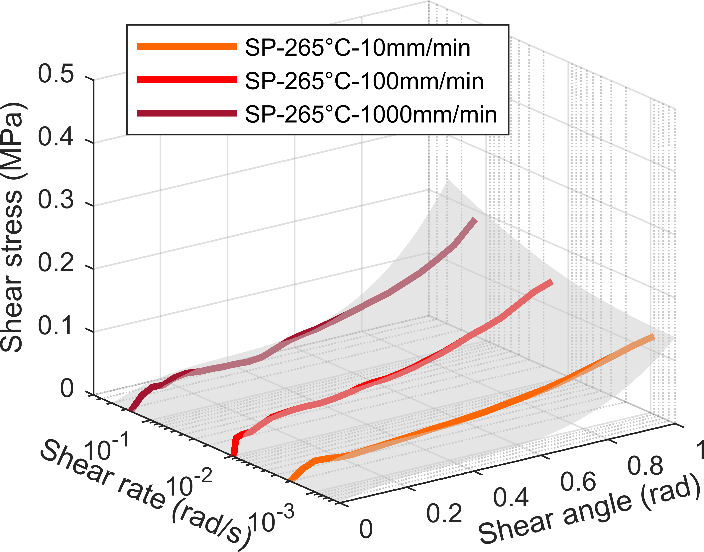 | 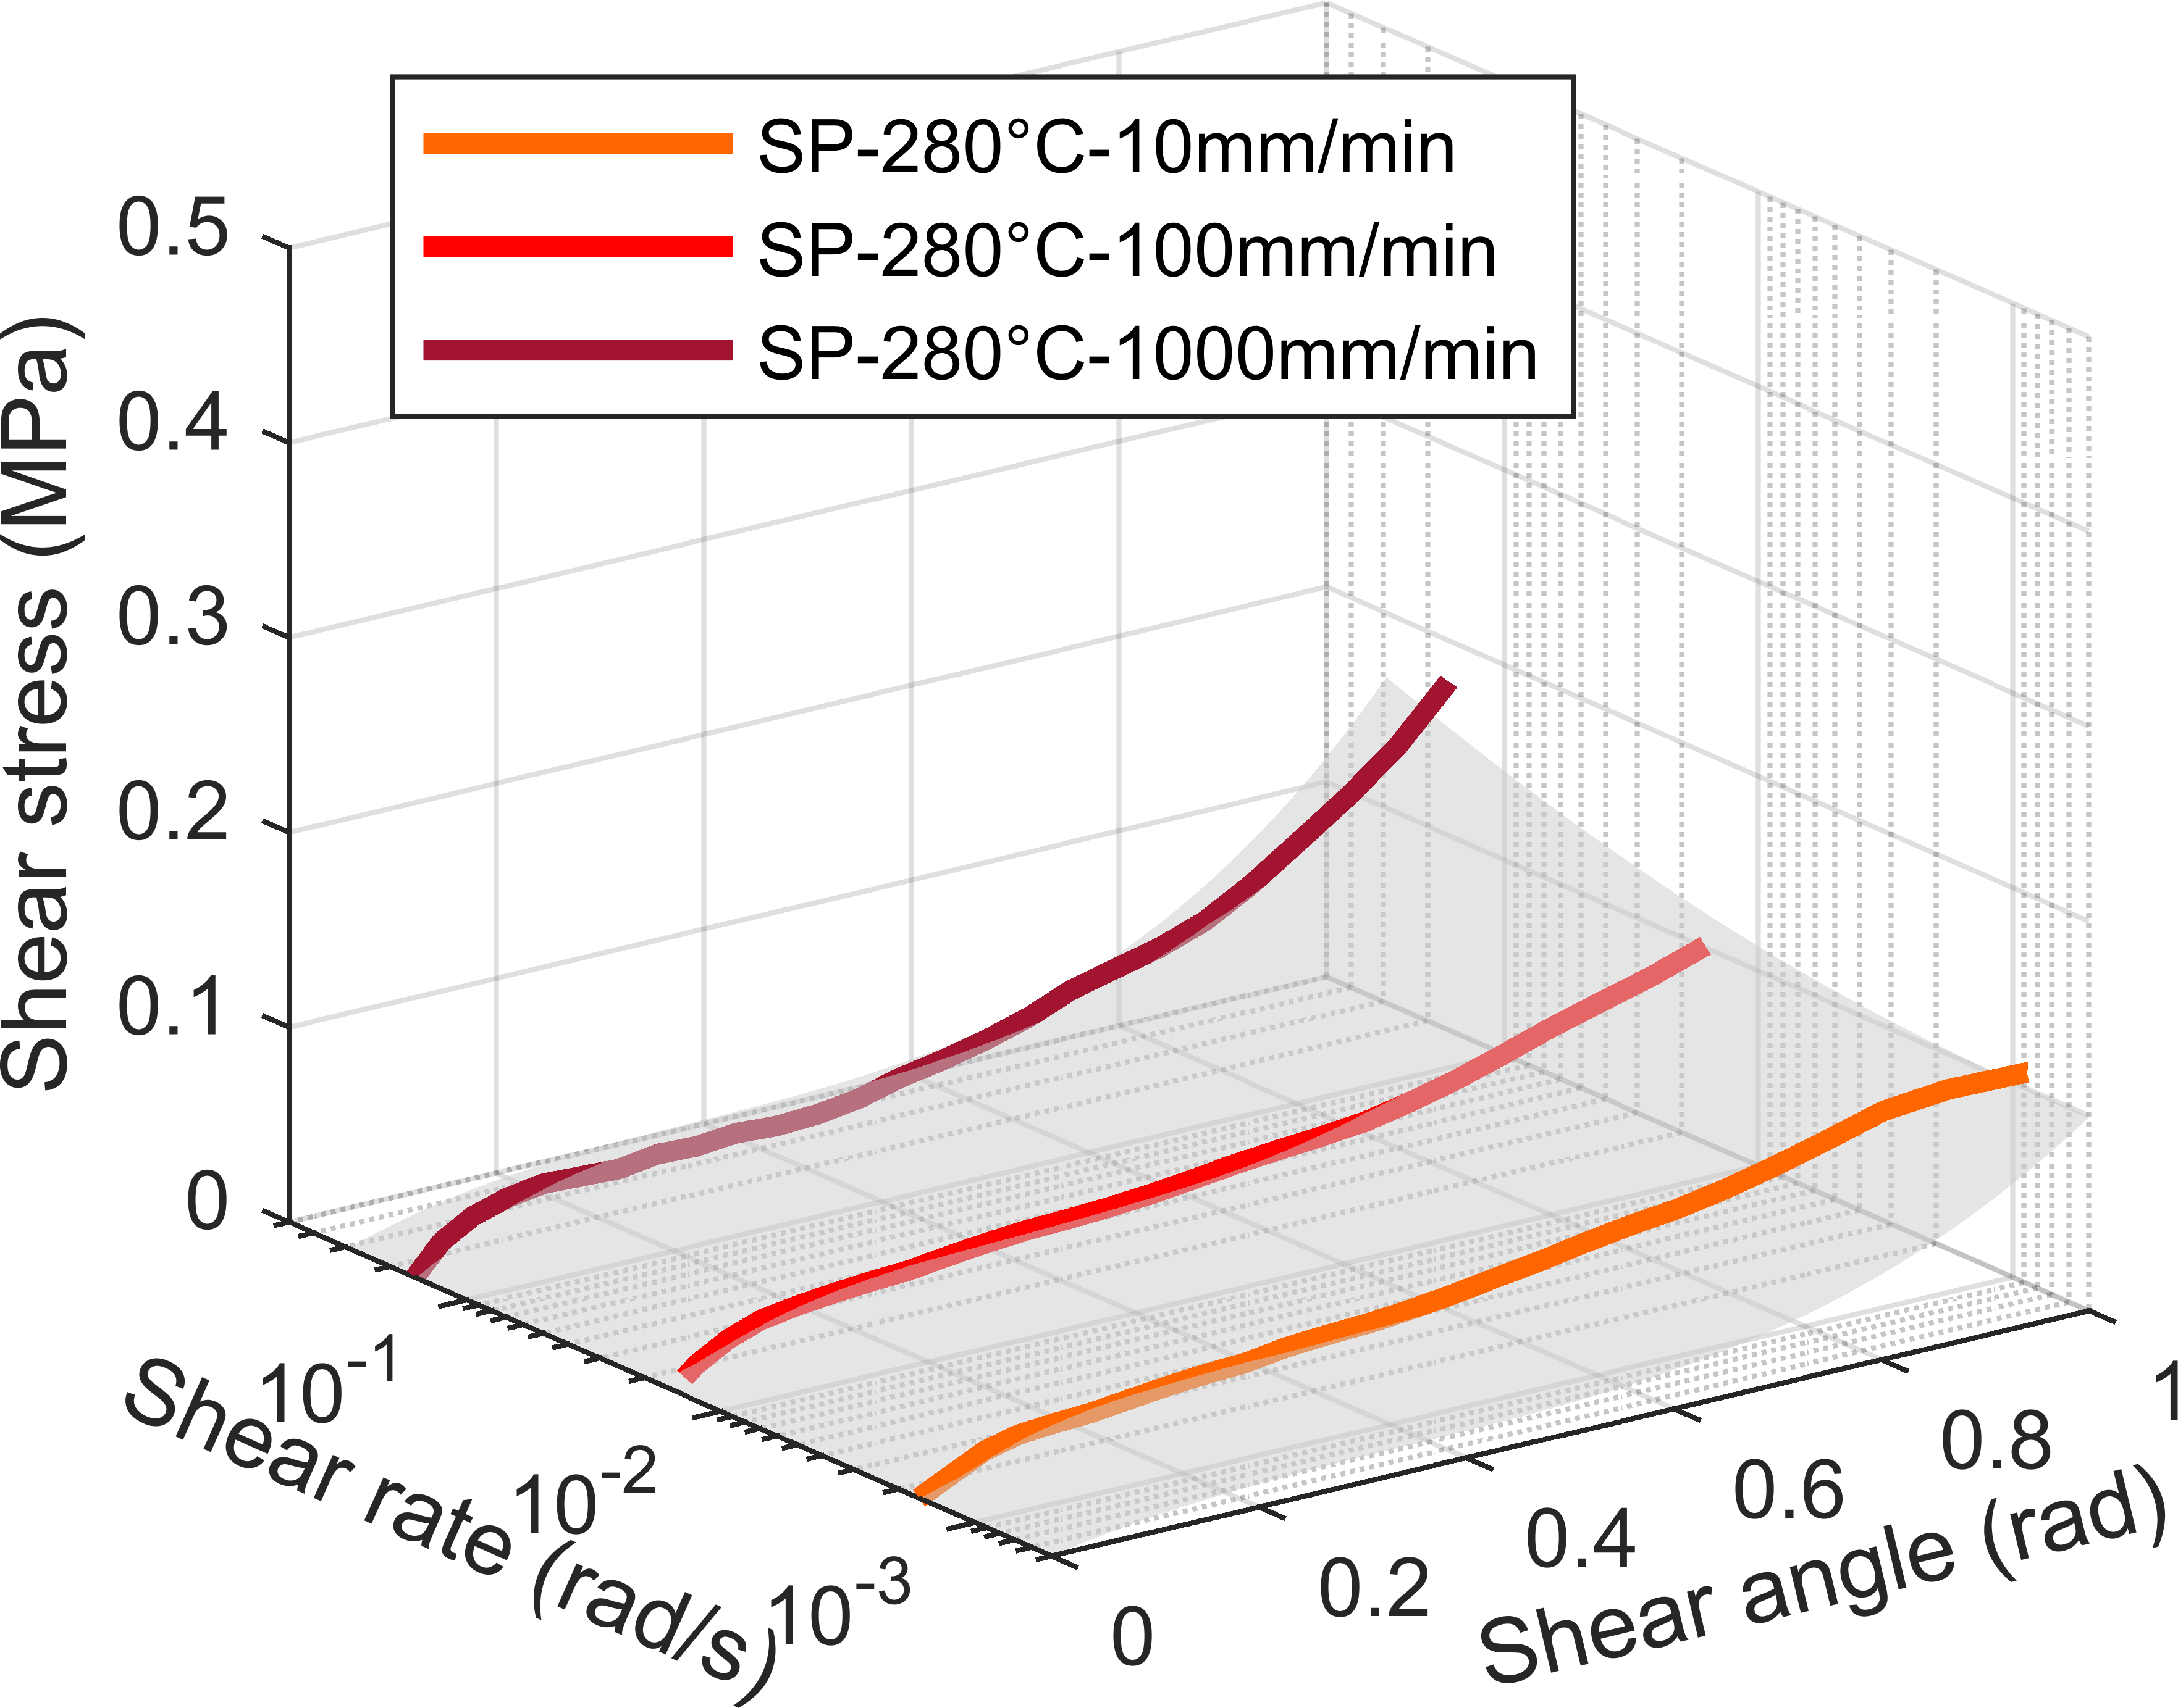
(c) | (d)
Figure 3. Comparison between experimental results (solid lines) and model prediction (grey surface) for the preconsolidated material at (a) 265°C and (b) 280°C and for the semipreg at (c) 265°C and (d) 280°C.

4. Conclusions

The shear behavior of a PA66/glass woven fabric was characterized from bias extension tests at different temperatures and shear rates representative of the thermoforming process. The material was tested both in its as-received powder impregnated form, and following a preconsolidation step.
Results show that while both materials present an increase of the shear stiffness with decreasing temperature, the semipreg is not sensitive to shear rate. This is explained by different friction mechanisms at the yarn crossover points: dry friction for the semipreg, compared to lubricated friction for the preconsolidated composite. Intra-ply slip mechanisms in semipregs leads to a characteristic pattern of dry zones and resin-rich boundaries that might affect the impregnation in a later phase. A temperature and rate-dependent model based on multiplicative decoupling was successfully used to represent the behaviour of the material in its processing range, and validated on virtual bias extension tests. An hemispheric forming setup is under development to further validate this model at a larger scale and investigate the forming and consolidation of non-consolidated stacks.

References

[1] U. Thomann, M. Sauter, P. Ermanni. A combined impregnation and heat transfer model for stamp forming of unconsolidated commingled yarn preforms. Composites Science And Technology, 64:1637-1651, 2004.
[2] M. Connor, S. Toll, J.A.E. Månson, A.G Gibson. A model for the consolidation of aligned thermoplastic powder impregnated composites. IJournal of Thermoplastic Composite Materials, 8:138-162, 1995.
[3] E. Guzman-Maldonado, N. Hamila, P. Boisse, J. Bikard. Thermomechanical analysis, modelling and simulation of the forming of pre-impregnated thermoplastic composites. Composites: Part A, 78:211–222, 2015.
[4] L. Liu, J. Chen, B. Zhu, T. Yu, X. Tao, J. Cao. The yarn-to-yarn friction of woven fabrics. Proceedings of the 9th international ESAFORM conference on material forming, Glasgow, United Kingdom, April 26-28 2006..
[5] R. Pierce, B. Falzon, M. Thompson, R. Boman. Implementation of a non-orthogonal constitutive model for the finite element simulation of textile composite draping. Applied Mechanics and Materials, 553:76–81, 2014.
[6] M. Machado, L. Murenu, M. Fischlschweiger, Z. Major. Analysis of the thermomechanical shear behavior of woven-reinforced thermoplastic matrix composites during forming. Composites: Part A, 86:39-48, 2016.

