EuroSun2026
TECHNICAL-ENERGY ANALYSIS OF THE EXPANSION OF PHOTOVOLTAIC SYSTEMS INTEGRATED INTO A PUBLIC EDUCATIONAL INSTITUTION BUILDING LOCATED IN SOUTHERN BRAZIL USING ADVANCED SIMULATION

Raúl Eduardo Fernandez Sales, Grazielli Bueno
Federal Institute of Paraíba, Santa Luzia (Brazil), Federal Institute of Paraná, Arapongas (Brazil) raul.sales@ifpb.edu.br, grazielli.bueno@ifpr.edu.br
Summary
This study presents a technical-energy assessment of expanding a grid-connected photovoltaic (PV) system at a public educational institution in Southern Brazil (Federal Institute Sul-rio-grandense, Passo Fundo Campus). By integrating twelve months of measured electricity consumption data with 3D PVsyst® simulations, the performance of the existing 59 kWp installation was evaluated alongside a proposed 29.75 kWp expansion designed to offset the daytime campus electrical demand. The simulations compared actual site conditions - comprising rooftop and building-integrated photovoltaic (BIPV) configurations - against an optimized reference scenario featuring ideal orientation, tilt angle, and zero shading. Results show that single-orientation rooftop arrays present annual yield reductions below 10%, whereas dual-orientation roofs exhibit losses up to 22%. The proposed vertical bifacial façade arrays showed yield reductions between 41% and 48% due to high incidence angles. Despite geometric constraints, BIPV systems remain technically feasible in low-latitude regions owing to a substantial diffuse radiation contribution, while simultaneously providing key architectural benefits, such as façade shading and enhanced indoor thermal comfort. This study confirms the reliability of 3D numerical modeling as a decision-support tool for optimizing PV distributed generation in institutional building retrofits.
Keywords: BIPV, Public educational institution, distributed generation, bifacial modules, PVsyst.
Field of application for the findings: Design, optimization, and expansion of grid-connected photovoltaic systems integrated into public and institutional buildings.
Addressed audience: Researchers, engineers, architects, energy planners, and students working in photovoltaic systems, building-integrated photovoltaics, and sustainable buildings
- Introduction
Photovoltaic (PV) energy has become one of the fastest-growing renewable energy technologies worldwide, playing a central role in the decarbonization of electricity systems. According to the International Energy Agency Photovoltaic Power Systems Programme (IEA PVPS), global cumulative PV capacity approached 3 TW by the end of 2025, driven by an estimated 698 GW of new installations during that year alone (IEA PVPS, 2026).
Brazil has followed this international trajectory, consolidating its position among the world's leading PV markets. By late 2025, the country reached approximately 65 GW of total installed solar capacity (EPE, 2026; IEA, 2025). Distributed generation accounts for the majority of this expansion, representing nearly 45 GW across more than 3.7 million grid-connected consumer units (EPE, 2026) - a trend spurred by favorable net-metering policies across residential, commercial, and institutional sectors.
This rapid expansion has brought building-integrated photovoltaics (BIPV) to the forefront as a multifunctional strategy that combines electricity generation with architectural performance (IEA PVPS, 2025). Unlike conventional rooftop systems, BIPV substitutes traditional building materials by embedding PV modules directly into façades, roofs, and shading elements. Consequently, these systems contribute to solar control, daylighting, and indoor thermal comfort while generating clean energy (Urbanetz et al., 2011; IEA PVPS, 2025). Given that buildings represent a major share of global electricity demand, envelope integration provides a clear pathway toward net-zero energy buildings (NZEBs) (IEA, 2025).
Public educational facilities are particularly well-suited for PV deployment. Their daytime operational schedules closely match solar generation profiles, and their physical footprint typically offers large roof and façade areas (IEA PVPS, 2025). Furthermore, solar installations in academic settings serve as living laboratories for engineering education and sustainability awareness (IEA, 2025). However, many existing institutional buildings were not originally designed for PV integration, imposing spatial constraints—such as non-optimal orientations, vertical surfaces, and urban shading—that can impair energy output (Santos and Rüther, 2014; Urbanetz et al., 2011).
Prior research indicates that tilt, orientation, operating temperature, and shading heavily dictate PV performance (Burger and Rüther, 2006; Nascimento et al., 2019). In tropical and subtropical low-latitude regions, yield reductions from non-ideal geometries are often partially offset by significant diffuse solar radiation, preserving the feasibility of BIPV applications (Urbanetz et al., 2011; Santos and Rüther, 2014). Nevertheless, most literature focuses on standalone rooftop or isolated BIPV setups. Detailed investigations assessing multi-array expansions that combine existing systems with new rooftop and vertical bifacial façade arrays under realistic operating conditions remain limited.
To address these complexities prior to physical implementation, advanced simulation software has become essential (IEA PVPS, 2025). PVsyst® is widely recognized for evaluating grid-connected PV systems, allowing three-dimensional modeling of irradiance distribution, electrical losses, thermal behavior, and bifacial performance (PVsyst SA, 2024).
In this context, the present study evaluates the technical and energy performance of expanding an existing PV installation at a public educational institution in Southern Brazil (approximately 28° S latitude). By combining measured 12-month consumption profiles with 3D PVsyst® modeling, the study quantifies the impact of non-optimal orientation, tilt angle, and building shading across both rooftop and vertical bifacial façade configurations compared to an ideal reference scenario. The findings establish a practical basis for optimizing institutional BIPV retrofits under subtropical solar conditions.

- Literature Review
Recent advances in building-integrated photovoltaic (BIPV) technology have shifted the research focus from simple electricity generation toward multifunctional building components capable of simultaneously improving energy efficiency, architectural integration, and occupant comfort. Unlike conventional rooftop photovoltaic systems, BIPV installations require a compromise between architectural requirements and photovoltaic performance, making their design considerably more complex. As a result, the energy performance of BIPV systems depends not only on the photovoltaic technology itself but also on façade geometry, building orientation, surrounding obstructions, and local climatic conditions (Urbanetz et al., 2011; IEA PVPS, 2025).
The introduction of bifacial photovoltaic modules has created new opportunities for BIPV applications, particularly in vertical façades and shading devices. Because bifacial modules are capable of converting both direct and reflected irradiance into electricity, their performance is strongly influenced by surface reflectance, spacing between buildings, façade configuration, and sky diffuse radiation. Recent investigations have demonstrated that bifacial façade systems can substantially increase annual energy production when these parameters are considered during the design stage, although the achievable gains remain highly dependent on the surrounding urban environment and installation geometry (Han et al., 2024). These findings indicate that façade-integrated bifacial systems should be evaluated using project-specific analyses rather than generalized design assumptions.
Another important aspect highlighted in recent literature is the increasing use of advanced numerical simulations to support photovoltaic system design. Three-dimensional modelling has become essential for accurately representing complex urban environments, where shading from nearby buildings, parapets, roof structures, and architectural elements significantly affects solar availability throughout the year. Simulation tools enable the evaluation of irradiance distribution, electrical losses, bifacial gains, and long-term system performance before installation, thereby reducing design uncertainties and supporting technical and economic decision-making (PVsyst SA, 2024; IEA PVPS, 2025). In particular, PVsyst® is one simulation platform used for modelling both conventional rooftop systems and BIPV applications due to its ability to combine integrate detailed electrical models with three-dimensional shading analysis.
Recent experimental studies have also emphasized the importance of combining simulations with measured operating data to improve model reliability. Liu et al. (2024), for example, demonstrated that façade-integrated photovoltaic systems exhibit significant interactions between solar gains, thermal behaviour, and building envelope characteristics, highlighting that simplified approaches may underestimate both electrical production and thermal effects. Such findings reinforce the need for simulation methodologies capable of representing realistic operating conditions, especially for retrofit projects in existing buildings.
Although considerable progress has been achieved in the analysis of rooftop photovoltaic systems and isolated BIPV applications, studies addressing the expansion of existing distributed generation systems through the combined use of rooftop and façade-integrated bifacial arrays remain limited. This gap is even more evident for public educational buildings, where architectural restrictions frequently determine the available installation area and influence overall system performance. Consequently, detailed simulation studies based on actual electricity consumption and realistic operating conditions remain essential to support the design and optimization of photovoltaic expansion projects in institutional buildings.

- Methodology
The methodological framework adopted in this study is presented in Figure 1, which summarizes the stages developed for the technical-energy assessment of the expansion of the photovoltaic system installed at the Passo Fundo Campus of the Federal Institute Sul-rio-grandense. Initially, the institution's electricity consumption profile was determined through the analysis of electricity bills covering the period from April 2024 to April 2025. Monthly electricity consumption, contracted demand, and measured demand were analyzed to identify the electrical load profile and provide the basis for sizing the expansion of the photovoltaic system.
The educational institution currently operates three grid-connected photovoltaic systems, totaling 59 kWp of installed capacity. These systems were implemented in different stages through energy efficiency projects funded by institutional programs and the local electric utility. In addition to the existing systems, a 29.75 kWp photovoltaic expansion was proposed, consisting of photovoltaic modules installed on building rooftops and façades, with the objective of increasing the institution's distributed generation capacity and enhancing the architectural integration of the photovoltaic systems.
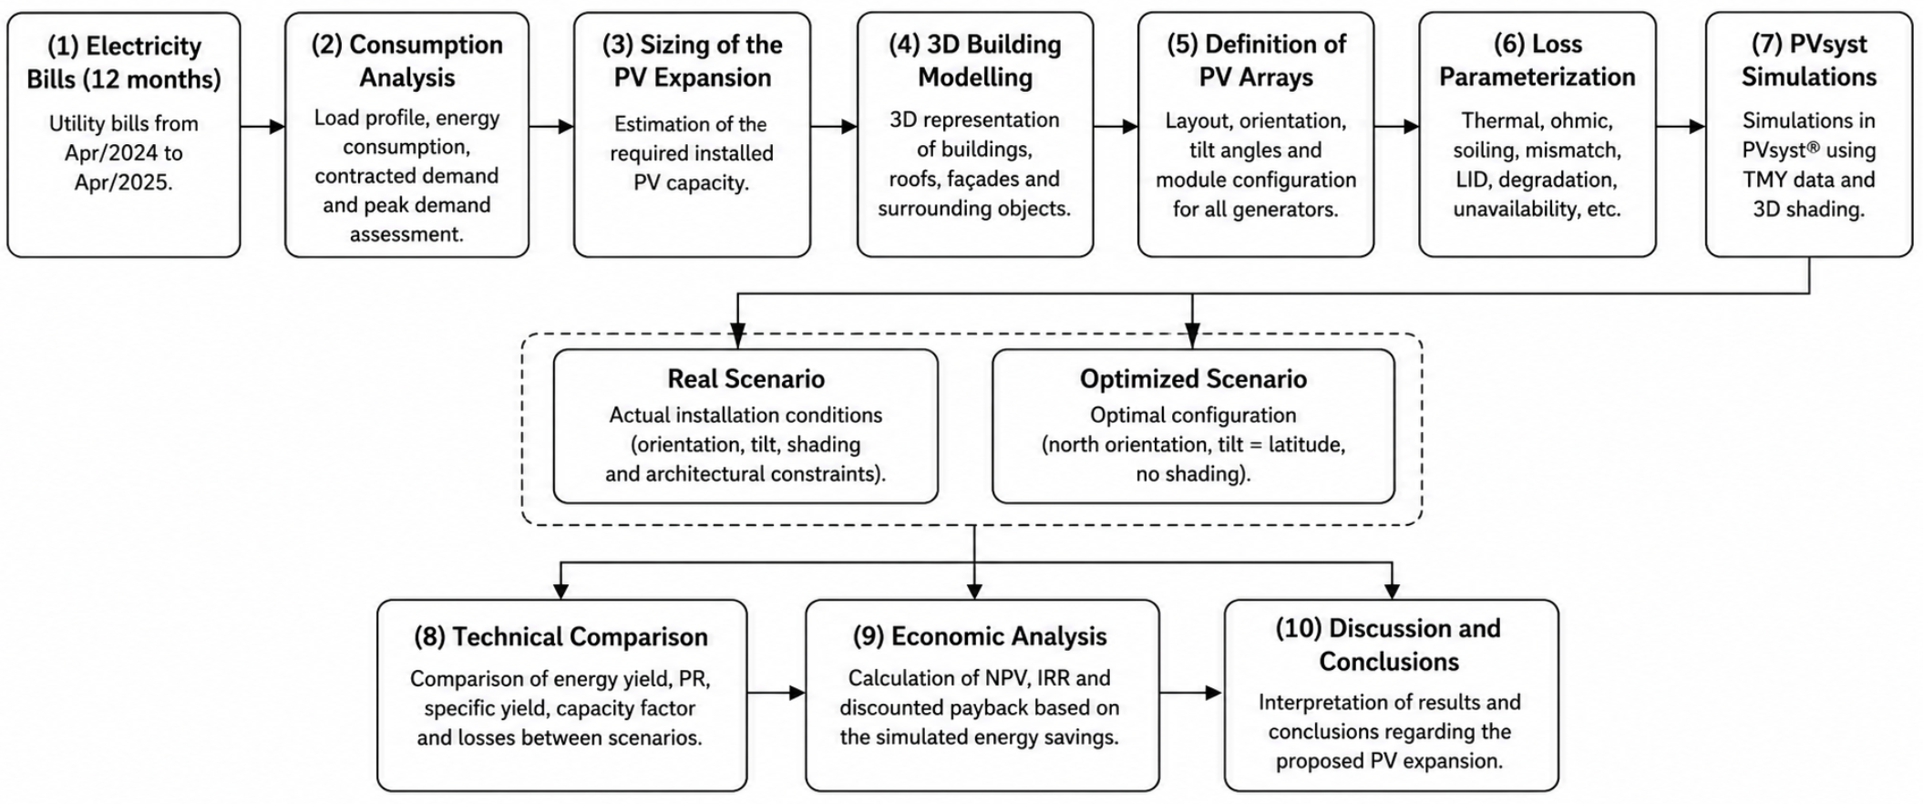
Fig. 1: Methodological framework adopted for the technical-energy assessment of the photovoltaic system expansion (generated with the help of AI).
Subsequently, a three-dimensional model of the campus buildings was developed using PVsyst®, reproducing the actual installation conditions of the existing photovoltaic systems. The model included the geometry of the rooftops and façades, the orientation of the photovoltaic modules, nearby obstacles, and potential shading sources, enabling a detailed assessment of shading losses throughout the year. Figures 2, 3, and 4 present the three-dimensional models of the existing photovoltaic generators developed within the simulation environment.
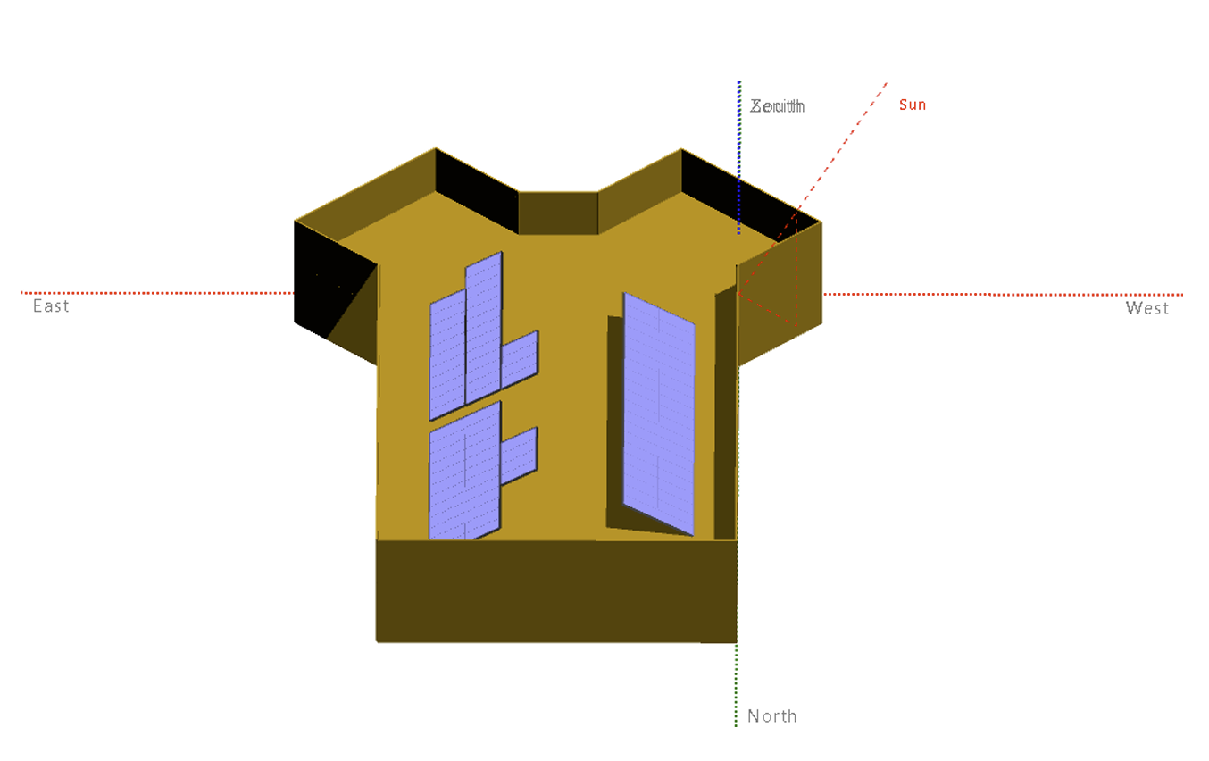
Fig. 2: Three-dimensional model of Generator 1 developed in PVsyst®
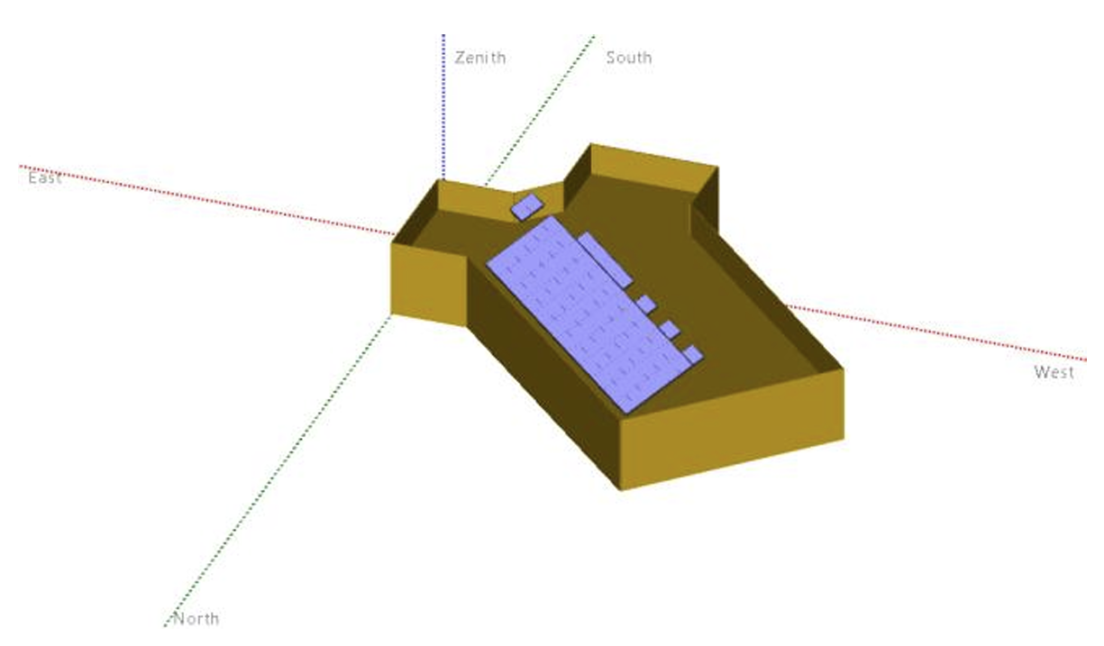
Fig. 3: Three-dimensional model of Generator 2 developed in PVsyst®
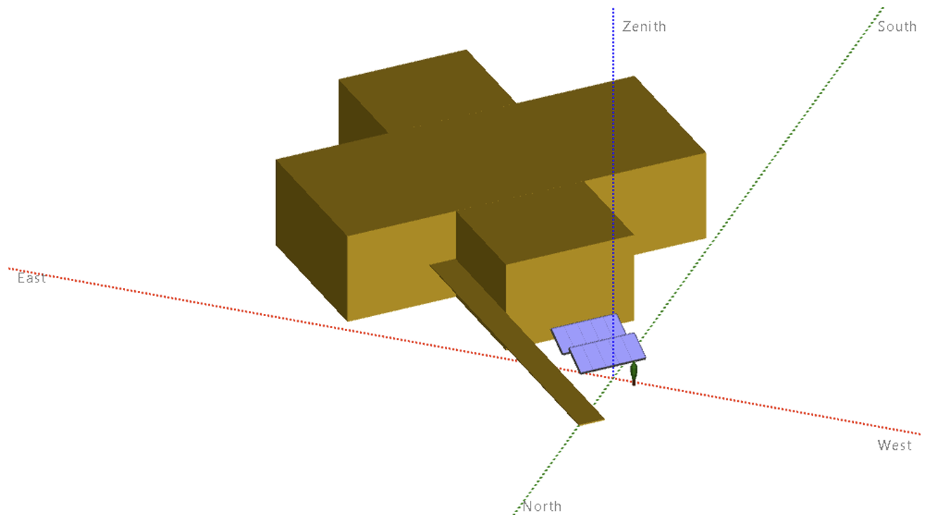
Fig. 4: Three-dimensional model of Generator 3 developed in PVsyst®
The existing photovoltaic systems present different installation configurations, whose characteristics are summarized in Table 1.
The simulations were performed using the Typical Meteorological Year (TMY) meteorological database available in PVsyst® for the municipality of Passo Fundo, Rio Grande do Sul, Brazil. The software was configured considering the actual project parameters and the electrical specifications of the components installed. Two additional adjustments were implemented during the modelling process: the correction of the maximum operating temperature to 353,15 K and the limitation of inverter overload losses to 6%, as adopted in the project.
Tab. 1: Characteristics of the existing photovoltaic systems
Generator | Installation location | Structure | Orientation | Remarks
1 | Building 3 | Fiber-cement roof | East/West | No nearby vegetation; inverter installed inside the building.
2 | Building 7 | Metal roof | Northeast | No vegetation with shading potential.
3 | Ground | Fixed structure | Northeast | Installation on a fixed ground-mounted structure.
The losses considered in the modelling followed the parameters configured in PVsyst®, including Light-Induced Degradation (LID), soiling losses, system unavailability, annual module degradation, mismatch losses, DC and AC ohmic losses, inverter losses, and spectral correction. All these parameters were configured according to the project specifications and are presented in Table 2.
Tab. 2: Parameters adopted in the PVsyst® simulations
Category | Parameter | Value
Maximum operating temperature | Operating temperature | 353,15 K
Inverter overload | Inverter overload losses | 6%
LID | Light-induced degradation | 2.0%
Soiling | Soiling losses | 3.0%
Mismatch | Module mismatch | 2.0%
String mismatch | String voltage mismatch | 0.15%
Module quality | Module quality loss | 0.50%
Annual degradation | Yearly degradation | 0.50%
Unavailability | Unavailability | 1.0%
Spectral correction | Spectral correction | According to PV module technology
Two simulation scenarios were evaluated: (i) the Real Scenario, representing the actual/planned installation conditions, including existing module orientations, tilt angles, architectural constraints, and site-specific shading; and (ii) the Optimized Scenario, assuming north-oriented modules (azimuth 0°), tilt angle equal to local latitude (28°), and zero shading to estimate the maximum energy generation potential.
The technical performance was evaluated across both scenarios using key indicators: annual and monthly energy yield, Performance Ratio (PR), capacity factor, and detailed loss mechanisms (thermal, optical, near shading, and electrical).

3.1 Sizing of the Photovoltaic System Expansion
To expand the institution's distributed generation capacity, a fourth photovoltaic system (Generator 4) was designed for installation on the rooftops and façades of the buildings at the Passo Fundo Campus. The system sizing was based on the analysis of the institution's average monthly off-peak electricity consumption, derived from the previously specified 12-month billing data, together with the estimated energy generation of the existing photovoltaic systems.
Initially, the monthly energy production of the existing photovoltaic systems was estimated using Equation (1), considering the installed capacity, the equivalent peak sun hours, and the Performance Ratio (PR). Subsequently, the installed capacity required for the expansion was determined using Equation (2), based on the difference between the institution's average electricity consumption and the estimated energy production of the existing systems. Following this procedure, an installed capacity of approximately 29.75 kWp was defined for the new photovoltaic system.
E=P×H×PR×30 (eq. 1)
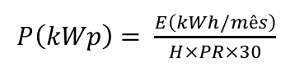 (eq. 2)
After the sizing procedure, Generator 4 was modeled using PVsyst®, reproducing the planned installation conditions of the photovoltaic modules on the rooftops and façades of the campus buildings. The three-dimensional model made it possible to represent the different photovoltaic arrays, as well as to analyze their orientations, tilt angles, and potential shading effects throughout the simulation process.
4. Results and Discussion
Initially, the performance of the three existing photovoltaic systems (Generators 1, 2, and 3) was evaluated by comparing the Real and Optimized scenarios. Table 3 summarizes the annual energy production, monthly averages, Performance Ratio (PR), and main loss mechanisms for both conditions.
The simulation results for Generators 1, 2, and 3 are summarized in Table 3, which presents the annual energy production, average monthly energy production, Performance Ratio (PR), and the main loss mechanisms for both the real and optimized configurations.
Tab. 3: Comparison of the performance indicators of Generators 1, 2, and 3 under the real and optimized configurations.
 | Simulation results | Ger1som | Generator1 | Ger2som | Generator2 | Ger3som | Generator3
Summary | Orientation | 28/90 - 28/-90 | 28/0 | 28/-45 | 28/0 | 28/45 | 28/0
Summary | Annual Energy Production (kWh/year) | 46.871 | 60.165 | 44.562 | 49.666 | 6.085 | 6.741
Summary | Average Monthly Energy Production (kWh/month) | 3905,9 | 5013,8 | 3713,5 | 4138,8 | 507,1 | 561,8
Summary | Performance Ratio (%) | 72,96 | 81,05 | 73,74 | 79,30 | 71,75 | 76,28
Global Horizontal Irradiation | Global incident in coll. Plane | -5,60% | 9,10% | 5,20% | 9,10% | 4,70% | 9,10%
Global Horizontal Irradiation | Near Shadings Irradiance loss | -6,64% | 0,00% | -4,36% | -0,08% | -6,58% | -0,51%
Global Horizontal Irradiation | IAM factor on global | -3,02% | -2,60% | -2,52% | -2,60% | -2,20% | -2,59%
Global Horizontal Irradiation | Soiling loss factor | -3,00% | -3,00% | -3,00% | -3,00% | -3,00% | -3,00%
 | PV Conversion (%) | 19,54 | 19,54 | 19,21 | 19,21 | 20,31 | 20,31
Array nominal energy  (at STC effic) | Module degradation loss (10 years) | -0,48% | -0,50% | -0,50% | -0,50% | -0,50% | -0,50%
Array nominal energy  (at STC effic) | PV loss due irradiance level | -0,78% | -0,45% | -0,60% | -0,48% | -0,65% | -0,51%
Array nominal energy  (at STC effic) | PV loss due temperature | -7,84% | -5,60% | -8,42% | -5,77% | -5,67% | -5,54%
Array nominal energy  (at STC effic) | Spectral correction | 0,11% | 0,16% | 0,15% | 0,17% | 0,13% | 0,16%
Array nominal energy  (at STC effic) | LID | -2,00% | -2,00% | -2,00% | -2,00% | -2,00% | -2,00%
Array nominal energy  (at STC effic) | Mismatch loss, modules & strings | -3,35% | -3,35% | -3,35% | -3,26% | -2,97% | -2,70%
Array nominal energy  (at STC effic) | Ohmic wiring loss | 0,69% | 0,74% | -0,50% | -0,50% | -0,15% | -0,15%
Array virtual energy  at MPP | Inverter loss during operation (efficiency) | -1,64% | -1,60% | -2,20% | -2,09% | -5,17% | -4,95%
Array virtual energy  at MPP | Inverter loss over nominal inv. Power | 0,00% | 0,00% | -1,33% | -1,75% | -2,55% | -3,06%
Array virtual energy  at MPP | Inverter loss due to max. Input current | 0,00% | 0,00% | 0,00% | 0,00% | 0,00% | 0,00%
Array virtual energy  at MPP | Inverter loss over nominal inv. Voltage | 0,00% | 0,00% | 0,00% | 0,00% | 0,00% | 0,00%
Array virtual energy  at MPP | Inverter loss due to power threshold | -0,01% | 0,00% | -0,01% | -0,01% | -0,03% | -0,02%
Array virtual energy  at MPP | Inverter loss due to voltage threshold | 0,00% | 0,00% | 0,00% | 0,00% | 0,00% | 0,00%
Array virtual energy  at MPP | Night consumption | -0,01% | -0,01% | 0,00% | 0,00% | 0,00% | 0,00%
 | Available Energy at Inverter Output | 47.570 | 60.791 | 45.137 | 50.208 | 6.167 | 6.835
 | AC ohmic loss | -0,33% | -0,03% | -0,05% | -0,06% | -0,26% | -0,27%
 | System unavailability | -1,44% | -1,00% | -1,22% | -1,02% | -1,08% | -1,11%
 | Performance comparison | 22,10% |  | 10,28% |  | 9,73%

It can be observed that Generator 1, installed on a rooftop with an East/West orientation, exhibited the greatest difference between the analyzed scenarios, with an increase of approximately 22.10% in annual energy production when simulated under the optimized configuration. For Generators 2 and 3, both installed with orientations close to geographic north, the gains were significantly lower, corresponding to 10.28% and 9.73%, respectively. These results demonstrate that systems installed with orientations close to the optimal condition exhibit lower sensitivity to changes in module orientation and tilt angle.
The loss analysis indicates that the main factors responsible for the reduction in energy generation were near shading, thermal losses, and mismatch losses. For Generator 1, shading losses reached approximately 6.64%, while temperature losses amounted to 7.84%. For Generator 2, thermal losses reached approximately 8.42%, whereas Generator 3 exhibited lower shading losses due to its ground-mounted installation with reduced interference from surrounding obstacles. The losses associated with the inverters remained below approximately 5%, while AC ohmic losses remained below 0.33%, confirming the appropriate sizing of the electrical components.
Following the evaluation of the existing photovoltaic systems, Generator 4, corresponding to the proposed photovoltaic expansion for the campus, was analyzed. Figure 5 illustrates the locations designated for the installation of the three photovoltaic arrays, while Figure 6 presents the three-dimensional model developed using the PVsyst® software, which was employed to perform a detailed analysis of the effects of module orientation, tilt angle, and shading on the energy performance of the system.

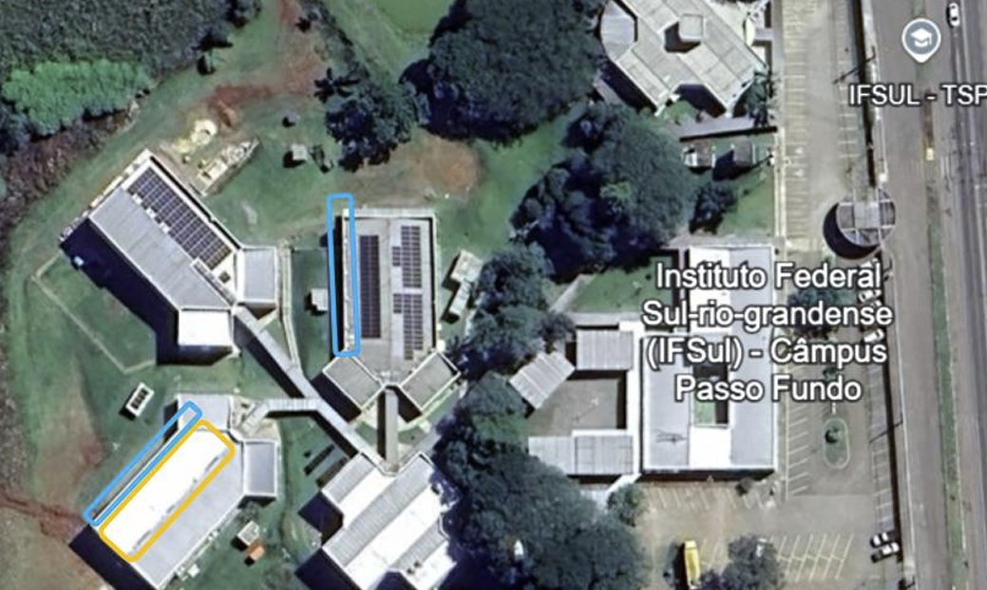
Fig. 5: Proposed installation locations of the photovoltaic arrays composing Generator 4

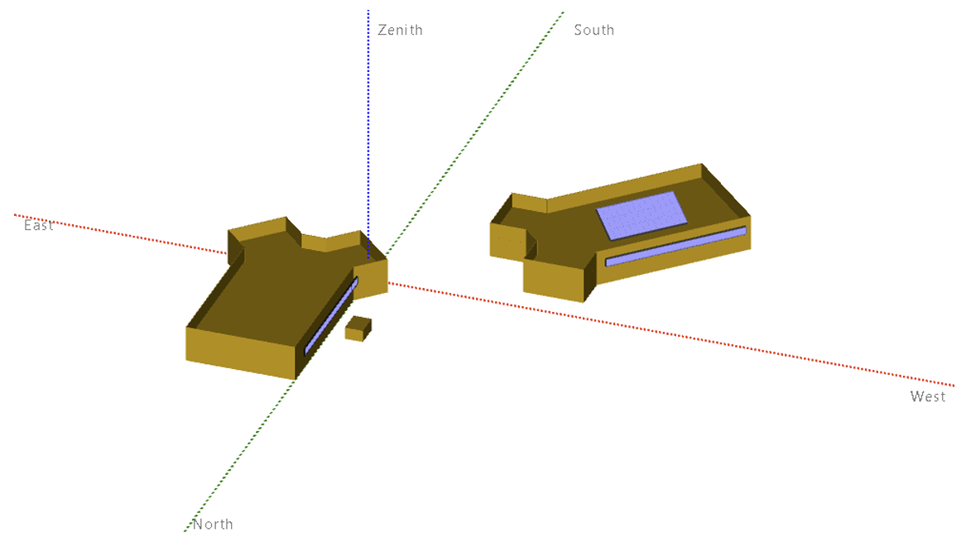
Fig. 6: Three-dimensional model of Generator 4 developed using the PVsyst® software

The main characteristics of the three proposed photovoltaic arrays are summarized in Table 4. The proposed system consists of photovoltaic modules installed on building rooftops and façades, using both conventional monocrystalline and bifacial photovoltaic modules according to the configuration defined for each installation location.
Tab. 4: Components of the photovoltaic arrays proposed for Generator 4
Array | Installation Location | Components
1 | Block 3 – Facade | 10 Risen Solar 660 Wp bifacial monocrystalline PV modules  1 ABB UNO-DM-5.0-TL-PLUS 5 kW inverter
2 | Block 5 – Roof | 39 Risen Solar 385 Wp monocrystalline PV modules  1 Growatt New Energy MAC 15KTL3-XL 15 kW inverter
3 | Block 5 – Facade | 10 Risen Solar 660 Wp bifacial monocrystalline PV modules  - ABB UNO-DM-5.0-TL-PLUS 5 kW inverter

Generator 4 was evaluated under the same Real and Optimized scenarios to assess the impact of architectural constraints on the proposed expansion. Individual simulations were also conducted for each of its three constituent arrays (Arrays 1, 2, and 3) to isolate the effects of façade and rooftop orientations, as presented in Table 5.
Tab. 5: Components of the photovoltaic arrays proposed for Generator 4
 | Simulation Results | Ger4som | Gerador4 | Array1som | Array1 | Array2som | Array2 | Array3som | Array3
Summary | Orientation (Tilt/Azimuth) | 90/90 - 28/45 - 90/45 | 28/0 | 90/90 | 28/0 | 28/45 | 28/0 | 90/45 | 28/0
Summary | Annual Energy Production (kWh/year) | 33.750 | 45.408 | 5.458 | 10.538 | 22.177 | 24.335 | 6.200 | 10.520
Summary | Average Monthly Energy Production (kWh/month) | 2812,5 | 3784,0 | 454,8 | 878,2 | 1848,1 | 2027,9 | 516,7 | 876,7
Summary | Performance Ratio | 76,88% | 80,13% | 76,88% | 79,50% | 76,63% | 80,70% | 77,93% | 79,37%
Global Horizontal Irradiation | Global incident in coll. Plane | -15,50% | 9,10% | -42,39% | 9,10% | 4,70% | 9,10% | -34,53% | 9,10%
Global Horizontal Irradiation | Near Shadings Irradiance loss | -2,28% | 0,00% | -1,49% | 0,00% | -2,02% | 0,00% | -0,86% | 0,00%
Global Horizontal Irradiation | IAM factor on global | -2,62% | -2,30% | -3,36% | -2,60% | -2,56% | -2,60% | -4,21% | -2,60%
Global Horizontal Irradiation | Soiling loss factor | -3,00% | -3,00% | -3,00% | -3,00% | -3,00% | -3,00% | -3,00% | -3,00%
 | PV Conversion | 20,12% | 20,12% | 21,25% | 21,25% | 19,21% | 19,21% | 21,25% | 21,25%
Array nominal energy (at STC effic) | Module degradation loss (10 years) | -0,50% | -0,50% | -0,47% | -0,47% | -0,50% | -0,50% | -0,50% | -0,47%
Array nominal energy (at STC effic) | PV loss due irradiance level | -0,93% | -0,49% | -1,82% | -0,50% | -0,56% | -0,48% | -1,47% | -0,50%
Array nominal energy (at STC effic) | PV loss due temperature | -7,77% | -5,46% | -5,48% | -5,05% | -8,88% | -5,78% | -5,36% | -5,05%
Array nominal energy (at STC effic) | Spectral correction | 0,41% | 0,16% | 0,97% | 0,16% | 0,18% | 0,17% | 0,71% | 0,16%
Array nominal energy (at STC effic) | LID | -2,00% | -2,00% | -2,00% | -2,00% | -2,00% | -2,00% | -2,00% | -2,00%
Array nominal energy (at STC effic) | Mismatch loss, modules & strings | -3,26% | -3,54% | -3,32% | -3,32% | -3,42% | -3,35% | -3,32% | -3,26%
Array nominal energy (at STC effic) | Ohmic wiring loss | -0,88% | -0,90% | -0,31% | -0,44% | -0,09% | -0,09% | -0,32% | -0,44%
Array virtual energy at MPP | Inverter loss during operation (efficiency) | -2,11% | -2,17% | -3,12% | -2,84% | -1,61% | -1,57% | -3,02% | -2,84%
Array virtual energy at MPP | Inverter loss over nominal inv. Power | 0,00% | -0,40% | -0,01% | -0,96% | 0,00% | 0,00% | 0,00% | -0,97%
Array virtual energy at MPP | Inverter loss due to max. Input current | 0,00% | 0,00% | 0,00% | 0,00% | 0,00% | 0,00% | 0,00% | 0,00%
Array virtual energy at MPP | Inverter loss over nominal inv. Voltage | 0,00% | 0,00% | 0,00% | 0,00% | 0,00% | 0,00% | 0,00% | 0,00%
Array virtual energy at MPP | Inverter loss due to power threshold | -0,01% | -0,01% | 0,00% | 0,00% | -0,01% | -0,01% | 0,00% | 0,00%
Array virtual energy at MPP | Inverter loss due to voltage threshold | 0,00% | 0,00% | 0,00% | 0,00% | 0,00% | 0,00% | 0,00% | 0,00%
Array virtual energy at MPP | Night consumption | -0,01% | -0,01% | 0,00% | 0,00% | -0,02% | -0,02% | 0,00% | 0,00%
 | Available Energy at Inverter Output | 34.055 | 45.997 | 5.519 | 10.809 | 22.433 | 24.829 | 6.275 | 10.714
 | AC ohmic loss | -0,04% | -0,10% | -0,29% | -0,42% | -0,75% | -0,80% | -0,45% | -0,63%
 | System unavailability | -0,85% | -1,19% | -0,85% | -1,19% | -0,89% | -1,20% | -0,77% | -1,19%
 | Comparison | 25,67% |  | 48,21% |  | 8,87% |  | 41,06%

The simulation results demonstrated that, considering the complete system, the actual installation configuration exhibited an approximate 25% reduction in annual energy production compared with the optimized scenario. When the façade-mounted photovoltaic arrays were analyzed individually, reductions ranging from 41% to 48% were observed, mainly due to the vertical installation of the photovoltaic modules. In contrast, the rooftop-mounted array, whose tilt angle is close to the local latitude and whose azimuth is favorable, presented a difference of approximately 8%, a value similar to that observed for the existing rooftop photovoltaic systems.
Despite the reductions observed for the vertically installed photovoltaic modules, the results demonstrate that the integration of photovoltaic systems into building façades provides satisfactory energy performance, particularly when associated with additional functions of the building envelope. As discussed in the report, the use of bifacial photovoltaic modules on the façades simultaneously contributes to electricity generation and to reducing the incidence of direct solar radiation on the classrooms, thereby improving indoor thermal comfort while enhancing the architectural functionality of the proposed solution.
- Conclusions
This study performed a comprehensive technical and energy assessment of expanding an existing grid-connected photovoltaic system in a public educational institution in Southern Brazil, combining rooftop and building-integrated photovoltaic (BIPV) configurations. By integrating twelve months of measured consumption data with 3D PVsyst® simulations, the research quantified the performance impacts of non-optimal module orientation, tilt angles, and building shading under subtropical low-latitude solar conditions.
The results demonstrated that conventional rooftop arrays installed with optimal tilt and favorable azimuth present minimal performance penalties (<10% yield reduction), whereas dual-orientation roof arrays suffer reductions up to 22%. Furthermore, vertical façade-mounted bifacial arrays experienced annual yield reductions between 41% and 48% due to high incidence angles. Nevertheless, the study highlights that façade-integrated bifacial systems remain technically viable in low-latitude regions owing to the significant diffuse radiation component. Beyond electricity generation, these BIPV applications offer critical architectural functionalities, such as envelope shading and thermal load reduction for instructional spaces.
Ultimately, these findings prove that advanced 3D simulation tools like PVsyst® are indispensable for decision-making in public retrofit projects. Proper executive planning allows institutional managers to balance architectural constraints and energy performance, accelerating the transition toward net-zero energy buildings in educational institutions..
5. References
Burger, B., Rüther, R. (2006). Inverter sizing of grid-connected photovoltaic systems in the light of local solar resource distribution characteristics and temperature. Solar Energy, 80(1), 32–45. https://doi.org/10.1016/j.solener.2005.08.012
Empresa de Pesquisa Energética (EPE). (2026). Balanço Energético Nacional 2026: Ano-base 2025. Rio de Janeiro, Brazil.
Han, M., Lu, L., Sun, B. (2024). Overall energy performance of building-integrated bifacial photovoltaic sunshades with different installation and building parameters in hot and humid regions. Solar Energy, 275, 112619. https://doi.org/10.1016/j.solener.2024.112619
International Energy Agency (IEA). (2025). Renewables 2025 - Analysis and Forecast to 2030. Paris, France: International Energy Agency.
International Energy Agency - Photovoltaic Power Systems Programme (IEA PVPS). (2025). Trends in Photovoltaic Applications 2025. Report IEA-PVPS T1-46:2025. St. Ursen, Switzerland.
International Energy Agency - Photovoltaic Power Systems Programme (IEA PVPS). (2026). Snapshot of Global PV Markets 2026. Report IEA-PVPS T1-47:2026. St. Ursen, Switzerland.
Liu, X., Yang, H., Wang, C., et al. (2024). Semi-experimental investigation on the energy performance of photovoltaic double skin façade with different façade materials. Energy, 295, 131049. https://doi.org/10.1016/j.energy.2024.131049
Nascimento, L. R., Rüther, R., Urbanetz, J., Zomer, C. D. (2019). Extreme solar overirradiance events: Occurrence and impacts on utility-scale photovoltaic power plants in Brazil. Solar Energy, 186, 370–381. https://doi.org/10.1016/j.solener.2019.05.008
PVsyst SA. (2024). PVsyst Photovoltaic Software - Version 7 User Manual. Geneva, Switzerland.
Santos, Í. P., Rüther, R. (2014). Limitations in solar module azimuth and tilt angles in building-integrated photovoltaics at low-latitude tropical sites in Brazil. Renewable Energy, 63, 116–124. https://doi.org/10.1016/j.renene.2013.09.008
Urbanetz, J., Rüther, R., Tiepolo, G. M. (2011). Compromises between form and function in grid-connected building-integrated photovoltaics (BIPV) at low-latitude sites. Building and Environment, 46(10), 2107–2113. https://doi.org/10.1016/j.buildenv.2011.04.024

