ANALYSIS OF BOREHOLE FIELD DESIGN FOR SEASONAL STORAGE OF RENEWABLE HEAT

Tomas Matuska, Borivoj Sourek
Czech Technical University in Prague
tomas.matuska@cvut.cz
Summary
As a part of complex energy system design, a sub-system combining a solar thermal system, an air-water heat pump using only electricity from the PV system and seasonal heat storage between summer and winter was modelled in the TRNSYS environment. To design the optimal configuration of the borehole field for seasonal storage, various variants were modelled: length of the boreholes, number of boreholes, borehole spacing for a defined ground massif and type of the boreholes (U-loop). The analysis has evaluated storage efficiency and usable heat supply to the low-temperature district heating system. General recommendations for the design of the borehole field were derived from the analysis: optimum total length of the boreholes, need for small spacing of the boreholes and overall compactness of the field volume.
Keywords: seasonal storage, borehole field, solar thermal system, heat pump, photovoltaic system
Field of application for the findings: seasonal heat storage, design of energy systems
Addressed audience: designers, planners
- Introduction
Within the framework of the SYNERGYS project, a unique infrastructure focused on research and testing of renewable energy sources is under preparation in ​​the campus of former Litoměřice (CZ) barracks, today RINGEN research centre for geothermal technologies. The research infrastructure will include pilot systems for the production, storage and supply of renewable heat for district heating (DH) purposes. The SYNERGYS project combines the topic of using a deep geothermal energy source and above-ground technologies using different types of thermal energy storage. The research infrastructure will be created with the aim of showing possible ways of transforming Czech cities towards a carbon-free future in the field of heat supply in cities.
Fig. 1: Scheme of SYNERGYS research infrastructure
The complex energy system, which is to be implemented by 2028, consists of several subsystems. The core of the entire system is a deep geothermal heat source with a depth of 3,5 km and a thermal output in the order of MW for the supply of renewable heat with a temperature level of 90 °C to the local district heating network. RINGEN centre itself will be supplied by energy for space heating and cooling from ground source heat pumps connected to the borehole field (BTES1) operated at temperatures between 0 °C and 15 °C. The PV system with a peak power 60 kW_{p} combined with a battery storage (50 kWh) will significantly reduce the energy consumption of the RINGEN building and allow to achieve the zero-energy standard. High-temperature storage system combined with an organic Rankine cycle (ORC) technology represents the topic of grid flexibility in the SYNERGYS project. Packed rock bed energy storage with achievable temperature 600 °C (PBTES with air heater) and pressurized hot water storage at 110 °C (HWTES with boiler) are charged by excess electricity from the grid and renewable power systems. The stored heat is utilized in evaporator of ORC plant with generating power output 75 kW_{e} and low-temperature heat output about 1000 kW which will be stored in borehole thermal energy storage (BTES2) at temperature level of 30 to 40 °C. Another energy source for low-temperature heat supply to BTES2 is photovoltaic-thermal system with glazed PVT collectors with total gross collector area about 280 m² (50 kW_{p}). Seasonal heat storage in the borehole field at usable temperatures above 50 °C will be investigated in the subsystem combining solar thermal system with a collector area of 1000 m² and air source heat pump powered only by PV system with PV modules area of 1000 m². Both systems will be connected to borehole thermal energy storage BTES3 with operating temperatures from 40 to 70 °C. Borehole fields BTES2 and BTES3 will be discharged into low-temperature district heating (DH) network emulator operated at temperature level 35/25 °C. While BTES2 will be discharged by means of water-water heat pump, BTES3 will be discharged directly. High-temperature heat pump will transform the heat from the DH network emulator to the temperature level of 90 °C for the DH system in Litoměřice.
The paper focuses on the design and analysis of two solar system concepts for fully renewable heat production: solar thermal system with photothermal collectors (SOL) and system combining photovoltaic modules and air- water heat pumps (PV-HP) which will be part of the SYNERGYS infrastructure. Computer modelling has been used to optimize the subsystem parameters. The paper shows an analysis of a seasonal heat storage design in the form of a field of ground boreholes (BTES3).
- Renewable heat production
Both solar systems use solar energy and ambient energy to convert it to fully renewable heat supplied to low temperature DH system with use of seasonal heat storage. To compare the benefits of solar systems the same available gross collector area has been defined.
The first source is a solar photothermal system (SOL system) which produces heat by direct conversion of solar radiation. Solar flat-plate collectors have a gross area of 1000 m² and are considered with a south orientation and slope 30°. Efficiency parameters of solar collectors are: η₀ = 0,76, a₁ = 1,97 W/m²K and a₂ = 0.015 W/m²K² (referred to gross area). The total flow rate of antifreeze liquid in the collector circuit is 50 m³/h. The heat transfer capacity rate of the heat exchanger UA = 150 kW/K has been designed with a heat power of approximately 600 kW at temperature of 70 °C (inlet from the collectors) and 30 °C (inlet from the load circuit). The load circuit is operated with water, and it is connected to the seasonal heat storage formed by a field of ground boreholes.
The second heat source is a combination of a photovoltaic system and high-temperature air source heat pump (PV-HP system). The production of usable heat by the heat pump from the ambient air uses only renewable electricity by adjusting the heat pump power input according to the PV system power output. PV modules with a gross area of 1000 m² and reference module efficiency 22 % (peak power 220 kW_{p}) are considered with a south orientation and slope 30°. The air-water heat pump is considered as a cascade of two units with a total heat output of 48 kW at A7/W30 at minimum speed (one unit, COP = 5,05) and a heat output of 620 kW at A20/W60 at maximum compressors speed (both units, COP = 2,76). Each unit has continuous power input control from 20 Hz to 120 Hz for compressors, resulting in the range of power control from 15 % to 100 %. Thus, the heat pumps do not consume any electricity from the public grid during their operation and use only renewable (PV) electricity to produce heat. The considered flowrate between condensers and borehole storage is 50 m³/h (similar to solar thermal system).
Both systems (SOL, PV-HP) supply the heat from spring to autumn (from April 30 to October 1) to a common seasonal heat storage - the field of ground borehole heat exchangers. In the winter period, heat extraction from the borehole field is considered directly to the low-temperature network with a temperature level of 35/25 °C. Fig. 2 shows the simplified scheme of energy flows. The seasonal storage is hydraulically separated from source and load circuits by small storage volume to provide a defined flow rate in the borehole field independent of the flowrates in the heat source and heat load circuits.
In order to design a given renewable heat system with a seasonal storage properly with high annual renewable heat supply to low-temperature network and with high utilization of seasonal storage capacity a simulation analysis has been performed. The analysis has been oriented especially to borehole field design. There were examined various variants of the ground borehole configuration: number N of boreholes (from 20 to 100 boreholes), length L of boreholes (from 50 to 100 m) and spacing S of boreholes (3 to 8 m) in the field for a given setup of renewable heat source in order to maximize the usable heat recovered from the storage. The simulation of individual variants of the borehole field was carried out in TRNSYS 18 software. Due to the nature of the investigated system with seasonal storage, a period of 10 years was simulated to reach the stabilized conditions within the seasonal storage. The results further presented are taken from the 10th year of the simulation, when steady-state operation of the seasonal storage is assumed.
Fig. 2: Scheme of analysed renewable heat system
The modelling of the borehole field was performed using the type 557a model (Pahud D. et al., 1997), which represents a simplified model of boreholes with pipe U-loops. The field is specified by the number of boreholes, their length (depth) and spacing, geometry and physical properties of materials (pipes, boreholes). The analysed borehole field in each variant has been considered with double U-loop with pipe dimension 40 x 3,7 mm and diameter of individual boreholes 152 mm. Cement grouting has been considered with a conservative thermal conductivity 1,4 W/m.K. The properties of the underground environment up to a depth of 600 m were based on the figures obtained from the geological survey in the given location (Litomerice, CZ). While the average thermal conductivity for the whole investigated underground profile is around 3,35 W/mK, the upper ground layers up to analyzed borehole depth 100 m have only 2,87 W/m.K in average. Thermal insulation (gravel) layer 30 cm thick with thermal conductivity 0,17 W/m.K has been considered on the terrain surface of borehole field to reduce the upper heat loss from storage volume to ambient. Volumetric heat capacity of the ground mass is 2800 kJ/m³.K in average. For simulations the flowrate 2250 l/h per borehole has been set.
- Analyses of borehole field design
The basic aim of the analysis was to investigate how the sizing and configuration of the borehole field can affect both the efficiency of the seasonal heat storage and the amount of renewable heat utilized by the low-temperature network. The analysis monitored annual energy flows in the system especially heat production of both solar systems (SOL, PV-HP), heat supplied to the seasonal storage in summer and extracted from it in winter, total renewable heat supplied into the low-temperature network, temperatures in the circuits and other necessary quantities to evaluate the performance of the whole system. To simulate the operation of the heat sources, hourly climate data with an annual average ambient air temperature of 7.7 °C and a horizontal solar irradiation of 1095 kWh/m².a were used (conservative climatic conditions).
Fig. 3 shows the dependence of the seasonal storage efficiency on the total length of boreholes given by number and depth of boreholes for different spacing of boreholes (S = 3 m, 5,5 m and 8 m) and different depth of individual boreholes (L = 50 m, 75 m and 100 m). Storage efficiency is evaluated as a ratio of annual extracted heat from the seasonal storage to heat supplied in it. It is obvious that smaller spacing of boreholes results in significantly higher efficiency. While borehole with spacing 3 m can achieve the efficiency even more than 60 %, the spacing 5,5 m achieves only around 50 % and for spacing 8 m it is under 40 %. While for smaller spacing of boreholes the shorter depth of individual boreholes achieves higher storage efficiency, for larger spacing the trend reverses and is opposite. A position of the optimum total length of boreholes is dependent both on the spacing and depth of individual boreholes. For the spacing S = 3 m the efficiency optimum lies between 3 and 4 km for depth of 50 m, for larger borehole depths the optimum moves to higher values of total length of boreholes (5 to 6 km). On the other hand, the difference in optimum storage efficiency for various depths is within few percents.
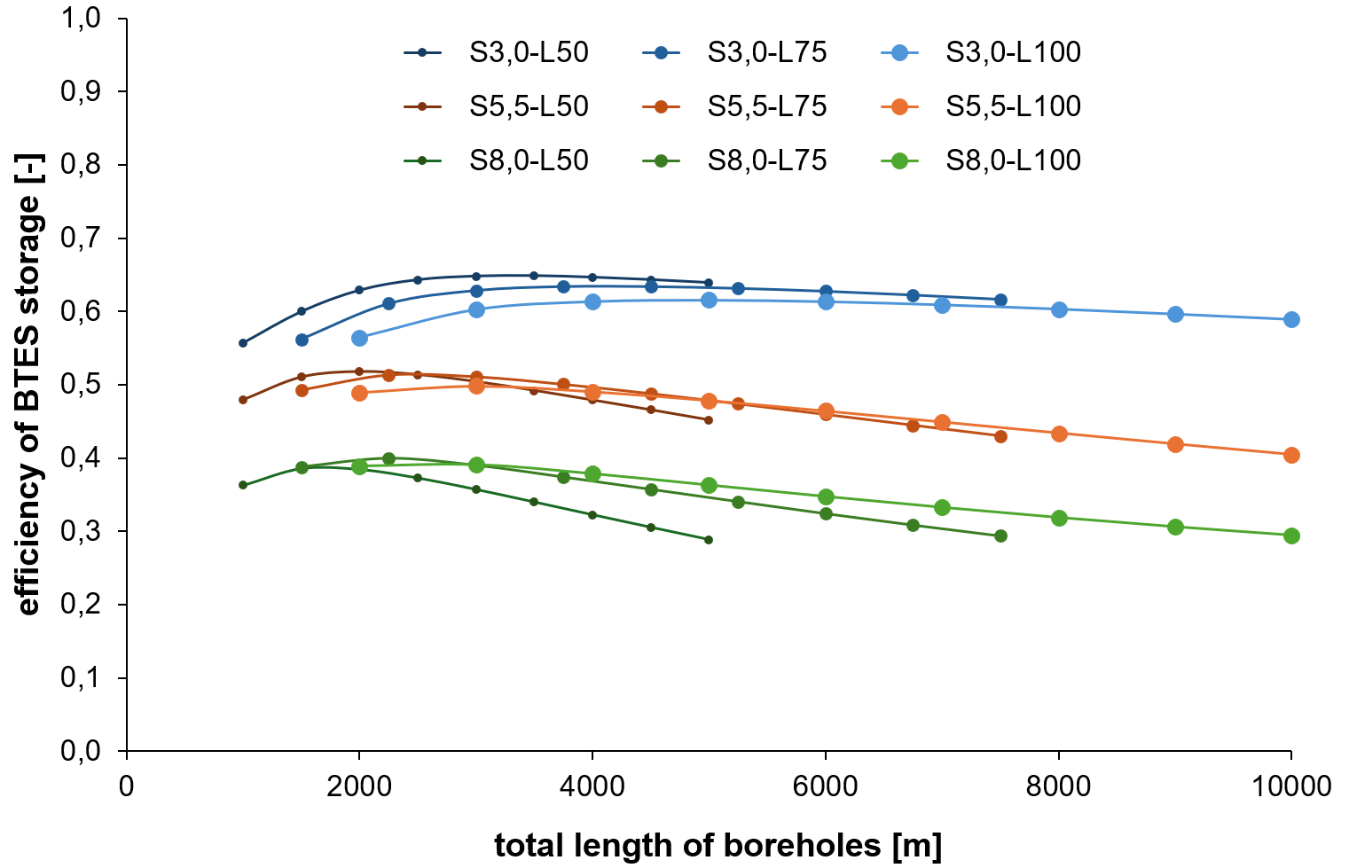
Fig. 3: Efficiency of seasonal borehole storage for different configurations of the field
Another evaluated aspect is the amount of total heat supplied by the renewable heat system to the low-temperature network. Fig. 4 shows the dependence of heat supply on the total length of boreholes, again with spacing and length as a parameter of presented curves. The results show very similar trend as for storage efficiency. Smaller spacing of boreholes together with short boreholes leading to compact storage volume enhances the heat supply. On the other hand, for small spacing of boreholes (S = 3 m) the clear optimum is hard to find. Increment in supplied heat for total length of boreholes above 6 km is very small. Design of total length of boreholes in range 5 to 6 km results in cheaper installation and only 3 % lower heat supply compared to flat optimum at 10 km. Optima for larger spacings result in reduced total length of boreholes, but with significantly lower heat supply to low-temperature network.
Design decisions should finally consider also practical issues, including economic view and feasibility of borehole field installation. Due to typical achievable verticality for low-cost drilling about 5 % the spacing S = 3 m is applicable only for shorter boreholes, otherwise more expensive realisation of boreholes should be applied. On the other side, high number of short boreholes to achieve necessary total length of boreholes needs a sufficient available ground floor area for the field installation.
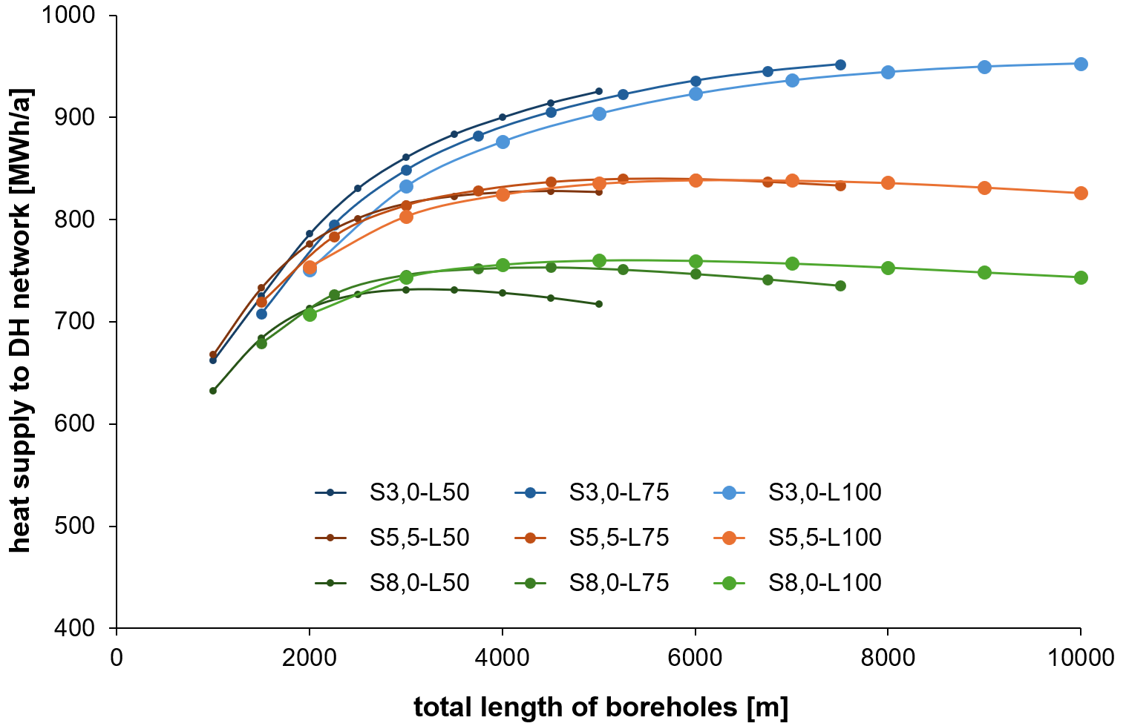
Fig. 4: Total energy supplied into low-temperature network for different configurations of the field
- Comparison of systems
Comparison of both systems (SOL, PV-HP) with a design of borehole field (R = 3 m, L = 100 m) is presented in graphs in Figure 5 as an example. Summer heat production and supply into the borehole field is very similar for both systems and dependent on the borehole design. The number of boreholes reflected in total length of boreholes and associated storage volume of the borehole field influences the operation temperature of the heat sources (SOL, PV-HP) in the summer (see Fig. 5, operation temperature in boreholes t_{BH}) and thus their efficiency and renewable heat production. Compared to solar thermal system SOL, the PV-HP system has finally higher total heat supply in all year round (summer, winter). The total annual heat production of heat pump for supply to borehole field and directly to DH network exceeds the SOL system production by approximately 10 % to 12 %. On the other side, the PV-HP system modelling hasn’t included reduction of efficiency and increase in electricity consumption during defrosting of evaporator which could bring the results closer.
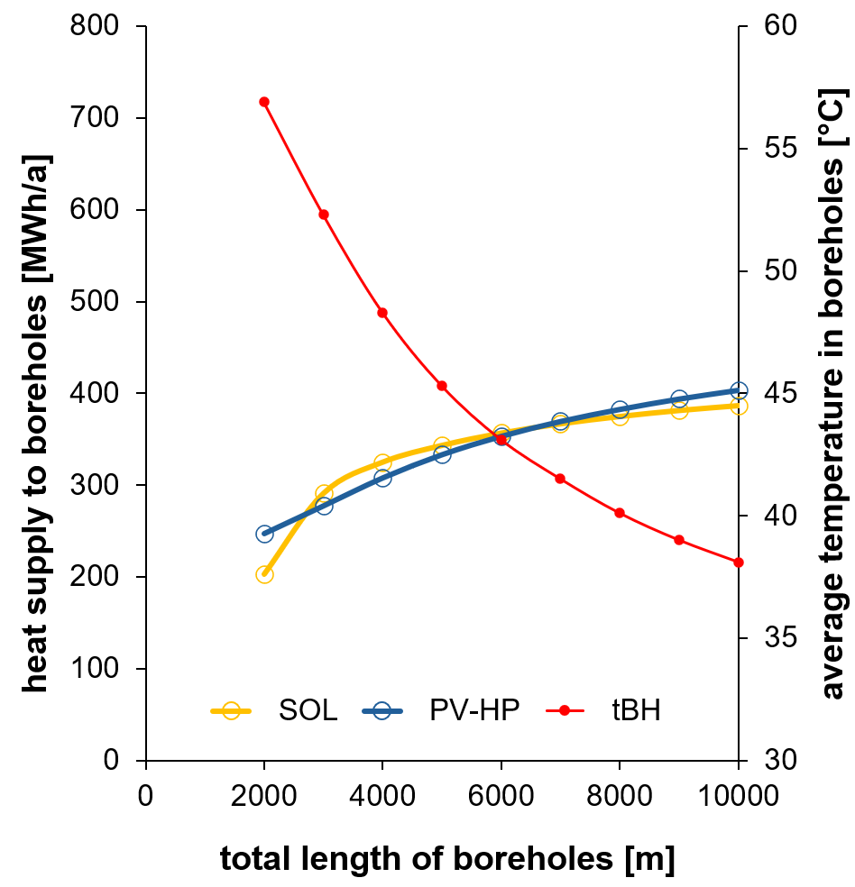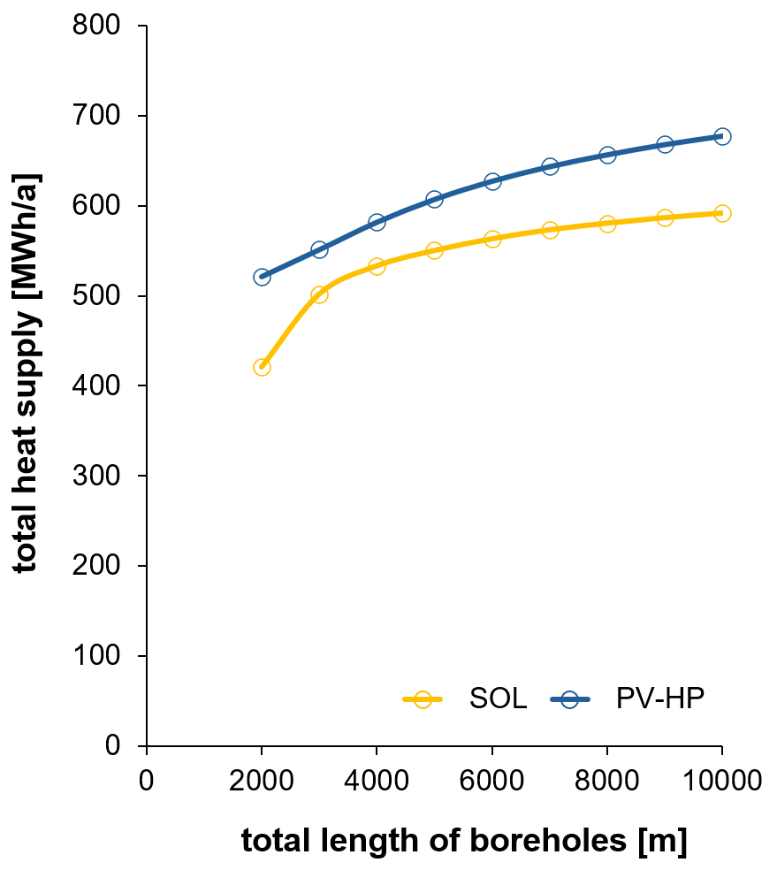
Fig. 5: Comparison of heat generated and supplied by analysed solar systems (summer period, all year)
- Conclusion
The simulation analysis of the borehole field for given system combining renewable heat sources sensitive to operation temperature (SOL, PV-HP) results in several conclusions that should be considered when designing the seasonal heat storage:
- the total length of the boreholes, i.e. their heat exchange surface, must correspond to the performance parameters of the heat sources to guarantee effective heat transfer to the ground mass without an excessive increase in the operation temperature (temperature difference between the liquid and the mass);
- there is a need for small spacing of boreholes, which significantly increase both heat supply and the efficiency of using seasonal storage, however respecting that the sufficient total borehole length and storage volume are ensured;
- in case of the small spacing shorter length of boreholes leads to slightly higher efficiency and total energy supplied – for larger spacings the trend is opposite;
- the total volume of the borehole field given by spacing and boreholes length must be chosen regarding to the amount of stored heat, assuming also the usable temperature required in the reservoir for further heat utilization (extraction of usable heat);
- the heat utilization and storage efficiency are influenced by the achieved temperature level of the storage – the optimum of these two main monitored parameters is then a compromise between a temperature level low enough for effective heat production by SOL and PV-HP sources (the lower the temperature, the higher the annual heat production of the sources and lower energy losses of storage itself) and a temperature level high enough for usable heat supply into the low-temperature network (the higher the temperature level reached in the storage, the higher the usable heat supply).
It has been been shown that PV-HP system is comparable to solar thermal system (SOL) when heat production supplied to borehole field in summer period is compared, while the annual total heat supply (to boreholes, to DH system) is higher for PV-HP by 10 to 12 % practically regardless of the borehole design.
It is obvious, that design of complex energy systems, such as the presented renewable heat supply system with seasonal storage, must be carried out with sufficiently reliable simulation tools that allow for parametric analyses and design optimization with low computational time requirements and with specific technical parameters of individual components (collectors, heat pumps, heat exchangers, control, borehole field, ground layers), as these can also significantly affect the results and possible trends in the entire analysis.
- Acknowledgement
This work has been supported by project SYNERGYS No. CZ.10.02.01/00/22_002/0000172 under EU Operational programme Just Transition.
- References
Operational Programme Just Transition (2023-2027): SYNERGYS project (Systems for Energy Synergy), https://synergys.cz/en/home
Klein, S.A. et al, 2017. TRNSYS 18: A Transient System Simulation Program, Solar Energy Laboratory, University of Wisconsin, Madison, USA, http://sel.me.wisc.edu/trnsys.
Pahud D., Hellström G., Mazzarella, L., 1997. Duct Ground Heat Storage Model for TRNSYS - User manual for the October 1996 version, Lausane 1997.

