EuroSun2026
Parametric Analysis of TES Temperature Effects on COP and Payback in PV–Heat Pump Systems for Residential DHW
Summary
Energy efficiency is a key pathway toward a sustainable society. In buildings, an especially relevant system combines on-site photovoltaics (PV), heat pumps (HP) for HVAC and domestic hot water (DHW) demand, and thermal energy storage (TES). However, existing studies often overlook a critical factor: the reduction in heat pump coefficient of performance (COP) caused by TES temperature differentials. This study investigates this effect using a DesignBuilder/EnergyPlus model of a PV+HP+TES system serving the DHW demand of a residential building in Spain. A parametric analysis of TES system volume and temperature was performed, along with a sensitivity analysis of TES payback period under different PV excess injection compensation prices. Results show that optimal TES temperature depends on storage volume and significantly affects savings. Additionally, payback period sensitivity to injection price behaved as non-linear, meaning that small price reductions may enable economic viability of PV+HP+TES systems under future renewable energy scenarios.
Keywords: Thermal Energy Storage, Heat Pumps, On-site PV, Parametric Analysis.
Field of application for the findings: Thermal Energy Storage
Addressed audience: Researchers and practitioners.
- Introduction
Global warming is one of the most significant challenges of this century. Among the available mitigation strategies, energy efficiency plays a central role. Buildings account for approximately 40% of annual energy demand in Europe, making them a key target for efficiency improvements (“In focus: Energy efficiency in buildings | Comisión Europea,” n.d.). A system of growing interest combines on-site photovoltaic (PV) generation, heat pumps (HP) for HVAC and domestic hot water (DHW), and thermal energy storage systems (TES) (Li et al., 2022).
In this combination, photovoltaic generation reduces grid electricity consumption and can often achieve favourable economic and life-cycle emission results (Latchiba et al., 2026). PV integrates well with heat pumps, which use electricity to provide heating, cooling and domestic hot water. In mild climates, heat pumps can attain high coefficients of performance (COP), making them competitive with fuel-based boilers (e.g., gas or biomass) (Schito et al., 2026). This is particularly relevant in residential buildings with low or no daytime occupancy, where substantial PV surpluses may occur despite the electricity consumed by the heat pump (Wang and Hui, 2026). When coupled with heat pumps through an appropriate control strategy, thermal energy storage (TES) can absorb part of this surplus by converting electricity into stored heat or cooling for later use.
TES systems can store heat or cold for periods from hours to months (Osterman and Stritih, 2021). Amongst the different TES technologies available, this study considers sensible heat storage with water as the storage medium (Agyenim and Hewitt, 2010). The system follows a daily charge–discharge cycle, shifting part of the heat pump’s electricity consumption towards periods of high PV availability. This load-shifting strategy increases PV self-consumption and can reduce grid electricity imports (Wang and Hui, 2026).
However, when approaching this effect, many studies overlook a critical factor: the reduction in heat pump coefficient of performance (COP). Charging the TES requires the heat pump to operate at a higher temperature lift, owed to the storage temperature range and the temperature differences required for heat transfer. Increasing this range enhances storage capacity but reduces the heat pump COP, creating a fundamental trade-off between storage capacity and conversion efficiency that must be carefully evaluated (Fischer et al., 2014; Osterman and Stritih, 2021). Furthermore, some studies neglect to account for the injection of excess PV electricity into the grid, a direct competitor with energy storage. This creates a gap in the integrated assessment and optimal design of PV+HP+TES systems, where long and dynamic simulations are required.
In this study, to evaluate the effects of TES system size, temperature and grid injection compensation price, a DesignBuilder/EnergyPlus model was developed for a 12-dwelling residential building in Pamplona, Spain. The system includes rooftop PV panels, a heat pump supplying domestic hot water, and a water storage tank acting as TES system. A parametric analysis was conducted on TES system temperature, volume, and PV excess injection price, using Spanish electricity prices from 2023. This model will be described in the methodology, followed by a discussion of the economic savings results.
- Methodology
  - DHW system modelling
The case study is a 12-dwelling residential building in Pamplona. DHW demand was estimated at 907.2 L/day at 60°C according to the Spanish regulation “CTE-DBHE-Anejo F”, with an hourly profile adapted from (Sborz et al., 2022), featuring afternoon and evening peaks. This DHW demand hourly profile is shown in Fig. 1.
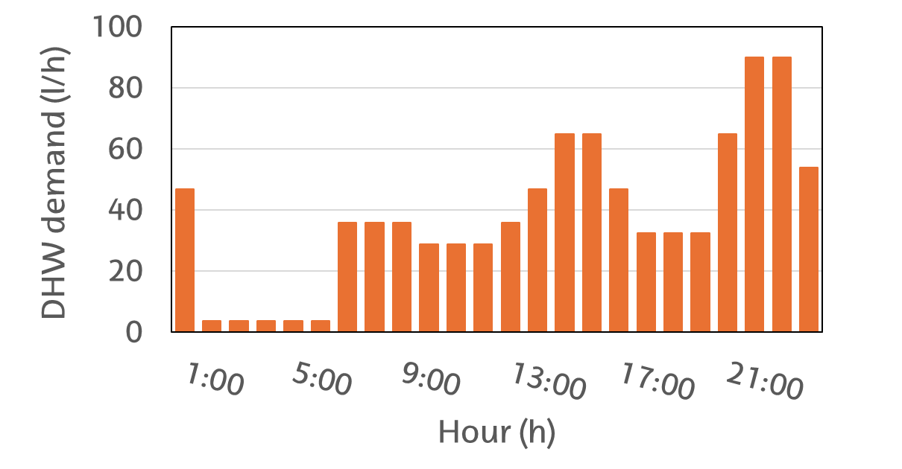
Fig. 1. DHW hourly demand profile
The system was modelled in DesignBuilder using a plant loop with a heat pump and a DHW loop with a storage tank acting as TES system. The heat pump charges the TES system in series, and the TES system discharges to meet the DHW demand.
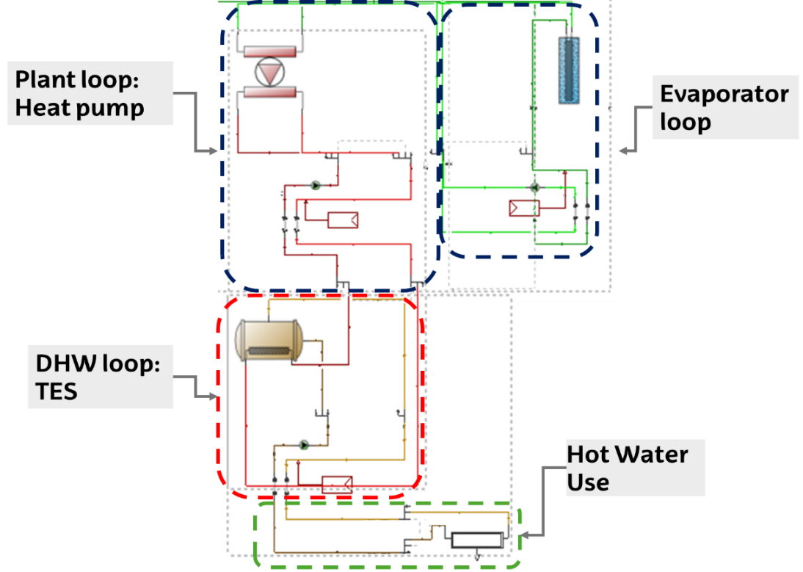
Fig. 2: DHW loops model in Design Builder
The configuration of the DHW TES system is in series. This is shown in Fig. 3. In a series configuration the heat pump feeds the TES system and the TES system directly satisfies the demand. If the heat pump could also bypass the TES system to satisfy demand then the configuration would be in parallel. The series configuration simplifies installation and control, thus it is commonly used in real cases. However, it also reduces the overall COP as the heat pump has to operate at higher than TES system temperatures at all times. Due to the series configuration being more common as well as more sensitive to TES system temperatures, it was chosen as the configuration for this study.

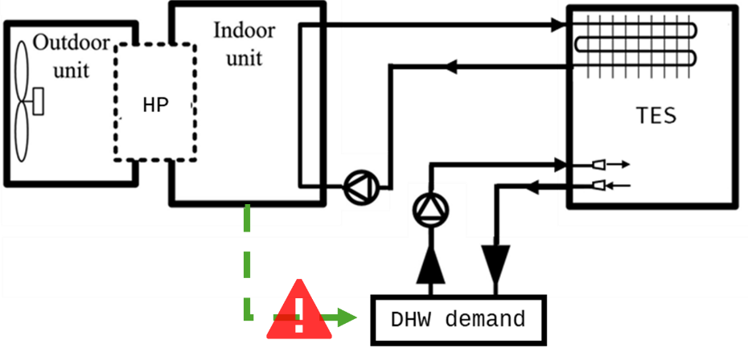
Fig. 3. HP + TES system in series configuration scheme
The model uses a heat pump based on the LIFT 81-P÷1204-P model from Trane. To reproduce its performance, the heat pump parameters in EnergyPlus were calibrated so that simulated electrical consumption matched manufacturer performance curves across outdoor and inlet load temperatures. The calibration consists on slightly changing the heat pump electricity consumption parameters related to source and inlet temperature in various yearly simulations until the heat pump electricity consumption matches that of the manufacturer. This calibration captures the COP reduction at higher load temperatures, which is key to the TES system temperature parametric analysis. The TES system base temperature was set to 60°C and charged up to a variable maximum temperature, defined as a parameter in the analysis. This is shown in Fig. 4, where the modified simulation electrical power at different load temperatures resembles that of the manufacturer for the high temperature heat pump.
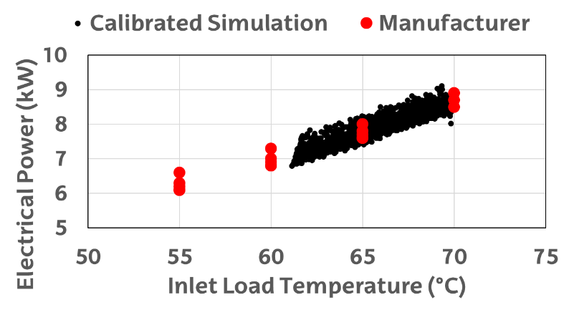
Fig. 4: Electrical power consumption of simulated modified heat pump and manufacturer data
  - TES system control strategy
The control strategy prioritizes charging the TES system during hours with the lowest electricity price, ensuring it is fully charged each 24 hour period. If PV generation presents excess electricity, that hour is considered in the strategy as having a price of 0 €/kWh. This promotes self-sustainability by using more of the generated PV electricity via storing it as heat in the TES system.
The strategy defines three operating modes: charge, discharge and compensation. The naming of the operating modes indicates if during that hour, the TES system temperature is expected to rise (Charging), decrease (Discharging) or stay constant by the end of the hour (Compensation).
The algorithm ranks the twenty four hours of each day by electricity price in ascending order, assigning a price of zero euros to hours when PV generation exceeds on-site consumption. It then selects as many hours for charging as required to raise the TES system state of charge from empty to full. The algorithm includes heat pump capacity as a function of outdoor temperature to determine achievable charging rates. Charging hours therefore occur during PV surplus periods and, when PV is insufficient, during low-price night hours.
Knowing the TES system nominal capacity in kilowatt hours and the hourly thermal demand, the algorithm next selects discharging hours from highest to lowest electricity price until the all the thermal energy of the TES system is allocated. During discharging hours the TES system outlet temperature decreases as energy is withdrawn.
The remaining mode is charge compensation. In compensation mode the heat pump supplies the same thermal energy to the TES system that the TES system has just discharged to meet demand in that hour, keeping the TES temperature effectively constant so stored heat can be reserved for future, more expensive hours.
The control strategy was implemented in MATLAB using demand and PV production time series derived from a simulation without the TES system. This creates a year long predictive schedule that was exported to EnergyPlus as hourly control schedules. In addition, a minimum temperature safeguard was implemented in the simulation that forces charging when TES system temperature falls below the 60° C setpoint to maintain adequate operating conditions.
Overall, the logic charges the TES system during low-price hours, with PV surplus hours treated as the lowest cost, and discharges during the highest-price hours. This load-shifting reduces grid electricity imports by increasing PV self-consumption and improves economic performance by avoiding purchasing high-cost electricity during the more expensive hours of the day.
  - Results calculations: Energy and economic results.
The grid electricity import reduction is calculated as the reduction in electricity drawn from the grid. The baseline (0 MWh·year⁻¹ savings) is the grid consumption for the smallest TES system volume and temperature (0.2 m3 at 70 °C). For each parametric case, hourly grid consumption was calculated where grid electricity import reduction equals the difference between the baseline grid consumption and the grid consumption for that case. The grid electricity import reduction in this study represents the additional PV self-consumption achieved by storing surplus PV as heat.
Economic savings are computed in two components. First, the reduced purchase cost: hourly grid consumption multiplied by the hourly electricity purchase price, summed for the year. Second, the compensation for exported PV: a compensation allocated as a reduction in the monthly electricity bill for injected PV energy, using market compensation rates applicable to small consumers from the Spanish market (“Análisis | ESIOS electricidad · datos · transparencia,” n.d.). Therefore the total annual economic savings equal the purchase cost minus the annual compensation credited for exported PV. This intrinsically gives value to excess energy, where the energy saving results do not give energy value to electricity injection onto the grid.
TES system investment cost for the simple payback analysis was obtained from the CYPE construction price generator (“Generador de precios de la construcción. CYPE Ingenieros” n.d.). Simple payback was calculated as TES system cost minus the baseline case (0.2 m³) cost divided by first-year total economic savings for the best-performing case at each volume. This yields an approximate number of years until capital is recovered if at least some TES system were to be installed, and is sufficient as a metric for the parametric comparison of compensation price for this study.
- Results
  - Grid electricity import reduction, effects of temperature and size
The first set of results focuses on the annual grid electricity import reduction of TES system implementation as a function of storage volume and maximum storage temperature. Tab. 1 presents savings (MWh·year-1) for each simulated combination, color-coded by performance and highlighting the top 10%.Three main trends from energy saving results are observed.
First, volumes below 1m³ result in net grid energy losses, as minor storage capacity fails to offset the COP reduction associated with higher operating temperatures.
Second, maximum savings occur at lower temperatures for larger volumes, with no particular constant capacity showing maximum savings. This indicates that the best TES system design for a particular case study depends on the specific volume–temperature combination.
Third, undersizing is penalized, but oversizing shows almost no effect. Undersized TES system configurations deplete before the end of the day and require morning recharging during high-price hours. In Tab. 1, this appears as a sharp decrease in savings when moving from optimal combinations to smaller volumes or lower temperatures. Note that this effect is specific to the herein-used series configurations, where the heat pump cannot bypass the TES system. However, once optimal volume for that temperature (or viceversa) is reached, grid electricity import reduction plateaus and higher capacities do not show significant decreases. Only at 80°C maximum temperature, where the thermal losses on the tank’s surface is higher, does the grid electricity import reduction decrease after the optimal at volumes 4-6m3.
Tab. 1 Grid electricity import reduction (MWh·year⁻¹) results from the parametric analysis
 | Maximum storage Temperature (°C)
TES  system volume (m3) | 70 | 72 | 74 | 76 | 78 | 80
0.2 | 0.00 | -0.04 | -0.09 | -0.15 | -0.25 | -0.37
0.4 | -0.02 | -0.09 | -0.09 | -0.21 | -0.35 | -0.41
0.5 | -0.02 | -0.07 | -0.18 | -0.24 | -0.39 | -0.51
0.6 | -0.03 | -0.14 | -0.24 | -0.29 | -0.44 | -0.49
0.8 | -0.16 | -0.15 | -0.16 | -0.27 | -0.34 | -0.39
1 | -0.15 | -0.20 | -0.16 | -0.23 | -0.20 | -0.09
2 | 0.32 | 0.68 | 1.07 | 0.78 | 0.71 | 1.24
3 | 0.96 | 0.91 | 1.35 | 2.26 | 2.47 | 2.45
4 | 0.70 | 1.92 | 2.57 | 2.68 | 2.62 | 2.54
5 | 1.56 | 2.53 | 2.77 | 2.68 | 2.59 | 2.62
6 | 2.15 | 2.77 | 2.74 | 2.67 | 2.61 | 2.53
7 | 2.60 | 2.76 | 2.70 | 2.61 | 2.81 | 2.30
8 | 2.82 | 2.79 | 2.67 | 2.74 | 2.60 | 2.14
9 | 2.90 | 2.62 | 2.74 | 2.68 | 2.44 | 2.14
10 | 2.72 | 2.58 | 2.75 | 2.63 | 2.48 | 2.29

This last effect of sharp losses on undersizing but plateauing if oversizing can be seen on the 3D plot shown in Fig. 5:. Following the TES system volume axis, only at maximum temperatures does the plateau present a slight descension for high temperatures and volume combinations, mostly due to losses through the tank‘s surface.

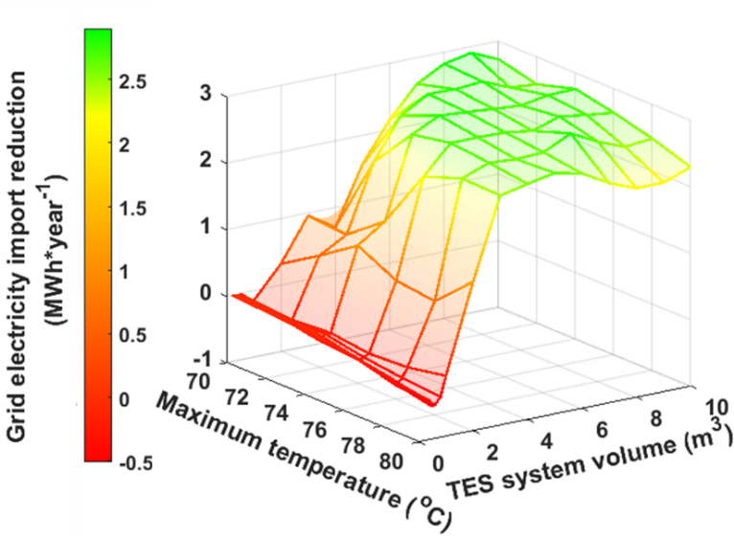
Fig. 5: 3D plot of influence of maximum temperature and TES system volume on grid electricity import reduction
  - Economic savings, effects of temperature and size
The second set of results are annual economic savings of TES system implementation. Tab. 2 presents savings (€·year⁻¹) for each simulated combination, color-coded by performance and highlighting the top 10%, with the same baseline case of 70°C and 0.2m³.
Two of the three main trends from energy saving results are observed, somewhat changed. Volumes now below 2m³ result in net economic losses, which is higher volumes than the minimum for grid electricity import reduction. This is due to the fact that using excess electricity from PV is injected has an economic value, therefore the economic savings are going to penalize TES systems as injecting onto the grid is a direct economic competitor to TES system.
Second, maximum savings occur at lower temperatures for larger volumes, but these optimal points do not correspond to a constant storage capacity nor concentrate at maximum temperature at low volumes. For example, 9m³ at 70°C (105 kWh of capacity) and 4 m³ at 74°C (65 kWh) yield similar savings. As with the grid electricity import reduction results, this shows that optimal performance depends on the specific volume–temperature combination.
Third, undersizing is still penalized more severely than oversizing but oversizing is now also penalized. In particular, the loss of COP at higher temperatures, causing less injection onto the grid, reaches a point where it is economically more suitable to not increase TES system capacity to avoid increasing the temperature further and injecting less electricity on the grid.
Tab. 2. Economic savings (€·year⁻¹) results from the parametric analysis
 | Maximum storage Temperature (°C)
TES  system  volume (m3) | 70 | 72 | 74 | 76 | 78 | 80
0.2 | 0 | -10 | -19 | -35 | -54 | -72
0.4 | -5 | -14 | -21 | -47 | -70 | -84
0.5 | -2 | -17 | -35 | -51 | -73 | -94
0.6 | -10 | -28 | -40 | -60 | -85 | -102
0.8 | -20 | -35 | -56 | -69 | -98 | -116
1 | -40 | -43 | -66 | -82 | -103 | -67
2 | -55 | 18 | 3 | 89 | 85 | 74
3 | 126 | 144 | 96 | 167 | 209 | 190
4 | 106 | 138 | 226 | 224 | 201 | 167
5 | 106 | 217 | 237 | 198 | 169 | 186
6 | 171 | 245 | 206 | 183 | 159 | 190
7 | 234 | 221 | 201 | 174 | 180 | 166
8 | 244 | 198 | 189 | 174 | 179 | 161
9 | 227 | 190 | 184 | 171 | 168 | 134
10 | 194 | 172 | 178 | 158 | 162 | 152
This oversizing penalization of economic savings is shown in Fig. 6. The 3D plot shows that for higher volumes and temperatures, instead of being a plateau of savings there is now a peak followed by a descent. This is characteristic of TES systems in series configuration: having to maintain high temperatures in the TES system without being able to bypass it penalizes the excess PV injection into the grid. As this injection has an economic value, oversizing, and in particular higher than optimal temperatures for each volume, leads to reduced economic savings.
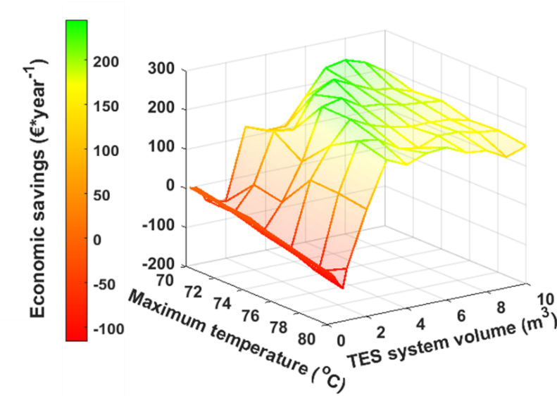
Fig. 6: 3D plot of influence of maximum temperature and TES system volume on economic savings
  - Simple payback period study: effect of electricity injection compensation price
Injecting excess PV electricity and receiving compensation effectively uses the grid as a storage resource with zero investment cost and a virtual efficiency equal to the ratio of the compensation price to the electricity purchase price, which varies hourly, daily and monthly. Consequently, the compensation price strongly influences TES system economics. Assessing how changes in compensation levels affect total TES system payback time is therefore important for system design and selection.
A simplified payback period analysis was performed by dividing TES system cost minus the baseline case (0.2 m³) cost by first-year economic savings for the best case at all volumes. This comparison with the baseline case using the smallest studied volume (0.2m³) is useful to compare different TES systems based on both their economic savings as well as initial investment. Fig. 7 shows payback period as a function of TES system volume using the best-case temperature for each case. Five different injection compensation price scenarios were calculated: from 100% (Spain 2023 as a baseline) down to 0%.
The simple payback period study showcases that using regular 2023 compensation prices, they payback period of the TES is higher than its lifetime (around 20 years for a typical TES system). In scenarios of reduced compensation prices, volumes of 2-5m³ present payback periods equal or lower to the TES system lifetime.
In addition, results show a non-linear relationship between compensation price and payback period. The initial reduction in compensation has the greatest impact, while further reductions produce smaller changes, indicating an asymptotic trend. A reduction of 25% causes volumes of 3m³ to have payback periods of lower than the 20 years of estimated lifetime of a TES system. This highlights the sensitivity of TES system economic viability to compensation schemes and its potential under future scenarios with increased PV penetration in the grid.
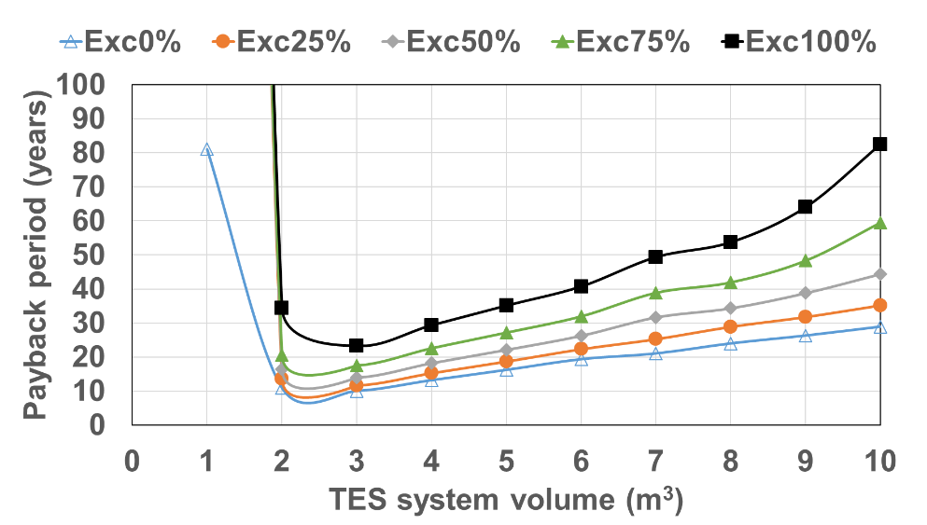
Fig. 7: Payback periods for different TES system volumes at the best-case maximum temperature
- Conclusions
This study researched the dynamic behavior of PV+HP+TES systems, using a DesignBuilder/EnergyPlus model of a residential building in Pamplona, Spain. The focus was the seldom studied influence of TES system temperature across different storage sizes in a parametric study of a DHW system as well as the effect of the compensation price for injecting excess PV onto the grid.
Results indicate that peak self-sustainability and economic results occur for specific combinations of TES system volume and operating temperature rather than for a single storage capacity. This highlights the importance of studying both variables and their influence in the design phase. In the series configuration studied, modest undersizing can sharply reduce savings as the TES depletes before the end of the day and recharges during high-price morning hours. This while also increasing operating temperatures and reducing the COP of the system result in oversizing being an important risk in series configurated PV + HP + TES systems.
As for oversizing, grid electricity import reductions are insensitive to moderate oversizing, reaching a plateau beyond certain temperature–size combinations of the TES system. Economic savings however are penalized by oversizing because higher TES system temperatures reduce heat pump COP, which in turn lowers injected PV onto the grid and the associated compensation. Because the grid electricity import reduction metric does not account for exported PV, reductions in exported energy do not change the reported energetic savings.
The study also examined how PV injection compensation affects TES system payback period. The relationship is significant and non-linear: small changes in compensation can strongly influence payback time, while further reductions have less effect. These findings highlight the need for case-by-case analyses under different grids, pricing schemes, and future renewable scenarios to evaluate the economic performance of TES systems.
- References
Agyenim, F., Hewitt, N., 2010. The development of a finned phase change material (PCM) storage system to take advantage of off-peak electricity tariff for improvement in cost of heat pump operation. Energy Build. 42, 1552–1560. https://doi.org/10.1016/j.enbuild.2010.03.027
Análisis | ESIOS electricidad · datos · transparencia [WWW Document], n.d. URL https://www.esios.ree.es/es/analisis/1001?vis=1&start_date=24-01-2025T00%3A00&end_date=24-01-2025T23%3A55&compare_start_date=23-01-2025T00%3A00&groupby=hour# (accessed 1.24.25).
Fischer, D., Toral, T.R., Lindberg, K.B., Wille-Haussmann, B., Madani, H., 2014. Investigation of Thermal Storage Operation Strategies with Heat Pumps in German Multi Family Houses. Energy Procedia 58, 137–144. https://doi.org/10.1016/J.EGYPRO.2014.10.420
Generador de Precios CYPE [WWW Document], n.d. URL http://generadordeprecios.info/obra_nueva/Instalaciones/IC_Calefaccion__climatizacion_y_A/Sistemas_de_conduccion_de_agua/Acumulador_para_A.C.S_0_0_33_0_0_0_0_0_0_0_0.html#gsc.tab=0 (accessed 1.23.25).
In focus: Energy efficiency in buildings | Comisión Europea, n.d.
Latchiba, W.E., Waita, S., Krueger, R., Mwabora, J.M., 2026. Assessment of the life cycle of photovoltaic solar technologies for sustainable energy transitions: Implications for climate policy and low-carbon system integration. Resources, Environment and Sustainability 25, 100328. https://doi.org/10.1016/J.RESENV.2026.100328
Li, Y., Rosengarten, G., Stanley, C., Mojiri, A., 2022. Electrification of residential heating, cooling and hot water: Load smoothing using onsite photovoltaics, heat pump and thermal batteries. J. Energy Storage 56, 105873. https://doi.org/10.1016/J.EST.2022.105873
Osterman, E., Stritih, U., 2021. Review on compression heat pump systems with thermal energy storage for heating and cooling of buildings. J. Energy Storage 39, 102569. https://doi.org/10.1016/J.EST.2021.102569
Sborz, J., Cominato, C., Kalbusch, A., Henning, E., 2022. Hourly and daily domestic hot water consumption in social housing dwellings: An analysis in apartment buildings in Southern Brazil. Solar Energy 232, 459–470. https://doi.org/10.1016/J.SOLENER.2021.12.067
Schito, E., Conti, P., Testi, D., Montagud-Montalvá, C., Vivancos, J.-L., 2026. Economic and environmental assessment of hybrid heat pumps: a cross-country analysis. Energy Build. 353, 116857. https://doi.org/10.1016/J.ENBUILD.2025.116857
Wang, L., Hui, C., 2026. Enhancing cost efficiency and energy performance in residential buildings with thermal energy storage and predictive control. Appl. Therm. Eng. 300, 131373. https://doi.org/10.1016/J.APPLTHERMALENG.2026.131373

