Study on mechanical and thermo-physical properties of CARBON BONDED CARBON FIBER COMPOSITES

Zhang Yao¹, Lu Zixing¹ and Yang Zhenyu¹

¹ Institute of Solid Mechanics, Beihang University, Beijing, 100083, China
Email: luzixing@buaa.edu.cn

Keywords: Carbon bonded carbon fiber composites, Random fiber network, Compressive mechianical properties, Thermo-physical properties, Finite element analysis,

Abstract
The thermal protective materials of the spacecraft were facing the challenge of increasing flight speed and the severe flight enveriments. Therefore, it is a challenge to balance the requirements between the excellent thermal insulation properties and good mechanical properties. Carbon bonded carbon fiber composites (CBCFs) have been widely used in aerospace engineering structures such as thermal tile due to their ultra-low density and perfect thermal insulation. In our previous work, we established a 3D fiber network model and simulated the compressive behavior of CBCFs, which is verified by the experiemental results of the unxial compression of CBCFs. In this paper, we focus on the compressive mechanical properties and the thermal conductivity of CBCFs at high temperature based on the 3D fiber network model. Due to the oxidation ablation, the elastic modulus degradation and the reduction in cross-sectional area of carbon fiber with the increasing temperature are considered. The effect of fiber length and fiber orientation on the compressive properties and thermal conductivity is also discussed. The results shows that the elastic modulus of CBCFs changes little due to the unchanged properties of carbon fiber below 823 K, while the elastic modulus of CBCFs obviously decreases with the increasing temperature at the moderate temperature. The compression strength of CBCFs reduced with the temperature rising, due to the limitation of the fiber strength and cross-sectional area. The proper increase of fiber length is beneficial to improve the mechanical properties, especially the in-plane direction of CBCFs, and the appropriate orientation angle α improve the out-of-plane properties of CBCFs. However, with the increase of the orientation angle α, the insulating capacity of CBCFs in out-of-plane direction is reduced. The microstructure parameters such as fiber orientation angle and fiber length are optimized according to the simulation results. This work provides a theoretical reference for the improvement and optimization of material preparation.

1. Introduction

CBCFs consist of the chopped carbon fibers and pyrolytic carbon derived from phenolic resin. During the preparation, the random carbon fibers pile up and bond with the pyrolytic carbon, which causes CBCFs as a typical fiber network materials[1; 2]. Moreover, carbon fiber exhibits degradation of mechanical properties at high temperature in air due to the oxidation reaction. For example, Feih[3] reported that the fiber modulus decreased with the temperature increasing in air, which limits their applications in high temperature environments with oxygen.
In order to improve mechanical properties of CBCFs, scholars have carried out a series of researches. The experimental research focuses increasing the performance of the materials by changing the processing technology[4; 5]. During the preparation process, high-temperature resistance elements such as Si and Zr[6; 7] were introduced to increase the high-temperature resistance of the CBCFs. Recently, some scholars adopted chemical vapor deposition methods for low-dimensional nanomaterials such as nanowires[8] to improve the mechanical properties of CBCFs. Nanowires are introduced into the surface of carbon fibers to enhance interfacial strength, and also to consume oxygen in order to avoid contact of oxygen with carbon fibers. As we know, the mechanical and thermo-physical properties both highly depend on the internal structure of porous materials. Therefore, it is necessary to understand the relationship between the properties and the structure of CBCFs.
For the theoretical study of porous materials, early Gibson and Ashby[9] established the cubic staggered model, analyzed the mechanical properties of foam and found a power exponential relationship between mechanical properties and the relative density of foam. However, this model is difficult to reflect detail structure of CBCFs. Picu et al.[10] analyzed the critical threshold of the feature length for the transformation of the tension/bending deformation mechanism in the fiber network based on the affine deformation assumption. At present, the research on thermo-physical properties of CBCFs is rarely reported. However, thermo-physical properties are an important indicator of composite materials. It is necessary to understand the thermo-physical properties of CBCFs for the application in thermal environments. Donaldson[11] established a simplified fiber network heat transfer model and analyzed the thermal conductivity of the material based on the internal microstructure. However, Donaldson’s simplified model used to calculate the heat transfer analysis are different from the real parameters, such as the internal parameters of fiber orientation distribution. For the affine deformation, it is confirmed that the internal deformation of the material is non-affine[12]. Therefore, the analysis of fiber network based on the theoretical model still has some limitations.
In this paper, we simulated the mechanical properties and thermal conduction of CBCFs at high temperture by the FE method. The influence of the structure parameters such as the fiber length and fiber orientation angle on the mechanical properties and thermo-physical properties are discussed.

2. Model and Method

2.1 3D fiber network model

In our previous work, a 3D random fiber network model was established based on the SEM of CBCFs. In order to characterize the fiber-bonded-fiber structure, we generate the random fibers in the domain based on the porosity of real CBCFs materials. Then, we propose the algorithm to check the location between any two fibers and delete the overlapped fibers. Next, we link the fibers with the bonding materials in which the least distance of any two fibers satisfied the bonding conditions. Then, we apply periodic boundary conditions and check the connectivity of the fiber network in order to delete the isolated fiber networks in the model. Finally, we established a 3D random fiber network which can reflect the internal structure of CBCFs as shown in Fig.1.

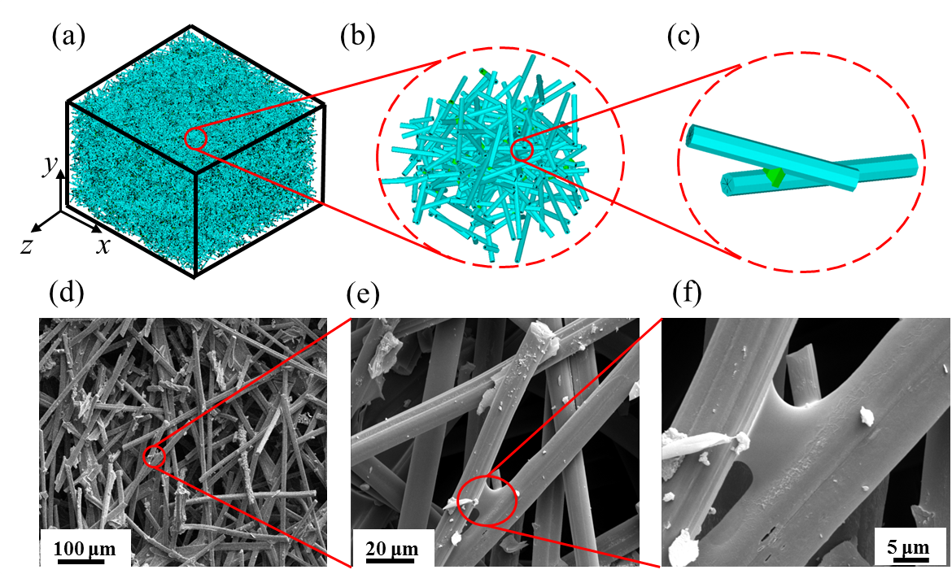
Figure 1. Geometrical model with random bonded networks (a) 3D model domain, (b) enlarged view of (a), (c) bonding materials between fiber and fiber.

As we know, the influence of oxidation ablation on the CBCFs can lead to the changes of internal morphology and the degradation of mechanical properties. Based on the experimental testing, Feih^{[3]} observed the SEM of carbon fibers following heat-treatment in air and found that the correlation between mass loss and diameter loss of carbon fiber is occurred due to surface oxidation. Due to skin-core heterogeneity of carbon fiber, the relationship between the fiber diameter and the mechanical properties was also tested by Feih. In our simulation, we also hypothesize that oxidation ablation only changes the cross-sectional dimensions of the carbon fibers and other geometric paraments of fiber unchange at high temperature. We established numerical models with different fiber diameters and the different mechanical properties at the corresponding temperature based on Feih’s experimental results listed in Table 1 (also shown in Fig. 2(c)).

Tabel 1. Fiber diameter (D), Elastic modulus(E), Strength(σ_{s}) and Thermal expansion(α_{L}) .vs. Temperture(T) when heated in air for 30 min^{[3]}.
T | D /μm | E /GPa | σ_{s} /GPa | α_{L}
773 K | 6.51 | 177.33 | 2.86 | 0.049
823 K | 6.69 | 191.48 | 3.00 | 0.036
873 K | 6.71 | 195.28 | 3.57 | 0.028
923 K | 6.72 | 197.47 | 4.44 | 0.024

2.2 Numercial simulation

In our work, carbon fibers are simulated as Timoshenko beam theory. Bonding materials are also treated as short beam for the purpose of matching the degree of freedoms. After a detailed analysis of the microstructure of the material, the represented volume element (RVE) of CBCFs is obtained with dimensions of 1.5 L×1.0 L×1.5 L (L is the single fiber length) and 6 meshes assigned to each fiber segment. The constituent materials are brittle both for carbon fiber and bonding materials, and the onset and propagation of damage could be revealed by the failure criterions of maximum principal stress rule:
where σ₁ is the maximum principal stress; E(T), G(T), and σ_{s}(T) are the elastic modulus, shear modulus, and fracture strength, respectively; T is the temperature. For each cell section, the onset and propagation of damage are implemented with stiffness reduction method.
Based on the above geometric model, periodic temperature boundary conditions are used to ensure that there is a clear heat exchange relationship between the RVE and other adjacent RVE, and the input and output heat balance[13]. According to the determined boundary conditions, the thermal conductivity of the anisotropic solids is used.
where, K_{i} is the corresponding thermal conductivity, q_{i} is the average heat flux in the i-direction heat flow output surface, and i is the temperature gradient.

3. Results

3.1 mechanical properties of CBCFs at high temperature

Fig. 2(b) and (c) represent the relationship between elastic modulus as well as compression strength of CBCFs and temperature. First, the mechanical properties of CBCFs are anisotropic and mechanical properties in in-plane direction are better than that of the out-of-plane direction. Second, elastic modulus of CBCFs decreases a little bit with temperature increment due to the unchanged elastic modulus and the cross-sectional area of fiber segment before 823 K, while elastic modulus of CBCFs decreased above 823 K. Third, compression strength of CBCFs obviously reduces with temperature increment, which causes by the significant limitation of fiber strength. Compared with elastic modulus and compression strength in two directions, the temperature increment has a great influence on the mechanical properties of CBCFs, especially for in-plane properties. Considering the internal microstructure, fibers mainly are distributed along the in-plane direction and demonstrate bending deformation. While, bending stiffness degraded due to the decrease of cross-sectional area with increasing temperature.
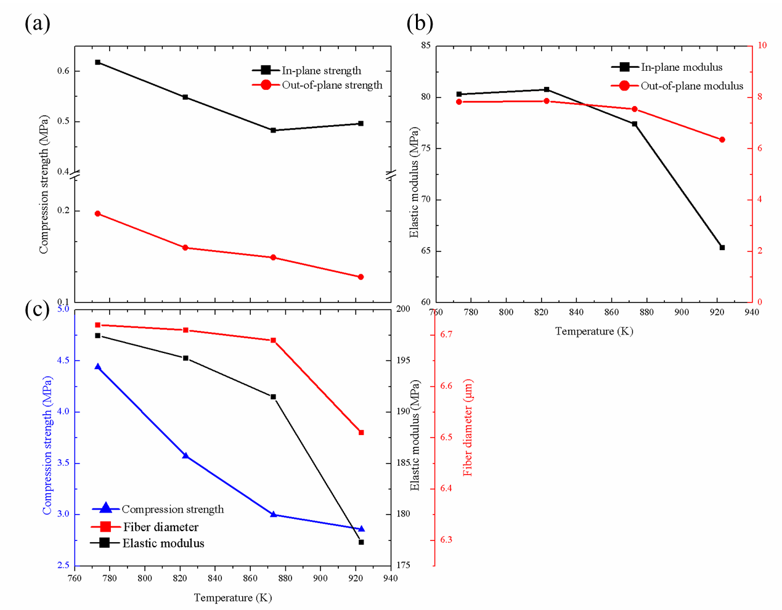
Figure 2. (a) Compressive strength and (b) Elastic modulus of CBCFs vs. temperature,(c) fiber diameter, elastic modulus and compression strength of single carbon fiber vs. temperature.

3.2 Thermo-physical properties of CBCFs at high temperature

In Table.2, the thermal conductivity coefficient measured by numerical simulation is smaller than those calculated theoretically in Donaldson’s work^{[11]}. The main reason for the difference: in the theoretical model, the fibers are arranged along an unidirectional direction in the plane, but in the actual material, the in-plane fiber orientation is randomly distributed (as seen in Fig. 3). Since the model only considers solid-phase heat transfer at 1000°C, the solid-phase thermal conductivity accounts for 79% in the overall thermal conductivity of CBCFs^{[11]}. Therefore, the ratio is converted to consider gas phase and heat radiation. At this point, the overall thermal conductivity of the material is 0.405 W/(m•K), which is between 0.398 W/(m•K) and 0.44 W/(m•K). Therefore, our numercial model established in this paper characterizes the internal mesostructure of the material, not only can simulate the mechanical properties of CBCFs, but also can simulate the thermo-physical properties such as thermal conductivity coefficient.

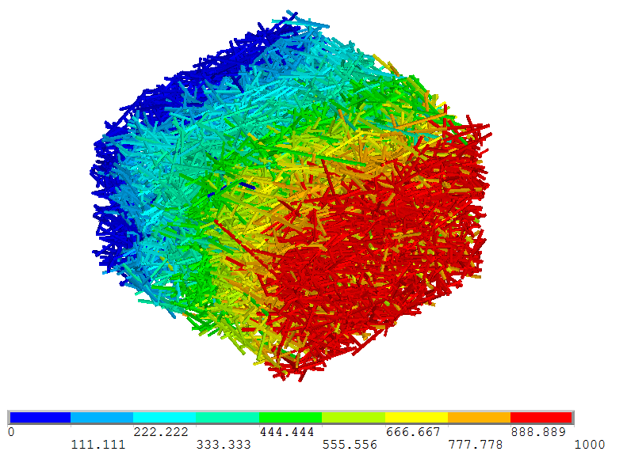
Figure 3. Temperature distribution in CBCFs.

Table 2. Varification of thermal conductivity of CBCFs along the in-plane direction
Temp. (K) | Solid conduction  (W/(m·K)) | Theoretical thermal conduction (W/(m·K)) | Experimental thermal conduction (W/(m·K))
298[14] | / | / | 0.398
1273^{[11]} | 0.38 | 0.49 | 0.44
1273 | 0.32 | / | 0.405

4. Discussion

In this section, we disscuse fiber length and fiber orientation α in order to investigate the influence of these two geometric parameters on the mechanical properties and thermo-physical properties.The results show that proper increase of fiber length is beneficial to improve the mechanical properties, especially the in-plane direction of CBCFs (Fig. 4(a) and (b)), and the appropriate orientation angle α improve the out-of-plane properties of CBCFs (Fig. 4(c) and (d)). However, with the increase of the orientation angle α, the insulating capacity of CBCFs in out-of-plane direction is reduced (seen in Fig. 4(e)). The microstructure parameters such as fiber orientation angle and fiber length are optimized according to the simulation results.
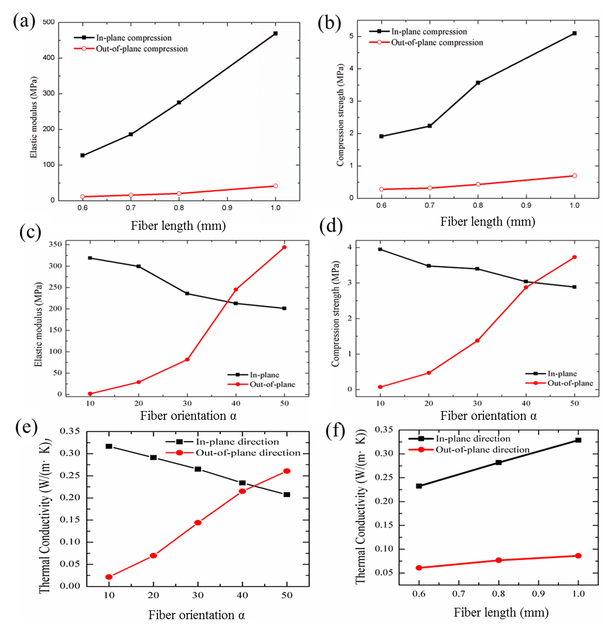
Figure 4. (a) Elastic modulus and (b) Compressive strength of carbon bonded carbon fiber composites vs. fiber length, (c) Elastic modulus and (d) Compressive strength of carbon bonded carbon fiber composites vs. fiber orientation, thermal conductivity of carbon bonded carbon fiber composites vs. (e) fiber angle and (f) fiber length.

5. Conclusions

In this paper, FEM simualtions are carried out on the mechanical property and thermo-physical property of CBCFs at high temperature, based on the 3D random fiber network model. Thermal conductivity of CBCFs is verified with previous experiments, which also proves that this numerical model is acceptable to charactize the internal structure of CBCFs. The results show that the best choice of fiber orientation α is 10°~ 20°, which is helpful to improve the mechanical property and the thermal conductivity. This work provides a method for the improvement and optimization of materials based on fiber networks.

Acknowledgments

The authors thank the support from the National Natural Science Foundation of China (Nos. 11672013, 11672014 and 11472025) and Defense Industrial Technology Development Program (No. JCKY2016601B001 and JCKY2016205C001) and the Fundamental Research Funds for the Central Universities.

References

[1] I.J. Davies, and R.D. Rawlings, Microstructural investigation of low-density carbon-carbon composites. Journal of Materials Science, 29:338-344, 1994.
[2] I.J. Davies, and R.D. Rawlings, Mechanical Properties in Compression of CVI-Densified Porous Carbon/Carbon Composite. Composites Science and Technology, 59:97-104, 1999.
[3] S. Feih, and A.P. Mouritz, Tensile properties of carbon fibres and carbon fibre–polymer composites in fire. Composites Part A: Applied Science and Manufacturing, 43:765-772, 2012.
[4] A.S. Ahmed, R.D. Rawlings, S.D. Ellacott, and A.R. Boccaccini, Oxidation and thermal degradation resistance of silicon carbide coated low density carbon–carbon composite. Advances in Applied Ceramics, 112: 23-32, 2013.
[5] T. Moskalewicz, F. Smeacetto, M. Salvo, A.R. Boccaccini, and A. Czyrskafilemonowicz, Microstructure characterization of erosion resistant coatings on carbon-bonded carbon fibre composites. Journal of Microscopy, 237:288-291, 2010.
[6] K.Z. Li, X. Jing, Q.G. Fu, H.J. Li, and L.J. Guo, Effects of porous C/C density on the densification behavior and ablation property of C/C–ZrC–SiC composites. Carbon, 57:161-168, 2013.
[7] M. Niu, H. Wang, L. Su, X. Fan, D. Zhang, and J. Shi, SiC / (SiC+Glass) / Glass Coating for Carbon-bonded Carbon Fiber Composites. Rsc Advances, 6: 61228-61234, 2016.
[8] X.F. Lu, and P. Xiao, Preparation of in situ grown silicon carbide nanofibers radially onto carbon fibers and their effects on the microstructure and flexural properties of carbon/carbon composites. Carbon, 59:176-183 ,2013.
[9] L.J.A.A. Gibson, and M.F. Ashby, Cellular Solids: Structure And Properties. Cambridge University Press, 1997.
[10] A. Shahsavari, and R.C. Picu, Model selection for athermal cross-linked fiber networks. Physical Review E, 86:011923, 2012.
[11] R.I. Baxter, R.D. Rawlings, N. Iwashita, and Y. Sawada, Effect of chemical vapor infiltration on erosion and thermal properties of porous carbon/carbon composite thermal insulation. Carbon, 38:441-449, 2000.
[12] F. Leonforte, A. Tanguy, J.P. Wittmer, and J.L. Barrat, Continuum limit of amorphous elastic bodies II: Linear response to a point source force. Physical Review B-Condensed Matter, 70:2199-2208, 2003.
[13] B. Xia, Finite Element Analysis on Thermo-physical Properties of 3D Braided Composites. Acta Aeronautica ET Astronautica Sinica, 32:1040-1049, 2011.
[14] C. Liu, J. Han, X. Zhang, C. Hong, and S. Du, Lightweight carbon-bonded carbon fiber composites prepared by pressure filtration technique. Carbon, 59:551-554, 2013.

