EuroSun2026
PERFORMANCE OF OPEN TYPE SOLAR THERMAL LIQUID DESICCANT REGENERATOR UNDER DIFFERENT OPERATING CONDITIONS
Gezahegn Habtamu Tafesse^{*1} (corresponding author)
¹Department of Mechanical Engineering, Indian Institute of Technology Delhi, New Delhi, 110016, India
gezisha@yahoo.com
Summary
A strong liquid desiccant is effective for dehumidifying outdoor air in an air dehumidifier unit of an open type sorption air conditioning technology and can be made strong again or regenerated by evaporating the water absorbed from the outdoor air using solar thermal energy in its solar regenerator unit. In this air condition technology, the exact same amount of mass of water absorbed by the desiccant solution in the dehumidifier must be rejected back to the ambient air through boiling for cyclic operation. This is challenging since solar energy and climate condition fluctuates throughout the day and several environmental and operational parameters also effective in making the desiccant strong again. This paper presents effects of operational and environmental conditions like solar regenerator absorber size; glazing gap and presence or absence of glazing; initial desiccant concentration; humidity and temperature of ambient on regeneration of solutions of lithium and calcium chlorides using a standalone solar thermal regenerator based on experimentally gathered data.

Keyword: Liquid desiccant regenerator, Calcium chloride, Lithium chloride, Solar thermal water evaporation, Solar energy, Sorption air-conditioning technology.
Field of application for the findings: Solar air conditioning and refrigeration
Addressed audience: Conference
1. Introduction
Solar-thermal energy presents a highly promising pathway for powering liquid desiccant air conditioning (LDAC) systems, which excel in hot and humid climates. LDAC systems utilize aqueous desiccant solutions to remove moisture from outdoor ambient air, depending entirely on the chemical affinity of the solution to absorb and desorb moisture. Liquid desiccant are water and solutions of common desiccants such as calcium chloride (CaCl2), lithium chloride (LiCl), and lithium bromide (LiBr). A critical operational parameter is the inlet mass concentration of the desiccant solution at the dehumidifier; higher concentrations increase air-drying capacity. However, there r is typical operating ranges for each desiccant. The effective operating concentration range was reported to 45-60% for LiBr, 30-45% for LiCl and 35-45% for CaCl₂ (Jain & Bansal, 2007). Maintaining these levels requires a regeneration process to remove absorbed water via boiling or evaporation using thermal energy. Dehumidifiers and solar regenerators act as reverse-potential mass transfer devices driven by vapor pressure gradients, which are controlled by solution concentration, temperature, and air humidity. While dehumidifiers require cold, concentrated solutions to absorb vapor, regenerators require heat to drive moisture out. Solar energy collection and regeneration of liquid desiccant can be achieved indirect or direct. The former uses a two-stage process where hot water generated in flat plate or evacuated tube collector warm the desiccant and regenerator it in a separate desorption tower. The later desorb water from the solution directly on the solar collector surface, eliminating the need for separate towers and blowers, making it a simpler, single-stage process (Mullick & Gupta, 1974; Collier, 1979). Further, in indirect regeneration the exiting solution temperature stays close to ambient, reducing the cooling load required before the desiccant re-enters the dehumidifier. Researchers have extensively evaluated direct open-type regenerators theoretically and experimentally. Theoretical performance under different climatic conditions has been assessed using analytical relations, modular codes, numerical simulations, and artificial neural networks( Collier,1979; Haim et al.,1992; Johannsen & Grossman, 1983; Aly 2011). These models rely on solving models obtained by combining the conservation of mass, vapor species, and energy to calculate water evaporation rates. Considerable experimentally, studies have evaluated unglazed, single-glazed and double-glazed solar regenerators (Hawlader et al., 1993; Alizadeh & Saman, 2002; Yang & Wang 1998). Experimental regeneration was often researched using two tanks at inlet and exist from the regenerator and .performance was commonly calculated using solution mass balance or inlet-to-outlet concentration differences, and moisture mass balance in ventilation air under forced convection (Kabbel, 2005; Elsarrag, 2008). A two tank method is used primarily to collect the and cool the strong desiccant before supplying it to the air dehumidifier. However, the residence time of solution over the absorber is very brief and it is difficult to regain back the targeted inlet concentration of the desiccant demanded at the inlet of air dehumidifier. A one tank standalone regeneration of desiccant solution in preferable since the estimation of evaporation is simple and the regeneration processes can be decoupled from the air dehumidifier. Moreover, regeneration performance depends heavily on system design like solar collector area or size & presence or absence of glazing; solution properties like quantity, desiccant type, concentration, & temperature, and climatic conditions such as solar irradiance and ambient air humidity ratio. To address these gaps, this work investigates the experimental regeneration performance of a standalone, open-type solar regenerator under natural convection. Following the procedure outlined by, the study applies the conservation of desiccant mass to a known, fixed quantity of lithium chloride and calcium chloride brines stored in a solution tank at the start of testing. The study evaluates performance under the specific weather conditions of Delhi to identify how key operational and environmental factors impact regeneration.
2. Experimental setup
The solar regenerators (SR), either glazed or unglazed, are comprises as main parts, a solution storage tank of 57 x 57 x 33 cm³ capacity, a 10 lpm capacity centrifugal pump, and a solar absorber with a solution distributor and a PVC gutter placed at its upstream and downstream ends, respectively( Fig. 11a &b). The two solar absorber were fabricated using 18 gauge corrugated galvanized sheet which was painted first iron oxide to protect it from corrosion and then painted black. It was framed by glass cover on top and placed in a wooden box packed with a12 cm thick thermocol insulation. The glass cover is detachable and can be adjusted to any gap starting from 8.5 cm. The absorber subassembly was placed on an angle iron support inclined at 14º. The aperture (& absorber) length and width of solar SR-A (Fig.1a) and SR-B (Fig. 1 b) were 2.6 m x 2 m (2.2 m x 1.84 m) and 0.9 m x 2 m (0.8 m x 1.84 m), respectively. Rectangular ventilation air openings were cut out of the wood frame between the glass and absorber at upstream and downstream facilitates escape of evaporating water. The solution distributor, made of two concentric pipes, has a length of 1.76 m and holes of 2.5 mm in diameter at every 20 mm gap. The gutter collects and redirects the hot solution back to the tank.
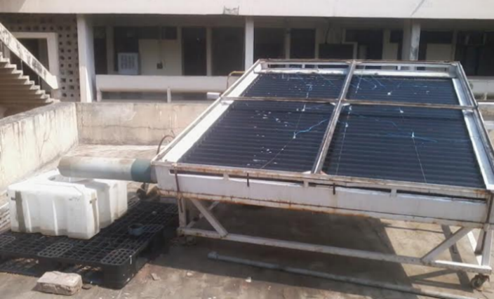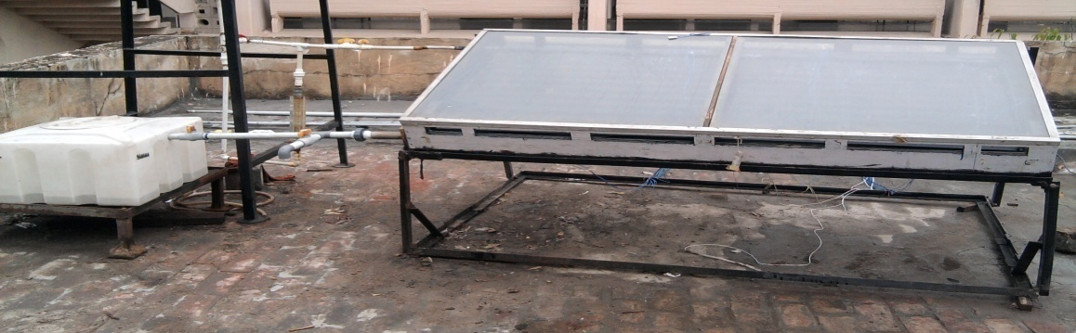
Fig. 1: Experimental solar thermal brine regenerators a) SR-A b) SR-B

3. Data collection and analysis
To evaluate the diurnal performance of open-air solar regenerators, a fixed quantity of desiccant brine was stored in a tank and initial volume, temperature, and density were measured to calculate the initial desiccant mass before starting the experiment. Because solar exposure heats the absorber plate early in the morning, the brine was first circulated until the tank and absorber reached thermal equilibrium. After this point, initial data were re-recorded afresh. Then from 9:00 a.m. to 4:00 p.m., the brine was continuously pumped over the absorber and returned to the tank. This continuous mixing eliminated temperature and concentration gradients, ensuring stable hourly measurements. A solution tank was used to store liquid desiccant and as control volume to record the change in thermodynamic state of the brine at every half an hour interval. The temperature of plate and glass surfaces were measured using T-type thermocouple wires fixed on the absorber (6 thermocouple wires for SR-B and 18 thermocouple wires for SR-A) and glass surface (two thermocouple wires for each SR), respectively. The ambient air DBT, WBT and solution temperature in the tank were measured using RTDs. Solution density and temperature were recorded manually every 30 minutes using a digital densitometer and a bulb thermometer. Simultaneously, an Agilent data logger recorded solar irradiance, air properties (DBT, WBT), and surface temperatures of glass and absorber every 10 seconds. Specific instruments included a Kipp & Zone Pyranometer for irradiance, T-type thermocouples for plate and glass temperatures, and RTDs for air and tank temperatures. Initial solution height and physical dimensions were measured using a scale and tape rule. Temperature Sensors and densitometer were calibrated using ice, boiling water, and distilled water, respectively. Finally, measurements were averaged over thirty minute and the performance parameters uncertainties were calculated using the general uncertainty principle (Dunn, 2005).
${U^{2}}_{R}=\sum_{i}^{n}{{\left(\frac{∂R}{∂x,i}U_{x,i}\right)}^{2}}$ (1)
Uncertainty of the densitometer, thermocouple wires/RTD and Pyranometer were 1/1000 g/cm³, ½ ºC and 0.03% of the reading of Pyranometer, respectively. The tape rule/scale's degree of uncertainty was 1mm. According to the scale measurement, there was 0.625 litre of estimated solution volume uncertainty. The peak values of uncertainty in an hour interval was determined to be 0.0014 kg/kg for calculating concentration increase, 0.05 kg for water evaporated, and 0.02 for solar regenerator efficiency.
The diurnal desiccant concentration rise in the solution between any time intervals was estimated using the measured solution temperature and density in the tank. In the concentration range of$0≤ξ≤0.56$ and$0≤ξ≤0.6$, respectively, the correlations of solution density for lithium chloride and calcium chlorides, respectively are given by Conde, (2004):

$ρ_{sol\left(ξ,T_{sol}\right)}=ρ_{H_{2}O\left(T_{sol}\right)} \left\{0.100791{\left(\frac{ξ}{1-ξ}\right)}^{3}-0.303792{\left(\frac{ξ}{1-ξ}\right)}^{2}+0.540966\left(\frac{ξ}{1-ξ}\right)+1\right\}$ (2)
$ρ_{sol\left(ξ,T_{sol}\right)}=ρ_{H_{2}O\left(T_{sol}\right)} \left\{ 0.105642{\left(\frac{ξ}{1-ξ}\right)}^{3}-0.4363{\left(\frac{ξ}{1-ξ}\right)}^{2}+0.836014\left(\frac{ξ}{1-ξ}\right)+1\right\}$ (3)
The density of water at solution temperature was obtained from (Conde, 2004) :
$ρ_{H_{2}O}\left(T_{sol}\right)=0.322\left(1+1.9937718430τ^{\frac{1}{3}}+1.0985211604τ^{\frac{2}{3}}-0.5094492996τ^{\frac{5}{3}}-1.761912427τ^{\frac{16}{3}}- 44.9005480267τ^{\frac{43}{3}}-723692.2618632τ^{\frac{110}{3}}\right)$ (4)
$τ=1- θ$ (5)
$θ=1-\frac{T_{sol}+273.15}{647}$ (6)
The concentration was estimated after solving the nonlinear density function using Newton-Rapson numerical iteration scheme every thirty minutes. Eevaporation rate was estimated using concentration change of desiccant attained in a known time interval and the initial mass of desiccant in the brine (Gezahegn et al., 2014).
$m_{v,Δt}=m_{d}\left[\frac{1}{ξ_{t_{o}+\left(n-1\right)*∆t}}-\frac{1}{ξ_{t_{o}+n*Δt}}\right],where n=1,2,…$ (7)
The mass flux of vapor from the surface of solution spread over the collector was calculated by

$m^{''}= \frac{m_{v,Δt}}{A_{ab}}$ (8)
The solar regenerator efficiency accounts for the combined efficiency of collection of sunlight and utilizing some fraction of it for regeneration. It is given by,
$η_{CR}={m_{v,Δt}h_{fg} }/{{I A}_{ab}∆t}$ (9)

The heat of vaporization of water from LiCl - or CaCl2 solutions is given by Conde ( 2004).
$h_{fg}=h_{fg,water}+{Δh}_{d}=2551+{Δh}_{d}$ (10)
At ambient conditions, the approximate latent heat of pure water was taken as 2551 kJ/kg. The differential heat of dilution of lithium chloride and calcium chloride brines respectively, are given by Conde (2004).
${Δh}_{d}=\left(169.105+457.85θ\right){\left[1+{\left(\frac{ξ}{0.845\left(0.6-ξ\right)}\right)}^{-1.965}\right]}^{-2.265}$ (11)
${Δh}_{d}=\left(-955.69+3011.974θ\right){\left[1+{\left(\frac{ξ}{0.855\left(0.8-ξ\right)}\right)}^{-1.965}\right]}^{-2.265}$ (12) The humidity ratios of water vapor on solution surface and in air were estimated using Eq. (13) and Eq. (14), respectively.
$W_{v,sol}=0.621945 {P_{v,sol}}/{{(P}_{∞}-}P_{v,sol})$ (13)
${ W}_{v,air}=0.621945 {P_{v,air}}/{{(P}_{∞}-}P_{v,air})$ (14)
The saturated water vapor pressure above on surfaces of calcium chloride brine (Eq. 15) and lithium chloride brine (Eq. 16), respectively were estimated from (Conde, 2004):
$$P_{v,sol}=P_{v, pw}\left(T_{sol}\right)\left\{1-{\left[1+{\left(\frac{ξ}{0.478}\right)}^{-5.2}\right]}^{-0.4}-0.018\exp^{-\frac{{\left(ξ-0.1\right)}^{2}}{0.005}}\right\}*$$
$\left\{\left(2-{\left[1+{\left(\frac{ξ}{0.31}\right)}^{3.698}\right]}^{0.6}\right)+\left({\left[1+{\left(\frac{ξ}{0.231}\right)}^{4.584}\right]}^{0.49}-1\right)θ\right\}$ (15)
$P_{v,sol}=P_{v, pw}\left(T_{sol}\right)\left\{1-{\left[1+{\left(\frac{ξ}{0.362}\right)}^{-4.75}\right]}^{-0.4}-0.03\exp^{-\frac{{\left(ξ-0.1\right)}^{2}}{0.005}}\right\}*$
$\left\{\left(2-{\left[1+{\left(\frac{ξ}{0.28}\right)}^{4.3}\right]}^{0.6}\right)+\left({\left[1+{\left(\frac{ξ}{0.21}\right)}^{5.1}\right]}^{0.49}-1\right)θ\right\}$ (16)
$P_{v, pw}\left(T_{sol}\right)=22210exp\left(\frac{-7.85823τ+1.839991τ^{1.5}-11.7811τ^{3}+22.6705τ^{3.5}-15.9393τ^{4}+1.77516τ^{7.5}}{1-τ}\right)$ (17)

From knowledge of the free stream humidity ratio and pressure of air, partial pressure of water vapor in air may be calculated by Eq.(18) and , humidity ratio from the measured values of DBT and WBT of air by Eq.(19) ASHRAE (,2009):
$P_{v,air}=\frac{P_{∞}*W}{0.621945+W}$ (18)

$W=\frac{\left(2501-2.326t^{*}\right){W^{*}}_{s}-1.006\left(t-t^{*}\right)}{2501+1.86t-4.186t^{*}}$ (19)
Where the humidity ratio of air and the saturation pressure of water in air at WBT for air temperature between 0 to 200oC, respectively are given by ASHRAE (2009):
${W^{*}}_{s}=0.621945\frac{{P^{*}}_{v,air}}{P_{∞}-{P^{*}}_{v,air}}$ (20)

${P^{*}}_{v,air}=exp⁡\left(\begin{aligned}-\frac{5800.2206}{t^{*}}+1.3914993-0.048640239t^{*}-0.000041764768{t^{*}}^{2} \\ -0.000000014452093{t^{*}}^{3}+6.5459673ln\left({ t}^{*}\right)\end{aligned}\right)$ (21)
The gradient of vapor pressure between vapor in air and vapor on solution surface is the major resistance to vapor mass transfer from brine to air. In comparing the evaporation, the evaporation flux was normalized by the differential vapor pressure ($P_{d}$) and the irradiance (I) received by the solar thermal regenerator as:
$m_{nor}={(m_{v,Δt})}/{(A_{ab}{I P}_{d})}={m^{''}}/{{I P}_{d}}$ (22)
The differential vapor pressure between vapor on solution surface and vapor in air was calculated by:
$P_{d}=P_{v,sol}-P_{v,air}$ (23)

4. Results and discussion
Diurnal performance of the two SR were calculated in terms of hourly concentration increase, evaporated mass and solar regenerator efficiency under different regenerating conditions for chlorides of calcium and lithium solutions. No corrosion of the absorber plate was observed during the entire experimentation period. Diurnal performance of a solar regenerator is affected by environmental and operational conditions. In this study, variables such as irradiance, temperature & humidity ratio of ambient air, glazing gap, presence or absence of glazing, SR size or area, initial concentration of desiccant at inlet to the solar regenerator and inlet temperature of solution are selected for identifying their effect on the regenerator performance. Impact of presence or absence of glass cover was also studied. Fig. 2 & Fig. 3 show typical day hourly mean experimental data and diurnal performance of unglazed SR-A on concentrating CaCl2 and LiCl solutions, respectively in the month of May.
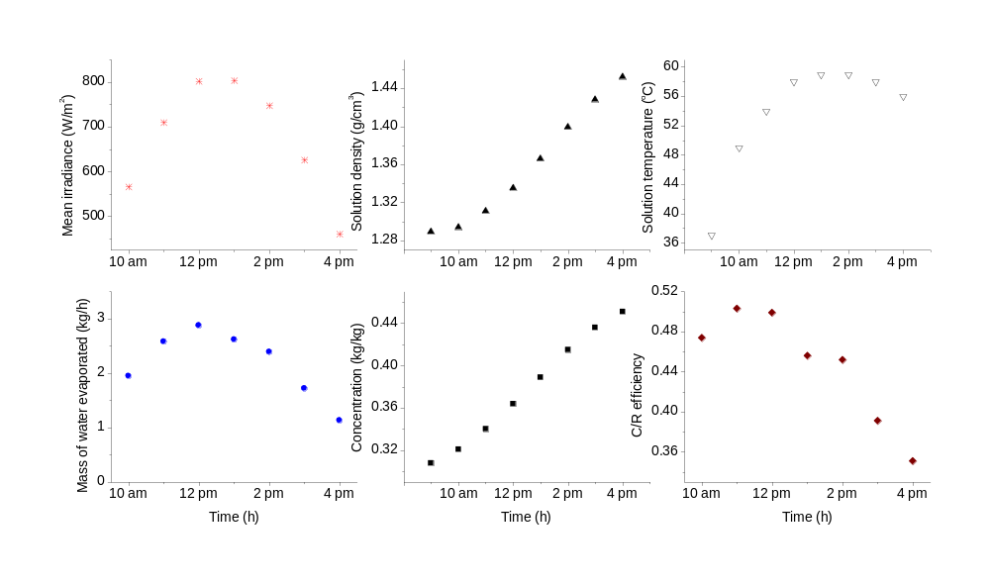
Fig. 2: Diurnal regeneration results for CaCl₂ solution using unglazed SR-A
The diurnal regeneration performance of CaCl₂ brine in SR-A is shown in Fig. 2. As seen, total evaporated quantity of water from calcium chloride brine was 15.2 kg with peak value of 2.87 kg between 11 am and 12 pm when the average irradiance was 802.3 W/m². There was rise in concentration of CaCl₂ in the brine from 0.30 at 9:00 am to0.45 at 4:00 pm. Change in concentration of CaCl₂ that corresponds to the peak evaporation of water was 0.024 kg/kg. The mean efficiency in regenerating CaCl₂ solution over the day was 44.6%.
As shown in Fig. 3, the LiCl concentration in the solution was raised from 0.32 at 9:00 am to 0.47 at 4:00 pm as due to evaporation of 16.5 kg of water. The peak value of the mass of water evaporated was 3.3 kg (between 11 am and 12 pm when the average irradiance was 871 W/m²) which caused change in concentration of 0.027 kg/kg. The mean solar regenerator efficiency over the day was 44.2 %.
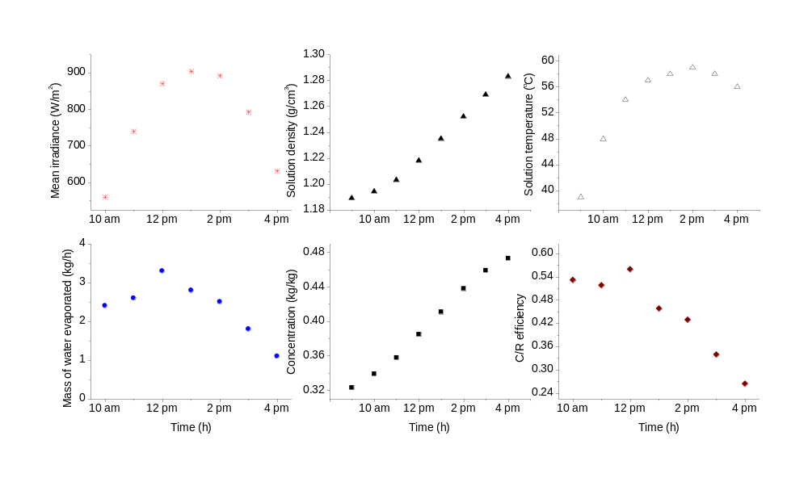
Fig.3: Diurnal regeneration results for LiCl solution using unglazed SR-A

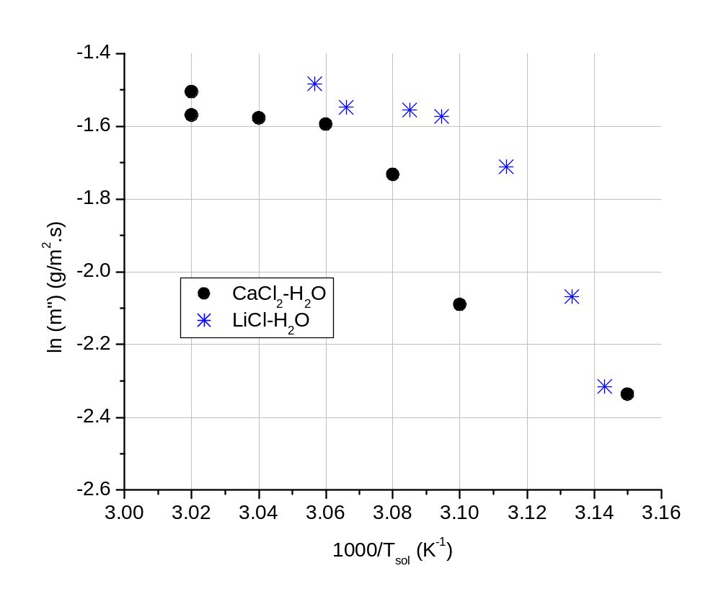
Fig 4: Variation of water evaporation flux from chlorides of calcium and lithium water solution with solution temperature

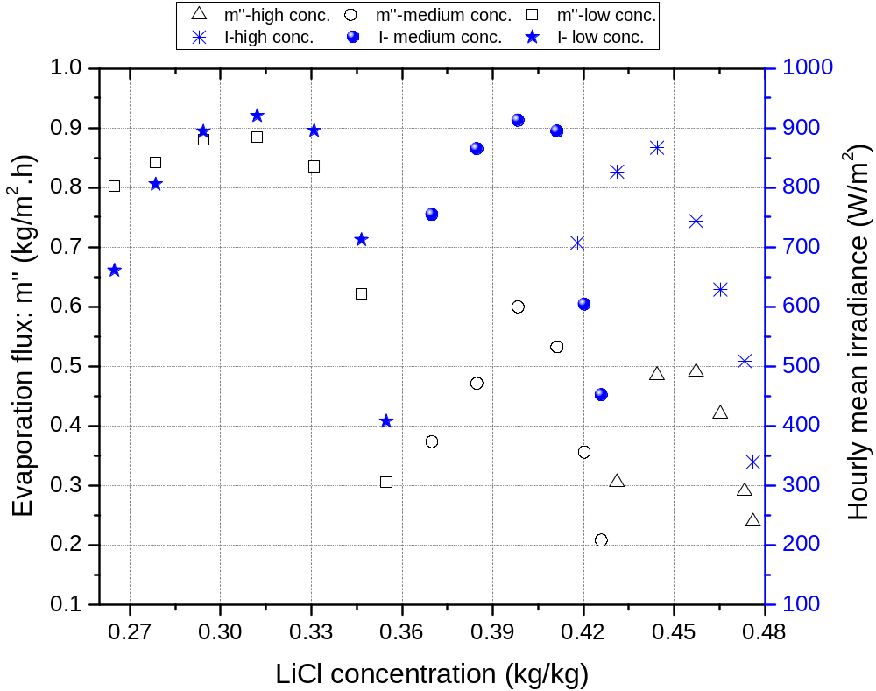
Fig.5: Diurnal evaporation flux of water from LiCl brine for low, medium & high initial concentration when using SR-B
. 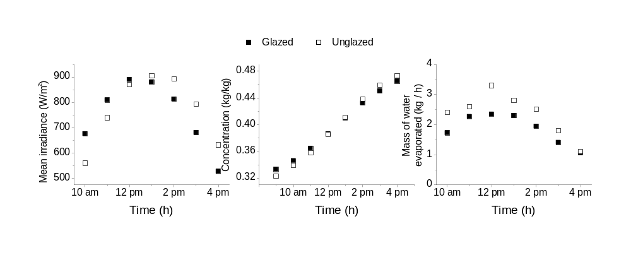

Fig. 6: Diurnal regeneration performance LiCl solution using glazed and unglazed solar C/R-A

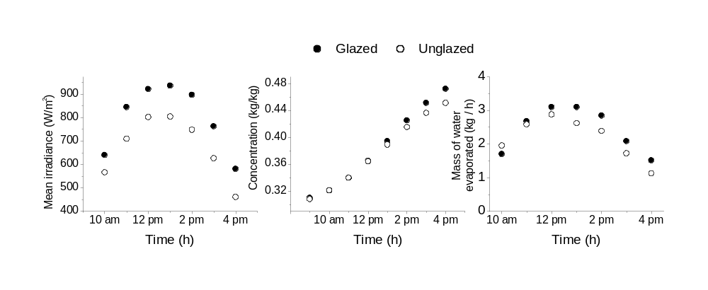
Fig.7: Diurnal regeneration performance CaCl₂ solution using glazed and unglazed SR-A
Effect of inlet brine temperature on diurnal evaporation flux from CaCl₂ and LiCl solutions are indicated in Fig. 4 in the form of Arrhenius plot. As seen, the evaporation flux of water increases exponentially with increase in solution temperature. The maximum solution temperature observed on regeneration of lithium chloride solution using SR-A was 68ºC in May when the ambient temperature was 45ºC. In this open type solar regenerator, the
maximum difference in temperature value between the solution and ambient is 23 ºC which has an advantage in reducing the cooling energy requirement of the desiccant solution to the operating temperature of an air dehumidifier when the two work in a cycle. However, the brine temperature going to solar regenerator can be enhanced by using a solar still as solution tank instead of the polyethylene tank.
Three days diurnal LiCl solution regeneration test results for low concentration (26.5 to 35%), medium concentration (37 to 42.6%) and higher concentration (42.4 to 47.8%). are presented in Fig. 5. For effective dehumidification of ambient air by a LiCl solution air cooling system, concentration of LiCl in brine was recommended to be 0.4 by Hawlader et al. (1993) and Yutong & Yang (2010) experimentally studied performance of an air cooling system coupled with open- type solar regenerator that uses lithium chloride solution of concentration between 0.33 up to 0.36. The day average vapor flux for low, medium and higher initial concentration of desiccant were 0.81, 0.42 and 0.37 kg/m².h, respectively. Regeneration performance was less for high concentration compared to low concentration due to higher potential for mass transfer to air as expected.

Fig. 6 shows l regeneration results for LiCl solution obtained using glazed and unglazed SR-A for nearly similar incident irradiance and initial concentration in the tank. The average irradiance incidents over the day on the glazed and unglazed regenerator were 753.7 and 770.5 W/m², respectively. Total evaporated quantity of water from glazed and unglazed SR-A during the day were 13.0 kg and 16.5 kg, respectively. The performance of unglazed SR-A was better than the glazed one mainly because the glass cover reduces the amount of irradiance that could be absorbed by the plate by approximately 17.5%. Ordinary window glass of 3.0 mm thick was used as glass cover, which had high optical losses. The ratio of vapor evaporation flux to the average irradiance received over the period of experimentation for the glazed and the unglazed SR-A for regeneration of LiCl solution were 0.61 and 0.75 kg/kWh, respectively.
Fig. 7 shows regeneration results of CaCl₂ solution using glazed and unglazed SR-A for same initial of desiccant concentration in the tank. The quantity of water vapor evaporated from glazed and unglazed SR-A over the day were 17.0 and 15.2 kg, respectively. On the basis of this typical day results indicated in Fig. 7, the evaporation performance of the glazed regenerator was better than unglazed SR-A because the glazed SR-A received more solar energy than the unglazed one. The average incident irradiance and the ratio of vapor flux to the average irradiance over the period of experimentation for the glazed and unglazed solar regenerators in regenerating CaCl₂ solution were 797.6 & 674.1 W/m² and 0.75 & 0.79 kg/kWh, respectively. Operating the solar regenerator without glass is not viable in Delhi due to contamination by dust and glazing is recommended.

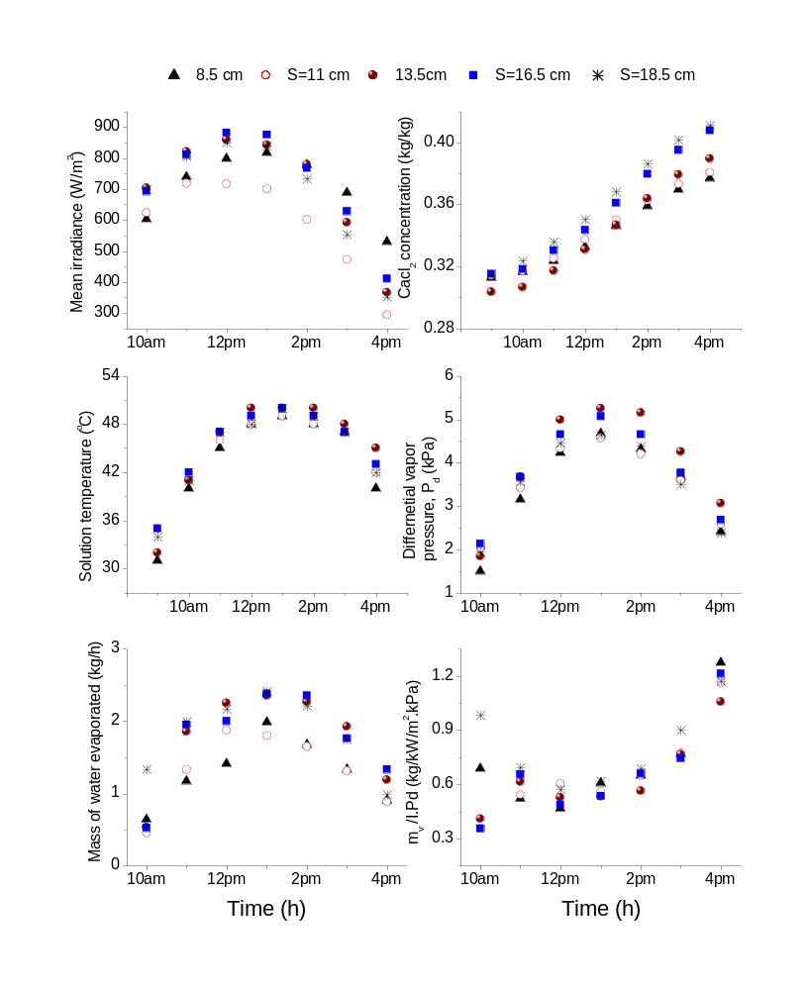
Fig.8: Diurnal performance in regeneration of CaCl₂ solution using glazed SR-A at different glazing gap
Fig. 8 depicts diurnal regeneration results for solar SR-A on regeneration of CaCl₂ solution in the month of October for almost same initial concentration, on five separate days, at five different glazing gaps. As depicted in Fig. 6, the quantity of evaporated vapor mass from the solution over the days was 9.1, 9.3, 12.3, 12.3 and 12.8 kg at glazing gap of 8.5, 11, 13.5, 16 and 18.5 cm, respectively. The variations in the total mass of water evaporated were mainly due to variation in the incident irradiance and solution temperature.
To neutralize the consequence of irradiance and solution temperature (also the concentration), the evaporation of water was normalized by the irradiance and the differential vapor pressure of water as per Eq. (22) and the result is shown in the last row of Fig. 6. The normalized evaporation of water was almost the same for all glazing gaps (except at the beginning) which signifies that glazing gap does not affect regeneration performance.
Fig. 9 shows the influence of humidity content of ambient air on evaporation rate of water in the month of May (hot & dry) and in October (moderate weather). Although the ambient air temperatures are much higher in May, the differential temperature of brine and ambient air were closer to each other for both months. The differential temperature of solution and air was of the order of 8-14.1 ºC and 8.3-13ºC in October and in May, respectively. This contributes to the minimization of cooling energy needed before sending the brine to the air dehumidifier during coupling with the open type solar regenerator. As seen, humidity ratio of air in October was higher than humidity ratio of water in May. The humidity ratio of air was higher in the morning time and gradually decreases towards evening from 13.7 to 9.8 g/kg in October and 11.4 to 8.8 g/kg in May. The peak values of equilibrium humidity ratio on solution surface were 63.1 g/ kg in May and 46.1 g/kg in October. The total amount of evaporation in May and October were 14 and 12.7 kg, respectively for almost similar irradiance and same initial solution concentration.
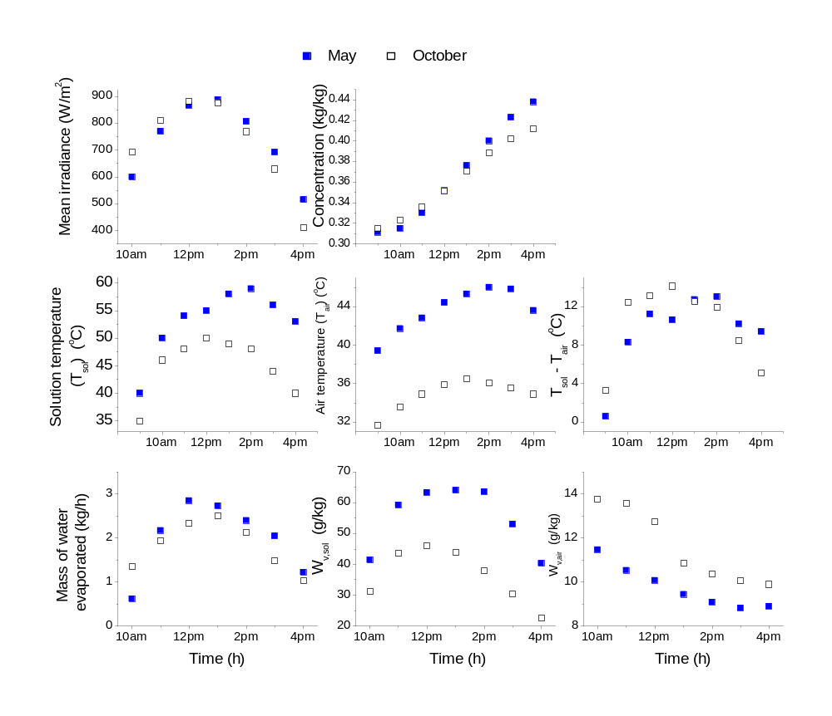

Fig.9: Diurnal liquid desiccant regeneration performance results of SR-A in May and October
5. Conclusions
This study investigated the performance of open-type solar liquid desiccant regenerators for regeneration CaCl₂ and LiCl solutions in Delhi, against design features such as: a) absorber sizes of 4.0 m² and 1.47 m², presence or absence of glass cover & glazing gap and b) operational parameters such as temperature & concentration of desiccant, and c) humidity and irradiance. The main finding are
- In typical day LiCl regeneration between 9 am to 4 pm, the 4.0m² regenerator evaporated 13.0 kg of water raising the desiccant concentration from 0.33 to 0.46 kg/kg with day average efficiency of 46.6 and irradiance of 753.7 W/m². Whereas the 1.47 m² regenerator evaporated 3.4kg of water raising the desiccant concentration 41.7 to 48.2 kg/kg with day average efficiency of 37.8% and irradiance of 705.6 W/m². These indicate that regeneration performance increases proportional to the size of collector.
- Unglazed regenerator performance was better than glazed regenerator. However, glazing is important to keep the solution clean from dust. Changing glazing air gap spacing from 8.5 to 18.5cm did not affect evaporation performance.
- The vapor flux of water reduces as the concentration of solution increases. At an average concentration of 39.6% and 44.7% for lithium chloride solution, the day average vapor flux was obtained to be 0.42 and 0.37 kg/m2.h, respectively.
- Performance was higher in hot/dry weather (May) compared to moderate weather (October) for similar initial desiccant concentration and irradiance.
- Regeneration increases exponentially with solution temperature.
Open-type solar regenerators are sustainable for regenerating desiccant as standalone or integrated with air dehumidifier. Standalone or decoupled operation allows simultaneous heat conversion and continuous regeneration of desiccant over sunshine hour with fluctuation climate and without pre-cooling it to meet the strict inlet temperature for dehumidifiers. Future standalone setups can achieve 100% solar operation using PV-driven solution pumps and solar still solution tanks.

Acknowledgement
The author would like to acknowledge Prof. Sanjeev Jain and Prof. S.C. Mullick for their advice & suggestions and the Ministry of New and Renewable Energy, government of India for the financial support.
References
Alizadeh, S., Saman, W.Y., 2002. An experimental study of a solar liquid desiccant regenerator. Solar Energy 72(4), 312–325.
Alizadeh, S., Saman, W.Y., 2002. An experimental study of a solar liquid desiccant regenerator. Solar Energy 72(4), 312–325.
Aly, A.A., 2011. Optimization of Desiccant Absorption System Using a Genetic Algorithm. Journal of Software Engineering and Applications, 4, 527-533.
ASHRAE. ASHRAE Handbook Fundamentals; ASHRAE: Atlanta, GA, USA, 2009.z
Collier, R., 1979. The analysis and simulation of an open cycle absorption refrigeration system. Solar Energy 23, 357-66.
Conde, M., 2004. Properties of aqueous solutions of lithium and calcium chlorides: formulations for use in air conditioning equipment design. International journal of thermal science, 43, 367-382.
Dunn, P.F., 2005. Measurement and Data Analysis for Engineering and Science, Intl. ed. McGraw-Hill, Boston
Elsarrag, E., 2008. Evaporation rate of a novel tilted solar liquid desiccant regeneration system. Solar energy,82, 663-668.
Gezahegn, H.T.; Mullick, S.C.; Jain, S.,2014. Transient Performance of a Liquid Desiccant Solar Regenerator. In Proceedings of the 2014 Purdue Conferences, International Refrigeration and Air Conditioning Conference, Paper 1486, West Lafayette, IN, USA, 14–17 .
Haim, I.,Grossman, G., Shavit, A., 1992. Simulation and analysis of open cycle absorption systems for solar cooling. Solar Energy 49 (6), 515-534.
Hawlader, M.N.A., Novak, K., Wood, B., 1993. Unglazed collector/regenerator performance for a solar assisted open cycle absorption cooling system. Solar energy,50 (1), 59-73.
Jain, S., Bansal, P.K., 2007.Performance analysis of a liquid desiccant dehumidification system. Int. journal of refrigeration, 30, 861-872.
Johannsen, A., Grossman, G., 1983. Performance simulation of regenerating type solar collectors. Solar energy, 30(2), 87-92.
Kabeel, A.E., 2005. Solar powered liquid desiccant regeneration using free and forced convection: An experimental comparative study. Solar Energy 79(5), 514–522.
Mullick, S., Gupta, M., 1974, “Solar desorption of absorbent solution,” Solar Energy 16, 19-24.
Yang, R., Wang, P.L., 1998. Experimental study for a double glazed forced flow solar collector/regenerator. Journal of Solar energy engineering,120,253-259.
Yutong, L., Yang, H., 2010. Experimental study of an open-cycle solar collector/regenerator using liquid desiccant for air conditioning. International Journal of green energy,7 (3), 273-288.

NOMENCLATURE AND SYMBOLS
Roman symbols
Aab | Absorber area [m²]
Δhd | differential enthalpy of  dilution [kJ kg⁻¹]
hfg | latent heat of vaporization of  water [kJ kg⁻¹]
I | mean irradiance [W m⁻²]
md | initial mass of desiccant in solution tank [kg]
mv,Δt | evaporation in an hour [kg h⁻¹]
m'' | evaporation flux [kg h⁻¹ m⁻²]
Pv,pw | vapor pressure of pure water [Pa]
P∞ | free stream pressure of air [Pa]
R | arbitrary result parameter (varies)
T | temperature [°C or K]
t | dry bulb temperature of air [°C]
t_{o} | initial time [h]
t* | wet bulb temperature of air [°C]
Δt | time step [h]
UR | result uncertainty [varies]
Ux | instrument uncertainty [varies]
W | humidity ratio of air [kg kg⁻¹]
Ws | humidity ratio of air at saturation  pressure of water [kg kg⁻¹]
W* | humidity ratio of air at wet bulb  temperature [kg kg⁻¹]
x | any parameter [varies]
Greek symbols
$$η_{C/R}$$ | Efficiency [-];
ξ | desiccant concentration [kg kg⁻¹]
ρ | mass density [kg m⁻³]
θ | reduced temperature [-]
Subscripts
ab | absorber
d | desiccant
sol | solution
SR | Solar regenerator
v | vapor

