Experimental study of dust EMISSION during trimming of CFRP structures with PCD tool

Ngoc NGUYEN-Dinh¹, Redouane ZITOUNE², Christophe BOUVET³, Sabine LEROUX⁴

¹Université de Toulouse, UPS, Institut Clément Ader, Toulouse, France
Email: dinh-ngoc.nguyen@iut-tlse3.fr
²Université de Toulouse, UPS, Institut Clément Ader, Toulouse, France
Email: redouane.zitoune@iut-tlse3.fr
³Université de Toulouse, ISAE-SUPAERO, Institut Clément Ader, Toulouse, France
Email: christophe.bouvet@isae.fr
⁴Université de Toulouse, Mines Albi, Institut Clément Ader, Albi, France
Email:sabine.le.roux@mines-albi.fr

Keywords:Respiratory, Trimming, CFRPs, Dust analysis, PCD tool

Abstract:
The size of the chips generated during machining of composites is influenced by the machining parameters. Specifically for CFRP made of thermoset matrix, chips are broken down to minute sizes and suspended in air. Due to the lighter weight, the chips in the form of dust particles can be emitted in the air which can be inhaled by operators in the workshop. Unfortunately,in the literature few studies deal with this problem. This study aims to investigate the influences of cutting parameters and tool wear during trimming of CFRPs on the number of harmful particles. The quantification of the dispersed particles was measured using a dust monitor. The results show that an increase of the feed speed and the radial depth of cut, leads to reduce number of harmful particles. For example, when feed speed increases form 500 mm/min to 1500 mm/min the number of harmful particles decreases by 37%. In addition, also with the increase of machining distance the number of harmful particles decreases for all machining conditions. Based on this work, it is recommended that, trimming with the combination of higher feed speed and higher depth of cut can reduced the dispersion of harmful particles.

1. Introduction

Fiber Reinforced Plastics (FRPs), an advanced class of composite materials, have been being widely used in various industrial fields (like aerospace) because of their high strength to weight ratio, high stiffness to weight ratio and long fatigue life. To conform to each application, composite structures are often fabricated to near net shape. However, after the demolding, the machining operations are commonly needed to get the final dimensions of composite structures. These operations are generally conducted using conventional process like: trimming and drilling [1]. Machining of composite materials is accompanied by a series of brittle fractures due to shearing and cracking of matrix material under application of the cutting forces generated by the physics of interaction between the cutting tool and workpiece [2-3]. This interaction is responsible for the generation of chips which is characterized by minimum sizes, hence is qualified as microchips. Machining of CFRP composites without lubricant (dry machining) is usually recommended by the companies. However, dry machining favors the apparition of damage, increases the rate of tool wear and mainly the emission of fine dust particles with extremely small sizes and sharp edges in to the air [4]. If we refer to the literature, damage observed during trimming of CFRP can be summarized as: delamination, uncut fibers, thermal and/or mechanical degradation of the matrix, interlaminar cracks. In fact, when the dry machining is conducted, the generation of defects mentioned above is accompanied with the emission of fine dust particles. The increasing usage of composite materials in industry leads to more frequent exposure to fine dust particles. Hence, the dust particles possess potential ability to damage respiratory system and cause toxic irritations. For these reasons, it is of paramount importance to minimize the emitted particles in the air during machining of CFRP in order to protect operators from the work related health hazards.
Surprisingly, these issues of dust particles resulting from machining of composite materials have been long time ignored, and there are very few studies related to them [5-6]. Haddad et al. [5] investigate the influences of the cutting parameters (cutting speed and feed speed) and tool geometries on the harmful particles when trimming the CFRP laminates. For this, three kinds of cutting tools made of tungsten carbide have been used, i.e. four flutes end mills, coated and uncoated burr tools. The obtained results show that the number of harmful particles decreases with increasing feed speed and/or decreasing cutting speed. It means that the combination of low cutting speed and high feed speed should be used to create minimum harmful particles. However, this combination of machining parameters favors the apparition of the machining damages and poor surface quality [1, 8]. Regarding the influence of the tool geometry, it was mentioned that number of harmful particles measured, when the four flutes end mills is used, are 235% and 115% superior to those generated when machining is conducted with coated and uncoated burr tools respectively. These results have been attributed to the fact that, when the burr tools is used, the temperature of machining is superior to the case of machining with four flutes end mills and this favors the adhesion of the carbon dust in between the tool groves of the burr tools. In addition, in the work of Klocke et al. [6], it was observed that, when trimming CFRP composite using PCD and carbide tool, dust particles generated is influenced by the nature of cutting tool material. In fact, the harmful particles generated when the PCD tool is used is 35% superior compared to the case when the carbide tool is used. This difference can be explained by the fact that, the PCD tool is characterized by smaller cutting edge radius when compared to those of carbide tools. It is also found that, the increase in cutting speed leads to an increase in mass concentration of dust particles.
The main objective of this work is to analyze the impact of cutting parameters (feed rate, and radial depth of cut), and tool wear (in term of cutting distance) on the number of harmful particles (respirable fraction) which might reach the pulmonary alveoli during trimming of CFRP specimens using PCD tool. The number of particles generated during machining is measured using a GRIMM laser spectroscopic dust monitor. Also, the morphology of dust particles was observed using SEM.

2. Experimental procedure

2.1. Material preparation

The CFRP laminates used in this study were made of unidirectional Prepregs supplied by Hexcel Composite Company and referenced under HEXPLY T700 260 M21 34% (T700/M21). Twenty layers of prepregs corresponding to the dimension of 300 mm x 300 mm and a thickness of 0.25 mm were stacked together to create plates with a theoretical thickness of 5.2 mm with the following stacking sequence: [90/90/-45/0/45/90/-45/90/45/90]_{s}. These plates were compacted using a vacuum pump in a controlled atmosphere. A mold for the laminate was prepared and placed in a vacuum bagging evacuated to 0.7 bars. Curing was then carried out at 180°C for 120 min during which the pressure was maintained at 7 bars in an autoclave. For more detail about the mechanical properties of composite materials, refer to the Table 1. After curing the coupons for trimming was prepared using abrasive water jet process (AWJ) to get the dimensions of each coupon, i.e. 280 mm x 14 mm x 5.2 mm or 280 mm x 16 mm x 5.2 mm depending on radial depth of cut of 2 mm or 3 mm respectively. The dimensions of these coupons were particular designed in order to obtain specimens for compressive testing according to the standard recommendation AFNOR NF T 51-120-3 (1995).

Table 1. Mechanical properties of HexPly T700-M21.

Composite materials (T700/M21) | Ply thickness: 0.26 mm  Fiber content: V_{f} = 59%  Stacking sequence  [90°/90/-45/0/45/90/-45/90/45/90]_{s}  Young modulus: E₁ = 142 GPa, E_{t} = 8.4 GPa  Shear modulus: G₁₂ = G₁₃ = 3.8 GPa, G₂₃ = 3.2GPa  Glass transition temperature: T_{g}= 187°C

2.2. Cutting parameters

Three levels of feed speed and two levels of radial depth of cuts were selected for trimming, while only one value of cutting speed was used in this study. In order to better analyze the damage generation in function of the machining parameters, new polycrystalline diamond cutters with two straight flutes (PCD) were used for each cutting condition (cf. Figure 1).The machining was conducted without lubricant (dry machining). The detail information of experimental parameters is presented in Table 2. For each machining condition a new cutting tool was used and three coupons are trimmed amounting to a total machining distance of 168 cm (28 cm × 2 faces × 3 specimens = 168 cm). The cutting faces and the direction of cutting with respect to the 0° orientation of the coupons are illustrated in the schematic view of Figure 2. The geometry of the cutting used is recommended by SECO tool Company for machining CFRPs.

Table 2. Summary of experimental conditions used for trimming of CFRP laminates.
Cutting tools | PCD tool: helix angle = 0°, rake angle = 5°, clearance angle = 7°  Diameter = 6 mm  Number of cutting edge = 2
Cutting conditions | Radial depth of cut (mm): (a_{e}) = 2 and 3  Cutting speed (m/min): V_{c} = 150  Feed speed (mm/min): V_{f} = 500, 1000 and 1500
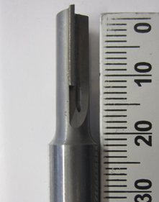

Figure 1. PCD tool with two straight flutes.

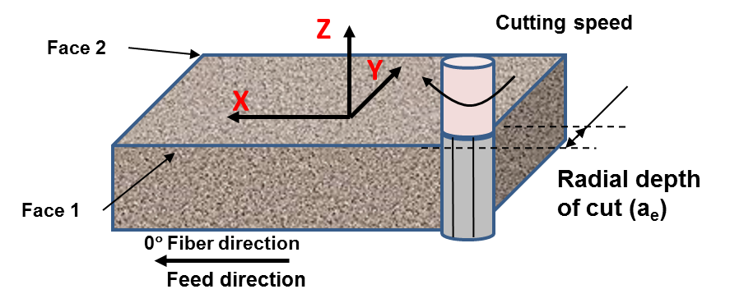

Figure 2. Schema of the axes and the machining directions.

2.3. Trimming setup and dust quantification

Trimming process was carried out using 5-axis CNC milling machine referenced under “DMU 85 mono-BLOCK” which has the maximum spindle speed of 18,000 rpm. The specimens were fixed firmly by cap screws on a specific fixture designed for this study (cf. Figure 3). For the quantification of the number and the average size of the dust particles generated during trimming, a GRIMM dust monitor (model 1.109) was utilized. This device can count the number of particles which have sizes ranging from 0.25 µm to 32 µm present one liter of the air. The interval for each measurement was set up for 6 seconds. The average number of particles was calculated to get the representative for each machining condition. After each machining test the dust settled on the machining table was collected in order to observe the morphology of the particles using scanning electron microscopy (SEM).

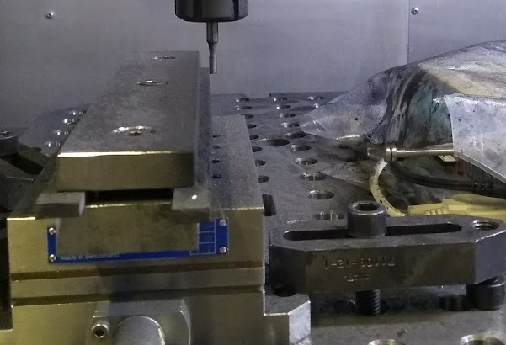
Fixture

Dust monitor

Specimen
Force sensor

Figure 3. Experimental devices for trimming tests.

3. Results and discussion

3.1. SEM observation of released dust particles

In order to analyze the morphology of dust particles, sheets of clean paper were placed on the machine table to collect the settled particles. Figure 4 shows the scanning electron microscope (SEM) observations of collected particles for two different feed speeds and for a cutting speed and depth of cut of 150 m/min and 3 mm, respectively. It is seen that particles are found to be irregular in shape and can be distinguished as free fibers, fine powder and fragments of fiber-matrix chunks. The presence of these different forms of chips can be explained by the fact that, relative angle "θ" between the direction of the cutting speed and the fiber orientation favors the generation of different form of chips. If we refer to the work of [2-3] which focuses on the mechanisms of chip formation for different values of the angle "θ" during orthogonal cutting, it was clearly identified for "θ = 90°", the chip has a form of powder (smaller particles). However, for "θ = 45°" and "θ = 0°", the chips are in the form of continuous and broken shapes respectively. These typical shapes of particles are identically observed for all trimming cases in this study regardless of cutting conditions as well as cutting distance. However, it is realized that the particles generated using feed speed of 1000 mm/min (cf. Figure 4b) have many chunks than those generated using feed speed of 500 mm/min (cf. Figure 4a).These can be explained by the fact that, with the increasing the feed speed, the theoretical chip thickness increases too.
It is important to mention that, for any condition of test used, a non-negligible quantity of chips (in form of powder) is dispersed in the air which is considered as machining dust. Thanks to the dust monitor it was possible to quantify the number and the size of these dispersed chips.

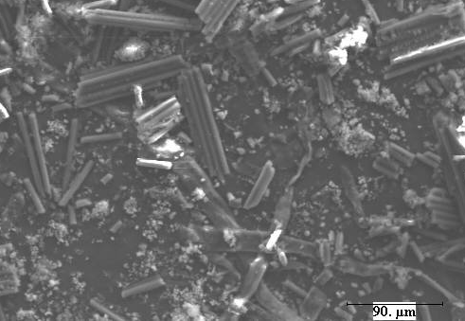
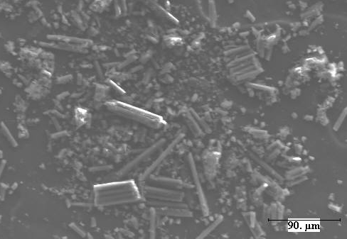
(b)
(a)
Powder
Free fiber

Fiber-matrix chunk
Fiber-matrix chunk

Powder
Free fiber

Figure 4. Typical SEM images of collected particles for cutting speed of 150 m/min and radial depth of cut of 3 mm (a) V_{f} = 500 mm/min, (b) V_{f} = 1000 mm/min.

3.2. Influence of the machining parameters on the generated particles

According to European Standard Norm EN 481 [7], the dust particles are distinguished in three categories viz.inhalable, thoracic and respirable. According to the norm, respirable dusts are the particles that can reach the lung and alveoli and are characterized by aerodynamic diameter lower than 10 µm. This category of the dust particles can pose serious health hazards for operators. As a result, reducing this part released particles plays an important role in safeguarding the health of operators. By this reason, in this study, only respirable particles (harmful particles) are analyzed.
Figure 5 shows the evolution of the total numbers of particles measured by the dust monitor for two different radial depth of cut as a function of particle sizes. In this case, the trimming concerns the first face of the specimen and is conducted with a feed speed of 500 mm/min and cutting speed of 150 m/min. It is clearly observed that, the increase in the radial depth of cut leads to a reduction of the total number of particles. This result is related to the increase in the chip thickness when the radial depth of cut increases. Based on this figure for both cases of radial depth of cut, it is observed that there are two clear peaks for the number particles which includethe major percentage of measured particles. These peaks correspond to the particles sizes including 0.3 µm and 0.35 µm for the first peak and 0.8 µm to 1 µm for the second peak. It is important to mention that, the first peak correspond to the major percentage of the total number of particles measured and represents 300 % more particles compared to number of particles measured for the second peak. If we refer to the study of Haddad et al. [5], overall size distribution follows the same trend, however, the total number of particles measured are different. This difference is clearly attributed to the tool geometry. In fact, with burr tool used by Haddad et al. [5] the total number of particles is less compared to the total number of particles obtained with PCD tool (in this study). Indeed, when the burr tool is used, the adhesion of a non-negligible quantity of carbon dust in between the tool groves was observed, which can explained the lower number of total particles in the air.

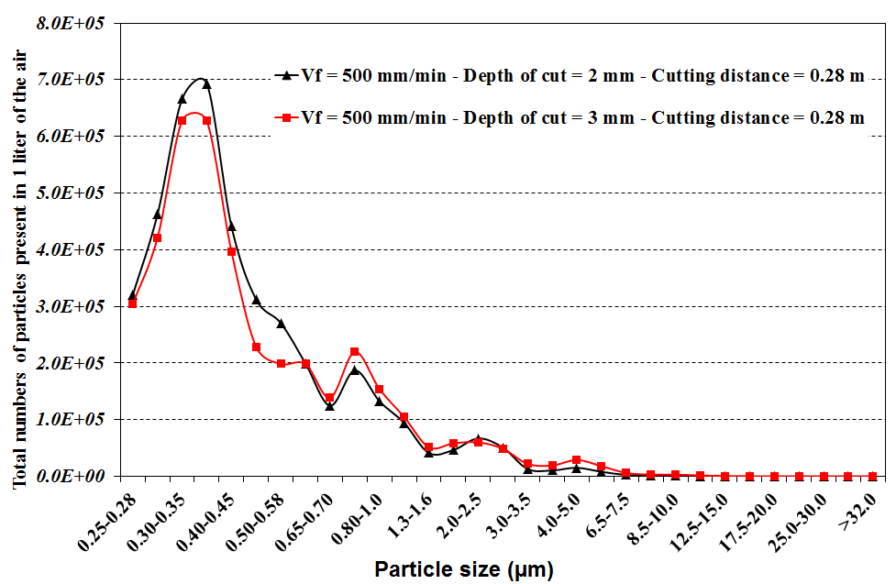

Figure 5. The number of particles present in 1 liter of the air vs. particle sizes for cutting speed of 150 m/min.
The numbers of harmful particles are calculated from total number of particles according to recommendation of European Standard Norm EN 481 [7]. The evolution of average value of harmful particle numbers present in 1 liter of the air as a function of feed speed and radial depth of cut is shown in Figure 6. Regarding the influence of feed speed, it is observed that an increase in feed speed leads to decrease in the number of harmful particles. Indeed, when feed speed varies from 500 mm/min to 1500 mm/min, the average values of harmful particle numbers decrease by 37% and 31% for depth of cut of 2 mm and 3 mm respectively.
For the impact of radial depth of cut, it can be seen that the number of harmful particles decreases with increasing values of radial depth of cut for any condition of feed speed tested. In fact, the number of harmful particles reduces by 35%, 24% and 29% for the feed speed of 500 mm/min, 1000 mm/min, and 1500 mm/min respectively when radial depth of cut increases from 2 mm to 3 mm.
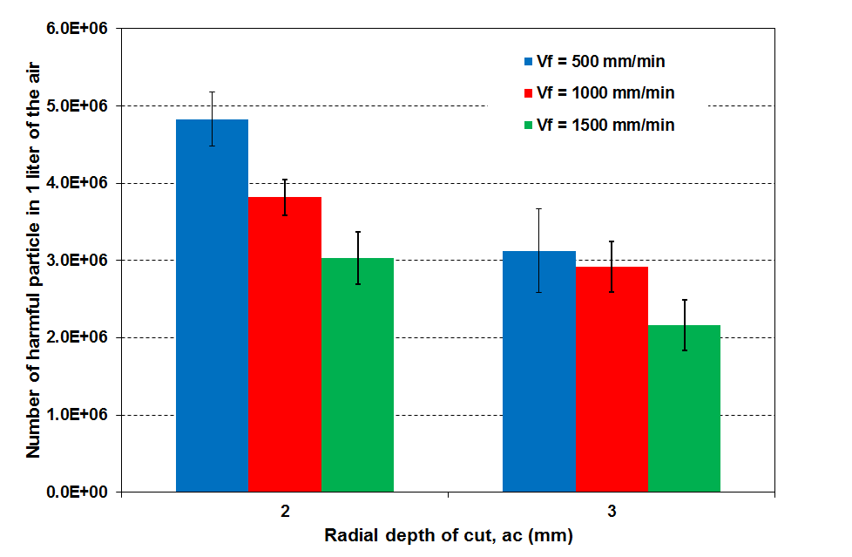

Figure 6. The evolution of harmful particle numbers as a function of cutting parameters for cutting speed of 150 m/min.

The influences of feed speed and radial depth of cut on the number of harmful particles as previously presented can be explained by the fact that when trimming with higher feed rate or higher depth of cutfavors the increase of the chip thickness and the volume of cut materials increases too. However, consequently, due to the higher chip thickness the probability to obtain the settled particles on the machine table with the form of free fibers and fiber-matrix chunk mentioned above (cf. Figure 4) increases. This conduction of machining is beneficial for the operator because quantity of particles in the air is reduced. However, if we refer to the literature, it is seen that, the increase in the feed speed, favors the degradation of the machining quality and increases the apparition of the uncut fibers and the matrix degradation [1, 8].
From Figure 6 a significant standard deviation of the average values can be observed. It is important to notice that, this standard deviation is calculated from six measures which correspond to the machining of each face of the three specimens tested for each condition with the same tool. Hence the non-negligible values of the standard deviation can be related to the effect of the wear of the cutting edge. Given that, the rate of the tool wear is strongly influenced by the machining parameters, particular the feed rate, which is one of the mean reasons responsible of the variation in the standard deviation values. In order to better understand the impact of the tool wear in terms of machining distance on the harmful particles for all the conditions tested is illustrated in Figure 7.
The number of harmful particles for two cutting distances, i.e. 0.28 m and 1.68 m corresponding to the first and the sixth face of the machined coupons is discussed. It can be seen that number of harmful particles measured in the last face are always inferior to the ones measured in the first face irrespective of cutting conditions and depth of cut. For example, when trimming is conducted with a feed speed of 500 mm/min and radial depth of cut of 3 mm the harmful particles decrease by 38% when the cutting distance varies from 0.28 m (first face of the first coupon) to 1.68 m (last face of the third coupon). In fact, with the increasing of the cutting distance, the radius of cutting edge increases as is observed in Figure 8. In this case, the value of the cutting edge radius becomes more important compared to the diameter of the carbon fibers (≈ 7µm), which favors the increase of the cutting forces. Consequently, the mechanisms of chip formation are due to the fracture induced by combination of bending and local buckling unlike shear mechanisms for the new tool (with cutting edge radius ≈ 7µm). For higher value of the cutting edge radius the probability to obtain chips in the form of free fibers and fiber-matrix chunk is more prominent. Finally, rougher chips are created corresponding to lager size of particles due to the heavier weight quickly drop on the machining platform.
From this analysis of harmful particles, it can be said that the number of harmful particles can be minimized if trimming process is conducted at higher feed speed and higher depth of cut. However, as mentioned earlier, this combination can give rougher machined surface which is also documented in [1, 8]. Finally for the optimization of the machining parameters in conventional process, it will be primordial to strike a balance between machining quality and the number of harmful particles released.
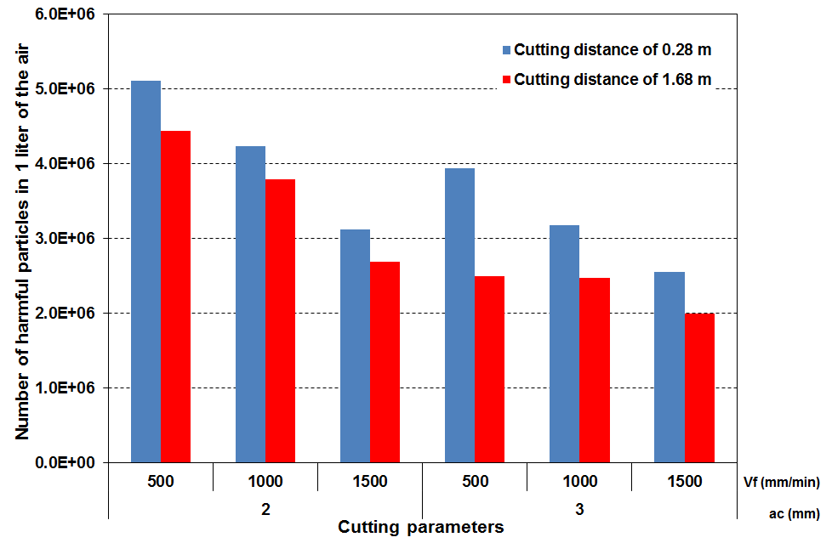

Figure 7. The influence of cutting distance on the number of harmful particles for various radial depth of cut for cutting speed of 150 m/min.

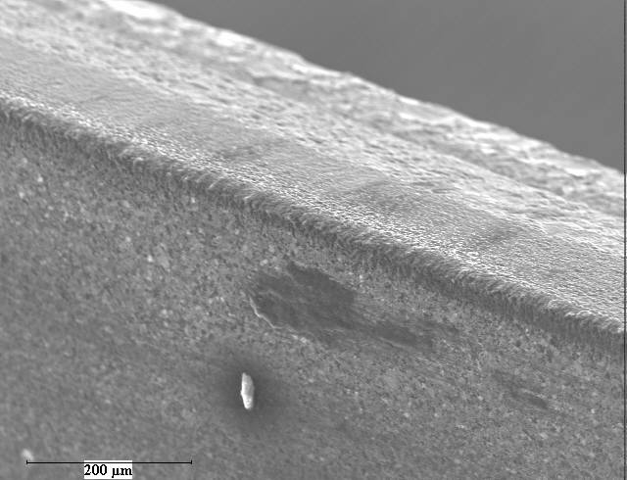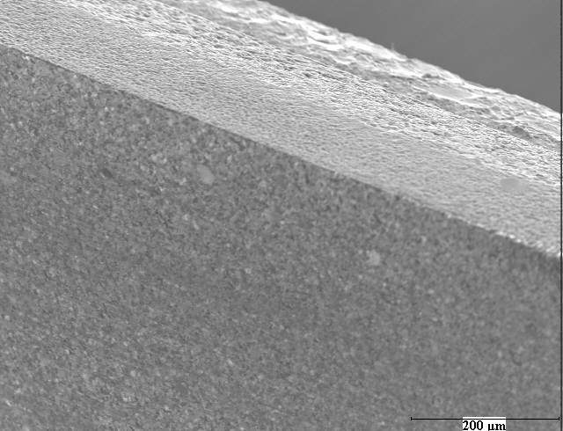
200 µm
200 µm
Cutting edge
(a)
200 µm
Cutting edge
(b)

Figure 8. SEM images of the cutting edge after trimming with a feed speed of 500 mm/min and a radial depth of cut of 2 mm (a) for machining distance of 0.28 m and (b) for machining distance of 1.68 m.

4. Conclusions

From the experimental study on the dust analysis during trimming of multidirectional CFRP composites using PCD tool, the following conclusions can be drawn:
- The SEM imaging conducted on the collected dust, have revealed the presence of three main forms of chips viz. fine powder (matrix and fibers), free fibers and fragment of fibers-matrix chunks.
- The increase of the feed speed, the radial depth of cut as well as the cutting distance favors the reduction of the harmful particles in the air and increases the formation of the chips with fiber-matrix chunk forms. For example, when trimming is conducted with feed speed of 500 mm/min and radial depth of cut of 3 mm, the harmful particles decrease by 38% when cutting distance varies from 0.28 m to 1.68 m.

Acknowledgments:

The authors wish to thank SECO tool Company (France) for its technical support.

5. References

[1] Ahmad JS. Machining of polymer composites.Springer; 2009.ISBN 9780-387-35539-9.
[2] Wang DH, Ramulu M and Arola D. Orthogonal cutting mechanisms of graphite/epoxy composite. Part I: Unidirectional laminate. Tools & Manufacture.1995; Vol. 35. No, 12, pp 1623-1638.
[3] Zitoune R, Collombet F, Lachaud F, Piquet R, Pasquet P. Experiment-calculation comparison of the cutting condition representative of the long fiber composite drilling phase. Composites Science and Technology. 2005; 65(3/4):455-66.
[4] M. Ramulu and J. Kramlich., “Machining Of Fiber Reinforced Composites: Review Of Environmental And Health Effects” International journal of Environmentally Conscious Manufacturing, Vol. 11, No.4, 2004, pp. 1-19
[5] Haddad M, Zitoune R, Eyma F, Castanié B. Study of the surface defects and dust generated during trimming of CFRP: Influence of tool geometry, machining parameters and cutting speed range. Composites - Part A. 2014; 66, 142-154. Vol. 60, No. 1, pp.107–113.
[6] Klocke, F., C. Koenig, C. Wuertz, and C. Dietz. Environmental Effects and Safety in Machining Fibrous Composites.Machining of Ceramics and Composites.Edited by S. Jahanmir, M. Ramulu, and P. Koshy, Marcel Dekker, Inc., New York (1999), pp. 411-425.
[7] European Standard Norm EN 481. Workplace atmospheres – size fraction definitions for measurement of airborne particles. Brussels: European Committee for Standardization; 1993.
[8] Ahmad JS, Urban N, and Cheraghi H. Machining Damage in Edge Trimming of CFRP.Materials and Manufacturing Processes.2012; 27: 802-808.

