EuroSun2026
HEAT PUMP SYSTEM INTEGRATED WITH
PVT COLLECTORS AND ICE STORAGE

Bruno Bavia Bampi¹, Björn Nienborg¹
¹ Fraunhofer Institute for Solar Energy Systems (ISE), Germany
bruno.bavia.bampi@ise.fraunhofer.de
Summary
This paper presents the field evaluation of a residential heat pump system using a hybrid renewable heat source combining 40.4 m² of photovoltaic-thermal (PVT) collectors and a 5.2 m³ ice storage. The heat sources supply a directly condensing 12 kW propane (R290) heat pump installed in a 172 m² two-family house in Germany. The system was monitored continuously over a complete 12-month period, from July 2025 to June 2026, as part of project HPPVT40. The PVT collectors were the main heat source for the heat pump, directly supplying 73% of the heat delivered to the evaporator, while the ice storage provided complementary heat, particularly during winter. The field evaluation also identified limitations affecting winter operation, mainly related to the available ice storage capacity and the operating temperature range of the PVT collectors. The results demonstrate the technical potential of combining PVT collectors and ice storage as a renewable heat source for residential heat pumps and provide important insights for the design and control of such systems for year-round operation.
Keywords: PVT, heat pump, ice storage
Field of application for the findings: residential heating system
Addressed audience: building energy researchers, engineers, system designers, and planners
- Introduction
The necessity of transitioning to climate-neutral energy systems highlights heat pumps (HP) as a critical technology for decarbonizing the residential heating sector. Photovoltaic-thermal (PVT) collectors have emerged as a promising technology for heat pump applications, as they simultaneously provide electricity and heat from the same collector area, and offer space-saving heat pump integration in urban environments, particularly where space for conventional heat sources is limited (Lämmle et al., 2020; Chhugani et al., 2022, 2023; Kramer et al., 2023; Kramer and Helmling, 2024). Within the project HPPVT40, a hybrid heat source concept was developed that combines PVT collectors with an ice storage. The PVT collectors serve as the primary energy source by “harvesting” solar radiation and ambient heat while simultaneously generating electricity for on-site consumption. The ice storage enhances source stability, while the PVT field (and partly the surrounding ground) is used for regenerating the ice storage (Bavia Bampi et al., 2023; Khamidov et al., 2024).
In addition, environmentally sustainable heat pump operation requires the use of low-global-warming-potential (GWP) refrigerants. Within the project, a propane (R290) heat pump with direct condensation in a buffer storage tank was developed, enabling a compact and hydraulically simplified system design while complying with future refrigerant regulations (Diewald et al., 2023, 2024).
This paper presents the comprehensive field evaluation of this system installed in a residential building in Germany. While previous publications reported the conceptual design of the system (Bavia Bampi et al., 2023; Khamidov et al., 2024), this work evaluates the performance over a complete, continuous 12-month operational cycle, analyzing seasonal fluctuations, system control stability, and system efficiency.
- Methodology
2.1. Demonstration Building
The system is installed in a residential two-family house located near Ulm, Germany (Figure 1). The building has a total heated living area of approximately 172 m². Each apartment is equipped with an independent space-heating circuit (HC1 and HC2). The heat distribution system consists of wall-mounted radiators designed for a nominal supply and return temperature of approximately 55/45 °C. Based on the gas consumption recorded in previous years, the building had an average annual gas consumption of approximately 29,000 kWh for a four-person household. Assuming a gas boiler efficiency of 90%, this corresponds to an estimated annual useful heat demand of approximately 26,100 kWh. The building's heating load was estimated at approximately 12 kW based on the consumption-based calculation. In comparison, the detailled heat load calculation according to DIN EN 12831 resulted in a design heat load of 19.6 kW.
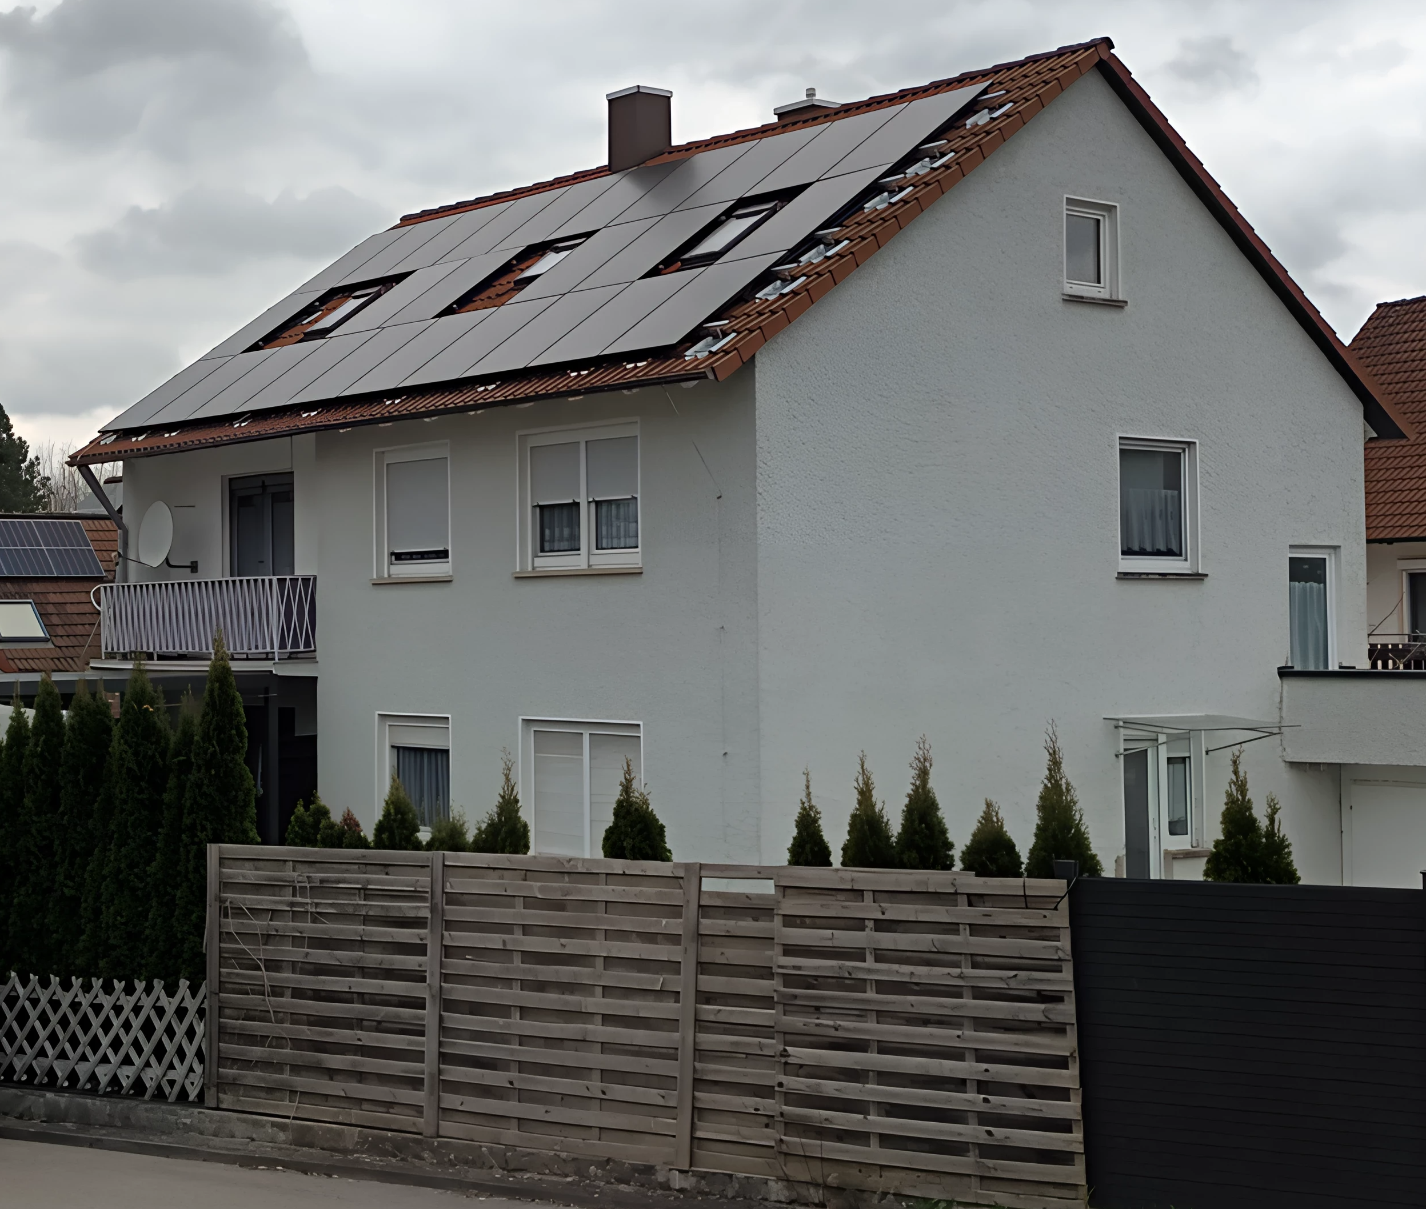
Figure 1. Photo of the residential two-family house where the demonstration system was implemented; the south-facing roof is covered with PVT collectors.
2.2. System Description
The heating system is based on a 12 kW propane (R290) heat pump with direct condensation integrated into a 780 L buffer storage tank. The system diagram is presented in Figure 2. The buffer storage is designed as a combi storage unit, providing energy both space heating and domestic hot water (DHW). DHW is prepared via an external freshwater station (FWS) connected to the combi storage. The building does not include a DHW circulation system. An electrical heating rod with a maximum capacity of 5.2 kW is connected to the buffer storage. It serves two purposes: (i) to utilize surplus electricity generated by the PVT collectors by converting it into heat stored in the buffer tank, and (ii) to provide backup heating capacity in case of heat pump limitations or peak demand. The existing gas boiler was also retained as an additional backup heater. The renewable heat source for the heat pump consists of two main components:
- PVT collectors: 40.4 m² (8.45 kWp) of uncovered modules with thermal insulation on the rear side, installed on the building roof, 30° tilt angle and south-facing orientation. For defrosting the collectors, a heat exchanger transfers heat from the buffer storage to the collector brine circuit when required.
- Ice storage: Two identical storage units with a total water volume of 5.2 m³. Each unit consists of an uninsulated plastic tank containing 2.6 m³ of water and is buried in the ground. The ice storage is regenerated by the PVT collectors and additionally gains heat from the surrounding soil when its temperature is below the soil temperature.
2.3 Heat Source Circuit Operation
The heat source circuit is designed for flexible hydraulic operation, allowing the PVT collectors and the ice storage to be operated either in parallel or in series, depending on operating conditions and control strategy. The heat source circuit is filled with water-glycol mixture (brine) with a freezing point of roughly −20 °C.
When the heat pump is operating, the heat source circuit can operate in four different modes, which are presented in Figure 2:
- PVT only: PVT collectors are the sole heat source for the HP evaporator.
- ICE only: Ice storage is the sole heat source for the HP evaporator
- PVT+ICE in parallel: PVT collectors and ice storage supply heat simultaneously and in parallel to the HP evaporator.
- PVT to HP to ICE in series: PVT collectors supply heat to the HP evaporator, and HP evaporator outlet flow is supplied to the ice storage to regenerate it. This mode happens when HP evaporator outflow temperature is higher than the ice storage temperature.
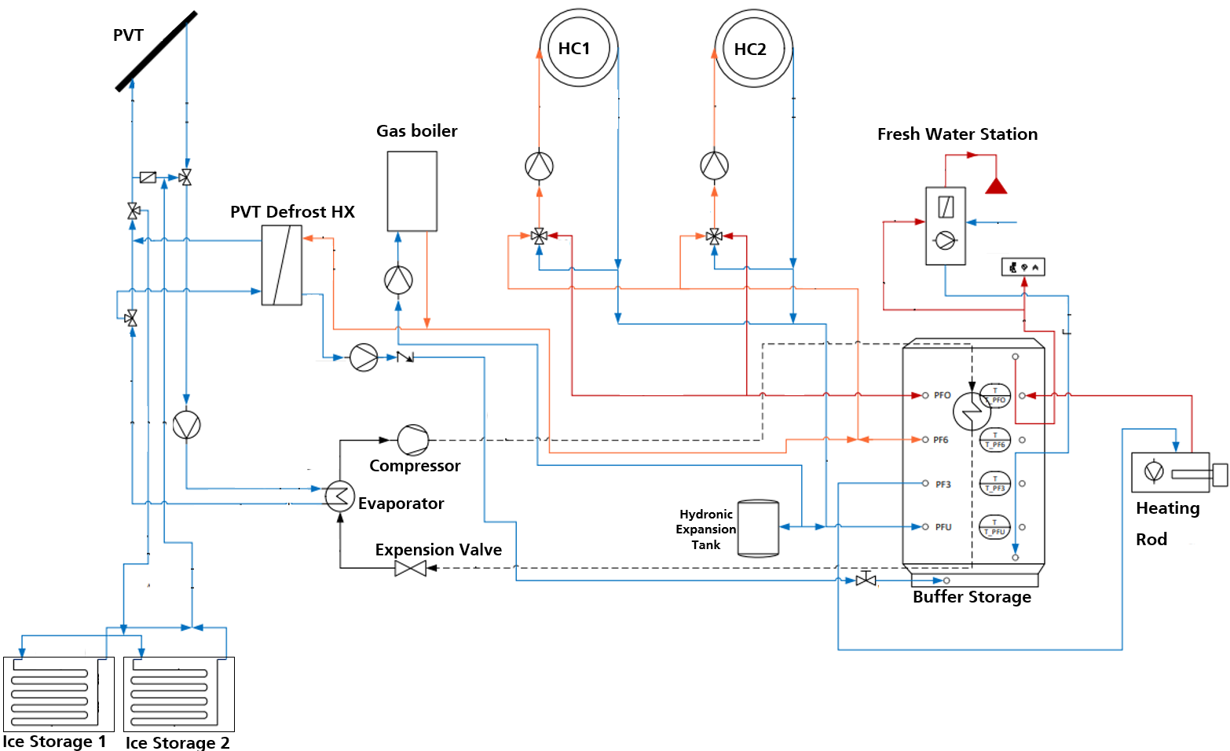
Figure 2. Heating system hydraulic diagram.
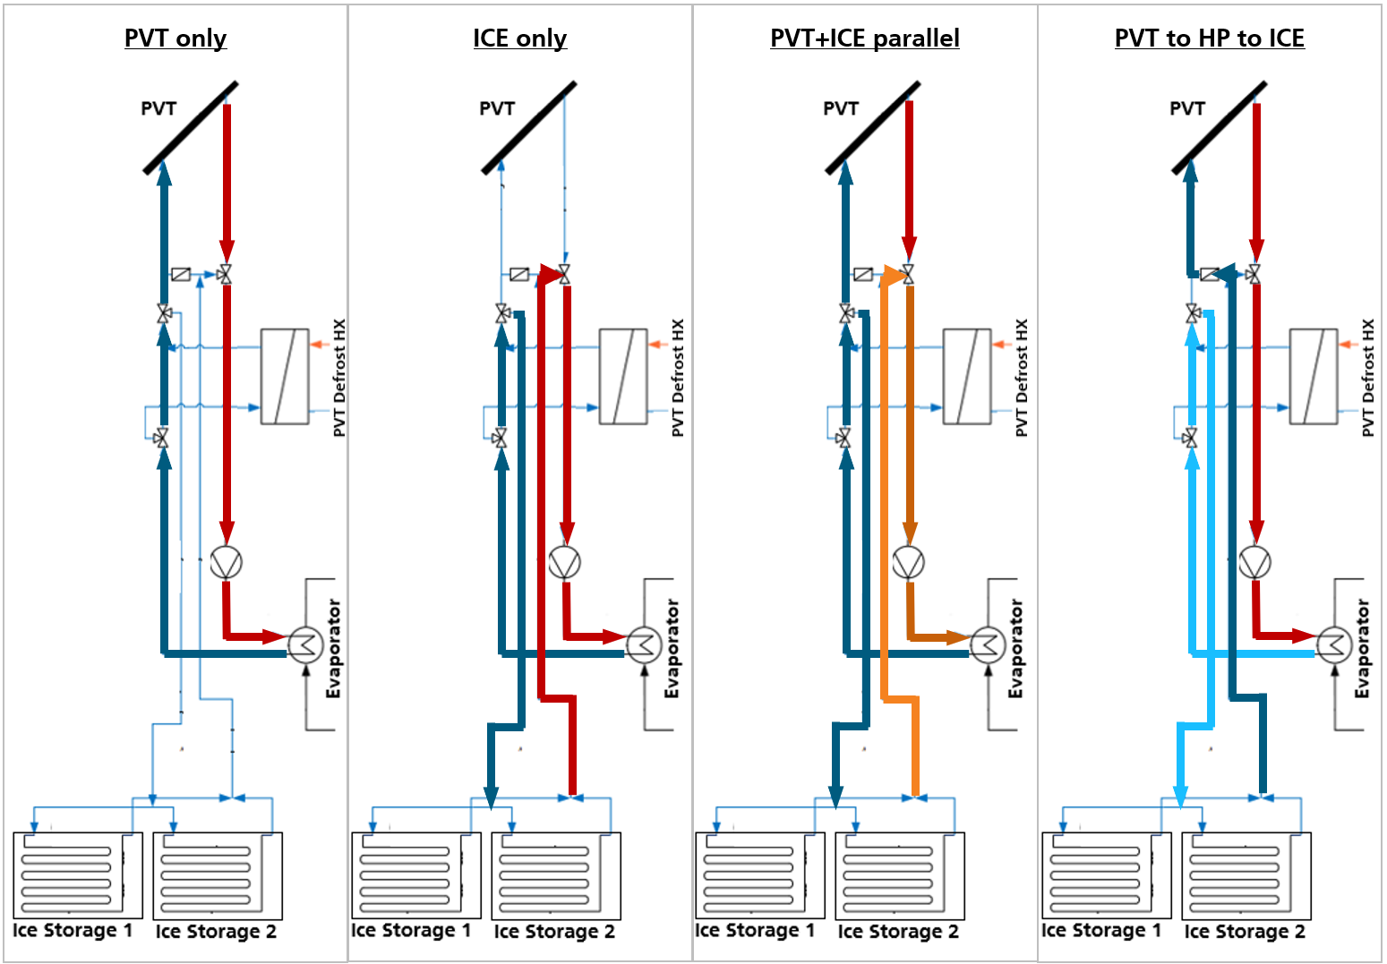
Figure 3. Heat source circuit operation modes when heat pump is on.
When the HP is switched off, a regeneration mode is available, in which the PVT collectors supply heat directly to the ice storage, called PVT to ICE.
2.4 Data acquisition and monitoring
System performance was monitored continuously through three distinct data acquisition channels, each employing a different sampling strategy:
- Heat Pump Controller: Utilizes event-based sampling recording exact start/stop events, compressor frequency, temperatures, and electrical power consumption of the heat pump.
- Heating System Controller: Logs sensors and operational parameters at a strict 1-minute sampling interval, monitoring and controlling the heat source brine loop, the space heating circuits (HC1, HC2), the fresh water station, and the electrical heating rod status.
- Solar Energy Management System: Records photovoltaic electricity generation, and overall household electrical power consumption at a 15-minute sampling frequency.
Thermal energy flows were measured using heat meters installed at all major hydraulic interfaces, including the HP evaporator, PVT collectors, ice storage, PVT defrost heat exchanger, space heating circuits HC1 and HC2, and fresh water station. The thermal output of the electrical heating rod was estimated indirectly from its measured electrical power consumption, assuming 98% conversion efficiency. Since the refrigerant mass flow rate of the heat pump was not measured directly, the condenser heat output was determined as the sum of the measured evaporator heat input and the electrical power input to the heat pump compressor. Data processing and evaluation were carried out using Python-based post-processing routines.
- Results and Discussion
This section presents the results of the continuous system monitoring over a full 12-month period, from July 1, 2025, to June 30, 2026. The analysis covers the system’s seasonal behavior and the performance of the integrated heat pump, PVT collectors, and ice storage throughout the complete annual cycle.
3.1 Weather Conditions
The system's performance is heavily influenced by local weather conditions. Therefore, the ambient air temperature and solar irradiance at the demonstration site were monitored. Figure 4 presents the highly resolved time-series of the ambient air temperature and the solar irradiance on the tilted PVT collector surface. A measurement issue occurred between April 22, 2026, at 08:00 and May 1, 2026, at 01:00, during which no data was recorded. Figure 5 shows the monthly solar irradiation on the PVT collector surface together with the monthly mean ambient air temperatures. Over the 12-month period, the cumulative solar irradiation on the PVT collector surface reached 1299 kWh/m², corresponding to a total solar energy input of approximately 52,479 kWh over the 40.4 m² collector area.
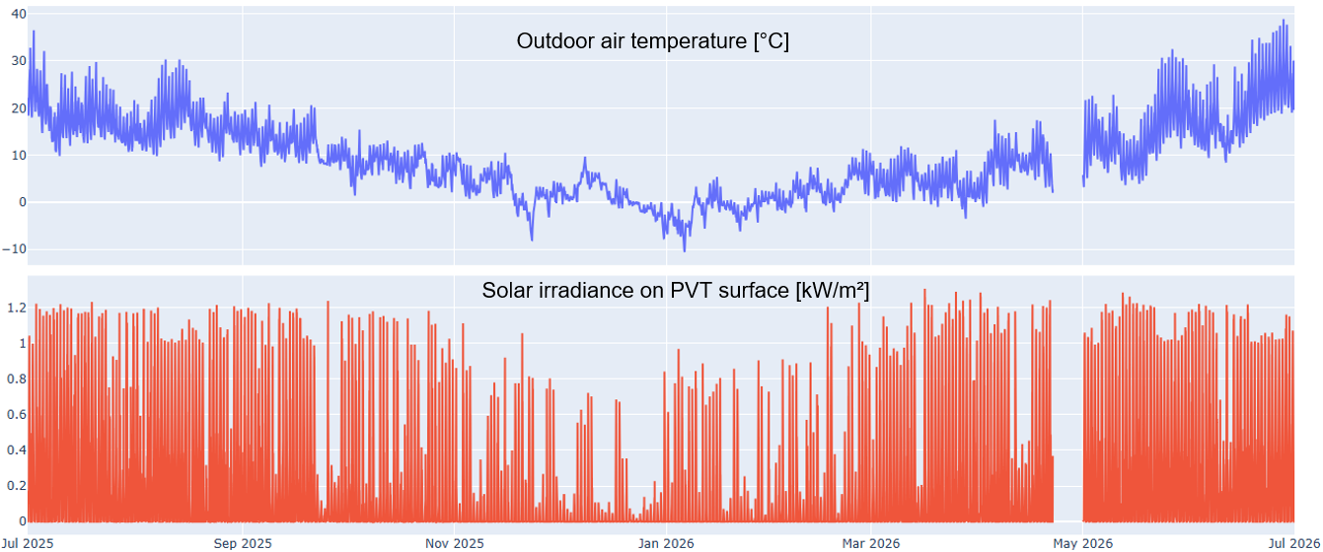
Figure 4. High-resolution time series of outdoor air temperature and solar irradiance on the tilted PVT collector surface.

Figure 5. Monthly solar irradiation on the tilted PVT collector surface and monthly mean outdoor air temperature.
3.2 Heat Demand and Heat Generation
During the 12-month measurement period, the total heat demand of the building was 24’042 kWh, which is close to the annual heat demand of 26,100 kWh estimated from historical gas consumption. Figure 6 presents the heat demand of the three main heat sinks: space heating via HC1 and HC2, DHW preparation, and active PVT collector defrosting. Space heating accounted for approximately 92% (22,031 kWh) of the total building heat demand. DHW preparation accounted for approximately 4% (979 kWh). Active PVT collectors defrosting accounted for an additional 4% (1033 kWh). The total heat generation by the heat pump, electrical heating rod and gas boiler amounted to 24,572 kWh. The heat pump provided 74% of this heat, while the electrical heating rod and gas boiler supplied 14% and 12%, respectively. The combined electricity consumption of the heat pump and electrical heating rod was 9,923 kWh. The heat pump’s heat source was primarily provided directly by the PVT collectors, which supplied approximately 73% of the total heat input to the heat pump evaporator. The remaining heat was mainly supplied by the ice storage, while a very small portion of approximately 0.5% originated from the defrost heat exchanger. This residual contribution occurred only during the initial defrosting events due to an incorrect control setting, which allowed the defrost heat exchanger to transfer heat to the heat source brine circuit while the heat pump was operating. The control strategy was subsequently corrected so that PVT collector defrosting occurs only when the heat pump is switched off.

Figure 6. Annual heat demand, heat generation, electricity consumption of the heat pump and electrical heating rod, and heat sources of the heat pump during the 12-month monitoring period.
Figure 7 presents the monthly heat generation and the contribution of the three heat generators: heat pump, electrical heating rod, and gas boiler. During the summer months, heat generation by electrical heating rod dominates. This results from the high availability of surplus PV electricity and the system control strategy, which prioritizes the use of PV surplus for thermal storage via the heating rod. An exception can be observed in months 8 and 9, corresponding to the beginning of the measurement campaign. During parts of these months, the heat pump operation was being tested, and the electrical heating rod was therefore disabled.
The gas boiler was used primarily during the winter months from December to February. This was mainly caused by two limitations. First, the thermal capacity of 5.2 m³ ice storage is not designed as a seasonal storage covering 100% of the winter demand; a larger storage could not be implemented at the demonstration site due to space constraints. By December, the storage increasingly reached its maximum allowable ice fraction. According to the manufacturer’s specifications, the ice fraction must not exceed 80%, and the storage should not be operated beyond this limit. Consequently, the ice storage could not be used as a heat source during many periods of the coldest winter months. Second, the operating temperature of the PVT collectors was limited. PVT systems used as heat sources for heat pumps can generally operate with very low brine temperatures, such as −15 °C. Such low temperatures are relevant during periods without solar radiation, when the PVT collectors operate primarily as air-source collectors by extracting heat from the ambient air. In this operating condition, the brine temperature must be below the outdoor air temperature to enable heat extraction from the ambient air. During the measurement period, the PVT collector outlet temperature was typically around 3–4 K below the outdoor air temperature during periods without solar irradiance, with differences reaching up to 7 K in some cases. Since this difference refers to the collector outlet temperature, the brine temperature within the collector can be even lower, highlighting the importance of allowing sufficiently low brine temperatures when using PVT collectors as a heat source for heat pumps. In the present system, however, the certified minimum brine temperature of the PVT collectors −5 °C which were not undercut to not undermine product warranty. This limitation constrained heat pump operation during several winter periods, requiring the heating rod and gas boiler to provide additional backup heating.

Figure 7. Monthly heat generation and the contribution of the three heat generators: HP, electrical heating rod, and gas boiler.
3.3 Electricity Consumption, PV Generation, and PV Self-Consumption
The PV system generated 9,423 kWh of electricity from a cumulative solar irradiation of 1299 kWh/m² on the 40.4 m² collector area, yielding a PV conversion efficiency of roughly 18.0%. From the total PV generation, roughly 55% was directly self-consumed in the building. The total electricity consumption in the building was 12,753 kWh, of which roughly 40% was directly supplied by on-site PV generation. The electrical heating rod mainly utilized surplus PV electricity, with 73% of its heat output derived from direct solar power. The heat pump PV electricity share was 27%, while for the household it was 39%. Figure 8 presents the monthly electricity consumption, PV generation and PV self-consumption, highlighting the seasonal mismatch between generation and consumption as well as the PV self-consumption variation.

Figure 8. Monthly electricity consumption, PV generation, and PV self-consumption during the 12-month monitoring period.
3.3 Heat Pump
The 12 kW direct-condensing propane (R290) heat pump developed within the project was used in the building. A distinctive feature of this HP is the integration of the condenser heat exchanger directly into the buffer tank. This configuration allows the HP to achieve high water temperatures for DHW preparation by de-superheating the refrigerant while actually condensing at a lower temperature required for space heating. To characterize the operating conditions of the HP, Figure 9 presents the average temperatures measured in the buffer tank during periods when the HP was operating. The tank temperature was measured at four different heights (bottom, 40%, 60%, and top), together with the inlet temperature of the HP evaporator. These measurements illustrate the temperature level at which the direct-condensing HP operated on the condenser and evaporator side. Figure 10 presents the monthly heat production of the heat pump together with the corresponding monthly seasonal performance factor (SPF). The SPF was calculated as the ratio of the heat generated by the heat pump to the electricity consumed by the compressor. Over the complete 12-month period, the heat pump achieved an annual SPF of 2.9.

Figure 9. Buffer tank temperature at four different heights and HP evaporator inflow temperature. Considering only the periods during which the heat pump was in operation

Figure 10. Monthly heat pump heat generation and seasonal performance factor (SPF).
3.3 Heat Pump Heat Source
The heat source management represents a core innovative aspect of the system, comprising both the management of heat supplied to the HP evaporator by the PVT collectors and ice storage, and the regeneration of the ice storage using the PVT collectors. Figure 11 presents the monthly heat supplied to the HP evaporator together with the average brine temperature entering the HP evaporator. The PVT collectors remained the dominant heat source throughout all months, partly due to a control strategy implemented to reduce the use of the ice storage. Given the storage’s limited thermal capacity, its discharge was prioritized for periods when the PVT collectors could not provide sufficient heat. Consequently, in several operating conditions, the PVT collectors were maintained as the heat source even when the ice storage could provide heat to the evaporator at a higher temperature. This strategy was first implemented in October, resulting in a clear reduction in the heat supplied by the ice storage in this month, as shown in Figure 11.

Figure 11. Monthly heat supplied to the heat pump evaporator by ice storage, PVT collectors and PVT defrost HX. And average brine inlet temperature during the 12-month monitoring period.
As presented in Figure 3. Heat source circuit operation modes when heat pump is on., the heat source brine circuit can operate in different hydraulic modes when heat pump is on. Figure 12 presents the monthly share of heat supplied to the evaporator by each of these operating modes. The PVT-only mode was clearly dominant throughout the monitoring period. In addition, the parallel operation of the PVT collectors and ice storage (PVT+ICE parallel mode) was particularly relevant during winter. Since the PVT brine temperature was limited to −5 °C, the ice storage was operated in parallel with the PVT collectors when necessary to prevent the brine temperature from falling below this threshold. The ICE-only mode became increasingly limited from October onward, following the implementation of the control strategy intended to preserve the available thermal capacity of the ice storage. The PVT to HP to ICE shows a relatively constant share around 10% of source energy all around the year. Nevertheless it contributes significantly to the regeneration of the ice storage during cold months (around one third, see Figure 14) and thus allows the extended PVT+ICE parallel and ICE only operation at other moments.

Figure 12. Monthly contribution of the different heat source operating modes to the heat supplied to the heat pump evaporator.
3.3.1 Ice Storage
Figure 13 shows the monthly regeneration and discharge of the ice storage by the PVT collectors and heat pump, respectively, together with the monthly average storage temperature. The total annual regeneration heat supplied by the PVT collectors to the ice storage was 6,855 kWh. Most of the regeneration heat was supplied during summer. However, a large portion of this heat is subsequently dissipated to the ground. From November to January, the heat transferred from the storage to the HP was higher than the heat supplied for ice storage regeneration by the PVT collectors.
During the winter period, the ice storage gains heat not only from the PVT regeneration but also from the surrounding ground. To approximate the ground heat gains contribution, a balance period was defined from the initial ice formation to the complete disappearance of ice within the storage. Initial ice formation was assumed when tank sensor first reached 0°C, and the complete ice-free state was defined when temperature rose above 0°C. This duration — spanning from November 20, 2025, to February 27, 2026 — was assumed to maintain a continuous two-phase ice-water mixture, and that the storage returned to a comparable energetic baseline state at both boundaries. Over this timeframe, an energy balance was formulated: total discharging to the heat pump accounted for 1840 kWh, while active regeneration via the PVT collectors supplied 1129 kWh. The resulting deficit of approximately 710 kWh represents the net heat transferred from the surrounding ground to the storage. This yields an average thermal ground heat gain of roughly 300 W. The area facing ground of each storage unit was around 8.8 m². While acknowledging that this is a rough estimation due to unknown storage states, it provides a macro-level estimation of ground heat gains.

Figure 13. Monthly heat supplied to ice storage by the PVT collectors (regeneration) and heat discharged from the ice storage to the HP evaporator, and monthly average storage temperature.
The ice storage can be regenerated by the PVT collectors in two different operating modes. In the first mode, the heat pump is switched off and the PVT collectors supply heat directly to the ice storage. In the second mode, the heat pump is operating, corresponding to the PVT-to-HP-to-ICE serial mode described in section 2.3. Figure 14 shows the regeneration heat supplied by the PVT collectors in these two operating modes. The PVT-to-HP-to-ICE serial mode is particularly relevant during winter, accounting for around 30 % share of the ice storage regeneration during December to February.

Figure 14. Monthly share of heat supplied by PVT collectors for ice storage regeneration according to operation mode: PVT-to-ICE (heat pump off) and PVT-to-HP-to-ICE serial (heat pump on) operating modes.
3.3.1 PVT collectors
The PVT collectors generated a total of 15,444 kWh of heat, of which 56% was supplied to the heat pump evaporator and 44% was supplied to the ice storage. In addition, 1,033 kWh of heat was extracted from the buffer storage for active PVT collector defrosting. Figure 15 presents the monthly PVT heat output and defrosting heat demand, together with the monthly average PVT supply temperatures when the collectors are supplying heat to the heat pump evaporator and to the ice storage. The defrost heat exchanger was installed in November, and the defrosting heat demand measured during this month may be overestimated due to commissioning and testing activities. The PVT heat output was measured both during periods with and without solar irradiance, shown in Figure 15. Heat extraction from the PVT collectors during periods without solar irradiance indicates operation solely as air-source collectors. This operating condition is particularly relevant during winter when the PVT collectors are used as a heat source for the heat pump.

Figure 15. Monthly PVT heat output and heat demand for active collector defrosting, distinguishing operation with and without solar irradiance as Irr > 0 and Irr = 0, respectively. And monthly average PVT supply temperatures when supplying to heat pump evaporator and ice storage.
Figure 16 presents the monthly heat output and incident solar irradiation when the PVT collectors operate as solar thermal collectors, i.e., when brine is circulated through the collectors. The corresponding thermal conversion efficiency is also shown. Over the 12-month period, the total solar irradiation incident on the PVT collector surface during these operating periods was 35,416 kWh, resulting in a thermal conversion efficiency of approximately 44%. However, the PVT collectors also operate as air-source collectors. This is particularly evident in December, when the calculated monthly thermal conversion efficiency exceeded 100%, as the heat extracted from the ambient air is not included in the incident solar irradiation.

Figure 16. Monthly PVT heat output, incident solar irradiation, and thermal conversion efficiency during operation.
3.4 System Efficiency
The HPPVT system efficiency is evaluated using the Seasonal Performance Factor (SPF), defined as the ratio of the useful heat generated to the corresponding final energy consumption. Two specific SPF definitions are assessed:
- Electrical Heat Generators SPF: This metric accounts for the combined heat output of the heat pump (18,140 kWh) and the heating rod (3,549 kWh), divided by their total electricity consumption (6,301 kWh and 3,622 kWh, respectively), yielding an overall SPF of 2.2. The high difference compared to the SPF of the heat pump only can mostly be attributed to the extended operation of the heating rod for self-consumption of PV electricity. Excluding periods with this operation mode yields an electric system SPF of 2.6.
- Grid-Specific Electrical Heat Generators SPF: This metric isolates imported electricity from the grid (4574 kWh for the heat pump and 992 kWh for the heating rod), highlighting the influence of on-site photovoltaic self-consumption on system performance. The resulting SPF is 3.9.
- Conclusions and Outlook
The 12-month field evaluation demonstrated the feasibility of the investigated heat pump system with a hybrid heat source combining PVT collectors and ice storage for residential heating. The PVT collectors were the dominant heat source throughout the year, while the ice storage provided complementary heat, particularly during periods of limited PVT availability.
The field operation also revealed important limitations during winter. The rear insulation of the PVT collectors and the minimum brine temperature limit of −5 °C restricted their operation as ambient-air heat source at low outdoor temperatures. Under these conditions, the 5.2 m³ ice storage was insufficient to provide the required heat storage capacity during the coldest periods. To ease these limitatoins, the control strategy prioritized the PVT collectors and preserved the ice storage for periods when PVT operation was constrained by the minimum brine temperature limit. Moreover, the PVT-to-HP-to-ICE serial operating mode enabled additional ice storage regeneration during winter. Although these strategies reduce the heat source temperature of the heat pump and therefore compromise heat pump efficiency, it was beneficial for maintaining the availability of the ice storage during the coldest periods when PVT operation was limited. Nevertheless, due to the exposed limitations, the heat source system could not provide enough heat to the heat pump during several winter periods, and the gas boiler was required as backup.
Future work will focus on improving the PVT collector design and heat source control. PVT collectors used as heat sources for heat pumps should avoid rear insulation and allow substantially lower minimum brine temperatures. These modifications must be investigated with the aim of increasing winter heat pump availability and reducing the dependence on backup heating.
- Acknowledgements
The work presented in this paper received funding from the German Federal Ministry of Economic Affairs and Climate Action (BMWK) under the grant agreement number FKZ 03EN4016A (HPPVT40). The authors acknowledge the good cooperation with the project partners ino Wärmepumpen GmbH, res – regenerative energietechnik und -systeme GmbH and goodmen energy GmbH.
- References
Bavia Bampi, B., Knapp, T., Pröll, M., Nienborg, B., 2023. Untersuchung von PVT-Wärmepumpen-Systemen mit Quellspeicher, in: 33. Symposium Solarthermie und Innovative Wärmesysteme 2023. DOI: 10.24406/publica-4025.
Chhugani, B., Pärisch, P., Helmling, S., Giovannetti, F., 2022. Comparison of PVT - heat pump systems with reference systems for the energy supply of a single-family house. Solar Energy Advances. 3, 100031. DOI: 10.1016/j.seja.2022.100031.
Chhugani, B., Pärisch, P., Giovannetti, F., 2023. Photovoltaic-Thermal (PVT) collectors as monovalent or bivalent heat sources for heat pumps in new multi-family houses, in: Proceedings of the ISES Solar World Congress (SWC 2023). pp. 1–9. DOI: 10.18086/swc.2023.04.03.
Diewald, K., Beckschulte, M., Fugmann, H., Schnabel, L., Thomas, C., 2023. Kondensatordesign in einem thermischen Speicher für eine R290 Wärmepumpe, in: Deutsche Kälte- und Klimatagung 2023. Available from: https://publica.fraunhofer.de/entities/publication/5c4ee7c9-51df-41cc-a2f4-adc9a72e724c (Accessed August 2026).
Diewald, K., Schnabel, L., Fugmann, H., Thomas, C., 2024. Innovative Condenser - Storage Tank - Concept for Residential Heat Pumps, in: 8th International High Performance Buildings Conference at Purdue 2024. DOI: 10.24406/H-522305.
Khamidov, D., Bavia Bampi, B., Frison, L., Nienborg, B., 2024. Model Predictive Control of a Heat Pump System Integrated with PVT Collectors and Ice Storage, in: Proceedings of EuroSun 2024. ISES and IEA SHC 15th International Conference on Solar Energy for Buildings and Industry. DOI: 10.18086/eurosun.2024.01.06.
Kramer, K.S., Mehnert, S., Munz, G., Helmling, S., Lämmle, M., 2023. Photovoltaic Thermal Technology Collectors, Systems, and Applications. Energy Technology. 11 (12), 2300378. DOI: https://doi.org/10.1002/ente.202300378.
Kramer, K., Helmling, S., 2024. IntegraTE: Initiative zur Marktetablierung und Verbreitung von Anlagen zur thermisch-elektrischen Energieversorgung mittels PVT-Kollektoren und Wärmepumpen im Gebäudesektor. Available from: https://wp-monitoring.ise.fraunhofer.de/integrate/german/index/Medien.html (Accessed August 2026).
Lämmle, M., Herrando, M., Ryan, G., 2020. Basic Concepts of PVT Collector Technologies, Applications and Markets (Report D5 of IEA SHC Task 60). International Energy Agency Solar Heating and Cooling Programme (IEA SHC). Available from: https://www.iea-shc.org/Data/Sites/1/publications/IEA-SHC-Task60-D5-Basic-Concepts-of-PVT-Technologies.pdf (Accessed August 30, 2026).

