**EXPERIMENTAL CHARACTERIZATION OF SATIN WEAVE COMPOSITE LAMINATE AT HIGH STRAIN RATES USING SPLIT HOPKINSON BAR TESTING**

Bharath Ravindran1*, Chaman Srivastava1, George Lampeas1

1Laboratory of Technology & Strength of Materials

Department of Mechanical Engineering and Aeronautics

University of Patras, Rion-26500

Email: [bharath.ravindran@upatras.gr](mailto:bharath.ravindran@upatras.gr), Web Page: <http://www.iconic-itn.eu>

**Abstract:** Composite materials exhibit superior mechanical properties over metallic materials and for this reason they attracted increased importance in recent decades. In the present work, two dimensional 5-harness satin carbon-epoxy woven composite laminates are investigated for high strain rate properties using Split Hopkinson Pressure Bar (SHPB) testing. The specimen geometry is designed to suit the testing facility and to achieve the desired strain rates. 5H satin carbon epoxy laminate is subjected to compressive testing in both 0° (warp direction) and 90° (weft direction). A high speed camera is used to capture the deformation and the failure patterns of materials. The experimental results are analyzed in terms of stress and strain curve, strain rate, failure modes for investigated material system.

**Keywords:** High strain rate, Split Hopkinson pressure bar, satin weave

1. **Introduction**

Carbon fibre woven composites have been increasingly employed in engineering applications when high performance, manufacturability and high specific energy absorption characteristics are required. Composite materials have been applied to design energy absorption elements of automobile, aerospace and shipbuilding structures for lightweight and high performance design [1]. During the service life, these structures would undergo complex loading conditions, e.g., multiaxial dynamic loading, resulting to high strain rate loading. The mechanical properties of composite materials may be different at high strain rate loading compared to those at quasi-static condition; for effective use of composite materials it is essential to fully understand the mechanical behavior under high strain rates and different loading conditions.

Several studies have been carried out on the performance of carbon fibre woven composites at different strain rates. With respect to compressive properties of woven composite systems, researchers [2-6] have observed that the initial modulus and strength are enhanced under high strain rate loading. However few studies [7-9] have been carried out so far on the compressive performance of satin weave carbon/epoxy woven composite at different strain rates, which is the subject of the present investigation. The results in [7-9] illustrated that the compressive properties are strain rate sensitive with highly direction dependency characteristic.

The objective of the present study is to derive the behavior of satin weave carbon/epoxy composites under high strain rate compressive loading. The compressive strength, modulus and failure strain were evaluated and are presented along warp and weft directions. The compression characteristics, as well as the strain rate dependency of mechanical properties and failure patterns are discussed by comparing experimental results obtained at different strain rates and loading directions both quantitatively and qualitatively.

1. **Material and specimen fabrication**

The material currently investigated is a 5-harness-satin weave carbon– epoxy representing a 2D woven composite. Satin weave is one of the three important textile weave types. 5HS weave is defined as four weft yarns floating over a warp yarn or four warp yarns floating over a single weft yarn. This arrangement produces fabric with maximum degree of smoothness without prominent weave features. The nominal ply thickness is 0.4 mm which were manually laid with stacking sequence of [0/90]5 and manufactured at Ulster University using the Vacuum Assisted Resin Transfer Moulding (VARTM) process (Fig 1), using a standard aerospace qualified epoxy resin system.

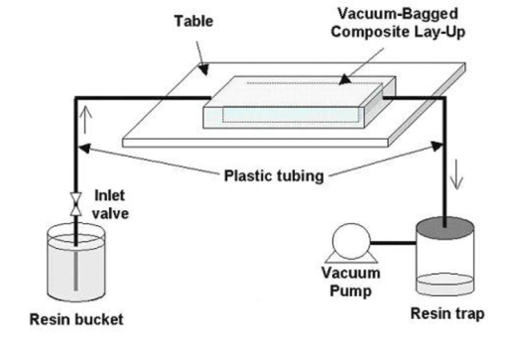

Figure 1. Vacuum Infusion Method [10]

The square plate produced was cut into compression specimen in both warp and weft directions as shown in Fig 2.

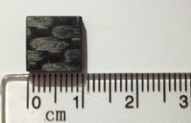

Figure 2. Compression Specimen

The nominal compression specimen dimensions were 10 x 10 x 4 mm (length x width x thickness).

1. **Experimental setup**

To determine the static strength, quasi-static tests were carried out on an MTS 100 KN machine in displacement control mode with a constant crosshead speed of 0.5mm/min. The load and crosshead displacement response for each test was recorded by the machine data acquisition system. For high strain rate testing, a SHPB is used. A standard compression SHPB facility consists of a striker bar, an incident bar and a transmission bar, while the test specimen is placed between the bars. Strain gauges are attached on the incident and transmission bars, in order to record strain histories, which are sent to a data acquisition system for data collection and further processing as shown in Fig 3.

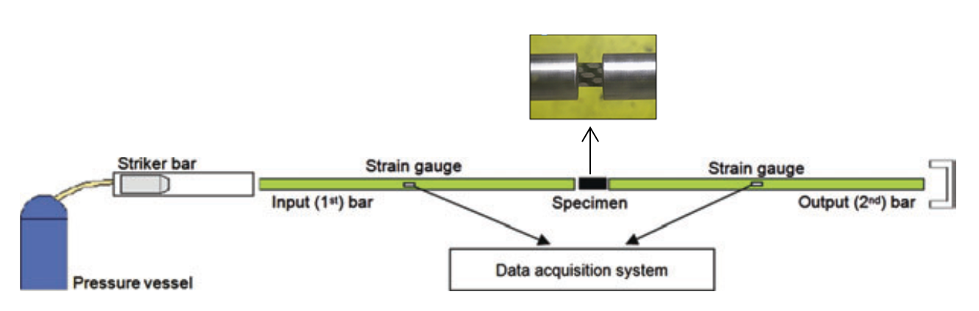

Figure 3. Schematic diagram of SHPB setup

The striker bar (impactor) is accelerated by a sudden release of compressed air in the gas gun (pipe) and impacts the input bar. By the impact, a compressive longitudinal wave (incident wave) is developed in the incident bar, which travels along the bar towards the specimen; when this compressive wave reaches the incident bar/specimen interface, a part of it is reflected back as a tensile wave, while the rest travels through the specimen and towards the transmission bar as a compressive wave. For the material properties derivation only the initial tensile reflected and the initial compressive transmitted waves are used and not the complete recorded pulse [11].

The segregated effective pulses, used as input in Equations (1) to (3), shown hereafter, in order to derive the specimen’s stress and strain histories, as well as, the strain rate during the experiment. The main SHB equations used are the following:

Specimen Stress:



(1) Where: A0 = Incident and transmission bars cross sectional area

As = Specimen cross sectional area

Eo = Striker, incident and transmission bars modulus of

Elasticity

εo(t) = Strain at transmission bar

σs(t) = Specimen stress

Specimen Strain:



(2)

Where: Ci = Wave velocity

Ls = Specimen length

ει(t) = Strain at incident bar

εs(t) = Specimen strain

Strain Rate:



(3)

A classical Split Hopkinson bar facility, based on the principle described previously, is installed at the Laboratory of Technology and Strength of Materials of University of Patras (Fig 4), which can achieve strain rate of the order of 100–10,000 s­­­-1.

|  |  |
| --- | --- |
|  | 4 |
| Figure 4. SHB facility of LTSM/UP | Figure 5. SHB pressurization system |
|  |  |

The pressurization system of the SHPB, which is shown in Fig 5, enables the safe system pressurisation up to 12bar, which is required in order to achieve strain rates of 10,000 s­­­-1 or higher (depending on specimen size). A control box allows the use of each pressure network branch with high accuracy, while fast activated pressure valves are installed to achieve high velocity air flow in the air – gun. The experimental process is almost fully automated, with very limited human interaction during the experiment execution. Typical electrical resistance strain gauges of 2mm gauge length are used. The incident, transmission and striker bars, of the SHPB apparatus, are made of maraging steel, having ultimate tensile strength of 980 MPa and yield stress of 760 MPa. The geometries of the striker, incident and transmission bars were in agreement with the American Society of Metals (ASM) handbook guidelines [12] and the related literature for the experimental configuration of a SHB arrangement [13].

1. **Experimental Results**

In the present investigation the static and high strain rate compressive behavior of the satin weave carbon/epoxy composite has been investigated along 0º (warp direction) and 90º (weft direction). Due to specific of the weaving satin weave fabric composite exhibit different properties along the warp and weft (fill) direction. The influence of the high strain rate on the loading direction, maximum stress and modulus is evaluated and compared with the quasi-static test response.

The satin weave carbon/epoxy composite specimen was loaded along 0º (warp) and 90º (weft) directions at three different strain rates. For each orientation, 2 specimens were tested. In Fig 6, the strain rate – time plot of specimens subjected to different pressure are presented, for three varied pressure values, i.e. 1.5, 2 and 3 bars which results to average strain rates of 1550 /s, 1800/s and 2100/s, respectively.

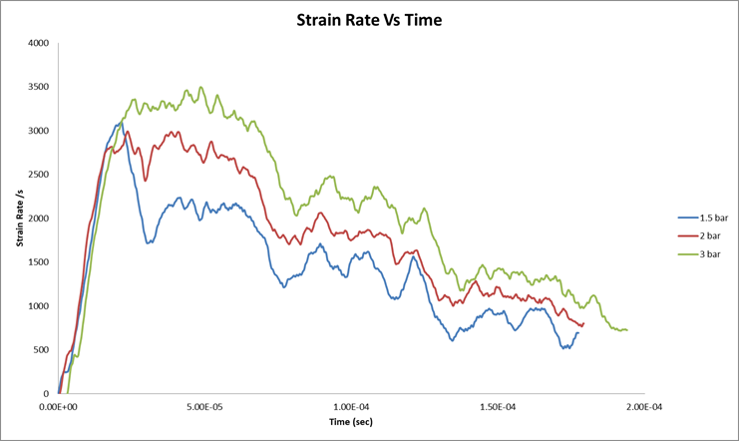

Figure 6. Strain Rate – Time response for varied pressure

Table 1

Properties of satin weave carbon/epoxy laminate under static and high strain rates compression loading along 0° (Warp Direction)

|  |  |  |  |  |
| --- | --- | --- | --- | --- |
| Strain Rate | Specimen | Peak stress  σult  MPa | Strain at peak stress  εult  (%) | Average Slope (Equivalent Modulus)  Ε  GPa |
| Quasi-Static | WA-SP01 | 391.20 | 5.24 | 7.46 |
| WA-SP02 | 383.28 | 4.86 | 7.86 |
| 1550 | WA-SP03 | 483.70 | 5.26 | 9.19 |
| WA-SP04 | 450.12 | 4.55 | 9.89 |
| 1800 | WA-SP05 | 521.07 | 5.41 | 9.63 |
| WA-SP06 | 516.84 | 5.17 | 9.98 |
| 2100 | WA-SP07 | 512.19 | 6.13 | 8.35 |
| WA-SP08 | 479.20 | 5.97 | 8.02 |

In table 1 the properties of satin weave composite under static and high strain rates compression loading along 0º (warp direction) are presented. The peak stress and the modulus values show increasing trends from quasi static to strain rate of 1800 /s, while no further increase was observed with further increase in the strain rate which is compatible with findings reported by author in Ref [14]. When compared to static properties, dynamic properties exhibit an increase of about 20%.

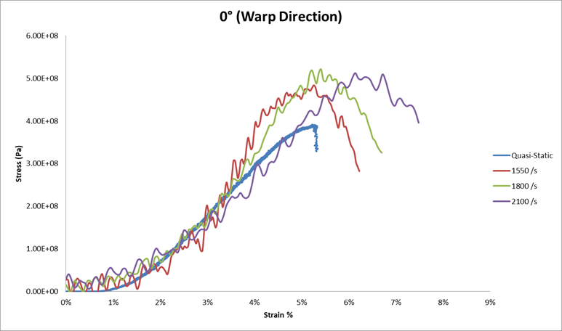

Figure 7. Stress–Strain responses of satin weave carbon/epoxy laminate for warp loading

In Fig 7 stress – strain plots of specimens in warp direction for quasi static and different strain rate are illustrated. It can been observed that for the quasi static specimen remains the final failure is close to the initial failure, while for dynamic loading the peak stress and the average initial slope of stress – strain plot (equivalent modulus) increases with increase in strain rate up to strain rate 1800 /s and then tend to be stabilised or slightly decrease. The predominant failure mode was delamination of the specimen into three or four sub laminates in both static and high strain rate. While Fig 8 shows the specimen exhibit combination of matrix failure with splitting at static loading.

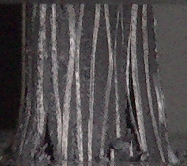 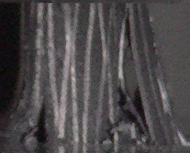 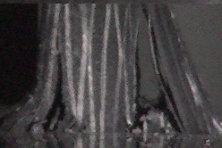

Figure 8. Failure mode at static loading

In table 2 the properties of satin weave composite under static and high strain rates compression loading along 90º (weft) are presented. The peak stress and equivalent modulus show increasing trend with the increase in strain rate.

Table 2

Properties of satin weave carbon/epoxy laminate under static and high strain rates compression loading along 90° (Weft Direction)

|  |  |  |  |  |
| --- | --- | --- | --- | --- |
| Strain Rate | Specimen | Peak stress  σult  MPa | Strain at peak stress  εult  (%) | Average slope (Equivalent Modulus)  Ε  GPa |
| Quasi-Static | WE-SP01 | 416.98 | 4.12 | 10.10 |
| WE-SP02 | 405.31 | 3.79 | 10.66 |
| 1550 | WE-SP03 | 510.16 | 4.72 | 10.81 |
| WE-SP04 | 534.28 | 4.95 | 10.79 |
| 1800 | WE-SP05 | 668.34 | 5.18 | 12.88 |
| WE-SP06 | 634.97 | 5.20 | 12.21 |
| 2100 | WE-SP07 | 706.12 | 4.39 | 16.08 |
| WE-SP08 | 687.06 | 4.41 | 15.57 |

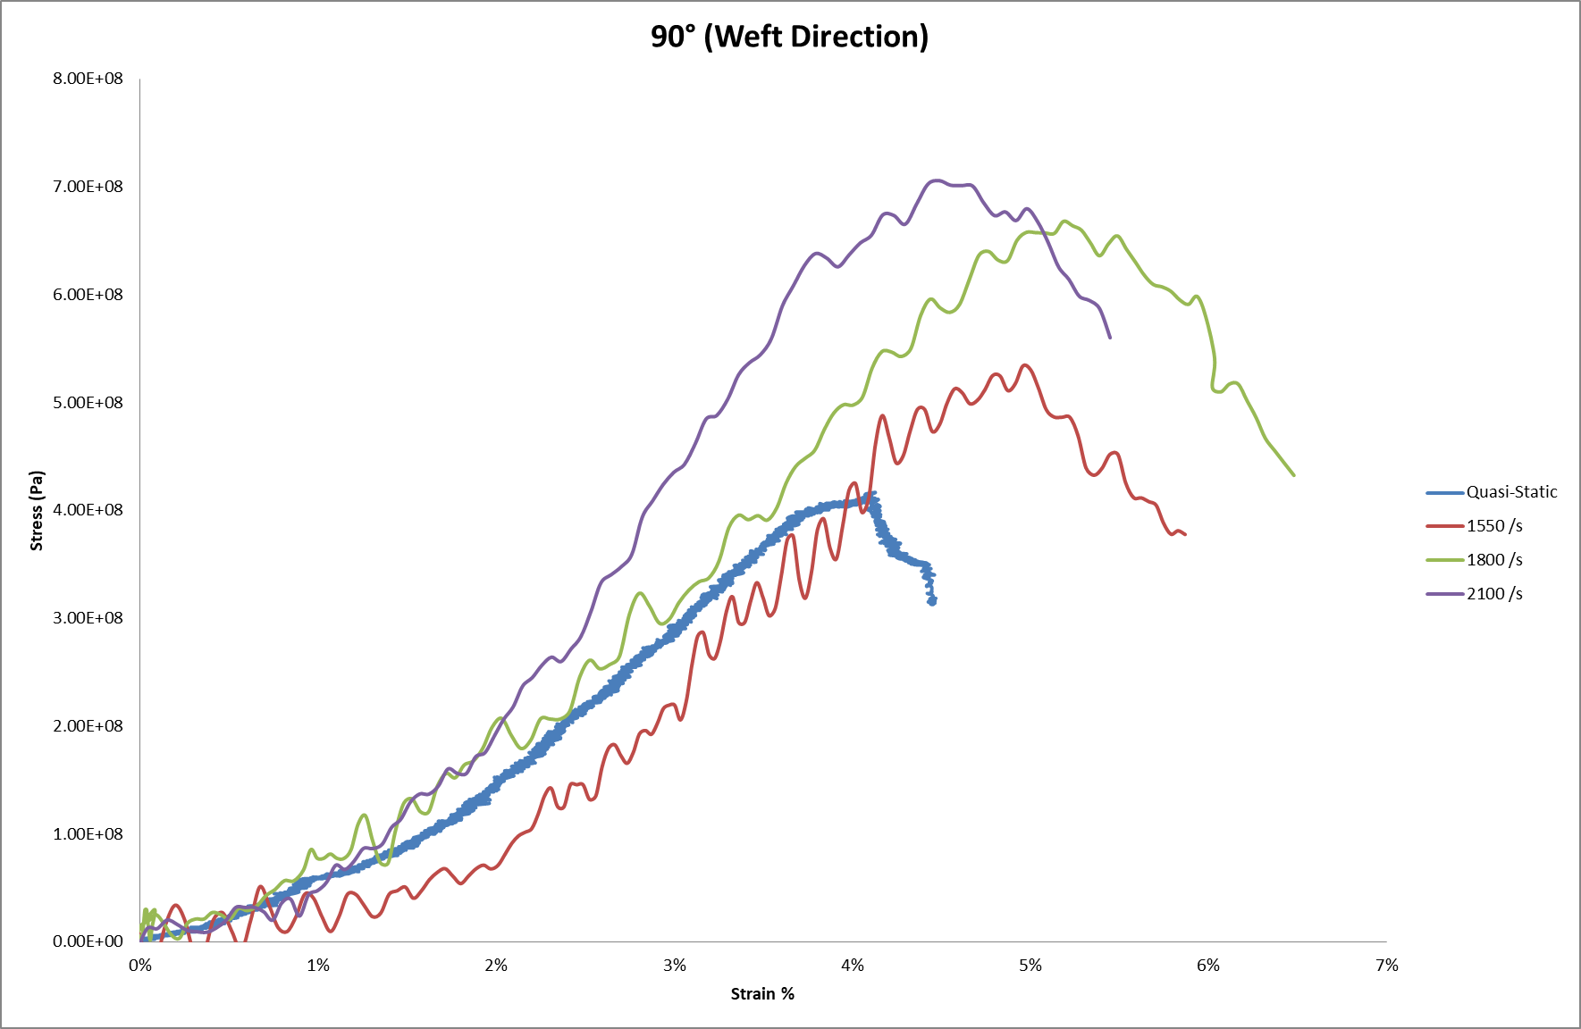

Figure 9. Stress–Strain responses of satin weave carbon/epoxy laminate for weft loading

In Fig 9 the stress – strain plots of specimens in weft direction for quasi static and increasing strain rates are presented. Similar trends to the warp direction test may be observed, with some difference in the final failure of quasi static loading, while for dynamic loading the peak stress and the average initial slope of stress – strain plot (equivalent modulus) increases with increase in strain rate. Also similar failure mode of matrix failure with delamination was observed in weft direction for both static and high strain rate loading.

1. **Conclusion**

Quasi-Static and high strain rate compressive experimental investigation on satin weave carbon/epoxy composite laminate along 0° (warp direction) and 90° (weft direction) were carried out. In all the cases, there is considerable increase in the strength and equivalent modulus at high strain rates, as compared to static loading. Ultimate strength and equivalent modulus along weft direction are higher to those of the warp direction at high strain rate loadings. In all the cases of quasi-static and high strain rate tests, the failure was predominantly combination of matrix failure with delamination (splitting). Based on the compressive properties and failure modes of satin weave composites, it can be concluded that compressive behaviours are highly dependent on loading direction. Furthermore, high strain rate dependencies of other properties like tension and shear have to be investigated.

1. **Acknowledgement**

The authors kindly acknowledge the support of European Union’s Horizon 2020 research and innovation programme under Marie Skłodowska-Curie grant agreement No 721256. The work is part of project entitled “Improving the Crashworthiness of Composite Transportation Structures" – ICONIC.

1. **Reference**
2. Obradovic J., Boria S., and Belingardi G., Lightweight design and crash analysis of composite frontal impact energy absorbing structures. *Compos. Struct.* 94 (2012) 423-30.
3. Hou J.P., and Ruiz C., Measurement of the properties of woven CFRP T300/914 at different strain rates. *Compos. Sci. Technol.* 60 (2000) 2829-34.
4. Todo M., Takahashi K., Beguelin P., and Kausch H.H., Strain-rate dependence of the tensile fracture behaviour of woven-cloth reinforced polyamide composites. *Compos. Sci. Technol.* 60 (2000) 763-71.
5. Foroutan R., Nemes J., Ghiasi H., and Hubert P., Experimental investigation of high strain-rate behavior of fabric composites. *Compos. Struct.* 106 (2013) 264-9.
6. Chen X., Li Y.L., Zhi Z., Guo Y.Z., and Ouyang N., The compressive and tensile behavior of a 0/90 C fiber woven composite at high strain rates. *Carbon* 61 (2013) 97-104.
7. Ma P., Jiang G., Chen Q., Miao X., and Zhao S., Compression behaviors of carbon woven composites with carbon nanotube-filled epoxy resin under high strain rates. *Textil. Res. J.* 85 (2015) 36-50.
8. Hosur M.V., Alexander J., Jeelani S., Vaidya U.K., and Mayer A., High Strain Compression Response of Affordable Woven Carbon/Epoxy Composites. *J. Reinf. Plast. Compos.* 22 (2003) 271-96.
9. Hosur M.V., Alexander J., Jeelani S., Vaidya U.K., Jeelani S., and Mayer A., Studies on the off-axis high strain rate compression loading of satin weave carbon/epoxy composites. *Compos. Struct.* 63 (2004) 75-85.
10. Koerber H., Xavier J., Camanho P.P., Essa Y.E., and Escalera F.M., High strain rate behaviour of 5-harnesssatin weave fabric carbon–epoxy composite under compression and combined compression–shear loading. *Int. J. Solids Struct.* 54 (2015) 172-182.
11. Posen Chiu., In-Mold coating of composites manufactured with the resin infusion between double flexible tooling processes by mean of co-infusion. Theses. 2004
12. Kaiser A. M., Advancements in the Split Hopkinson Bar Test, MSc Thesis, Blacksburg, Virginia, 1998
13. Kuhn, H., Medlin, D., ASM Handbook Volume 08: Mechanical Testing and Evaluation, ASM International, USA
14. Lee, O.S., Kim, M.S., “Dynamic material property characterization by using split Hopkinson pressure bar (SHPB) technique”, Nuclear Engineering and Design, 226, 119 – 125 (2003).
15. M.V. Hosur, J. Alexander, U.K. Vaidya, S. Jeelani, A. Mayer, Studies on the off-axis high strain rate compression loading of satin weave carbon/epoxy composites, Composite Structures, Volume 63, Issue 1, 2004, Pages 75-85.