EuroSun2026
POLYGENERATING SOLAR COLLECTOR’S ALLIANCE (POLYGEN ALLIANCE)
João P. Cardoso^{1,2}, Maryam Shalaby³ (corresponding author), Marco Pellegrini⁴, Rakshya Shrestha⁴
¹ Laboratório Nacional de Energia e Geologia, I.P., Estrada do Paço do Lumiar, 22, 1649-038 Lisboa, Portugal
² Department of Building Engineering, Energy Systems and Sustainable Science, University of Gävle, 80 176 Gävle, Sweden
³ MG Sustainable Engineering AB, 753 21 Uppsala, Sweden
⁴ Alma Mater Studiorum – Università di Bologna, Via Zamboni, 33, 40126 Bologna BO, Italy
E-mails: joao.cardoso@lneg.pt, maryam@mgsust.com, marco.pellegrini3@unibo.it, rakshya.shrestha2@unibo.it
Summary
Polygenerating Solar Collectors offer a pathway to higher overall solar conversion efficiency, optimised land use and reduced system complexity by offering multiple outputs and/or services. Their development, however, remains constrained by the novelty of the topic (resulting in fragmented research), the challenges associated with optimising solar radiation use by having polygeneration in a single device, fragmented research focused on isolated technologies and single output streams, the absence of harmonised modelling and testing methodologies, and limited dialogue among researchers, industry, policymakers, and standardisation bodies.
The Polygenerating Solar Collector’s Alliance (PolyGen Alliance), established under the EU-funded SPECTRUM project, provides a flexible collaborative platform that aims to address these barriers. It connects stakeholders working on polygenerating solar technologies to facilitate knowledge exchange, identify research gaps, align performance metrics and methodologies, and accelerate the transition from laboratory innovation to scalable deployment. Following the formal launch in March 2026 and initial membership across Europe and beyond, the Alliance will expand to open meetings and joint activities in 2027 to convert this early network into sustained collaboration among researchers, industry and related initiatives.
Keywords: Polygeneration, solar collectors, hybrid solar technologies, solar energy, R&D+i hub.
Field of application for the findings: Renewable energy systems, solar thermal and hybrid technologies, solar fuels, industrial process and energy applications.
Addressed audience: Researchers, technology developers, system integrators, industry stakeholders, policy and standardisation bodies
- Introduction
The transition toward climate-neutral energy systems requires renewable technologies that can deliver multiple useful outputs efficiently while minimising land use and system complexity. Most studies that use expressions such as "solar polygeneration system" consider plant configurations comprising solar collectors and/or photovoltaic (PV) panels plus electrolysers, Organic Rankine Cycles (ORCs), heat pumps, storage systems, desalination units, and other components (Kasaeian et al., 2020; Khodadadi and Sheikholeslami, 2022; Zhang et al., 2025). Individual solar technologies have advanced to the point of being mature and commercially available both as single-output (solar collectors, photovoltaic modules) or two-output (photovoltaic-thermal collectors) systems. However, fully integrated collectors that simultaneously produce energy (electricity, heating, and cooling), chemicals or commodities are an emerging technology, being at earlier stages of the research, development, demonstration and deployment cycle.
Recent reviews about solar-based polygeneration systems make this gap explicit. Girishkumar et al. (2026) report that: comprehensive analyses of the optimal integration of photovoltaic-thermal (PVT) systems within multi-output frameworks remain scarce; standardised frameworks for combining energy sources in polygeneration systems are lacking; the absence of universally accepted performance metrics for multi-output energy systems complicates cross-technology comparison. Limited real-world performance validation is also noted under diverse operating conditions, together with incomplete techno-economic and policy/regulatory assessment. In the closely related field of hybrid photovoltaic-thermal collectors, Herrando et al. (2023) identify scientific and engineering challenges, research gaps and innovation pathways for both collectors and systems, resulting in a dedicated discussion to key challenges for technology adoption. Broader reviews of solar multi-energy hybrid systems similarly report uneven research and development progress across configurations and highlight remaining technical challenges and research directions (Wang et al, 2024).
These findings point to a need that goes beyond another isolated prototype study: a collaborative forum where the community can exchange knowledge and discuss modelling approaches, experimental protocols, performance metrics, and deployment issues. The Polygenerating Solar Collector’s Alliance (PolyGen Alliance) was created to fill that role (IEA SHC, 2026). It is supported by the EU-funded SPECTRUM project (https://project-spectrum.eu/), but it is intended as an independent, member-driven platform for the wider community working on solar polygenerating collectors and their applications.
This paper describes the concept, operational approach, early outcomes and dissemination activities of the PolyGen Alliance, including its launch, membership growth, performance-parameter considerations, and linkages with international initiatives such as IEA SHC Task 72.
- Methodology
The PolyGen Alliance adopts a lightweight, facilitative approach rather than a rigid organisational structure with formal governance. It evolves in response to members’ needs and contributions, prioritising practical knowledge exchange over administrative overhead.
2.1 Concept and Scope
The Alliance focuses on polygenerating solar collectors as single integrated devices. To limit and clarify the scope of the Alliance, the authors defined a polygenerating solar collector as “a solar-energy conversion device that simultaneously delivers at least three useful products or services, without requiring separate downstream conversion units to establish its polygenerating nature”. Figure 1 provides a conceptual visualisation of this definition, in which a measured prototype result is not shown, but rather a concept used in the launching stage to make the definition operational: a collector architecture that assigns spectral bands to different conversions and delivers at least three useful outputs from the same aperture.
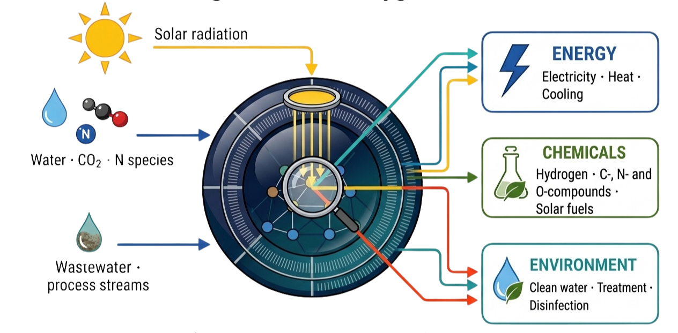
Figure 1. Illustrative Polygenerating Solar Collector concept, showing the potential simultaneous outputs of Energy, Environment, and Chemicals.
The Alliance’s scope encompasses both component-level and collector-level integration aspects. Key technological components include solar catalysts, solar reactors, photovoltaic elements, thermal receivers, optical devices (concentrators and spectral splitters), and insulation materials. These must operate in coordination within a single architecture, balancing thermal, electrical, and chemical outputs while maintaining efficiency and stability.
Collector-level focus areas include:
- Synergic solar-to-hydrogen / solar-to-chemical pathway;
- Thermal and photovoltaic conversion;
- Hybrid solar architectures;
- Integration with water and wastewater treatment.
Cross-cutting focus areas include:
- Multi-physics modelling and simulation;
- Experimental methodologies and validation protocols;
- Performance metrics and key performance indicators (KPIs);
- Environmental and social life-cycle assessment (LCA) and life-cycle costing (LCC);
- Standardisation, regulatory, and market aspects.
2.2 Launch and Operational Approach
The Alliance was formally launched in March 2026 with its first session meeting. Objectives included defining scope and purpose, aligning communication approaches, and identifying the Alliance roadmap.
Core activities comprise thematic discussions on technological and non-technological challenges, exchange of best practices, identification of common barriers, alignment of modelling approaches and experimental protocols, and facilitation of collaboration across projects and networks (while respecting intellectual-property constraints).
Communication is lean and targeted: a dedicated section on the SPECTRUM website (https://project-spectrum.eu/polygen-alliance/https://project-spectrum.eu/polygen-alliance/), a registration form for interested stakeholders, integration into the SPECTRUM newsletter, and periodic updates. Engagement prioritises quality networks over volume, including linkages with existing initiatives.
2.3 Collaboration with Other Projects and International Initiatives
The Alliance aims to collaborate with projects and international initiatives working on topics relevant to polygenerating collector development. Outreach will be used to open that collaboration. Planned actions include a first in-person workshop in spring 2027, a series of virtual meetings on selected cross-cutting topics, a Special Issue in an international peer-reviewed journal to collect scientific contributions and continued joint work with relevant IEA SHC Tasks and the IEA Hydrogen TCP.
- Initial Results
3.1 Launch and Positioning
The PolyGen Alliance was launched in March 2026 in a meeting of researchers and innovation actors working on hybrid solar technologies. Participants voted for the name, confirmed a collector-level rather than component- or system-only scope, and adopted a lightweight operating model based on thematic exchange, identification of research gaps and alignment of methods, without a heavy governance structure.
The meeting fixed two working layers that now structure the PolyGen Alliance activity (Figure 2):
- Collector level: synergic solar-to-hydrogen or, more general, solar-to-chemical pathway; thermal and photovoltaic conversion; hybrid solar architectures; integration with water and wastewater treatment.
- Cross-cutting: multi-physics modelling and simulation; experimental methods and validation protocols; performance metrics and KPIs; environmental and social life-cycle assessment (LCA) and life-cycle costing (LCC); standardisation, regulatory and market aspects.
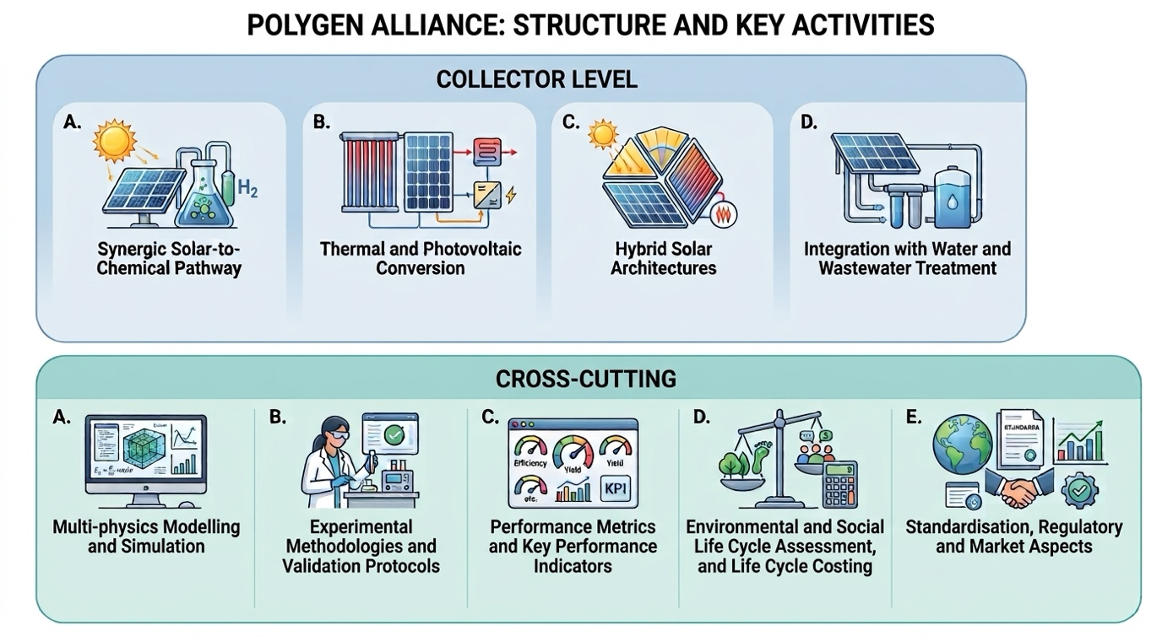
Figure 2. Thematic structure of the PolyGen Alliance: collector-level and cross-cutting focus areas.
3.2 Membership and geographic reach
A public registration form on the Alliance webpage collects expressions of interest. As shown in Figure 3, early registrants include experts from Portugal, Sweden, Italy, Austria, and Brazil. Organisation types include national laboratories, universities, and technology developers. Fields declared at sign-up include solar thermal energy, solar testing, solar-to-hydrogen processes, photovoltaic-thermal collectors, mechanical engineering and sustainability.
This remains an early cohort rather than a closed membership. The relevant result is that interest already extends beyond a single project consortium and even beyond Europe.
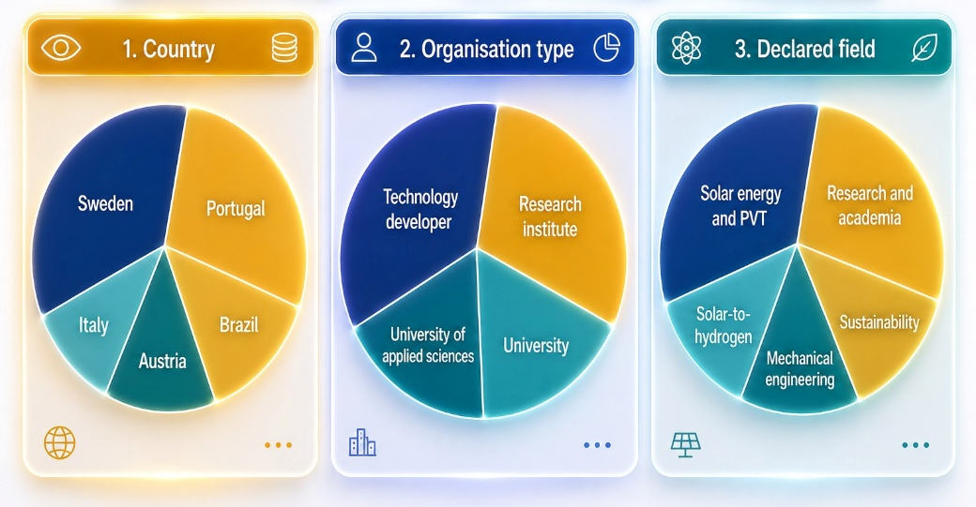
Figure 3. Profile of early PolyGen Alliance registrants by country, organisation type, and declared field.
3.3 Alliance webpage and external visibility
Online interest in the Alliance has been monitored since its launch. Over the last 3-month period (June to August 2026), the Alliance content received 77 views from 31 active users, with an average engagement time of 55 seconds. Traffic was low on most days, with short peaks of six to eight views, as expected for a specialist network in its first months. These visits accounted for about 14% of activity at the host project site during the same time window. Figure 4 summarises the main engagement indicators.
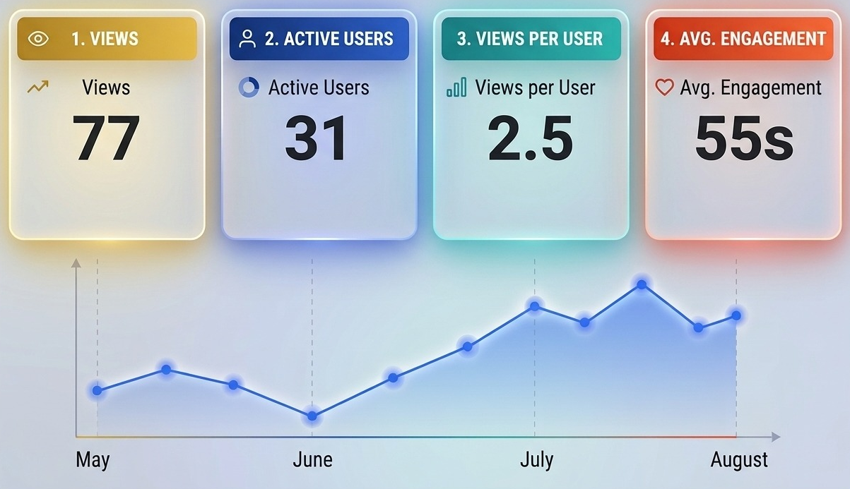
Figure 4: PolyGen Alliance webpage analytics.
External visibility specific to the Alliance includes a feature in the IEA SHC Solar Update newsletter (May 2026), a public invitation to join circulated on We Don’t Have Time, and presentations at IEA SHC Task 72 expert meetings.
The Alliance was also promoted through the SPECTRUM project newsletter, including a dedicated issue inviting experts to join, and through the project’s LinkedIn channel. These posts and the newsletter were used to point readers to the Alliance content and the registration form, utilising the well-established network and audience of the project.
3.4 Collaboration with IEA SHC Task 72
Alignment with IEA SHC Task 72 (Solar Photoreactors for the Production of Fuels and Chemicals) is already operational. The PolyGen Alliance and related work were presented at Task 72 expert meetings. In October 2025, a hybrid workshop on materials for solar photochemistry applications was held jointly between the SPECTRUM project and Task 72 and attracted participants from universities, research institutes, and industry. This workshop started the collaboration between the IEA Task 72 and the PolyGen Alliance through the SPECTRUM project.
3.5 Performance parameters under discussion
Launch discussions and Task 72 exchanges produced an initial working list of parameters for comparing polygenerating collectors. These are not a standard. They are the set currently used to structure dialogue on multi-output performance, aiming to support comparability and technology validation:
- Overall solar-to-useful energy conversion efficiency (accounting for all outputs);
- Individual vector efficiencies (electrical, thermal, chemical/fuel);
- Spectral utilisation and matching of solar spectrum segments to conversion processes;
- Stability and durability under combined thermal–electrical–chemical loads;
- Specific land-use productivity (output per unit aperture or ground area);
- Environmental and social indicators from LCA/LCC (e.g., greenhouse-gas intensity, water footprint, socio-economic co-benefits);
- Integration metrics (system complexity reduction, land-use optimisation relative to separate single-output systems).
This list is an early Alliance output and the starting point for later shared protocols.
- Conclusions
Polygenerating solar collectors can increase overall solar yield and reduce land use and system complexity, but only if heat, electricity, and chemical or environmental outputs are provided by a single device. The literature still reports weak collector-level integration, few shared performance metrics, and limited cross-study comparisons. The PolyGen Alliance was set up to address that gap as a member-facing platform.
The first months of operation show that such a platform can be made concrete. The Alliance operates on an agreed definition of a polygenerating collector and a two-layer agenda (system integration and cross-cutting methods). Early registrants already span five countries and mix technology developers, research institutes and universities. Online content attracted a small but repeat audience between May and August 2026 (77 views, 31 active users). Promotion in the SPECTRUM project channels, a feature in the IEA SHC Solar Update, an article on the wedonthavetime media platform, and a working link with IEA SHC Task 72 extended that reach beyond the founding group and placed the Alliance in front of the community it needs.
The working list of performance parameters is the most transferable of the early outputs. It is not a standard. It is a shared starting point for later protocols.
The Alliance aims to move beyond its inception phase and start the operationalisation phase, promoting meetings and information exchange between its members, aligning methodological approaches. If that happens, the Alliance can help move polygenerating collectors from isolated prototypes toward comparable, deployable technology.
- Acknowledgement
This work has been carried out within the framework of the SPECTRUM project, funded by the European Union under grant agreement no. 101172891. Views and opinions expressed are however those of the author(s) only and do not necessarily reflect those of the European Union or CINEA. Neither the European Union nor CINEA can be held responsible for them.
- References
Girishkumar, G.S., Kamesh, M.R., Shreekala, N., Yogaraj, D., Mohammed Nadeem, M., Hemanth, B.R. and Nagaprasad, K.S., 2026. Solar-based polygeneration systems for a carbon-neutral future with focus on hydrogen production: A comprehensive review. Nature Environment and Pollution Technology, 25(2), B4362. https://doi.org/10.46488/NEPT.2026.v25i02.B4362
Herrando, M., Wang, K., Huang, G., Otanicar, T., Bany Mousa, O., Agathokleous, R.A., Ding, Y., Kalogirou, S., Ekins-Daukes, N., Taylor, R.A. and Markides, C.N., 2023. A review of solar hybrid photovoltaic-thermal (PV-T) collectors and systems. Progress in Energy and Combustion Science, 97, 101072. https://doi.org/10.1016/j.pecs.2023.101072
IEA SHC, 2026. Solar Update, vol. 82. International Energy Agency Solar Heating and Cooling Programme, May 2026. https://www.iea-shc.org/Data/Sites/1/publications/2026-05-Solar-Update-Newsletter.pdf (accessed 25 August 2026).
Kasaeian, A., Bellos, E., Shamaeizadeh, A., Tzivanidis, C., 2020. Solar-driven polygeneration systems: Recent progress and outlook. Applied Energy, 264, 114764. https://doi.org/10.1016/j.apenergy.2020.114764
Khodadadi, M., Sheikholeslami, M., 2022. Review on poly-generation application of photovoltaic/thermal systems. Sustainable Energy Technologies and Assessments, 52, 102172. https://doi.org/10.1016/j.seta.2022.102172
Wang, G., Zhang, Z. and Lin, J., 2024. Multi-energy complementary power systems based on solar energy: A review. Renewable and Sustainable Energy Reviews, 199, 114464. https://doi.org/10.1016/j.rser.2024.114464
Zhang, S., Zhang, Y., Yang, Y., Guo, L., Zhang, D., Liu, G., Li, D., 2025. Multi-level study on solar-driven polygeneration system with thermal energy storage based on pinch method and multi-objective optimization. International Journal of Hydrogen Energy, 106, 644-661. https://doi.org/10.1016/j.ijhydene.2025.01.360

