Failure Behavior for the subelement of cylindrical composite lattice under compressive load

Min-Hyeok Jeon¹, Min-Song Kang¹, In-Gul Kim¹ and Sang-Woo Lee²

¹Aerospace Engineering, Chungnam National University, Daejeon, Korea
Email: mhjeon@cnu.ac.kr
²Defence and Aerospace Division, Hankuk Fiber Co., Miryang, Korea

Keywords: composite lattice structure, compression test, failure analysis, failure mode

Abstract
In this paper, the axial compressive test and failure analysis for suselement of cylindrical composite lattice structures were conducted to investigate its failure behavior. The subelement cut from the full-scale lattice structure contains five single unit cell. Finite element model was made based on microscopic cross sectional inspection of structure and failure analysis was performed using stress based Tsai-Wu failure criterion. Numerical failure analysis was performed in two steps for the detailed examination of failure behavior. First, internal force distribution nearby failed location was calculated by static analysis of subelement. Next, we applied the load and boundary conditions obtained from the calculated internal force in previous step to finite element analysis for the helical-helical knot. Failure mode was estimated by comparison of failure indices based on the Tsai-Wu failure criterion and compared with the recorded visual images of test specimen during testing.

1. Introduction

The cylindrical composite lattice structure of Fig. 1 is highly efficient under various loading and extensively used as structural element such as interstage, payload adapters of space launch vehicle and fuselage components for aircraft, etc. When the launch vehicle lifts off, the lattice structures are mainly used to support the compressive load. The composite lattice structures consist of curvilinear helical and circumferential hoop ribs and are more efficient than laminated skin cylinder in terms of strength and weight reduction. These structures are fabricated by the continuous filament winding technique and each rib consists of unidirectional layers which are interlaced at knots. The number of layers of knot is twice of those of rib without knot due to the constant thickness of rib in lattice structure. Therefore, the discontinuity of thickness and fiber volume fraction of each ply, voids and defects are observed in ribs and knots. Such a problem can reduce stiffness and strength of lattice structure and structural reliability may become decreased.

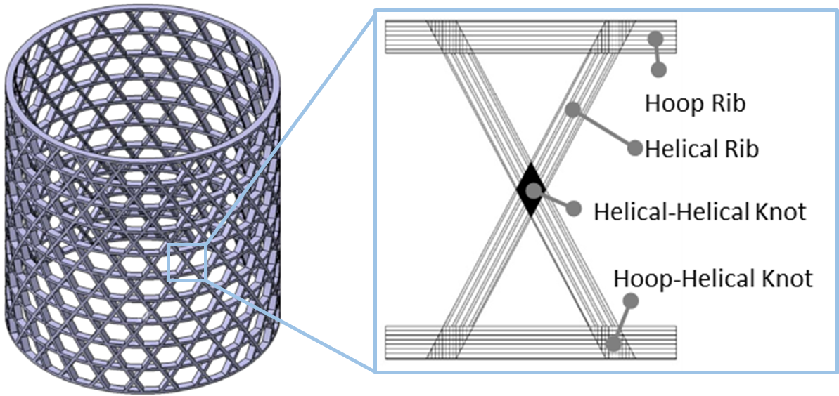

Figure 1. Cylindrical composite lattice structure.
Not only the buckling failure but also the failure behavior of composite lattice structures under axial loading are significant practical interest and has been extensively studied and reported. Totaro et el. [1] conducted buckling test and analysis of local buckling of composite lattice structure. Buragohain et el. [2] also conducted compression test of cylindrical composite lattice structure and it was compared with numerial analysis of critical buckling load and buckled shape. Not only buckling, compressive fracture test and prediction of failure load were performed by Jingxuan et el. [3]. However, it is difficult to predict the exact failure mode and load for composite lattice structures with various uncertainty. Therefore, it is necessary to test composite lattice structure and to examine failure behavior by using finite element analysis.
In this paper, failure behavior of cylindrical composite lattice structure was discussed by compression test and failure analysis. In compression tests, the subelements which consist of five single unit cell were prepared to simulate the fracture behavior under loading condition of full-scale lattice structure. The microscopic cross-sectional inspection of rib and knot and compression tests of subelement were performed. Numerical failure analysis was performed in two steps for the detailed examination of failure behavior. First, internal force distribution near by failed location was calculated by static analysis of subelement. Next, we applied the load and boundary conditions obtained from the calculated internal force in previous step to the knot. Failure analysis was performed according to Tsai-Wu failure criterion and failure mode was estimated by comparison of failure indices. Results of analysis were compared with test results qualitatively.

2. Compression Test of Subelement

The subelement, which is compression test specimen, cut from full-scale cylindrical composite lattice structure is shown in Fig. 2. When the full-scale structure is subjected to compressive load, the load will be applied in helical direction. The subelement specimens consist of five unit cell in order to apply load to central unit cell in helical direction. Main purpose of designing test specimen like this was to observe failure load and mode of unit cell with minimizing loading boundary effect. Hence, subelement contains five unit cell in order to apply load in helical direction to central unit cell. The thickness and width of each rib are 10 and 6.7mm, respectively and the carbon fiber(T700 grade) tow of H2550 12K(Hyosung) was used. Compression tests were conducted by universial testing machine(Instron 5900R) of 100kN capacity in a displacement control mode with a constant cross-head speed of 1.3mm/min. The several strain gagues were attached at both side of helical rib and hoop rib and the strains were recorded for further comparison with FEA results.

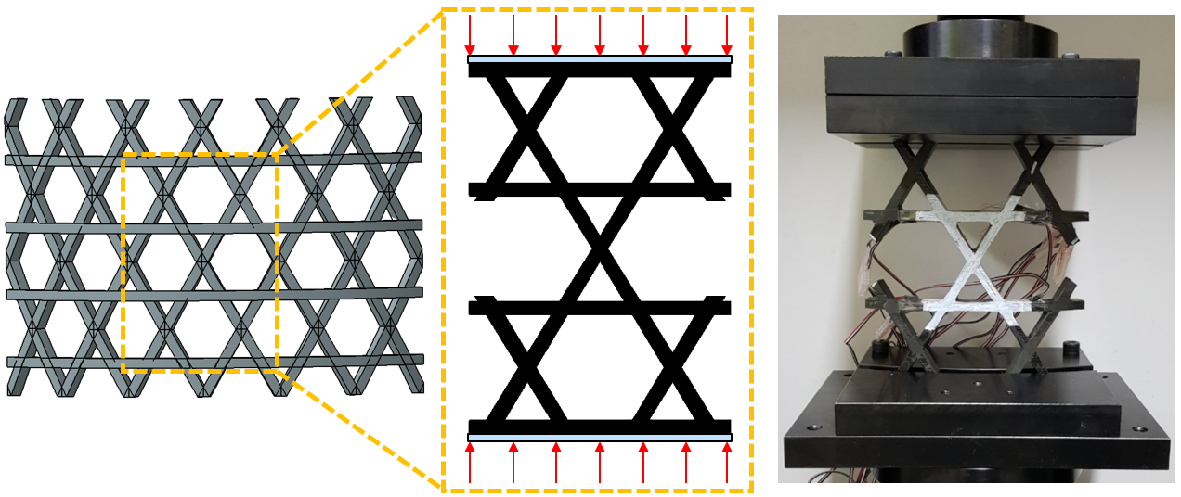

Figure 2. Subelement specimen for compression test.

3. Finite Element Analysis

Static analysis of subelement was performed using CHEXA8 element and 3D orthotropic properties of MSC.NASTRAN (Fig. 3.a). As a results of analysis, bending deformation from inner to outer direction was occurred. And internal force distribution nearby failed location (Fig. 3.b) was calculated. Since applied force and stress of inner side were larger than those of outer side, failure will occur at inner side first. The force distribution calculated in previous step was applied to finite element model of planar 5 layers of inner side to examine the failure behavior efficiently and the failure analysis was performed (Fig. 3.c).

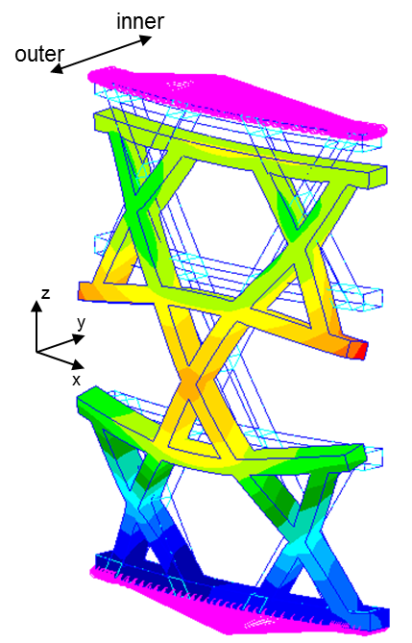 | 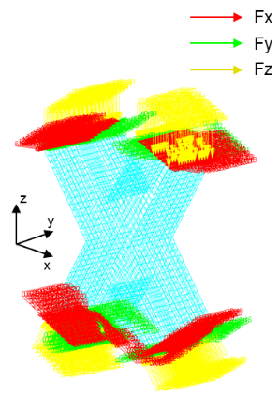 | 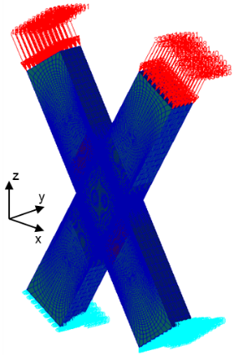
(a) Static analysis of subelement | (b) Force distribution nearby failed location | (c) Failure analysis

Figure 3. Process of finite element analysis.

Finite element model for failure analysis was created based on the microscopic cross sectional inspection. As a result of inspection in Fig. 4, stacking sequence of knot is [32/-32]₁₇ and there was resin rich area at the connection part of knot and rib.

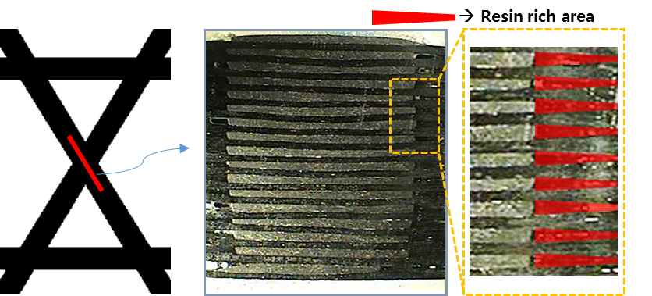

Figure 4. Cross sectional inspection at knot.

Continuity of fiber and resin rich area was modeled according to inspection results as shown in Fig. 5. 3D orthotropic property was used for resin in the same way as a fiber to calculate failure indices. Stiffness and strength of fiber were calculated according to fiber volume fraction using rule of mixture and strength theory of Table 1. Fiber volume fractions of rib and knot were 42 and 60 % respectively which is result of ignition test(ASTM D2584) [4]. When the compressive load is applied to the model, the stress singularity was occurred in the connecting point of 32˚ and -32˚ fiber element due to discontinuity of mechanical properties and different loading direction. For the reduction of singularity, connection part of knot and rib was modeld by spline shape and thin resin layer was inserted. Although the model was improved for divergence of stress solution, the singularity of stress solution still existed, but the analysis was performed to estimate the approximate and relative failure behavior at helical-helical knot.

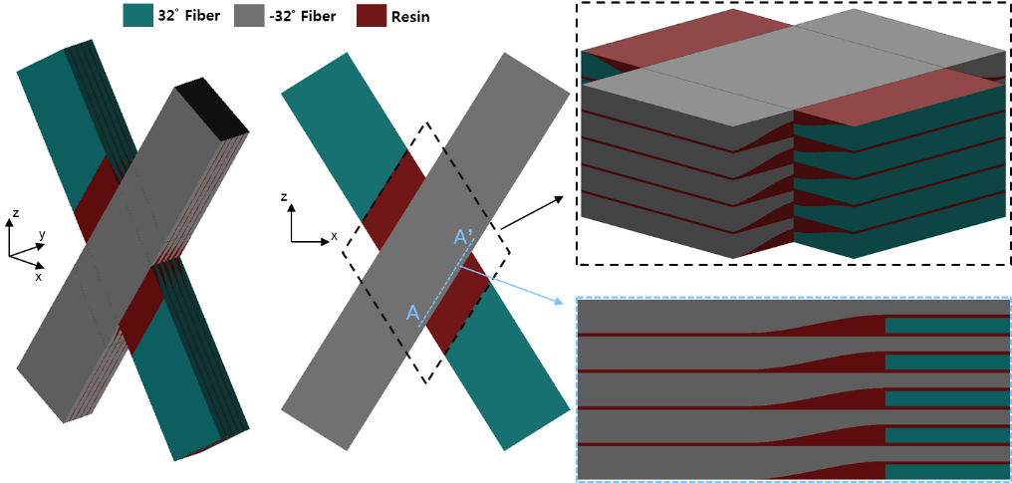

Figure 5. Finite element model for failure analysis.

Table 1. Stiffness and strength according to fiber volume fraction [5].

 | Expression
Stiffness | E₁ = E_{f1}V_{f} + E_{m}V_{m} | (1.a)
Stiffness | 1 / E₂ = V_{f} / E_{f2} + V_{m} / E_{m} | (1.b)
Stiffness | 1 / G₁₂ = V_{f} / G_{f12} + V_{m} / G_{m} | (1.c)
Strength | X_{t} = X_{tf} V_{f} + X_{tm} V_{m} | (2.a)
Strength | X_{c} = X_{cf} V_{f} + X_{cm} V_{m} | (2.b)
Strength | Y_{t} = Y_{tm} C_{V} [1 + (V_{f} – V_{f}^{1/2}) (1 – E_{m} / E_{f2})] | (2.c)
Strength | Y_{c} = Y_{cm} C_{V} [1 + (V_{f} – V_{f}^{1/2}) (1 – E_{m} / E_{f2})] | (2.d)
Strength | S_{LT} = S_{LTm} C_{V} [1 + (V_{f} – V_{f}^{1/2}) (1 – G_{m} / G_{f})] | (2.e)
Strength | (C_{V}=1 – (4 V_{V} / (π (1 - V_{f})))^{1/2}) | (2.e)
(X : longitudinal, Y : transverse, LT : shear, t : tensile, c : compressive, V_{f} : fiber volume fraction,
V_{m} : matrix volume fraction, C_{V} : void fraction, V_{V} : void volume fraction)

The void volume fraction was assumed to be 0 % in this study.
Tsai-Wu failure criterion of Eq. 3 was used for failure analysis here [6].

F = F₁ σ₁ + F₂ σ₂ + F₃ σ₃ + F₁₁ σ₁² + F₂₂ σ₂² + F₃₃ σ₃² + F₄₄ τ₁₂² + F₅₅ τ₂₃² + F₆₆ τ₁₃²  +2 F₁₂ σ₁ σ₂ + 2 F₂₃ σ₂ σ₃ + 2 F₁₃ σ₁ σ₃ | (3)
(F₁ = 1 / X_{t} – 1 / X_{c}, F₂ = 1 / Y_{t} – 1 / Y_{c}, F₃ = 1 / Z_{t} – 1 / Z_{c}, F₁₁ = 1 / X_{t} X_{c}, F₂₂ = 1 / Y_{t} Y_{c}, F₃₃ = 1 / Z_{t} Z_{c},
F₄₄ = 1 / S₁₂, F₅₅ = 1 / S₂₃, F₆₆ = 1 / S₁₃, F_{ij} = – (F_{ii} F_{jj})^{1/2} / 2)

4. Results and Discussion

The load-displcement curves for compression test are plotted in Fig. 6 and the average failure load of three specimen was about 26.5kN. From the recorded visual images of the test in Fig. 6, fiber breakage and delamination occurred at the knot in central unit cell. Since compressive load was concentrated at the knot in central unit cell, fiber breakage and delamination occurred due to increased stress of longitudinal and thickness direction of fiber.

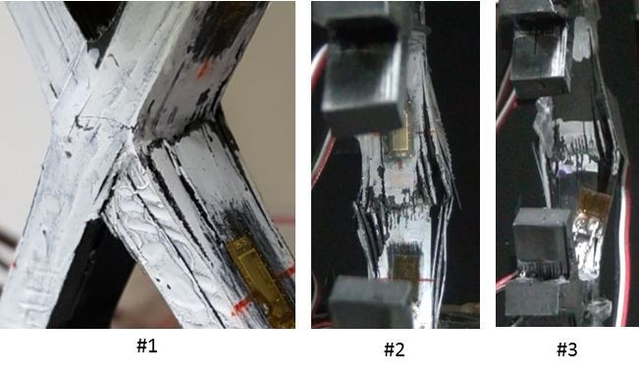

Figure 6. Load-displacement curves and failure mode of subelement.

The results of failure analysis are shown in Fig. 7. As the bending deformation occurred, the stress of the inner side element was largest. For the analysis of failure behavior, the terms of failure index were compared in element with large failure index. For the estimation of failure mode, the failure mode was assumed to be caused by largest term of failure index. First, F₁₁ σ₁² was largest due to the high stress in fiber direction. Therefore, initial failure of structure will be the fiber failure. Next, in case of resin elements, F₆₆ τ₁₃² was largest due to shear stress in 13 direction, the failure of resin layer will cause the delamination. To sum up, fiber breakage and delamination will occur sequentially. The compression test results of the subelement also indicate the fiber breakage and delamination at the knot and agreed well with results of the failure analysis.

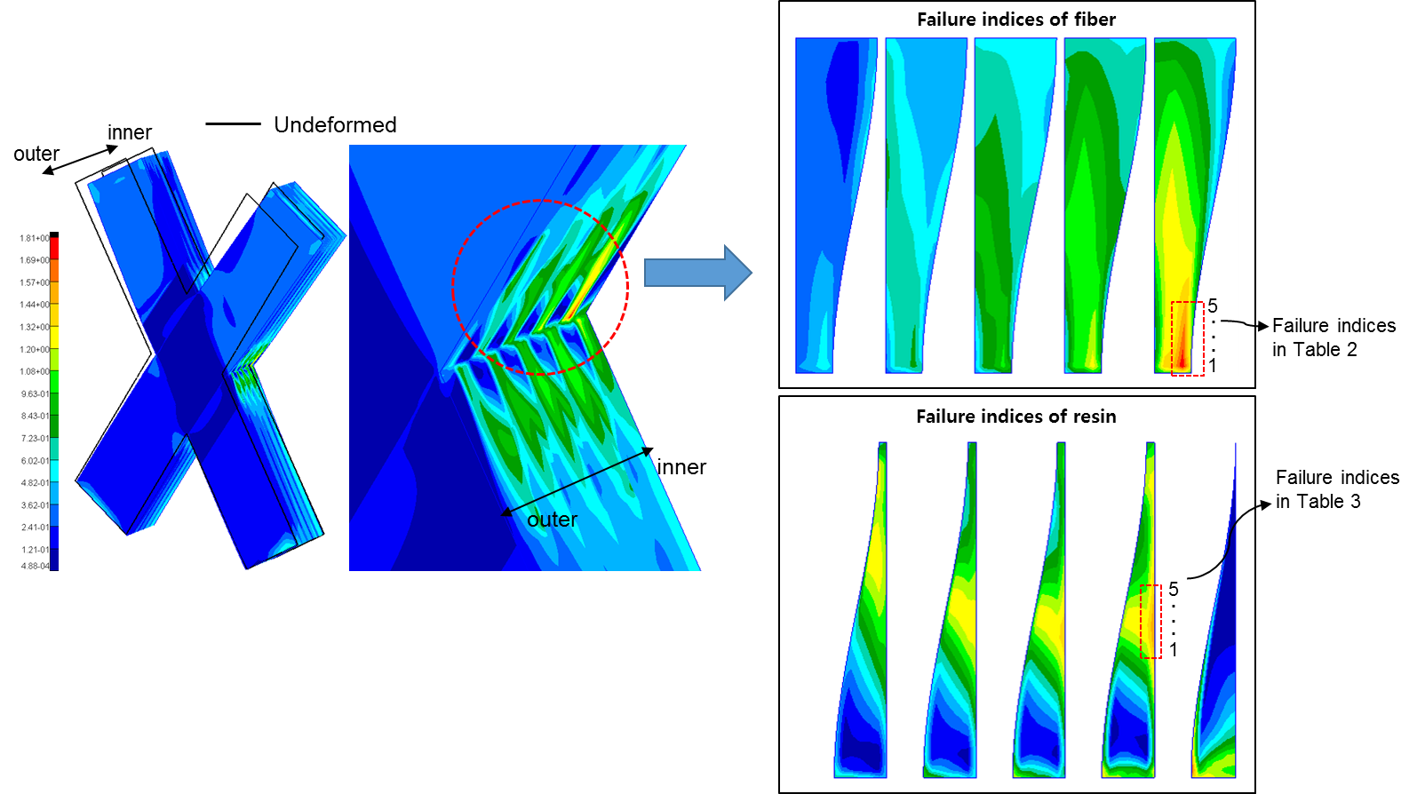

Figure 7. Results of failure analysis – failure indices.
Table 2. Failure indices of fiber element.

 | 1 | 2 | 3 | 4 | 5
F₁ σ₁ | 1.001 | 0.993 | 0.985 | 0.980 | 0.974
F₂ σ₂ | -0.073 | -0.079 | -0.063 | -0.061 | -0.061
F₃ σ₃ | -0.103 | -0.031 | -0.011 | -0.003 | 0.002
F₁₁ σ₁² | 1.225 | 1.182 | 1.129 | 1.073 | 1.013
F₂₂ σ₂² | 0.010 | 0.011 | 0.007 | 0.007 | 0.007
F₃₃ σ₃² | 0.019 | 0.002 | 0.000 | 0.000 | 0.000
F₄₄ τ₁₂² | 0.000 | 0.000 | 0.000 | 0.000 | 0.001
F₅₅ τ₂₃² | 0.089 | 0.018 | 0.004 | 0.001 | 0.000
F₆₆ τ₁₃² | 0.180 | 0.076 | 0.040 | 0.024 | 0.015
2 F₁₂ σ₁ σ₂ | -0.108 | -0.115 | -0.089 | -0.084 | -0.082
2 F₂₃ σ₂ σ₃ | -0.152 | -0.045 | -0.016 | -0.004 | 0.003
2 F₁₃ σ₁ σ₃ | -0.013 | -0.004 | -0.001 | 0.000 | 0.000
F. I. | 2.074 | 2.007 | 1.984 | 1.933 | 1.871

Table 3. Failure indices of resin element.

 | 1 | 2 | 3 | 4 | 5
F₁ σ₁ | -0.080 | -0.092 | -0.112 | -0.117 | -0.122
F₂ σ₂ | -0.024 | -0.029 | -0.042 | -0.043 | -0.044
F₃ σ₃ | 0.037 | 0.025 | 0.005 | -0.007 | -0.019
F₁₁ σ₁² | 0.018 | 0.025 | 0.037 | 0.040 | 0.043
F₂₂ σ₂² | 0.002 | 0.003 | 0.005 | 0.005 | 0.006
F₃₃ σ₃² | 0.004 | 0.002 | 0.000 | 0.000 | 0.001
F₄₄ τ₁₂² | 0.072 | 0.089 | 0.111 | 0.116 | 0.120
F₅₅ τ₂₃² | 0.219 | 0.240 | 0.263 | 0.240 | 0.215
F₆₆ τ₁₃² | 0.561 | 0.624 | 0.697 | 0.649 | 0.597
2 F₁₂ σ₁ σ₂ | -0.005 | -0.008 | -0.014 | -0.015 | -0.015
2 F₂₃ σ₂ σ₃ | 0.009 | 0.007 | 0.002 | -0.002 | -0.007
2 F₁₃ σ₁ σ₃ | 0.003 | 0.002 | 0.001 | -0.001 | -0.002
F. I. | 0.816 | 0.886 | 0.953 | 0.864 | 0.772

5. Conclusions

The failure behavior of cylindrical composite lattice structure was studied by compression test and failure analysis of subelement. In the compression test, fiber breakage and delamination occurred by compressive load and stress in the knot. Static analysis of subelement and failure analysis of failed area were performed to examine detail failure mode and initial failure. The knot was modeled describing continuity of fiber and resin rich area which are results of cross sectional inspection. Failure mode was predicted by Tasi-Wu failure criterion and it was found that fiber breakage and delamination will occur by compressive normal stress of fiber layer in longitudinal direction and transverse shear stress of resin rich area, respectively. The failure behavior of cylindrical composite lattice was estimated by failure analysis, which agreed well with the test results.

Acknowledgments

This work was supported by Civil-Military Technology Cooperation Program (Development of the Composite Lattice Structure, (15-CM-MA-12)).

References

[1] G. Totaro, F. D. Nicola, and P. Caramuta. Local buckling modelling of anisogrid lattice structures with hexagonal cells : An experimental verification. Composite Structures, 106:734–741, 2013.
[2] M. Buragohain and R. Velmurugan. Study of filament wound grid-stiffened composite cylindrical structures. Composite Structures, 92:1031–1038, 2011.
[3] H. Jingxuan, R. Mingfa, S. Shiyong, H. Qizhong, and S. Xiannian. Failure prediction of advanced grid stiffened composite cylinder under axial compression. Composite Structures, 93:1939–1946, 2011.
[4] ASTM D2584. Standard Test Method for Ignition Loss of Cured Reinforced Resins.
[5] V. Lupasteanu, N. Taranu, and S. Popoaei. Theoretical strength properties of unidirectional reinforced fiber reinforced polymer compoistes. Buletinul Institutului Politehnic din lasi. Sectia Constructii, Arhitectura, 59.6:83, 2013.
[6] S. Tsai and E. Wu. A general theory of strength for anisotropic materials. Journal of Composite Materials, 5.1:58-80, 1971.

