EuroSun2026
Sequential optimization of Building-integrated Photovoltaics (BIPV) façade allocation
Anshuman Abhisek Mishra¹, Christian Dierk³, Gabriele Lobaccaro², Francesco Goia¹
¹ Department of Architecture and Technology, Faculty of Architecture and Design, Norwegian University of Science and Technology (NTNU), Trondheim, Norway
² Department of Civil and Environmental Engineering, Faculty of Engineering, Norwegian University of Science and Technology (NTNU), Trondheim, Norway
³ FibR GmbH, 71394 Kerner, Germany
Corresponding author: anshuman.a.mishra@ntnu.no
Summary
Building-integrated Photovoltaics (BIPV) offers the dual function for integrating PVs as both energy providers and building envelope components. Facades are, however, complex systems that simultaneously influence both the energy demand, the daylight comfort and the glare aspects of a building. Allocating opaque BIPVs on the wall in a suitable manner renders the problem into a complex optimization with multiple objectives, thus requiring detailed design inputs, typically unavailable at the start of the design process. On the counter, optimization at a late stage reduces the PV allocation potential. The aim of this paper is to investigate a sequential, stepwise optimization process, such that the BIPV allocation process can match the building design process, with reduced complexity and curtailed computation time. The outcome of this work aims to inform on the impact of defining different baselines and transfer of optima through the steps, to achieve and preserve the maximum number of Global optima, as generated in a full optimization process. In the case of Oslo, 65% of the optima were attained with just 28% of the simulations for the self-determined baseline while 17% were recovered but at a lower expense of 7.5% simulations for the baseline from literature. In the case of Madrid, both baselines managed to recover 58.6% of the optima with just 17% of the runs.
Keywords: BIPV, Façade, Optimization, Energy-efficiency, Daylight
Field of application for the findings: Energy Efficient Buildings
Addressed audience: Architects, solar consultants, building energy consultants, academics
- Introduction
1.1 Background:
Façade are responsible for a comfortable indoor climate, good daylight conditions and outward views. The competing parameters – PV area on opaque facade surfaces and window area - both benefit from maximizing. Having a higher opaque surface area helps to convert maximum solar incident radiation for the former, while proper window dimensions, ensuring standard daylight access, along with a well-insulated façade area, lowers overall energy demand with reduction in energy losses due to fenestrations. Added to the window opening size, there is also the need of shading elements such as louvres and blinds, which help tackle perceptible glare issues. These elements thus have competing goals, to be allocated within the same area, with trade-offs for maximizing one at the cost of the other. This makes the façade design process a multi-objective optimization problem, where the conflicting performance objectives generate not one single solution, but often a range of optimal solutions, spread along a pareto front. These solutions offer the best trade-offs between the competing objectives, where changing one objective makes the other(s) worse.
Multi-objective optimization (MOO) of building facades using various tools is becoming more common. A recent review study could find around 50 search results, even for such a niche topic, after removing duplicates and screening across various databases (Shan and Junghans, 2023). There has also been a higher output in the last decade, with developments in optimization tools, especially Genetic Algorithms. The paper also documents the increase in façade optimization studies looking into combined thermal-visual comforts since 2012, whereas energy along with economic concerns has always been a popular theme for MOO searches. Despite their advantages for solving complex problems, MOOs require detailed problem definition to extract any relevant & useful outcomes. At the same time, they also tend to be computationally resource- & time-intensive.
As tools for solar applications and building designs improve, integrated design for solar PVs or BIPVs is logical and practical. The possibility of combining two functions – building envelope and energy generation into the same building element benefits both material and energy cost reductions, as well as emissions – two very relevant ambitions in current high-performance buildings. As shown in Fig. 1 (below), even as far back as the 90s, it was not difficult to imagine future projects to have more integrated architectural and engineering developments, as well as the possibility of involving the final users as stakeholders.
In high-performance buildings (HPB), integrated design processes are essential to ensure that balanced design decisions can be taken such that a variety of design-performance criteria are met. This also means dealing with inter-dependent variables that can be highly constrained and compete against each other to maximize their goals at the cost of others. There are two primary ways of lowering the net energy demand in HPBs – the first is to design it to be ultra-efficient, and the other is by offsetting some or all the (grid) delivered energy by local energy generation – also termed a net (or near net-) Zero Energy building, if the net total annual delivered energy is from local generation only. While the former seems straight-forward, it is seldom budget-friendly, leading to design complexity and over-construction - a challenging prospect in some scenarios. The latter has, however, gained more popularity and brings the solar PVs into the picture; the economic benefits during the use phase are advantageous. With lowering PV costs and a faster break-even point, justifying increased initial investments is easier.
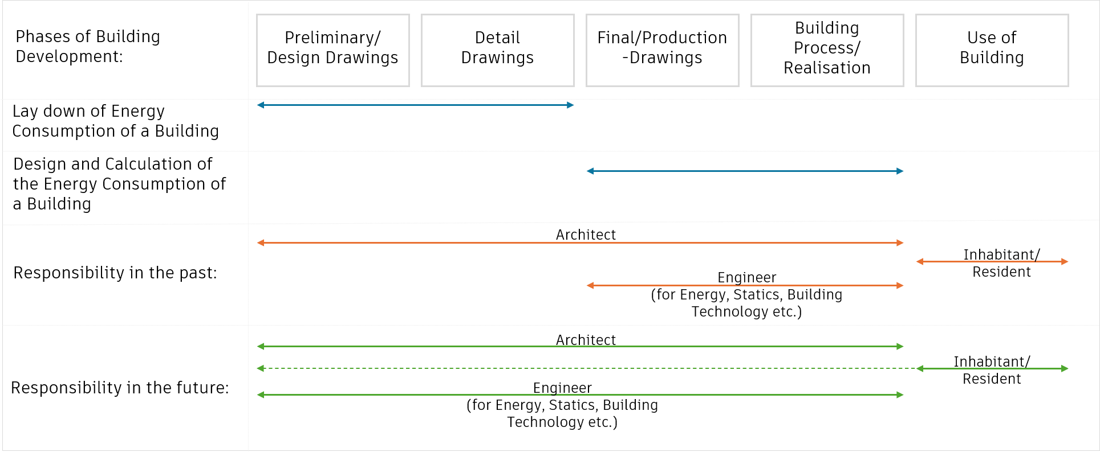
Fig.1: Planning Responsibilities and Lay Down of Energy Consumption chart from the 90s (recreated) (Sick et al., 1996)
The current approach for the integrated design & development of BIPV projects continues to remain a step-by-step process, often following the standard architectural design development steps such as Concept Design, Schematic Design, Detailed Design and Good-for-construction (GFC). These steps rely often on thumb rules-based approaches, and sometimes supported with simplified, disjointed simulations informing initial decisions. More detailed components and material information which is generally available at a later stage is of limited benefit for PV allocation, as the scope to benefit from optimization is reduced. A better approach is to develop a stepwise optimization where the variables can be optimized in steps, passing on the optima in steps while keeping other variables fixed. It also has a higher potential of being replicated in the stepwise development stages in real world architectural projects. While there exist some well-developed research, the focus has been primarily with whole building optimizations as done for different building form and systems design stages (Gagnon et al., 2019; Talami et al., 2021, 2020). A focused approach specific to facades is being explored in this paper, adding novelty to this research.
1.2 Research Questions:
- Is it possible to recover any optima in a stepwise optimization approach for BIPV façade allocation, compared to a global optimization process?
- How is the stepwise optimization effectiveness affected by the choice of baselines and optimization objectives?
In this paper, the aim is to evaluate a stepwise optimization approach in place of a single but complex multi-objective optimization problem solving for the just allocation of windows, shading devices and opaque PV on a south façade, for a representative case in Madrid (Spain) and Oslo (Norway). The two chosen locations represent two extreme latitudes with different solar conditions across major European cities and help in validating the process in different scenarios. The results and discussion reflect on the process of defining appropriate baselines and the transfer of optima across the steps, as well as the objectives in the optimization.
- Methodology
In this paper, the aim is to break down the complex, high order optimizations into a simpler, sequential approach, where stepwise optimizations with limited variables are deployed while aiming to achieve values similar to the Global optima. Such a process should be easier to deploy, enabling higher chances of a fair allocation of BIPV elements in a typical building/façade design process. Without full optimization, the goal is to recover a good number of Global optima values. A single office BESTEST case scenario - 8x6x2.7m (Fig. 4) is selected with the South façade exposed to full outdoor conditions where the windows, shading elements and the BIPV allocation occurs (Ron Judkoff and Joel Neymark, 1995). The primary concerns being investigated here are Energy demand (minimize), Daylight Autonomy (meet threshold and maximize), Glare (meet comfort criteria and minimize) and PV production (maximize). Energy demand and PV production are combined to keep it a 3-objective problem. This is done in 3 steps (Fig. 2), where for every step, all the other variables are fixed as per a chosen baseline. In the subsequent steps, the input choices in the stepwise optima matching those in the Global optima are carried over. The same objectives are used for the optimization in each step.
As a starting point, a full factorial search is chosen as the method to explore all possible combinations over other optimization or genetic algorithms. Such algorithms, although quite popular, can be computationally extensive requiring careful adjustment of grouping and selection. Moreover, they are also prone to getting trapped in local maxima/minima as well as producing different results in different runs (Talami et al., 2020). Full factorial search benefits from extracting a pareto front from the total possible outcomes conceivable given the chosen combination of variables such that the stepwise assessments are easier to conduct from an extensive set of inputs-outputs data covering all the possible outcomes.
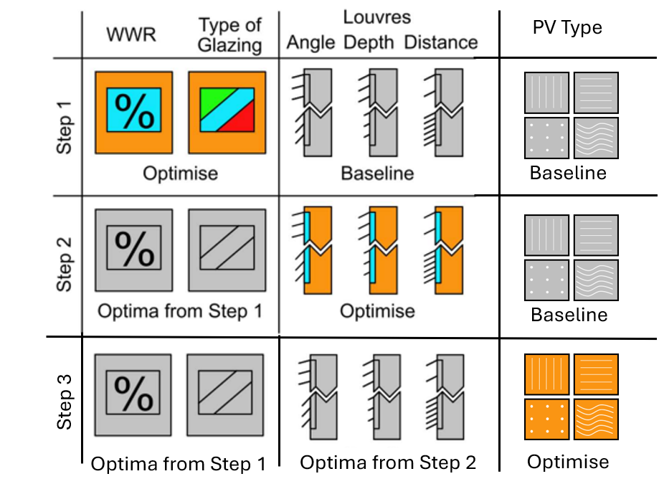
Fig. 2: 1. Steps of Optimization 2. The BESTEST case building model 3. Detailing of window, louvre and PV modelling
2.1 Climates
The case study explores two primary climates, across Europe – Oslo in Norway and Madrid in Spain. They represent two major capital cities in the European area, one on the Mediterranean belt, and the other at the Northern extent. The Oslo climate, located at the Southern part of the Scandinavian Peninsula, is represented here by a TMYx climate file taken from Oslo-Fornebu, at 59.90˚N 10.62˚E with an elevation of 17mts SL. This climate file is classified as a Temperate Oceanic Climate (Cfb) according to the Köppen climate classification, which can be considered also as a ‘Marine’ climate, with humid temperature climate sub-type. This implies a narrow band of annual temperature variation, marked by cool summers (avg. temperature below 22˚C) and mild winters (around 0˚C or higher). A common feature is also annual rain, and some snowfall in the winters (skybrary.aero, n.d.). As per ASHRAE standard 169-2021, Oslo is classified as climate type-5C. Here, the direct normal radiation ranges from 12.64kWh/m² in the dark months of November to a much higher 183.556kWh/m² in the month of June, with long days. The diffused horizontal radiation is the least in December at just 4.1kWh/m² while being 15 times higher at 63.4kWh/m² in the month of July.
Tab.1: Weather files utilized (Lawrie and Crawley, 2026)
Location | Geographic classification | Weather File
Oslo | WMO_Region_6_Europe/NOR_Norway | NOR_OS_Oslo-Fornebu.AP.014881_TMYx
Madrid | WMO_Region_6_Europe/ESP_Spain | ESP_MD_Madrid-Torrejon.AFB.082270_TMYx

Madrid on the other hand is in the centre of the Iberian Peninsula. Located at 40.48˚N 3.43 ˚W at an elevation of 618mts SL, the Madrid climate is characterized as 4B ASHRAE Climate (Std 169-2021). As per Köppen climate classification, Madrid is classified as a Cold semi-arid climate (BSk), found mostly on the elevated portions of temperate zones, and close to a humid continental or Mediterranean Climate. They feature warm to dry summers, but colder winters. This climate type is often located farther from large water bodies and can also experience wide day-night diurnal temperature swings. The monthly direct normal radiation varies from around 96kWh/m² in December to a peak of 284kWh/m² in July. For the diffused horizontal radiation, the range is from 21 kWh/m² to 61 kWh/m² in the months of December and April, respectively.
These represent a good variation of thermal and solar ranges between the two climates, and thus a good test for the stepwise allocation process in diverse climates.
2.2 Features and numerical modelling/simulation tools
The building environment and the simulation is developed in the 3D NURBS-modelling software Rhino, and its visual programming language – Grasshopper. This tool is quite commonly used as it can simultaneously support 3d modelling, energy and daylight simulations as well as iterative studies, all within the same program. For the simulation, the tried and tested building energy simulation engine - EnergyPlus and daylight simulation engine - Radiance are utilized (Tab.2). For the iterative study, Colibri, developed by Thornton Tomasetti, as part of their TTToolbox set is utilized. Grasshopper supports parametric modelling where both aspects of geometry and controls for the simulation, including inputs for enriching the simulation models, can both be generated & simulated within the same environment.
Tab.2: Versions of the simulation tools utilized
 | Ladybug Tools | EnergyPlus | Radiance | OpenStudio | Python
Version | 1.8.113 | 24.2.0 | 5.4 2023-11-05 | 3.9.0 | 3.10.10

For running energy simulations, HB Annual Loads component is employed, rather than running the full simulation. This is a simplified, quicker simulation version that is usually run at 1 run/timestep, instead of 6, with an error tolerance of upto 5%., It was increased to 4 timesteps per hour in the study, which should make the error less than 1%. This offers considerable time savings, which makes it easier to run a parametric performance exploration, with many changing variables.
For the daylight simulations, Radiance-based HB Annual Daylight component was utilized. This component considers the geometry of the room, as well as the specified test grid, which in this case has a grid size of 1x1m, placed at 0.8m from the floor and 0.5m from the wall. HB Annual Daylight also permits the user to specify Radiance-specific detailing level of the simulation, such as for Ambient Resolution (-ar), Ambient Bounces (-ab), Ambient Divisions (-ad) etc. There are 3 default templates that can also be chosen which supply these values. The mid-level was chosen, after experimenting with all the 3, as the difference in output between low- and mid-level was considerable, whereas that between the mid- and high-level was limited, while the simulation time was much higher, for the latter. The daylight illuminance level thresholds for the study were set at a low of 100lux, desired of 500lux and upper bound of 3000lux, which gave outputs for Daylight Autonomy of the room at sDA500, 50, a well-accepted threshold for offices and task areas (Standards Norge, 2021). For daylight analyses, it is also not sufficient to meet just the daylight thresholds, without commenting on the risk of glare, which can lead to additional controls, that might reduce the daylight autonomy of a room during usage. For this reason, shading devices were utilized in the form of horizontal louvres. The upper threshold of UDI>3000lux was used as an alternate indicator of glare risk, however, it is used here to highlight glare risk than as a true measure, as there is no view defined. This is the primary challenge of involving image-based glare studies into complex BPS simulations, as the time & detailing of glare studies, can be a challenge, especially at early design stages, where not enough decisions have yet been made, to define a proper ‘view’. In this respect, Honeybee does offer a simplified HB Imageless Annual Glare tool which was utilized to further define the glare risk. The HB Imageless Annual Glare, developed by Nathaniel Jones, is a faster, annual glare tool, than is used to indicate the glare autonomy of a space (Jones, 2019). Instead of a view, it utilizes a grid, similar to HB Annual Daylight, but placed at a higher plane of 1.3m from the ground, representing a seated user’s eye-position. This uses an enhanced 2-phase method that takes into fixed window shading devices, and results in DGP, which is used to compute the glare autonomy of a room. A threshold of 0.45 was chosen with a target time of 95% which is the minimum standard for glare risk threshold, generally accepted in early design stages, where discomfort from glare does not exceed 5% of the occupancy time(Standards Norge, 2021). Both HB Imageless Annual Glare and HB Annual Loads are not suitable for modelling dynamic daylight control devices.
2.3 Office building geometry and equipment
It is possible to apply this workflow to buildings of different typologies and uses. Office typology is one of the more popular study cases with well documented standards, energy use documentation, daylight studies, found in many case-studies as well as prior façade studies (Goia, 2016; Goia et al., 2013; Taveres-Cachat et al., 2019). In this study, a single office room, based on the BESTEST case, developed by Ron Judkoff and Joel Neymark is utilized (Ron Judkoff and Joel Neymark, 1995). The room is 8m wide by 6m deep with a 2.7m floor-to-ceiling height. It has auto-generated windows to the south façade (Fig. 3), based on a façade of size 8x3.4m. While the south façade is entirely exposed to the outdoor conditions, 2/3rd scaled portions of the top, east-west and bottom surfaces have outdoor (ground for the bottom) conditions, to contribute for heat transfer, as would be the case if a building, instead of a room, is modelled. Towards the north, half part of the façade has an external boundary condition, whereas 2/5 of that is modelled as a window (only in terms of heat-transfer, not daylight). The remainder fraction is of adiabatic type, which means EnergyPlus will be applying the same conditions on both sides of the wall, a simplified internal wall assuming climatized environment on both sides.
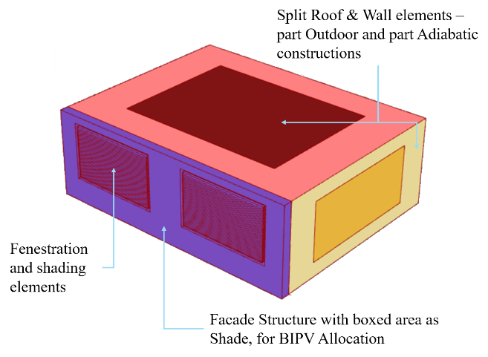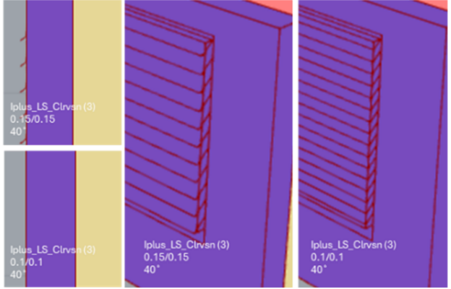
Fig. 3: BESTEST case Office geometry with detailed South Façade consisting of the study variables and split external surfaces. Façade features with different configurations of the louvre geometry
The south façade also has two construction types based on the climate – 0.18W/m²K U-value for Oslo (DiBK, 2017) and 0.40W/m²K for Madrid (Bienvenido-Huertas et al., 2019). Both the walls have layers of Stucco, External Generic Insulation (0.03W/m-K), 150mm bricks and Gypsum, out-to-in. Only the insulation layer thickness is varied to meet the target U-values. The PV-layers are not included in the wall construction, since there can be many variations in the choice of the panel and the style of integration, however, the base construction should nevertheless meet the expected construction standards.
In terms of the building/room operations, a Medium Office program, from which an ASHRAE 90.1 2019/IECC 2021 version of the ClosedOffice Program is utilized. This is further modified with the use of weekly heating-cooling setpoints (20 & 26˚C) and setbacks (16 & 32˚C) as per building occupancy. In addition, a ClosedOffice program also tends have a higher load of electrical equipment, which is modified further with a weekly schedule, as well as a reduced load of 5W/m² such that the cooling loads represent more climatic effects than being dominated with internal loads. In the case of an entire building, this same balance would naturally occur with the presence of lower load zones such as circulation areas, which would take down the average internal heat gains from the equipment. The room is supplied with heating-cooling with an Ideal Air system employing a Differential Enthalpy Economizer, with 80% sensible & latent heat recovery. The infiltration is calculated for 0.6ACH at 50Pa, and ventilation is set at 0.0014 m³/s-m² & 0.014 m³/s-person, based on floor area and occupants, respectively.
2.4 Façade features
The façade here consists of the External South-wall construction, Windows, Louvres and PVs. The last two are modelled simply as EnergyPlus shade elements, while the Incident Radiation on the PVs is calculated with a parallel Radiance based simulation. Eventhough Honeybee/EnergyPlus simulations work on single-surface models with no thickness, an external element is modelled here, as an EnergyPlus ‘Shade’ element to account for the thickness of the wall (Fig. 3). This element varies as per the thickness of the insulation and represents realistic challenges with respect to the availability of daylight, glare and issues of shading on the panels due to the louvre size and placement towards the higher end of the parametric modelling. This is an interesting aspect as there can be unintended consequences of the choice of louvre sizes towards the energy generation, more so, when the windows are bigger (justifying larger louvre use) and the Opaque PV area limited, and thereafter shaded, due to the choice of the louvre size and positioning. In addition, there is a border encasing the offset façade element, which prevents any sunlight leakage into the window through the peripheral gaps – a representative geometry suitable for Daylight simulations, as well as for EnergyPlus compatibility. Window technology and PV types are both varying parameters as shown below in Tab.3 and Tab.4.
Tab.3: Variety of Window-glass technologies details *Glass composition: external/cavity(/middle)/inner ‘:’ implies coating – gas fill/aerogel; Ar = 90% Argon gas filling, Kr = 90% Krypton gas filling; *approx.
Family | Name - as used in this study | Glass composition* | U-value (W/m²K) | SHGC (G-value EN410/0.87) (%) | VT (%) | Pane thickness (mm) | Weight (Kg/m²) | Source
Thermal Insulation Glass (low e-coating) | iplus 1.1T (2) | 4/16/:4 Ar | 1.1 | 76 | 82 | 24 | 20 | Agc-interpane
Thermal Insulation Glass (low e-coating) | iplus LS on Clearvision (3) | 4:/16/4/16/:4 Ar | 0.7 | 72 | 76 | 44 | 30 | Agc-interpane
Thermal Insulation Glass (low e-coating) | iplus 1.0 (3) | 4:/16/4/16/:4 Ar | 0.5 | 49 | 65 | 44 | 30 | Agc-interpane
Solar control glass – Magneton coatings (soft coatings) | Energy 70/37 (3) | 6:/16/4/16/:4 Ar | 0.6 | 39 | 64 | 46 | 35 | Agc-interpane
BENGglas (Vacuum glazing) | Extra clear |  | 0.5 | 78 | 83 | 8.3 | 21 | BENG Glas
BENGglas (Vacuum glazing) | Triple coated |  | 0.35 | 37.9 | 68 | 8.3 | 21 | BENG Glas
Tab.4: PV technology details *STC – AM=1.5 1000W/m², 25˚C, NOCT – AM=1.5 800W/m², 20˚C 1m/s, BSTC – Front side radiation 1000W/m², back side reflection radiation 135W/m² AM=1.5 25˚C
Producer | PV Name, and as used in the study | Type | Max power (Pmax/W) | Rated efficiency (%) | Layers | Panel Size (mm)
Longi | S10_Double-glass | LR7-54HJD | 510 | 25 (STC) | Double glass – 2.0mm semi-tempered+1.6mm semi-tempered, Black anodized aluminium alloy fram | 1800x1134x30
Hanover Solar | MONO Glass_470HW | HS470M-60-18X | 470 | 21.73 (STC) | Tempered High Transmission Glass, GRPU Frame | 1908x1134x30
Hanover Solar | HJT_  Glass-glass  _700M | HJT-132 720W Dual Glass | 720(STC),  790 (BSTC) | 23.18 (both STC, BSTC) | Double glass – 2.0mm coated tempered glass, Anodized aluminium alloy frame | 2384x1303x35
2.5 Study variables and sensitivity analysis
Tab.5: Parametric Variables, range of values and baseline for sensitivity analysis
STEP | Parameter | Range (Step) | Number of variables | Test cond. for sensitivity analyses
- | Locations | Oslo-Madrid (2) | 2 | Oslo, Madrid
1 | Window Technology | 6 (item) | 6 | Iplus_LS-Clearvision (3)  4:/16/4/16/:4 Ar
1 | WWR | 30%-60% (10%) | 4 | 40%
2 | Louvre depth | 0.1-0.3 (0.1) | 3 | 0.2
2 | Louvre distance | 0-0.15 (0.05) | 4 | 0.1
2 | Louvre angle | 0˚- 40˚ (10˚) | 5 | 30˚
3 | PV Type | 3 (item) | 3 | HJT_Glass-glass_700M – 23.8%

The study has 6 main types of parametric variables that are iterated in different steps of the study, as shown in Tab.5. The first step consists of Window geometry and type related features, which are important to meet daylight requirements. The second step concerns the louvre arrangements in terms of the louvre depth, louvre distance (measured in addition to the base value which is the same as the louvre depth) and the louvre angle, all concerning glare related issues. The last step concerns the PV type. In total, this leads to 4320 different combinations at each of the two locations – Oslo and Madrid.
In these studies, it is also important to assess how the variables affect the measure outputs, and if there are any linear or gradual trends – important for choosing the baselines in the stepwise optimization process. A conservative baseline is chosen for this sensitive analysis, and as can be seen in Fig.4, it is window technology that has the mostly irregular trends. Net delivered energy characteristics mostly follow linear trends, whereas daylight and glare values show some inconsistency, especially in how they are affected by louvre depths and louvre angles. Based on this, the baselines for the stepwise simulation are also chosen.
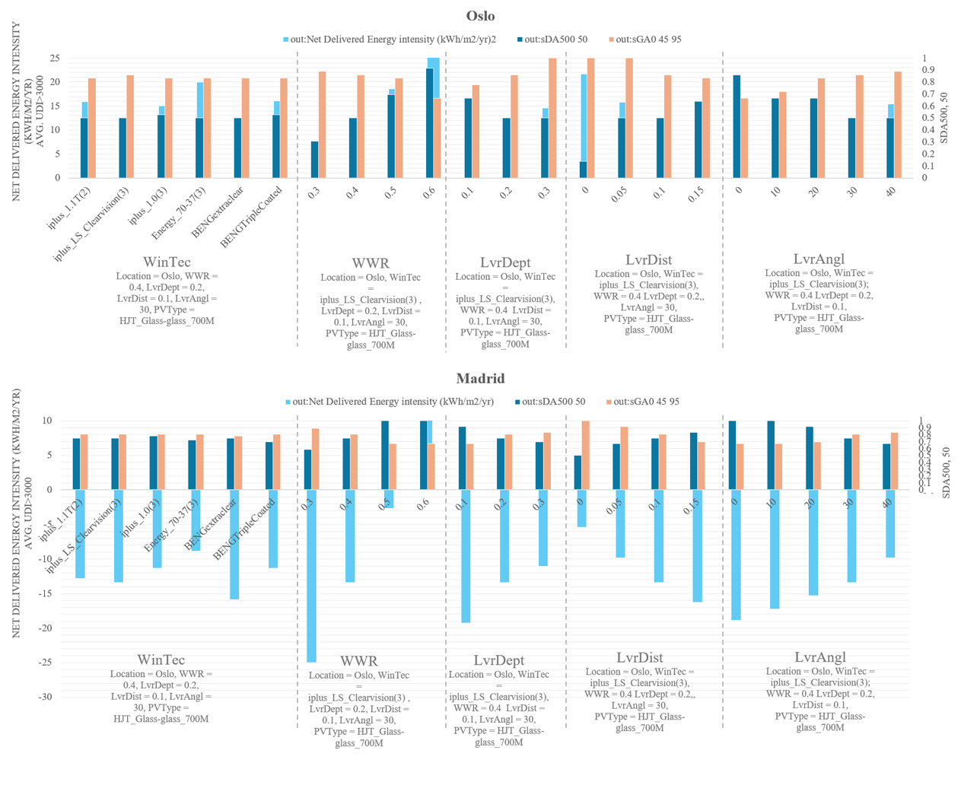
Fig.4: Sensitivity Analysis of the different variables in the chosen test conditions
2.6 Stepwise Optimization Set-up:
To test the stepwise optimization, a full factorial search is carried out with 6 design variables – WWR, Window Technologies, PV types and shading element designs: louvre depth-distance-angles. This leads to an optimization routine of 4320 design variable combinations in the search for global optima. For the global optima, the parameters collected are – heating energy intensity, cooling energy intensity, lighting energy intensity, PV production intensity, net delivered energy intensity, daylight autonomy-DA (500, 50%), glare autonomy-GA (0.45,95%) and UDI>3000Lux, both the average of the sensor grid, as well as the maximum value at any single grid point. A combination of these values will helps determine the final objective, mainly between the net delivered energy intensity (taking into account the energy contributions from the PV generation), the DA and the UDI>3000, whereby basic goals of the DA and GA are being met, such that the optima points meet the expected daylight and glare-risk thresholds (Fig. 5).
In the stepwise optimization, at each design step, one or a grouped combination of variables will be iterated, while the remaining variables are constrained at a baseline value (Fig. 2). There are two baselines chosen here – the self-determined baseline (also referred to as ‘baseline values’) and those based on Literature values. The optima attained from the previous step will define the design variable to be iterated against in the subsequent steps. The challenge here is therefore to define good baselines and approaches to transfer optima, that will help retain as many Global optima outputs as possible.
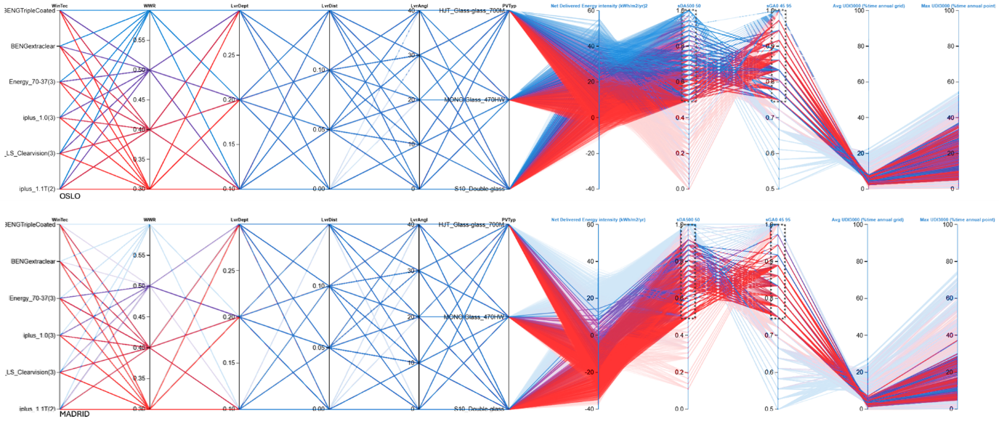
Fig. 5: Full-factorial search of Madrid (Top) and Oslo – 4320 variations each, and the relevant results filtered with thresholds
- Results
This study has a full-factorial search which is used for benchmarking. Of the 4320 outputs, irrelevant results have been filtered out based on failure to meet the standard daylight thresholds as well as glare thresholds with some relaxation for the glare (75%, instead of 95%). This was important, since in the stepwise optimization, conservative starting points are crucial, but they also lead to difficulties in meeting the Glare thresholds, which are affected most by the louvre geometries, but louvre geometries are conservative values in step 1 and are not optimized until step 2.
It is also to be noted that the glare Autonomy is used as filter, but the actual optimization attempts to minimize the UDI>3000 Lux parameter instead. This is done because true glare studies are more complex, and the metrics utilized here are simplified versions, also accounting for no specific views or positions to save time, but to have annual data instead. Therefore, the output values here are more indicative of the ‘risk of glare’ than attempting to optimize simplistic glare values. Glare can be addressed in later stages with finer geometry controls and detailed simulations.
Looking at the result table (Fig. 6), it is immediately evident that there are significant savings in the number of simulations required, while still maintaining the possibility of finding optima from the Global study. In the case of Oslo, for the baseline values, 65% of the optima were attained with just 28% of the simulations. For the baseline middle values based on literature (Taveres-Cachat et al., 2019), in Oslo, only 17% of the optima were recovered, but only at the expense of 7.5% simulations from the Global Exploration. In the case of Madrid, both baselines managed to recover 58.6% of the optima with just 17% of the runs, which is considerable savings of time and processing power, while retaining the capacity to find nearly 2/3rds of the optima.
In all the tested scenarios, it can be observed that the 2nd step is the most sensitizing to the outcomes, especially concerning daylight-glare performance. However, the 1st step results play a crucial role in the direction the subsequent rounds of stepwise optimization would be developing upon. For example, it is possible that few well-performing window sizes might require specific louvre arrangements to meet the daylight and glare threshold, and therefore, in conservative baseline starting scenarios (self-determined baseline values in this case), they might not pop up in the attained optima. In case of Madrid, 1/3rd of the WWR sizes is not attained in either of the baseline scenarios. In case of Oslo, a different scenario emerges. While the solar/daylight availability is lower than Madrid, the presence of low-level sun in the sky makes it a higher risk for glare related issues. In the Middle (literature) based baseline values, specific choices of louvre geometry do lead to attaining the minor WWR value, but that also considerably narrows down the attainment of optima in the subsequent steps. While this led to considerable savings in the simulation time and computational resources, it also narrows down the selection of the final optima obtained.
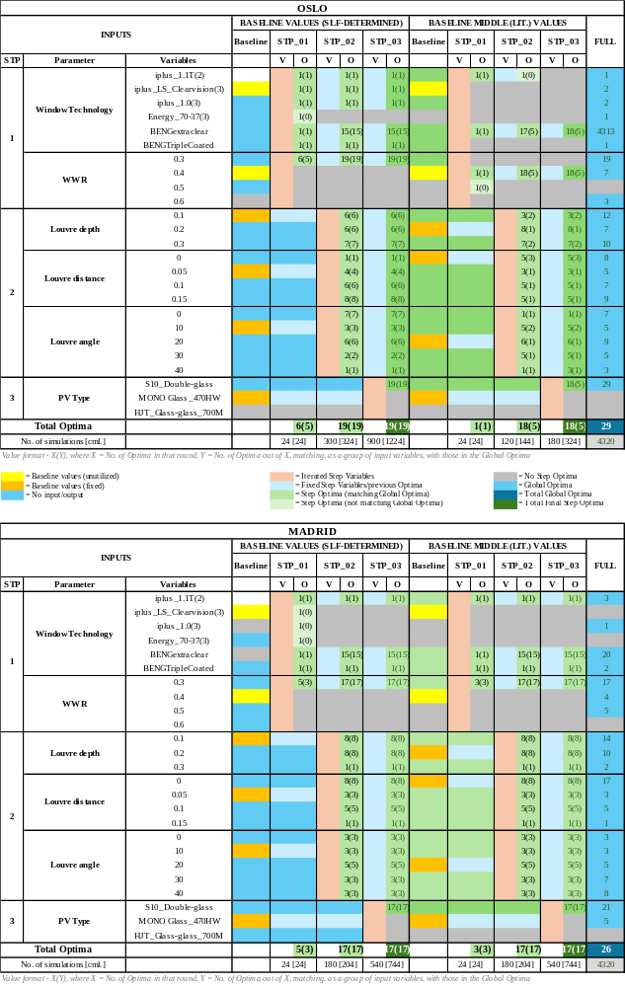
Fig.6: Overall result of the study summarizing the occurrences of optima in the stepwise & Global searches
- Discussion, limitations & future work
The outcome of this research can help to make better decisions while integrating BIPVs into the building. The alignment of the stepwise progress, similar to the design development process of a typical architecture project, helps simplify the optimisation process. A very detailed optimisation can certainly give better outcomes, but it might be deployed far too late into the project – some of the critical decisions will already have long been taken and cannot not be reversed. On the other hand, there are now considerable savings in computation time and resources - a win on two fronts.
On the side of the limitations, it should also be considered that the room geometry balance is easier to achieve than at building level. Most buildings are a combination of building programs, and complex forms, making it challenging to achieve a suitable energy balance. Additionally, there might be a context of other buildings, trees, vegetations and other obstructions which can compromise the quality of the Solar simulation outputs. In terms of design development, there can also be continued change into the building form later into the design process which can render the initial optimizations less relevant, or even irrelevant. Another issue is the choice and impact of the variables chosen, and their individual capacity to affect the optimum. It might be wiser to run in parallel, 2 or even 3 varying baselines to have a better chance at obtaining an optimum. Even in the case of multiple runs, there are considerable savings in simulation time, as for eg. in Madrid, running 2 baselines will be 34% and 3 will be ~52% of the global search, which is still smaller than a full run.
Another issue that is explored to a limited extent in this research work is the quality of the optima. While the primary goal of this study was to check first if it was even possible to obtain optima in a sequential optimisation process, there was less attention paid to the quality of the optima obtained in the different steps. Going further, this needs its own investigation, as it might improve the quality of the stepwise optimization, either by 1) eliminating sub-optimal step optima early-on, or 2) by discarding less than optimum baselines chosen. This categorization of the optima quality can either be with an amalgamated value of the multiple-objectives chosen – can also be weighted to prioritize some objectives higher. Alternatively, a new index can be chosen overall, relevant to the project, and can be used as a qualifier, such as cost, complexity or weight, which may be independent of the performance metrics, but nevertheless relevant to the project.
- Conclusion
This paper started with the goal of breaking down large, MOO that are needed for appropriate allocation of façade BIPVs, as there are many competing objectives that are needed to be met. In addition, there are challenges with the availability of detailed information at different stages of the architectural design process where this BIPV allocation would take place, and there is a risk that sub-optimal decisions might be taken based on simplistic know-hows or traditional thumb rules, rather than a mathematically simulated decision. Added to that, the cost of computational time and resources for running large, complex optimizations can hinder optimum allocation.
Here, based on a standardised office room, with proportional surfaces exposed to outdoor conditions, an MOO was carried out, in a stepwise manner, and benchmarked with full-factorial exploration. Based on the results presented earlier, it can be concluded that is infact a possibility to obtain some number of optima, which significantly reduces the number of simulations to be run. This was repeated for two different climates – Oslo, cold climate with low-angle sun with limited availability across the year (despite periods of long days), and colder, heating dominated building operations. The other location was Madrid in the south of Europe, which has warmer climate, more balanced availability of sun across the year, located higher on the Zenith. In the case of Oslo, 65% and 17% of the optima were attained with just 28% and 7.5% of the simulations, respectively, for two different baselines. In Madrid, 58.6% of the optima with just 17% of the global in both the runs. Further research into this topic can help make the optimal allocation of BIPVs on building envelopes, a more accessible and inclusive process for the typical building design and PV integration process in the industry.
- Acknowledgement
We would like to express our gratitude to the EU Horizon and Swiss SERI funded project MASS-IPV (Grant No.- 101135299) for funding and supporting this research activity.
- Bibliography
Bienvenido-Huertas, D., Oliveira, M., Rubio-Bellido, C., Marín, D., 2019. A Comparative Analysis of the International Regulation of Thermal Properties in Building Envelope. Sustainability 11, 5574. https://doi.org/10.3390/su11205574
DiBK, 2017. Byggteknisk forskrift (TEK17) [WWW Document]. Dir. Byggkvalitet. URL https://www.dibk.no/regelverk/byggteknisk-forskrift-tek17/14/innledning-til-kapittel-14-energi (accessed 7.27.26).
Gagnon, R., Gosselin, L., Armand Decker, S., 2019. Performance of a sequential versus holistic building design approach using multi-objective optimization. J. Build. Eng. 26, 100883. https://doi.org/10.1016/j.jobe.2019.100883
Goia, F., 2016. Search for the optimal window-to-wall ratio in office buildings in different European climates and the implications on total energy saving potential. Sol. Energy 132, 467–492. https://doi.org/10.1016/j.solener.2016.03.031
Goia, F., Haase, M., Perino, M., 2013. Optimizing the configuration of a façade module for office buildings by means of integrated thermal and lighting simulations in a total energy perspective. Appl. Energy 108, 515–527. https://doi.org/10.1016/j.apenergy.2013.02.063
Jones, N.L., 2019. Fast Climate-Based Glare Analysis and Spatial Mapping. Presented at the Building Simulation 2019, Rome, Italy, pp. 982–989. https://doi.org/10.26868/25222708.2019.210267
Lawrie, L.K., Crawley, D.B., 2026. climate.onebuilding.org [WWW Document]. climate.onebuilding.org. URL https://climate.onebuilding.org/#gsc.tab=0 (accessed 7.27.26).
Ron Judkoff, Joel Neymark, 1995. International Energy Agency building energy simulation test (BESTEST) and diagnostic method [WWW Document]. SciSpace - Pap. https://doi.org/10.2172/90674
Shan, R., Junghans, L., 2023. Multi-Objective Optimization for High-Performance Building Facade Design: A Systematic Literature Review. Sustainability 15. https://doi.org/10.3390/su152115596
Sick, F., Erge, T., Peterka, C., 1996. Photovoltaics in Buildings - A Design Handbook for Architects and Engineers (International Energy Agency (IEA), Paris, France), IEA Solar Heating and Cooling Programme - Photovoltaics in Buildings. Fraunhofer Institute for Solar Energy Systems (FhG-ISE), Freiburg, Germany.
skybrary.aero, n.d. Temperate Oceanic Climate (Cfb) [WWW Document]. URL https://skybrary.aero/articles/temperate-oceanic-climate-cfb (accessed 7.27.26).
Standards Norge, 2021. NS-EN 17037:2018+A1:2021 - Daylight in Buildings.
Talami, R., Wright, J., Howard, B., 2021. Multi-criteria robustness assessment of a sequential whole-building design optimization, in: Building Simulation. Presented at the Building Simulation 2021, IBPSA, pp. 2015–2022. https://doi.org/10.26868/25222708.2021.30818
Talami, R., Wright, J., Howard, B., 2020. A comparison between sequential and simultaneous whole-building design optimization for building performance, in: BSO Conference. Presented at the BSO Conference 2020, IBPSA-England, pp. 72–79.
Taveres-Cachat, E., Lobaccaro, G., Goia, F., Chaudhary, G., 2019. A methodology to improve the performance of PV integrated shading devices using multi-objective optimization. Appl. Energy 247, 731–744. https://doi.org/10.1016/j.apenergy.2019.04.033

