EuroSun2026
Community Transformation Office (OTC) role in the deployment of Energy Communities in Spain

Summary
Energy communities (ECs) are emerging as tools for a fair energy transition through shared renewable energy. Hence, the European Union (EU) has positioned ECs as key elements of its energy transition strategy, by creating a regulatory framework that defines them as Renewable Energy Communities (RECs) and Citizen Energy Communities (CECs). However, EC initiatives face regulatory and financial barriers related to legal compliance, initial investments, establishment, the implementation of energy projects, and the subsequent data management. In this context, support mechanisms, such as Community Transformation Offices (OTCs) in Spain, have emerged to guide and assist citizens, supporting them throughout the process of creating and consolidating ECs. This paper shows the current development of ECs in Spanish rural and urban areas and the role of one OTC in their deployment, achieving thirteen consolidated ECs, more than three hundred consultancies and sixty dissemination actions in Aragón and Guadalajara over an eighteen-month period.
Keywords: energy communities, shared renewable energy, regulatory barriers, financial barriers, Community Transformation Offices
Field of application for the findings: Sustainable and Solar Energy Transition: Renewable Energy Strategies, Scenarios, Financing and Policies, Renewable Energy Education, Citizen Participation / Empowering Consumers, Carbon Neutral Regions, Sustainability and LCA
Addressed audience: scientific community, general public
- Introduction
Renewable Energy Communities (RECs) and Citizen Energy Communities (CECs), introduced respectively by Directive (EU) 2018/2001 on the promotion of the use of energy from renewable sources and Directive (EU) 2019/944 on common rules for the internal electricity market, define energy communities as legal entities based on open and voluntary participation and controlled by citizens, local authorities or SMEs (European Parliament and Council, 2018, 2019). Their main objective is to deliver environmental, economic or social benefits to their members or local areas rather than financial profit, while enabling collective participation in energy activities such as generation, consumption, sharing or supply. These initiatives are gaining momentum across several European Union countries as mechanisms to make energy systems more accessible, open and democratic, while promoting clean and renewable energy solutions, among which solar photovoltaic self-consumption has become one of the most widely adopted models (Gallego-Castillo et al., 2021).
At European level, ECs have moved from a niche cooperative model to a recognised component of the EU energy transition. The European Commission frames energy communities as collective, citizen-driven initiatives that can improve public acceptance of renewable energy, mobilise private investment, reduce energy poverty, lower energy bills and create local green jobs (European Commission, 2026). Their relevance increased after the Clean Energy for All Europeans Package and was further reinforced by REPowerEU, which set the political objective of having at least one energy community in every municipality with more than 10,000 inhabitants by 2025. Recent EU monitoring indicates that more than 8,000 energy communities exist across the EU, while the Energy Communities Repository assessed 107 initiatives in all Member States, reporting 12,022 MW of installed capacity, more than €34.3 million in investment and 3.5 million tonnes of CO₂ equivalent greenhouse gas emissions avoided (European Commission, 2024). In parallel, REScoop.eu reports a network of around 2,500 energy communities involving approximately 2 million citizens, illustrating the growing scale and social relevance of the movement across Europe (REScoop.eu, 2026).
Within this European framework, the Spanish regulatory context regarding ECs remains limited to the transposition of both Directives and the establishment of conditions for collective self-consumption, while still leaving undefined how these communities can manage their energy or operate as market participants within the electricity system. Despite these barriers (Khorrami et al., 2025; Yiasoumas et al., 2023), ECs have expanded rapidly in Spain in recent years. According to the ECODES/Energía Común 2025 indicators report, Spain reached 837 active energy community initiatives, 182 more than the previous year, meaning that one out of every ten Spanish municipalities already host at least one energy community. The report also shows that these initiatives are maturing in terms of their social and territorial role: more than half of the analysed communities either implement or plan to implement measures against energy poverty, confirming their potential as local tools for energy justice and social inclusion. It also identifies Catalonia, the Valencian Community, the Basque Country and Navarre as the regions with the highest number of initiatives, while pointing to significant recent growth in Galicia, the Canary Islands and Extremadura (ECODES / Energía Común, 2025).
In parallel with this expansion, specific support mechanisms have emerged to help overcome regulatory, technical, administrative and social barriers. In Spain, Community Transformation Offices (OTCs), promoted by IDAE, follow a one-stop shop model by providing citizens and local stakeholders with free access to technical, legal, economic and administrative guidance. The ECODES/Energía Común 2025 report highlights their relevance, noting that half of the existing Spanish energy communities were created during the previous two years, coinciding with the deployment of these territorial support offices.
This work shows how one OTC has played a key role in the establishment and development of EC initiatives in heavily depopulated rural (Alonso et al., 2024) and urban areas in the region of Aragon and Guadalajara, Spain. The analysis focuses on the support provided to emerging communities, their consolidation process and the contribution of the OTC model to sustainable development, energy transition and collective energy activities at local level.
- Approach
The OTC is designed to address key barriers commonly faced by ECs, including the lack of a specific regulatory framework, challenges related to governance and collective decision-making, limited financial resources, and difficulties in behavioural change and user engagement. Additional challenges include the need for viable business and contracting models, improvements in energy efficiency and consumption reduction, as well as technical and environmental constraints. To tackle these challenges, the OTC implements a comprehensive methodology based on four main pillars:
2.1 Territorial engagement and initial diagnosis.
A preliminary assessment is conducted in each territory to identify existing initiatives, key stakeholders, organisation level, and potential interest from the local population, as well as relevant socio-economic and contextual factors. This territorial engagement phase is essential to adapt the support process to the specific characteristics of each municipality, especially in rural or depopulated areas where social capital, available human resources, municipal capacities and previous experience in collective initiatives can vary significantly. The diagnosis also helps identify suitable public or private spaces for future renewable installations, existing concerns or mistrust regarding collective energy models, and potential opportunities to link the EC with broader local priorities such as energy poverty reduction, local development, public building efficiency or municipal climate strategies.
2.2 Participatory facilitation and governance support.
The OTC organises participatory workshops focused on defining the collective vision and mission for the EC, improving internal organisation, and strengthening governance structures. This includes decision-making processes, conflict prevention tools, coordination mechanisms, and inclusive participation strategies to ensure effective and resilient group functioning. Special attention is given to building trust among participants, clarifying roles and responsibilities, and helping the driving group establish simple internal rules for communication, task distribution and meeting dynamics. These facilitation activities are particularly relevant in early-stage initiatives, where technical progress often depends on the group’s ability to make shared decisions, manage expectations and maintain long-term motivation. By reinforcing governance capacities from the beginning, the OTC supports the transition from informal interest groups to more autonomous and stable community organisations.
2.3 Multidisciplinary advisory services.
Targeted support is provided through workshops and consultancy services covering legal, technical, economic, administrative, and social aspects (Fig. 1). Special attention is given to the selection of the most suitable legal structure for ECs, which are mainly established as non-profit associations or consumer cooperatives, by analysing their respective legal, fiscal, administrative and financial implications. Technical advisory activities include energy consumption analysis, system design proposals, energy sharing schemes, optimisation strategies, and basic engineering for collective self-consumption systems. Economic advisory focuses on investment analysis, financing mechanisms, cost allocation among participants, and payback assessments based on expected savings. Administrative guidance supports ECs in meeting legal obligations and navigating bureaucratic procedures, reducing potential barriers, time, and costs during the establishment process. The main added value of this multidisciplinary support lies in coordinating these different areas within a single advisory framework, allowing emerging ECs to make coherent decisions and progress from initial concept to implementation with greater confidence.
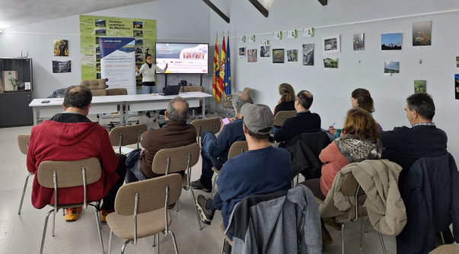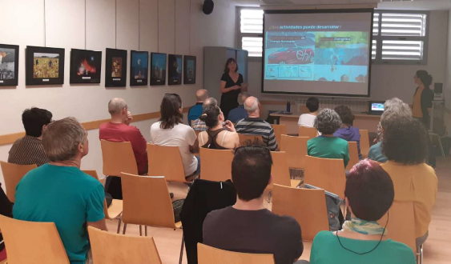
Fig. 1: OTC advisory sessions with energy communities
2.4 Dissemination and awareness-raising.
Energy communities are promoted as citizen-led initiatives through public talks, social media, and conventional communication channels, increasing visibility and engagement at the local level. These actions also help translate technical and regulatory concepts into accessible language, reducing mistrust and making the EC model understandable for citizens, municipalities and local businesses. Dissemination is therefore conceived not only as communication, but as a first step for participation, replication and the identification of potential driving groups.
Overall, this integrated approach allows the OTC to adapt its intervention to each local context, especially in rural and depopulated areas. By combining territorial diagnosis, participatory governance, multidisciplinary advisory services and dissemination, it provides a coherent support pathway that accompanies emerging ECs from initial mobilisation to consolidation.
- Energy Communities’ challenges and barriers
The deployment of Energy Communities (ECs) in Spain, particularly in rural and depopulated areas, faces a complex set of barriers that transcend technical engineering. Based on the experience of the OTC, these barriers can be grouped into four main categories that determine whether an initiative can move from initial mobilisation to a viable and operational community.
3.1 Regulatory and Administrative Barriers
A key obstacle is the persistent regulatory uncertainty within the Spanish legal framework. Although European Directives have been partially transposed, there is still a lack of detailed national and local provisions defining and clarifying how ECs can operate as full market participants beyond collective self-consumption.
In addition, emerging groups face significant administrative burdens when completing digital registration procedures, formalising their legal status or applying for public funding. In several small municipalities, a lack of specialised staff and insufficient technical training among local authorities can inadvertently slow down the development of EC projects.
3.2 Social and Governance Challenges
The social and organisational dimension of energy communities is often one of the most critical factors affecting their development. Based on the OTC experience, weak internal cohesion, limited participation and unresolved governance tensions are frequently among the main causes of initiative stagnation or dissolution.
Many emerging groups lack previous experience in sustained participatory processes and culture or in managing together complex collective projects. As a result, responsibilities tend to be unevenly distributed, a small number of members often assume most tasks due to a limited available time, unclear role distribution or uneven engagement. Thus, participation may decline over time, reducing the group’s capacity to make decisions and maintain project momentum.
Without professional facilitation, groups may also lack practical tools for conflict prevention, mediation and shared decision-making. Unresolved tensions can progressively erode trust among participants and create blockages that delay both organisational consolidation and technical implementation. Additionally, there is a persistent distrust towards incumbent actors in the traditional electricity system, which can make some citizens cautious about new collective energy models. This scepticism may reduce initial engagement, especially when the benefits, governance rules and responsibilities of the EC are not clearly explained.
3.3 Technical and Infrastructure Constraints
Technical feasibility cannot always be assumed, especially in older rural settlements. Finding suitable rooftops or land that comply with both technical requirements, such as orientation, shading and structural capacity, and urban planning regulations, remains a recurrent challenge.
Once the installation is completed, commissioning issues are common, often due to the slow response times from distribution companies or technical mismatches with existing infrastructure. In addition, technical awareness among citizens and local technicians regarding the possibilities of collective self-consumption under Spanish R.D. 244/2019 remains limited (Spain, 2019).
3.4 Economic and Contextual Hardships
Financial viability remains a major concern for small-scale citizen-led initiatives. The need for significant upfront capital, together with the complexity of managing energy projects without a profit motive, creates substantial barriers to participation, engagement and consolidation. In the regions where the OTC has been working, Aragon and Castile-La Mancha, particularly Guadalajara, depopulation reduces the number of people available to form a robust driving group, limiting the human resources required to manage the community.
Finally, designing viable business models and assessing different financing options, such as crowdfunding, bank loans or grants, requires a level of financial expertise that most citizen groups do not initially possess.
- Practical Steps for Energy Communities’ Implementation
To address these multifaceted barriers, the OTC implemented the four-pillar support framework explained in section 2 while relying, within the participatory facilitation pillar, on the "Triangle of Group Effectiveness" as a specific group-work methodology. This methodology is based on three interrelated dimensions: results, people and processes; and helps move beyond traditional engineering by placing social and territorial realities at the centre of the project. The "Triangle of Group Effectiveness" provides the necessary tools for conflict prevention and robust governance (Fig. 2). This approach ensures that energy community initiatives are not only technically viable but also socially resilient and administratively sound.
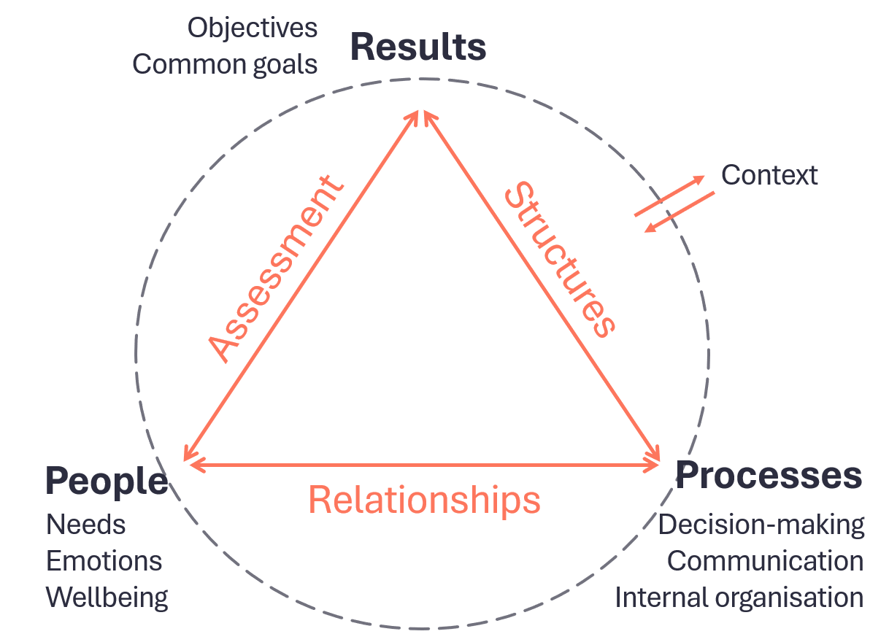
Fig. 2: Triangle of Group Effectiveness methodology
Drawing on the OTC’s practical experience and its comprehensive triangle methodology, a five-step roadmap was developed to guide energy community initiatives from inception to operation:
- Building the Team: Forming a motivated "Grupo Motor" (Driving Group) composed of citizens, local businesses, and representatives from the City Council.
- Legal Constitution: Selecting the most appropriate legal form and drafting their statutes. To support this stage, the OTC guides each community through a structured step-by-step process, as illustrated in Tab. 1:
Tab. 1: Comparison of legal forms for energy community constitution.
Legal form | Most suitable context | Main advantages | Main limitations
Association | Small-scale, citizen-led pilots or residential neighbourhoods | Fast to set up, low initial complexity, focused on social cohesion | It struggles with high investments or complex energy sales
Cooperative | Projects with significant industrial investment or long term-growth | Robust for economic activity, energy sharing, and financial trust | Slower to set up, higher initial complexity, requires stronger governance and capital

- Defining Goals: Designing the technical project, identifying priorities and selecting suitable financing models.
- Implementation: managing permits and licences, coordinating stakeholders and executing solar PV installations or whatever the EC decides to do.
- Community Management: Monitoring energy production, sharing results among members, and maintaining participatory governance over time.
By keeping the energy community group aligned with these five steps, and by combining territorial engagement, the Triangle of Effectiveness and specialised advisory services, energy community initiatives can progress steadily despite the challenges and obstacles they face. This structured and timed approach enables communities to address social, technical, administrative and economic issues progressively, while significantly increasing their chances of long-term success.
- Results
The activities implemented by the OTC produced measurable results across the main dimensions of its intervention: dissemination and awareness-raising, territorial engagement, participatory support, multidisciplinary advisory services and the creation of Energy Communities across the target regions during one year and half. These results reflect both the operational capacity of the OTC and the relevance of a structured support mechanism for helping citizen-led initiatives move from initial mobilisation to formal constitution and early implementation.
The main quantitative outcomes of the OTC activity are summarised in Tab. 2. They provide an overview of the number of actions carried out, the advisory services delivered, the communities supported and the public reached during the implementation period.
Tab. 2: OTC activity outcomes
Category | Indicator | Result
Community support | Accompaniment actions carried out | 62
Dissemination and outreach | Dissemination actions | 60
Dissemination and outreach | Social media impacts | +25,000
Advisory services | Economic advisory sessions | 32
Advisory services | Legal advisory sessions | 75
Advisory services | Social advisory sessions | 35
Advisory services | Administrative advisory sessions | 62
Advisory services | Technical advisory sessions | 147
Community creation | Energy communities formally established | 13
Community creation | Consolidated groups | 21
Public engagement | People informed | 1,515
These outcomes show that the OTC combined broad territorial engagement with specialised advisory support, enabling emerging initiatives to address social, organisational, technical, administrative and economic barriers in a coordinated way.
The following subsections analyse these results in greater detail, linking the quantitative outcomes with their territorial, social, economic and organisational implications, as well as with the development of specific energy community cases.
5.1. Quantitative Performance and Advisory Reach
Building on the quantitative overview presented in Tab. 2, this subsection highlights the OTC’s execution capacity and advisory reach in relation to the initial work plan. The office achieved a 206% execution rate in dissemination activities and a 103% rate in multidisciplinary advisory services, showing a high level of implementation.
In total, the OTC delivered 316 advisory sessions to 54 groups, mainly in technical, legal, administrative and economic-financial areas. Technical advisory was the most requested service, with 147 actions, followed by legal (75), administrative (62), and economic-financial (32) advisory services.
Regarding community consolidation, 21 groups reached a consolidated stage, exceeding the initial target of 15. Among them, 13 energy communities were formally constituted and 8 were completing legal registration by the end of the OTC’s activity period.
5.2. Territorial Impact and the Demographic Challenge
A core objective of the OTC was to contribute to territorial revitalisation in rural areas facing significant depopulation. The OTC intervened in 61 municipalities classified under the demographic challenge category, including:
- 48 municipalities in Aragon, in the provinces of Teruel and Huesca, where ECs such as Mudéjar Alumbra (Alcorisa) and Ansó became reference cases for local energy sovereignty.
- 13 municipalities in Guadalajara, highlighting the constitution of La Yunta Power which illustrates the potential of ECs in high-priority depopulation areas.
The OTC also operated in eight municipalities included in Just Transition Agreements, supporting territories formerly dependent on coal mining in their transition towards a green economy. These results show that, when supported through locally adapted accompaniment, ECs can become practical tools for territorial development, citizen mobilisation and rural energy transition.
5.3. Economic Impact and Energy Justice
The economic advisory sessions focused on making renewable energy and self-consumption projects both accessible and profitable for small-scale consumers. The OTC used tools such as PVGIS to design installations, estimate production, calculate investment needs and payback periods, helping groups assess the feasibility of their projects. In cases such as Luco de Jiloca the expected payback period was approximately four years, with an average investment of €1,000 per member.
Energy justice was also addressed through specific guidance for vulnerable consumers. Informative sessions included specific modules on how collective self-consumption could be combined with the Bono Social electricity discount. For local City Councils, the OTC provided strategies and advise on how ECs could become institutional and practical tools to reduce energy poverty and distribute local renewable benefits more fairly within their borders.
5.4. Social Innovation and Gender Perspective
Social innovation was addressed through a care-centred approach focused on group cohesion, governance and long-term sustainability. The OTC’s accompaniment actions (62) and social advisory sessions (35) were conducted to train groups in conflict prevention, role distribution, participatory organisation and efficient shared decision-making.
Moreover, the OTC prioritized gender as a transversal criterion. The technical team was mainly led by women, while workshops formats and schedules were intentionally designed to favour work-life balance. In major events, such as the encounter in Luco de Jiloca, dedicated conciliation spaces were provided for participants with caregiving responsibilities.
5.5. Digital Impact and Networking
The OTC developed a communication and networking strategy to extend the impact of its activities beyond direct advisory work. This strategy combined digital dissemination with peer-to-peer exchange among emerging energy communities, reinforcing the collective dimension of the energy transition and supporting continuity after the formal OTC activity period. To ensure the transition remains a collective effort, the OTC built a robust communication network:
- Digital dissemination: the project’s digital dissemination generated more than 25,000 social media impacts, with LinkedIn accounting for the highest visibility, reaching 16,914 impacts.
- Peer-to-peer networking: Following the I Encuentro de Comunidades Energéticas de Aragón in May 2025, the OTC promoted the Red de #ComunidadesEnergéticas through a WhatsApp Community, involving 12 different EC projects. This network serves as a peer-to-peer support channel for sharing technical questions, regulatory updates and news, practical experiences and success stories, ensuring collaboration and activities continue beyond the OTC’s funding period.
5.6. Real cases
As a result of this integrated approach, 13 energy communities were formally established (Fig. 3), while eight additional initiatives were completing the process of legal constitution by the end of the OTC’s activity period, in 2025. These results demonstrate the effectiveness of territorial support mechanisms in fostering the development of ECs, especially in rural contexts. Two representative cases are presented below to illustrate the diversity of implementation pathways and challenges encountered.
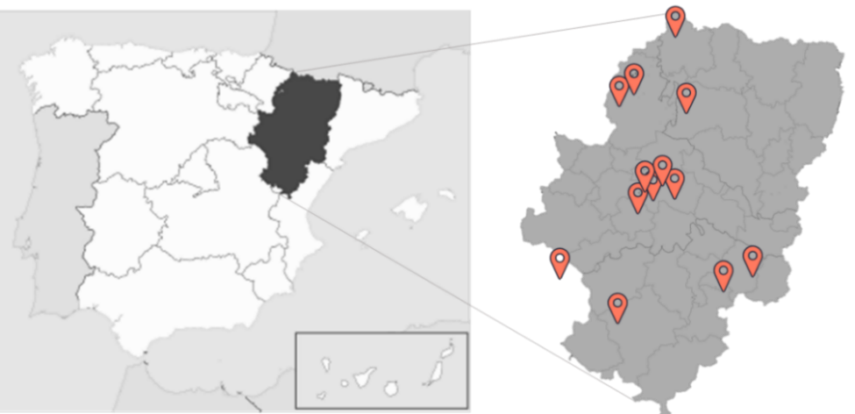
Fig. 3: Aragon map representing energy communities formally established.
5.6.1 Mozota
The Mozota case, located in a rural municipality in the province of Zaragoza, serves as a benchmark for combining technical energy projects with local cultural identity. The initiative began with an informative session in February 2024, which successfully mobilised a local driving group and initiated a two-year process towards the installation stage of its energy community project. Throughout this period, the community faced significant challenges related to local administration, permitting delays, and limited initial knowledge of the energy community model, showing that, in small municipalities, local authorities, citizens and stakeholders initially encountered some difficulties in understanding how energy communities work and how to put them into practise.
Although the photovoltaic installation was completed (Fig. 4), the community had not been able to start operating by the end of the analysed period, because the final grid connection remained unresolved with the distribution company. The main pending issue concerns the approval of the grid connection and evacuation point, which illustrates the dependence of community-scale projects on external distribution procedures even after the physical installation is ready.
During these two years, the driving group invested considerable effort in maintaining cohesion and motivation among its members, working intensively on dialogue, collaboration, and effective communication to sustain participation and keep the community united despite the administrative and technical delays.
Overall, Mozota represents a clear example of a community which needed to address simultaneously regulatory, technical, and organizational barriers from public administration and distribution companies before being able to move forward. The case also shows that the completion of the physical installation does not necessarily imply immediate commissioning, as grid-connection procedures can remain a critical bottleneck.
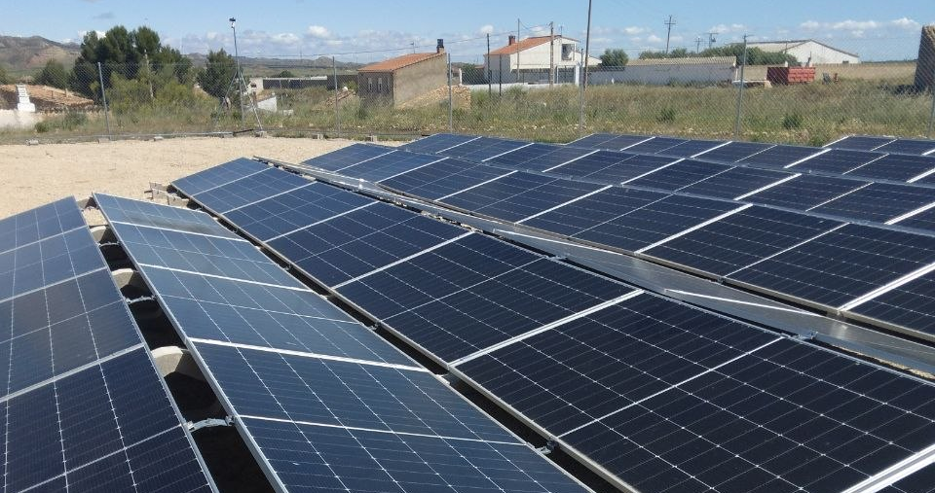
Fig. 4: Photovoltaic system installed in Mozota.

5.6.2 Peñaflor
Peñaflor de Gállego, a rural neighbourhood of Zaragoza, provides a contrasting case in which an existing citizen association led the energy transition and became the main driver of the EC project. Unlike initiatives that begin with a newly created driving group, this case shows how a pre-existing local organisation can facilitate mobilisation, trust-building and continuity in the development of a collective energy project.
The energy community was legally constituted in August 2024, as a non-profit cooperative society of consumers and users. At the time analysed, it had 20 members, including a very active core group of eight people coordinating organisational tasks and driving the daily operations.
The project illustrates a clear example of successful public-private synergy. The OTC and the Zaragoza City Council worked together to provide information and accompaniment to this group (Fig. 5). At the end of the OTC’s activity period, the community was in the final stages of securing a municipal roof lease to host its first solar photovoltaic installation.
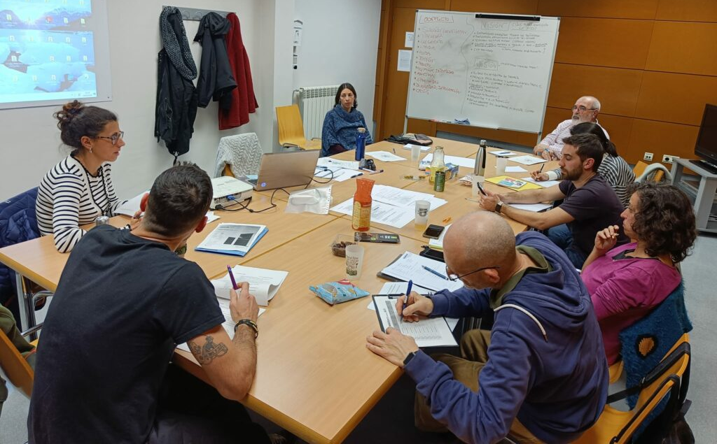
Fig. 5: Peñaflor Driving Group during a meeting.
During this waiting period for the approval of the photovoltaic installation on the municipal building, Peñaflor carried out several initiatives, including the promotion of solar energy, electrical invoice workshops, and collective biomass purchasing.
Altogether, Peñaflor demonstrates how a small group initially organised around neighbourhood social issues can progressively acquire the organisational capacity required to manage complex energy projects, bridging the gap between urban and rural energy needs and priorities.
- Replicator keys
Based on the OTC’s activities in Aragon and Guadalajara, several key factors have been identified for making energy community projects successful and replicable in other territories. These elements act as the foundational requirements that ensure the transition from a supported initiative to autonomous and sustainable energy communities.
6.1. The Five Essential Replicator Keys
The effective replication of the EC model depends on five core elements:
- A Physical Location: Securing a viable rooftop or land is the technical starting point. Collaboration with local City Councils is often the most effective way to secure these spaces through roof leases.
- A Motivated Driving Group: Whether led by citizens, existing associations, or the local government, a core group of committed individuals is required to coordinate tasks, manage daily operations, sustain participation and maintain project momentum.
- Continuous Professional Support: To prevent initiatives from feeling overwhelmed or becoming blocked by technical, legal or administrative hurdles, access to a one-stop-shop advisory model such as the OTC is particularly relevant during the first 12 to 18 months.
- Continuous Local Communication: The EC model must be explained repeatedly and in accessible terms to build trust within the community. Success depends on overcoming scepticism through constant local dissemination, informative sessions and direct dialogue with citizens and stakeholders.
- Networking: Replicability is enhanced when communities do not operate in isolation. Connecting with other energy communities allows for peer-to-peer learning, exchange of practical and technical solutions, and collective problem-solving.
6.2. Institutionalizing Replicability: tools for autonomy
To ensure that the replicator keys remain active after the OTC’s direct intervention, three institutional tools were developed to support the autonomy of emerging energy communities and renewable energy initiatives:
- Empowerment through Training: Driving Groups participated in workshops where they acquired practical skills in governance, group care, and efficient decision-making including the distinction between consensus and consent. These activities aimed to strengthen autonomy, internal capacities and reduce dependence on external support.
- Practical Roadmap Guide: A final "Next Steps" guide was delivered to all consolidated groups as a practical resource for addressing future challenges and navigating the operational phase with greater autonomy.
- The Peer-to-Peer Network: By establishing the Red de #ComunidadesEnergéticas WhatsApp Community, the OTC promoted a self-sustaining ecosystem where now more than 12 projects can resolve doubts and share updates and experiences collectively.
- Conclusions
The OTC shows that territorial one-stop-shop support mechanisms can accelerate the development of citizen-led energy communities by combining technical, legal, administrative, economic and social advisory services. This integrated approach helped emerging initiatives move from initial mobilisation to legal constitution and early implementation.
The results confirm the relevance of this model: the OTC achieved a 206% execution rate in dissemination activities, delivered 316 advisory sessions and supported the consolidation of 21 groups, including 13 formally established energy communities. These outcomes indicate that structured accompaniment can reduce uncertainty and strengthen the capacity of local actors, particularly in rural and depopulated territories.
The experience also shows that technical feasibility alone is not sufficient. Social cohesion, local communication, governance capacity and institutional coordination are critical for project continuity. At the same time, administrative complexity and grid-connection delays remain important barriers that can prevent completed installations from becoming operational.
The analysis also identifies five practical conditions for replication: access to a suitable physical location, the existence of a motivated driving group, continuous professional support, sustained local communication and peer-to-peer networking. These elements are essential to help communities move from externally supported initiatives towards more autonomous and resilient organisations.
Overall, the OTC model offers a transferable approach for other European regions facing similar challenges of depopulation, energy poverty and collective renewable energy deployment. Its added value lies not only in accelerating project development, but also in building local capacities, strengthening community governance and creating support networks that can sustain energy community initiatives beyond the period of direct institutional assistance.
- References
Alonso, M.P., Gargallo, P., Lample, L., López-Escolano, C., Miguel, J.A., Salvador, M., 2024. Measuring the relationship between territorial exclusion and depopulation – A municipal classification proposal to guide territorial balance. Journal of Rural Studies. 111, 103421. https://doi.org/10.1016/j.jrurstud.2024.103421
ECODES / Energía Común, 2025. Observatorio Energía Común. Informe de indicadores 2025. Fundación Ecología y Desarrollo. Available at: https://ecodes.org/images/que-hacemos/03.Energia_y_personas/Comunidades_Energ%C3%A9ticas/Energia_comun/Informe_indicadores_energia_comun_2025.pdf (accessed 10 August 2026).
European Commission, 2024. Energy Communities Repository products. Directorate-General for Energy. Available at: https://energy.ec.europa.eu/topics/markets-and-consumers/energy-consumers-and-prosumers/energy-communities/energy-communities-repository-products_en (accessed 10 August 2026).
European Commission, 2026. Energy communities. Directorate-General for Energy. Available at: https://energy.ec.europa.eu/topics/markets-and-consumers/energy-consumers-and-prosumers/energy-communities_en (accessed 10 August 2026).
European Parliament and Council, 2018. Directive (EU) 2018/2001 of the European Parliament and of the Council of 11 December 2018 on the promotion of the use of energy from renewable sources (recast). Official Journal of the European Union, L 328, 82–209. Available at: https://eur-lex.europa.eu/eli/dir/2018/2001/oj/eng (accessed 10 August 2026).
European Parliament and Council, 2019. Directive (EU) 2019/944 of the European Parliament and of the Council of 5 June 2019 on common rules for the internal market for electricity and amending Directive 2012/27/EU (recast). Official Journal of the European Union, L 158, 125–199. Available at: https://eur-lex.europa.eu/eli/dir/2019/944/oj/eng (accessed 10 August 2026).
Gallego-Castillo, C., Heleno, M., Victoria, M., 2021. Self-consumption for energy communities in Spain: a regional analysis under the new legal framework. Energy Policy. 150, 112144. https://doi.org/10.1016/j.enpol.2021.112144
Khorrami, S., Falvo, M.C., Pompili, M., 2025. A Review on Energy Communities Development, Opportunities and Challenges in Germany, Spain, and Italy. IEEE Access. https://doi.org/10.1109/ACCESS.2025.3579336
REScoop.eu, 2026. REScoop.eu is the European federation of energy communities. Available at: https://www.rescoop.eu/ (accessed 10 August 2026).
Spain, 2019. Real Decreto 244/2019, de 5 de abril, por el que se regulan las condiciones administrativas, técnicas y económicas del autoconsumo de energía eléctrica. Boletín Oficial del Estado, 83, 35674–35719. Available at: https://www.boe.es/eli/es/rd/2019/04/05/244 (accessed 10 August 2026).
Yiasoumas, G., Berbakov, L., Janev, V., Asmundo, A., Olabarrieta, E., Vinci, A., Baglietto, G., Georghiou, G.E., 2023. Key Aspects and Challenges in the Implementation of Energy Communities. Energies. 16, 4703. https://doi.org/10.3390/en16124703

