Investigation of the longitudinal shear behaviour of the tufted composites

C. Hui, C. Chen, P. Wang, X. Legrand

ENSAIT, GEMTEX, Universityof Lille, 2 Allée Louise et Victor BP 30329, 59100 Roubaix, France
Email: chan.hui@ensait.fr; chen.chen@ensait.fr; peng.wang@ensait.fr; xavier.legrand@ensait.fr

Keywords: Textile composites, 3D preform, Tufting, Shear behaviour

Abstract

This study focus on the tufting technology to improve the mechanical performance of the through-the-thickness reinforced fabric and composite. Developed from conventional stitching, tufting is a method used to link together dry reinforcements or strengthen composite by inserting thread through the thickness of the preform [10]. Tufting can be used to combine different types of textiles such as woven or braided layers. It requires only one side access of thread and does not require the use of second thread which makes it simpler and cost economic. This paper outlines the manufacture of tufted sample and the influence of the tufting density on the mechanical properties of tufted composite, in particular, the longitudinal shearing, is deeply analysed. The first results show that the longitudinal shear stiffness increases due to the presence of through-the-thickness yarns. More important tufting density is used more important longitudinal shear stiffness can be observed. By contrast, the more important tufting density brings out the heavier composite part, the ratio shear load to mass will be modified. On the other hand, the more important tufting density may lead to more degradation of the tufting threads and of the structure of the reinforced fabric.

1. Introduction

Laminated composites are wildly used in many industrial fields such as transport, construction, energy and defence. Comparing with metal materials, laminated composite presents better mechanical performances such as high specific strength and stiffness. However, the laminations of two-dimensional layered fibre structure have shown limitations including high cost and some inferior mechanical properties such as interlaminar shear [1, 2]. Therefore, a large number of works were conducted on the development of 3D preforms with reinforcements of high in-plane densities, and including also the insertion of through-the-thickness yarns to connect layers thereby combining excellent mechanical properties of layers to improve the resistance to delamination and impact resistance [3, 4]. Different approaches of forming 3D preforms were brought out and classified according to processes of inserting fibres in the thickness. 3D weaving, braiding, knitting and other specific technologies such as stitching, z-pinning and tufting were applied on insertion of through-thickness fibrous structure [5-9].

The present paper is focus on tufting and LRI process, and analyse the influence of tufting density on the longitudinal shear stiffness of tufted 3D composite. As a popular and low-cost through-thickness reinforcement (TTR) method, most types of textile can be reinforced by tufting and can be used to the thick fabric. Despite tufting has some advantages and potential application in industrial area. However, it still exists some limitation, which need to investigate.

The aim of the present paper is to investigate the longitudinal shearing property, therefore, tufted composites are designed and manufactured, then by means of tensile test to realize the effect of through-thickness thread on longitudinal shearing. Meanwhile, study the influence of tufting density on longitudinal shearing property.

2. Experimentation Methodology

2.1. Tufting process

Under investigation of the effect of inserting through-thickness thread on longitudinal shearing of tufted composite. The delamination toughness in lengthways may be prevented or be delayed by means of reinforcing with tufting thread, such as carbon thread.

In order to overcome the issue above, the representative preform samples were tufted by a home-designed tufting device shown in Figure. 1. It is this device to carry out the tufting process, which refers to insert a tufting needle with thread at and only at one side access. The tufting thread is placed into the preform with a simple friction, the tufting loop is formed while the needle retracts, hereto completes a whole tufting cycle, and obtains the tufted preformed. The tufting process sketched in Figure. 2. During the tufting process, the hollow needle is used as the tufting needle, which decreases the thread damage, with a diameter of 2mm, the pressure of tufting needle and presser foot is 2.5bar while being initialized a starting position based on predetermined length of tuft loop, which need to be well controlled.

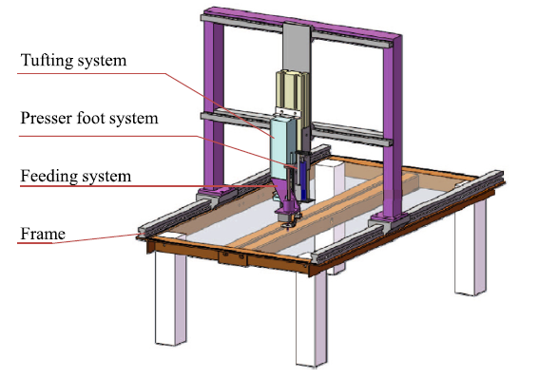

Figure 1. The tufting device [10].

Figure 2. Schema of tufting process [11].

2.2. Materials

2.2.1. Tufted preform characteristics and manufacturing

The tufted preform comprised twenty cross-plies (0/90) of E-Glass fabric, with an area density of 454.5±5 g/m², then the plies were tufted together with twisted 2 × 1k-67Tex Tenax®-J HTA-40 carbon thread (see in Tab. 1). In order to understand the roles of tufting thread, a twenty cross-plies, 2D laminated preform as a reference, for studying further the influence of tufting density on the tensile properties of tufted composite, three patterns of tufting density were 3mm, 6mm, and 9mm, respectively. Therefore a reference composite sample and three tufted composites samples were prepared.

Table 1. Tufting carbon thread properties.

Thread specification | Linear density (tex) | Number of filament | Twist (T/m)
Tenax®-J HTA-40 | 2 × 67 | 2 × 1000 | 240 ±16

2.2.2. Resin characteristics and liquid resin infusion process

In order to obtain the tufted 3D composites, the tufted 3D preform were infused. The resin used in this paper was an epoxy resin SR8200 and an epoxy hardener SD7230, from SICOMIN®, with a ratio of 100 : 37 by the liquid resin infusion (LRI) process, LRI process is an advanced infusion process with advantages of cost-effective and lower material storage, which can respond to produce the large, thick or complex composite. The resin flow through the thickness of preform, dut to a low pressure between the inlet and the outlet [12]. The example of tufted composite sample is shown in Figure. 3.

(a) (b)

Figure 3. Tufted composite sample, (a) top view and (b) bottom view.

3. Result

An Instron 5985 universal testing machine was used to measure the tensile resistance of three tufting density types. The tufted specimen was fixed onto two steel plate in the help of a structural adhesive EC-9323B/A from 3M Scotch-Weld®, then to mount them on the Instron testing machine, the test set-up is shown in Figure. 4.

Regarding tensile test, a total of five specimens were test for each composite sample (mentioned in section 2.2.1). The specimen is rectangular, its length (L) is 65mm and its width (W) is 20mm, its thickness (T) is 7.5mm, n the displacement (Δ) (shown in Figure 4(c) ), which refers to the initial state is accumulated during the test; therefore the shear stress can be calculated as the following equation (Eq. 1), and the shear strain in radian can be expressed as the following equation (Eq. 2)

τ = P/ (L × W).  ε =arctan(tan(Δ/T)). | (1)  (2)

Where τ is the shear stress, P is the load on the specimen shear stress, ε is the shear strain in radian; to sum up that when P equals the maximum load, then τ is the ultimate shear strength, noted as τ_{max}.

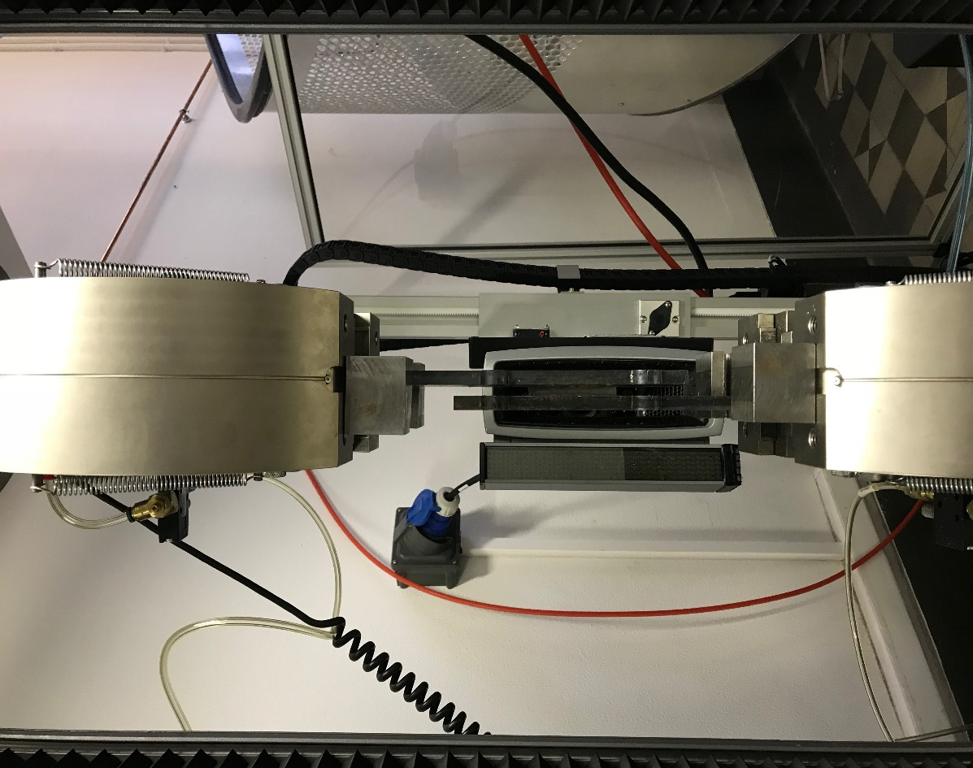
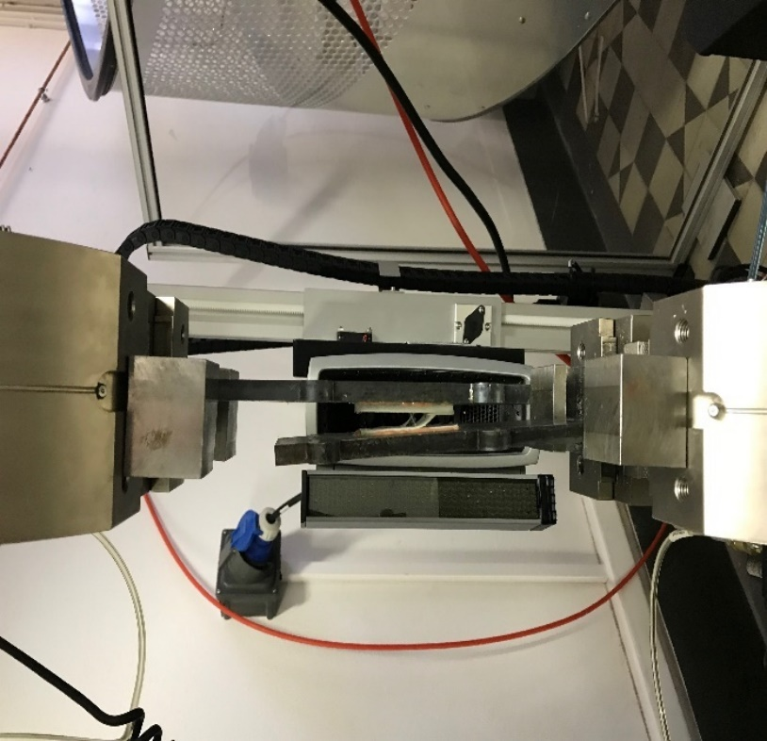
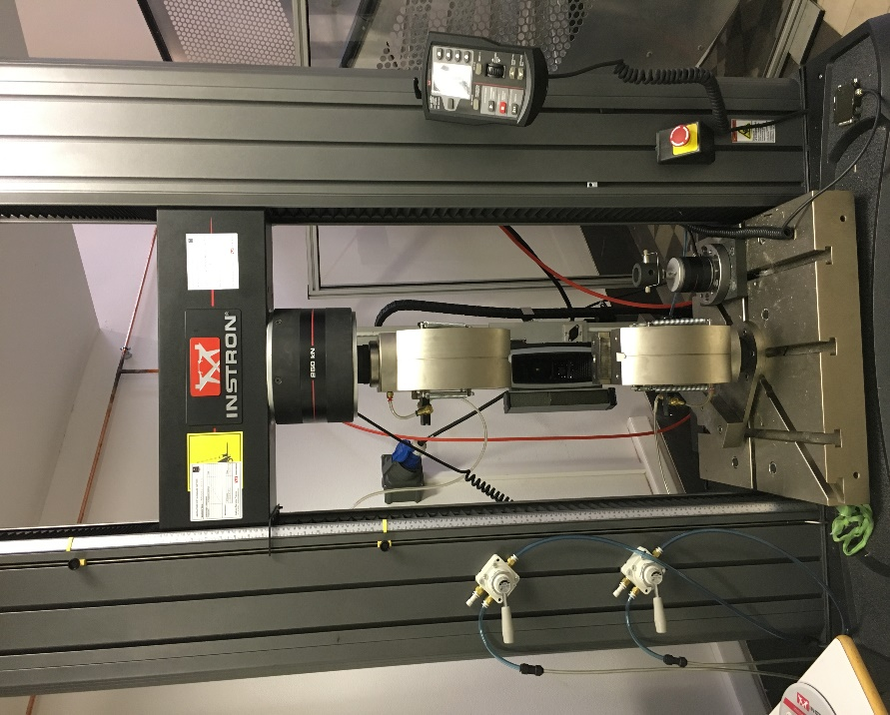
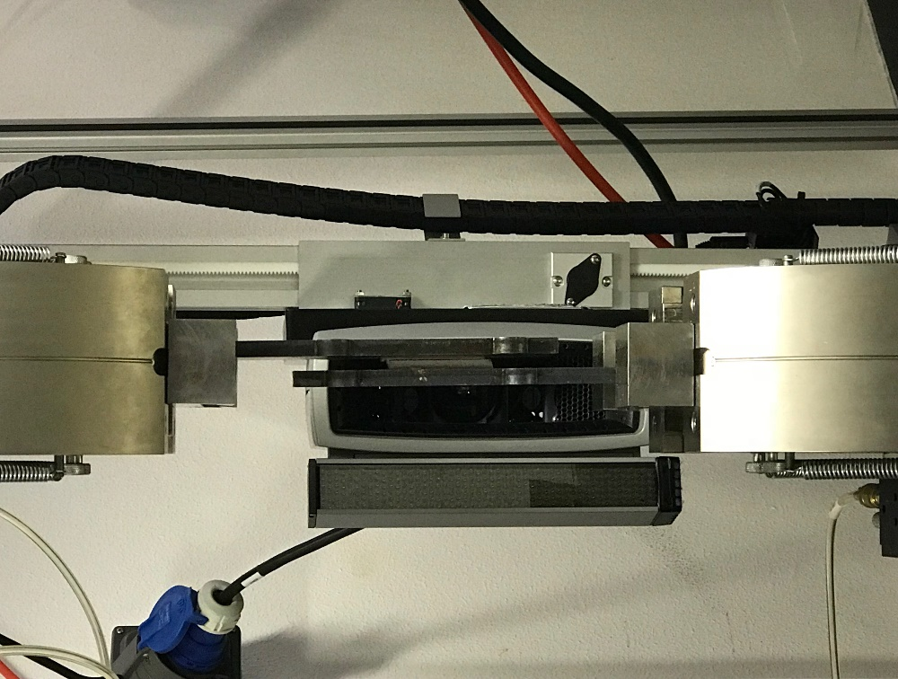
Δ

(a) (b) (c) (d)

Figure 4. Tensile test set-up, (a) at Instron 5985 testing machine, (b) at the initial state, (c) at the testing state and (d) at the breakage state

The measured load-strain (radian) data is shown in Figure 5. From observing and analysing these plots, it is found that with a tufting thread penetrate through the thickness of preform, all the plis are connected together, then to enhance the Z-direction as a result, so that the tufted composite need more time to break, meanwhile from the curve, tufting density of 6mm spent more time than that of 9mm, and spend less time than that of 3mm. However, this regulation was not suitable to the influence of tufting density on the shear load. It may be the stable structure of the preform was destructed by the insertion thread, in addition, the tufting thread could not form a tight structure, like the tufting density of 9mm.

The Figure. 6 demonstrates the ultimate longitudinal shear strength of tufted composite by means of histogram. Firstly, to compare the tufted composite, as the tufting density increases, the stronger the shear strength becomes, it means that the shear strength of tufting density of 3mm was the strongest, and that of tufting density of 9mm was weakest; Then to compare the tufted 3D composite with 2D laminated composite, from the tufting density of 3mm and 6mm perspective, the shear strength was increased under the preform was penetrated a tufting thread. On the contrary, the tufting thread insert into the preform with the density of 9mm did not bring the increase of shear strength.

Figure 5. Representative shear stress-strain (radian) curves for tufted composite

Figure 6. Representative ultimate shear strength histogram for tufted composite

4. Conclusions

The longitudinal deformation behaviour and the influence of tufting density on the tufted composite during the longitudinal shear test is investigated. It has been demonstrated that the larger deformation may be occur by the tufted composite, and the tufting density is a major factor of this issue. Although through the results of the present paper, the through-thickness thread could bring some positive influences on the shear strength under some situation, it still exist the negative effect, so to optimize the tufting process, including the characteristic of materials, manufacturing process, could be the future work.

Acknowledgements

This work is supported in part by the China Scholarship Council (CSC) (Grant CSC N° 201708070021), Mechanic and Textiles (MTC) Group for the GEMTEX laboratory in ENSAIT and EDSPI in Lille1 University (Grant INE N° OCNIAP00042).

References

[1] A. Faggiani, B.G. Falzon. Predicting low-velocity impact damage on a stiffened composite panel. Compos, Part A: Appl Sci Manuf, Vol. 41, pp.737–749, 2010.
[2] B. G. Falzon, et al. Brown An investigation of Mode I and Mode II fracture toughness enhancement using aligned carbon nanotubes forests at the crack interface. Composite Structures, Vol. 106, pp. 65-73, 2013.
[3] S. D. Green, et al. Numerical modelling of 3D woven preform deformations. Composite Structures, Vol. 108, pp. 747–756, 2014.
[4] Mahadik Y, et al. Characterisation of 3D woven composite internal architecture and effect of compaction. Compos A Appl Sci Manuf, Vol. 41, pp.872–880, 2010.
[5] A. P. Mouritz, B. N. Cox. A mechanistic interpretation of the comparative in-plane mechanical properties of 3D woven, stitched and pinned composites. Composites: Part A, Vol. 41, pp. 709–728, 2010.
[6] A. P. Mouritz, B. N. Cox. A mechanistic approach to the properties of stitched laminates. Composites Part A, Vol. 31A, pp. 1–27, 2000.
[7] A. P. Mouritz, et al. Review of applications for advanced three-dimensional fibre textile composites. Composites Part A, Vol. 30A, pp. 1445–1461, 1999.
[8] A. P. Mouritz, et al. A review of the effect of stitching on the in-plane mechanical properties of fibre-reinforced polymer composites. Composites Part A, Vol. 28A, pp. 979–991, 1997.
[9] X. Chen, et al. An overview on fabrication of three-dimensional woven textile preforms for composites. Textile Research Journal, Vol. 81, pp. 932-944, 2011.
[10] L.S. Liu, T. Zhang, P. Wang, X. Legrand, D. Soulat. Influence of the tufting yarns on formability of tufted 3-Dimensional composite reinforcement. Composites Part A, Vol 78: 403-411, 2015.
[11] Giuseppe Dell’ Anno et al. Exploring mechanical property balance in tufted carbon fabric/epoxy composites. Composites Part A, Vol 38, Issue 11: 2366-2373, 2007.
[12] P. Wang, S. Drapier, J. Molimard, A. Vautrin, J.C. Minni. Characterization of Liquide Resin Infusion (LRI) filling by fringe pattern projection and in-situ thermocouples. Composites Part A, Vol 41: 36-44, 2010.

