Numerical investigation of mechanical response of bio-inspired nacre-like composites under impact loading

Cui Shaokang¹, Lu Zixing¹ and Yang Zhenyu¹

(¹Institute of Solid Mechanics, Beihang University, Beijing 100083, China)
Email: zyyang@buaa.edu.cn

Keywords: Bioinspired composites, Hierarchical structures, Impact behavior, Finite element method (FEM)

Abstract

Natural biological materials have achieved multifunctional properties for special purposes in the long course of organism survival. Among them there are some materials that show excellent toughness compared to their constituents yet do not sacrifice much stiffness and strength, for instance nacre, which is a big challenge confronted by the conventional material design strategy. In this paper, the dynamic behaviors of nacre-like structure is investigated using finite element method (FEM). A parametric study is conducted focusing on the role of stagger arrangement and different aspect ratio of tablets (reinforcement) for improved impact-resistant performance. Concerning the effect of the stagger arrangement, the shockwaves propagated through the continuous material leading to a localized failure while complex shockwave patterns are observed in all other structures. It is clearly seen that the influenced area increased with the increasing stragger levels, which signifies the more complex structures could dissipate more energy.

1. Introdution

Nacre has received a great deal of attention because of its superme mechanical property of simotaneously possessing high stiffness, strength and toughness, which is a commonly tradeoff in the traditional engineering materials [1]. Recently it was reported that it is the hierarchical structure and stagger arrangement that contributes to the outstanding properties [2-6]. However, limited studies on the dynamic behaviors of the nacre-like composites have been conducted [7-10]. Knipprath et al. [7] investigated the effect of layer continuity of the nacre-like composites, matrix properties and the tablets (bricks or stiff material) waviness on the mechanical properties under high strain-rate environment using finite element method (FEM), and it was found that the discontinuous composites showed notable improvements in sustaining impact relative to the continuous (bulk) ones and that the variation of binding matrix properties highlighted the advantage of the lower energy fracture toughness and that there existed an optimum value of tablet waviness. Flores et al. [8] also studied the difference of ballistic performance between the continuous and discontinuous layer configurations at different plate thickness and impactor velocities, and they found that the discontinuous layer configuration performed better than the continuous one at 5.4 mm, but this was not the case when plate thickness was 7.5 and 9.6 mm, especially for the lower impact velocities. The reason would be that the bending resistance increases with the increasing plate thickness and the decreasing impact velocity. Gu et al. [9] carried out the experimental study on hierarchical structures through 3D-printing for the first time, and combined with the FEM analysis they reported that simulation data agreed well with the experimental data and that both experimental and simulation data showed the nacre-like design was able to prevent the penetration of the projectile upon impact. Nevertheless, there is a lack of report on the influence of the stagger level on the impact behavior of the nacre-like structure as well as the influence of the aspect ratio of the tablets, despite the fact that these ideas have all been mentioned in recent works [7-9]. Therefore it is of great importance to investigate the mechanical porperties of nacre-like composites under impact loadings since the biological shells are naturally exposed to the hydrostatic pressure or frequent attacks from predators.

In the present paper, a series of simulations are carried out to investigate the influence of stagger arrangement level and different aspect ratios of tablets on the impact-resistant performance of the nacre-like composites.

2. Finite element modeling

2.1 Modeling of bio-inspired structures

All models in this paper are created by Python scripts and then are simulated in the Dassault Systemes SIMULIA Abaqus CAE 2016. To study the role of the stagger arrangement level (SAL) in the dynamic behaviors of the composites, three levels involving the stagger arrangement from SAL0 to SAL3 were adopted (for instance, SAL2 means that the model was arranged staggerly in two directions), and the representative unit cells and the corresponding meanings were shown in Fig. 1 and Tab. 1. It should be noted that the SAL3 was the approximately duplication of the “brick-mortar” structure and it was refered to as nacre-like composites (NLCs) in this paper henceforth. In Fig.1, there are two different materials shown in different colors in all models except SAL0, the matrix and tablets, also known as “mortar” and “brick” phases. It can also be seen from the Fig.1, there are three layers in NLCs glued by four mortar layers, forming three different types of NLCs, and the basic idea is illustrated in the Fig. 2. The left picture in the Fig.2 (a) is the top view of the bottom one of the three layers in NLCs, and the middle two pictures are the top views of layers formed by one quarter and half of the bottom one, respectively. Thus, it should be noticed that the layers in NLC1 and NLC2 overlaps 1/4 and 1/2, respectively, which is between the 1/3 of the overlap observed in the nacre [8]. The modeling schemes shown in Fig. 2(b) shows the middle layer is the 90° rotation of the bottom one. The geometry parameters of all models were shown in Tab. 2, and the size of tablets was calculated to achieve almost the indentical volume fraction of the tablets to maintain the single variable condition since the volume fraction of the tablets could be the factor that impacts the dynamic performance of composites, which would be the future work of our study.

(a) (b) (c)
(d) (e) (f)

Figure 1. Representative uint cells involving different stagger arrangement levels:
(a) SAL0, (b) SAL1, (c) SAL2, (d) NLC1, (e) NLC2, (f) NLC3.

Table 1. Corresponding meanings in different configurations.

Configuration | Meanings
SAL0 | Bulk plate (continuous material)
SAL1 | Classical layered composite
SAL2 | Stagger arranged in two directions
NLC1 | Nacre-like composite 1
NLC2 | Nacre-like composite 2
NLC3 | Nacre-like composite 3

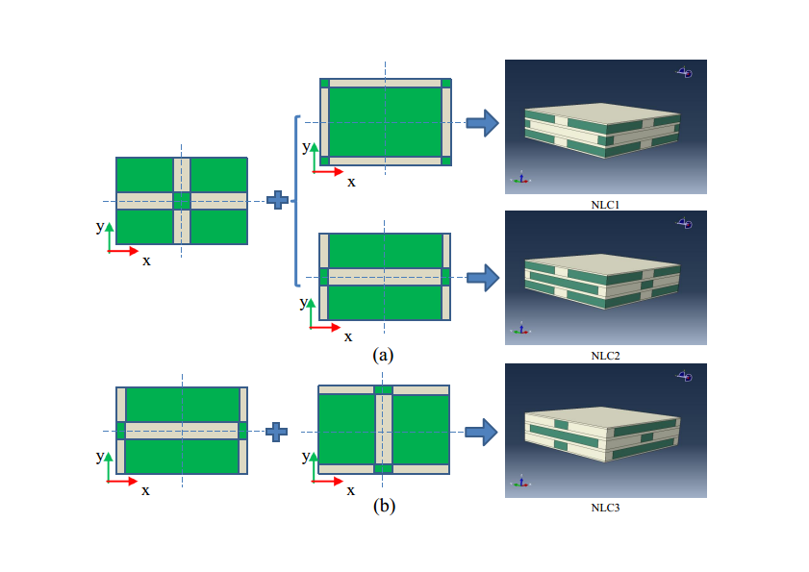

Figure 2. Modeling schemes of three NLCs.

Table 2. Geometry parameters of all models.

Model | Cell size  (mm) | Tablets size  (mm) | Stacking number | Model size (1/4) (mm) | Volume fraction (V_{f}) (%)
SAL1 | 12×12×5.6 | - | 2.5 | 48×48×14 | 53.57
SAL2 | 12×12×3.5 | 11×11×1 | 4 | 48×48×14 | 54.76
NLC1  NLC2  NLC3 | 12×12×4 | 10.05×10.05×1 | 3.5 | 48×48×14 | 54.59

2.2 Modeling of different aspect ratio of tablets

The specific aspect ratio of tablets in NLCs was around 10 as can be seen from Tab. 2, which is a typical value employed in the past research work [1-6]. For clarity, the aspect ratio of tablets in NLCs models was calculated by the ratio of in-plane length to out-of-plane thickness of tablets based on the assumption that the in-plane shape of tablets was a square and so as the unit cells. By this definition, the different aspect ratios of tablets in NLCs could be accomplished through the following simple calculation while the volume fraction of tablets remained indentical. The volume fraction of tablets in the original models shown in Tab.2 was calculated in Eq.1:
$V_{f}=\frac{\left[{\left(l\right)}^{2}+{\left(L-l\right)}^{2}\right]}{{\left(L\right)}^{2}}×\frac{3h}{H}$ (1)
Where, V_{f} is the original volume fraction of tablets, l and h are the original length and thickness of tablets, and L and H are the original length and thickness of unit cells, respectively. The volume fraction of models with different aspect ratios of tablets was then derived:
$V_{f}^{'}=\frac{\left[{\left(l^{'}\right)}^{2}+{\left(L^{'}-l^{'}\right)}^{2}\right]}{{\left(L^{'}\right)}^{2}}×\frac{3h^{'}}{H^{'}}$ (2)
Where, $V_{f}^{'}$ is the volume fraction of tablets, $l^{'}$ and $h^{'}$ are the original length and thickness of tablets, and $L^{'}$ and $H^{'}$ are the original length and thickness of unit cells in models with different aspect ratios, respectively. Thus, if we set $L^{'}=L/C, {H^{'}=H, l}^{'}=l/C,h^{'}=h$ , with C being the coefficient that controls the specified aspect ratio value of tablets, it could be easily seen from Eq.1 and Eq.2 that $V_{f}^{'}=V_{f}$. The coefficient C was set to be 0.5,1,2,4, and the models were denoted as, for examples, NLC1-AR2, NLC1-AR1, NLC1-AR05, NLC1-AR025, respectively, as AR stood for aspect ratio, and the also model was the same as one in Tab.2 when C was 1. The four different unit cells involving four different aspect ratios of tablets were shown in Fig.3.

(a) (b) (c) (d)

Figure 3. Representative uint cells involving different aspect ratio:
(a) NLC1-AR2, (b) NLC1-AR1, (c) NLC1-AR05, (d) NLC1-AR025.

2.3 Material models and mesh sensitivity

Regarding the material properties, a rate-independent constitutive model was adopted for the tablets and Johnson-Cook model was used for the matrix, the same material models in Refs [8,9], and the interface property between the tablet and matrix phase was assumed to be perfectly bonded because of the information that the 3D-printing process would achieve an excellent adhesion between different materials [9,10] and the fact that the matrix usually serves as an interface. The material parameters of tablet and matrix were shown in Fig.4 (a) and Tab.3, respectively. And the projectile was modeled as a rigid body using steel material as in Refs [7-10], which could be regarded as a worst scenario since there was no projectile deformation during impact. The diameter of projectile was 20 mm, the density 7.9 g/cm³, Young’s modulus 210 GPa and Poisson’s ratio 0.3. A typical total finite element model was shown in Fig.4 (b), here only one quarter was modeled due to the symmetry of the model, and the size was 48×48×14 mm. The mesh sensitivity was also conducted in Fig.5, and the element size was chosen as 0.3×0.3×0.3 mm. The target was impacted by projectile at velocity of 50 m/s.

(a) (b)

Figure 4. Material model of tablet and FEM models:
(a) Material model of tablet, (b)finite element models in this paper.

Table 3. Material model of matrix

A (MPa) | B (MPa) | n | C | m | D1 | D2 | D3 | D4 | D5
520 | 477 | 0.52 | 0.001 | 1 | 0.096 | 0.049 | -3.465 | 0.0016 | 1.099

Figure 5. Predicted residual velocities with different element numbers
along the thickness in the model.

3 Results and discussion

3.1 Influence of the stagger arrangement levels

Concerning the effect of the stagger arrangement level, the velocity profile of different models was shown in Fig.6. It can be seen from Fig.6 that the SAL0 performed worst of all models and the SAL1 yielded the best impact-resistance performance while there was no much difference between the four others. The stress contours in Fig.7 at impact time t=0.5 ms might shed light on the explanation. As can be seen from Fig.7 that the shockwaves propagated through the continuous material (SAL0) leading to a catastrophic failure while complex shockwave patterns were observed in all other structures and there was a much more significant global deformation in SAL1 than the others. Moreover, it is clearly seen that the influenced areas increased with the increasing stragger levels, which signifies the more complex structures could dissipate more energy. What’s more, it should be noted that the influenced areas of SAL2, NLC1, NLC2 and NLC3 were almost same to each other. Therefore the role of stagger arrangement level may not be as we thought it would be and it needs further investigation.

Figure 6. Velocity profiles of different models at 50 m/s.

(a) (b) (c)
(d) (e) (f)

Figure 7. Stress contours of different models at critical time t=0.5 ms:
(a) SAL0, (b) SAL1, (c) SAL2, (d) NLC1, (e) NLC2, (f) NLC3.
3.2 Influence of the different aspect ratio of tablets

With respect to the effect of the aspect ratio of tablets, the residual velocities of different models were shown in Fig.8. It can clearly be seen that the aspect ratio of tablets had a remarkable influence on the dynamic response of NLCs, and that as the aspect ratio of tablets became smaller, there was a obvious improvement in the impact-resistance performance in all NLCs, but there was a slight decline in NLC3-AR025. Furthermore, it was the stress contours of matrix phase of NLCs at impact time t=0.264 ms shown in Fig.9, which may be the possible reason for this phenomenon. It was apparent that the influenced areas grew progressively with the decreasing aspect ratios of tablets, which could induce much more energy dissipation therefore lead to the higher impact-resistance.

(a) (b) (c)

Figure 8. Residual velocities of different aspect ratio of tablets with different models:
(a) NLC1, (b) NLC2, (c) NLC3.

(a) (b) (c) (d)

Figure 9. Stress contours of matrix phase of models with different aspect ratio of tablets
(a) NLC1-AR2, (b) NLC1-AR1, (c) NLC1-AR05, (d) NLC1-AR025.

4. Conclusions

Three 3D FEM models which approximately mimics “brick-mortar” structure of nacre biological material was created. Tegother with bulk material, classical layer composites a series of simulations were carried out to investigate the effect of stagger arrangement level and aspect ratio of tablets on the dynamic properties of nacre-like composites under impact velocity of 50 m/s. The results indicated that the role of stagger arrangement level might not be the important factor that contributes to the outstanding impact-resistance property of NLCs and that the aspect ratio of tablets had a noticeable impact the dynamic behavior of NLCs. Namely, the smaller the aspect ratio of tablets be, the more impact loadings could NLCs withstand. This results would provide some guidance to the future structure design.

Acknowledgments

The authors thank the support from the National Natural Science Foundation of China (Nos. 11672013, 11672014 and 11472025) and Defense Industrial Technology Development Program (No. JCKY2016601B001 and JCKY2016205C001) and the Fundamental Research Funds for the Central Universities.

References

[1] H. Gao, Application of Fracture Mechanics Concepts to Hierarchical Biomechanics of Bone and Bone-like Materials. International Journal of Fracture, 138,101,2006.
[2] S. Dipanjan, and M.J. Buehler, Structural hierarchies define toughness and defect-tolerance despite simple and mechanically inferior brittle building blocks. Sci Rep, 1, 35,2011.
[3] L.S. Dimas, and M.J. Buehler, Tough and stiff composites with simple building blocks. Journal of Materials Research, 28:1295-1303,2013.
[4] L.S. Dimas, and M.J. Buehler, Influence of geometry on mechanical properties of bio-inspired silica-based hierarchical materials. Bioinspiration & Biomimetics, 7: 036024,2012 .
[5] L. Shi, and V. Ronfard, Tough Composites Inspired by Mineralized Natural Materials: Computation, 3D printing, and Testing. Advanced Functional Materials, 23:4629-4638,2013.
[6] R. Mirzaeifar, L.S. Dimas, Q. Zhao, and M.J. Buehler, Defect-Tolerant Bioinspired Hierarchical Composites: Simulation and Experiment. Acs Biomater.sci.eng, 1:150414064726000,2015.
[7] C. Knipprath, I.P. Bond, and R.S. Trask, Biologically inspired crack delocalization in a high strain-rate environment. Journal of the Royal Society Interface, 9:665,2012.
[8] E.A. Flores-Johnson, L. Shen, I. Guiamatsia, and G.D. Nguyen, Numerical investigation of the impact behaviour of bioinspired nacre-like aluminium composite plates. Composites Science & Technology, 96:13-22,2014.
[9] G.X. Gu, M. Takaffoli, A.J. Hsieh, and M.J. Buehler, Biomimetic additive manufactured polymer composites for improved impact resistance. Extreme Mechanics Letters, 9:317-323,2016 .
[10] G.X. Gu, M. Takaffoli, and M.J. Buehler, Hierarchically Enhanced Impact Resistance of Bioinspired Composites. Advanced Materials, 29,2017.

